Supplementary Information
A Transferable Fragment Dictionary for Eco-Safety and Environmental Risk Assessment
Chen-Chen Zhao⁺, Shaoyi Hou⁺, Cheng Fu, Peng Peng, Guoqiang Wang, Jian-Jun Feng, Shujuan Zhang,* and Jing Ma*
Dedication
C.-C. Zhao, S. Hou, C. Fu, Prof. Dr. G. Wang, Prof. Dr. J. Ma
State Key Laboratory of Coordination Chemistry, School of Chemistry and Chemical Engineering, Collaborative Innovation Center of Advanced Microstructures
Nanjing University, Nanjing, Jiangsu 210023, P. R. China
E-mail: majing@nju.edu.cn
P. Peng, Prof. Dr. S. Zhang
State Key Laboratory of Pollution Control and Resource Reuse, School of Environment
Nanjing University, Nanjing, Jiangsu 210023, P. R. China
E-mail: sjzhang@nju.edu.cn
Prof. Dr. J.-J. Feng
State Key Laboratory of Chemo/Biosensing and Chemometrics, Advanced Catalytic Engineering Research Center of the Ministry of Education, College of Chemistry and Chemical Engineering
Hunan University, Changsha, Hunan 410082, P. R. China
[+] These authors contributed equally to this work.

List of Figures and Tables 3
Section 1 Attention-Guided Fragment Identification. 5
Section 1.1 Model Architecture with Self-Attention. 5
Section 1.2 Attention-Guided Fragment Identification. 6
Section 2 eFragD fragments preprocessing. 9
Section 2.1 Frequency analysis. 9
Section 2.2 Frequency analysis of fragment containing C=O, C=N, and C=S. 10
Section 2.3 Frequency analysis of halogen (X) fragments. 14
Section 2.4 Frequency analysis of hydroxyl fragments. 14
Section 2.5 Frequency analysis of heterocyclic five-membered rings. 15
Section 3 Machine learning algorithms. 22
Section 3.1 Machine learning parameters. 22
Section 3.2 Evaluation metrics. 24
Section 3.3 Machine learning performance. 26
Section 3.4 Performance of RF regression models with RDKit, MACCS and ECFP6 descriptors. 27
Section 3.5 Feature importance analysis of eFragD-RFR model. 28
Section 3.6 Phosphate-like groups analysis. 29
Section 3.7 Performance of RF regression model with eFragD features and common descriptors. 31
Section 3.8 Performance of external validation. 32
Section 3.9 Application of eFragD in toxicity screening for perovskite ligands. 33
Section 4 Cyanocidal activity assays. 35
Section 4.1 Culturing Microcystis aeruginosa. 37
Section 4.2 Inhibition experiments. 37
Section 4.3 Molecules used in cyanocidal activity experiments and collected from literature. 38
Section 4.4 Cyanodical activity experiments. 42
Section 4.5 Classification criteria for molecular cyanodical activity. 43
Section 4.6 Molecular-protein interaction analysis. 44
Section 5 Boundary conditions and dictionary for the eFragD method. 52
Section 6 Procedure and code script of eFragD method. 53

List of Figures and Tables

Figure S1. Toxicity prediction using the graph convolutional neural network (GCNN) method. 7
Figure S2. Flowchart of self-attention mechanism. 7
Figure S3. A histogram of molecules and their toxicity distribution. 10
Figure S4. Confusion matrix for classification learning using the eFragD-RFC model. 22
Figure S5. Performance of different machine learning algorithms. 27
Figure S6. Performance of RF regression models with RDKit (a), MACCS (b), and ECFP6 (c) descriptors. 28
Figure S7. Feature importance analysis of eFragD-RFR model. feature_importances_ (left-bottom plot) and Pearson correlation coefficient (r) (right-top plot). 29
Figure S8. Performance of RF regression algorithms with eFragD features and several physicochemical descriptors. 32
Figure S9. Performance of the eFragD-RF model on the external validation set. a, Confusion matrix of the eFragD-RFC model. b, Performance curve of eFragD-RFR model comparing with T.E.S.T. software. 33
Figure S10. Predicted acute oral toxicity (LD₅₀) of organic ligands for hybrid perovskite materials using the eFragD-RFR model. 34
Figure S11. Cyanodical activity of new molecules (listed in Table S19, Nos. 1-11 and 45) on a cyanobacterium (FACHB-905). 44
Figure S12. Cyanodical activity of antibiotics (listed in Table S19, Nos. 12-30) on a cyanobacterium (FACHB-905). 44
Figure S13. Descriptor’s analysis. (a) Pearson correlation coefficient (r) between different features and cyanodical activity. (b) SHAP analysis of the six descriptors. 45
Figure S14. Binding energies between different molecules and target protein. 46
Figure S15. Molecular-protein interaction analysis. 52
Figure S16. The procedure and code script of eFragD method. 54

Table S1. Hyper-parameters of DeepMoleNet. 6
Table S2 Attention visualization of selected molecules. 8
Table S3. Acute oral toxicity values based on toxicity categories. 10
Table S4. Frequency analysis of fragments containing C=O, C=N and C=S. 11
Table S5. Frequency analysis of fragments containing C=O/N/S with different bond-linked environments. 14
Table S6. Frequency analysis of fragments containing halogen. 15
Table S7. Frequency analysis of hydroxyl groups. 15
Table S8. Frequency analysis of heterocyclic five-membered rings. 16
Table S9. List of eFragD descriptors. 17
Table S10. Schematic structures and the frequency index analysis of prominent fragments in Category I. 19
Table S11. Schematic structures and the frequency index analysis of prominent fragments in Category II. 20
Table S12. Schematic structures and the frequency index analysis of prominent fragments in Category III. 21
Table S13. Some important parameters used in regression and classification models. 23
Table S14. Frequency analysis of P=O/S/N-containing molecules. 30
Table S15. Frequency analysis of phosphate-like groups. 31
Table S16. Relationship between the charges and toxicity values variation of fragments attached to the benzene ring. 35
Table S17. Comparison of properties between molecules for rodent toxicity prediction and cyanocides. 36
Table S18. Impact of fragments on molecular acute toxicity and cyanocidal activity. 37
Table S19. Molecules used in cyanocidal activity assays. 39
Table S20. Molecules collected from literature. 42
Table S21. IE_{96 h} experimental values of molecules. 44
Table S22. Boundary conditions and dictionary for the eFragD method. 53

Supplementary Information

Section 1. Attention-Guided Fragment Identification
To enhance the interpretability and fragment selection process in molecular toxicity prediction, we introduced a self-attention mechanism into the molecular representation model. Unlike black-box neural networks, the attention weights provide explicit insights into which atomic regions most influence the model’s output, offering a data-driven strategy for identifying key substructures for toxicity modeling.

Section 1.1 Model Architecture with Self-Attention
A Graph Convolutional Neural Network (GCNN) model, named DeepMoleNet program developed by our group, incorporating a self-attention mechanism was constructed to process molecular graph inputs. Molecular structures are represented as graphs, where atom types and atom pairs serve as inputs for individual nodes and edges. Features include atomic attributes such as atomic species, chirality, aromaticity, hydrogen atom count, force field charges, van der Waals radii, among others. Chemical bond-related features include ring information and topological distances. The dataset is randomly split into training, validation, and test sets with an 8:1:1 ratio. Following an extensive hyperparameter tuning process (the specific hyperparameters as detailed in Table S1), the model displayed the r value of 0.86 for train set (corresponding a value of 0.71 for test set),shown in Figure S1. This result implied that molecular structure (in terms of graph nodes/edges) and toxicity are intricately linked.
Table S1. Hyper-parameters of DeepMoleNet.
Category | Hyper-parameter | Value
Message Passing Function | Message passing steps T | 4
Message Passing Function | Edge network layers | 3
Message Passing Function | Edge network hidden dim | 96
Update Function | Node hidden units dim | 32
Update Function | LSTM layer | 2
Update Function | Attention layer | 2
Readout Function | Set2set computations M | 2
Readout Function | Output NN hidden layer | 2
Readout Function | NN hidden units | 256
Auxiliary Target/ACSFs | Radial functions | [1, 1], [1, 2], [1, 3]
Auxiliary Target/ACSFs | Angular functions | [1, 1, 1], [1, 2, 1], [1, 1, -1], [1, 2, -1]
Training | Initial learning rate | 5×10⁻⁴
Training | Scheduler | Cosine Annealing LR
Training | Optimizer | Adam
Training | Batch size | 64
Training | Training epochs | 1000

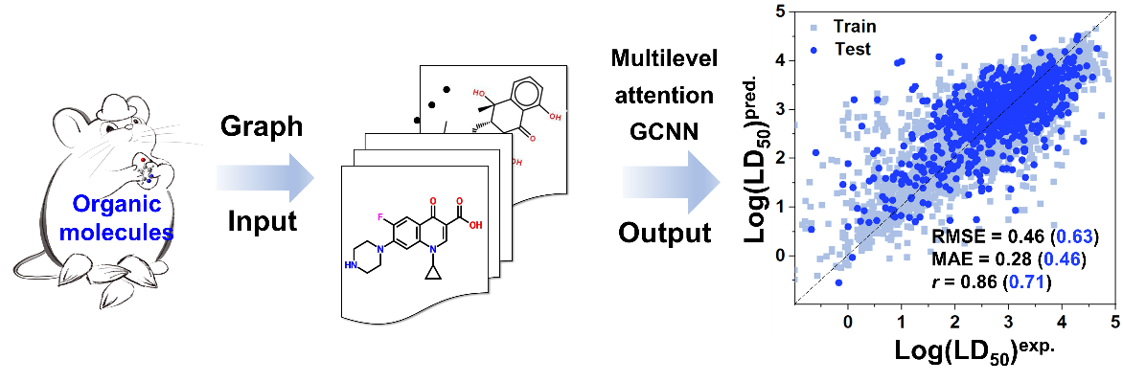
Figure S1. Toxicity prediction using the graph convolutional neural network (GCNN) method.

A series of graph convolutional layers were followed by a self-attention pooling layer, enabling the model to learn weighted atom-level contributions to toxicity (LD₅₀) predictions, shown in Figure S2.

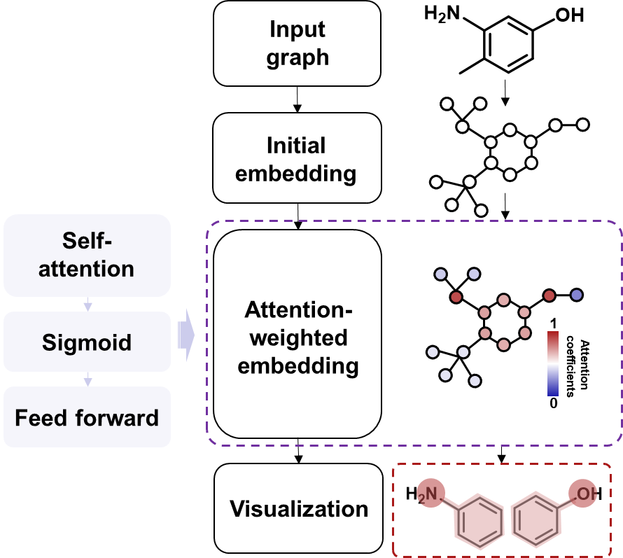
Figure S2. Flowchart of self-attention mechanism.

Section 1.2 Attention-Guided Fragment Identification
To visualize the results, attention weights were projected onto 2D molecular structures. As shown in Table S2, several highly toxic and non-toxic molecules were selected from the training dataset. Regions with higher attention weights (highlighted in red) correspond to atoms and substructures deemed more relevant to predicted toxicity values.
For instance, in the molecule CAS: 103-90-2, atoms belonging to phenol and amide groups exhibited strong attention signals. Interestingly, heavier atoms such as nitrogen (N), sulfur (S), and phosphorus (P) were frequently assigned higher attention, providing guidance for selecting relevant molecular fragments (e.g., sulfonamides, nitro groups, phosphates) for toxicity assessment. These high-attention regions were cross-referenced with fragments from the preliminary eFragD pool to identify overlapping chemically meaningful substructures.
Table S2 Attention visualization of selected molecules.
Molecules | Attention Visualization | Fragments
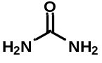 | 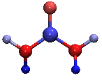 | 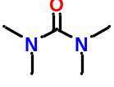
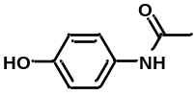 | 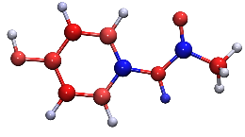 | 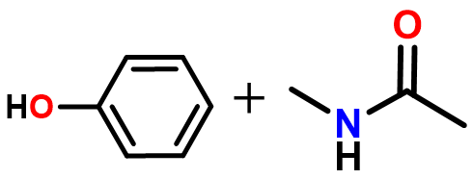
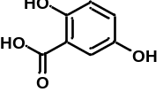 | 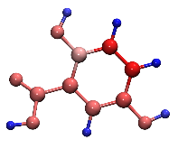 | 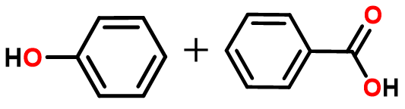
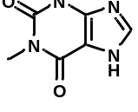 | 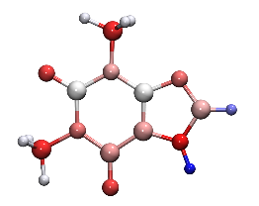 | 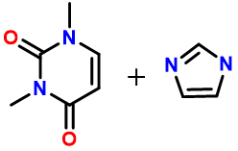
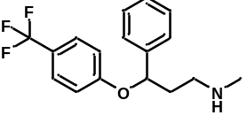 | 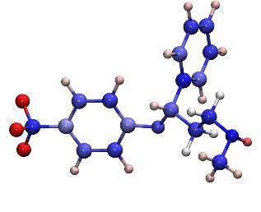 | -CF₃
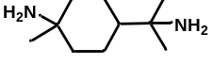 | 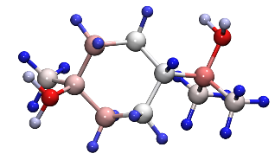 | -NH₂
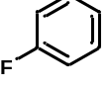 | 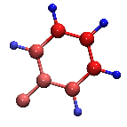 | 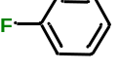
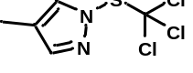 | 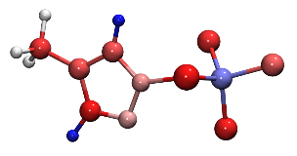 | 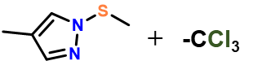
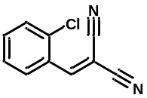 | 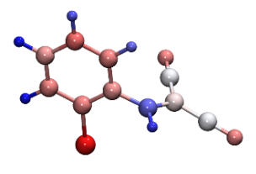 | 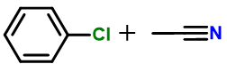
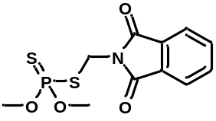 | 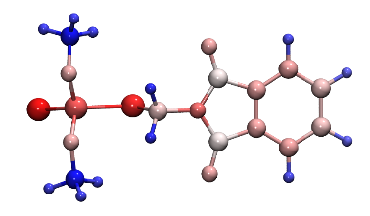 | 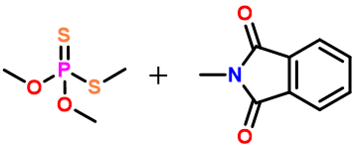
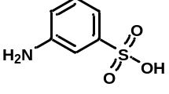 | 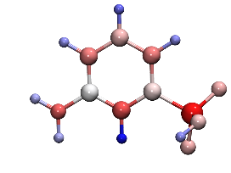 | 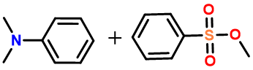
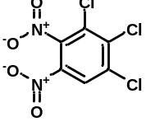 | 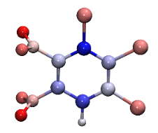 | 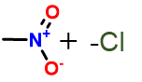
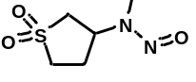 | 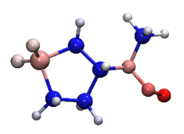 | 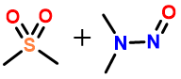

Section 2. eFragD fragments preprocessing
Patterns in the eFragD defined with a general purpose to cover representative substructures, as many as possible. Not all of these patterns are necessary for toxicity prediction modeling. Therefore, a preliminary pattern filtering step is necessary and important.
Herein, the statistical fragments were preprocessed as follows: (1) Similar groups were merged to improve the occurrence frequency of fragments based on frequency analysis, as detailed in Section 2.1-Section 2.5. (2) The Pearson correlation coefficient (r) between all pairs of descriptors were calculated, and the redundant descriptors with the r higher than the threshold (0.8) were removed. (3) Substructures occurring fewer than 50 times were excluded from the dataset.

Section 2.1 Frequency analysis
Following the classification criteria of the People's Republic of China National Standard GB30000.18-2013, the Log(LD₅₀) values of the provided molecules were mapped into three categories representing different toxicity levels (detailed categories and molecular distributions are outlined in Table S3 and Figure S3).
Table S3. Acute oral toxicity values based on toxicity categories.
Acute oral toxicity | Category I  Danger | Category II  Warning | Category III  Safety
LD₅₀ (mg/kg) | ≤300 | ＞300 & ≤2000 | ＞2000
Log(LD₅₀, mg/kg) | ≤2.477 | ＞2.477 & ≤3.301 | ＞3.301
Numbers of molecules | 2095 | 3017 | 2692

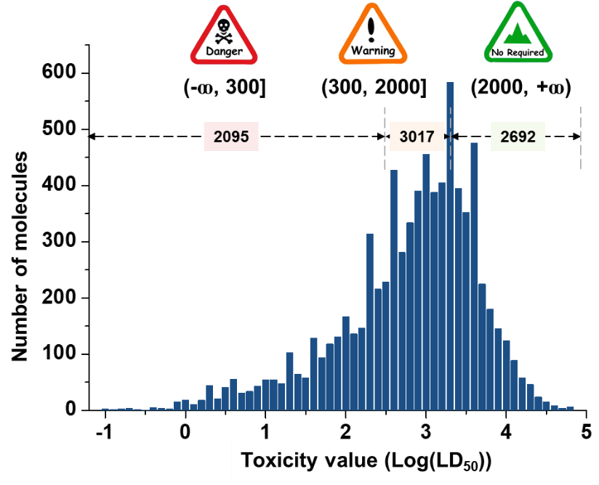
Figure S3. A histogram of molecules and their toxicity distribution.
Frequency analysis based on fragments could promote the identification of more meaningful substructures. Frequency index for each fragment (Freq.) was defined by equation (Eq. 12):
$Freq. = \frac{N_{Fij}/ N_{j}}{N_{Fi_total}/ N_{total}}$ Eq. 12
Where N_{Fij} and N_{j} are the number of molecules containing the specific fragment (number: F_{i}) and the number of compounds in category j (j = I, II and Ⅲ, respectively), respectively. N_{Fi_total} and N_{total} are the total number of molecules containing the F_{i} and the total number of compounds in the dataset, respectively.

Section 2.2 Frequency analysis of fragment containing C=O, C=N, and C=S.
Carbonyl groups, imine groups and thioketone groups：Molecules containing imine groups and thioketone groups predominantly fall into toxic categories (I & II). In contrast, those with carbonyl groups are more likely to belong to category III (non-toxic).
C(=O)-O (ester)-like substructures. Compounds containing ester or amide groups on chains tend to be non-toxic, while molecules with other related-fragments exhibits similar toxicity (I & II categories). Notably, lactones and lactams groups are primarily associated with toxic compounds.
O-C(=O)-O (Peroxoic acid)-like substructures. Molecules containing these fragments are more frequently found in toxic compounds, particularly those with aminoperoxoic acid and thio-peroxoic acid groups.
C(=O)-O-C(=O) (Acetic anhydride)-like substructures. Except for C(=O)-O/S/N-C(=O) fragments, which are frequently present in non-toxic compounds, other related structures are generally toxic.

Table S4. Frequency analysis of fragments containing C=O, C=N and C=S.
Fragment | Structure | Total Number |  | Frequency index in Categories
Fragment | Structure |  |  | I | II | I & II | III
Thioketone | 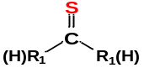 |  | 155 | 1.373 | 1.232 | 1.290 | 0.449
Imine | 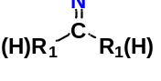 |  | 365 | 1.688 | 1.018 | 1.292 | 0.445
Carbonyl | 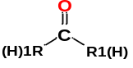 |  | 5275 | 0.876 | 0.906 | 0.893 | 1.202
Hydrazone | 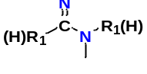 |  | 84 | 1.467 | 1.352 | 1.399 | 0.242
Isoxazole | 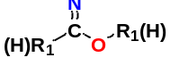 |  | 13 | 0.862 | 1.191 | 1.057 | 0.892
Thiohydrazone | 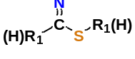 |  | 4 | 0.000 | 1.936 | 1.145 | 0.725
Thioamide | 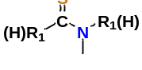 |  | 12 | 1.245 | 1.076 | 1.145 | 0.725
Thioester | 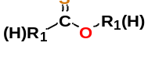 |  | 3 | 1.245 | 1.721 | 1.526 | 0.000
Amide | 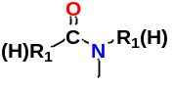 |  | 680 | 0.642 | 1.188 | 0.965 | 1.066
Ester | 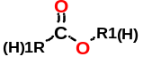 |  | 1620 | 0.627 | 0.801 | 0.730 | 1.513
Thioformyl | 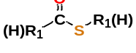 |  | 12 | 0.622 | 1.506 | 1.145 | 0.725
Lactones | - |  | 114 | 1.605 | 0.770 | 1.111 | 0.814
Lactam | - |  | 93 | 0.763 | 1.471 | 1.182 | 0.655
Peroxoic acid -like | 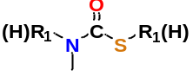  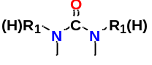  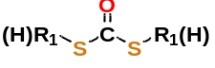 |  | 152 | 0.565 | 1.342 | 1.024 | 0.954
Peroxoic acid -like | 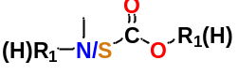 |  | 262 | 1.767 | 0.877 | 1.241 | 0.542
Peroxoic acid -like | 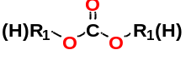  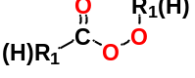 |  | 20 | 0.747 | 1.420 | 1.145 | 0.725
Peroxoic acid -like | 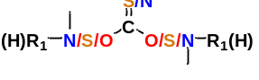 |  | 134 | 1.169 | 1.274 | 1.231 | 0.562
Acetic anhydride-like | 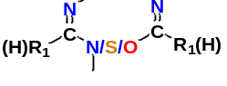 |  | 5 | 0.747 | 2.065 | 1.526 | 0.000
Acetic anhydride-like | 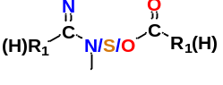 |  | 22 | 1.018 | 1.173 | 1.110 | 0.791
Acetic anhydride-like | 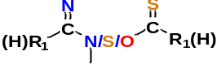 |  | 1 | 3.734 | 0.000 | 1.526 | 0.000
Acetic anhydride-like | 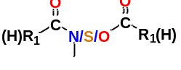 |  | 86 | 0.564 | 0.870 | 0.745 | 1.484

The above-mentioned fragments are further subdivided based on different bonding environments, including the presence of halogen atoms or double bonds. Frequency analysis (Table S5) indicates that these bond-linked environments do not significantly affect the fragment classification. Therefore, the related fragments will be merged into the previously discussed groups.
Table S5. Frequency analysis of fragments containing C=O/N/S with different bond-linked environments.
Fragment | Total Number | Frequency index in Categories
Fragment | Total Number | I | II | I & II | III
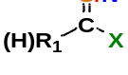 | 0 | - | - | - | -
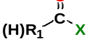 | 27 | 0.000 | 1.246 | 0.737 | 1.497
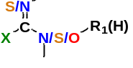 | 0 | - | - | - | -
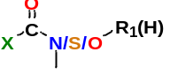 | 10 | 0.749 | 1.035 | 0.918 | 1.155
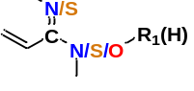 | 18 | 0.832 | 1.869 | 1.445 | 0.160
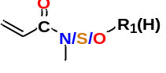 | 316 | 0.841 | 0.835 | 0.837 | 1.307
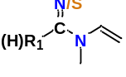 | 2 | 0.000 | 1.294 | 0.765 | 0.000
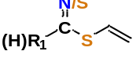 | 0 | - | - | - | -
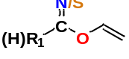 | 0 | - | - | - | -
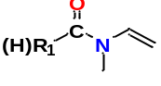 | 24 | 0.000 | 0.970 | 0.574 | 1.805
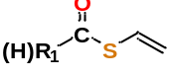 | 0 | - | - | - | -
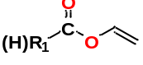 | 38 | 0.689 | 0.545 | 0.604 | 1.900

Section 2.3 Frequency analysis of halogen (X) fragments
Table S6 shows that molecules containing F/Cl/Br are predominantly classified into categories I and II (toxic), while those containing I are more likely to be classified into category III (non-toxic). The number of molecules containing I is relatively small, only X = F/Cl/Br was considered when compiling the statistics for halogen-related features.
Table S6. Frequency analysis of fragments containing halogen.
Fragments | Total Number | Frequency index in Categories
Fragments | Total Number | I | II | I & II | III
X = F | 1539 | 1.799 | 0.860 | 1.244 | 0.535
X = Cl | 3360 | 1.287 | 1.004 | 1.120 | 0.772
X = Br | 402 | 1.875 | 0.681 | 1.169 | 0.678
X = I | 94 | 0.913 | 0.577 | 0.714 | 1.543

Section 2.4 Frequency analysis of hydroxyl fragments
The differences between primary, secondary, and tertiary hydroxyl groups were specifically analyzed in Table S7. It was found that molecules containing primary and secondary hydroxyls predominantly belong to category III (non-toxic), while those containing tertiary hydroxyls are mainly classified into categories I and II (toxic). As a result, the hydroxyl-related features were revised to differentiate between tertiary hydroxyl groups (Tert-OH) and other types of hydroxyl groups (NoTert-OH).
Table S7. Frequency analysis of hydroxyl groups.
Fragments | Total Number | Frequency index in Categories
Fragments | Total Number | I | II | I & II | III
-C-OH | 205 | 1.110 | 1.045 | 1.072 | 0.863
-CH-OH | 661 | 0.740 | 0.789 | 0.769 | 1.440
-CH₂₋OH | 579 | 0.413 | 0.700 | 0.582 | 1.794

Section 2.5 Frequency analysis of heterocyclic five-membered rings
Molecules containing heterocyclic five-membered rings, including furan, thiophene, pyrrole, as well as their benzofused derivatives (benzofuran, benzothiophene, and benzopyrrole), are predominantly associated with toxic categories, which are combined for statistical analysis.
Table S8. Frequency analysis of heterocyclic five-membered rings.
Fragments | Total Number | Frequency index in Categories
Fragments | Total Number | I | II | I & II | III
furan/benzofuran | 77 | 0.970 | 1.341 | 1.189 | 0.640
thiophene/benzo-thiophene | 38 | 1.277 | 1.359 | 1.325 | 0.382
pyrrole/benzo-pyrrole | 107 | 1.361 | 1.206 | 1.269 | 0.488

Table S9. List of eFragD descriptors.
No. | Feature | No. | Feature | No. | Feature | No. | Feature
F1* | 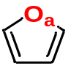 | F2* | 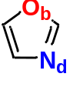 | F3* | 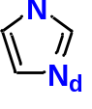 | F4* | 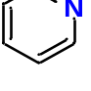
F5* | 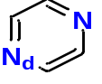 | F6* | 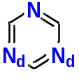 | F7 | 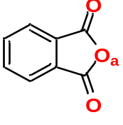 | F8 | 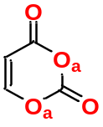
F9* | 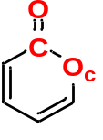 | F10 | 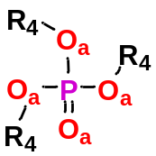 | F11 | 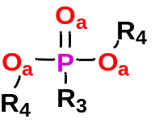 | F12 | 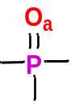
F13 | 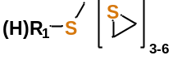 | F14 | 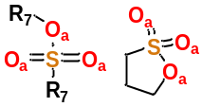 | F15 | 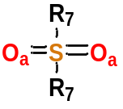 | F16 | 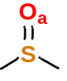
F17 | 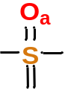 | F18 | 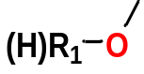 | F19 | 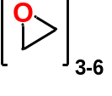 | F20 | 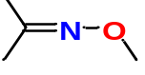
F21 | 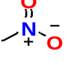 | F22 | 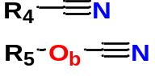 | F23 | 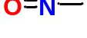 | F24 | -NH₂
F25 | 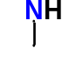 | F26 | 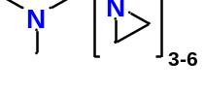 | F27 | 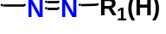 | F28 | 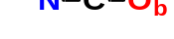
F29 | 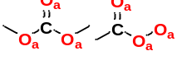 | F30 | 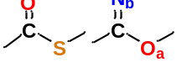 | F31 | 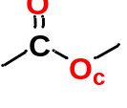 | F32 | 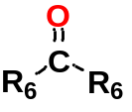
F33 | 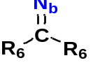 | F34 | 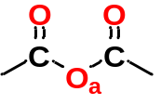 | F35 | 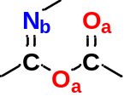 | F36* | 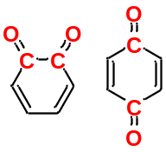
F37 | X_{total}  (X=F, Cl, Br) | F38 | X-R₂  (X=F, Cl, Br) | F39 | X-Ph  (X=F, Cl, Br) | F40 | N_{Bicyclic}
F41 | Tert-OH | F42 | NoTert-OH | F43 | F_{sp3} | F44 | M_{HA}
F45 | N_{HET} | F46 | q_{max} | F47 | q_{min} | F48 | ∆q
F49 | N_{C} | F50 | N_{CH} | F51 | N_{CH2} | F52 | N_{CH3}
- a: O can be replaced with N or S
- b: O/N can be replaced with S
- c: O can be replaced with N
- d: Atom position is variable
- []₃₋₆: Includes 3-6 membered rings
- *: Includes fused benzene, dibenzene, etc.

Table S10. Schematic structures and the frequency index analysis of prominent fragments in Category I.
Fragment ID | Structure | Frequency index in Categories |  |  | Total Number
Fragment ID | Structure | I | II | III | Total Number
F10 | 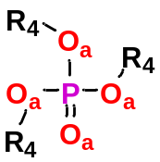 | 2.635 | 0.530 | 0.255 | 556
F12 |  | 2.628 | 0.472 | 0.327 | 806
F11 |  | 2.535 | 0.369 | 0.514 | 203
F20 |  | 2.486 | 0.627 | 0.263 | 132
F13 |  | 1.980 | 0.773 | 0.493 | 1228
F3* |  | 1.914 | 0.798 | 0.516 | 337
F22 |  | 1.768 | 0.751 | 0.682 | 310
F38 | X-R₂  (X=F, Cl, Br) | 1.654 | 0.859 | 0.649 | 2621
F23 | 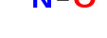 | 1.609 | 1.116 | 0.396 | 139
F21 |  | 1.488 | 0.879 | 0.755 | 491
F37 | X_{total}  (X=F, Cl, Br) | 1.481 | 0.937 | 0.697 | 5291
F39 | X-Ph  (X=F, Cl, Br) | 1.335 | 0.986 | 0.755 | 2379
F49 | N_{C} | 1.328 | 0.851 | 0.912 | 4561
F40 | Bicyclic | 1.263 | 0.973 | 0.826 | 2873
F29 |  | 1.245 | 1.103 | 0.694 | 593
F25 |  | 1.197 | 1.010 | 0.836 | 2212
F9* |  | 1.195 | 1.086 | 0.752 | 262
F49 | N_{CH3} | 1.083 | 0.939 | 1.004 | 12692
F41 | Tert-OH | 1.065 | 1.057 | 0.885 | 203

Table S11. Schematic structures and the frequency index analysis of prominent fragments in Category II.
Fragment ID | Structure | Frequency index in Categories |  |  | Total Number
Fragment ID | Structure | I | II | III | Total Number
F30 |  | 1.182 | 1.439 | 0.367 | 142
F1* |  | 1.173 | 1.293 | 0.537 | 232
F24 | -NH₂ | 0.749 | 1.198 | 0.973 | 956
F4* |  | 1.110 | 1.163 | 0.732 | 289
F26 |  | 1.126 | 1.157 | 0.726 | 6062
F33 |  | 1.084 | 1.122 | 0.798 | 3412

Table S12. Schematic structures and the frequency index analysis of prominent fragments in Category III.
Fragment ID | Structure | Frequency index in Categories |  |  | Total Number
Fragment ID | Structure | I | II | III | Total Number
F14 |  | 0.611 | 0.543 | 1.814 | 238
F42 | NoTert-OH | 0.589 | 0.748 | 1.602 | 1234
F34 |  | 0.597 | 0.750 | 1.594 | 100
F17 |  | 0.785 | 0.666 | 1.541 | 807
F31 |  | 0.637 | 0.883 | 1.414 | 2624
F29 |  | 0.926 | 0.729 | 1.361 | 149
F36* |  | 0.868 | 0.856 | 1.264 | 816
F32 | 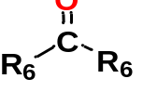 | 0.850 | 0.893 | 1.237 | 4790
F18 | 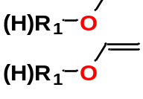 | 0.776 | 0.951 | 1.229 | 4814
F19 |  | 0.794 | 0.968 | 1.197 | 155
F51 | N_{CH2} | 0.837 | 0.971 | 1.159 | 20732
F50 | N_{CH} | 0.967 | 0.919 | 1.116 | 7419

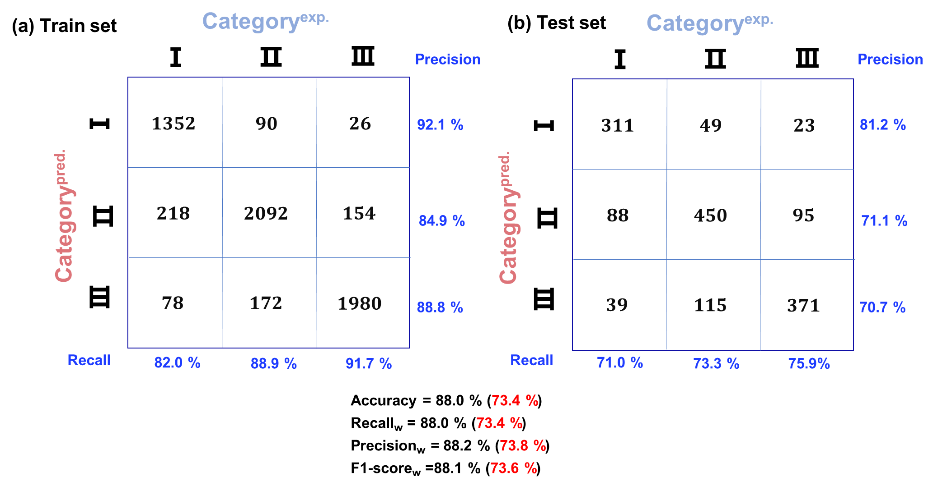
Figure S4. Confusion matrix for classification learning using the eFragD-RFC model.

Section 3. Machine learning algorithms

Section 3.1 Machine learning parameters
Random Forest Regression (RFR), Decision Tree (DT), Bootstrap Aggregating (BAG), Adaptive Boosting (AdaB), Elastic Net (ElaNET), Extra Tree Regression (EXTree), Extra Trees (EXTrees), Gradient Boosting Regression (GDB), Gaussian Process Regression (GPR), k-Nearest Neighbors (kNN), Lasso, Light Gradient Boosting Machine (LightGBM), Multi-Layer Perceptron (MLP), Ridge, Stochastic Gradient Descent (SGD), Support Vector Regression (SVR), eXtreme Gradient Boosting (XGBoost) machine-learning algorithms (including regression models and multi-classification models) are implemented in Auto-CheML. The datasets were shuffled by random numbers, and 80% were separated out as the training set and the 20% of database were used in the predicting phase. Model hyperparameters are optimized on the training set via GridSearchCV algorithm based on a five-fold cross validation, listed in Table S13.
Table S13. Some important parameters used in regression and classification models.
Method | Model | Optimized parameters
Regression | RFR | n_estimators = 300, random_state = 0, max_depth = 1, min_samples_leaf = 2, min_samples_split = 10
Regression | DT | max_depth = 11, min_samples_leaf = 12, min_samples_split = 21, random_state = 87
Regression | BAG | max_features = 0.66449, max_samples = 0.97322,  n_estimators = 642, random_state = 43
Regression | AdaB | learning_rate = 0.03832,  n_estimators = 92, random_state = 55
Regression | ElaNET | alpha = 0.10620, l1_ratio = 0.04783,  max_iter = 3378, random_state = 10
Regression | EXTree | max_depth = 10, max_features= 1.0, random_state= 52
Regression | EXTrees | max_depth = 30, max_features = 0.53588, min_samples_leaf = 1, min_samples_split = 6, n_estimators = 330, random_state = 56
Regression | GDB | learning_rate = 0.01, max_depth = 30, max_features = 1.0, max_leaf_nodes = 90, min_impurity_decrease = 0.0, min_samples_leaf = 1, min_samples_split = 20, min_weight_fraction_leaf = 0.0, n_estimators = 1451,  random_state = 57, subsample= 1.0
Regression | GPR | alpha = 0.16777, kernel = Rational Quadratic (alpha = 1, length_scale = 1), n_restarts_optimizer = 9, random_state = 90
Regression | kNN | n_neighbors = 6, p = 1.29273
Regression | Lasso | alpha = 0.01040, max_iter = 1415, random_state = 29
Regression | LightGBM | learning_rate = 0.11405, n_estimators = 178,  num_leaves = 44, random_state = 30
Regression | MLP | alpha = 0.08635, hidden_layer_sizes = 1209,  learning_rate_init = 0.00663, random_state = 13
Regression | Ridge | alpha = 0.98579, max_iter = 2572,  random_state = 70, tol = 0.00072
Regression | SGD | alpha = 0.02572, loss = squared_error,  max_iter = 1450, penalty = None, random_state = 88,  tol = 4.54843e-05
Regression | SVR | C = 2.04907, epsilon = 0.33756,  gamma = 0.04069
Regression | XGBoost | colsample_bytree = 0.5, gamma = 0.0, learning_rate = 0.01, max_delta_step = 0, max_depth = 30, min_child_weight = 5, n_estimators = 1161, random_state = 4, reg_alpha = 0.83771, reg_lambda = 0.0, subsample = 1.0
Classification | RFC | n_estimators = 300, max_features = sqrt, max_depth = None, min_samples_leaf = 2, min_samples_split = 10

Section 3.2 Evaluation metrics
For regression models, the mean absolute error (MAE) (Eq. 1), the root-mean-square error (RMSE) (Eq. 2) and the correlation coefficient (r) (Eq. 3) were adopted to evaluate the performance of each regression model. For classification tasks, the predictive power of each model is be evaluated in terms of precision (Eq. 4), recall (Eq. 5), accuracy (Eq. 6), the F1 score (Eq. 7) and the area under the receiver operating characteristic (ROC) curve (AUC-ROC).
$MAE= \frac{1}{n}\sum_{i=1}^{n}{\left|y_{i}^{pred}-y_{i}^{exp}\right|}$ Eq. 1
$RMSE= \sqrt{\frac{1}{n}\sum_{i=1}^{n}{{(y_{i}^{pred}-y_{i}^{exp})}^{2}}}$ Eq. 2
$r = \frac{\sum_{i=1}^{n}{(y_{i}^{exp}-\overline{y^{exp}})(y_{i}^{pred}-\overline{y^{pred}})}}{\sqrt{\sum_{i=1}^{n}{{(y_{i}^{exp}-\overline{y^{exp}})}^{2}}}\sqrt{\sum_{i=1}^{n}{{(y_{i}^{pred}-\overline{y^{pred}})}^{2}}}}$ Eq. 3
$Precision= \frac{TP}{TP+FP}$ Eq. 4
$Recall= \frac{TP}{TP+FN}$ Eq. 5
$Accuracy= \frac{TP+TN}{TP+TN+FP+FN}$ Eq. 6
$F1-score = \frac{2×P×R}{P+R}$ Eq. 7
where, $y_{i}^{pred}$ is the predicted toxicity value for each molecule, $y_{i}^{exp}$ is the experimental toxicity value for each molecule, $\overline{y^{exp}}$ and $\overline{y^{pred}}$ are the mean experimental and predicted toxicity value over all molecules, and n is the number of molecules; true positive (TP) and true negative (TN) are cases correctly predicted as positive and negative (within the same class), respectively; false positive (FP) and false negative (FN) are cases falsely predicted as positive and negative (belonging to different classes), respectively. For example, For class Ⅰ, TP is the number of compounds of class Ⅰ correctly predicted as class Ⅰ, FP is the number of compounds of classes Ⅱ&Ⅲ incorrectly predicted as class Ⅰ, false negative (FN) is the number of compounds of class Ⅰincorrectly predicted as class Ⅱ/Ⅲ , and (TN) is the number of compounds of class Ⅱ(Ⅲ) correctly predicted as class Ⅱ(Ⅲ).
Considering the dataset as a multi-class classification, the F1-score (Eq. 11) was calculated as the indicator for all classes using the weighted-average method (Eq. 8-10) in this study, as follows:
w_{Ⅰ} : w_{Ⅱ} :w_{Ⅲ} = n_{Ⅰ} : n_{Ⅱ} : n_{Ⅲ} Eq. 8
Weigted-Precision (Precision_{w}) = P_{Ⅰ} × w_{Ⅰ} + P_{Ⅱ} × w_{Ⅱ} + P_{Ⅲ} × w_{Ⅲ} Eq. 9
Weigted-Recall (Recall_{w}) = R_{Ⅰ} × w_{Ⅰ} + R_{Ⅱ} × w_{Ⅱ} + R_{Ⅲ} × w_{Ⅲ} Eq. 10
${F1-score}_{w} = \frac{{2×Precision}_{w}×{Recall}_{w}}{{Precision}_{w}+{Recall}_{w}}$ Eq. 11
where, P_{Ⅰ-Ⅲ}/R_{Ⅰ-Ⅲ} represents the precision/recall for each class, w_{Ⅰ-Ⅲ} denotes the weight of each class relative to the total classes, determined by the number of instances (n_{Ⅰ-Ⅲ}) for each class.

Section 3.3 Machine learning performance

Figure S5. Performance of different machine learning algorithms.

Section 3.4 Performance of RF regression models with RDKit, MACCS and ECFP6 descriptors
Each molecule is described using a chemical fingerprint of structural keys. The predefined dictionary contains a SMILES list of substructure patterns. In this study, three types of chemical fingerprint dictionaries include Molecular ACCess System (MACCS, contains 166 descriptors), Extended-Connectivity Fingerprint (ECFP6, includes 2048 bits) and RDKit fingerprints were available in RDKit package.

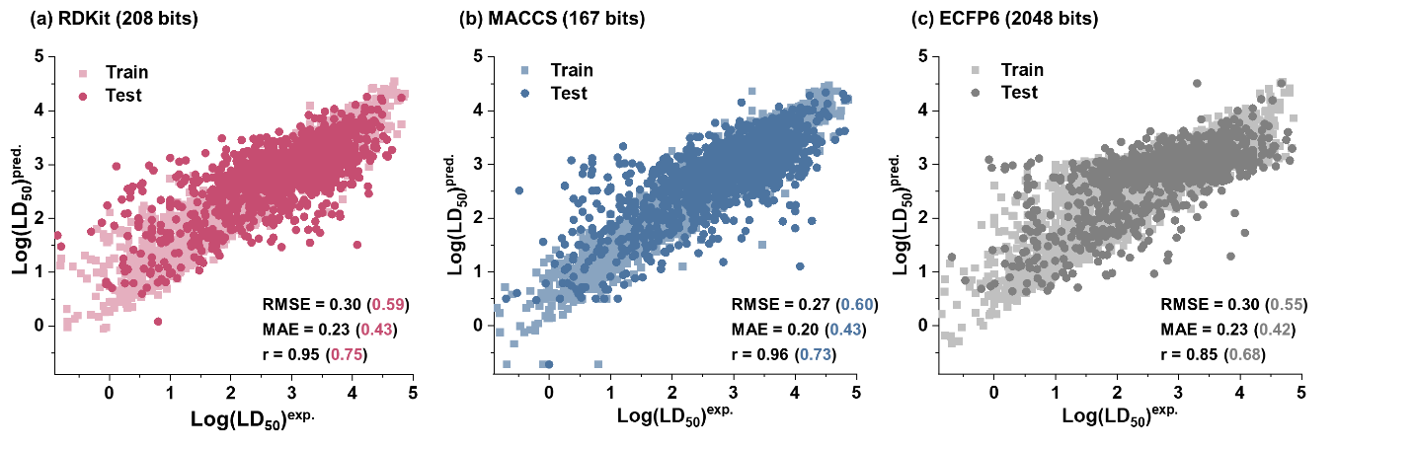
Figure S6. Performance of RF regression models with RDKit (a), MACCS (b), and ECFP6 (c) descriptors.

Section 3.5 Feature importance analysis of eFragD-RFR model
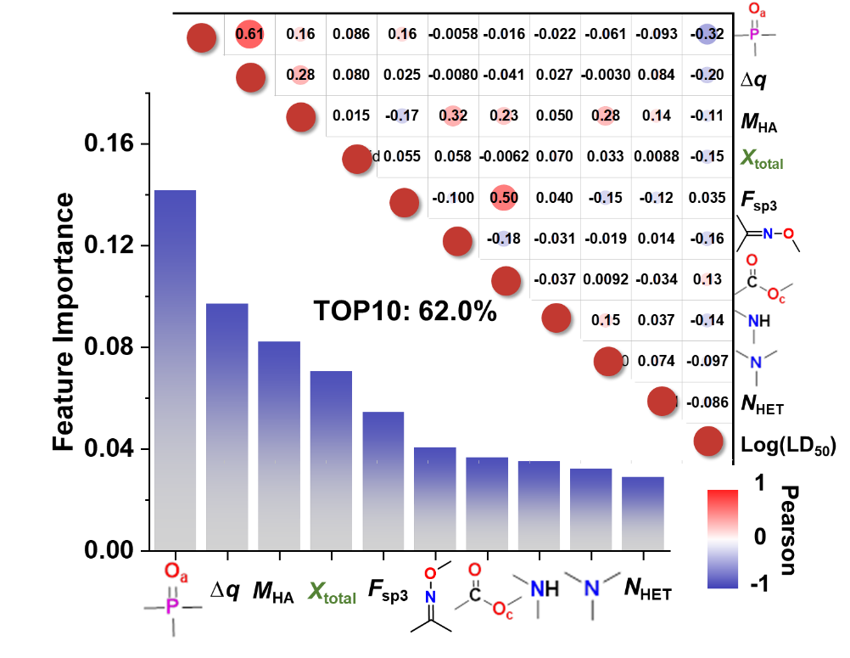
Figure S7. Feature importance analysis of eFragD-RFR model. feature_importances_ (left-bottom plot) and Pearson correlation coefficient (r) (right-top plot).

Section 3.6 Phosphate-like groups analysis
Phosphorus double-bond compounds. Table S14 lists the frequency factors for molecules containing P=O, P=S, and P=N double bonds. It was found that molecules containing these groups are predominantly distributed in category I.
Table S14. Frequency analysis of P=O/S/N-containing molecules.
Fragments | Total Number | Frequency index in Categories
Fragments | Total Number | I | II | I & II | III
P=O | 367 | 2.48 | 0.45 | 1.28 | 0.47
P=S | 386 | 2.80 | 0.52 | 1.45 | 0.15
P=N | 11 | 3.73 | 0 | 1.53 | 0
Phosphate-like compounds. Table S15 presents the frequency analysis of phosphorus-like compounds (phosphorus-containing compounds and phosphorus-sulfur compounds), including molecules containing these groups (contain) and those exclusively comprising them (only). It was observed that toxicity decreases with the number of oxygen atoms attached to the phosphorus. Specifically, when only the phosphate group (P(=O)O₃ (only)) is present, 12 out of 18 molecules were found to fall within the non-toxic range. Phosphate groups are widely present in biological systems (e.g., DNA, RNA, and ATP) and are generally not associated with significant toxicity.
Toxicity is typically observed in certain organophosphate compounds, particularly synthetic organophosphates. In these compounds, the oxygen or hydrogen atom in the phosphate group is replaced by an amine, sulfur, or organic group, as seen in organophosphates used as pesticides or nerve agents (e.g., parathion, malathion, sarin, VX). These compounds can irreversibly inhibit acetylcholinesterase and directly affect neuronal function, leading to neurotoxic effects.
This toxicity is not attributed to the natural presence of phosphate itself but is associated with its chemical environment, the structure of the specific compound, or its intended use.
Table S15. Frequency analysis of phosphate-like groups.
Name | Fragment | Total Number | Frequency index in Categories
Name | Fragment | Total Number | I | II | I & II | III
Trithiophosphate | P(=O)S₃ (contain) | 2 | 3.73 | 0 | 1.53 | 0
Trithiophosphate | P(=S)S₃ (contain) | -
Trithiophosphate | P(=O)S₃ (only) | 2 | 3.73 | 0 | 1.53 | 0
Trithiophosphate | P(=S)S₃ (only) | -
Dithiophosphate | P(=O)S₂O (contain) | 14 | 3.47 | 0.18 | 1.53 | 0
Dithiophosphate | P(=S)S₂O (contain) | - |  |  |  | -
Dithiophosphate | P(=O)S₂O (only) | 10 | 3.36 | 0.29 | 1.53 | 0
Dithiophosphate | P(=S)S₂O (only) | -
Phosphonothioyl | P(=O)SO₂ (contain) | 70 | 3.04 | 0.44 | 1.50 | 0.04
Phosphonothioyl | P(=S)SO₂ (contain) | 145 | 2.94 | 0.41 | 1.44 | 0.16
Phosphonothioyl | P(=O)SO₂ (only) | 16 | 3.27 | 0.32 | 1.53 | 0
Phosphonothioyl | P(=S)SO₂ (only) | 5 | 2.99 | 0.52 | 1.53 | 0
Phosphate | P(=O)O₃ (contain) | 132 | 2.32 | 0.49 | 1.24 | 0.55
Phosphate | P(=S)O₃ (contain) | 113 | 2.48 | 0.73 | 1.44 | 0.15
Phosphate | P(=O)O₃ (only) | 18 | 0.41 | 0.72 | 0.59 | 1.77
Phosphate | P(=S)O₃ (only) | 11 | 1.02 | 1.64 | 1.39 | 0.26

Section 3.7 Performance of RF regression model with eFragD features and common descriptors
The several physicochemical descriptors include the numbers of hydrogen bond donors (N_{H-D}) and acceptors (N_{H-A}), molecular polarity index (MPI), molecular polarizability (α) and LogP.
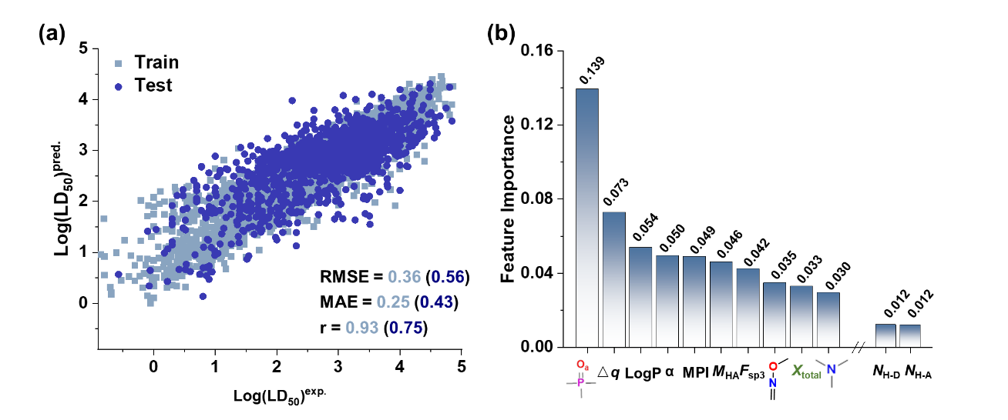
Figure S8. Performance of RF regression algorithms with eFragD features and several physicochemical descriptors.

Section 3.8 Performance of external validation
The ultimate challenge for generating a computational toxicity model is to apply these predictions and evaluate the toxicity potential of a new set of compounds. 1,283 chemicals that were independent from the dataset used in above research but have experimental rat oral LD₅₀ values were taken as an external validation set. The eFragD fingerprints were tested by the multiclass and regression model (eFragD-RFC and eFragD-RFR), respectively, shown in Figure S9, which yield a classification accuracy of 65.4% and a regression r value of 0.54 with RMSE of 0.43. The model present here can be easily considered an improvement on the T.E.S.T. software (Version 5.1.2) of this endpoint.
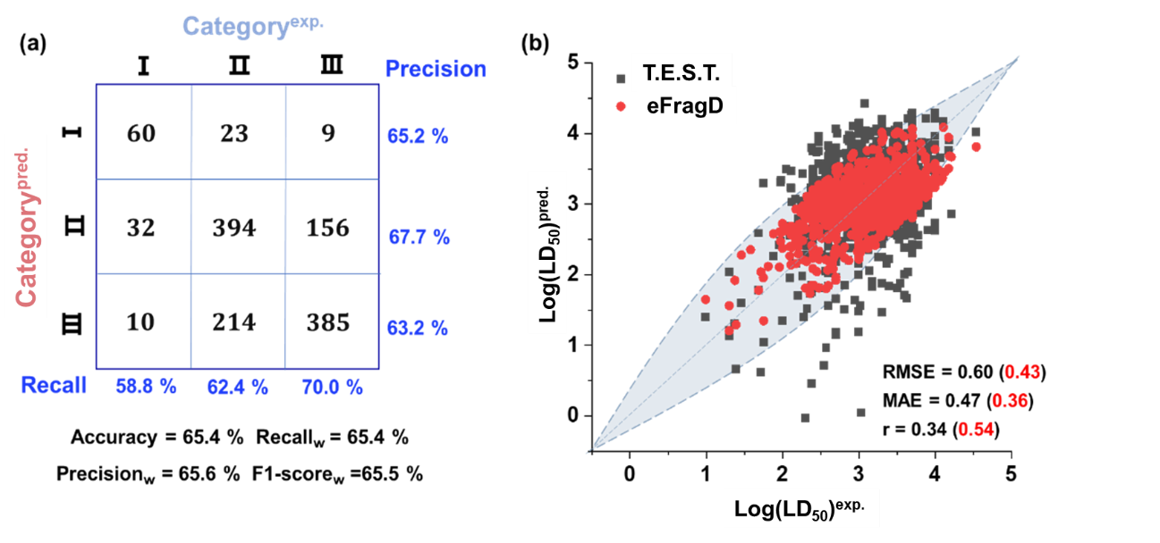

Figure S9. Performance of the eFragD-RF model on the external validation set. a, Confusion matrix of the eFragD-RFC model. b, Performance curve of eFragD-RFR model comparing with T.E.S.T. software.

Section 3.9 Application of eFragD in toxicity screening for perovskite ligands
To evaluate the broader utility of the eFragD framework beyond biological and environmental applications, we extended its use to high-throughput materials discovery. In this context, eFragD was applied as a pre-screening module for assessing the acute toxicity of organic ligands frequently used in hybrid perovskite materials, where molecular toxicity is a key consideration for sustainable design.
A set of 122 organic ligands—commonly proposed in the perovskite literature and not included in our original training set—was compiled for evaluation. Using eFragD-derived descriptors and the pre-trained eFragD-RFR model, we predicted the oral LD₅₀ values of these compounds (Figure S10).

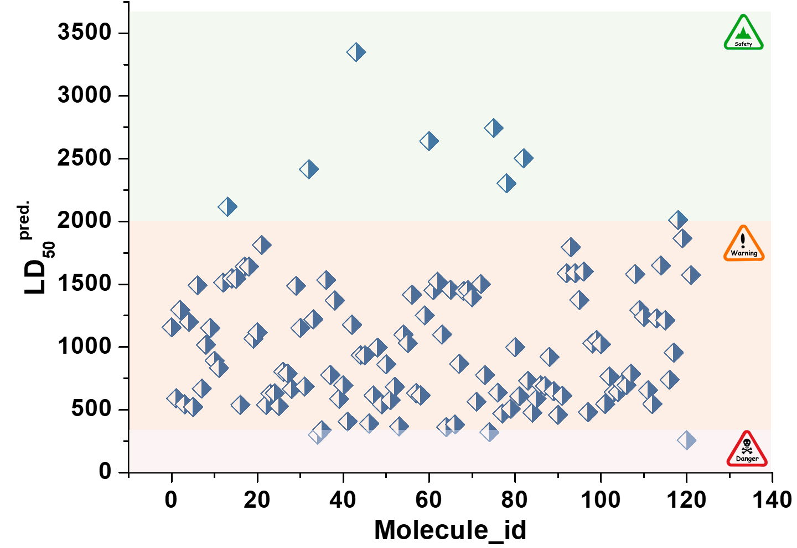

Figure S10. Predicted acute oral toxicity (LD₅₀) of organic ligands for hybrid perovskite materials using the eFragD-RFR model.
Table S16. Relationship between the charges and toxicity values variation of fragments attached to the benzene ring.
Fragment | Influence
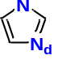 | The more negative the charge of the pyrazole group attached to the benzene ring, the higher the toxicity.
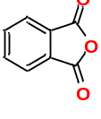 | The more negative the charge of the anhydride group attached to the benzene ring.  Notably, these compounds exhibit toxicity only when the anhydride group is part of a phthalic anhydride structure.

Section 4 Cyanocidal activity assays
Table S17. Comparison of properties between molecules for rodent toxicity prediction and cyanocides.
 | Rodent |  | Cyanobacteria
 |  | Similarity
Molecular size | Smaller molecules typically have better membrane permeability, enhancing bioavailability.
Physicochemical properties | Lipophilicity, and Water Solubility (LogP: 1-5), Polarity (Neutral or Polar)  Appropriate hydrophobicity helps molecules penetrate the cell membrane, while hydrophilicity may enhance interactions with targets.
 |  | Difference
Target site | In vivo proteins or enzymes that lead to toxic responses. They may target key organs and systems such as the liver, kidneys, or central nervous system. |  | Primarily targeting specific biological pathways or organelles in cyanobacteria, such as the photosynthesis pathway, protein synthesis, or cell membrane function, to inhibit the growth and reproduction of cyanobacteria.
Pharmacokinetics | The stability in the aquatic environment does not need to be considered. |  | It needs to be stable in the aquatic environment and able to effectively penetrate cyanobacterial cells.
Toxicological properties | Acute toxicity |  | Inhibition of algae with ecotoxicologically acceptable

Table S18. Impact of fragments on molecular acute toxicity and cyanocidal activity.
Fragment | Example | Rodent | Cyanobacteria
Hydroxyl/ Carboxyl | Phenols¹  polyphenol¹  fumaric acid² | Higher water solubility facilitates distribution and excretion within the body. | Electrostatic interactions and hydrogen bonding with cyanobacterial cell components, leading to membrane damage, oxidative stress, and disruption of photosynthesis.
Amino/Imine | Aniline and p-toluidine³ | Increase the lipophilicity of the compound, allowing it to bind with intracellular proteins and leading to toxic reactions. | Bind to receptors or enzymes on the cyanobacterial cell surface, disrupting their normal function and exerting an inhibitory effect.
Aromatic ring containing nitrogen | 1,2,3-Triazole Aminopyrimidines⁴ | By donating electrons through lone pairs, it enhances the affinity for certain receptors or increases the molecule's lipophilicity. | Providing both hydrogen bond donors and acceptors to interact with amino acid residues.
Carbonyl | β-cyclocitral⁵  acetylacetone⁶  anthraquinone⁷ | Stability and low reactivity make it difficult for them to interact with molecules in the body, thereby reducing reactive toxicity. | Inhibit photosynthesis by either binding at specific amino acid residues or generating oxidative stress.

Section 4.1 Culturing Microcystis aeruginosa
Microcystis aeruginosa (FACHB-905) was sourced from Freshwater Algae Culture Collection at the Institute of Hydrobiology, Chinese Academy of Sciences (Wuhan, China). The BG11 medium was purchased from YFXBIO Biotech Co., Ltd. (Nanjing, China). The FACHB-905 culture was maintained in autoclaved BG11 medium at 25°C under a 12:12 light/dark cycle, with a light intensity of 3000 lx, provided by cool-white fluorescent lamps.

Section 4.2 Inhibition experiments
The Microcystis aeruginosa culture was diluted to an optical density at 680 nm (OD₆₈₀) of approximately 0.2, corresponding to a cell density of 5 × 10⁶ cells/mL, using sterile BG11 medium. Ten-milliliter aliquots of the diluted suspension were transferred to a sterile six-well plate for the inhibition assay. Chemicals (Table S19) were added at the desired concentrations (10 mg/L). A solution without added compounds served as the blank control (CK). Each experimental condition was replicated three times. During the incubation period, a 2 mL sample was taken at regular intervals to monitor cell growth.

Section 4.3 Molecules used in cyanocidal activity experiments and collected from literature.
Table S19. Molecules used in cyanocidal activity assays.
 | Chemical  number |  | Abbreviation | Structure | LD₅₀^{exp.}  (mg/kg) | LD₅₀^{pred.}  (mg/kg)
New molecules | 1⁸ |  | 3aa | 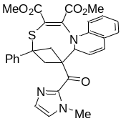 | - | 138
New molecules | 2⁹ |  | 3ab | 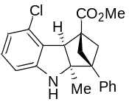 | - | 154
New molecules | 3⁹ |  | 3ac | 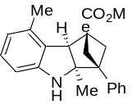 | - | 192
New molecules | 4¹⁰ |  | 3ad | 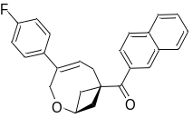 | - | 470
New molecules | 5¹¹ |  | 3ba | 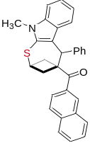 | - | 358
New molecules | 6¹⁰ |  | 4ai | 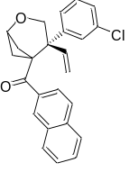 | - | 313
New molecules | 7¹¹ |  | 4ar | 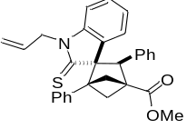 | - | 316
New molecules | 8⁸ |  | 5aa | 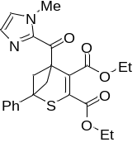 | - | 414
New molecules | 9⁸ |  | 5ccb | 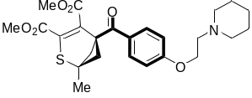 | - | 886
New molecules | 10¹¹ |  | 8 | 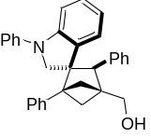 | - | 494
New molecules | 11¹¹ |  | 9 | 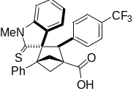 | - | 225
Antibiotics | 12 | Amoxicillin | AMX | 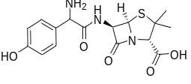 | - | 5420.83
 | 13 | Ampicillin | AMP | 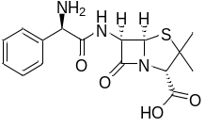 | 10000 | -
 | 14 | Ornidazole | ORN | 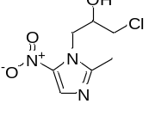 | 1781 | -
 | 15 | Erythromycin | ERY | 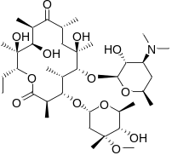 | 4599 | -
 | 16 | Ciprofloxacin | CIP | 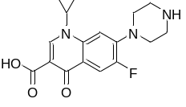 | - | 4344
 | 17 | Sulfamethoxazole | SXT | 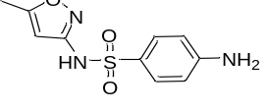 | 6203 | -
 | 18 | Sulfadiazine | SDI | 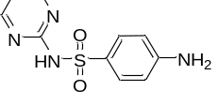 | - | 8452
 | 19 | Thiamphenicol | THI | 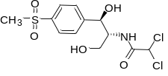 | 6994 | -
 | 20 | Metronidazole | MTR | 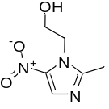 | 3002 | -
 | 21 | Streptomycin | STR | 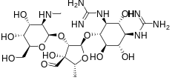 | - | 9134
 | 22 | Roxithromycin | ROX | 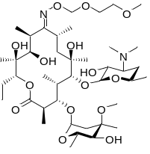 | 829 | -
 | 23 | Chloramphenicol | CHL | 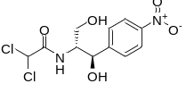 | 2502 | -
 | 24 | Norfloxacin | NOR | 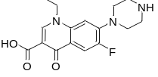 | - | 4261
 | 25 | Doxycycline | DOX | 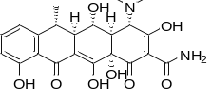 | - | 2020
 | 26 | Tetracycline | TC | 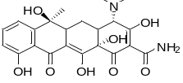 | 807 | -
 | 27 | Tinidazole | TIN | 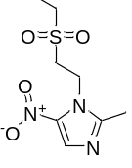 | 2711 | -
 | 28 | Ceftizoxime | CZX | 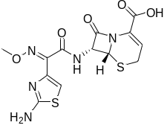 | - | 14383
 | 29 | Oxytetracycline | OXY | 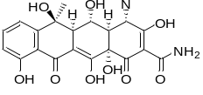 | 4799 | -
 | 30 | Levofloxacin | LVX | 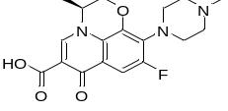 | 3589 | -

Table S20. Molecules collected from literature.
 | Chemical | Abbreviation | Structure | Enolized form | LD₅₀^{exp.}  (mg/kg) | LD₅₀^{pred.}  (mg/kg)
31 | Gallic acid | GA | 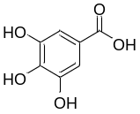 | - | - | 2800
32 | Pyrogallol | PG | 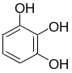 | - | - | 1750
33 | Anthraquinone | AQ | 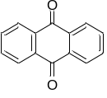 | - | - | 3048
34 | Lysine | Lys | 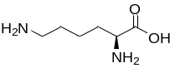 | - | - | 1576
35 | Ethyl 2-methylacetoacetate | EMAA | 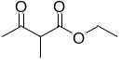 | 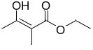 | - | 8000
36 | Coumarin | Coumarin | 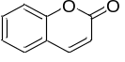 | - | 293 | -
37 | Naphthol | NP | 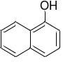 | - | 1870 | -
38 | Styrene | ST | 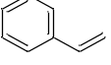 | - | 2650 | -
39 | Diuron | DU | 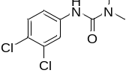 | - | 1017 | -
40 | Endothall | ET | 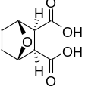 | - | 206 | -
41 | Salicylic acid | SA | 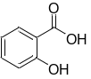 | - | 891 | -
42 | (-)-Catechin | (-)-C | 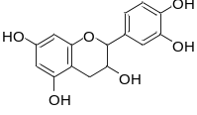 | - | - | 2645
43 | Ellagic acid | EA | 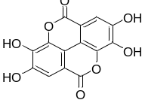 | - | - | 1560
44 | Fumaric acid | FA | 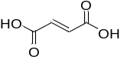 | - | 9300 | -
45 | Acetylacetone | AA | 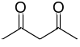 | 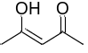 |  | 2861
46 | 3-Methyl-2,4-pentanedione | AA-CH₃ | 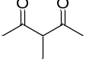 | 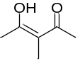 |  | 2044
47 | 3-Athyl-2,4-pentanedione | AA-CH₂CH₃ | 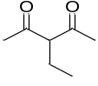 | 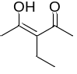 |  | 983
48 | 3-Chloro-2,4-pentanedione | AA-Cl | 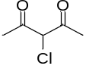 | 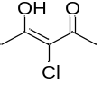 |  | 819
49 | 3,3-Dimethyl-2,4-pentanedione | AA-2CH₃ | 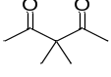 | - |  | 1008
50 | 1,1,1-Trifluoro-2,4-pentanedione | AA-F₃ | 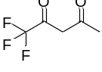 | 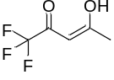  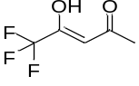 |  | 255
Some molecules (Table S20) exhibit enol-keto tautomerism with the energies of tautomer being nearly, allowing them to coexist at room temperature.

Section 4.4 Cyanocidal activity experiments
The cyanocidal activities of the compounds against Microcystis aeruginosa were analyzed. A systematic evaluation of the inhibitory effects of various compounds on Microcystis aeruginosa is presented in Figures S9 and S10. The resulting OD₆₈₀ values, shown in these figures, indicate that the new molecule (5ccb) was significantly lower than that of the blank control (CK) after 4 days of exposure, exhibiting an inhibitory effect (Figure S11). Most of antibiotics effectively inhibited the growth of the selected cyanobacterium. Notably, β-lactam antibiotics, quinolones and macrolides were the most effective cyanocides (Figure S12).
Figure S11. Cyanocidal activity of new molecules (listed in Table S19, Nos. 1-11 and 45) on a cyanobacterium (FACHB-905).
Figure S12. Cyanocidal activity of antibiotics (listed in Table S19, Nos. 12-30) on a cyanobacterium (FACHB-905).

Section 4.5 Classification criteria for molecular cyanocidal activity
The inhibitory effects (IE) of the tested molecules were calculated using the following formula (Eq. 13). The IE value at 10 mg/L chemical and 96 h incubation with Microcystis aeruginosa (IE_{96 h}) was selected as a criterion for effectiveness. Molecules with IE_{96 h} values greater than 20% were considered to have significant inhibitory effect (SIE) and were assigned a value of 1. By contrast, molecules with IE_{96 h} values less than 20% were regarded as no observed effect (NOE) and were assigned a value of 0.
${IE}_{96 h}= \frac{{OD}_{680}\left(sample\right)-{OD}_{680}\left(CK\right)}{{OD}_{680}\left(CK\right)}$ Eq. 13
Table S21. IE_{96 h} experimental values of molecules.
Abbr. | IE_{96 h} (%) | Abbr. | IE_{96 h} (%) | Abbr. | IE_{96 h} (%)
3aa | -15.042 | AMX | 83.141 | CHL | 59.496
3ab | 3.408 | AMP | 85.373 | NOR | 76.796
3ac | -10.421 | ORN | 32.061 | DOX | 65.589
3ad | -15.893 | ERY | 77.423 | TC | 58.108
3ba | -12.818 | CIP | 71.696 | TIN | 20.842
4ai | -21.191 | SXT | 8.308 | CZX | 89.254
4ar | -12.135 | SDI | 6.294 | OXY | 61.850
5aa | -2.752 | THI | 72.852 | LVX | 78.074
5ccb | 50.038 | MTR | 11.794 | AA | 83.289
8 | -16.985 | STR | 76.868
9 | -10.398 | ROX | 82.566

The molecular characteristics used in the prediction of cyanodical activity including the number of active fragments (N_{Frag}), fragment density per unit area (N_{Frag}/Å²) and the number of aromatic rings (N_{AR}), LogP (use PoLogP), α and MPI. The Pearson correlation coefficients (r) for these features and cyanodical activity are shown in Figure S13a. The active fragments identified using eFragD include nitrogen-containing heterocycles (e.g., thiazole, oxazole, pyrazole), halogens, oximes, thioethers, sulfonyl groups, esters, ethers, hydroxyls, amides, nitro groups, amines, thioketones, imines, carbonyls, aldehydes, and phenols. The fragment density per unit area refers to the density of fragments on the van der Waals surface of the molecule. The van der Waals surface of the molecule were calculated used the multiwfn.
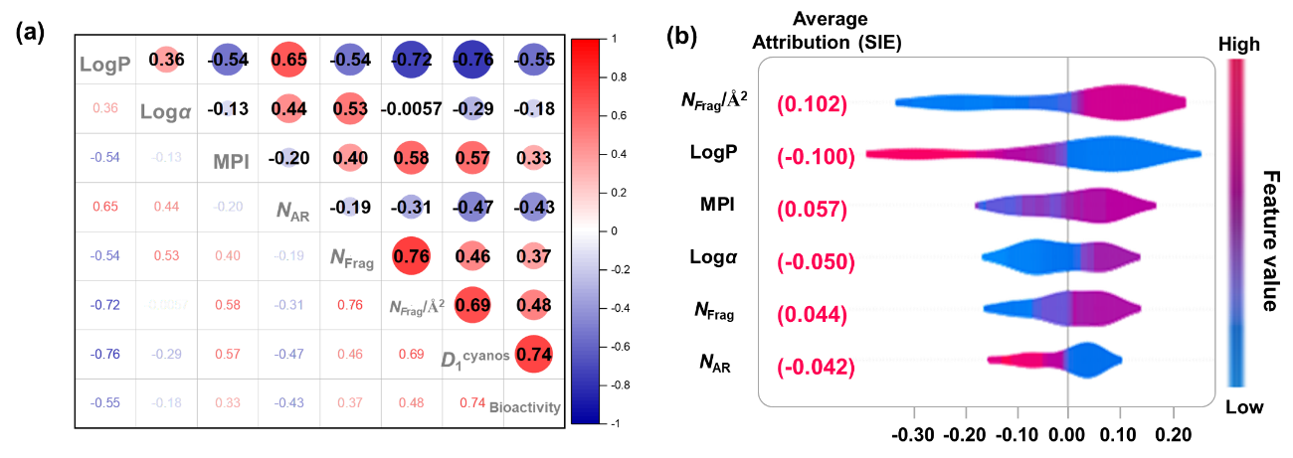
Figure S13. Descriptor’s analysis. (a) Pearson correlation coefficient (r) between different features and cyanodical activity. (b) SHAP analysis of the six descriptors.

Section 4.6 Molecular-protein interaction analysis
Non-heme iron proteins (Protein Data Bank ID: 2AXT), a typical non-heme iron protein, was used to analyze the interaction mechanisms between different molecules and the protein. Prior to molecular docking, the enol and deprotonated forms of some molecules were considered, with the conformation having the highest binding energy selected as the final result. Considering the conformational diversity and multiple binding models, the average binding energy (Ē_{binding}) was calculated by averaging the binding energies of conformations with binding energy differences less than 2 kcal/mol. The binding energy was then normalized by dividing it by the number of atoms in each molecule to compare binding efficiency (Ē_{binding} / per atom, Figure S13b).
As shown in the Figure S14, most molecules with higher binding energies exhibit better cyanodical activity. Further analysis of the number of binding sites (Figure S15) and LogP values allows for the exclusion of molecules with no effective inhibitory effect (blue-colored parts). Therefore, screening for cyanocides should not only focus on binding energy but also consider additional factors, such as polarity, hydrophobicity, and the number of key hydrogen bonds, to comprehensively evaluate the interaction between molecules and the proteins.
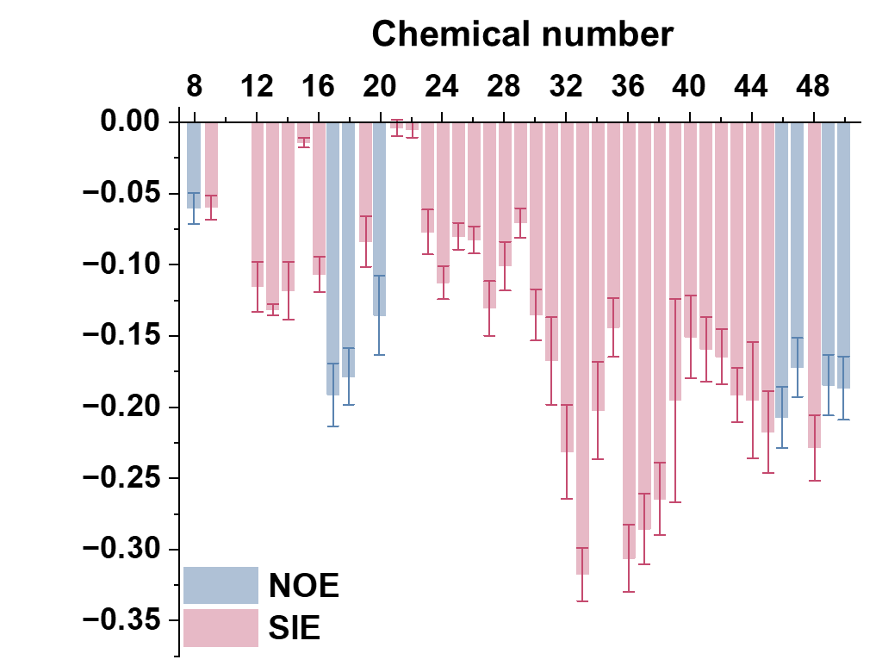
Figure S14. Binding energies between different molecules and target protein.

Molecular-protein interaction analysis (green represents protein, pink represents small molecule) using Autodock Tool (hydrogen bonds shown as yellow dashed lines) and Poseview Tool¹² ( black dashed lines for hydrogen bonds, green dashed lines for π-π interactions, and green solid lines for hydrophobic interactions), are shown in Figure S15.
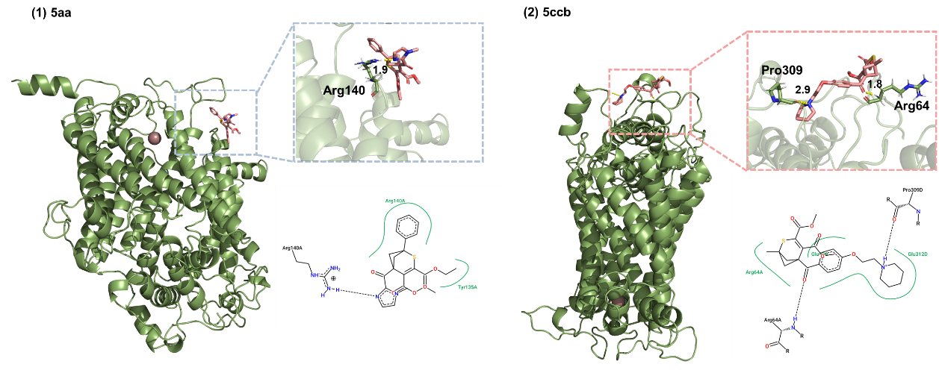
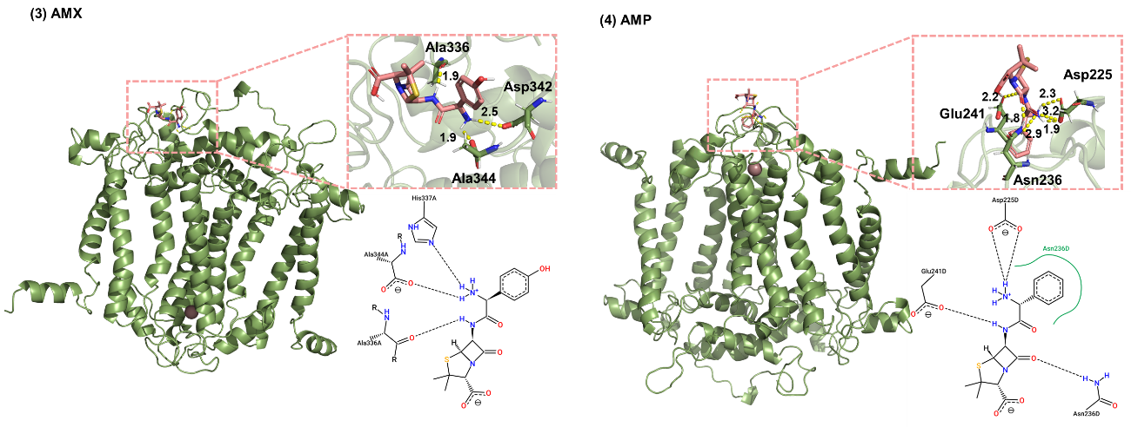
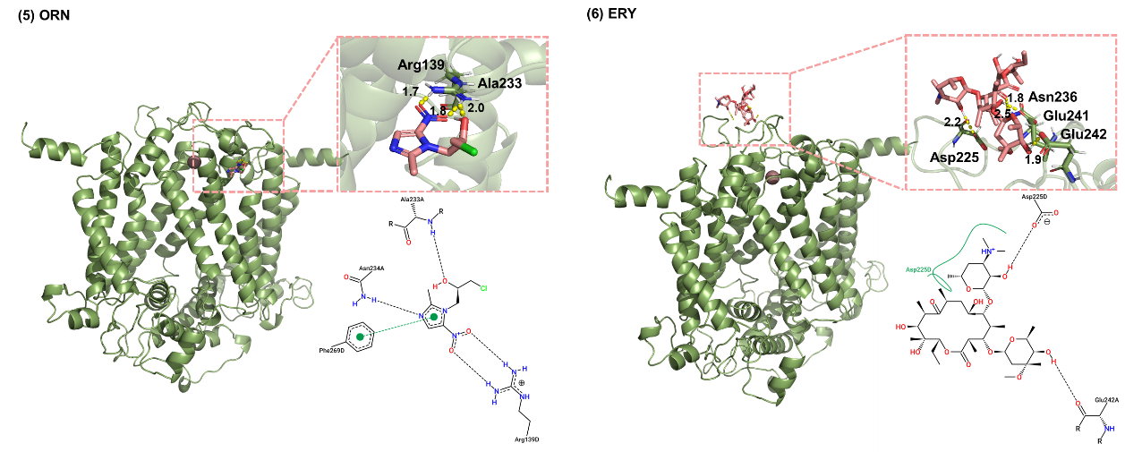
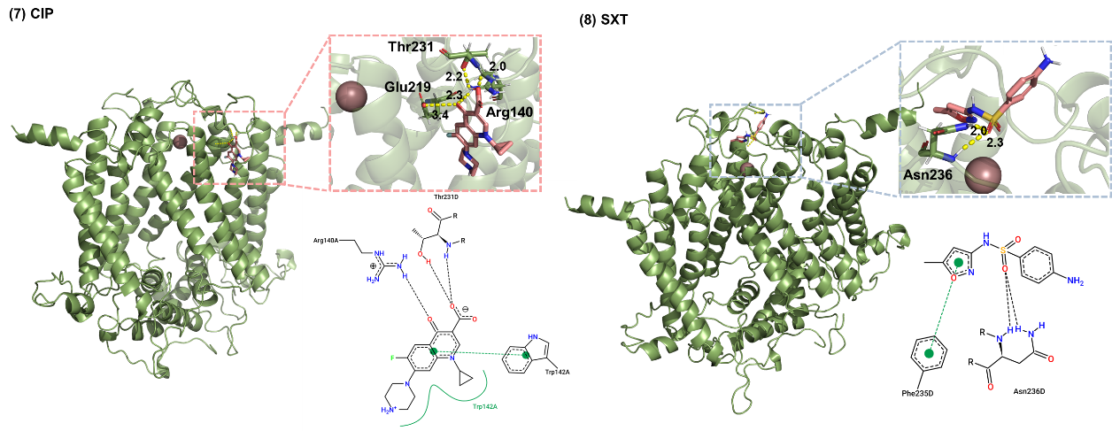
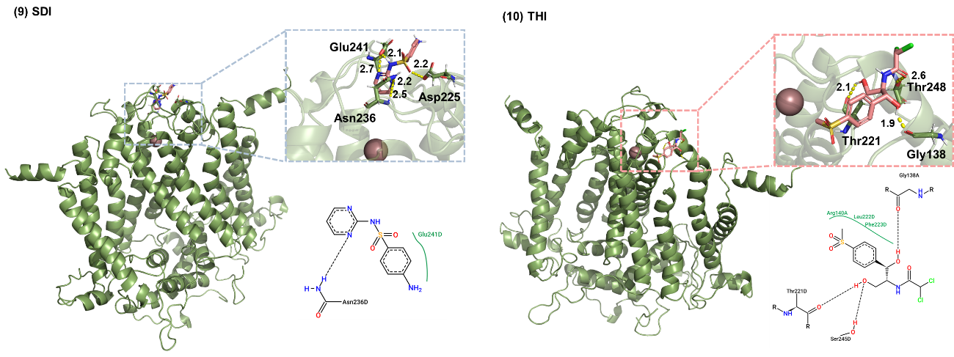
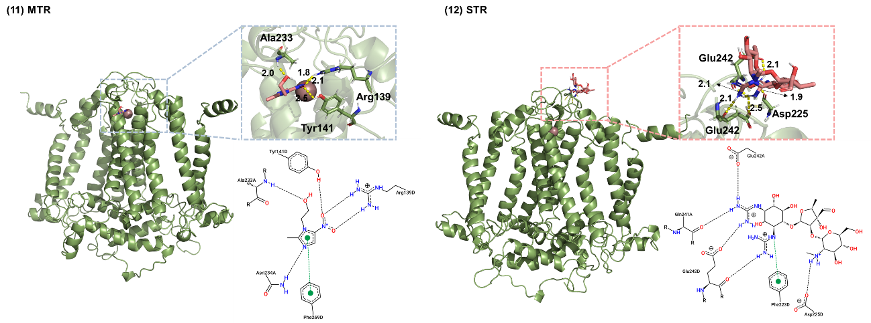
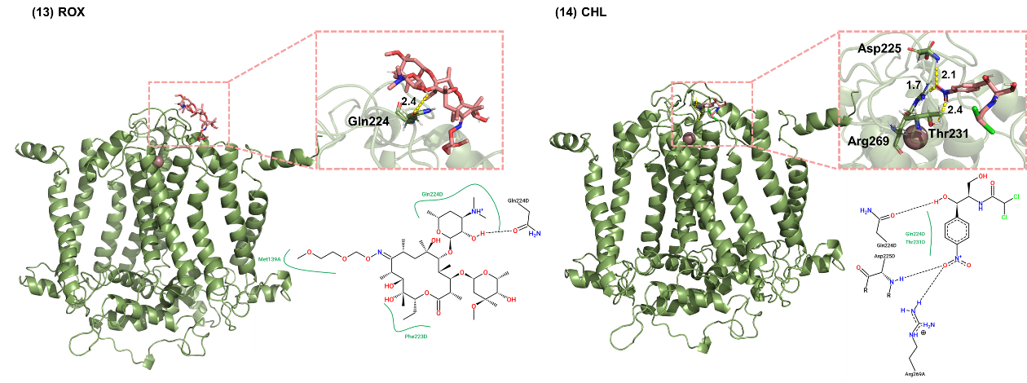
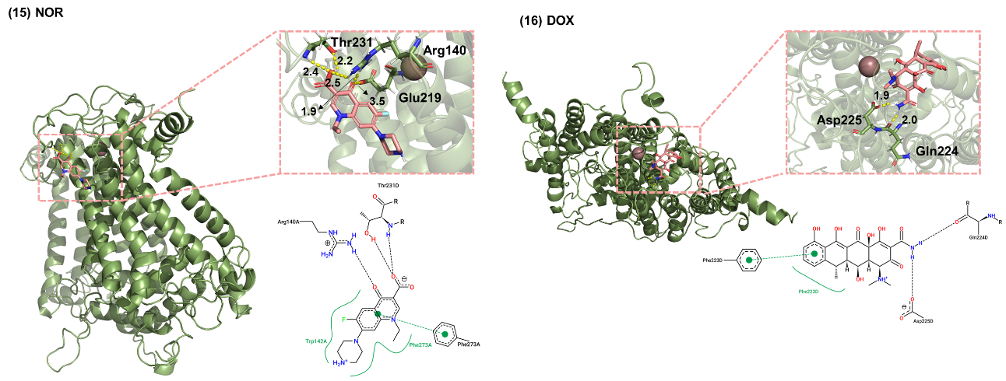
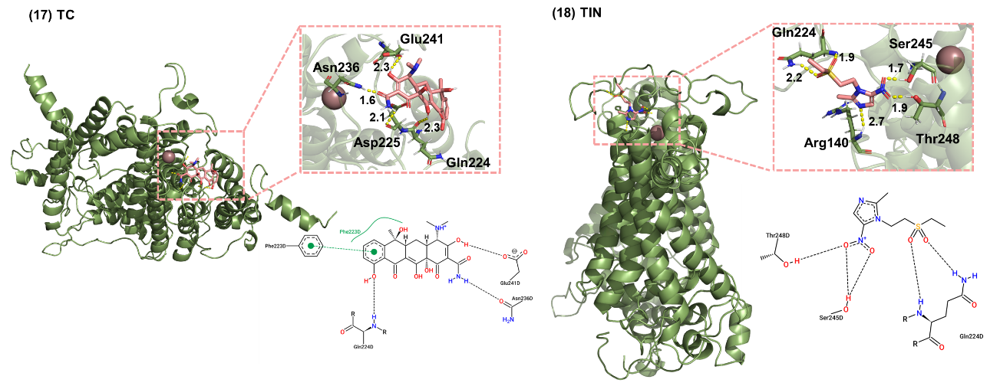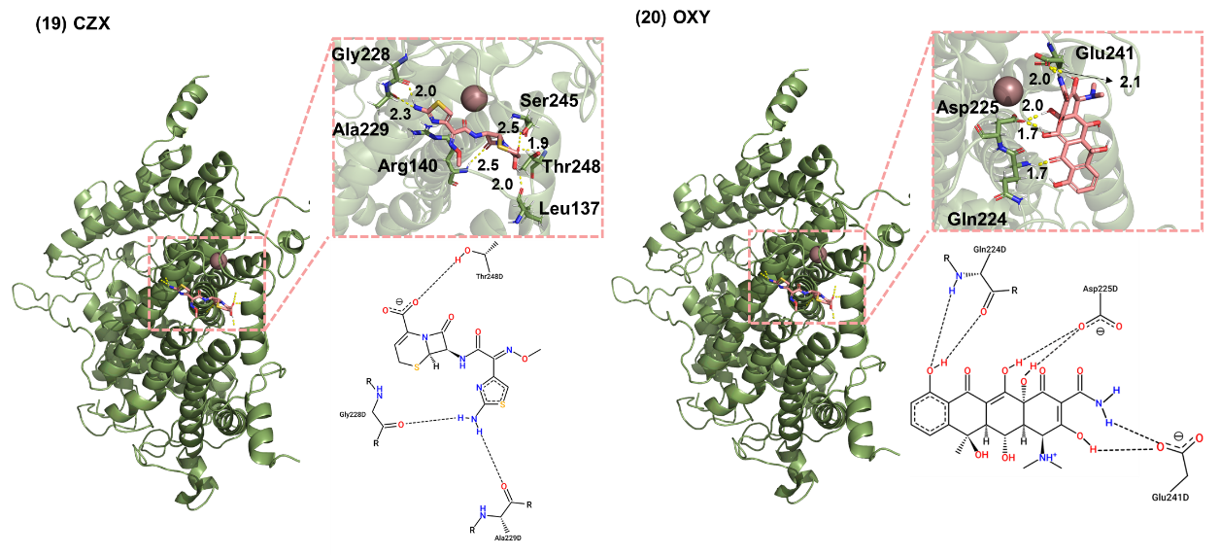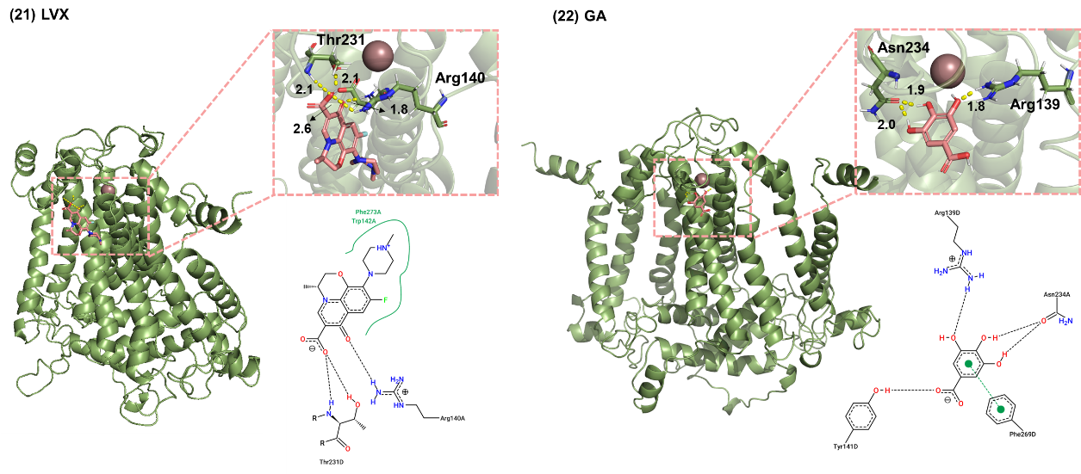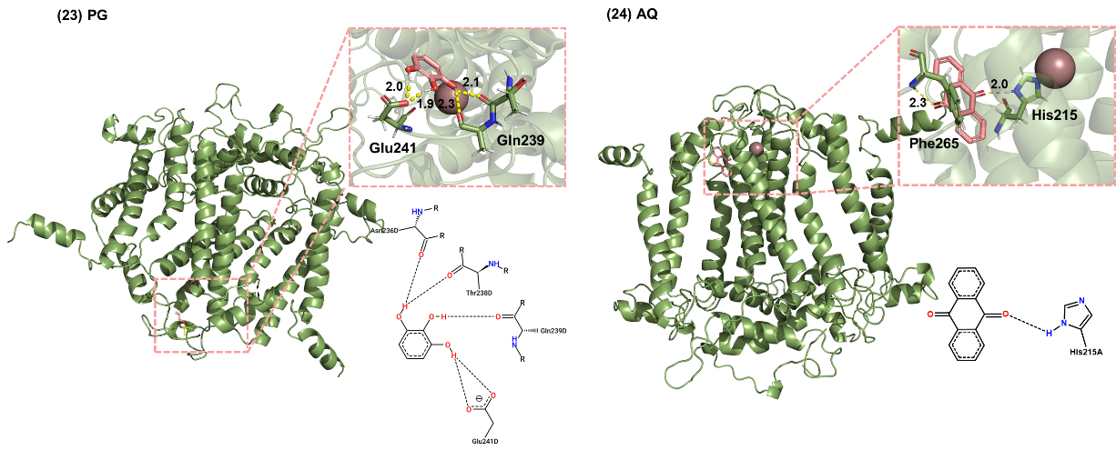
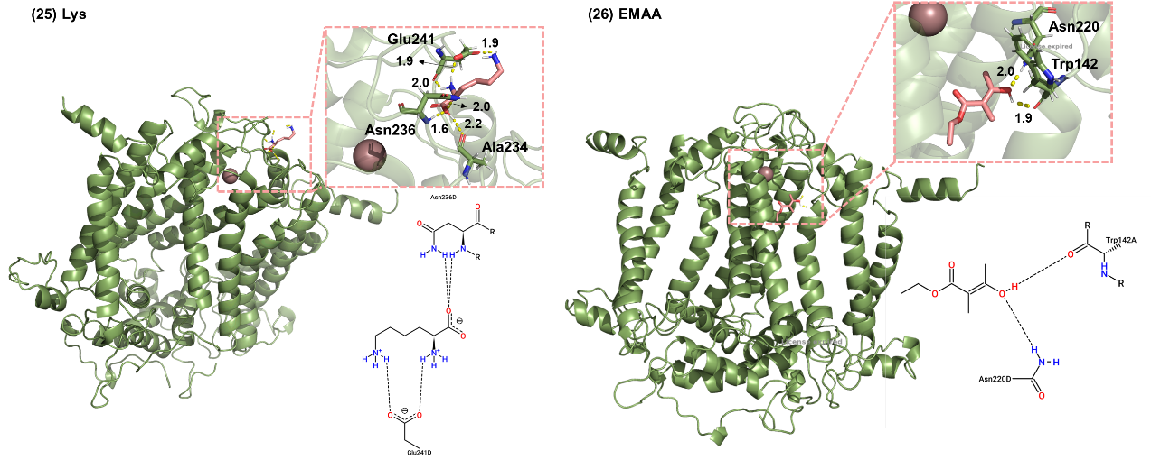
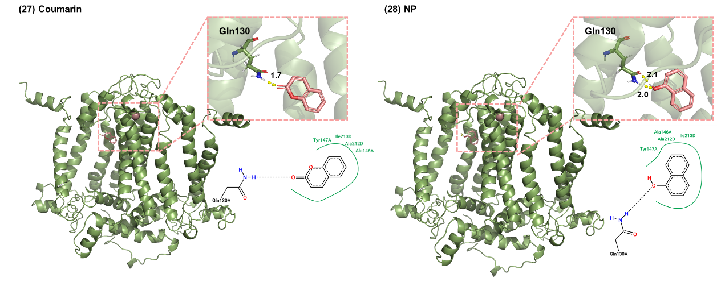
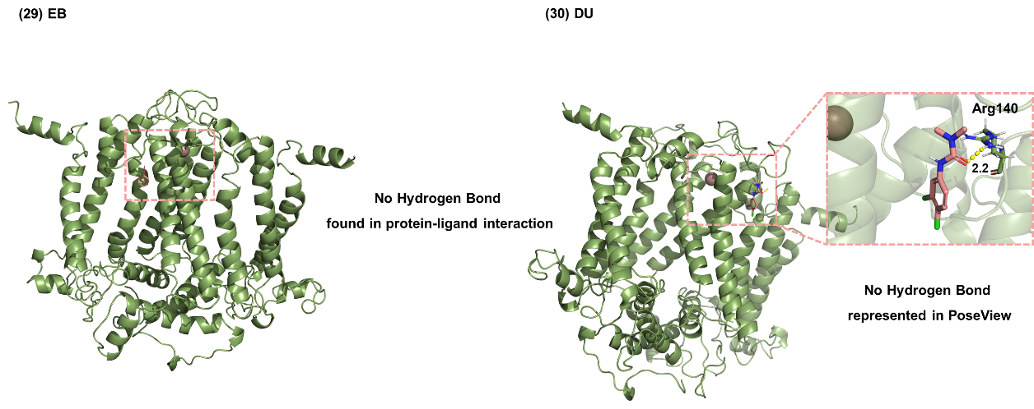
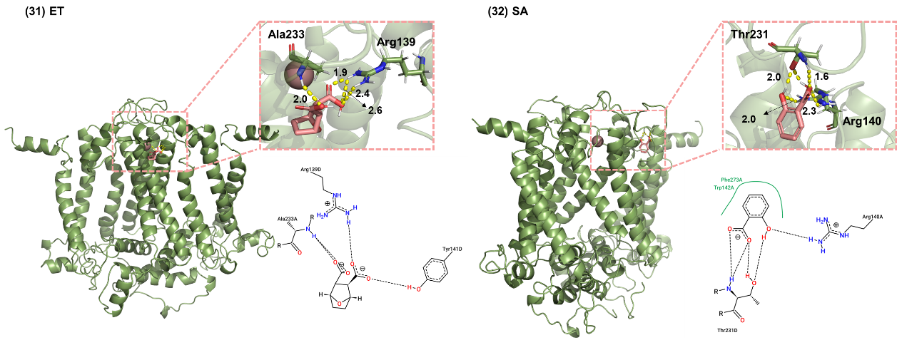
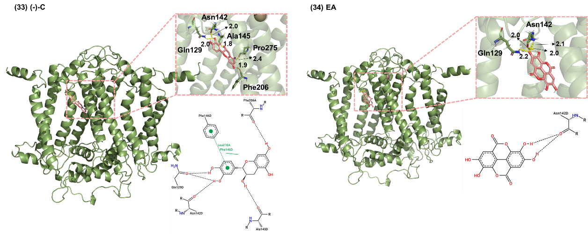
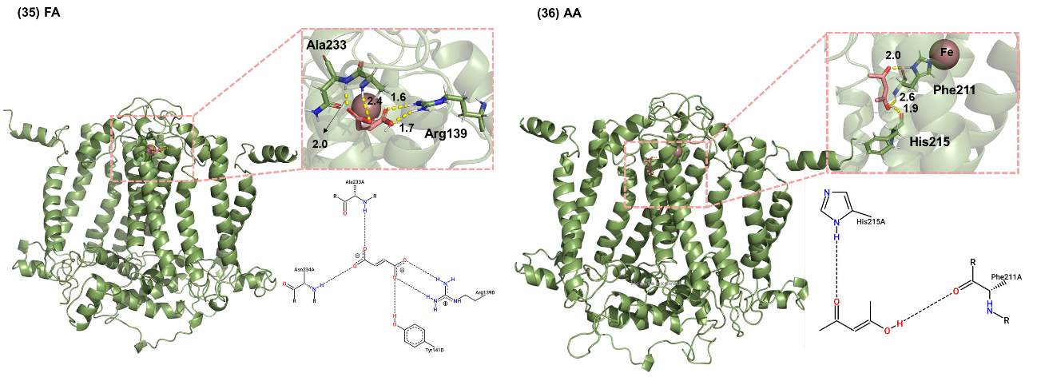
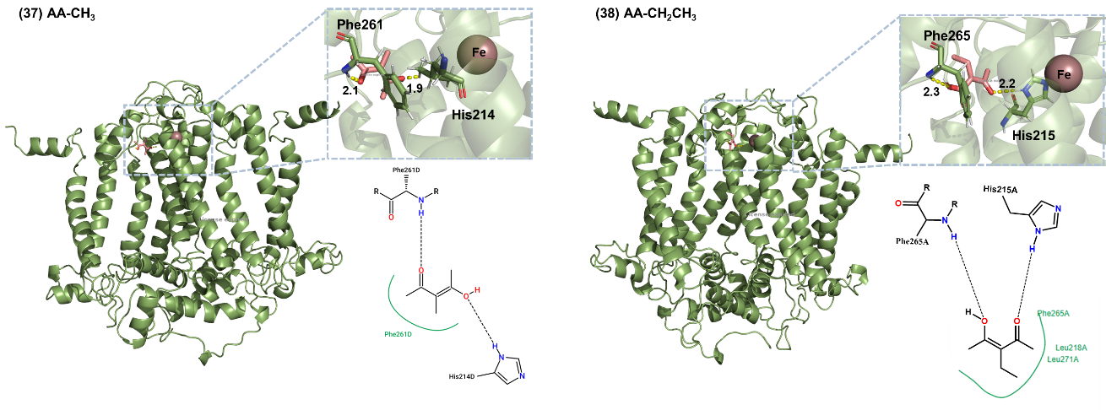
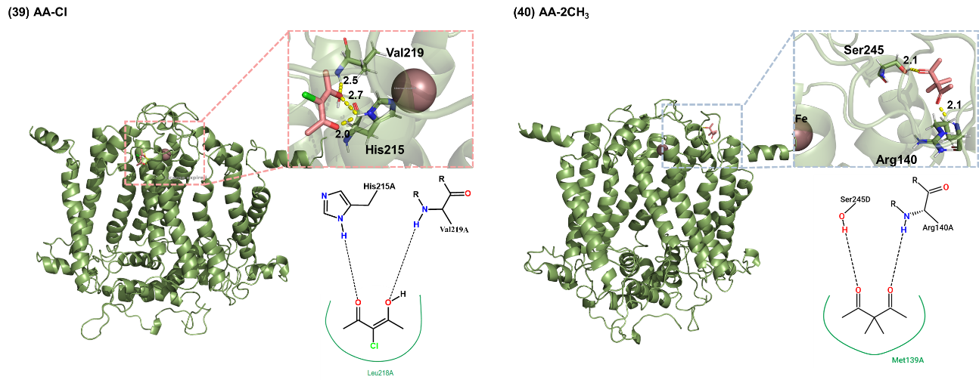
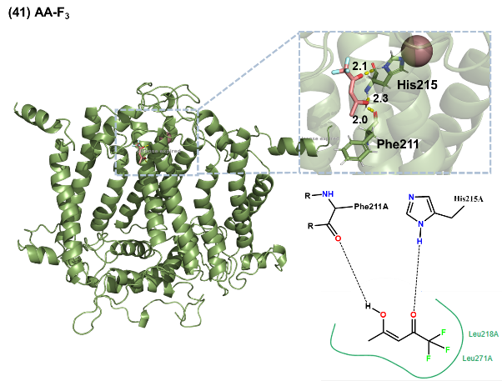
Figure S15. Molecular-protein interaction analysis.

Section 5. Boundary conditions and dictionary for the eFragD method
The basic dictionary encompassed the Atom dictionary and the Bond dictionary, considering three neighboring atoms. To expedite frequency retrieval, eliminate redundant codes and enhance accuracy, these dictionaries are further consolidated into two high-quality components using concise codes lines (Lists by atom index and Counters by element). It is noteworthy that, during the data collection process, aligning the atomic indices of the optimized molecular structure with those in the physicochemical information ensures subsequent atomic matching. These five dictionaries coexist in the eFragD framework with boundary rules detailed in Table S22, enabling rapid retrieval.

Table S22. Boundary conditions and dictionary for the eFragD method.
Rule |  | Name |  | Meaning
Boundary Condition | R₁ |  |  | Alkyl/Aryl
Boundary Condition | R₁(H) |  |  | Alkyl/Aryl/H
Boundary Condition | R₂ |  |  | Alkyl
Boundary Condition | R₂(H) |  |  | Alkyl/ H
Boundary Condition | R₃ |  |  | Any atom, except N/O/S
Boundary Condition | R₄ |  |  | C/H, not a heteroatom
Boundary Condition | R₅ |  |  | C
Boundary Condition | R₆ |  |  | C/N/O/H
Boundary Condition | R₇ |  |  | C/H, not C(=O), C(=N), C(=S)
Boundary Condition | X |  |  | F/Cl/Br/I
Dictionary | Basic dictionary |  | Atom dictionary | Read and stored the literal names of elements associated charge information.
Dictionary |  |  | Bond dictionary | Captured connectivity information (bonded atoms pairs and atom environment).
Dictionary | Lists by atom index |  |  | Described the bond-connecting atoms indices.
Dictionary | Counters by element |  |  | Documented the atom nearest neighbors and their counts of bond-connecting for each atom.

Section 6. Procedure and code script of eFragD method
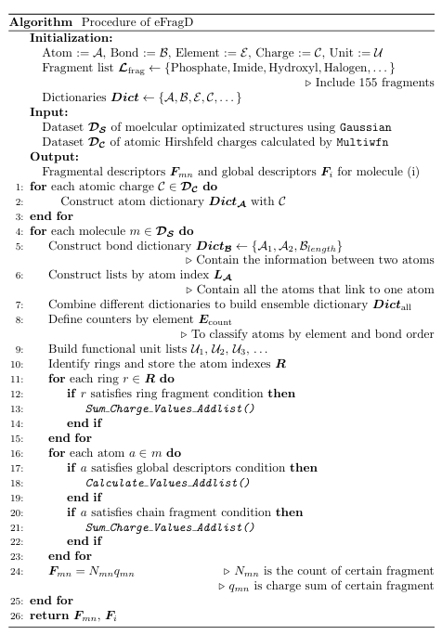
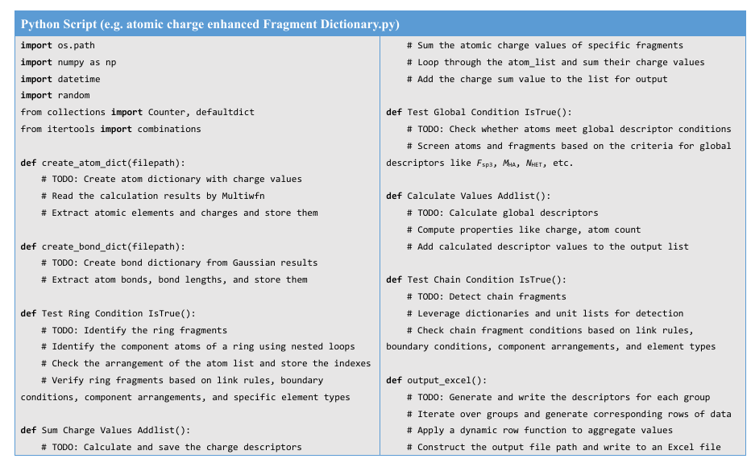
Figure S16. The procedure and code script of eFragD method.
References
- Nakai, S. et al. Myriophyllum spicatum-released allelopathic polyphenols inhibiting growth of blue-green algae Microcystis aeruginosa. Water Res. 34, 3026-3032 (2000).
- Wei, P. et al. Efficient inhibition of cyanobacteria M. aeruginosa growth using commercial food-grade fumaric acid. Chemosphere 301, 134659-134666 (2022).
- Batterton, J. et al. Anilines selective toxicity to blue-green algae. Science 199, 1068-1070 (1978).
- Zhou, Y. et al. Synthesis and activity of 1,2,3-Triazole aminopyrimidines against cyanobacteria as PDHc-E1 competitive inhibitors. J. Agric. Food Chem . 67, 12538-12546 (2019).
- Wang, X. et al. β-cyclocitral induced rapid cell death of Microcystis aeruginosa. Environ. Pollut. 348, 123824 (2024).
- Yilimulati, M. et al. Regulation of photosynthesis in bloom-forming cyanobacteria with the simplest β-diketone. Environ. Sci. Technol. 55, 14173-14184 (2021).
- Jančula, D. et al. Critical review of actually available chemical compounds for prevention and management of cyanobacterial blooms. Chemosphere 85, 1415-1422 (2011).
- Xiao, Y. et al. Divergent synthesis of sulfur‐containing bridged cyclobutanes by Lewis acid catalyzed formal cycloadditions of pyridinium 1,4‐zwitterionic thiolates and bicyclobutanes. Angew. Chem. Int. Ed. 63, e202408578 (2024).
- Wu, F. et al. Zinc‐catalyzed enantioselective formal (3+2) cycloadditions of bicyclobutanes with imines: catalytic asymmetric synthesis of azabicyclo[2.1.1]hexanes. Angew. Chem. Int. Ed. 63, e202406548 (2024).
- Zhou, J. L. et al. Palladium-catalyzed ligand-controlled switchable hetero-(5+3)/enantioselective [2σ+2σ] cycloadditions of bicyclobutanes with vinyl oxiranes. J. Am. Chem. Soc. 146, 19621-19628 (2024).
- Wang, J. J. et al. Switching between the [2π+2σ] and hetero‐[4π+2σ] cycloaddition reactivity of bicyclobutanes with Lewis acid catalysts enables the synthesis of spirocycles and bridged heterocycles. Angew. Chem. Int. Ed. 63, e202405222 (2024).
- Stierand, K. et al. Molecular complexes at a glance: automated generation of two-dimensional complex diagrams. Bioinformatics 22, 1710-1716 (2006).

