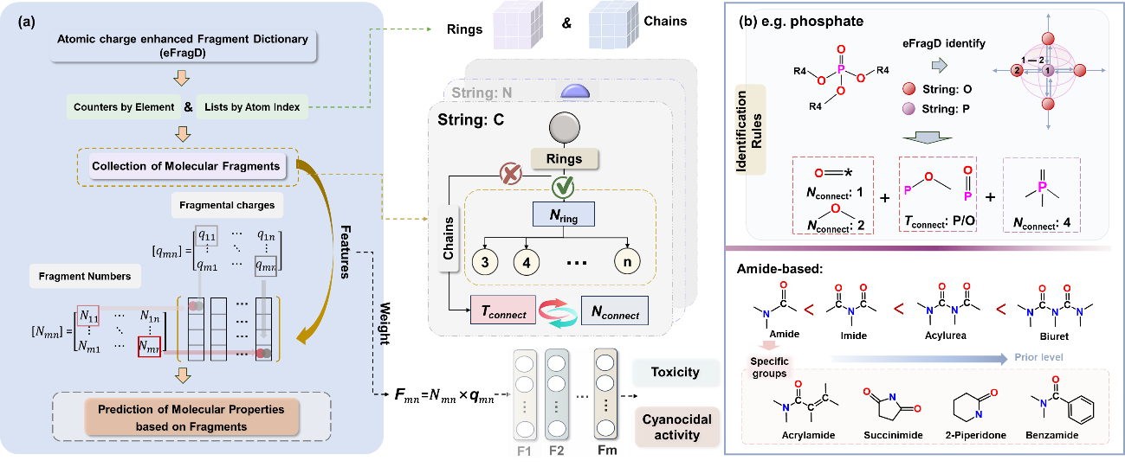
Extended Data Figure 1 | Illustration of the eFragD construction and embedding process. (a) Workflow for eFragD descriptors construction. (b) Examples demonstrating the fragment identification rules in eFragD and associated prioritization criteria.
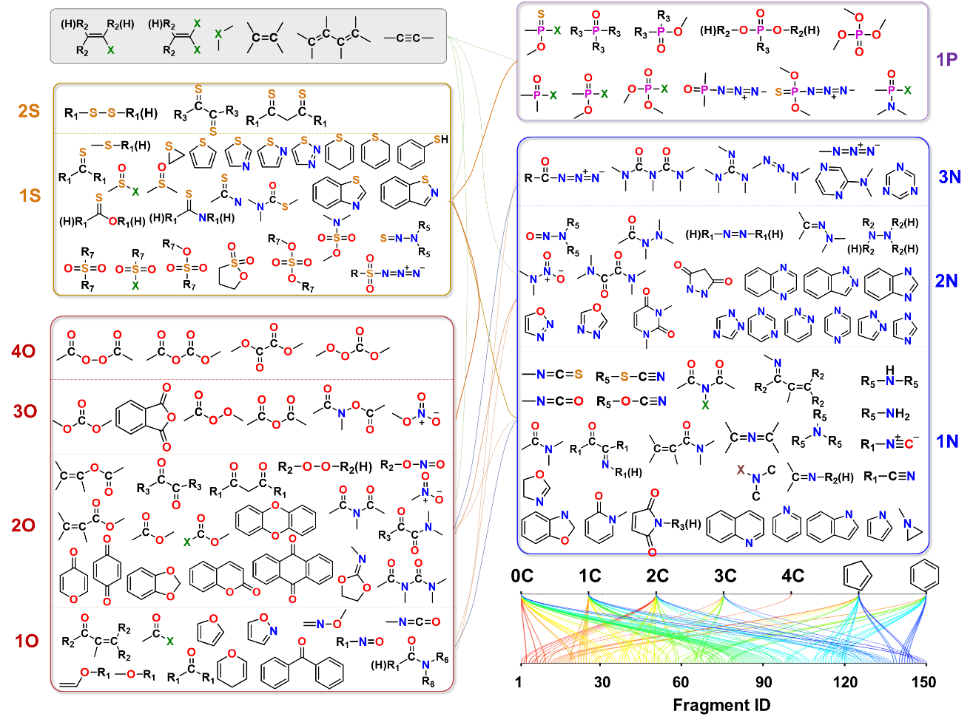
Extended Data Figure 2 | Specific fragments identified by the eFragD method. The labels next to the elements indicate the number of the specific element within the fragment (e.g., "1N" represents the fragment containing one nitrogen atom). The interlinked lines denote the relation between two groups containing two types of atoms. Fragment ID represents the number of the 155 fragments.

