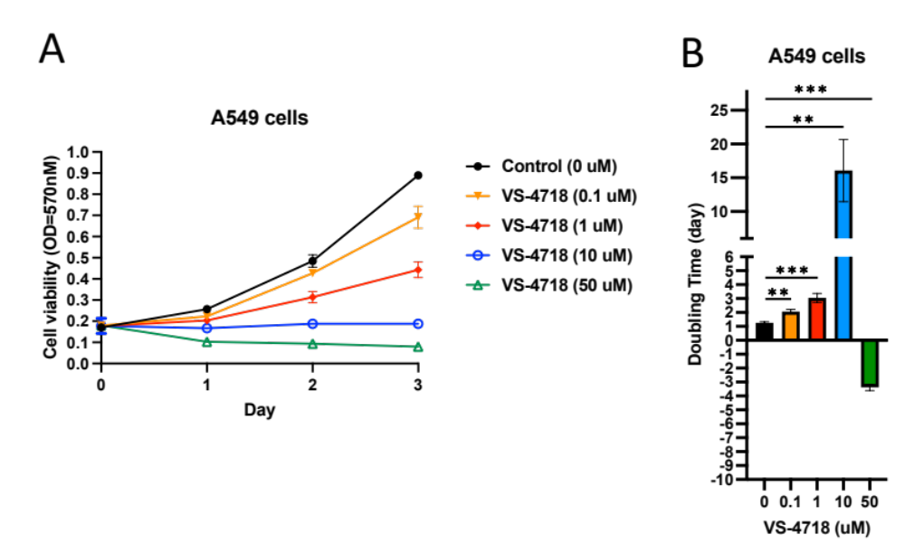Figure S1. FAK inhibitor VS-4718 suppresses tumor growth in human lung cancer cells. (A) Cell viability measured by OD570 nm over 4 days in A549 cells treated with VS-4718 at concentrations of 0, 0.1, 1, 10, and 50 μM. Data are expressed as mean ± standard deviation (SD). (B) Doubling time analysis showing dose-dependent effects of VS-4718 treatment in A549 cells. **p < 0.01, ***p < 0.001 compared to control group.

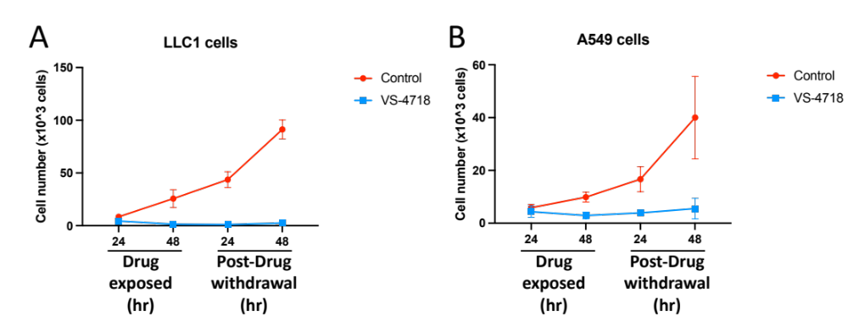
Figure S2. Duration of VS-4718 anti-proliferative effects in lung cancer cell lines after drug withdrawal. Cell proliferation was measured by cell counting at 24 and 48 h during drug exposure and at 24 and 48 h following drug withdrawal. (A) LLC1 cells and (B) A549 cells were treated with VS-4718 or vehicle control. Data represent mean ± SD. VS-4718 treatment significantly suppressed cell growth in both cell lines, with inhibitory effects persisting even after drug removal.

