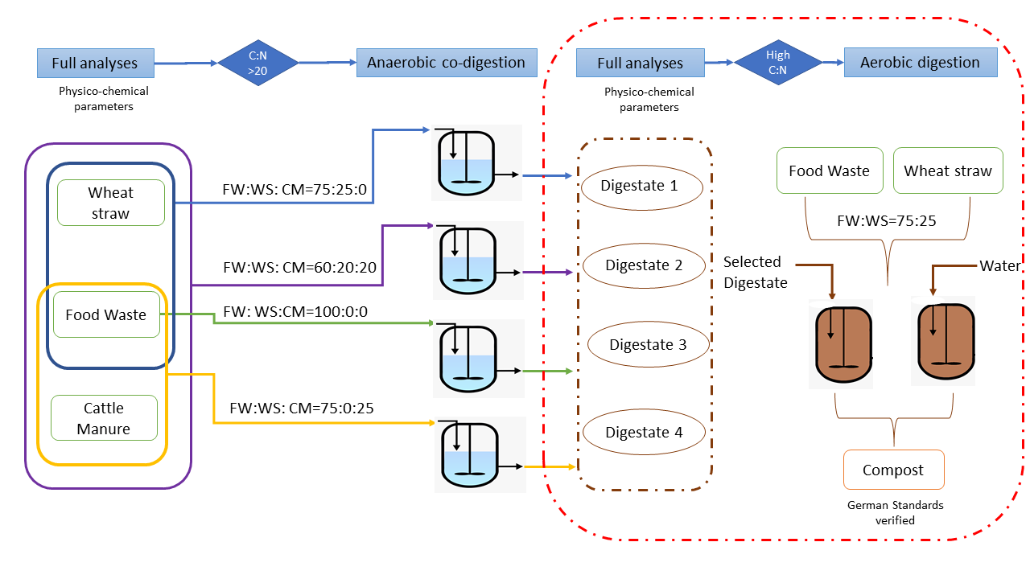
Graphical Abstract
Figure 1. Conceptualization of the overall « RenewValue » approach.

