Supplementary Figures and Tables
Supplementary Figures

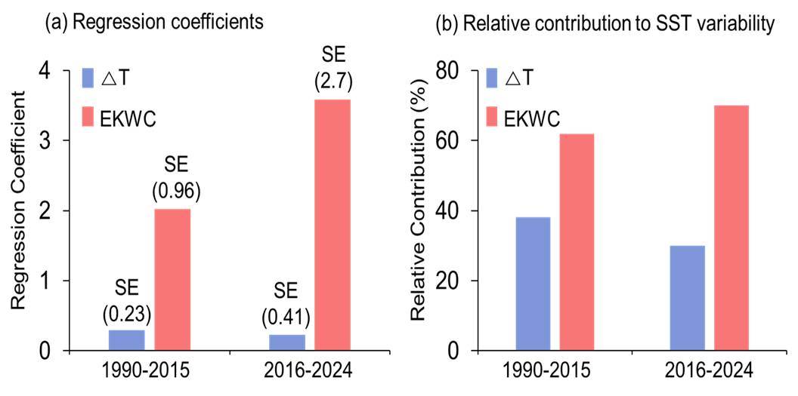
Supplementary Figure S1. Regression results of winter SST variability in the WNP using ΔT (SST–AT thermal contrast, blue) and EKWC strength (red) as predictors. (a) Raw regression coefficients and (b) standardized contributions are shown for the pre-shift (1990–2015) and post-shift (2016–2024) periods. The results highlight a shift from mixed atmosphere–ocean forcing before 2015 toward enhanced oceanic control, with EKWC contributions increasing relative to ΔT after 2015.

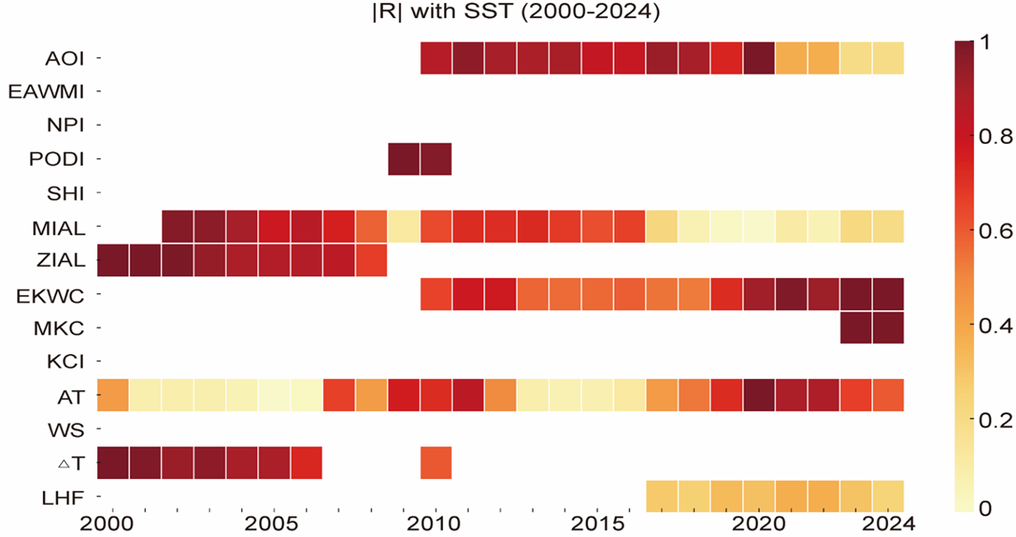
Supplementary Figure S2. Expanding correlations between winter SST in the WNP and candidate atmospheric and oceanic drivers during 2000–2024. Absolute correlation coefficients (|R|) are shown for climate indices (AOI, EAWMI, NPI, PDOI, SHI, MIAL, ZIAL) and local forcing variables (EKWC, MKC, KCI, AT, WS, ΔT, LHF). Warmer colors indicate stronger correlations. Results highlight the dominance of atmospheric indices (e.g., AOI, MIAL) before 2015 and the strengthening of oceanic control (EKWC, MKC) after the mid-2010s regime shift.

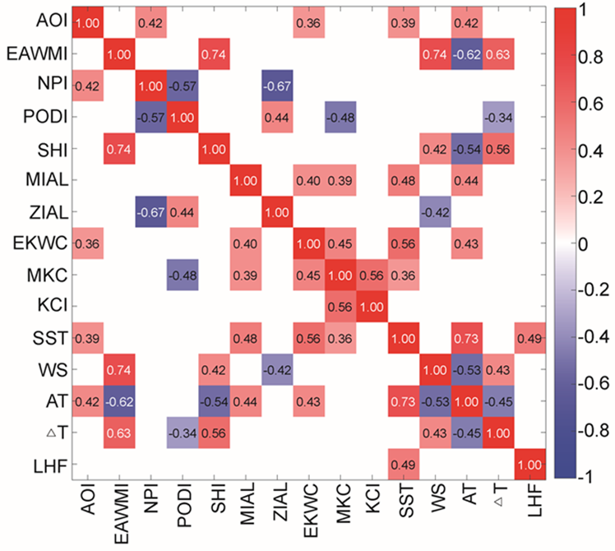
Supplementary Figure S3. Correlation matrix among winter SST, large-scale climate indices, and local forcing variables in the WNP during 1990–2024. Variables include atmospheric indices (AOI, EAWMI, NPI, PDOI, SHI, MIAL, ZIAL), oceanic drivers (EKWC, MKC, KCI), and local flux terms (AT, WS, ΔT, LHF). Color shading denotes the magnitude and sign of Pearson correlation coefficients, with red (positive) and blue (negative) indicating the direction of association. Strong positive correlations are observed between SST, EKWC, and MIAL, highlighting basin-scale atmosphere–ocean coherence, while negative associations emerge between PDOI, NPI, and other indices.

Supplementary Table
Model type | Variables | R² | p-value
Full period
Single | MIAL | 0.232 | 0.0034
Single | AOI | 0.149 | 0.0221
2-variable | AOI+MIAL | 0.326 | 0.0018
2-variable | PDOI+MIAL | 0.311 | 0.0026
2-variable | NPI+MIAL | 0.277 | 0.0056
All-variable | AOI+EAWMI+NPI+PDOI+SHI+MIAL+ZIMA | 0.371 | 0.0067
Group A
Single | MIAL | 0.285 | 0.0132
Single | AOI | 0.134 | 0.1661
Single | PDOI | 0.072 | 0.3477
2-variable | AOI+MIAL | 0.398 | 0.0047
2-variable | PDOI+MIAL | 0.331 | 0.0143
2-variable | AOI+PDOI+MIAL | 0.459 | 0.0032
Group B
Single | MIAL | 0.323 | 0.1812
Single | AOI | 0.289 | 0.2144
Single | EAWMI | 0.253 | 0.2531
2-variable | AOI+MIAL | 0.387 | 0.1319
2-variable | EAWMI+MIAL | 0.361 | 0.1578
3-variable | AOI+EAWMI+MIAL | 0.406 | 0.4183

Supplementary Table S1. Performance of multiple linear regression models explaining winter SST variability in the WNP during 1990–2024. Candidate predictors include large-scale atmospheric indices (AOI, PDOI, NPI, EAWMI, SHI) and Aleutian Low position indices (MIAL, ZIAL). Results are presented for the full period (1990–2024), pre-shift (1990–2015), and post-shift (2016–2024). Adjusted R² and p-values indicate the explanatory power and significance of each predictor set, highlighting the dominant role of AOI, PDOI, and MIAL before 2015, and the emergence of AOI, EAWMI, and MIAL as key drivers after the regime shift.

Period (Years) | Variable | Significant Index | r | p-value | Direction
2003-2015 | Total chl-a | PDOI | 0.65 | 0.017 | Positive
 | micro | PDOI | 0.59 | 0.033 | Positive
 | nano | NPI | -0.56 | 0.045 | Negative
 | Pico | NPI | 0.64 | 0.017 | Positive
2016-2024 | Total chl-a | - | - | - | -
 | micro | LHF | -0.70 | 0.035 | Negative
 | nano | EKWC | -0.71 | 0.032 | Negative
 | pico | - | - | - | -
Test | Statistic | Effect size | p-value | Notes
PERMANOVA (pre vs post) | F = 3.05 | R² = 0.132 | 0.007 | n_pre = 13, n_post = 9
Procrustes (PCA loadings) | M² = 0.845 | - | 0.011 | Significant difference
Supplementary Table S2. Significant correlations between winter phytoplankton variables (total chlorophyll-a, micro-, nano-, and pico-phytoplankton) and climate indices before (2003–2015) and after (2016–2024) the 2015 SST regime shift in the WNP. For each variable, the table lists the significant index, correlation coefficient (r), p-value, and direction of the relationship.

Supplementary Table S3. Results of multivariate statistical tests assessing regime-dependent shifts in phytoplankton–climate relationships before (2003–2015) and after (2016–2024) the 2015 SST regime shift in the WNP. PERMANOVA detected a significant difference in community–climate structure between the two periods (F = 3.05, R² = 0.132, p = 0.007), based on 13 pre-shift and 9 post-shift years.

Period | Response | n | Selected Predictors | R² | Adj. R²
2003–2015 | chl | 13 | PDOI, △T, EAWMI, WS | 0.61 | 0.42
2003–2015 | micro | 13 | PDOI, NPI, KCI, WS | 0.54 | 0.30
2003–2015 | nano | 13 | NPI, △T, ZIMA, PDOI | 0.39 | 0.08
2003–2015 | pico | 13 | NPI, △T, PDOI, ZIMA | 0.50 | 0.25
2016–2024 | chl | 9 | AOI, LHF, KCI | 0.58 | 0.34
2016–2024 | micro | 9 | LHF, KCI, EKWC | 0.58 | 0.33
2016–2024 | nano | 9 | EKWC, SST_EAST, MKC | 0.61 | 0.37
2016–2024 | pico | 9 | EKWC, SST_EAST, MKC | 0.57 | 0.32
Supplementary Table S4. Supplementary Table S4. Results of standardized multiple regression models identifying climatic and oceanic predictors of phytoplankton variability before (2003–2015) and after (2016–2024) the 2015 SST regime shift in the WNP. For each response variable (total chlorophyll-a, micro-, nano-, and pico-phytoplankton), the table shows the number of years (n), selected predictors, and model performance (R² and adjusted R²).

