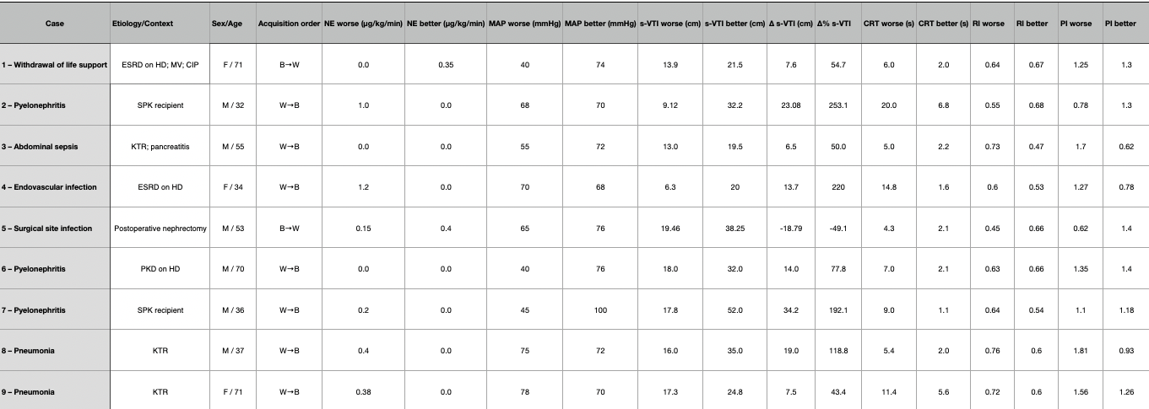

Table 1. Abbreviations:
ESRD, end-stage renal disease; HD, hemodialysis; MV, mechanical ventilation; CIP, critical-illness polyneuropathy; KTR, kidney transplant recipient; SPK, simultaneous pancreas–kidney (transplant) recipient (si en la tabla dejaste “PK recipient”, sugerencia: cambiar a SPK por claridad); PKD, polycystic kidney disease; NE, norepinephrine; MAP, mean arterial pressure; s-VTI, splenic velocity–time integral; CRT, capillary refill time; RI, resistive index; PI, pulsatility index.
Acquisition order: W→B, sampling chronology worse→better; B→W, better→worse.
Units: NE in μg/kg/min; MAP in mmHg; s-VTI in cm; CRT in s.

