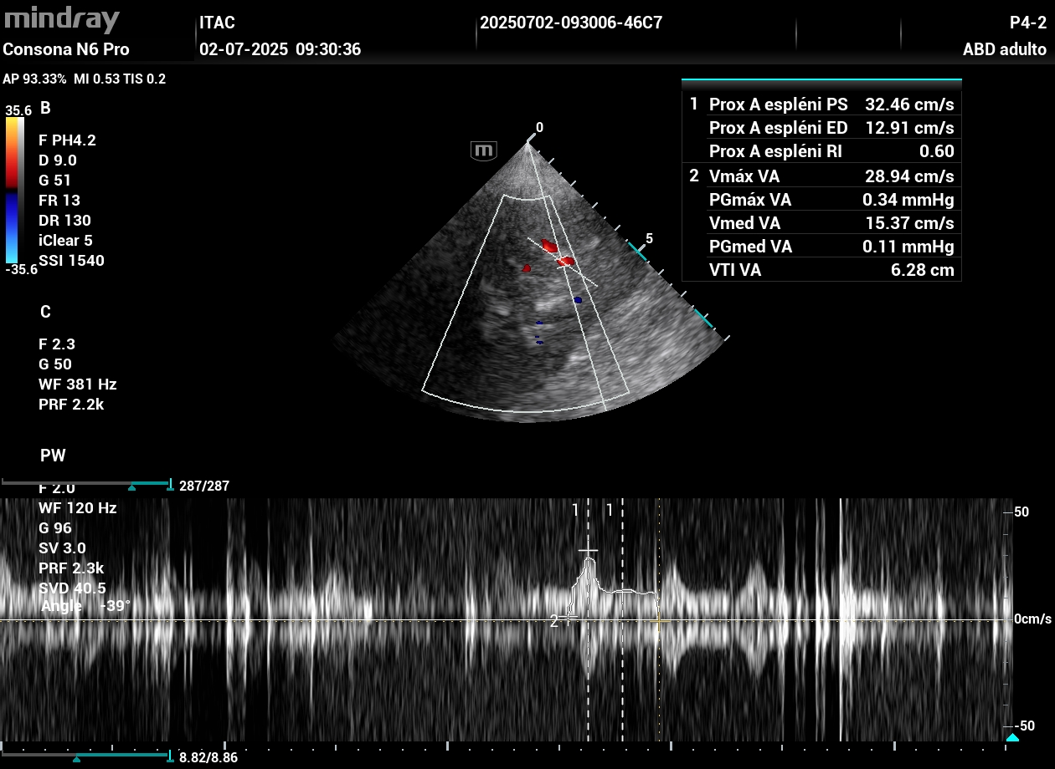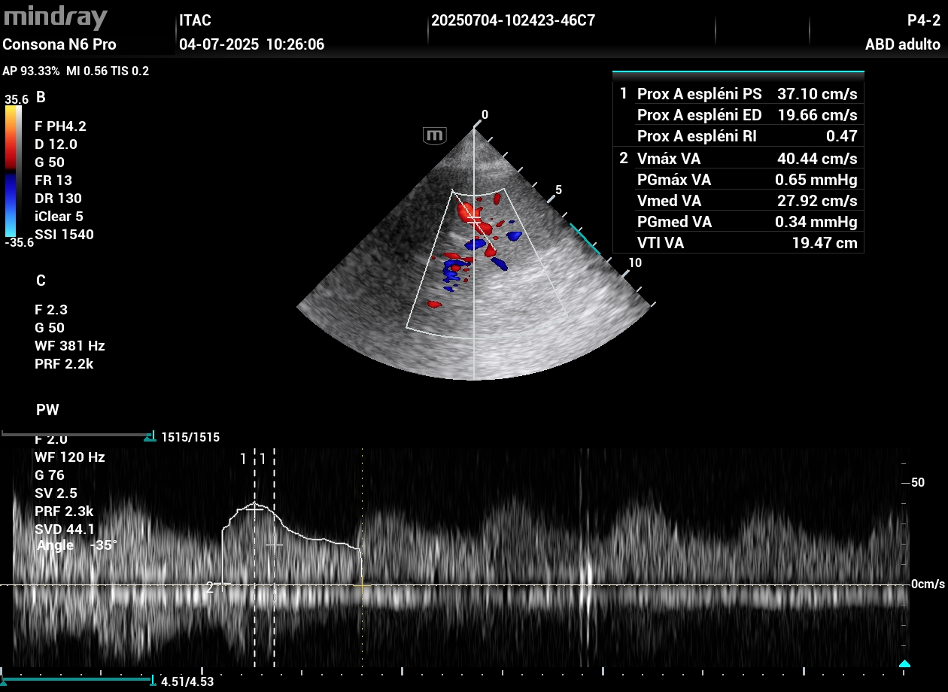
Figure S1.. Representative splenic Doppler in septic shock (case 4). Left (Worse): CRT 14.8 s, s-VTI 6.3 cm on NE 1.2 µg/kg/min + vasopressin 0.04 U/min (MAP 70 mmHg). Right (Better): CRT 1.6 s with s-VTI 19.6 cm off vasopressors (RI 0.60→0.47; PI 1.27→0.78). Despite remaining below the healthy benchmark (~39 cm), 220% increase in s-VTI highlights a dynamic, state-dependent signal.

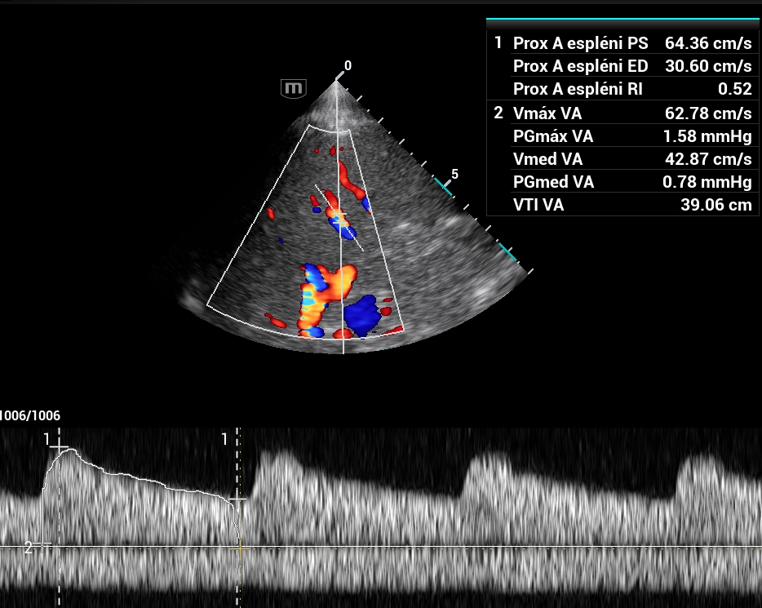

Figure S2. Splenic pulsed‑wave Doppler in a healthy volunteer (control) demonstrating VTI 39 cm, RI 0.52, and PI 0.79.

