Supplementary materials
Preregistered Predictive model
The model with only preregistered predictors (i.e., PA-BT correlation, PA-DBT correlation, and total use of each skill) was similar to the model reported in the main manuscript, however the accuracy was slightly lower, at 60% (95% CI [.47, .724]). Sensitivity was .23 and specificity was .88 (Figure S1). The selected lambda was .13.
Figure S1
Sensitivity and specify of the estimated model
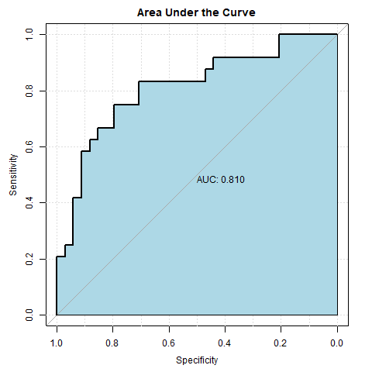
Akin to the model reported in the main manuscript, behavioral activation was a predictor of improvement. PA-CBT correlation was again a predictor of non-improvement. Differing from the model in the manuscript, emotion regulation was a predictor of improvement, total skills use was not a retained predictor (the effect was negligible in the main manuscript). Table S1 reports all retained predictors.
Table S1
Coefficients of the selected model with minimum lambda.
Predictor | Log Odds | Odds Ratio
(Intercept) | -0.27 | 0.76
PABTcor | -0.20 | 0.82
totDBT | 0.02 | 1.02
ba_tot | 0.24 | 1.27
emoreg_tot | 0.10 | 1.10
Note. PA-DBT correlation, Total BT skills, total skills overall, and total use of: self-assessment, behavioral scheduling, mindfulness, exposure, cognitive restructuring, interpersonal effectiveness/communication, and distress tolerance were not retained in the model.

