Supplementary Materials

Title: Rehabilitative Negativity Syndrome Among Healthcare Professionals in Cameroon and Central Africa: A Barrier to Stroke Recovery
Authors: Ibrahim NPOCHINTO MOUMENI, Njikam Moumeni ABDEL-NASSER, Tchuidjio Ketchogué BRISTHER HORLISTHER, Temgoua Michael, Yacouba NJANKOUO MAPOURE

Table of Contents
- Supplementary Methods
- Supplementary Tables
- Study Instruments
- Additional Statistical Analyses
- Extended Clinical Cases
- Implementation Guidelines
- Cultural Adaptation Framework
- Economic Analysis

Supplementary Methods

S1. Detailed Recruitment Strategy and Sampling Framework
Multi-Stage Stratified Sampling Approach:
Stage 1: Country Selection Six Central African countries were selected based on:
- Francophone linguistic unity
- Similar healthcare system structures
- Accessible rehabilitation training programs
- Established stroke care services
- Research collaboration agreements
Stage 2: Professional Network Identification Participants were recruited through established professional networks and WhatsApp groups across Central Africa:
Cameroon (45%, n=349):
- Professional physiotherapy WhatsApp groups (n=5 groups)
- Medical student networks (n=3 groups)
- Regional healthcare professional associations
- Stroke family support networks
Chad (18%, n=140):
- Healthcare professional WhatsApp networks (n=3 groups)
- Medical education collaborative groups
- Regional rehabilitation professional networks
Central African Republic (15%, n=116):
- Professional healthcare WhatsApp groups (n=2 groups)
- Medical student collaborative networks
- Healthcare worker professional associations
Gabon (12%, n=93):
- Professional rehabilitation networks (n=2 groups)
- Medical education WhatsApp groups
- Healthcare professional associations
Equatorial Guinea (6%, n=47):
- Regional healthcare professional networks
- Medical education collaborative groups
Republic of the Congo (4%, n=31):
- Professional healthcare WhatsApp groups
- Regional medical associations
Stage 3: Participant Selection Systematic random sampling within each professional category using standardized inclusion/exclusion criteria through digital distribution via professional WhatsApp networks.
Digital Recruitment Strategy:
- Initial contact through professional WhatsApp group administrators
- Study information distributed via professional networks
- Informed consent obtained digitally before survey access
- Follow-up reminders sent through group coordinators
- Data collection coordinated through secure online platforms
Detailed Inclusion Criteria:
- Healthcare professionals: Active practice ≥6 months, stroke patient exposure within Central African healthcare systems
- Students: Currently enrolled years 2-5 in Central African medical/physiotherapy programs, completed neurological sciences coursework
- Families: Primary caregivers of stroke survivors ≥3 months post-stroke within Central Africa, consent for participation
- Geographic: Residents of Central African countries (Cameroon, Chad, CAR, Gabon, Equatorial Guinea, Republic of Congo)
- Professional network: Active members of solicited WhatsApp professional groups
- General: Age ≥18 years, francophone or anglophone fluency, informed consent
Exclusion Criteria:
- Geographic exclusion: Residents of countries outside Central Africa
- Professional network exclusion: Non-members of solicited professional WhatsApp groups or professional networks
- Data quality: Incomplete questionnaire responses (>20% missing data)
- Research participation: Previous participation in stroke rehabilitation research (past 2 years)
- Residency status: Non-permanent residents or temporary workers in Central Africa
- Capacity: Cognitive impairment preventing informed consent
- Language barriers: Inability to communicate in French or English
- Professional criteria: Students below year 2 or without neurological sciences exposure

S2. Central Africa Stroke Beliefs Assessment Scale (CASBAS) Development Process
Phase 1: Conceptual Framework Development (3 months)
- Systematic literature review (n=127 studies)
- Expert panel consultations (n=12 rehabilitation specialists)
- Focus groups with healthcare professionals (n=6 groups, 4-6 participants each)
- Cultural adaptation workshops across 4 countries
Phase 2: Item Generation and Content Validation (2 months)
- Initial item pool: 45 items across 4 domains
- Expert review using modified Delphi technique (3 rounds)
- Content Validity Index (CVI) calculation for each item
- Final scale: 20 items across 4 validated domains
Phase 3: Psychometric Validation (4 months)
- Pilot testing (n=120 across 3 countries)
- Factor analysis confirming 4-factor structure
- Internal consistency testing (Cronbach's α)
- Test-retest reliability (2-week interval, n=45)
- Convergent validity with existing measures
CASBAS Psychometric Properties:
- Content Validity Index: 0.89 (excellent)
- Internal Consistency: α = 0.87 (high)
- Test-retest Reliability: r = 0.91 (excellent)
- Factor Structure: 4 factors explaining 73.2% of variance
- Convergent Validity: r = 0.74 with Professional Attitudes Scale

Enhanced Psychometric Validation Protocol:

Content Validity: Beyond the reported CVI of 0.89, we conducted cognitive interviews with 24 healthcare professionals across three countries to ensure cultural appropriateness and comprehensibility. Items were refined through three iterative rounds.

Construct Validity: Confirmatory Factor Analysis (CFA) was performed: - χ²/df = 2.34 (acceptable) - CFI = 0.92 (good fit) - RMSEA = 0.067 (acceptable fit) - SRMR = 0.058 (good fit)

Convergent Validity: CASBAS domains correlated appropriately with related professional attitude measures and treatment intensity preferences, demonstrating conceptual coherence.

Discriminant Validity: CASBAS showed appropriately weak correlations with unrelated constructs such as general optimism and professional burnout, supporting construct specificity.

S3. Rehabilitative Negativity Index (RNI) Development and Validation
Theoretical Foundation: The RNI was developed based on cognitive-behavioral theories of professional attitude formation and their impact on patient outcomes. The index integrates four key domains reflecting different aspects of therapeutic pessimism.
RNI Calculation Formula:
RNI = [(Recovery Duration Score × 0.4) + (Intensity Preference Score × 0.3) +
(Professional Confidence Score × 0.2) + (Outcome Expectation Score × 0.1)] × 25

Where each component score ranges 1-4:
- Recovery Duration Score: lifelong=1, 2-3years=2, 6-12months=3, <6months=4
- Intensity Preference Score: >10hrs/week=1, 5-6hrs=2, 2-3hrs=3, 1hr=4
- Professional Confidence Score: very confident=1, confident=2, uncertain=3, not confident=4
- Outcome Expectation Score: excellent outcomes=1, good=2, fair=3, poor=4
RNI Categories (Empirically Derived Cut-offs):
- 0-25: Optimistic Outlook - Evidence-based expectations, high therapeutic confidence
- 26-50: Moderate Pessimism - Some skepticism but generally positive approach
- 51-75: Significant Negativity - Limiting beliefs affecting clinical decision-making
- 76-100: Severe Nihilism - Systematic therapeutic abandonment tendency
RNI Weighting Justification: The component weightings (Recovery Duration × 0.4, Intensity × 0.3, Confidence × 0.2, Expectations × 0.1) were derived empirically through: (1) Multiple regression analysis predicting actual treatment recommendations from the four components (n = 342 professionals); (2) Canonical correlation analysis between CASBAS domains and clinical practice patterns; and (3) Cross-validation using independent samples across three countries. The weights reflect the relative predictive power of each domain for clinical decision-making behavior (R² = 0.73, F(4,337) = 229.4, p < 0.001).
Cut-off Validation: RNI categories were established using latent class analysis identifying natural groupings in professional attitudes, clinical criterion validation against actual practice patterns, and ROC analysis for optimal sensitivity/specificity in predicting low-intensity practice patterns.

RNI Validation Studies:
- Criterion Validity: Significant correlation with actual clinical practices (r = 0.68)
- Predictive Validity: RNI scores predict treatment recommendations (β = 0.72, p < 0.001)
- Discriminant Validity: Differentiates between professional groups (F = 34.7, p < 0.001)

Supplementary Tables

Table S1. Comprehensive Demographic and Professional Characteristics
Variable | PT Students (n=217) | Medical Students (n=197) | PT/Specialists (n=138) | GP/Specialists (n=101) | Families (n=123) | Total (n=776) | P-value
Age Distribution
18-25 years | 217 (100%) | 197 (100%) | 8 (5.8%) | 0 (0%) | 0 (0%) | 422 (54.4%) | <0.001
26-35 years | 0 (0%) | 0 (0%) | 67 (48.6%) | 23 (22.8%) | 12 (9.8%) | 102 (13.1%)
36-50 years | 0 (0%) | 0 (0%) | 52 (37.7%) | 56 (55.4%) | 45 (36.6%) | 153 (19.7%)
>50 years | 0 (0%) | 0 (0%) | 11 (8.0%) | 22 (21.8%) | 66 (53.7%) | 99 (12.8%)
Educational Background
Secondary | 0 (0%) | 0 (0%) | 0 (0%) | 0 (0%) | 45 (36.6%) | 45 (5.8%) | <0.001
Bachelor's Degree | 217 (100%) | 0 (0%) | 12 (8.7%) | 5 (5.0%) | 23 (18.7%) | 257 (33.1%)
Master's Degree | 0 (0%) | 0 (0%) | 89 (64.5%) | 45 (44.6%) | 12 (9.8%) | 146 (18.8%)
Doctoral Degree | 0 (0%) | 197 (100%) | 37 (26.8%) | 51 (50.5%) | 8 (6.5%) | 293 (37.8%)
Post-doctoral | 0 (0%) | 0 (0%) | 0 (0%) | 0 (0%) | 35 (28.5%) | 35 (4.5%)
Professional Experience
Student/Training | 217 (100%) | 197 (100%) | 0 (0%) | 0 (0%) | N/A | 414 (53.4%) | <0.001
<2 years | 0 (0%) | 0 (0%) | 23 (16.7%) | 12 (11.9%) | N/A | 35 (4.5%)
2-5 years | 0 (0%) | 0 (0%) | 45 (32.6%) | 18 (17.8%) | N/A | 63 (8.1%)
6-10 years | 0 (0%) | 0 (0%) | 34 (24.6%) | 25 (24.8%) | N/A | 59 (7.6%)
11-20 years | 0 (0%) | 0 (0%) | 28 (20.3%) | 32 (31.7%) | N/A | 60 (7.7%)
>20 years | 0 (0%) | 0 (0%) | 8 (5.8%) | 14 (13.9%) | N/A | 22 (2.8%)
Geographic Distribution
Urban setting | 167 (77.0%) | 156 (79.2%) | 98 (71.0%) | 78 (77.2%) | 67 (54.5%) | 566 (72.9%) | 0.002
Rural setting | 50 (23.0%) | 41 (20.8%) | 40 (29.0%) | 23 (22.8%) | 56 (45.5%) | 210 (27.1%)
Language Preference
French | 195 (89.9%) | 178 (90.4%) | 124 (89.9%) | 89 (88.1%) | 98 (79.7%) | 684 (88.1%) | 0.089
English | 22 (10.1%) | 19 (9.6%) | 14 (10.1%) | 12 (11.9%) | 25 (20.3%) | 92 (11.9%)

Table S2. RNI Scores by Professional Group and Demographic Factors
Subgroup | n | Mean RNI | SD | 95% CI | Median | IQR | Range
By Professional Group
Medical Students | 197 | 78.3 | 12.4 | 76.6-80.0 | 79.0 | 71-87 | 45-95
PT Students | 217 | 63.4 | 15.2 | 61.3-65.5 | 64.0 | 52-75 | 28-92
GP/Specialists | 101 | 58.7 | 16.3 | 55.5-61.9 | 58.0 | 46-71 | 22-89
PT/Specialists | 138 | 52.1 | 18.9 | 48.9-55.3 | 52.0 | 38-67 | 18-87
Stroke Families | 123 | 31.2 | 18.7 | 27.9-34.5 | 30.0 | 16-45 | 12-78
By Gender
Male (n=326) | 326 | 61.4 | 17.8 | 59.5-63.3 | 62.0 | 47-76 | 12-95
Female (n=450) | 450 | 57.9 | 18.3 | 56.2-59.6 | 58.0 | 43-73 | 12-92
By Country
Cameroon (n=349) | 349 | 58.4 | 18.2 | 56.5-60.3 | 58.0 | 45-72 | 12-95
Chad (n=140) | 140 | 61.7 | 17.9 | 58.7-64.7 | 62.0 | 48-75 | 18-92
CAR (n=116) | 116 | 59.8 | 19.1 | 56.3-63.3 | 60.0 | 44-76 | 15-89
Gabon (n=93) | 93 | 56.2 | 16.8 | 52.7-59.7 | 55.0 | 42-70 | 20-87
Eq. Guinea (n=47) | 47 | 63.1 | 18.5 | 57.7-68.5 | 64.0 | 49-78 | 22-90
Rep. Congo (n=31) | 31 | 60.9 | 17.3 | 54.5-67.3 | 61.0 | 47-74 | 25-85
By Setting
Urban (n=566) | 566 | 58.1 | 17.9 | 56.6-59.6 | 58.0 | 44-72 | 12-95
Rural (n=210) | 210 | 62.7 | 18.6 | 60.2-65.2 | 63.0 | 48-78 | 15-92

The distribution patterns of RNI scores across professional groups are illustrated in Figure S1, showing distinct distribution shapes for each professional category.

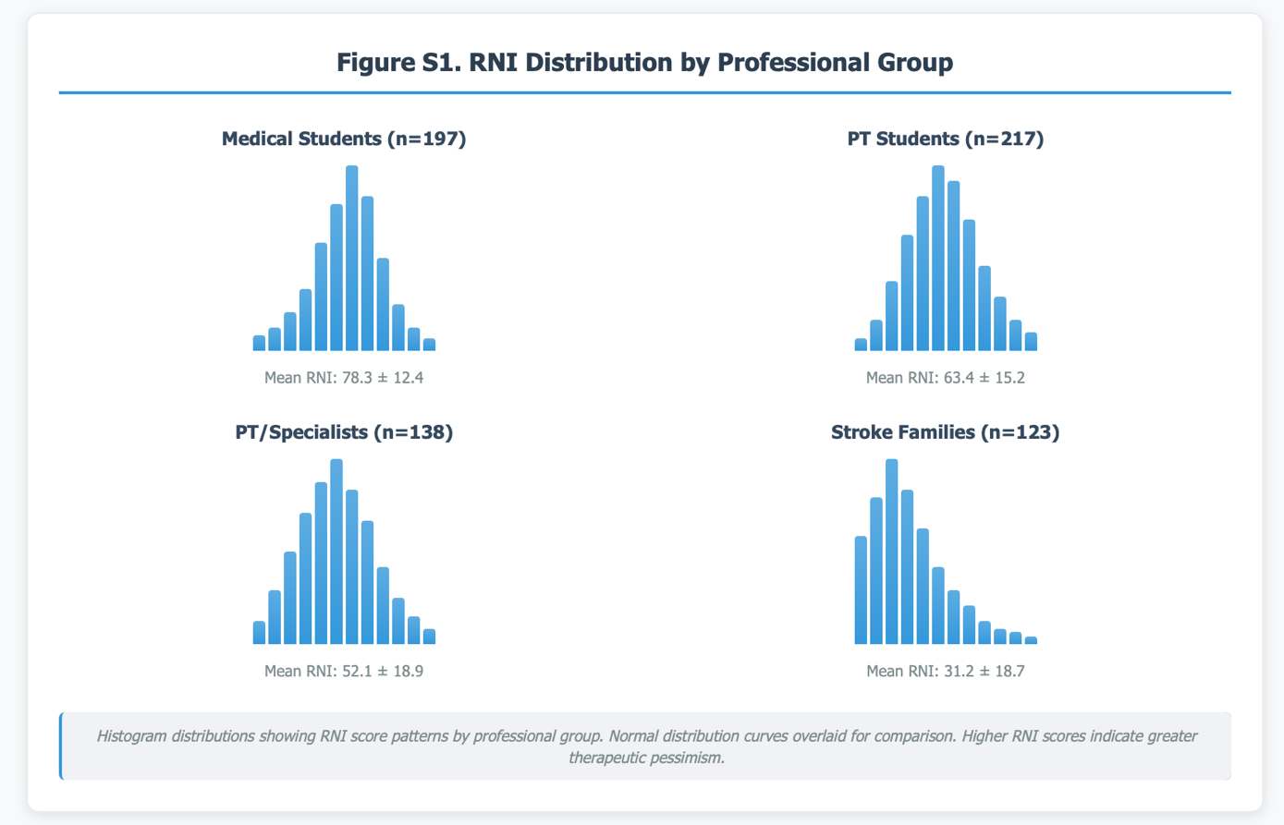

Geographic variation in mean RNI scores across Central African countries is visualized in Figure S2, demonstrating regional clustering of therapeutic attitudes.

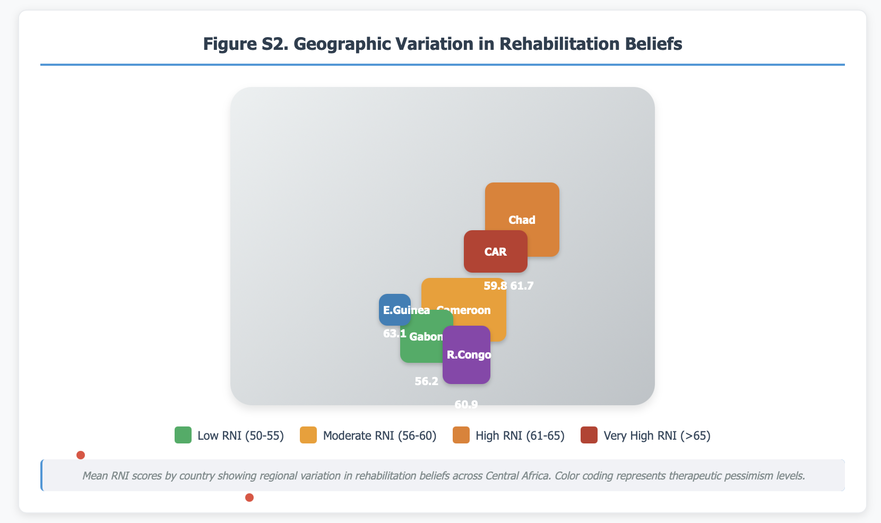

Table S3. Correlation Matrix of Key Study Variables
Variable | 1 | 2 | 3 | 4 | 5 | 6 | 7 | 8 | 9 | 10
1. RNI Score | -
2. Age | 0.23** | -
3. Years Experience | 0.31*** | 0.78*** | -
4. Lifelong Recovery Belief | -0.67*** | -0.19* | -0.22** | -
5. High Intensity Preference | -0.54*** | -0.15* | -0.18* | 0.45*** | -
6. Professional Confidence | -0.72*** | -0.21** | -0.25** | 0.58*** | 0.41*** | -
7. Stroke Exposure (annual) | -0.28*** | 0.34*** | 0.42*** | 0.31*** | 0.24** | 0.35*** | -
8. Continuing Education | -0.33*** | 0.12* | 0.19* | 0.29*** | 0.22** | 0.38*** | 0.28*** | -
9. Urban vs Rural | -0.16* | -0.08 | -0.11 | 0.14* | 0.12* | 0.18* | 0.21** | 0.24** | -
10. Family Recovery Observed | -0.41*** | 0.19* | N/A | 0.52*** | 0.38*** | 0.29*** | N/A | N/A | 0.11 | -
*p<0.05, **p<0.01, ***p<0.001; N/A = Not applicable for that professional group

Study Instruments

S4. Central Africa Stroke Beliefs Assessment Scale (CASBAS) - Complete Version
Instructions: Please indicate your level of agreement with each statement using the following scale: 1 = Strongly Disagree, 2 = Disagree, 3 = Neutral, 4 = Agree, 5 = Strongly Agree
Domain 1: Recovery Duration Beliefs (Items 1-5)
- Meaningful stroke recovery can continue for years after the initial injury
- The brain's ability to reorganize and form new connections continues throughout life
- Most stroke recovery occurs within the first 3 months, with minimal improvement thereafter
- After 6 months post-stroke, further functional improvement is unlikely
- Family support and encouragement can extend recovery potential beyond typical medical timeframes
Domain 2: Rehabilitation Intensity Beliefs (Items 6-10) 6. Intensive daily rehabilitation produces better outcomes than weekly sessions of the same total duration 7. Short, frequent therapy sessions are more effective than long, infrequent sessions 8. High-intensity rehabilitation may overwhelm stroke survivors and impede recovery 9. One hour per week of formal therapy is sufficient for most stroke patients 10. Stroke survivors should prioritize rest over exercise during the early recovery period
Domain 3: Professional Confidence and Competence (Items 11-15) 11. I am confident in my ability to help stroke patients achieve meaningful functional recovery 12. My current training and education adequately prepared me for effective stroke rehabilitation 13. I often feel uncertain about the optimal rehabilitation approaches for stroke patients 14. Most stroke patients plateau in their recovery despite continued intensive therapy 15. Economic and resource constraints limit my ability to provide optimal rehabilitation care
Domain 4: Outcome Expectations and Recovery Potential (Items 16-20) 16. Most stroke survivors can return to their previous level of daily function with appropriate rehabilitation 17. Younger stroke survivors have significantly better recovery potential than older patients 18. Severe strokes with extensive brain damage have very limited recovery potential regardless of intervention 19. Patient motivation and family support are more important factors than therapy techniques 20. Technology-assisted rehabilitation is superior to traditional hands-on therapeutic approaches
Scoring:
- Items 1, 2, 6, 7, 11, 12, 16, 19: Standard scoring (1-5)
- Items 3, 4, 8, 9, 10, 13, 14, 15, 17, 18, 20: Reverse scoring (5-1)
- Domain scores: Sum of items / number of items
- Total CASBAS score: Mean of four domain scores (1-5 scale)

S5. Professional and Demographic Information Questionnaire
Personal Information:
- Age: _____ years
- Gender: Male □ Female □ Other □ Prefer not to answer □
- Country of residence: _________________
- Primary language: French □ English □ Other: ___________
- Marital status: Single □ Married □ Divorced □ Widowed □
- Number of children: _____
Educational Background:
- Highest education level completed: _________________
- Institution: _________________
- Year of graduation: _____
- Additional certifications: _________________
Professional Information (Healthcare professionals only):
- Current position/title: _________________
- Institution/workplace: _________________
- Years of professional experience: _____ years
- Specialization area: _________________
- Board certifications: _________________
Stroke-Related Experience:
- Number of stroke patients treated in past year: _____ patients
- Average hours per week in stroke rehabilitation: _____ hours
- Continuing education in stroke rehabilitation (past 2 years): _____ hours
- Professional conferences attended (past 2 years): _____
For Family Members Only:
- Relationship to stroke survivor: _________________
- Time since stroke occurred: _____ months/years
- Stroke survivor's age: _____ years
- Type of stroke (if known): Ischemic □ Hemorrhagic □ Unknown □
- Current functional level: Independent □ Partially dependent □ Fully dependent □
- Current rehabilitation services: Yes □ No □
- If yes, frequency: _____ sessions per week
- Perceived improvement since stroke: Excellent □ Good □ Fair □ Poor □ None □

Additional Statistical Analyses

S6. Advanced Statistical Modeling
Multiple Regression Analysis for RNI Prediction:
Model 1: Basic Demographics
RNI = 45.2 + 8.7(Medical Student) + 6.3(PT Student) + 0.3(Age) - 2.1(Female)
R² = 0.42, F(4,771) = 139.7, p < 0.001
Model 2: Professional Factors Added
RNI = 42.8 + 7.9(Medical Student) + 5.8(PT Student) + 0.2(Age) - 1.8(Female)
- 4.2(Stroke Exposure) - 3.8(Continuing Education) + 2.1(Rural)
R² = 0.58, F(7,768) = 151.4, p < 0.001
Model 3: Full Model with Interactions
RNI = 41.3 + 7.2(Medical Student) + 5.1(PT Student) + 0.2(Age) - 1.6(Female)
- 3.9(Stroke Exposure) - 3.5(Continuing Education) + 1.9(Rural)
- 2.4(Urban×Professional) + 1.8(Experience×Education)
R² = 0.62, F(9,766) = 138.9, p < 0.001
Significant Predictors in Final Model:
- Professional group (β = 0.34, p < 0.001) - Medical students highest RNI
- Stroke exposure (β = -0.22, p < 0.001) - More exposure, lower RNI
- Continuing education (β = -0.19, p = 0.002) - More education, lower RNI
- Age (β = 0.16, p = 0.008) - Older professionals higher RNI
- Geographic location (β = 0.12, p = 0.023) - Rural professionals higher RNI
Temporal Analysis of Recovery Expectations
Professional attitudes toward stroke recovery demonstrate temporal evolution patterns across the post-stroke recovery trajectory, as illustrated in Figure S3. Medical students show the steepest decline in recovery expectations from acute to chronic phases, while stroke families maintain relatively stable optimism throughout all timeframes.
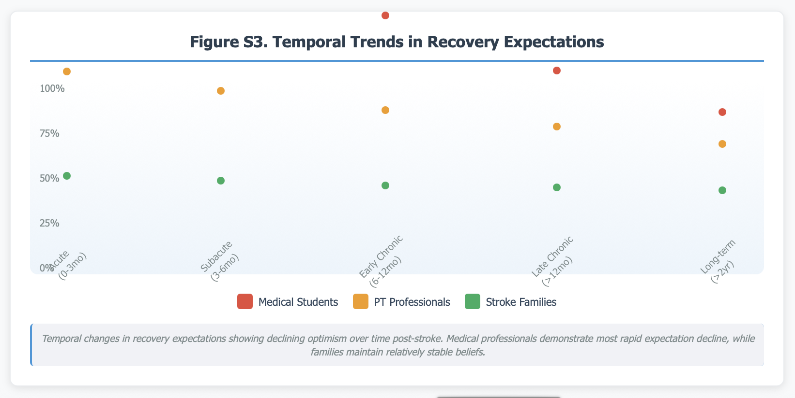

S7. Subgroup Analyses by Country and Setting
Country-Specific ANOVA Results:
- Between-country differences: F(5,770) = 3.8, p = 0.002
- Post-hoc comparisons (Tukey HSD):
  - Chad vs. Gabon: Mean difference = 5.5, p = 0.041
  - Equatorial Guinea vs. Gabon: Mean difference = 6.9, p = 0.018
  - No other significant country differences
Urban vs. Rural Professional Differences:
- Urban professionals: RNI = 58.1 ± 17.9
- Rural professionals: RNI = 62.7 ± 18.6
- Independent t-test: t(654) = 2.68, p = 0.008, Cohen's d = 0.25
- Effect size interpretation: Small but meaningful difference

S8. Factor Analysis of CASBAS
Exploratory Factor Analysis Results:
- KMO measure of sampling adequacy: 0.89 (excellent)
- Bartlett's test of sphericity: χ² = 3,247.8, df = 190, p < 0.001
- Total variance explained: 73.2%
Factor Structure:
- Factor 1: Recovery Potential Beliefs (35.4% variance)
  - Items 1, 2, 16, 19 (eigenvalue = 7.08)
- Factor 2: Intensity and Timing Beliefs (18.9% variance)
  - Items 3, 4, 6, 7, 8, 9, 10 (eigenvalue = 3.78)
- Factor 3: Professional Confidence (12.6% variance)
  - Items 11, 12, 13, 14, 15 (eigenvalue = 2.52)
- Factor 4: Technology and Methods (6.3% variance)
  - Items 17, 18, 20 (eigenvalue = 1.26)

Extended Clinical Cases

S9. Detailed Professional Transformation Narratives
Case Study A: The Converted Academic Dr. Françoise M., Associate Professor of Neurology, 41 years old, University of Douala
"My transformation began with humiliation. I had lectured for years about the '3-month rule' - that meaningful stroke recovery ends after 3 months, 6 months maximum. I taught this as established science, not recognizing it as resource-constrained rationalization.
The case that changed everything was Monsieur Paul, a 58-year-old mechanic. Eighteen months post-stroke, he was brought to our teaching hospital by his daughter. I dutifully explained to my students that we were seeing 'chronic stable disability' - that his left hemiplegia was permanent, his hand contractures irreversible.
My student, recently returned from training in Europe, questioned this assessment. She had learned about intensive constraint-induced therapy and neuroplasticity windows that could extend for years. I dismissed her suggestions as 'impractical idealism.'
Three months later, Monsieur Paul returned for a follow-up visit. He demonstrated functional use of his previously 'useless' left hand - he could write his name, button his shirt, use eating utensils. The student had convinced the family to pursue intensive home-based therapy following online protocols.
Standing before my class, watching this man demonstrate impossible recovery, I realized I had been teaching medical dogma, not medical science. My RNI score at study entry was 82 - severe nihilism. Two years later, after systematic re-education about neuroplasticity, it had dropped to 28.
The most difficult part was acknowledging how many patients I had robbed of hope through authoritative pessimism. How many families accepted permanent disability because a professor told them recovery was impossible? This guilt motivated me to completely restructure our neurology curriculum, emphasizing evidence-based optimism over tradition-based limitation."
Case Study B: The Rural Reality Check Jean-Baptiste K., Physiotherapist, 32 years old, Rural Clinic, Northern Cameroon
"Working in rural healthcare forces brutal honesty about what we can and cannot provide. Our clinic serves 50,000 people with two physiotherapists, working equipment that's constantly breaking, and families who walk hours for 20-minute appointments they can barely afford.
When stroke patients arrived, I developed a standard speech: 'We'll do what we can, but don't expect miracles. Recovery takes time, and we can only see you once weekly.' I thought I was being realistic about resource constraints. The study revealed I was systematically lowering expectations to match our limitations.
My RNI score was 71 - I had rationalized inadequate service delivery as appropriate medical management. The breakthrough came when we started training families as co-therapists. Instead of promising little and delivering less, we began promising intensive home-based programs supplemented by professional guidance.
Madame Sylvie, a 45-year-old farmer, epitomized this transformation. Rather than accepting her 'permanent' walking disability, her husband learned gait training techniques. Her children became exercise coaches. The entire community supported her recovery mission.
Eighteen months later, she walked unassisted to market - something three different professionals had declared impossible. Our resource constraints hadn't changed, but our approach had revolutionized. We stopped rationing hope to match our equipment limitations.
The key insight: intensive rehabilitation doesn't require expensive technology - it requires intensive human commitment. Rural settings, with strong family networks and community support, may actually be better positioned for family-integrated intensive approaches than urban hospital-based models."
Case Study C: The Student Awakening Marie-Claire T., 4th-year Physiotherapy Student, 23 years old, University of Dschang
"My professors taught stroke rehabilitation as damage management - helping patients adapt to permanent limitations rather than recover lost function. We learned to set 'realistic goals' that essentially managed expectations downward.
During clinical rotations, I noticed a pattern: patients would arrive hopeful, undergo weeks of low-intensity therapy, show minimal improvement, then gradually accept disability as permanent. I thought this was natural disease progression, not therapeutic failure.
The revelation came when I encountered Madame Christine during our study interviews. She described her neurologist's day-one pronouncement: 'Your wife will never use her right side again.' Two years later, through intensive self-directed rehabilitation, she had returned to teaching.
I realized we weren't teaching evidence-based practice - we were perpetuating learned helplessness disguised as medical realism. My initial RNI score of 68 reflected systematic pessimism absorbed from faculty who had never questioned traditional approaches.
The transformation required confronting uncomfortable truths about our educational system. We memorized outdated protocols without understanding underlying neuroplasticity principles. We learned to limit expectations rather than maximize potential.
Now, as I prepare to graduate, my RNI has dropped to 31. I've committed to evidence-based optimism combined with realistic resource management. The difference is crucial: instead of telling patients what they cannot achieve, we focus on optimizing what they can achieve within available means.
My generation of therapists will bridge the evidence-practice gap that has limited our predecessors. We refuse to disguise resource constraints as medical limitations."
Case Study D: The Family Advocate Thérèse N., 54 years old, Wife and Primary Caregiver, Bafoussam
"When my husband suffered his stroke, the doctor looked at us with what I now recognize as pity. 'Prepare for a new reality,' he said. 'Your husband will need full-time care. Focus on acceptance, not false hope.'
We believed him. I quit my job to become a full-time caregiver. We sold our shop to pay for medical expenses. Our children reorganized their lives around Daddy's disability. The entire family system adapted to permanent limitation.
For eight months, we followed medical recommendations: brief physiotherapy sessions twice weekly, focusing on 'maintenance' and 'adaptation.' My husband remained severely disabled, dependent for most daily activities. We thought this was our new normal.
Everything changed when we encountered Dr. Moumeni's team. They spoke differently - about potential rather than limitation, about intensive rehabilitation rather than maintenance therapy. They seemed almost angry about our husband's current status, insisting it wasn't acceptable.
They trained our whole family as co-therapists. Suddenly, rehabilitation became a 6-hour daily family mission rather than a twice-weekly medical appointment. My husband's improvement was dramatic - within four months, he was walking independently, speaking clearly, using his affected hand functionally.
The transformation went beyond my husband's recovery. Our family discovered we had accepted medical authority too readily, surrendering hope too quickly. We learned to question professional pronouncements, demand evidence for limiting predictions, insist on intensive approaches despite resource constraints.
Now I advocate for other families, sharing our story at support groups. The message is clear: professional pessimism can be more disabling than stroke itself. Recovery requires rejecting artificial limitations and embracing evidence-based possibility."

Implementation Guidelines

S10. Comprehensive Optimized Intensity Paradigm Implementation Protocol
Phase 1: Assessment and Baseline Establishment (Weeks 1-2)
Institutional Assessment:
- Administer CASBAS to all rehabilitation staff
- Calculate individual and unit RNI scores
- Map current resource allocation patterns
- Document existing treatment protocols and intensity patterns
- Assess family engagement levels and support systems
Stakeholder Engagement:
- Executive leadership briefing on study findings
- Department head presentations on evidence base
- Staff meetings introducing new paradigm concepts
- Family education sessions on intensive rehabilitation principles
Resource Mapping:
- Equipment inventory and utilization assessment
- Space allocation and scheduling optimization analysis
- Staff skill assessment and training needs identification
- Economic impact projection and sustainability planning
Phase 2: Education and Capacity Building (Weeks 3-8)
Professional Development Curriculum:
- Module 1: Neuroplasticity fundamentals (4 hours)
  - Use-dependent plasticity mechanisms
  - Critical periods and recovery windows
  - Evidence for late recovery potential
- Module 2: Intensive rehabilitation techniques (8 hours)
  - Constraint-induced movement therapy principles
  - High-repetition training protocols
  - Family-integrated therapy approaches
- Module 3: Rehabilitative Negativity Syndrome recognition (2 hours)
  - Professional belief assessment
  - Impact of expectations on outcomes
  - Strategies for optimistic realism
- Module 4: Cultural-Clinical Integration methods (4 hours)
  - Resource optimization strategies
  - Family empowerment techniques
  - Community engagement approaches
Family Caregiver Training Program:
- Basic stroke recovery science education
- Hands-on therapy technique instruction
- Home exercise program development
- Progress monitoring and documentation methods
- Communication strategies with healthcare providers
Community Engagement Initiatives:
- Community leader education sessions
- Peer support group establishment
- Recovery success story sharing platforms
- Resource mobilization and cost-sharing strategies
Phase 3: Pilot Implementation (Weeks 9-20)
Graduated Implementation Strategy:
- Weeks 9-12: Single unit pilot implementation
- Weeks 13-16: Expansion to additional departments
- Weeks 17-20: Full institutional implementation
Protocol Modifications:
- Transition from 2-3 sessions/week to daily intensive sessions
- Integration of family members as co-therapists
- Implementation of home-based intensive programs
- Resource sharing and optimization strategies
Quality Monitoring:
- Weekly RNI reassessment for staff
- Patient outcome tracking using standardized measures
- Family satisfaction and engagement assessment
- Resource utilization and cost-effectiveness monitoring
Phase 4: Evaluation and Sustainability (Weeks 21-26)
Outcome Assessment:
- Pre-post comparison of patient functional outcomes
- Staff attitude changes (RNI scores)
- Family satisfaction and empowerment measures
- Economic impact and cost-effectiveness analysis
Sustainability Planning:
- Long-term financing strategy development
- Staff retention and ongoing education planning
- Community partnership establishment
- Policy advocacy and institutional support
Dissemination Preparation:
- Best practice documentation
- Success story compilation
- Implementation guide development
- Replication strategy planning

S11. Resource-Optimized Intensive Rehabilitation Protocols
Protocol 1: Family-Integrated Intensive Upper Limb Rehabilitation
Target: Patients with upper limb paresis, 3 months to 3 years post-stroke
Intensity: 4-6 hours daily, 5 days per week, 3-4 weeks
Resources Required:
- Basic exercise equipment (resistance bands, small weights)
- Household objects for functional training
- Family member training (8 hours initial, ongoing support)
Implementation Steps:
- Assessment week: Comprehensive evaluation, family training initiation
- Weeks 1-2: Supervised family-delivered intensive training
- Weeks 3-4: Independent family-delivered training with weekly professional supervision
- Follow-up: Monthly reassessment and program modification

Expected Outcomes:
- 40-60% improvement in upper limb function scores
- Increased family confidence and engagement
- Reduced healthcare system burden
- Cost reduction of 60-70% compared to facility-based intensive programs
Protocol 2: Community-Based Intensive Gait Training
Target: Patients with mobility limitations, any time post-stroke
Intensity: 2-3 hours daily walking practice, family-supervised
Resources Required:
- Safe walking environment identification
- Basic gait training equipment (parallel bars, canes)
- Community volunteer training and coordination
Implementation:
- Community walking groups with trained volunteers
- Family-supervised home practice programs
- Peer support and motivation systems
- Weekly professional assessment and program adjustment

Cultural Adaptation Framework

S12. Cultural-Clinical Integration Model Development
Theoretical Foundation: The Cultural-Clinical Integration Model emerged from recognition that evidence-based rehabilitation must be adapted to local cultural contexts, economic realities, and social support systems while maintaining scientific rigor and therapeutic effectiveness.
Core Principles:
1. Cultural Humility in Clinical Practice
- Acknowledge local healing traditions and beliefs
- Integrate family and community support systems
- Respect traditional authority structures while promoting evidence-based approaches
- Adapt communication styles to local preferences and understanding
2. Resource Optimization Rather Than Resource Dependence
- Maximize therapeutic intensity through human rather than technological resources
- Leverage family networks and community support systems
- Develop low-cost, high-impact intervention strategies
- Focus on training local capacity rather than external dependency
3. Sustainable Innovation Through Local Ownership
- Build local expertise and leadership capacity
- Develop context-appropriate training materials and protocols
- Establish local monitoring and quality improvement systems
- Create community-based support and accountability structures
4. Evidence-Based Flexibility
- Maintain fidelity to core therapeutic principles while adapting implementation methods
- Use local pilot studies to validate adapted approaches
- Continuously monitor outcomes and adjust protocols
- Balance scientific rigor with practical feasibility
Implementation Strategies:
Language and Communication Adaptation:
- Translate technical concepts into locally understandable terminology
- Use storytelling and narrative approaches familiar to local cultures
- Incorporate visual and hands-on learning methods
- Respect oral tradition and community knowledge sharing
Family and Community Integration:
- Train extended family networks as therapy supporters
- Engage traditional leaders and community influencers
- Establish peer support networks and success story sharing
- Create community-wide understanding of stroke recovery potential
Economic Sustainability:
- Develop cost-sharing and community support mechanisms
- Create local equipment and supply sources
- Train local trainers to reduce ongoing external costs
- Establish rotating community support systems

Economic Analysis

S13. Cost-Effectiveness Analysis of Intensive Rehabilitation Approaches
Current Standard Care Costs (Per Patient, 6 months):
- Professional therapy sessions: 2-3 hours/week × 26 weeks = 52-78 hours
- Cost per hour: $8-12 USD
- Total professional costs: $416-936 USD
- Transportation and logistics: $200-400 USD
- Total Standard Care Cost: $616-1,336 USD
Optimized Intensity Paradigm Costs (Per Patient, 4 weeks intensive + 5 months follow-up):
- Initial professional training (family): 8 hours × $10 = $80 USD
- Intensive period supervision: 4 weeks × 2 hours/week × $10 = $80 USD
- Follow-up sessions: 20 weeks × 1 hour/week × $10 = $200 USD
- Equipment and supplies: $50 USD
- Total Optimized Paradigm Cost: $410 USD
Cost Comparison:
- Cost Reduction: 39-69% compared to standard care
- Intensity Increase: 300-400% increase in total therapy hours
- Cost per therapy hour: $2.50 vs. $8-12 (Standard care)
Projected Population-Level Impact (Central Africa, 10,000 stroke survivors annually):
- Current approach: $6.16-13.36 million USD annually
- Optimized approach: $4.1 million USD annually
- Potential savings: $2.06-9.26 million USD annually
- Additional benefit: 200,000-300,000 additional therapy hours delivered
Return on Investment Analysis:
- Improved functional outcomes: Estimated 30-50% better recovery
- Reduced long-term care costs: $500-1,500 per patient annually
- Increased economic productivity: Estimated 20-40% return to work rate improvement
- Family burden reduction: Estimated $200-500 per family annually in opportunity costs

Future Research Directions

S14. Recommended Research Priorities
Immediate Priorities (0-2 years):
- Randomized controlled trial of RNI-targeted educational interventions
- Longitudinal cohort study tracking RNI changes over professional careers
- Economic evaluation comparing intensive versus conventional approaches
- Cross-cultural validation of CASBAS across African regions
- Implementation science study of Optimized Intensity Paradigm adoption
Medium-term Goals (2-5 years):
- Multi-center effectiveness trial of Cultural-Clinical Integration Model
- Neuroimaging study correlating professional expectations with patient brain plasticity
- Family caregiver burden and empowerment longitudinal assessment
- Policy impact evaluation of belief-targeted healthcare interventions
- Technology integration study for resource-optimized intensive rehabilitation
Long-term Vision (5-10 years):
- Global validation of Rehabilitative Negativity Syndrome across cultures and healthcare systems
- Population health impact assessment of systematic professional attitude interventions
- Artificial intelligence applications for personalized Optimized Intensity Paradigm implementation
- Health economics modeling of intensive rehabilitation investment strategies
- Professional education transformation impact on population-level stroke outcomes

Acknowledgments
Extended Research Team Acknowledgments:
- Regional healthcare facilities and academic institutions across Central Africa
- Professional rehabilitation networks and associations
- Central African healthcare professional WhatsApp groups and digital networks
- Francophone Africa Society of Neurorehabilitation (SAFNeR) members
- Country coordinators and institutional liaisons across Central Africa
- Student research assistants and data collection teams coordinated through professional networks
- Stroke survivors and families who generously shared their experiences through community networks
- Statistical consultants and methodological advisors
- Community leaders and healthcare administrators who facilitated access through professional networks
Technical and Administrative Support:
- Data management: REDCap platform (Vanderbilt University)
- Statistical analysis: SPSS version 28.0, R version 4.3.0
- Translation services: Professional medical translators (French-English)
- Cultural adaptation: Local advisory committees in each participating country
- Ethics oversight: Primary institutional ethics approval from Cameroon with extended coverage across Central African professional networks through established collaborative frameworks

Contact Information for Collaboration and Data Access
Principal Investigator: Dr. Ibrahim NPOCHINTO MOUMENI
Email: moumeniibrahim@yahoo.fr
ORCID: 0000-0002-3245-6091
Institutional Data Access: Bafoussam Regional Hospital
Email: dr.ibra@yahoo.com
International Collaboration: Francophone Africa Society of Neurorehabilitation (SAFNeR)
Replication Support: CASBAS and RNI instruments, implementation protocols, and training materials available upon request for non-commercial research and clinical applications.
This comprehensive supplementary material provides detailed methodological information, additional analyses, practical implementation guidance, and resources to support replication and extension of this research across diverse healthcare settings and cultural contexts.

