SUPPLEMENTARY FOLDER

Supplementary Files Legend

Supplementary Figure S1a and b: Risk of Bias Assessment
Supplementary Table S1: Risk of Bias Assessment Details
Supplementary Figure S2: Funnel Plot
Supplementary Figure S3: Sensitivity Analysis
Supplementary Table S2: Sensitivity Analysis Details
Supplementary Table S3: Subgroup Analysis By Study Design
Supplementary Table S4: Detailed Search Strategy
Supplementary Table S5: PICOS
Supplementary Figure S1a and b: Risk of Bias Assessment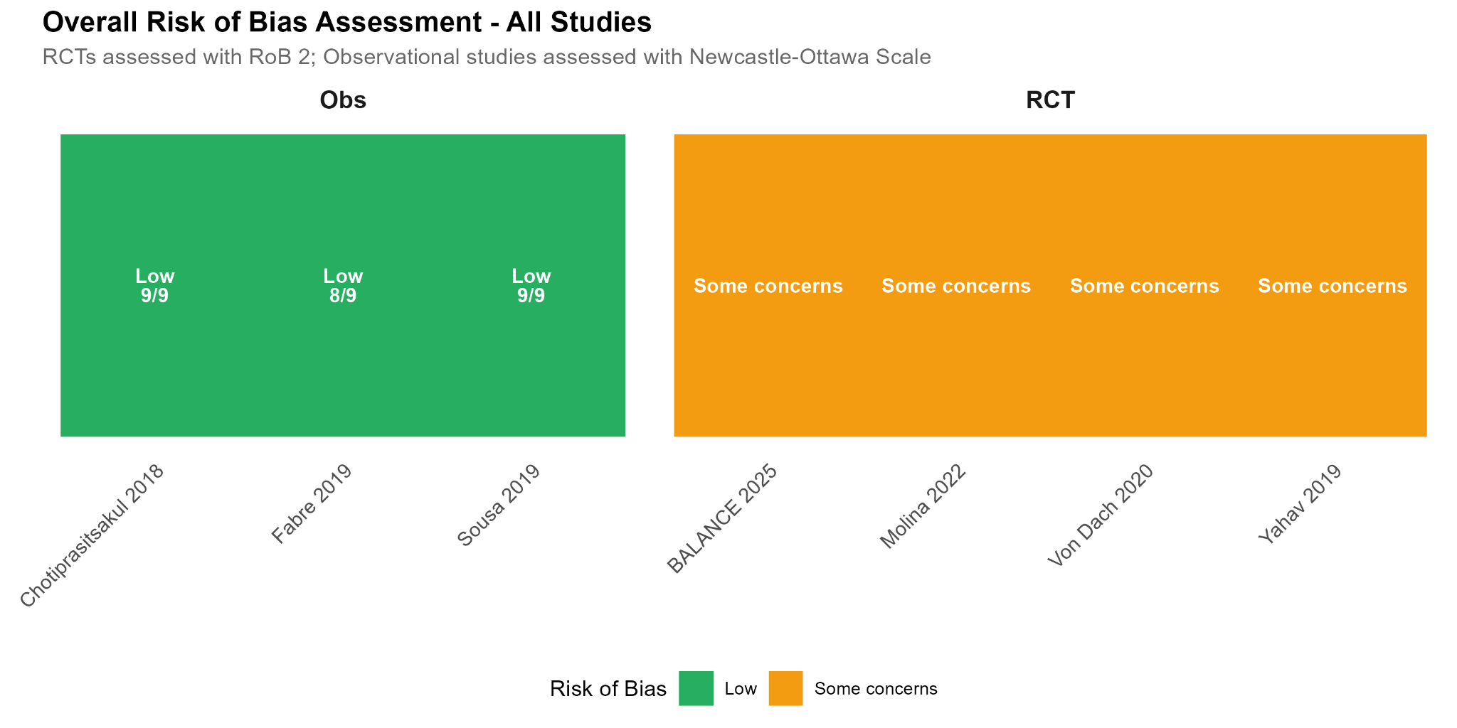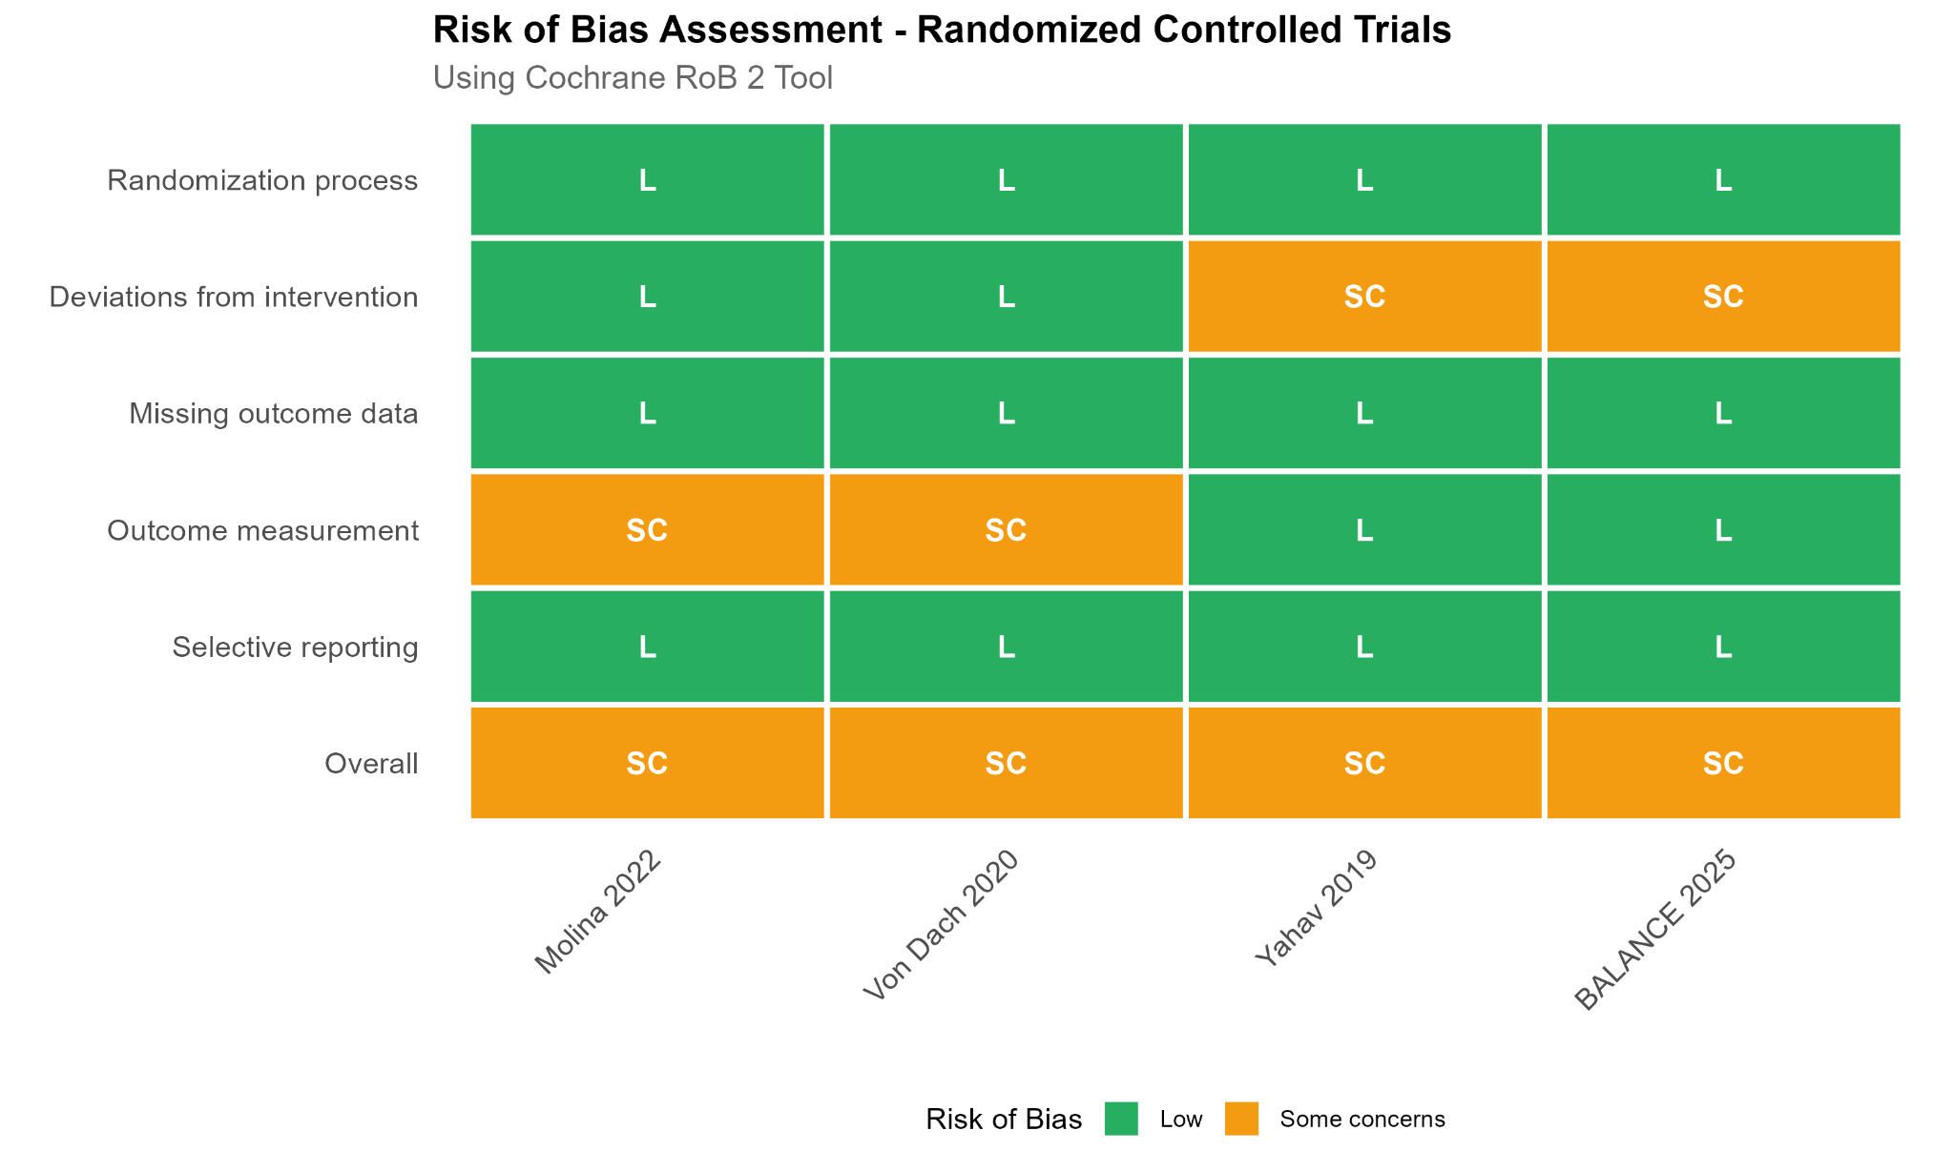

Table S1: Risk of Bias Assessment Details
Study | Tool | Domain 1 | Domain 2 | Domain 3 | Domain 4 | Domain 5 | Overall
RCTs (RoB 2)
BALANCE 2025 | RoB 2 | Low | Some concerns | Low | Low | Low | Some concerns
Molina 2022 | RoB 2 | Low | Low | Low | Some concerns | Low | Some concerns
Von Dach 2020 | RoB 2 | Low | Low | Low | Some concerns | Low | Some concerns
Yahav 2019 | RoB 2 | Low | Some concerns | Low | Low | Low | Some concerns
Observational (NOS) |  | Selection | Comparability | Outcome | Total | Quality
Chotiprasitsakul 2018 | NOS | 4/4 | 2/2 | 3/3 | 9/9 | High | -
Fabre 2019 | NOS | 3/4 | 2/2 | 3/3 | 8/9 | High | -
Sousa 2019 | NOS | 4/4 | 2/2 | 3/3 | 9/9 | High | -

Supplementary Figure S2: Funnel Plot
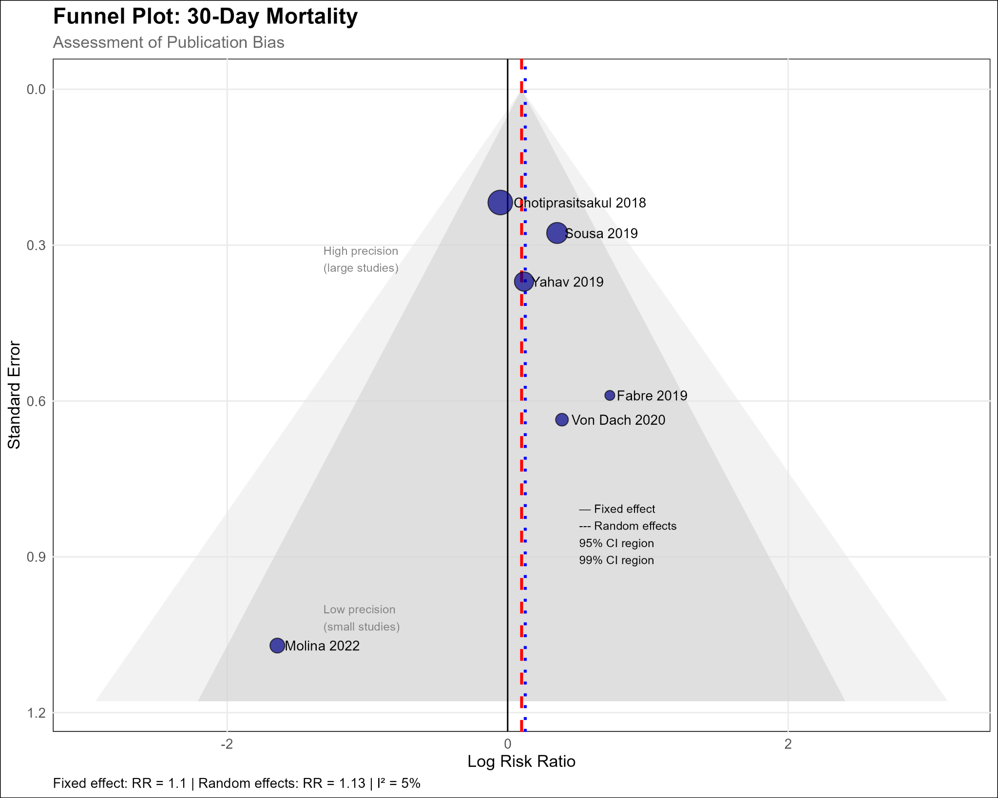

Supplementary Figure S3: Sensitivity Analysis
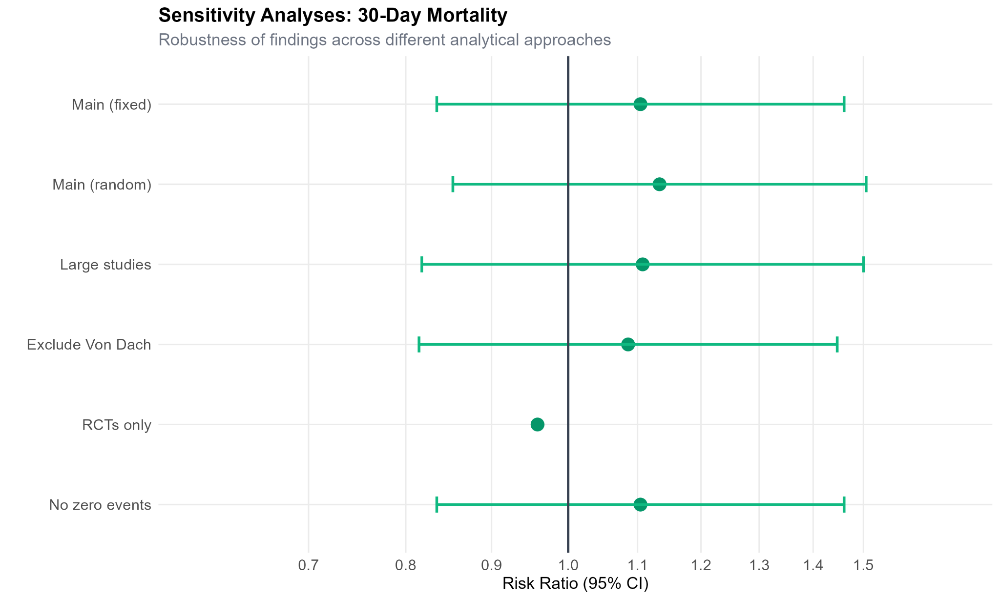

Supplementary Table S2: Sensitivity Analysis Details
Analysis | Studies (n) | Patients (n) | RR (95% CI) | I² (%) | P-value
Main analysis (fixed) | 6 | 2,550 | 1.10 (0.83-1.46) | 5 | 0.487
Random effects | 6 | 2,550 | 1.13 (0.85-1.51) | 5 | 0.386
Large studies only | 3 | 2,100 | 1.11 (0.82-1.50) | 0 | 0.509
RCTs only | 3 | 1,134 | 0.96 (0.54-1.71) | 29 | 0.886
Exclude Von Dach | 5 | 2,241 | 1.09 (0.81-1.45) | 22 | 0.574

Supplementary Table S3: Subgroup Analysis By Study Design
Outcome | Subgroup | Studies | RR (95% CI) | I² (%) | P-interaction
30-day mortality | RCT | 3 | 0.96 (0.54-1.71) | 29 | 0.739
 | Observational | 3 | 1.16 (0.84-1.59) | 16
30-day relapse | RCT | 3 | 1.03 (0.52-2.03) | 0 | 0.494
 | Observational | 3 | 0.75 (0.43-1.33) | 0

Supplementary Table S4: Detailed Search Strategy

Database | Search Terms / Strategy Used
PubMed | ("gram-negative bacteremia"OR "gram negative bloodstream infection" OR “Enterobacterales bacteremia” OR “E.coli bacteremia” OR “Klebsiella bacteremia”) AND ("antibiotic duration" OR "short course" OR "long course" OR "7 days" OR "14 days" OR “antimicrobial stewardship”) AND (“randomized controlled trial” OR “randomised controlled trial” OR “RCT” OR “clinical trial”) AND ("ICU" OR "general ward" OR "medical ward" OR “surgical ward” OR “hospital ward”)
Cochrane Library | ("gram-negative bacteremia" OR "gram negative bloodstream infection" OR "Enterobacterales bacteremia" OR "E.coli bacteremia" OR "Klebsiella bacteremia") AND ("antibiotic duration" OR "short course" OR "long course" OR "7 days" OR "14 days" OR "antimicrobial stewardship") AND ("randomized controlled trial" OR "randomised controlled trial" OR "RCT" OR "clinical trial") AND ("ICU" OR "general ward" OR "medical ward" OR "surgical ward" OR "hospital ward")
ClinicalTrials.gov | Condition/Disease: gram-negative bacteremia  Other Terms: antibiotic duration, short course, long course, general ward, RCT  Study Type: Interventional  Recruitment Status: Recruiting, Completed  Location: All  Phase: All
Scopus | TITLE-ABS-KEY(("gram negative bacteremia" OR "gram negative bloodstream infection" OR "Enterobacterales bacteremia" OR "E.coli bacteremia" OR "Klebsiella bacteremia") AND ("antibiotic duration" OR "short course" OR "long course" OR "7 days" OR "14 days" OR "antimicrobial stewardship") AND ("randomized controlled trial" OR "randomised controlled trial" OR "RCT" OR "clinical trial") AND ("ICU" OR "general ward" OR "medical ward" OR "surgical ward" OR "hospital ward"))
Embase | ('gram negative bacteremia'/exp OR 'gram negative bloodstream infection':ti,ab OR 'Enterobacterales bacteremia':ti,ab OR 'E.coli bacteremia':ti,ab OR 'Klebsiella bacteremia':ti,ab) AND ('antibiotic duration'/exp OR 'short course':ti,ab OR 'long course':ti,ab OR '7 days':ti,ab OR '14 days':ti,ab OR 'antimicrobial stewardship':ti,ab) AND ('randomized controlled trial'/exp OR 'randomised controlled trial':ti,ab OR 'RCT':ti,ab OR 'clinical trial':ti,ab) AND ('intensive care unit':ti,ab OR 'general ward':ti,ab OR 'medical ward':ti,ab OR 'surgical ward':ti,ab OR 'hospital ward':ti,ab)
Supplementary Table S5: PICOS
Population | Hospitalized adults (≥18 years) with Gram-negative bacteremia (patients must be hemodynamically stable and appropriate for a shorter-course therapy).
Intervention | Short-course systemic antibiotic therapy (≤10 days), any antibiotic class and route.
Control | Long-course systemic antibiotic therapy (>10 days), using the same antibiotic regimen or an agent with equivalent antimicrobial spectrum as the intervention.
Outcomes | Studies must report at least one of the primary outcomes (e.g. 30-day mortality or infection relapse). Data on secondary outcomes (e.g. 90-day mortality, recurrent infection, Clostridioides difficile infection, antibiotic-related adverse events, and emergence of resistance) will also be collected.
Study design | Randomized controlled trials, observational studies

