Supplementary file
Dendrimer Functionalized Metal Oxide Nanoparticle mediated Self-Assembled Collagen Scaffold for Skin Regenerative Application: Function of Metal in Metal oxides

Mohan Vedhanayagamª, Anandasadagopan Suresh kumar ^{c}, Balachandran Unni Nairª and Kalarical Janardhanan Sreeram^{b*}
ªInorganic and Physical Chemistry Laboratory, CSIR-Central Leather Research Institute, Adyar, Chennai, 600 020, Inida
^{b}CATERS Laboratory, CSIR-Central Leather Research Institute, Adyar, Chennai 600 020 India
^{c}Biochemistry and Biotechnology Laboratory, CSIR-Central Leather Research Institute, Adyar, Chennai, 600 020, India

* Corresponding authors. E-mail: kjsreeram@clri.res.in; Tel. +91 44 2441 1630; Fax. +91 44 2491 2150
S 1.0 Experimental Section
S 1.1 Synthesis of Triethoxysilane poly (amidoamine) dendrimer (TES-PAMAM – G₃)
Triethoxysilane poly (amidoamine) dendrimer generation (G₃) was synthesized using modified reported procedure[1]. Briefly, under nitrogen atmosphere (3-aminopropyl) Triethoxy silane and methyl acrylate (1:2 ratios) were added to dry methanol and refluxed for 12h at 90ºC. The obtained white color product was separated by column chromatography and designated as TES-PAMAM-G_{0.5}. This half-generation product was further reacted with ethylene diamine (1:5 ratios) in dry methanol and refluxed for 90ºC for 96 h. The reaction mixture was allowed to cool to ambient temperature followed by separation via column chromatography and designated as TES-PAMAM-G₁. Following this, methyl acrylate and ethylene diamine was alternatively added two times to TES-PAMAM-G₁ leading to generation TES-PAMAM-G₃ product. The ideal synthetic scheme of TES-PAMAM -G₃ dendrimer by divergent method is shown in Fig. S1.

S 1.2 In vitro Antibacterial activity Assay of MO –TES-PAMAM-G₃ NPs
Antibacterial activity of MO-TES-PAMAM-G₃ nanoparticle was investigated against Gram –positive Staphylococcus aureus and Gram – negative Escherichia coli bacteria by using turbidity measurement. Two different bacterial cultures (Escherichia coli and Staphylococcus aureus) were freshly prepared by overnight cultivation at 37°C in the nutrient broth. The bacterial suspensions, post 24 hours of incubation, were centrifuged at 4000 rpm for 10 min and resuspended in 0.01M MgSO₄ to achieve turbidity of 0.5 McFarland standard, which approximately corresponds to 10⁸.CFU/mL[2]. MO-TES-PAMAM-G₃ samples were made by making serial two-fold dilutions (25 µg - 200µg/mL) in sterile distilled water. The positive control used in this study is the antibiotic streptomycin sulfate salt (25µg/mL). The MIC assay was performed in 96-well microtitre plates by adding 100μL of nutrient broth (2X concentration) to each well followed by 100μL of MO-TES-PAMAM-G₃ (25, 50, 100 and 200 µg/ml) in triplicates. Then, to each well 10μL of bacterial suspension was added. The final volume of samples in the wells was 210μL. The microtitre plates were wrapped with vapor film and the absorbance was read at 600 nm at three different intervals (6, 12, 18 and 24 h) to determine turbidity of the samples.
S1.3 Measurement of Reactive Oxygen Species (ROS)
The generated ROS was measured in S.aureus and E.coli after acquaintance to various concentrations (25, 50, 100, and 200 µg/mL) of different metal oxide nanoparticles with dichlorofluorescein diacetate (DCFH-DA) as fluorescence agent. 1 ml of bacterial culture was centrifuged for 5 min at 5000g and the resultant pellet was resuspended in PBS of various treatment concentrations containing 30 μg/ml DCFH-DA dye. The mixture was placed in an environmental shaker for 30 min at 37°C. In a similar manner, the treated culture was pelleted followed by resuspension in 200μlof Phosphate Buffered Saline (PBS) in each. The plates were then placed on a shaker in dark condition for 10-15 minutes at room temperature. The resultant intensity of fluorescence was measured using a microplate reader (Tecan Infinite M200) at an excitation wavelength of 485 nm and emission wavelength of 528 nm. The values were documented as percentage of fluorescence intensity in comparison to the control wells.
S1.4 Lipid peroxidation (LPO) measurement
Malondialdehyde (MDA), a bio-marker of LPO was used to measure the lipid peroxidation level
by using BODIPY 581/591C11 4, 4-difluoro -5-(4-phenyl-1,3-butadienyl)-4-bora-3a-,4a-diaza –s-indacene-3-undecanoic acid. An analog of fluorescent fatty acid – BODIPY possess fluorescent properties eventually emiting green fluorescence post lipid oxidation triggered via excessive intracellular ROS production. Bacteria are exposed to MOs and MO-TES-PAMAM-G₃ NPs (25 - 200µg/mL) and the resultant cell suspension was subjected to 10 minutes wash with phosphate buffer (PBS) (thrice) to exclude any unbound nanoparticle. To 1 ml of the washed cells suspension, 40 µL of BODIPY dye (2 µM) was added and incubated in the dark at 37ºC followed by a 10 minutes wash in PBS to exclude any untreated dye. 100 µL of this cell suspension (washed) was transferred into 96 well plates and the resultant green fluorescence emitted owing to the lipid peroxidation was read in a fluorescent microplate reader tuned to an excitation wavelength of 490 nm and emission wavelength of 520 nm. Bacterial cells treated with 5% hydrogen peroxide for 20 minutes was used a positive control. All the experiments were repeated three times and average values were reported.
S 2.0 Results and Discussion
S 2.1 Antibacterial Activity of dendrimer functionalized metal oxide nanoparticles (MO-TES-PAMAM-G₃ NPs)
Antibacterial activity of dendrimer functionalized metal oxide nanoparticle (MO-TES-PAMAM-G₃ NPs) was evaluated against and Gram-negative E. coli and Gram positive S.aureus bacteria through turbidity measurement and observed results are present in Fig. S4.As per the figurative representation, the negative control showed higher turbidity at all the time durations due to their increase in bacterial growth, whereas in the positive control owing to the presence of the antibiotic gentamicin, significant inhibition in the bacterial growth was observed. In the case of MO-TES-PAMAM-G₃ nanoparticle (25-200 µg/ml), there was no significant inhibition of bacterial growth during the 6 and 12 h the treatment due to the lag phase. After increasing the time duration to 18 and 24 h, MO-TES-PAMAM-G₃ NPs displayed gradual decrease in the absorbance with an increase in the concentration, clearly indicating inhibition in the growth of S.aureus and E.coli bacteria. Bacterial cell wall which is negatively charged attracts dendrimer functionalized metal oxide nanoparticles that are positively charged via electrostatic interactions, which results in the disruption of cell walls thereby increasing their permeability leading to bacterial damage. As per the pictorial representation, MO-TES-PAMAM-G₃ nanoparticles exhibited higher antibacterial activity towards S.aureus (gram positive bacteria) than E. coli(gram negative bacteria). This revelation can be associated to the presence of a single layered cell wall in the Gram–positive bacteria while that of the multilayered structure with an outer cell membrane’s presence in the Gram - negative bacteria. Dendrimer functionalized ZnO, TiO₂ and CeO₂ nanoparticles (100 - 200 µg/ml) showed ≥ 50% bacterial growth inhibition at 24 h, whereas Fe₃O₄ and SiO₂ nanoparticle did not show significant growth inhibition (p ≥ 0.005).The order of antibacterial activity of MO-TES-PAMAM-G₃ nanoparticle is as follows: ZnO > TiO₂> CeO₂> Fe₃O₄> SiO₂. Among the various metal oxide nanoparticles that were studied, ZnO-TES-PAMAM-G₃ nanoparticles exhibited higher antibacterial activity (85% growth inhibition, Minimum inhibitory concentration (MIC) -200 µg/ml) against both the bacterial strains (Fig. S4). These observations were consistent with the reported literature indicating that ZnO nanoparticle exhibited higher antibacterial activity than TiO₂, Fe₃O₄, CeO₂ and SiO₂ nanoparticles[3-4]. The generation of ROS is one of the key molecular mechanisms underlying the antibacterial activity of most of the nanoparticles[5-6].
S2.2 Effect of dendrimer functionalized metal oxides in intracellular ROS generation
To detect ROS generation in metal oxide and dendrimer functionalized metal oxide nanoparticles treated bacterial strains, fluorometric assay involving intracellular oxidation of 2, 7-dichlorofluoroscein diacetate (DCFH –DA) was carried out and results are displayed in Fig. S5. According to the figurative representation, an increase in the fluorescence intensity was observed in a dose dependent manner in the MOs and MO-TES-PAMAM-G₃ NPs indicating intracellular ROS due to the formation of 2’7’-dichlorofluorescein (DCF). The generation of intracellular ROS in S.aureus is much greater when compared to that in E.coli. This might be attributed to the interaction and internalization of nanoparticles, which is higher in S.aureus as when compared to E.coli. The effects of the five MOs and MO-TES-PAMAM-G₃ NPs were different in intracellular ROS generation. It is noteworthy to see that dendrimer functionalized metal oxide nanoparticles (MO-TES-PAMAM-G₃ NPs) slightly decreases the ROS production than pure metal oxide nanoparticles. This observation can be interpreted through surface area of nanoparticle providing surface reactivity. The pure metal oxide nanoparticle providing large surface area leads to higher ROS generation, whereas the dendrimer functionalization on metal oxide nanoparticles reduces the surface availability, due to presence of dendrimer molecules on the surface, leading to decreased ROS generation. However, the observed decreases in ROS generation of dendrimer functionalized metal oxide nanoparticle did not have a negative impact on antibacterial activity on both the bacterial strains. Such observation was consistent with Mohammadi et al,who reported that polymer coated iron oxide nanoparticles release lower ROS than pure iron oxide nanoparticles[7]. Dendrimer functionalized metal oxides nanoparticle produce ROS in the following order: ZnO >TiO₂ > CeO₂ > Fe₃O₄ > SiO₂. The ROS generation efficiency of nanoparticles can be attributed to the difference in the size of the nanoparticles [4, 6, 8-9]. Reports state that the quality of the metal oxide nanocrystals decreases with the decrease in the size of the nanoparticle, resulting in enhanced vacancies of interstitial metal ions and oxygen. Many such electron-hole pairs are generated from these crystal defects which translocate to the surface of the nanoparticles and contribute greatly in the generation of ROS. The holes and electrons present in the metal oxide treated bacterial strains react with hydroxyl ions and oxygen respectively in that are present in the aqueous environment. This results in the production of highly reactive free radicals like hydroxyl radical from the holes and superoxide anion radical from the electrons. In fig. S5, ZnO nanoparticle exhibited higher intracellular ROS owing to its smaller size when compared to other metal oxide nanoparticles. This finding seems to be consistent with Ashutosh et al, who have reported that ZnO nanoparticle exhibited higher ROS generation than TiO₂ and Fe₃O₄ nanoparticle in E. coli[10]. This observation inferred that the mechanism of antibacterial activity of MOs and MO-TES-PAMAM-G₃ NPs was through increased ROS formation in the bacterial strains.
S2.3 Lipid peroxidation
To confirm the connection between MDA and ROS in the metal oxide and dendrimer functionalized metal oxide nanoparticle treated bacterial strains, we measured the MDA content and the observed result is presented in Fig. S6. According to the observation displayed in the figure, the MDA level increased in both the bacterial strains after exposure to the metal oxide and dendrimer functionalized metal oxides nanoparticles (25-200µg/ml). It is important to note that the ZnO nanoparticle treated bacterial strains exhibited higher level of MDA due to their smaller size, leading to higher ROS production when compared to other metal oxide nanoparticles. This result was in good agreement with the intracellular ROS production and antibacterial activity of MOs and MO-TES-PAMAM-G₃ NPs. Our result showed that the metal oxide and dendrimer functionalized metal oxide nanoparticle has increased the production of MDA in a dose dependent manner, which likely contributed to the disintegration of the bacterial cell membrane.
Based on the observed results, we hypothesized that the mechanism (Fig. S7) of antibacterial activity of ZnO –TES-PAMAM-G₃nanoparticleattributes to the positively charged amino groups of the dendrimer, which interact with the negatively charged bacterial membrane through electrostatic interaction. Subsequently, the smaller size (14 nm) of the dendrimer functionalized the ZnO nanoparticle to penetrate into the bacterial cell membrane leading to an increase in the intracellular ROS production on the surface over time through the small size coupled with large crystal defects. This enhanced intracellular ROS subsequently resulted in the increase in the level of malondialdehyde (MDA) generation ultimately leading to cell death via disruption of the bacterial membrane’s integrity.

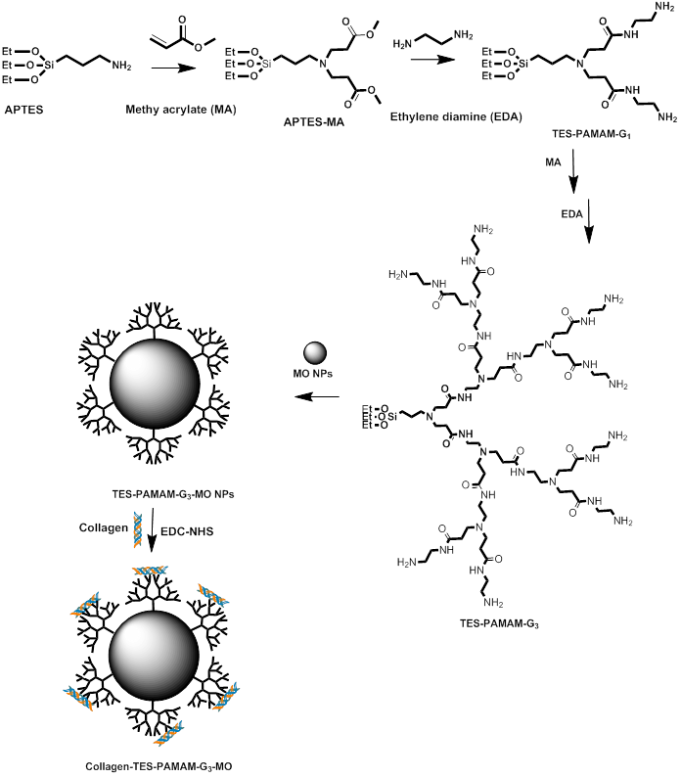
Fig. S1. Synthesis of TES-PAMAM-G₃-funcitonalized Metal oxide nanoparticle

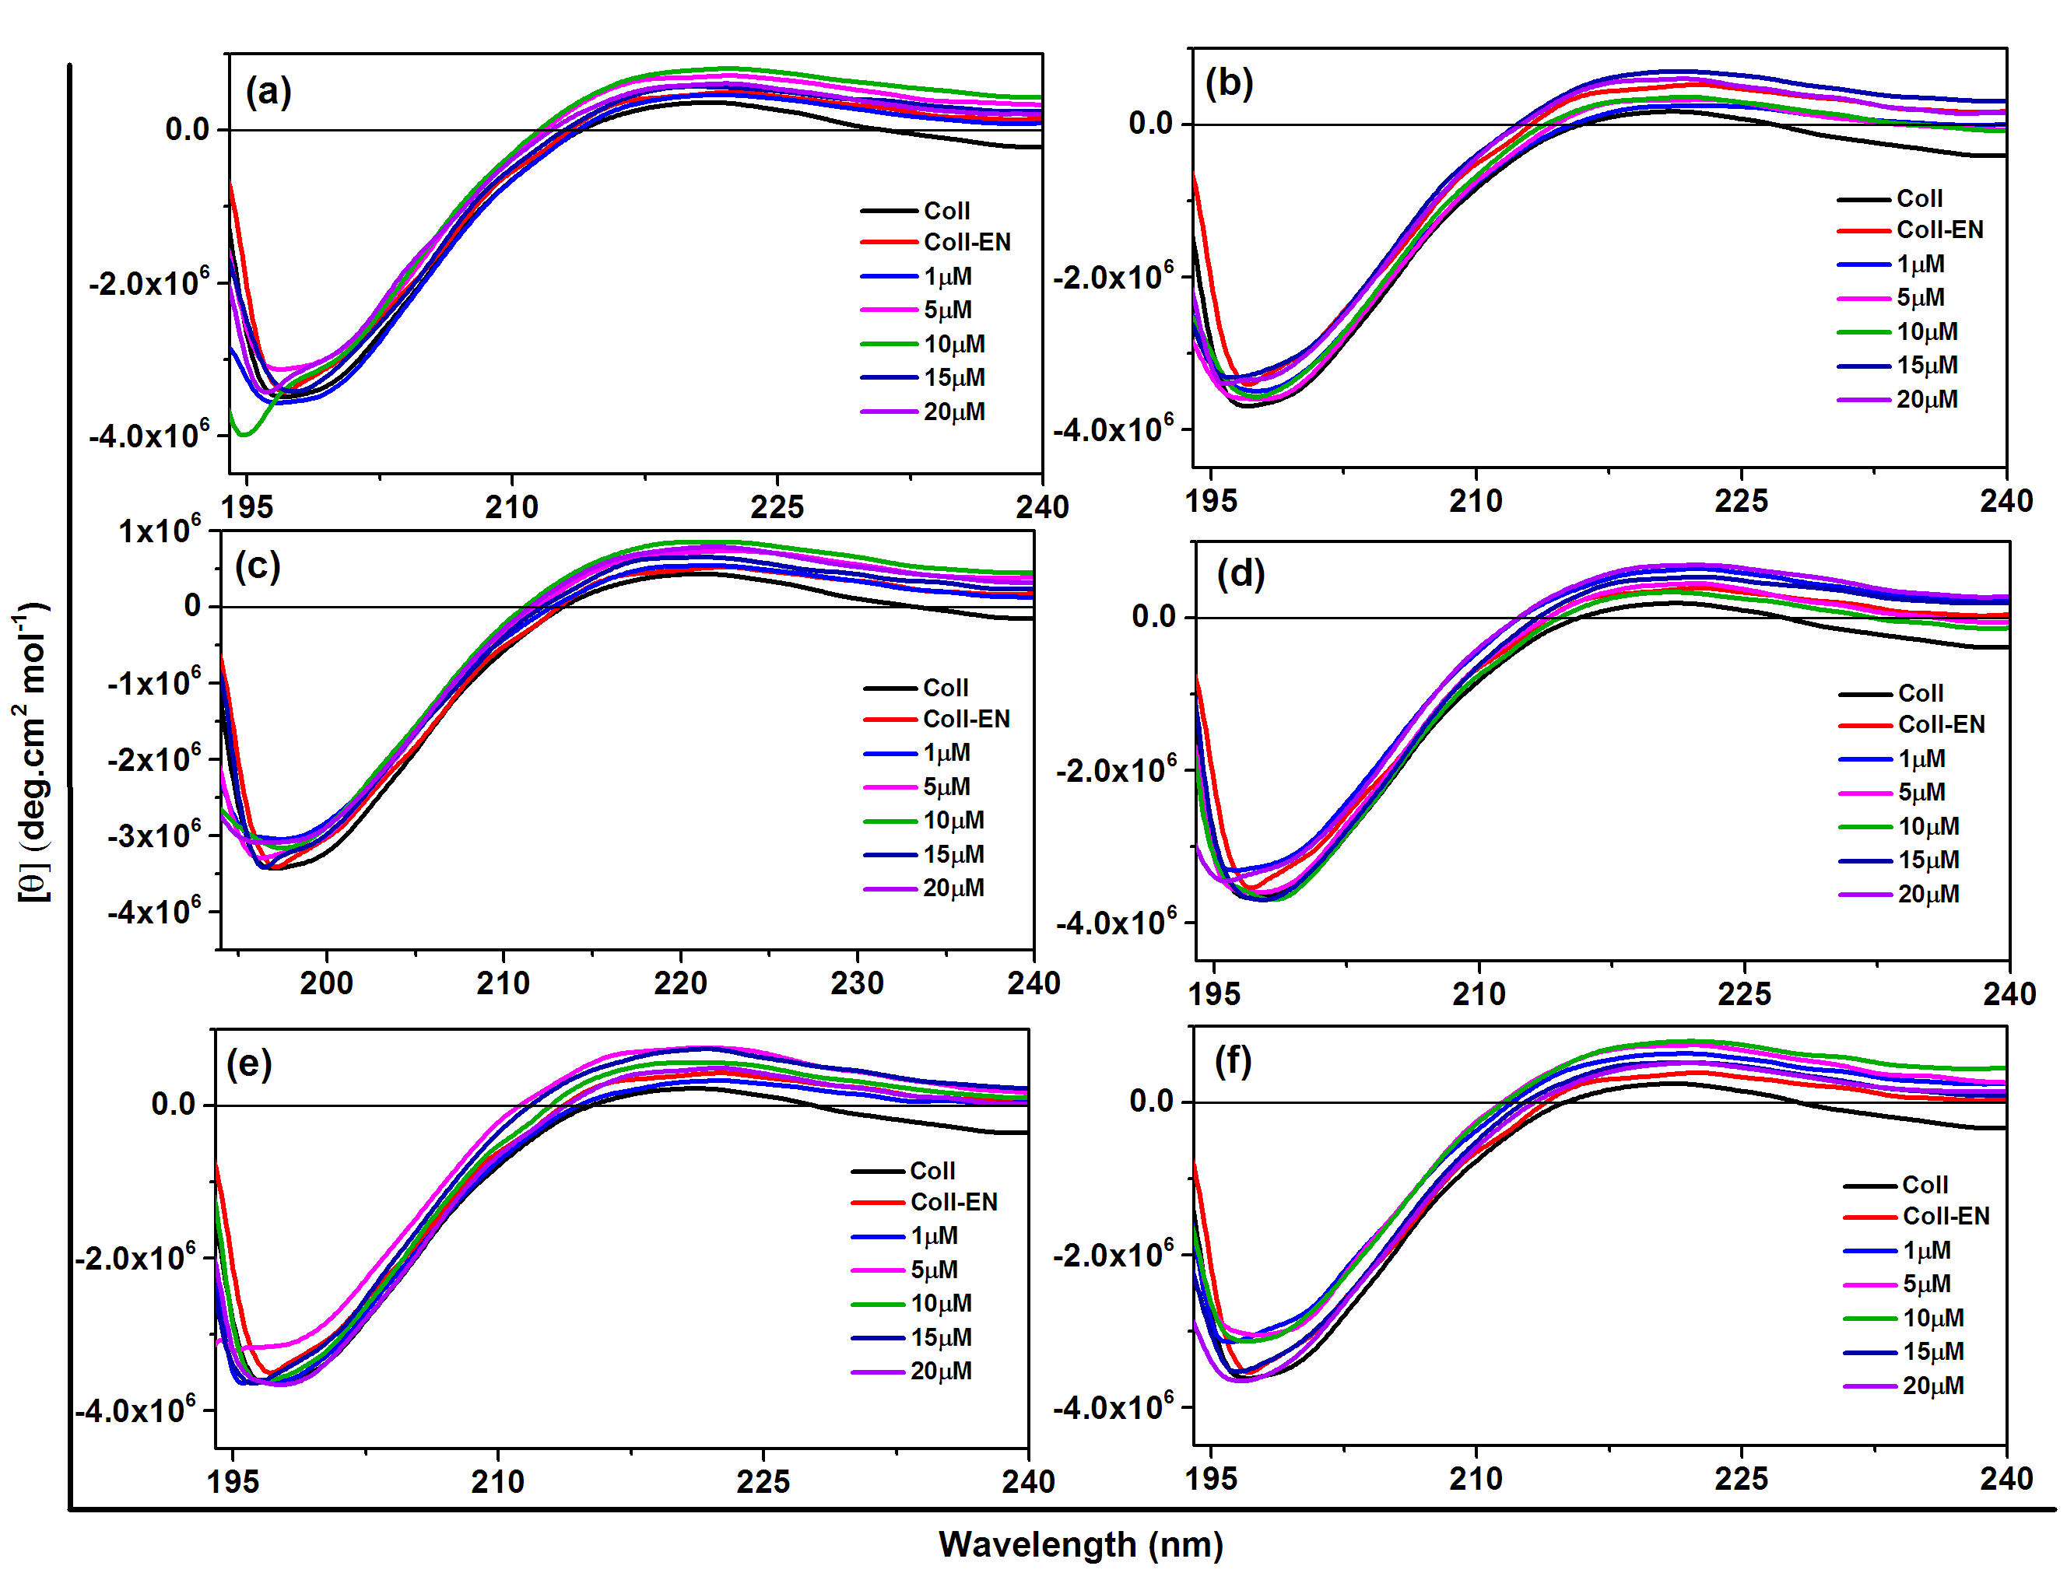

Fig. S2.The CD spectrum of collagen interact with different concentration of a) TES-PAMAM -G₃ b) ZnO-TES-PAMAM -G₃ c) TiO₂-TES-PAMAM -G₃d) Fe₃O₄-TES-PAMAM -G₃ e) CeO₂-TES-PAMAM -G₃ and f) SiO₂-TES-PAMAM -G₃

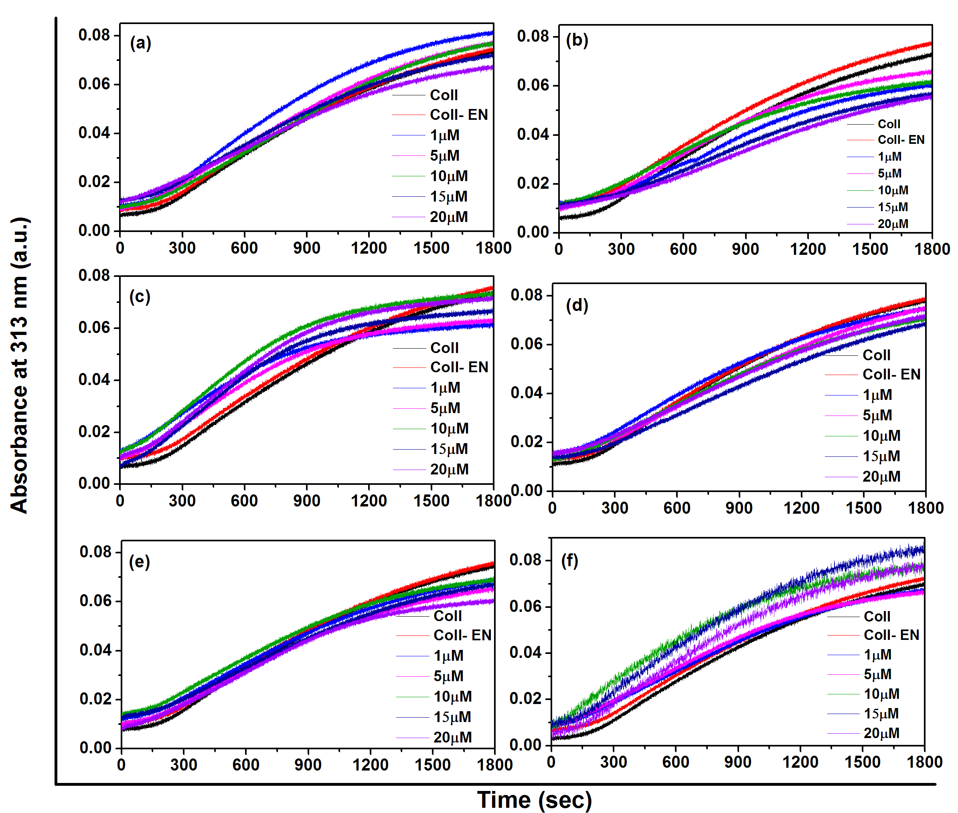

Fig. S3. Self-assemble processes of collagen with different concentration of a) TES-PAMAM -G₃ b) ZnO -TES-PAMAM -G₃ c) TiO₂-TES-PAMAM -G₃ d) Fe₃O₄-TES-PAMAM -G₃ e) CeO₂-TES-PAMAM -G₃and f) SiO₂-TES-PAMAM -G₃

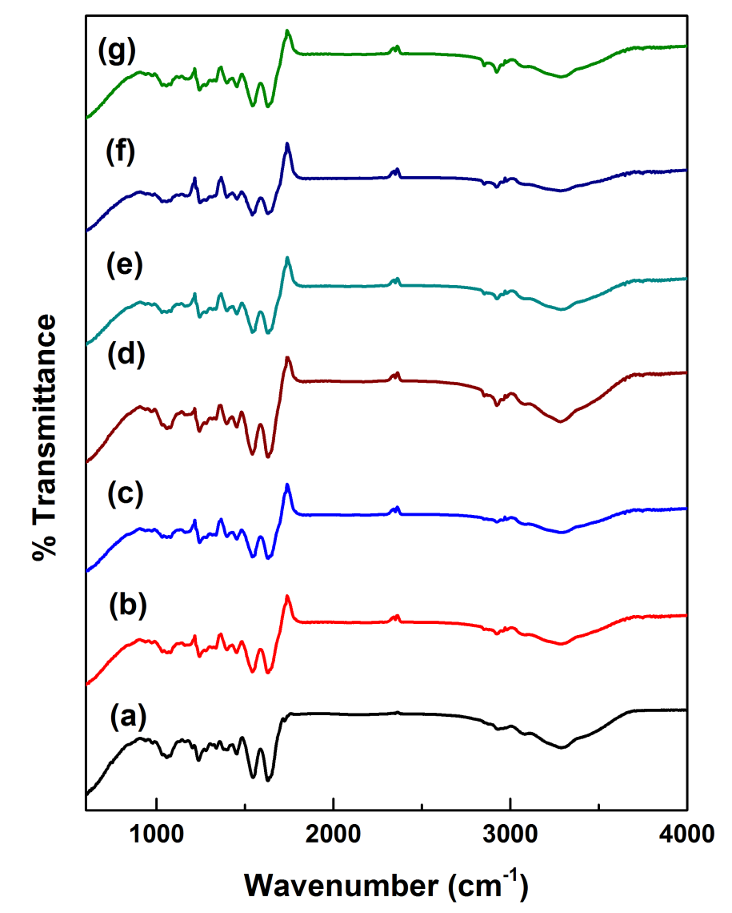

Fig. S4.The FTIR spectrum of a) collagen, b) TES-PAMAM -G₃-collagen, c) ZnO -TES-PAMAM -G₃-collagen d) TiO₂-TES-PAMAM -G₃-collagen e) Fe₃O₄-TES-PAMAM -G₃-collagen f) CeO₂ -TES-PAMAM -G₃-collagen and g) SiO₂-TES-PAMAM -G₃- collagen scaffolds

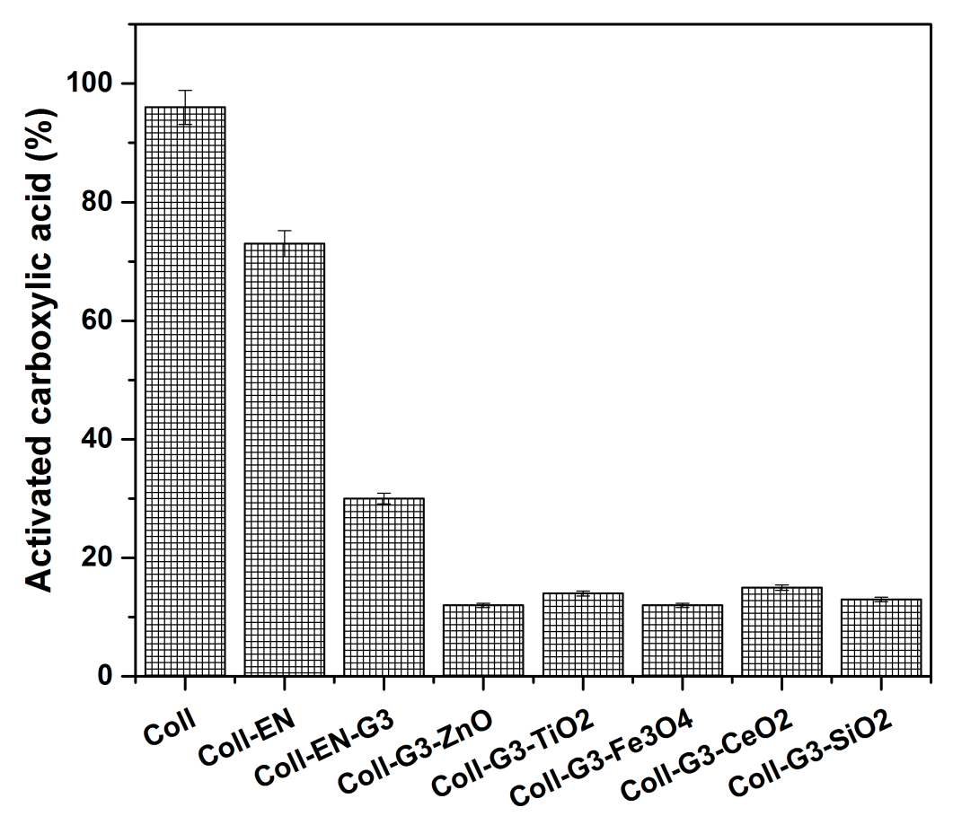

Fig. S5.Percentage of the activated carboxylic group in EDC-NHS, TES-PAMAM-G₃, and MOs-TES-PAMAM-G₃NPscross-linked collagen scaffolds

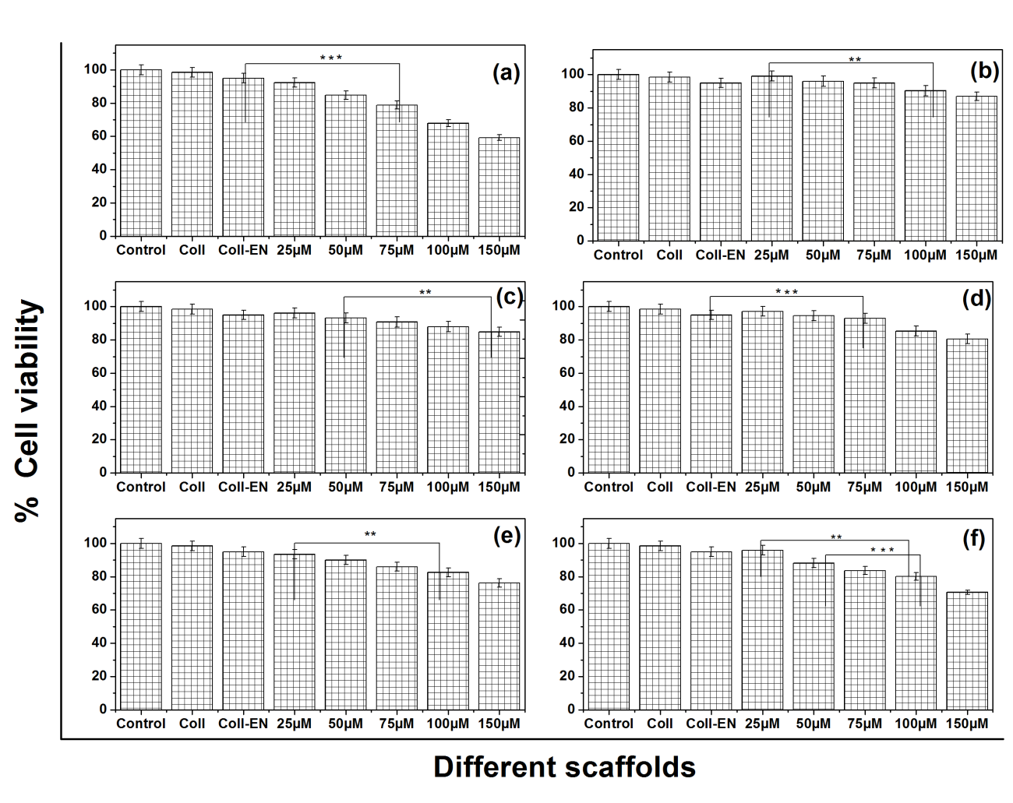

Fig. S6.MTT assay for metal oxide nanoparticle mediated scaffolds such as a) TES-PAMAM -G₃-collagen, b) ZnO-TES-PAMAM -G₃-collagen c) TiO₂-TES-PAMAM -G₃-collagen d) Fe₃O₄-TES-PAMAM -G₃-collagen e) CeO₂-TES-PAMAM -G₃-collagen f) SiO₂-TES-PAMAM -G₃- collagen compared with collagen scaffold, collagen-EDC-NHS and control at varying concentration of functionalized metal oxide nanoparticles.

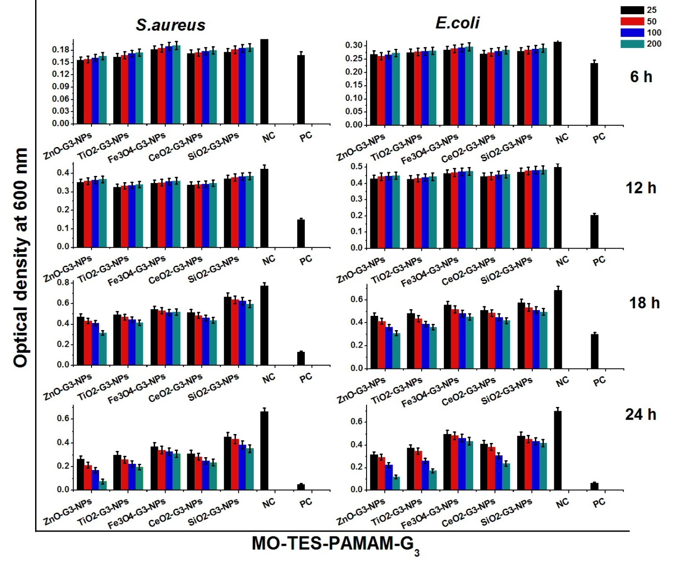
Fig. S7. Antibacterial activity of TES-PAMAM-G₃ dendrimer functionalized different metal oxides nanoparticle (MO-TES-PAMAM-G₃ NPs, 25, 50, 100 and 200 µg/mL) against S.aureus and E.coli by turbidity assay.

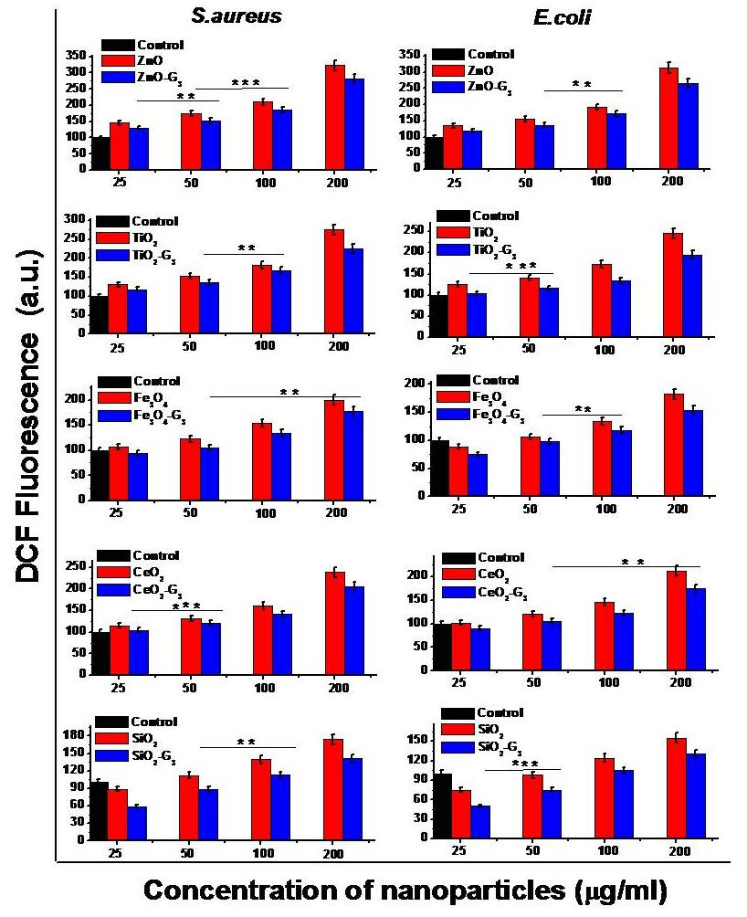
Fig. S8 Quantification of intracellular ROS production by bacterial strains after 24h treatment with different concentration of metal oxides and dendrimer functionalized metal oxide nanoparticle using DCFH-DA probe. The results are represented as mean the fluorescencent intensity ± SD (n=3). ** represents p< 0.03, *** represent p < 0.001.

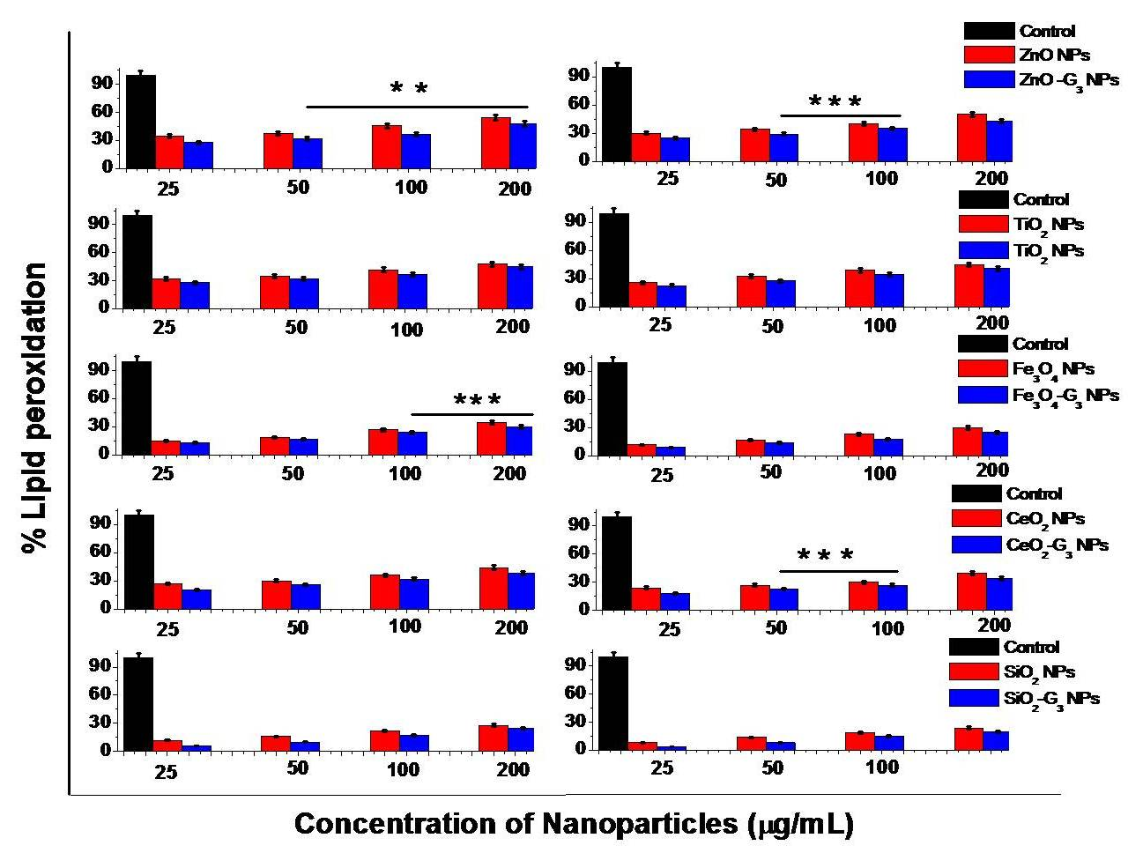
Fig. S9 Quantification of MDA production in bacterial strains after 24h treatment with different concentration of metal oxides and dendrimer functionalized metal oxide nanoparticle. ** represents p< 0.03, *** represent p < 0.003

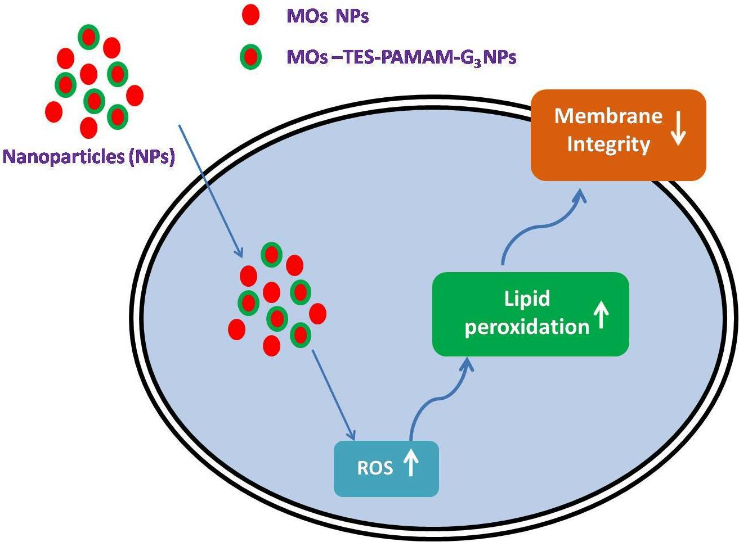

Fig. S10 Possible mechanism of antibacterial activities exhibited by MOs and MOs-TES - PAMAM- G₃ NPs

Table 1 Crystal structure, size and lattice constant of synthesized metal oxide nanoparticles
Nanoparticle | Crystallite structure and Phase group | Lattice Constant (Aº) | The crystallite size(nm)
ZnO | Hexagonal with wurzite (P6₃mc) | a=3.2508 and c=5.2069 | 4
TiO₂ | Tetragonal (I4₁/amd) | a = 3.784 and c=9.515 | 7
Fe₃O₄ | Cubic (Fd₃m) | a = 8.39 | 11
CeO₂ | Cubic fluorite (Fm3m) | a = 5.411 | 9
SiO₂ | Hexagonal | a = 4.913 and c=5.405 | 7

Table 2. Hydrodynamic size and zeta potential of dendrimer functionalized different metal oxide nanoparticles
Types of TES-PAMAM-G₃ MO NPs | Hydrodynamic radius (d.nm) | PDI | Zeta Potential (ζ)  (mV)
TES-PAMAM-G₃ | 9.0 | 0.247 | +14.37
ZnO | 14 | 0.346 | +30.60
TiO₂ | 17 | 0.375 | +27.00
Fe₃O₄ | 25 | 0.154 | +15.60
CeO₂ | 20 | 0.398 | +23.45
SiO₂ | 12 - 23 | 0.339 | +12.60

Table 3. Mechanical strength of functionalized nanoparticle cross-linked collagen scaffold

Sample  Concentration | Lag(t) (sec)
Sample  Concentration | Collagen- 144 sec: Collagen-EDC-NHS-14 sec
Sample  Concentration | TES-PAMAM  (G₃) | ZnO-G₃ | TiO₂-G₃ | Fe₃O₄-G₃ | CeO₂-G₃ | SiO₂-G₃
1 μM | 94 | 76 | 55 | 75 | 68 | 80
5 μM | 74 | 62 | 52 | 62 | 58 | 56
10 μM | 70 | 59 | 46 | 53 | 53 | 50
15 μM | 68 | 48 | 40 | 45 | 49 | 35
20 μM | 28 | 30 | 34 | 41 | 43 | 25

Table 4. Nucleation time of collagen with EDC-NHS, TES-PAMAM-G_{3,} and MOs-TES-PAMAM-G₃ NPs during the self-assembly process.

Scaffold | Load | Elongation (%) | Tensile Strength  (MPa) | Young’s Modulus  (MPa)
Coll | 0.82 | 8.36 | 0.76±0.4 | 7.71±0.3
Coll-EN | 1.33 | 1.88 | 2.21±0.1 | 90.00±0.8
Coll-EN-G₃ | 7.87 | 6.67 | 10.93±0.7 | 181.00±0.5
Coll-EN-G₃-ZnO | 7.63 | 5.36 | 11.56±0.9 | 273.14±0.2
Coll-EN-G₃-TiO₂ | 3.60 | 4.58 | 5.54±0.5 | 135.30±1.0
Coll-EN-G₃-Fe₃O₄ | 4.78 | 5.31 | 5.68±0.2 | 100.01±0.3
Coll-EN-G₃-CeO₂ | 2.99 | 3.65 | 2.84±0.9 | 76.49±0.5
Coll-EN-G₃-SiO₂ | 2.48 | 1.69 | 5.51±0.6 | 236.00±0.2

Table 5. Release of metal ions from nanoparticle mediated collagen based scaffolds

Scaffold | Metal Line Intensity | Concentration  (ppm)
Control  Collagen  Collagen-G₃  Collagen-G₃-ZnO  Collagen-G₃-TiO₂  Collagen-G₃-Fe₃O₄  Collagen-G₃-CeO₂  Collagen-G₃-SiO₂ | -  -  -  158153  87614  76036  116761  111490 | -  -  -  0.1245  0.1096  0.9117  0.0617  0.1517

References
1. Vedhanayagam, M.; Unni Nair, B.; Sreeram, K. J., (2018),Collagen-ZnO scaffolds for wound healing applications: role of dendrimer functionalization and nanoparticle morphology. ACS Appl. Bio Mater., 1 (6), 1942-1958.
2. Nikolić, B.; Vasiljević, B.; Mitić-Ćulafić, D.; VUKOVIĆ-GAČIĆ, B.; KNEŽEVIĆ-VUKČEVIĆ, J.; LESJAK, M.; MIMICA DUKIĆ, N., (2016), Screening of the antibacterial effect of Juniperus sibirica and Juniperus sabina essential oils in a microtitre platebased MIC assay. Botanica Serbica, 40 (1).
3. Adams, L. K.; Lyon, D. Y.; Alvarez, P. J. J., (2006),Comparative eco-toxicity of nanoscale TiO2, SiO2, and ZnO water suspensions. Water Res.,40 (19), 3527-3532.
4. Li, Y.; Zhang, W.; Niu, J.; Chen, Y., (2012),Mechanism of photogenerated reactive oxygen species and correlation with the antibacterial properties of engineered metal-oxide nanoparticles. ACS Nano, 6 (6), 5164-5173.
5. Lyon, D. Y.; Brunet, L.; Hinkal, G. W.; Wiesner, M. R.; Alvarez, P. J. J., (2008),Antibacterial activity of fullerene water suspensions (nC60) is not due to ROS-mediated damage. Nano letters,8 (5), 1539-1543.
6. Braydich-Stolle, L. K.; Schaeublin, N. M.; Murdock, R. C.; Jiang, J.; Biswas, P.; Schlager, J. J.; Hussain, S. M., (2009),Crystal structure mediates mode of cell death in TiO 2 nanotoxicity. J. Nanoparticle Res., 11 (6), 1361-1374.
7. Mohammadi, M. R.; Malkovskiy, A. V.; Jothimuthu, P.; Kim, K.-M.; Parekh, M.; Inayathullah, M.; Zhuge, Y.; Rajadas, J., (2018),PEG/dextran double layer influences Fe ion release and colloidal stability of iron oxide nanoparticles. Sci. Rep., 8 (1), 1-11.
8. Cho, S.; Lee, B.; Park, W.; Huang, X.; Kim, D.-H., (2018),Photoperiodic flower mimicking metallic nanoparticles for image-guided medicine applications. ACS Appl.Mater. Interfaces, 10 (33), 27570-27577.
9. Wei, X.; Zhu, G.; Fang, J.; Chen, J., (2013),Synthesis, characterization, and photocatalysis of well-dispersible phase-pure anatase TiO2 nanoparticles. Int. J.Photoenergy, 2013.
10. Kumar, A.; Pandey, A. K.; Singh, S. S.; Shanker, R.; Dhawan, A., (2011), Engineered ZnO and TiO2 nanoparticles induce oxidative stress and DNA damage leading to reduced viability of Escherichia coli. Free Rad. Biol.Med., 51 (10), 1872-1881.

