Supplementary Table 1. ICD-10 codes with description
Cancer site | ICD-10 code | Description
Liver | C78.7 | Secondary malignant neoplasm of liver - Malignant neoplasms
Primary cancer sites
Esophagus | C15 | Malignant neoplasm of esophagus
Stomach | C16 | Malignant neoplasm of stomach
Colon | C18 | Malignant neoplasm of colon
Rectum | C20 | Malignant neoplasm of rectum
Pancreas | C25 | Malignant neoplasm of pancreas
Bronchus and lung | C34 | Malignant neoplasm of bronchus and lung
Breast | C50 | Malignant neoplasm of breast
Ovary | C56 | Malignant neoplasm of ovary
Prostate | C61 | Malignant neoplasm of prostate
Kidney | C64 | Malignant neoplasm of kidney, except renal pelvis

Supplementary Table 2. Annual deaths stratified by gender, race, region, urbanization status, and 10-year age groups
Year | Overall | Female | Male | Hispanics | NH Asian or Pacific Islander | NH Black or African American | NH White | NH American Indian or Alaska Native | Northeast | Midwest | South | West | Urban | Rural | 45-54 years | 55-64 years | 65-74 years | 75-84 years | 85+ years
1999 | 22667 | 11302 | 11365 | 874 | 392 | 2557 | 18702 | 82 | 4956 | 5859 | 8073 | 3779 | 18211 | 4456 | 2237 | 4105 | 6923 | 6806 | 2596
2000 | 22028 | 10862 | 11166 | 929 | 389 | 2453 | 18126 | 74 | 4713 | 5476 | 8180 | 3659 | 17531 | 4497 | 2253 | 4046 | 6547 | 6539 | 2643
2001 | 21335 | 10537 | 10798 | 953 | 408 | 2392 | 17443 | 83 | 4545 | 5543 | 7722 | 3525 | 16924 | 4411 | 2283 | 3961 | 6214 | 6378 | 2499
2002 | 20610 | 10115 | 10495 | 959 | 424 | 2199 | 16887 | 86 | 4279 | 5387 | 7595 | 3349 | 16293 | 4317 | 2134 | 4092 | 5783 | 6117 | 2484
2003 | 19602 | 9660 | 9942 | 944 | 392 | 2143 | 16001 | 73 | 4142 | 5036 | 7170 | 3254 | 15434 | 4168 | 2148 | 3869 | 5368 | 5894 | 2323
2004 | 18727 | 9177 | 9550 | 902 | 398 | 2045 | 15265 | 78 | 3856 | 4773 | 6854 | 3244 | 14764 | 3963 | 2011 | 3905 | 5011 | 5455 | 2345
2005 | 18467 | 9052 | 9415 | 869 | 416 | 2080 | 14992 | 82 | 3692 | 4691 | 6824 | 3260 | 14534 | 3933 | 2030 | 3804 | 4949 | 5355 | 2329
2006 | 17732 | 8703 | 9029 | 978 | 405 | 1979 | 14265 | 73 | 3468 | 4442 | 6606 | 3216 | 14103 | 3629 | 1830 | 3666 | 4722 | 5081 | 2433
2007 | 17219 | 8481 | 8738 | 937 | 485 | 1958 | 13739 | 86 | 3196 | 4152 | 6547 | 3324 | 13633 | 3586 | 1934 | 3754 | 4519 | 4804 | 2208
2008 | 16778 | 8173 | 8605 | 958 | 411 | 1937 | 13347 | 92 | 3069 | 4017 | 6476 | 3216 | 13292 | 3486 | 1894 | 3639 | 4555 | 4536 | 2154
2009 | 17401 | 8406 | 8995 | 1132 | 508 | 2014 | 13636 | 81 | 2930 | 3840 | 6942 | 3689 | 13928 | 3473 | 1884 | 3959 | 4694 | 4584 | 2280
2010 | 17886 | 8568 | 9318 | 1200 | 579 | 2046 | 13928 | 96 | 2972 | 3896 | 6958 | 4060 | 14420 | 3466 | 1942 | 4137 | 4794 | 4605 | 2408
2011 | 18703 | 9095 | 9608 | 1355 | 581 | 2205 | 14442 | 93 | 3094 | 4282 | 7164 | 4163 | 15024 | 3679 | 1988 | 4308 | 5005 | 4752 | 2650
2012 | 19190 | 9234 | 9956 | 1428 | 552 | 2192 | 14880 | 92 | 3152 | 4111 | 7588 | 4339 | 15373 | 3817 | 1955 | 4530 | 5389 | 4773 | 2543
2013 | 20016 | 9490 | 10526 | 1532 | 620 | 2319 | 15398 | 96 | 2993 | 4156 | 8369 | 4498 | 16124 | 3892 | 1989 | 4677 | 5739 | 4931 | 2680
2014 | 21588 | 10360 | 11228 | 1630 | 656 | 2411 | 16715 | 124 | 2898 | 4637 | 9095 | 4958 | 17439 | 4149 | 2050 | 5072 | 6438 | 5306 | 2722
2015 | 23979 | 11431 | 12548 | 1806 | 832 | 2646 | 18485 | 148 | 3295 | 5289 | 9815 | 5580 | 19267 | 4712 | 2208 | 5690 | 7373 | 5669 | 3039
2016 | 27404 | 13419 | 13985 | 2166 | 912 | 3220 | 20885 | 148 | 3423 | 5970 | 11551 | 6460 | 22091 | 5313 | 2510 | 6697 | 8353 | 6484 | 3360
2017 | 28795 | 13962 | 14833 | 2296 | 1016 | 3124 | 22143 | 164 | 3329 | 6475 | 12072 | 6919 | 23164 | 5631 | 2533 | 6849 | 8956 | 6902 | 3555
2018 | 30750 | 14947 | 15803 | 2553 | 1165 | 3404 | 23387 | 187 | 3387 | 6975 | 12737 | 7651 | 24876 | 5874 | 2601 | 7271 | 9782 | 7439 | 3657
2019 | 32040 | 15521 | 16519 | 2746 | 1228 | 3446 | 24409 | 170 | 3577 | 7333 | 13201 | 7929 | 25968 | 6072 | 2614 | 7354 | 10143 | 8069 | 3860
2020 | 33723 | 16436 | 17287 | 2876 | 1325 | 3676 | 25603 | 203 | 4023 | 7851 | 13722 | 8127 | 27178 | 6545 | 2767 | 7634 | 10830 | 8496 | 3996
2021 | 35128 | 17254 | 17874 | 2909 | 1424 | 3718 | 26701 | 157 | 4141 | 8042 | 14276 | 8669 | 28414 | 6714 | 2792 | 7864 | 11490 | 8812 | 4170
2022 | 36953 | 17873 | 19080 | 3051 | 1411 | 3942 | 28106 | 180 | 4302 | 8618 | 15229 | 8804 | 29833 | 7120 | 2835 | 7954 | 12004 | 9729 | 4431
2023 | 38611 | 18716 | 19895 | 3159 | 4234 | 4234 | 29312 | 206 | 4570 | 8738 | 16375 | 8928 | 31243 | 7368 | 2940 | 7910 | 12667 | 10511 | 13184
Total | 597332 | 290774 | 306558 | 41142 | 21163 | 66340 | 466797 | 2954 | 92002 | 139589 | 237141 | 128600 | 479061 | 118271 | 56362 | 130747 | 178248 | 158027 | 82549

Supplementary Table 3. Annual age-adjusted mortality rates per 100,000 stratified by gender, race, region, and urbanization status, and crude mortality rates per 100,000 stratified by 10-year age groups
Year | Overall | Female | Male | Hispanics | NH Asian or Pacific Islander | NH Black or African American | NH White | NH American Indian or Alaska Native | Northeast | Midwest | South | West | Urban | Rural | 45-54 years | 55-64 years | 65-74 years | 75-84 years | 85+ years
1999 | 23.8 | 20.6 | 28.4 | 17.6 | 16.5 | 31.1 | 23.6 | 21.0 | 24.9 | 26.0 | 23.8 | 19.8 | 23.5 | 25.0 | 6.1 | 17.3 | 37.6 | 55.7 | 62.5
2000 | 22.8 | 19.5 | 27.4 | 17.8 | 15.3 | 29.4 | 22.7 | 16.2 | 23.5 | 24.1 | 23.9 | 18.8 | 22.3 | 25.0 | 6.0 | 16.7 | 35.6 | 52.9 | 62.3
2001 | 21.7 | 18.7 | 25.9 | 17.2 | 14.8 | 27.9 | 21.6 | 17.3 | 22.4 | 24.1 | 22.0 | 17.6 | 21.1 | 24.3 | 5.8 | 15.8 | 33.8 | 50.6 | 57.9
2002 | 20.5 | 17.6 | 24.7 | 16.4 | 14.2 | 25.1 | 20.6 | 16.3 | 20.8 | 23.1 | 21.2 | 16.3 | 19.9 | 23.4 | 5.3 | 15.3 | 31.4 | 47.9 | 56.9
2003 | 19.2 | 16.6 | 22.8 | 15.2 | 12.7 | 23.6 | 19.2 | 14.2 | 19.9 | 21.3 | 19.6 | 15.5 | 18.5 | 22.3 | 5.3 | 13.8 | 29.0 | 45.7 | 52.0
2004 | 18.0 | 15.5 | 21.5 | 14.1 | 12.3 | 22.1 | 18.1 | 14.6 | 18.3 | 19.9 | 18.3 | 15.0 | 17.4 | 20.9 | 4.8 | 13.3 | 26.8 | 42.0 | 51.6
2005 | 17.4 | 15.1 | 20.7 | 12.6 | 12.0 | 21.7 | 17.5 | 14.7 | 17.3 | 19.3 | 17.8 | 14.7 | 16.7 | 20.5 | 4.8 | 12.4 | 26.2 | 41.0 | 49.6
2006 | 16.4 | 14.2 | 19.4 | 13.5 | 11.4 | 20.0 | 16.4 | 13.5 | 16.1 | 18.0 | 16.8 | 14.2 | 15.9 | 18.5 | 4.2 | 11.5 | 24.6 | 38.8 | 50.0
2007 | 15.5 | 13.6 | 18.2 | 12.3 | 12.4 | 19.0 | 15.6 | 14.8 | 14.6 | 16.5 | 16.2 | 14.3 | 15.0 | 18.0 | 4.4 | 11.3 | 22.9 | 36.7 | 43.8
2008 | 14.9 | 12.9 | 17.4 | 12.0 | 10.1 | 18.4 | 14.9 | 14.4 | 13.8 | 15.7 | 15.7 | 13.4 | 14.3 | 17.3 | 4.3 | 10.7 | 22.2 | 34.7 | 41.5
2009 | 15.0 | 13.0 | 17.8 | 13.4 | 11.8 | 18.7 | 14.9 | 11.9 | 13.1 | 14.7 | 16.3 | 14.9 | 14.6 | 16.8 | 4.2 | 11.2 | 22.1 | 35.2 | 42.5
2010 | 15.2 | 13.1 | 18.1 | 13.5 | 13.0 | 18.4 | 15.1 | 14.5 | 13.0 | 14.7 | 16.1 | 16.1 | 14.9 | 16.6 | 4.3 | 11.3 | 22.1 | 35.3 | 43.8
2011 | 15.5 | 13.5 | 18.1 | 14.4 | 12.1 | 19.1 | 15.3 | 13.9 | 13.3 | 15.8 | 16.1 | 15.9 | 15.1 | 17.4 | 4.4 | 11.3 | 22.3 | 36.1 | 46.2
2012 | 15.5 | 13.4 | 18.1 | 14.2 | 10.8 | 18.4 | 15.5 | 12.4 | 13.3 | 15.0 | 16.5 | 16.0 | 15.0 | 17.8 | 4.4 | 11.7 | 22.5 | 36.0 | 43.2
2013 | 15.7 | 13.5 | 18.7 | 14.4 | 11.6 | 18.7 | 15.7 | 12.6 | 12.4 | 14.9 | 17.7 | 16.2 | 15.3 | 17.9 | 4.5 | 11.9 | 22.8 | 36.7 | 44.4
2014 | 16.6 | 14.5 | 19.3 | 14.4 | 11.4 | 18.6 | 16.8 | 15.4 | 11.9 | 16.2 | 18.7 | 17.3 | 16.2 | 18.7 | 4.7 | 12.7 | 24.4 | 38.8 | 44.2
2015 | 17.9 | 15.6 | 20.9 | 15.1 | 13.8 | 20.0 | 18.2 | 18.8 | 13.2 | 18.2 | 19.6 | 18.8 | 17.3 | 21.0 | 5.1 | 13.9 | 26.8 | 40.7 | 48.3
2016 | 20.1 | 18.0 | 22.7 | 17.3 | 14.1 | 23.5 | 20.3 | 17.5 | 13.6 | 20.2 | 22.4 | 21.2 | 19.4 | 23.4 | 5.9 | 16.2 | 29.2 | 45.6 | 52.7
2017 | 20.6 | 18.3 | 23.5 | 17.5 | 14.9 | 22.2 | 21.1 | 18.7 | 12.8 | 21.6 | 23.0 | 22.2 | 19.8 | 24.5 | 6.0 | 16.3 | 30.2 | 46.9 | 55.0
2018 | 21.5 | 19.2 | 24.5 | 18.6 | 16.4 | 23.6 | 22.0 | 20.2 | 13.0 | 22.7 | 23.5 | 24.0 | 20.8 | 25.0 | 6.2 | 17.2 | 32.1 | 48.3 | 55.9
2019 | 22.0 | 19.7 | 25.1 | 19.1 | 16.7 | 23.2 | 22.7 | 18.0 | 13.5 | 23.6 | 23.9 | 24.4 | 21.4 | 25.5 | 6.4 | 17.3 | 32.2 | 50.5 | 58.4
2020 | 22.8 | 20.5 | 25.8 | 19.2 | 17.0 | 24.2 | 23.5 | 20.4 | 14.9 | 25.0 | 24.3 | 24.4 | 21.9 | 27.3 | 6.9 | 18.0 | 33.3 | 51.6 | 60.0
2021 | 23.8 | 21.7 | 26.5 | 18.8 | 18.9 | 24.7 | 25.0 | 17.2 | 15.2 | 25.7 | 25.4 | 26.4 | - | - | 6.9 | 18.4 | 34.1 | 54.4 | 69.8
2022 | 24.3 | 21.8 | 27.7 | 18.9 | 17.5 | 25.6 | 25.7 | 18.9 | 15.4 | 26.8 | 26.4 | 25.9 | - | - | 7.0 | 18.9 | 35.5 | 55.5 | 68.3
2023 | 25.1 | 22.6 | 28.2 | 18.8 | 17.7 | 27.1 | 26.6 | 21.1 | 16.3 | 27.0 | 27.9 | 25.8 | - | - | 7.3 | 18.9 | 36.5 | 57.2 | 70.7
CDC suppresses the counts of fewer than 10 in CDC WONDER data to protect confidentiality, and death rates are marked unreliable for a count less than 20. Our data did have suppressed or unreliable data for subgroups with lower counts. This limitation has been indicated in the manuscript with “-” in the tables and dotted lines in figures.

Supplementary Table 4. Annual deaths and age-adjusted mortality rates (AAMR) per 100,000 associated with secondary malignant neoplasm of liver (SMNL) stratified by primary cancer sites
Year | Esophagus |  | Stomach |  | Colon |  | Rectum |  | Pancreas |  | Bronchus and lung |  | Breast* |  | Ovary* |  | Prostate** |  | Kidney
 | Deaths (n = 14880) | AAMR | Deaths (n = 14331) | AAMR | Deaths (n = 100846) | AAMR | Deaths (n = 13831) | AAMR | Deaths (n = 68142) | AAMR | Deaths (n = 104893) | AAMR | Deaths (n = 55382) | AAMR | Deaths (n = 8192) | AAMR | Deaths (n = 17829) | AAMR | Deaths (n = 11892) | AAMR
1999 | 404 | 0.4 | 672 | 0.7 | 5288 | 5.6 | 541 | 0.6 | 1746 | 1.8 | 3939 | 4.1 | 1940 | 3.7 | 204 | 0.4 | 516 | 1.4 | 516 | 0.4
2000 | 414 | 0.4 | 683 | 0.7 | 5053 | 5.2 | 487 | 0.5 | 1684 | 1.7 | 3890 | 4.0 | 1854 | 3.5 | 207 | 0.4 | 508 | 1.4 | 508 | 0.4
2001 | 392 | 0.4 | 594 | 0.6 | 4712 | 4.8 | 465 | 0.5 | 1725 | 1.8 | 3834 | 3.9 | 1814 | 3.3 | 220 | 0.4 | 545 | 1.4 | 545 | 0.4
2002 | 403 | 0.4 | 606 | 0.6 | 4341 | 4.3 | 449 | 0.5 | 1705 | 1.7 | 3608 | 3.6 | 1850 | 3.3 | 216 | 0.4 | 527 | 1.3 | 527 | 0.3
2003 | 400 | 0.4 | 504 | 0.5 | 4157 | 4.1 | 396 | 0.4 | 1601 | 1.6 | 3439 | 3.4 | 1810 | 3.2 | 206 | 0.3 | 484 | 1.2 | 484 | 0.4
2004 | 405 | 0.4 | 508 | 0.5 | 3462 | 3.3 | 388 | 0.4 | 1668 | 1.6 | 3288 | 3.2 | 1827 | 3.2 | 209 | 0.3 | 444 | 1.1 | 444 | 0.4
2005 | 425 | 0.4 | 496 | 0.5 | 3532 | 3.4 | 386 | 0.4 | 1602 | 1.5 | 3109 | 2.9 | 1727 | 2.9 | 181 | 0.3 | 464 | 1.1 | 464 | 0.3
2006 | 375 | 0.3 | 396 | 0.4 | 3354 | 3.1 | 348 | 0.3 | 1595 | 1.5 | 3027 | 2.8 | 1560 | 2.6 | 201 | 0.3 | 472 | 1.1 | 472 | 0.3
2007 | 379 | 0.3 | 441 | 0.4 | 3144 | 2.8 | 347 | 0.3 | 1538 | 1.4 | 2910 | 2.7 | 1619 | 2.6 | 175 | 0.3 | 422 | 0.9 | 422 | 0.3
2008 | 359 | 0.3 | 389 | 0.4 | 2913 | 2.6 | 355 | 0.3 | 1547 | 1.4 | 2927 | 2.6 | 1534 | 2.5 | 205 | 0.3 | 431 | 0.9 | 431 | 0.3
2009 | 386 | 0.4 | 410 | 0.4 | 2969 | 2.6 | 387 | 0.3 | 1590 | 1.4 | 3049 | 2.6 | 1651 | 2.6 | 206 | 0.3 | 454 | 1.0 | 454 | 0.3
2010 | 415 | 0.3 | 429 | 0.4 | 2967 | 2.5 | 366 | 0.3 | 1749 | 1.5 | 3254 | 2.8 | 1629 | 2.5 | 204 | 0.3 | 464 | 1.0 | 464 | 0.3
2011 | 434 | 0.4 | 448 | 0.4 | 3018 | 2.5 | 375 | 0.3 | 1899 | 1.6 | 3454 | 2.9 | 1705 | 2.6 | 229 | 0.3 | 539 | 1.1 | 539 | 0.3
2012 | 452 | 0.3 | 452 | 0.4 | 3070 | 2.5 | 410 | 0.3 | 2009 | 1.6 | 3523 | 2.9 | 1830 | 2.7 | 256 | 0.4 | 566 | 1.1 | 566 | 0.3
2013 | 504 | 0.4 | 521 | 0.4 | 3088 | 2.4 | 405 | 0.3 | 2147 | 1.7 | 3654 | 2.9 | 1882 | 2.7 | 265 | 0.4 | 576 | 1.1 | 576 | 0.3
2014 | 534 | 0.4 | 492 | 0.4 | 3327 | 2.6 | 488 | 0.4 | 2421 | 1.9 | 3924 | 3.0 | 2022 | 2.8 | 291 | 0.4 | 642 | 1.2 | 642 | 0.4
2015 | 660 | 0.5 | 556 | 0.4 | 3687 | 2.8 | 467 | 0.4 | 2835 | 2.1 | 4408 | 3.3 | 2259 | 3.1 | 348 | 0.5 | 726 | 1.3 | 726 | 0.4
2016 | 764 | 0.6 | 634 | 0.5 | 4331 | 3.2 | 626 | 0.4 | 3437 | 2.5 | 4946 | 3.6 | 2623 | 3.6 | 440 | 0.6 | 865 | 1.5 | 865 | 0.4
2017 | 760 | 0.5 | 651 | 0.5 | 4388 | 3.2 | 671 | 0.5 | 3722 | 2.7 | 5224 | 3.7 | 2736 | 3.6 | 481 | 0.6 | 913 | 1.5 | 913 | 0.4
2018 | 833 | 0.6 | 714 | 0.5 | 4654 | 3.3 | 752 | 0.6 | 4153 | 2.9 | 5390 | 3.7 | 3010 | 4.0 | 513 | 0.7 | 973 | 1.6 | 973 | 0.5
2019 | 961 | 0.7 | 702 | 0.5 | 4725 | 3.3 | 757 | 0.5 | 4442 | 3.0 | 5741 | 3.9 | 3083 | 4.0 | 521 | 0.7 | 1085 | 1.7 | 1085 | 0.5
2020 | 987 | 0.7 | 748 | 0.5 | 4854 | 3.3 | 897 | 0.6 | 4744 | 3.2 | 5853 | 3.9 | 3212 | 4.1 | 578 | 0.7 | 1222 | 1.9 | 1222 | 0.5
2021 | 1016 | 0.7 | 708 | 0.5 | 5079 | 3.5 | 943 | 0.6 | 5166 | 3.5 | 5973 | 4.0 | 3394 | 4.4 | 573 | 0.7 | 1220 | 1.9 | 1220 | 0.5
2022 | 1085 | 0.7 | 769 | 0.5 | 5263 | 3.6 | 1038 | 0.7 | 5495 | 3.6 | 6026 | 3.9 | 3337 | 4.2 | 619 | 0.8 | 1323 | 2.0 | 1323 | 0.5
2023 | 1133 | 0.7 | 808 | 0.6 | 5470 | 3.7 | 1087 | 0.7 | 5922 | 3.8 | 6503 | 4.2 | 3474 | 4.4 | 644 | 0.8 | 1448 | 2.1 | 1448 | 0.5
* Only breast and ovarian cancers in females have been included.
** Only males were selected for prostate cancer.

Supplementary Table 5. Annual percentage changes (APC) and average annual percentage changes (AAPC) in age-adjusted mortality rate per 100,000 from 1999-2023 in SMNL-related mortality stratified by primary cancer sites
State | APC Segment 1 | APC Segment 2 | APC Segment 3 | APC Segment 4 | AAPC
Esophagus | 1999-2012 = -1.12 [-3.73 to 0.64] | 2012-2019 = 10.41* [7.18 to 20.98] | 2019-2023 = 0.16 [-7.35 to 4.31] | - | 1999-2023 = 2.33* [1.66 to 3.05]
Stomach | 1999-2008 = -6.90* [-10.38 to -4.80] | 2008-2023 = 2.67* [1.66 to 4.21] | - | - | 1999-2023 = -1.03* [-1.60 to -0.41]
Colon | 1999-2008 = -8.27* [-9.87 to -7.59] | 2008-2013 = -1.39 [-6.30 to 2.75] | 2013-2016 = 8.96* [5.02 to 11.57] | 2016-2023 = 2.30* [0.87 to 3.11] | 1999-2023 = -1.78* [-2.03 to -1.58]
Rectum | 1999-2009 = -7.40* [-10.68 to -5.40] | 2009-2023 = 7.31* [6.10 to 9.26] | - | - | 1999-2023 = 0.91* [0.36 to 1.54]
Pancreas | 1999-2008 = -3.03* [-3.96 to -2.40] | 2008-2013 = 4.03* [1.47 to 6.41] | 2013-2017 = 12.75* [10.90 to 15.31] | 2017-2023 = 5.76* [4.83 to 6.45] | 1999-2023 = 3.12* [2.95 to 3.30]
Bronchus and lung | 1999-2008 = -5.37* [-7.24 to -3.31] | 2008-2014 = 3.05 [-7.29 to 4.59] | 2014-2017 = 6.64* [2.24 to 8.39] | 2017-2023 = 1.65* [0.08 to 2.72] | 1999-2023 = -0.10 [-0.32 to 0.14]
Breast | 1999-2008 = -4.32* [-6.46 to -3.47] | 2008-2013 = 1.39 [-2.71 to 4.72] | 2013-2018 = 8.32* [6.46 to 12.09] | 2018-2023 = 1.79 [-0.37 to 3.13] | 1999-2023 = 0.67* [0.39 to 0.92]
Ovary | 1999-2010 = -2.82* [-4.60 to -1.44] | 2010-2017 = 12.00* [9.90 to 20.98] | 2017-2023 = 3.66* [0.99 to 5.48] | - | 1999-2023 = 2.93* [2.50 to 3.45]
Prostate | 1999-2009 = -4.38* [-6.71 to -2.82] | 2009-2023 = 6.25* [5.50 to 7.31] | - | - | 1999-2023 = 1.68* [1.30 to 2.21]
Kidney, except renal pelvis | 1999-2010 = -3.41* [-5.64 to -1.69] | 2010-2019 = 6.60 [-1.04 to 15.05] | 2019-2023 = -0.11 [-7.79 to 4.38] | - | 1999-2023 = 0.79* [0.20 to 1.35]
“-” here means no more APC segments were available. Statistically significant values have been represented by an asterisk “*”.

Supplementary Table 6. Annual incidence of cancers (without SMNL) from 1999-2021
Year | Esophagus | Stomach | Colon | Rectum | Pancreas | Bronchus and Lung | Breast* | Ovary* | Prostate** | Kidney and Renal Pelvis
1999 | 12984 | 19177 | 106643 | 26171 | 28581 | 186695 | 174382 | 18387 | 197822 | 30041
2000 | 13323 | 19117 | 107848 | 26988 | 29406 | 187877 | 174720 | 18901 | 204362 | 31884
2001 | 13450 | 19045 | 108190 | 27022 | 30115 | 190914 | 176990 | 18947 | 211755 | 33825
2002 | 13568 | 19335 | 107277 | 26999 | 30636 | 194136 | 176788 | 18853 | 214408 | 35763
2003 | 14242 | 19905 | 108051 | 27594 | 32531 | 200175 | 171301 | 19175 | 203373 | 38264
2004 | 14810 | 19810 | 106365 | 27553 | 33345 | 201629 | 172393 | 18903 | 203087 | 40249
2005 | 14803 | 19588 | 104985 | 27832 | 34654 | 206393 | 175873 | 19117 | 204896 | 42501
2006 | 15255 | 19726 | 103605 | 27574 | 35928 | 207655 | 180409 | 19379 | 224047 | 44672
2007 | 15345 | 20092 | 103057 | 27844 | 36791 | 209612 | 187003 | 19377 | 238593 | 46630
2008 | 15946 | 20084 | 102484 | 27864 | 38690 | 212997 | 192928 | 19705 | 227850 | 48494
2009 | 16214 | 20509 | 98859 | 27925 | 39109 | 213845 | 198710 | 19368 | 223688 | 49467
2010 | 15565 | 21359 | 95855 | 27438 | 40464 | 211392 | 196545 | 19104 | 216446 | 49283
2011 | 16027 | 21738 | 95726 | 27538 | 41933 | 212039 | 204359 | 19276 | 222427 | 50788
2012 | 16058 | 22002 | 94307 | 27694 | 43571 | 214999 | 207653 | 19114 | 190573 | 52594
2013 | 16513 | 22409 | 94979 | 28426 | 44605 | 216500 | 214175 | 19367 | 188960 | 53998
2014 | 16847 | 22897 | 96007 | 29441 | 46523 | 218959 | 218312 | 19475 | 183472 | 56388
2015 | 17288 | 22995 | 96365 | 29760 | 48309 | 222309 | 224298 | 19597 | 196064 | 58556
2016 | 17545 | 23278 | 96793 | 30254 | 49548 | 222976 | 227252 | 18858 | 204175 | 60508
2017 | 17773 | 23311 | 96042 | 30608 | 51362 | 225411 | 232139 | 18808 | 219497 | 62463
2018 | 18571 | 23384 | 97230 | 30799 | 53214 | 225124 | 237559 | 18003 | 227502 | 63384
2019 | 19218 | 23873 | 97346 | 31314 | 54965 | 228349 | 246422 | 17998 | 240804 | 65879
2020 | 17785 | 21725 | 84982 | 27256 | 53252 | 201893 | 220736 | 16770 | 210234 | 59314
2021 | 18225 | 25321 | 92653 | 30878 | 54248 | 207289 | 246100 | 17467 | 236028 | 62578
Total | 367355 | 490680 | 2295649 | 652772 | 951780 | 4819168 | 4657047 | 433949 | 4890063 | 1137523
* Only breast and ovarian cancers in females have been included.
** Only males were selected for prostate cancer.

Supplementary Table 7. Annual age-adjusted incidence rates per 100,000 from 1999-2021 of cancer sites (without SMNL)
Year | Esophagus | Stomach | Colon | Rectum | Pancreas | Bronchus and Lung | Breast | Ovary | Prostate | Kidney and Renal Pelvis
1999 | 13.8 | 20.4 | 113.3 | 27.8 | 30.3 | 197.7 | 336.3 | 35.2 | 483.5 | 31.9
2000 | 13.9 | 20.0 | 112.7 | 28.2 | 30.7 | 196.1 | 331.1 | 35.5 | 490.5 | 33.2
2001 | 13.8 | 19.5 | 111.1 | 27.6 | 30.9 | 196.0 | 328.6 | 34.9 | 497.2 | 34.6
2002 | 13.6 | 19.5 | 108.3 | 27.1 | 30.9 | 195.9 | 321.7 | 34.0 | 491.2 | 35.8
2003 | 13.9 | 19.5 | 106.1 | 26.8 | 31.9 | 196.4 | 302.5 | 33.6 | 450.9 | 37.1
2004 | 14.2 | 19.1 | 102.6 | 26.3 | 32.1 | 194.7 | 298.5 | 32.5 | 439.2 | 38.3
2005 | 13.9 | 18.5 | 99.3 | 25.9 | 32.7 | 195.8 | 298.4 | 32.3 | 432.2 | 39.6
2006 | 14.0 | 18.2 | 96.1 | 25.1 | 33.3 | 193.4 | 300.1 | 32.0 | 459.3 | 40.7
2007 | 13.7 | 18.2 | 93.5 | 24.7 | 33.4 | 191.2 | 304.5 | 31.4 | 473.2 | 41.5
2008 | 13.9 | 17.8 | 90.9 | 24.2 | 34.2 | 189.8 | 307.7 | 31.3 | 436.8 | 42.1
2009 | 13.8 | 17.8 | 85.8 | 23.7 | 33.9 | 186.5 | 310.4 | 30.1 | 413.7 | 42.0
2010 | 13.0 | 18.1 | 81.4 | 22.7 | 34.2 | 180.4 | 301.2 | 29.1 | 389.1 | 40.9
2011 | 13.0 | 18.0 | 79.7 | 22.4 | 34.8 | 177.2 | 308.5 | 29.0 | 388.1 | 41.3
2012 | 12.8 | 17.8 | 76.8 | 21.9 | 35.2 | 175.1 | 308.0 | 28.2 | 321.5 | 41.8
2013 | 12.8 | 17.8 | 75.6 | 22.1 | 35.2 | 172.1 | 312.6 | 28.2 | 310.4 | 42.0
2014 | 12.8 | 17.7 | 74.6 | 22.4 | 35.9 | 169.8 | 313.0 | 27.7 | 292.8 | 42.8
2015 | 12.8 | 17.4 | 73.4 | 22.2 | 36.5 | 168.2 | 316.1 | 27.4 | 304.4 | 43.5
2016 | 12.7 | 17.3 | 72.2 | 22.2 | 36.6 | 164.7 | 314.9 | 26.0 | 309.2 | 44.1
2017 | 12.6 | 16.9 | 70.2 | 22.2 | 37.1 | 162.2 | 317.0 | 25.5 | 323.5 | 44.7
2018 | 12.9 | 16.6 | 69.8 | 22.0 | 37.5 | 157.8 | 320.1 | 24.1 | 328.0 | 44.5
2019 | 13.0 | 16.6 | 68.7 | 22.0 | 38.0 | 156.2 | 327.7 | 23.7 | 339.3 | 45.5
2020 | 12.1 | 15.2 | 60.3 | 19.4 | 36.8 | 137.7 | 296.7 | 22.3 | 296.7 | 41.1
2021 | 12.2 | 17.4 | 65.0 | 21.9 | 36.9 | 138.6 | 326.8 | 23.1 | 327.8 | 43.0

Supplementary Table 8. Annual percentage changes (APC) and average annual percentage changes (AAPC) in age-adjusted incidence rate per 100,000 from 1999-2021 stratified by cancer sites (without SMNL)
Cancer Site | APC Segment 1 | APC Segment 2 | APC Segment 3 | APC Segment 4 | AAPC
Colon | 1999-2021 = -2.79* [-2.98 to -2.60] | - | - | - | 1999-2021 = -2.79* [-2.98 to -2.60]
Bronchus and Lung | 1999-2006 = -0.15 [-0.69 to 1.49] | 2006-2019 = -1.74* [-1.97 to -1.48] | 2019-2021 = -6.68* [-9.19 to -4.24] | - | 1999-2021 = -1.70* [-1.92 to -1.46]
Breast | 1999-2004 = -2.49* [-6.88 to -0.69] | 2004-2021 = 0.39* [0.14 to 0.93] | - | - | 1999-2021 = -0.27 [-0.48 to 0.05]
Prostate | 1999-2008 = -1.11 [-2.14 to 1.38] | 2008-2014 = -6.29* [-12.16 to -3.97] | 2014-2021 = 1.39 [-0.57 to 7.01] | - | 1999-2021 = -1.77* [-2.20 to -1.19]
Kidney and Renal Pelvis | 1999-2006 = 3.42* [2.55 to 4.81] | 2006-2019 = 0.69* [0.45 to 2.11] | 2019-2021 = -2.94 [-5.34 to 0.31] | - | 1999-2021 = 1.21* [0.98 to 1.49]
Esophagus | 1999-2008 = 0.11 [-0.45 to 0.59] | 2008-2011 = -2.73 [-3.54 to 0.67] | 2011-2019 = -0.07 [-2.33 to 1.50] | 2019-2021 = -2.84* [-4.60 to -0.40] | 1999-2021 = -0.62* [-0.77 to -0.46]
Stomach | 1999-2021 = -0.91* [-1.09 to -0.73] | - | - | - | 1999-2021 = -0.91* [-1.09 to -0.73]
Ovary | 1999-2015 = -1.75* [-1.90 to -1.54] | 2015-2021 = -3.19* [-4.37 to -2.56] | - | - | 1999-2021 = -2.14* [-2.29 to -2.02]
Rectum | 1999-2011 = -2.00* [-5.74 to -1.26] | 2011-2021 = -0.57 [-1.24 to 2.31] | - | - | 1999-2021 = -1.36* [-1.66 to -0.98]
Pancreas | 1999-2019 = 1.11* [1.06 to 1.18] | 2019-2021 = -1.72* [-2.49 to -0.37] | - | - | 1999-2021 = 0.85* [0.78 to 0.93]
“-” here means no more APC segments were available. Statistically significant values have been represented by an asterisk “*”.

Supplementary Table 9. Annual deaths and age-adjusted mortality rates (AAMR) per 100,000 stratified by primary cancer sites (without SMNL-related mortality)
Year | Esophagus |  | Stomach |  | Colon |  | Rectum |  | Pancreas |  | Bronchus and lung |  | Breast* |  | Ovary* |  | Prostate** |  | Kidney
 | Deaths (n = 383240) | AAMR | Deaths (n = 297621) | AAMR | Deaths (n = 1239883) | AAMR | Deaths (n = 194252) | AAMR | Deaths (n = 988152) | AAMR | Deaths (n = 3997272) | AAMR | Deaths (n = 1211749) | AAMR | Deaths (n = 369454) | AAMR | Deaths (n = 1071581) | AAMR | Deaths (n = 378969) | AAMR
1999 | 12758 | 13.3 | 13404 | 14.1 | 56689 | 59.6 | 7284 | 7.6 | 29851 | 31.3 | 159164 | 166.6 | 47401 | 86.0 | 14111 | 25.9 | 45392 | 130.6 | 12377 | 13.0
2000 | 13039 | 13.5 | 13306 | 13.8 | 56929 | 59.1 | 7367 | 7.7 | 30077 | 31.2 | 162420 | 168.1 | 47837 | 85.7 | 14572 | 26.4 | 44377 | 126.0 | 13014 | 13.5
2001 | 13295 | 13.5 | 12903 | 13.2 | 55817 | 57.0 | 7196 | 7.3 | 30506 | 31.1 | 162917 | 165.9 | 47590 | 83.8 | 14875 | 26.5 | 44103 | 122.8 | 13327 | 13.5
2002 | 13508 | 13.5 | 12696 | 12.7 | 55702 | 55.9 | 7044 | 7.0 | 30924 | 31.0 | 164618 | 164.6 | 47726 | 82.6 | 15178 | 26.6 | 43603 | 119.2 | 13512 | 13.5
2003 | 13699 | 13.4 | 12589 | 12.4 | 54630 | 53.9 | 7042 | 6.9 | 31429 | 30.9 | 164992 | 162.0 | 47589 | 80.9 | 15140 | 26.1 | 42648 | 113.6 | 13592 | 13.3
2004 | 13850 | 13.3 | 12274 | 11.9 | 51910 | 50.4 | 6831 | 6.6 | 32442 | 31.3 | 164942 | 159.3 | 47016 | 78.7 | 15138 | 25.7 | 41526 | 108.6 | 13725 | 13.2
2005 | 14321 | 13.5 | 11948 | 11.3 | 51346 | 48.9 | 6888 | 6.5 | 33383 | 31.6 | 166338 | 157.7 | 47213 | 77.5 | 15270 | 25.4 | 41553 | 105.8 | 13949 | 13.2
2006 | 14507 | 13.3 | 11729 | 10.9 | 51250 | 47.8 | 6952 | 6.4 | 34254 | 31.8 | 165914 | 154.4 | 47142 | 75.9 | 15416 | 25.2 | 40949 | 101.5 | 14023 | 13.0
2007 | 14412 | 13.0 | 11777 | 10.7 | 50928 | 46.4 | 6977 | 6.3 | 34936 | 31.8 | 165893 | 151.6 | 46915 | 74.1 | 15218 | 24.4 | 41392 | 99.8 | 14286 | 13.0
2008 | 14619 | 12.9 | 11741 | 10.4 | 49955 | 44.6 | 7296 | 6.4 | 36101 | 32.2 | 166196 | 148.6 | 46970 | 72.8 | 14937 | 23.5 | 40866 | 95.8 | 14577 | 13.0
2009 | 14806 | 12.7 | 11465 | 10.0 | 48527 | 42.4 | 7206 | 6.2 | 36561 | 31.8 | 165549 | 145.0 | 46807 | 71.2 | 14998 | 23.1 | 40223 | 91.9 | 14555 | 12.6
2010 | 15402 | 13.0 | 11739 | 10.0 | 48091 | 41.3 | 7433 | 6.3 | 37860 | 32.4 | 166021 | 143.1 | 47733 | 71.3 | 15117 | 23.1 | 40214 | 89.7 | 14900 | 12.7
2011 | 15288 | 12.6 | 11389 | 9.5 | 47781 | 39.9 | 7215 | 5.9 | 38363 | 32.0 | 164412 | 137.9 | 47293 | 69.2 | 14909 | 22.2 | 39682 | 85.4 | 15297 | 12.7
2012 | 15611 | 12.5 | 11542 | 9.4 | 47206 | 38.5 | 7261 | 5.8 | 39913 | 32.4 | 165542 | 135.1 | 47674 | 68.3 | 14990 | 21.8 | 39141 | 81.4 | 15441 | 12.5
2013 | 15675 | 12.2 | 11530 | 9.1 | 47048 | 37.4 | 7421 | 5.8 | 40131 | 31.8 | 164256 | 130.6 | 47430 | 66.7 | 14916 | 21.3 | 39127 | 78.7 | 15701 | 12.4
2014 | 15825 | 12.1 | 11702 | 9.1 | 46668 | 36.2 | 7484 | 5.8 | 41691 | 32.1 | 163563 | 126.7 | 47463 | 65.4 | 14753 | 20.6 | 39599 | 77.1 | 15681 | 12.1
2015 | 16191 | 12.0 | 11577 | 8.8 | 47217 | 35.8 | 7624 | 5.7 | 42937 | 32.4 | 161967 | 122.1 | 48196 | 65.1 | 14516 | 19.9 | 40020 | 75.6 | 16319 | 12.3
2016 | 16445 | 11.9 | 11774 | 8.7 | 46708 | 34.7 | 8059 | 5.9 | 44256 | 32.6 | 157677 | 116.3 | 47966 | 63.8 | 14845 | 19.9 | 41722 | 76.8 | 15793 | 11.7
2017 | 16448 | 11.6 | 11436 | 8.3 | 46611 | 33.9 | 8202 | 5.9 | 45659 | 32.8 | 155230 | 111.5 | 48843 | 63.6 | 14925 | 19.5 | 42154 | 75.2 | 15989 | 11.5
2018 | 16597 | 11.5 | 11414 | 8.1 | 46509 | 33.1 | 8286 | 5.8 | 46710 | 32.8 | 152005 | 106.5 | 49642 | 63.4 | 14516 | 18.7 | 43412 | 75.1 | 16312 | 11.5
2019 | 17176 | 11.7 | 11429 | 8.0 | 45973 | 32.1 | 8534 | 5.9 | 47677 | 32.7 | 149830 | 102.6 | 49859 | 62.7 | 14193 | 17.9 | 44360 | 74.6 | 16360 | 11.3
2020 | 17171 | 11.5 | 11751 | 8.0 | 46646 | 32.0 | 8903 | 6.1 | 49139 | 33.1 | 148983 | 99.8 | 52118 | 64.6 | 14426 | 17.9 | 48464 | 79.5 | 17376 | 11.8
2021 | 17343 | 11.6 | 11544 | 8.0 | 46734 | 32.6 | 9533 | 6.6 | 50323 | 34.2 | 148128 | 100.1 | 52585 | 66.5 | 14400 | 18.1 | 48445 | 82.2 | 17296 | 11.9
2022 | 17667 | 11.5 | 11416 | 7.6 | 46612 | 31.4 | 10035 | 6.8 | 50965 | 33.5 | 146493 | 95.4 | 52586 | 64.1 | 14207 | 17.4 | 49205 | 79.7 | 17702 | 11.7
2023 | 17587 | 11.3 | 11546 | 7.7 | 46396 | 31.0 | 10179 | 6.8 | 52064 | 33.7 | 144222 | 92.4 | 52155 | 63.3 | 13888 | 16.8 | 49404 | 78.3 | 17865 | 11.7
* Only breast and ovarian cancers in females have been included.
** Only males were selected for prostate cancer.

Supplementary Table 10. Annual percentage changes (APC) and average annual percentage changes (AAPC) in age-adjusted mortality rate per 100,000 from 1999-2023 stratified by primary cancer sites (without SMNL-related mortality)
State | APC Segment 1 | APC Segment 2 | APC Segment 3 | APC Segment 4 | AAPC
Esophagus | 1999-2005 = -0.05 [-0.61 to 1.06] | 2005-2018 = -1.09* [-2.15 to -0.92] | 2018-2023 = -0.37 [-0.92 to 0.84] | - | 1999-2023 = -0.68* [-0.78 to -0.55]
Stomach | 1999-2007 = -3.53* [-4.61 to -3.12] | 2007-2018 = -2.35* [-3.20 to -2.04] | 2018-2023 = -1.30 [-2.03 to 0.22] | - | 1999-2023 = -2.53* [-2.65 to -2.43]
Colon | 1999-2013 = -3.46* [-4.12 to -2.89] | 2013-2019 = -2.32* [-3.97 to -1.68] | 2019-2023 = -0.87 [-1.88 to 0.87] | - | 1999-2023 = -2.75* [-2.87 to -2.65]
Rectum | 1999-2004 = -3.04* [-5.35 to -1.70] | 2004-2014 = -1.41 [-2.92 to 0.05] | 2014-2019 = 0.60 [-1.99 to 2.43] | 2019-2023 = 3.81* [2.23 to 6.43] | 1999-2023 = -0.49* [-0.67 to -0.29]
Pancreas | 1999-2023 = 0.35* [0.29 to 0.41] | - | - | - | 1999-2023 = 0.35* [0.29 to 0.41]
Bronchus and lung | 1999-2005 = -1.01* [-1.37 to -0.34] | 2005-2013 = -2.27* [-2.65 to -1.96] | 2013-2019 = -4.08* [-5.04 to -3.73] | 2019-2023 = -2.40* [-3.07 to -0.99] | 1999-2023 = -2.44* [-2.52 to -2.35]
Breast | 1999-2014 = -1.86* [-2.40 to -1.05] | 2014-2018 = -1.06* [-2.22 to -0.50] | 2018-2021 = 1.62* [0.55 to 2.35] | 2021-2023 = -2.07* [-3.40 to -0.57] | 1999-2023 = -1.32* [-1.42 to -1.22]
Ovary | 1999-2003 = 0.44 [-0.55 to 2.05] | 2003-2023 = -2.25* [-2.37 to -2.16] | - | - | 1999-2023 = -1.81* [-1.91 to -1.68]
Prostate | 1999-2014 = -3.51* [-3.71 to -3.37] | 2014-2018 = -0.80 [-3.12 to 0.38] | 2018-2021 = 3.15* [1.92 to 4.10] | 2021-2023 = -2.10* [-3.77 to -0.31] | 1999-2023 = -2.13* [-2.26 to -2.05]
Kidney, except renal pelvis | 1999-2001 = 1.78 [-0.51 to 3.42] | 2001-2013 = -0.71* [-1.64 to -0.44] | 2013-2017 = -1.94* [-2.88 to -0.10] | 2017-2023 = 0.40 [-0.21 to 1.50] | 1999-2023 = -0.43* [-0.59 to -0.29]
“-” here means no more APC segments were available. Statistically significant values have been represented by an asterisk “*”.

Supplementary Table 11. Annual number and percentage of deaths associated with secondary malignant neoplasm of liver stratified by place of death
Year | Total | IPH |  | OEF |  | Home |  | Hospice |  | Nursing home
Year | Number | Number | Percentage | Number | Percentage | Number | Percentage | Number | Percentage | Number | Percentage
1999 | 21113 | 8220 | 38.9 | 363 | 1.7 | 9277 | 43.9 | - | - | 3253 | 15.4
2000 | 20441 | 7826 | 38.3 | 331 | 1.6 | 9006 | 44.1 | - | - | 3278 | 16.0
2001 | 19780 | 7526 | 38.0 | 331 | 1.7 | 8769 | 44.3 | - | - | 3154 | 15.9
2002 | 19026 | 7084 | 37.2 | 363 | 1.9 | 8503 | 44.7 | - | - | 3076 | 16.2
2003 | 17991 | 6582 | 36.6 | 293 | 1.6 | 8074 | 44.9 | 93 | 0.5 | 2949 | 16.4
2004 | 17138 | 6076 | 35.5 | 308 | 1.8 | 7879 | 46.0 | 201 | 1.2 | 2674 | 15.6
2005 | 17184 | 5822 | 33.9 | 301 | 1.8 | 7638 | 44.4 | 639 | 3.7 | 2784 | 16.2
2006 | 16493 | 5534 | 33.6 | 286 | 1.7 | 7140 | 43.3 | 820 | 5.0 | 2713 | 16.4
2007 | 16157 | 5171 | 32.0 | 273 | 1.7 | 7098 | 43.9 | 1071 | 6.6 | 2544 | 15.7
2008 | 15574 | 4884 | 31.4 | 240 | 1.5 | 6794 | 43.6 | 1214 | 7.8 | 2442 | 15.7
2009 | 16106 | 4545 | 28.2 | 277 | 1.7 | 7253 | 45.0 | 1541 | 9.6 | 2490 | 15.5
2010 | 16794 | 4602 | 27.4 | 267 | 1.6 | 7679 | 45.7 | 1739 | 10.4 | 2507 | 14.9
2011 | 17766 | 4710 | 26.5 | 281 | 1.6 | 8263 | 46.5 | 1953 | 11.0 | 2559 | 14.4
2012 | 18130 | 4621 | 25.5 | 267 | 1.5 | 8368 | 46.2 | 2478 | 13.7 | 2396 | 13.2
2013 | 18770 | 4507 | 24.0 | 272 | 1.4 | 9118 | 48.6 | 2447 | 13.0 | 2426 | 12.9
2014 | 20643 | 4697 | 22.8 | 308 | 1.5 | 9925 | 48.1 | 3080 | 14.9 | 2633 | 12.8
2015 | 23045 | 4977 | 21.6 | 290 | 1.3 | 11509 | 49.9 | 3571 | 15.5 | 2698 | 11.7
2016 | 26343 | 5347 | 20.3 | 356 | 1.4 | 13132 | 49.9 | 4671 | 17.7 | 2837 | 10.8
2017 | 27580 | 5384 | 19.5 | 351 | 1.3 | 13814 | 50.1 | 5081 | 18.4 | 2950 | 10.7
2018 | 29151 | 5550 | 19.0 | 378 | 1.3 | 15172 | 52.0 | 5132 | 17.6 | 2919 | 10.0
2019 | 30510 | 5691 | 18.7 | 350 | 1.1 | 15922 | 52.2 | 5422 | 17.8 | 3125 | 10.2
2020 | 31919 | 5018 | 15.7 | 414 | 1.3 | 19696 | 61.7 | 4498 | 14.1 | 2293 | 7.2
2021 | 33164 | 5454 | 16.4 | 404 | 1.2 | 20158 | 60.8 | 4732 | 14.3 | 2416 | 7.3
2022 | 34886 | 6319 | 18.1 | 437 | 1.3 | 20334 | 58.3 | 5058 | 14.5 | 2738 | 7.8
2023 | 36602 | 6953 | 19.0 | 415 | 1.1 | 20556 | 56.2 | 5660 | 15.5 | 3018 | 8.2
Total | 562306 | 143100 | 25.4 | 8156 | 1.5 | 281077 | 50.0 | 61101 | 10.9 | 68872 | 12.2
CDC suppresses the counts of fewer than 10 in CDC WONDER data to protect confidentiality, and death rates are marked unreliable for a count less than 20. Our data did have suppressed or unreliable data for subgroups with lower counts. This limitation has been indicated in the manuscript with “-” in the tables and dotted lines in figures.

Supplementary Table 12. Annual deaths from 1999-2023 stratified by states
State | 1999 | 2000 | 2001 | 2002 | 2003 | 2004 | 2005 | 2006 | 2007 | 2008 | 2009 | 2010 | 2011 | 2012 | 2013 | 2014 | 2015 | 2016 | 2017 | 2018 | 2019 | 2020 | 2021 | 2022 | 2023 | Total
Alabama | 271 | 277 | 275 | 253 | 248 | 242 | 236 | 254 | 245 | 224 | 245 | 224 | 225 | 177 | 180 | 191 | 213 | 198 | 232 | 257 | 227 | 304 | 343 | 437 | 422 | 6400
Alaska | 17 | 20 | 24 | 15 | 17 | 17 | 15 | 17 | 37 | 51 | 27 | 48 | 19 | 26 | 26 | 29 | 18 | 21 | 16 | 28 | 40 | 26 | 19 | 27 | 32 | 632
Arizona | 276 | 278 | 261 | 199 | 222 | 199 | 213 | 214 | 196 | 183 | 162 | 223 | 299 | 286 | 311 | 355 | 457 | 463 | 504 | 647 | 699 | 723 | 858 | 812 | 794 | 9834
Arkansas | 343 | 350 | 356 | 438 | 423 | 441 | 468 | 364 | 415 | 416 | 405 | 347 | 316 | 335 | 341 | 372 | 483 | 552 | 588 | 666 | 635 | 564 | 607 | 579 | 595 | 11399
California | 2055 | 1979 | 2033 | 1860 | 1830 | 1803 | 1804 | 1822 | 1910 | 1846 | 2327 | 2528 | 2556 | 2562 | 2716 | 2962 | 3274 | 3380 | 3323 | 3663 | 3846 | 3738 | 3980 | 3892 | 4021 | 67710
Colorado | 211 | 209 | 195 | 186 | 178 | 176 | 179 | 157 | 152 | 137 | 135 | 161 | 109 | 155 | 158 | 149 | 184 | 519 | 585 | 556 | 391 | 473 | 605 | 527 | 474 | 6961
Connecticut | 277 | 239 | 239 | 221 | 168 | 190 | 192 | 185 | 141 | 163 | 134 | 152 | 140 | 154 | 168 | 142 | 177 | 159 | 151 | 175 | 175 | 219 | 254 | 263 | 246 | 4724
Delaware | 67 | 67 | 78 | 66 | 60 | 72 | 55 | 61 | 59 | 65 | 78 | 138 | 180 | 164 | 177 | 177 | 132 | 180 | 148 | 156 | 98 | 102 | 75 | 164 | 189 | 2808
District of Columbia | 59 | 60 | 50 | 54 | 30 | 25 | 26 | 40 | 26 | 40 | 29 | 25 | 28 | 22 | 17 | 25 | 24 | 26 | 28 | 27 | 18 | 22 | 20 | 22 | 34 | 777
Florida | 1719 | 1745 | 1585 | 1557 | 1521 | 1415 | 1348 | 1458 | 1427 | 1145 | 1140 | 1058 | 1040 | 1164 | 1373 | 1384 | 1555 | 2180 | 2291 | 2340 | 2638 | 2632 | 2998 | 3172 | 3482 | 45367
Georgia | 391 | 355 | 390 | 383 | 348 | 321 | 310 | 313 | 342 | 312 | 325 | 354 | 361 | 382 | 386 | 458 | 483 | 587 | 706 | 719 | 760 | 799 | 853 | 844 | 1027 | 12509
Hawaii | 90 | 100 | 75 | 80 | 72 | 91 | 78 | 66 | 80 | 85 | 82 | 76 | 69 | 59 | 61 | 72 | 90 | 104 | 163 | 235 | 256 | 303 | 311 | 284 | 279 | 3261
Idaho | 81 | 64 | 50 | 68 | 61 | 31 | 46 | 35 | 40 | 52 | 62 | 87 | 117 | 115 | 109 | 105 | 133 | 151 | 181 | 203 | 185 | 197 | 235 | 247 | 288 | 2943
Illinois | 1105 | 1131 | 1049 | 982 | 896 | 817 | 783 | 706 | 719 | 717 | 688 | 667 | 622 | 622 | 611 | 708 | 672 | 817 | 873 | 892 | 825 | 839 | 930 | 966 | 931 | 20568
Indiana | 454 | 413 | 448 | 416 | 379 | 367 | 361 | 345 | 284 | 305 | 325 | 320 | 773 | 822 | 999 | 1112 | 1255 | 1387 | 1413 | 1417 | 1546 | 1509 | 1323 | 1233 | 1144 | 20350
Iowa | 357 | 370 | 341 | 367 | 322 | 316 | 337 | 333 | 328 | 340 | 276 | 279 | 250 | 253 | 265 | 312 | 426 | 438 | 507 | 515 | 568 | 505 | 519 | 472 | 485 | 9481
Kansas | 227 | 184 | 236 | 281 | 261 | 267 | 240 | 222 | 196 | 166 | 167 | 228 | 238 | 213 | 234 | 245 | 280 | 354 | 381 | 500 | 462 | 403 | 437 | 449 | 415 | 7286
Kentucky | 344 | 371 | 380 | 329 | 301 | 288 | 294 | 289 | 265 | 291 | 306 | 265 | 256 | 255 | 294 | 347 | 342 | 455 | 405 | 471 | 564 | 744 | 726 | 795 | 844 | 10221
Louisiana | 295 | 295 | 264 | 320 | 301 | 223 | 304 | 285 | 286 | 281 | 217 | 175 | 159 | 186 | 199 | 213 | 219 | 236 | 251 | 257 | 267 | 280 | 347 | 351 | 335 | 6546
Maine | 97 | 113 | 96 | 90 | 72 | 89 | 84 | 54 | 74 | 53 | 48 | 57 | 46 | 58 | 88 | 63 | 91 | 100 | 96 | 133 | 172 | 150 | 160 | 144 | 154 | 2382
Maryland | 345 | 417 | 315 | 317 | 271 | 297 | 267 | 262 | 249 | 249 | 220 | 266 | 208 | 192 | 168 | 207 | 204 | 288 | 375 | 362 | 402 | 460 | 546 | 718 | 824 | 8429
Massachusetts | 369 | 337 | 362 | 314 | 317 | 277 | 287 | 264 | 270 | 239 | 229 | 223 | 224 | 216 | 180 | 218 | 353 | 338 | 331 | 310 | 331 | 356 | 412 | 435 | 593 | 7785
Michigan | 828 | 720 | 760 | 729 | 632 | 633 | 724 | 628 | 615 | 675 | 642 | 655 | 686 | 626 | 551 | 594 | 776 | 763 | 731 | 777 | 798 | 963 | 1040 | 1048 | 1063 | 18657
Minnesota | 343 | 302 | 290 | 315 | 293 | 264 | 247 | 220 | 259 | 222 | 218 | 198 | 210 | 193 | 220 | 208 | 268 | 397 | 478 | 522 | 620 | 612 | 600 | 725 | 802 | 9026
Mississippi | 389 | 432 | 416 | 396 | 367 | 367 | 334 | 315 | 308 | 329 | 301 | 274 | 274 | 323 | 317 | 369 | 328 | 331 | 363 | 374 | 348 | 387 | 366 | 384 | 412 | 8804
Missouri | 473 | 406 | 448 | 422 | 375 | 383 | 354 | 402 | 313 | 313 | 289 | 323 | 304 | 297 | 283 | 296 | 368 | 442 | 465 | 454 | 449 | 484 | 535 | 602 | 718 | 10198
Montana | 49 | 62 | 40 | 46 | 33 | 30 | 35 | 36 | 42 | 39 | 40 | 32 | 34 | 28 | 32 | 34 | 41 | 33 | 48 | 42 | 43 | 67 | 66 | 71 | 89 | 1112
Nebraska | 123 | 135 | 121 | 121 | 155 | 108 | 154 | 126 | 101 | 104 | 114 | 111 | 112 | 82 | 111 | 155 | 161 | 223 | 311 | 352 | 328 | 326 | 311 | 262 | 208 | 4415
Nevada | 157 | 176 | 138 | 118 | 140 | 145 | 138 | 150 | 115 | 95 | 70 | 87 | 92 | 84 | 105 | 136 | 127 | 437 | 634 | 765 | 682 | 677 | 661 | 754 | 694 | 7377
New Hampshire | 128 | 110 | 119 | 88 | 98 | 88 | 77 | 77 | 65 | 73 | 55 | 78 | 97 | 109 | 111 | 66 | 74 | 73 | 112 | 136 | 104 | 127 | 142 | 117 | 154 | 2478
New Jersey | 845 | 834 | 792 | 702 | 651 | 608 | 589 | 597 | 534 | 455 | 454 | 516 | 492 | 454 | 454 | 417 | 435 | 440 | 435 | 484 | 470 | 487 | 470 | 475 | 464 | 13554
New Mexico | 116 | 112 | 97 | 121 | 81 | 105 | 110 | 120 | 126 | 134 | 135 | 134 | 164 | 170 | 174 | 177 | 178 | 168 | 155 | 154 | 144 | 145 | 155 | 156 | 164 | 3495
New York | 1903 | 1806 | 1668 | 1676 | 1699 | 1524 | 1384 | 1248 | 1153 | 1196 | 1122 | 1080 | 1161 | 1176 | 1048 | 1065 | 1121 | 1186 | 1121 | 1104 | 1242 | 1395 | 1473 | 1574 | 1518 | 33643
North Carolina | 604 | 637 | 620 | 583 | 540 | 527 | 534 | 516 | 530 | 503 | 508 | 415 | 420 | 559 | 694 | 662 | 701 | 830 | 770 | 779 | 854 | 842 | 858 | 1027 | 1203 | 16716
North Dakota | 76 | 66 | 89 | 86 | 61 | 64 | 70 | 55 | 57 | 69 | 53 | 67 | 52 | 41 | 37 | 47 | 45 | 57 | 58 | 50 | 44 | 57 | 66 | 62 | 64 | 1493
Ohio | 1369 | 1306 | 1279 | 1213 | 1221 | 1166 | 1029 | 1047 | 943 | 814 | 785 | 766 | 724 | 679 | 603 | 668 | 698 | 746 | 868 | 1035 | 1264 | 1665 | 1802 | 2188 | 2256 | 28134
Oklahoma | 272 | 284 | 263 | 282 | 304 | 291 | 290 | 224 | 234 | 198 | 204 | 193 | 221 | 212 | 231 | 246 | 243 | 258 | 328 | 352 | 288 | 338 | 337 | 374 | 318 | 6785
Oregon | 210 | 177 | 166 | 182 | 169 | 182 | 181 | 158 | 161 | 171 | 154 | 219 | 217 | 248 | 268 | 370 | 459 | 492 | 545 | 597 | 714 | 838 | 869 | 939 | 1009 | 9695
Pennsylvania | 1208 | 1142 | 1142 | 1047 | 1011 | 949 | 963 | 938 | 847 | 792 | 785 | 756 | 792 | 822 | 772 | 776 | 869 | 951 | 898 | 883 | 895 | 1098 | 1033 | 1078 | 1198 | 23645
Rhode Island | 99 | 96 | 74 | 101 | 81 | 79 | 72 | 67 | 76 | 61 | 66 | 66 | 46 | 61 | 51 | 49 | 43 | 43 | 44 | 38 | 44 | 61 | 56 | 47 | 71 | 1592
South Carolina | 391 | 349 | 302 | 282 | 266 | 280 | 290 | 294 | 265 | 286 | 243 | 285 | 359 | 385 | 448 | 576 | 725 | 777 | 781 | 866 | 875 | 980 | 913 | 848 | 848 | 12914
South Dakota | 63 | 65 | 66 | 63 | 52 | 61 | 65 | 54 | 51 | 36 | 46 | 38 | 59 | 49 | 48 | 65 | 49 | 46 | 55 | 62 | 84 | 85 | 71 | 78 | 68 | 1479
Tennessee | 545 | 536 | 509 | 510 | 527 | 505 | 509 | 462 | 505 | 560 | 558 | 610 | 549 | 489 | 527 | 584 | 616 | 593 | 574 | 755 | 891 | 928 | 1013 | 1206 | 1462 | 16523
Texas | 1447 | 1402 | 1387 | 1296 | 1167 | 1045 | 1085 | 1031 | 964 | 1173 | 1702 | 1894 | 2153 | 2283 | 2552 | 2705 | 2974 | 3408 | 3525 | 3624 | 3590 | 3549 | 3433 | 3434 | 3344 | 56167
Utah | 88 | 77 | 47 | 55 | 56 | 48 | 57 | 49 | 62 | 65 | 74 | 61 | 58 | 65 | 79 | 72 | 87 | 83 | 98 | 86 | 122 | 149 | 123 | 149 | 134 | 2044
Vermont | 30 | 36 | 53 | 40 | 45 | 52 | 44 | 38 | 36 | 37 | 37 | 44 | 96 | 102 | 121 | 102 | 132 | 133 | 141 | 124 | 144 | 130 | 141 | 169 | 172 | 2199
Virginia | 378 | 414 | 353 | 348 | 334 | 334 | 302 | 285 | 276 | 255 | 272 | 244 | 234 | 236 | 268 | 309 | 355 | 421 | 447 | 521 | 541 | 588 | 612 | 653 | 800 | 9780
Washington | 405 | 378 | 369 | 380 | 359 | 395 | 382 | 368 | 383 | 338 | 398 | 385 | 406 | 518 | 443 | 475 | 508 | 581 | 619 | 651 | 766 | 756 | 750 | 889 | 902 | 12804
West Virginia | 213 | 189 | 179 | 181 | 162 | 181 | 172 | 153 | 151 | 149 | 189 | 191 | 181 | 224 | 197 | 270 | 218 | 231 | 260 | 211 | 205 | 203 | 229 | 221 | 236 | 4996
Wisconsin | 441 | 378 | 416 | 392 | 389 | 327 | 327 | 304 | 286 | 256 | 237 | 244 | 252 | 234 | 194 | 227 | 291 | 300 | 335 | 399 | 345 | 403 | 408 | 533 | 584 | 8502
Wyoming | 24 | 27 | 30 | 39 | 36 | 22 | 22 | 24 | 20 | 20 | 23 | 19 | 23 | 23 | 16 | 22 | 24 | 28 | 48 | 24 | 41 | 35 | 37 | 57 | 48 | 732

Supplementary Table 13. Annual age-adjusted mortality rates per 100,000 stratified by states
State | 1999 | 2000 | 2001 | 2002 | 2003 | 2004 | 2005 | 2006 | 2007 | 2008 | 2009 | 2010 | 2011 | 2012 | 2013 | 2014 | 2015 | 2016 | 2017 | 2018 | 2019 | 2020 | 2021 | 2022 | 2023
Alabama | 17.2 | 17.4 | 17.1 | 15.4 | 14.9 | 14.4 | 13.8 | 14.5 | 13.6 | 12.2 | 13.2 | 11.7 | 11.6 | 9.0 | 8.7 | 9.1 | 9.9 | 9.3 | 10.4 | 11.6 | 10.2 | 13.2 | 14.7 | 18.4 | 17.7
Alaska | - | 16.6 | 19.6 | - | - | - | - | - | 23.5 | 27.3 | 14.8 | 27.7 | - | 13.8 | 12.0 | 14.7 | - | 8.5 | - | 11.6 | 17.7 | 10.3 | - | 9.5 | 10.9
Arizona | 15.7 | 15.6 | 14.1 | 10.5 | 11.4 | 9.8 | 10.0 | 9.9 | 8.6 | 7.9 | 6.7 | 9.0 | 11.8 | 10.8 | 11.3 | 12.5 | 15.3 | 15.0 | 16.0 | 19.9 | 20.6 | 20.8 | 25.6 | 23.0 | 21.7
Arkansas | 34.1 | 34.6 | 34.9 | 42.2 | 40.3 | 41.5 | 43.1 | 32.9 | 36.9 | 36.2 | 34.6 | 29.6 | 26.0 | 27.2 | 27.6 | 29.2 | 37.5 | 42.4 | 44.5 | 48.4 | 45.8 | 40.3 | 43.1 | 40.8 | 42.3
California | 20.7 | 19.6 | 19.6 | 17.5 | 16.9 | 16.3 | 15.9 | 15.8 | 16.3 | 15.3 | 18.8 | 20.0 | 19.4 | 19.0 | 19.6 | 20.6 | 22.1 | 22.4 | 21.5 | 23.3 | 24.1 | 23.1 | 24.9 | 23.6 | 24.0
Colorado | 17.6 | 17.0 | 15.2 | 14.4 | 13.3 | 12.4 | 12.5 | 11.0 | 10.1 | 8.7 | 8.5 | 9.8 | 6.3 | 8.7 | 8.6 | 7.8 | 9.1 | 24.8 | 27.3 | 25.3 | 17.1 | 20.5 | 26.3 | 22.0 | 19.5
Connecticut | 21.6 | 18.4 | 18.2 | 16.7 | 12.3 | 13.7 | 13.8 | 13.0 | 9.9 | 11.1 | 8.9 | 10.3 | 9.2 | 10.1 | 10.7 | 8.7 | 11.0 | 9.8 | 9.0 | 10.3 | 10.0 | 12.6 | 14.6 | 14.7 | 13.8
Delaware | 24.4 | 24.2 | 27.4 | 22.6 | 19.9 | 22.8 | 17.3 | 18.3 | 18.0 | 18.7 | 21.9 | 38.0 | 47.0 | 41.6 | 43.8 | 42.8 | 31.4 | 40.9 | 33.0 | 33.3 | 21.0 | 20.5 | 14.7 | 30.5 | 34.2
District of Columbia | 30.5 | 30.7 | 25.6 | 28.2 | 15.6 | 12.9 | 13.2 | 20.8 | 13.2 | 20.2 | 14.9 | 12.0 | 13.6 | 10.4 | - | 11.3 | 10.9 | 10.9 | 12.2 | 10.9 | - | 8.9 | 8.6 | 9.9 | 14.1
Florida | 24.2 | 24.4 | 21.8 | 20.9 | 19.9 | 18.2 | 16.9 | 17.9 | 17.2 | 13.5 | 13.1 | 12.1 | 11.3 | 12.4 | 14.2 | 13.9 | 15.1 | 20.5 | 21.0 | 20.7 | 22.8 | 22.4 | 25.6 | 26.1 | 27.9
Georgia | 17.2 | 15.6 | 16.5 | 15.7 | 14.0 | 12.5 | 11.6 | 11.3 | 11.8 | 10.5 | 10.5 | 11.2 | 11.1 | 11.2 | 10.8 | 12.6 | 13.2 | 15.3 | 17.6 | 17.4 | 18.0 | 18.4 | 19.6 | 18.8 | 22.7
Hawaii | 20.9 | 22.9 | 16.6 | 17.2 | 15.1 | 18.4 | 15.2 | 12.7 | 15.1 | 15.8 | 14.7 | 13.1 | 12.1 | 10.0 | 10.2 | 11.2 | 14.5 | 15.6 | 23.7 | 34.4 | 38.0 | 43.4 | 44.1 | 38.3 | 37.8
Idaho | 20.1 | 15.5 | 11.9 | 15.6 | 13.5 | 6.8 | 9.6 | 7.1 | 8.0 | 10.2 | 11.3 | 15.4 | 20.4 | 19.0 | 17.4 | 16.2 | 19.6 | 22.1 | 25.5 | 27.5 | 24.3 | 25.0 | 29.0 | 29.5 | 33.2
Illinois | 26.7 | 27.2 | 25.0 | 23.1 | 20.7 | 18.8 | 17.7 | 15.9 | 15.8 | 15.5 | 14.7 | 13.9 | 12.8 | 12.5 | 12.2 | 13.8 | 12.9 | 15.4 | 16.1 | 16.1 | 14.7 | 15.0 | 16.6 | 16.9 | 16.3
Indiana | 21.9 | 19.8 | 21.2 | 19.4 | 17.4 | 16.6 | 16.0 | 15.1 | 12.0 | 12.7 | 13.4 | 12.9 | 30.4 | 32.1 | 38.2 | 41.6 | 45.8 | 49.8 | 50.0 | 49.3 | 52.1 | 50.6 | 45.1 | 40.2 | 37.4
Iowa | 30.7 | 31.9 | 29.3 | 31.2 | 27.0 | 26.1 | 27.5 | 26.9 | 26.1 | 26.7 | 21.6 | 21.7 | 19.4 | 19.1 | 19.8 | 22.9 | 31.1 | 31.0 | 35.3 | 35.2 | 39.3 | 34.0 | 35.4 | 31.6 | 31.8
Kansas | 23.6 | 19.1 | 23.8 | 28.2 | 26.1 | 26.7 | 23.5 | 21.3 | 18.4 | 15.5 | 15.2 | 20.7 | 21.1 | 19.1 | 20.2 | 20.6 | 23.2 | 28.8 | 31.2 | 39.3 | 36.6 | 31.3 | 33.8 | 34.1 | 31.1
Kentucky | 24.9 | 26.4 | 26.5 | 22.5 | 20.4 | 19.1 | 19.3 | 18.7 | 16.5 | 17.9 | 18.2 | 15.6 | 14.8 | 14.3 | 16.3 | 18.5 | 17.9 | 23.9 | 20.6 | 23.5 | 27.9 | 36.2 | 36.0 | 38.5 | 40.9
Louisiana | 20.6 | 20.4 | 18.1 | 21.5 | 19.8 | 14.3 | 19.4 | 18.5 | 17.9 | 17.6 | 13.0 | 10.6 | 9.4 | 10.8 | 11.0 | 11.5 | 11.6 | 12.5 | 13.0 | 13.0 | 13.5 | 13.6 | 16.8 | 17.0 | 16.4
Maine | 19.5 | 22.4 | 18.8 | 17.2 | 13.6 | 16.4 | 15.3 | 9.7 | 12.9 | 8.9 | 7.8 | 9.3 | 7.6 | 9.1 | 13.8 | 9.6 | 13.6 | 14.7 | 13.6 | 18.4 | 23.4 | 19.4 | 20.5 | 18.3 | 19.5
Maryland | 20.6 | 24.3 | 17.9 | 17.7 | 14.7 | 15.8 | 13.9 | 13.6 | 12.5 | 12.2 | 10.4 | 12.5 | 9.4 | 8.4 | 7.4 | 8.9 | 8.3 | 11.5 | 14.7 | 14.1 | 15.0 | 17.3 | 20.1 | 25.6 | 29.1
Massachusetts | 15.7 | 14.2 | 15.2 | 13.0 | 13.1 | 11.3 | 11.4 | 10.5 | 10.6 | 9.1 | 8.8 | 8.3 | 8.3 | 7.8 | 6.2 | 7.6 | 11.8 | 11.2 | 10.6 | 9.9 | 10.5 | 11.2 | 12.8 | 12.8 | 17.7
Michigan | 24.7 | 21.3 | 22.1 | 20.8 | 17.8 | 17.5 | 19.8 | 16.8 | 16.1 | 17.4 | 16.2 | 16.3 | 16.5 | 15.0 | 12.9 | 13.7 | 17.6 | 17.1 | 16.1 | 16.6 | 16.9 | 20.2 | 22.0 | 21.7 | 21.7
Minnesota | 20.9 | 18.3 | 17.1 | 18.4 | 16.6 | 14.7 | 13.5 | 11.9 | 13.7 | 11.2 | 11.0 | 9.7 | 10.1 | 9.0 | 10.2 | 9.4 | 11.6 | 16.9 | 20.1 | 21.0 | 24.7 | 24.0 | 23.3 | 27.8 | 30.2
Mississippi | 41.3 | 45.5 | 43.3 | 40.6 | 36.9 | 36.6 | 32.5 | 30.2 | 29.4 | 30.4 | 27.2 | 24.5 | 24.3 | 27.9 | 26.7 | 30.3 | 26.6 | 26.3 | 28.2 | 29.0 | 26.6 | 28.6 | 28.4 | 29.2 | 30.2
Missouri | 23.1 | 19.7 | 21.5 | 20.0 | 17.5 | 17.6 | 16.1 | 17.9 | 13.7 | 13.4 | 12.1 | 13.4 | 12.4 | 11.7 | 11.0 | 11.5 | 13.9 | 16.5 | 16.9 | 16.5 | 15.9 | 16.9 | 18.8 | 20.9 | 24.5
Montana | 14.8 | 18.5 | 11.6 | 13.0 | 9.3 | 8.0 | 9.3 | 9.3 | 10.5 | 9.5 | 9.6 | 7.4 | 8.3 | 6.2 | 6.8 | 7.3 | 8.9 | 6.6 | 9.5 | 8.1 | 8.4 | 12.6 | 11.5 | 13.1 | 15.2
Nebraska | 19.6 | 21.5 | 19.3 | 18.7 | 24.0 | 16.5 | 23.2 | 18.7 | 14.4 | 15.2 | 15.8 | 15.5 | 15.1 | 11.0 | 15.0 | 20.0 | 20.6 | 28.2 | 38.7 | 43.1 | 38.8 | 38.4 | 37.3 | 29.8 | 24.2
Nevada | 26.2 | 28.9 | 21.0 | 16.8 | 19.0 | 19.2 | 17.5 | 18.4 | 13.3 | 10.8 | 7.8 | 9.7 | 9.1 | 8.2 | 9.9 | 12.5 | 11.3 | 36.0 | 51.3 | 60.0 | 51.9 | 50.1 | 49.0 | 54.0 | 48.6
New Hampshire | 31.2 | 26.5 | 28.0 | 20.2 | 22.0 | 19.2 | 16.5 | 16.1 | 13.0 | 14.3 | 10.8 | 14.4 | 17.7 | 19.3 | 18.6 | 11.0 | 12.1 | 11.8 | 17.5 | 20.4 | 14.8 | 17.8 | 20.4 | 16.1 | 20.5
New Jersey | 27.9 | 27.3 | 25.6 | 22.3 | 20.4 | 18.8 | 18.2 | 18.1 | 15.9 | 13.4 | 13.2 | 14.8 | 13.9 | 12.5 | 12.2 | 11.2 | 11.3 | 11.4 | 10.8 | 11.9 | 11.4 | 11.6 | 11.0 | 10.8 | 10.7
New Mexico | 20.2 | 18.7 | 16.1 | 19.1 | 12.4 | 15.9 | 16.2 | 16.7 | 17.3 | 18.1 | 17.4 | 16.7 | 20.3 | 19.9 | 20.1 | 20.3 | 20.0 | 18.1 | 16.4 | 15.9 | 14.6 | 14.6 | 15.9 | 15.1 | 15.7
New York | 28.5 | 26.8 | 24.4 | 24.1 | 24.2 | 21.4 | 19.3 | 17.3 | 15.7 | 16.1 | 14.9 | 14.0 | 14.9 | 14.8 | 12.9 | 13.0 | 13.3 | 13.9 | 12.7 | 12.5 | 13.9 | 15.3 | 15.9 | 16.6 | 16.1
North Carolina | 22.5 | 23.5 | 22.3 | 20.4 | 18.5 | 17.6 | 17.2 | 15.9 | 16.0 | 14.7 | 14.5 | 11.6 | 11.3 | 14.6 | 17.5 | 16.2 | 16.7 | 19.3 | 17.5 | 16.9 | 18.3 | 17.5 | 18.1 | 21.1 | 24.2
North Dakota | 30.7 | 25.9 | 35.2 | 33.7 | 23.7 | 24.4 | 26.3 | 20.1 | 21.0 | 25.3 | 18.3 | 23.3 | 18.3 | 13.9 | 12.5 | 15.6 | 14.6 | 18.9 | 18.5 | 15.9 | 14.1 | 17.3 | 20.3 | 18.7 | 17.7
Ohio | 33.4 | 31.7 | 30.7 | 28.7 | 28.5 | 26.8 | 23.5 | 23.5 | 20.8 | 17.9 | 16.7 | 16.2 | 15.2 | 13.8 | 12.1 | 13.0 | 13.5 | 14.3 | 16.4 | 19.0 | 23.1 | 30.0 | 32.7 | 38.7 | 39.7
Oklahoma | 22.0 | 22.7 | 20.9 | 22.0 | 23.6 | 22.2 | 21.8 | 16.5 | 17.0 | 14.3 | 14.1 | 13.3 | 14.9 | 13.9 | 14.9 | 15.9 | 15.2 | 15.8 | 19.9 | 20.8 | 17.0 | 19.2 | 19.7 | 21.6 | 18.4
Oregon | 17.3 | 14.4 | 13.2 | 14.2 | 12.9 | 13.5 | 13.2 | 11.1 | 11.2 | 11.5 | 9.9 | 14.4 | 13.5 | 14.8 | 15.6 | 21.1 | 26.0 | 26.2 | 29.3 | 30.9 | 36.1 | 41.6 | 44.1 | 46.0 | 49.2
Pennsylvania | 23.8 | 22.4 | 22.3 | 20.3 | 19.3 | 18.0 | 18.2 | 17.3 | 15.6 | 14.4 | 14.2 | 13.3 | 13.7 | 14.1 | 13.2 | 13.1 | 14.4 | 15.7 | 14.4 | 14.1 | 14.0 | 17.2 | 16.2 | 16.4 | 18.0
Rhode Island | 24.9 | 23.4 | 18.3 | 24.1 | 19.6 | 18.6 | 16.8 | 15.1 | 17.3 | 14.0 | 14.3 | 14.5 | 10.1 | 13.4 | 10.5 | 9.8 | 9.6 | 9.2 | 8.5 | 7.5 | 8.6 | 11.8 | 10.3 | 8.9 | 13.0
South Carolina | 29.1 | 25.6 | 21.4 | 19.7 | 17.9 | 18.5 | 18.6 | 18.2 | 15.8 | 16.8 | 13.8 | 15.6 | 19.5 | 19.7 | 22.0 | 27.5 | 33.9 | 35.2 | 33.9 | 36.7 | 35.8 | 39.1 | 37.1 | 33.2 | 32.0
South Dakota | 21.6 | 22.9 | 22.4 | 21.3 | 17.4 | 20.3 | 21.4 | 17.4 | 15.5 | 11.2 | 13.7 | 11.0 | 17.0 | 14.7 | 13.5 | 17.9 | 12.9 | 12.1 | 13.6 | 16.2 | 21.3 | 21.2 | 18.4 | 18.8 | 16.0
Tennessee | 27.7 | 27.2 | 25.4 | 24.9 | 25.2 | 23.7 | 23.4 | 20.5 | 21.8 | 23.5 | 22.9 | 24.6 | 21.5 | 18.7 | 19.5 | 21.3 | 21.6 | 20.4 | 19.6 | 25.0 | 28.9 | 29.7 | 32.5 | 37.8 | 45.1
Texas | 24.9 | 23.7 | 22.9 | 20.8 | 18.3 | 16.0 | 16.1 | 14.9 | 13.4 | 15.8 | 21.9 | 24.0 | 26.3 | 26.8 | 29.1 | 29.8 | 31.6 | 35.0 | 35.5 | 35.2 | 34.2 | 32.8 | 32.1 | 31.1 | 29.6
Utah | 16.4 | 14.3 | 8.4 | 9.5 | 9.4 | 7.7 | 9.1 | 7.5 | 9.1 | 9.3 | 10.3 | 8.2 | 7.7 | 8.0 | 10.2 | 8.9 | 10.1 | 9.3 | 10.3 | 9.0 | 12.4 | 14.5 | 11.9 | 14.1 | 12.4
Vermont | 13.9 | 16.4 | 23.8 | 17.8 | 19.5 | 22.1 | 18.2 | 15.3 | 14.0 | 14.9 | 13.7 | 16.9 | 34.6 | 35.8 | 41.0 | 34.9 | 43.5 | 42.3 | 44.9 | 38.8 | 44.3 | 40.0 | 41.6 | 47.7 | 50.0
Virginia | 17.1 | 18.4 | 15.1 | 14.6 | 13.6 | 13.5 | 11.8 | 10.8 | 10.2 | 9.2 | 9.7 | 8.4 | 8.0 | 7.7 | 8.3 | 9.6 | 10.5 | 12.3 | 12.7 | 14.4 | 14.6 | 15.6 | 16.3 | 16.6 | 20.2
Washington | 21.7 | 20.0 | 19.1 | 19.1 | 17.8 | 18.9 | 17.9 | 16.6 | 16.7 | 14.5 | 16.2 | 15.5 | 16.0 | 19.7 | 16.3 | 17.1 | 17.5 | 19.3 | 20.4 | 20.7 | 23.7 | 23.0 | 23.0 | 26.6 | 26.3
West Virginia | 28.5 | 25.2 | 23.7 | 23.6 | 20.9 | 23.2 | 22.0 | 19.3 | 18.4 | 17.8 | 23.0 | 22.6 | 21.4 | 26.0 | 22.5 | 30.5 | 24.0 | 25.3 | 27.8 | 22.5 | 21.7 | 21.3 | 24.4 | 23.4 | 25.2
Wisconsin | 23.2 | 19.6 | 21.3 | 19.8 | 19.2 | 16.0 | 15.7 | 14.2 | 13.1 | 11.6 | 10.5 | 10.7 | 10.7 | 9.8 | 7.9 | 9.0 | 11.5 | 11.6 | 12.7 | 14.9 | 12.8 | 14.7 | 14.6 | 18.5 | 20.4
Wyoming | 14.4 | 16.4 | 17.7 | 22.0 | 20.1 | 12.4 | 11.9 | 12.8 | 9.6 | 9.4 | 11.3 | - | 10.3 | 10.5 | - | 9.4 | 9.1 | 12.8 | 19.9 | 9.8 | 14.2 | 13.2 | 13.9 | 21.4 | 17.9
CDC suppresses the counts of fewer than 10 in CDC WONDER data to protect confidentiality, and death rates are marked unreliable for a count less than 20. Our data did have suppressed or unreliable data for subgroups with lower counts. This limitation has been indicated in the manuscript with “-” in the tables and dotted lines in figures.

Supplementary Table 14. Annual percentage changes (APC) and average annual percentage changes (AAPC) for states from 1999-2023
State | APC Segment 1 | APC Segment 2 | APC Segment 3 | APC Segment 4 | APC Segment 5 | AAPC
Alabama | -4.03* (1999-2016) | 10.92* (2016-2023) | - | - | - | 0.11 (1999-2023)
Alaska | -3.79* (2000-2023) | - | - | - | - | -3.79* (2000-2023)
Arizona | -7.83* (1999-2008) | 9.41* (2008-2021) | -5.90 (2021-2023) | - | - | 1.32* (1999-2023)
Arkansas | 4.74* (1999-2004) | -5.21* (2004-2013) | 15.89* (2013-2017) | -2.53* (2017-2023) | - | 0.78* (1999-2023)
California | -4.37 (1999-2006) | 6.35 (2006-2010) | 1.98 (2010-2023) | - | - | 0.79* (1999-2023)
Colorado | -6.69* (1999-2013) | 52.54* (2013-2016) | -1.70 (2016-2023) | - | - | 0.74 (1999-2023)
Connecticut | -7.25* (1999-2009) | 0.18 (2009-2017) | 7.61* (2017-2023) | - | - | -1.23* (1999-2023)
Delaware | -4.32 (1999-2008) | 39.88 (2008-2011) | -5.62 (2011-2018) | -19.37* (2018-2021) | 50.02* (2021-2023) | 1.55* (1999-2023)
District of Columbia | -13.39* (1999-2004) | -2.68 (2004-2023) | - | - | - | -5.01* (1999-2023)
Florida | -5.87* (1999-2012) | 14.05 (2012-2016) | 5.17* (2016-2023) | - | - | 0.39 (1999-2023)
Georgia | -5.42* (1999-2009) | 5.83* (2009-2023) | - | - | - | 0.99* (1999-2023)
Hawaii | -4.52* (1999-2014) | 32.18* (2014-2019) | -1.99 (2019-2023) | - | - | 2.62* (1999-2023)
Idaho | -12.98* (1999-2006) | 18.59* (2006-2011) | 5.19* (2011-2023) | - | - | 2.04* (1999-2023)
Illinois | -6.33* (1999-2011) | 2.61* (2011-2023) | - | - | - | -1.96* (1999-2023)
Indiana | -5.97* (1999-2009) | 44.96* (2009-2012) | 5.71* (2012-2019) | -9.08* (2019-2023) | - | 2.13* (1999-2023)
Iowa | -3.41* (1999-2013) | 17.08* (2013-2017) | -2.54* (2017-2023) | - | - | -0.04 (1999-2023)
Kansas | 4.52* (1999-2004) | -12.16* (2004-2008) | 5.13 (2008-2015) | 17.72* (2015-2018) | -3.70* (2018-2023) | 1.48* (1999-2023)
Kentucky | -4.45* (1999-2012) | 10.36* (2012-2023) | - | - | - | 2.07* (1999-2023)
Louisiana | -2.04 (1999-2008) | -17.49* (2008-2011) | 4.91* (2011-2023) | - | - | -0.78* (1999-2023)
Maine | -7.98 (1999-2011) | 12.69 (2011-2019) | -2.77 (2019-2023) | - | - | -0.64 (1999-2023)
Maryland | -6.42* (1999-2014) | 15.07* (2014-2023) | - | - | - | 1.12* (1999-2023)
Massachusetts | -5.60* (1999-2013) | 18.80 (2013-2016) | -6.51 (2016-2019) | 14.36* (2019-2023) | - | 0.19 (1999-2023)
Michigan | -3.27* (1999-2013) | 4.60* (2013-2023) | - | - | - | -0.07 (1999-2023)
Minnesota | -5.37* (1999-2014) | 33.21* (2014-2017) | 6.03* (2017-2023) | - | - | 1.61* (1999-2023)
Mississippi | -5.04* (1999-2010) | 1.01* (2010-2023) | - | - | - | -1.81* (1999-2023)
Missouri | -5.20* (1999-2013) | 14.89 (2013-2016) | 0.32 (2016-2020) | 13.62* (2020-2023) | - | 0.27 (1999-2023)
Montana | -5.84* (1999-2013) | 8.08* (2013-2023) | - | - | - | -0.27 (1999-2023)
Nebraska | -3.16* (1999-2013) | 26.54* (2013-2018) | -10.09* (2018-2023) | - | - | 0.82 (1999-2023)
Nevada | -9.01* (1999-2013) | 64.20* (2013-2017) | -1.45 (2017-2023) | - | - | 2.42* (1999-2023)
New Hampshire | -9.64* (1999-2007) | 1.95* (2007-2023) | - | - | - | -2.07* (1999-2023)
New Jersey | -7.31* (1999-2009) | -1.71* (2009-2023) | - | - | - | -4.09* (1999-2023)
New Mexico | -7.09* (1999-2003) | 2.97* (2003-2014) | -6.82* (2014-2019) | 1.80 (2019-2023) | - | -1.05* (1999-2023)
New York | -6.49* (1999-2009) | -1.76 (2009-2017) | 4.67* (2017-2023) | - | - | -2.22* (1999-2023)
North Carolina | -5.31* (1999-2011) | 12.21* (2011-2014) | 0.38 (2014-2021) | 16.28* (2021-2023) | - | 0.08 (1999-2023)
North Dakota | -5.23* (1999-2013) | 1.56 (2013-2023) | - | - | - | -2.46* (1999-2023)
Ohio | -4.38* (1999-2004) | -8.24* (2004-2013) | 5.93* (2013-2017) | 24.45* (2017-2020) | 11.24* (2020-2023) | 0.87* (1999-2023)
Oklahoma | 0.65 (1999-2004) | -9.80* (2004-2009) | 3.22* (2009-2023) | - | - | -0.17 (1999-2023)
Oregon | -3.43* (1999-2009) | 12.89* (2009-2020) | 5.56 (2020-2023) | - | - | 4.90* (1999-2023)
Pennsylvania | -4.97* (1999-2011) | 2.41* (2011-2023) | - | - | - | -1.35* (1999-2023)
Rhode Island | -5.64* (1999-2018) | 8.18* (2018-2023) | - | - | - | -2.92* (1999-2023)
South Carolina | -12.48* (1999-2002) | -3.07 (2002-2010) | 16.70* (2010-2015) | 3.25* (2015-2020) | -6.08* (2020-2023) | 0.40 (1999-2023)
South Dakota | -5.13* (1999-2010) | 2.76* (2010-2023) | - | - | - | -0.94 (1999-2023)
Tennessee | -1.81* (1999-2016) | 11.95* (2016-2023) | - | - | - | 2.02* (1999-2023)
Texas | -7.66* (1999-2007) | 22.07* (2007-2010) | 5.54* (2010-2017) | -2.98* (2017-2023) | - | 0.65* (1999-2023)
Utah | -13.43* (1999-2004) | 2.98* (2004-2023) | - | - | - | -0.68 (1999-2023)
Vermont | 28.53 (1999-2001) | -5.62 (2001-2009) | 40.40 (2009-2012) | 1.68 (2012-2023) | - | 5.30* (1999-2023)
Virginia | -6.58* (1999-2012) | 12.92 (2012-2016) | 6.76* (2016-2023) | - | - | 0.25 (1999-2023)
Washington | -2.78* (1999-2010) | 4.31* (2010-2023) | - | - | - | 1.00* (1999-2023)
West Virginia | -4.41 (1999-2007) | 4.96 (2007-2014) | -1.70 (2014-2023) | - | - | -0.73 (1999-2023)
Wisconsin | -6.70* (1999-2013) | 8.23* (2013-2023) | - | - | - | -0.75* (1999-2023)
Wyoming | -6.05* (1999-2011) | 5.91* (2011-2023) | - | - | - | -0.25 (1999-2023)
“-” here means no more APC segments were available. Statistically significant values have been represented by an asterisk “*”.

Supplementary Figure 1. Central illustration summarizing key findings for SMNL-related mortality in the US from 1999 to 2023
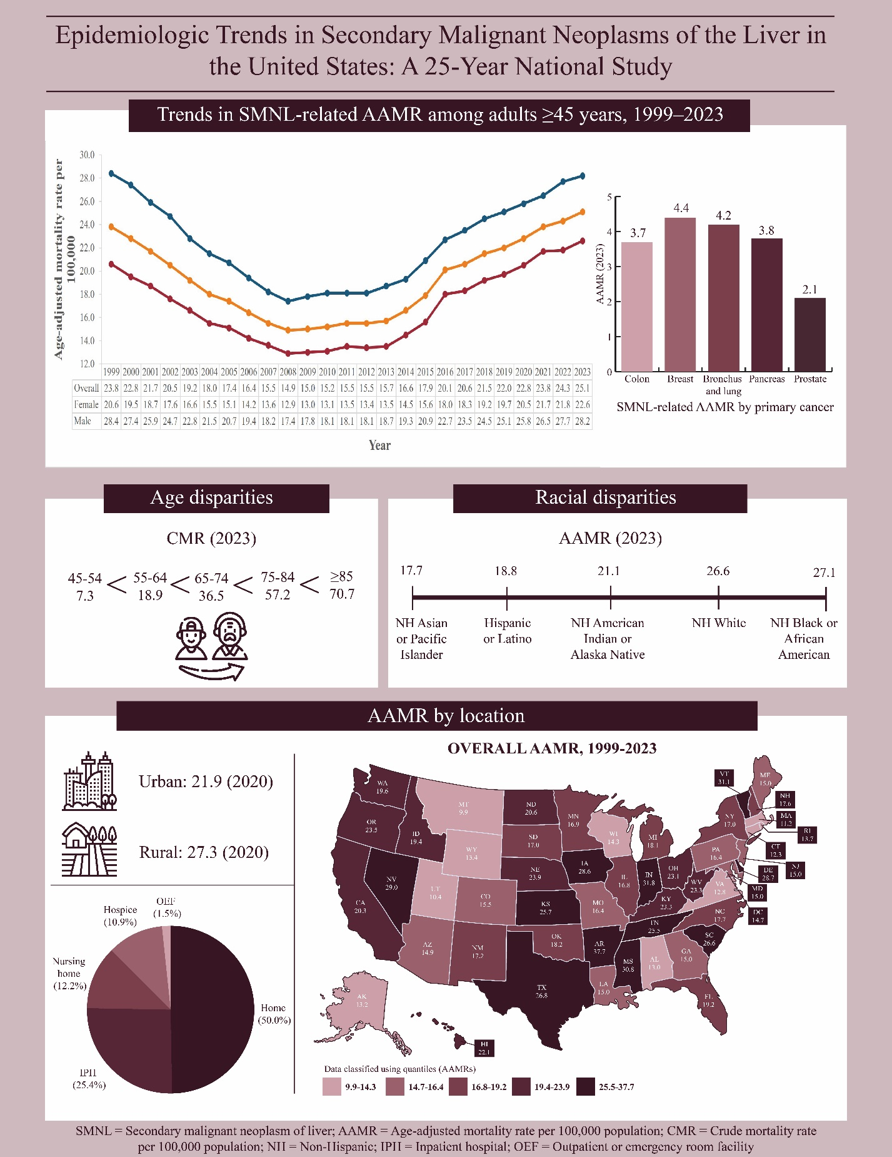

Supplementary Figure 2. Annual age-adjusted incidence rates per 100,000 stratified by cancer sites
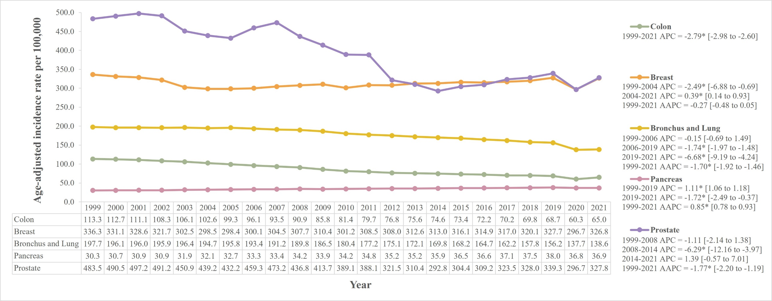
Statistically significant values have been represented by an asterisk “*”.

Supplementary Figure 3. Annual age-adjusted mortality rates per 100,000 for male and female patients with breast cancer and secondary malignant neoplasm of liver from 1999-2023 (Sensitivity analysis)
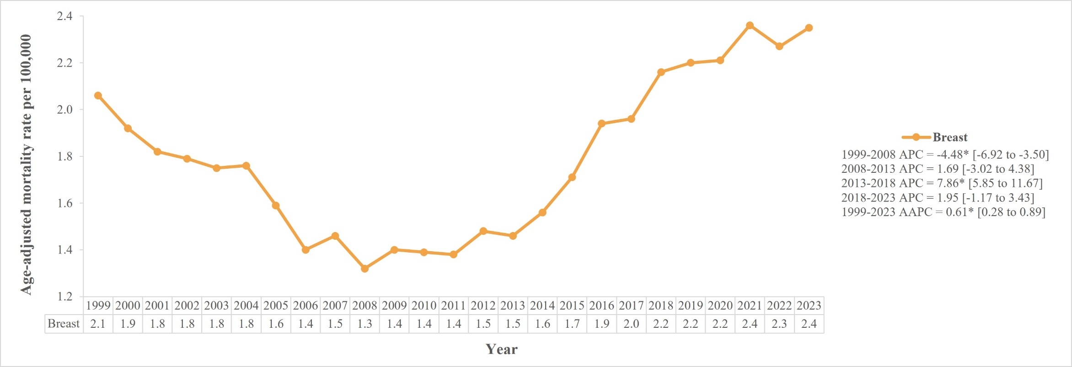
Statistically significant values have been represented by an asterisk “*”.

Supplementary Figure 4. Annual age-adjusted incidence rates per 100,000 for male and female patients with breast cancer from 1999-2021 (Sensitivity analysis)
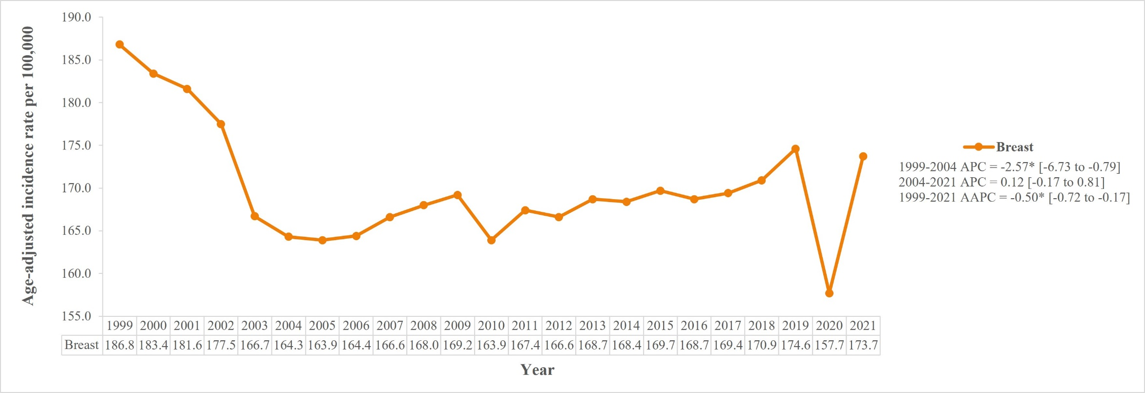
Statistically significant values have been represented by an asterisk “*”.

Supplementary Figure 5. Annual age-adjusted mortality rates per 100,000 for the top five primary cancers leading to highest SMNL-related mortality (without SMNL as a contributing cause of death)
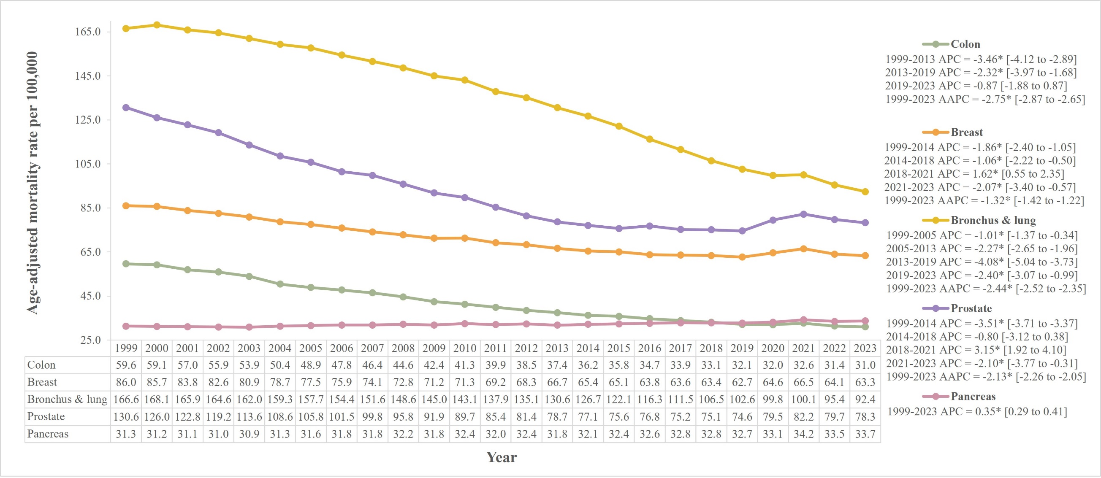
Statistically significant values have been represented by an asterisk “*”.

Supplementary Figure 6. Crude mortality rates per 100,000 stratified by 10-year age groups
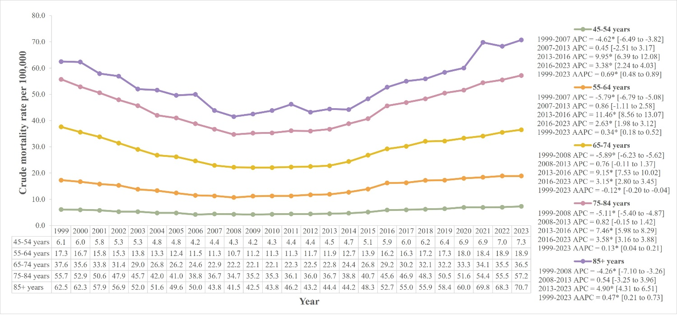
Statistically significant values have been represented by an asterisk “*”.

Supplementary Figure 7. Annual percentage of SMNL-related deaths stratified by place of death
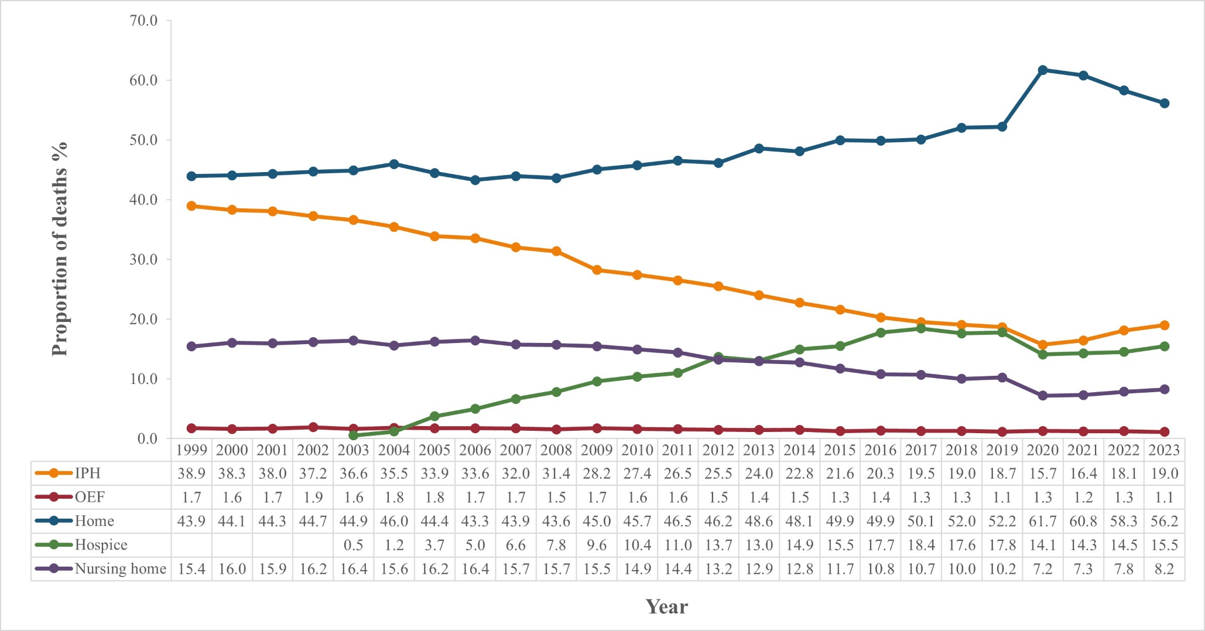
Data for hospice facilities were either suppressed or unreliable before 2003

Supplementary Figure 8. Average annual percentage changes from 1999-2023 stratified by states
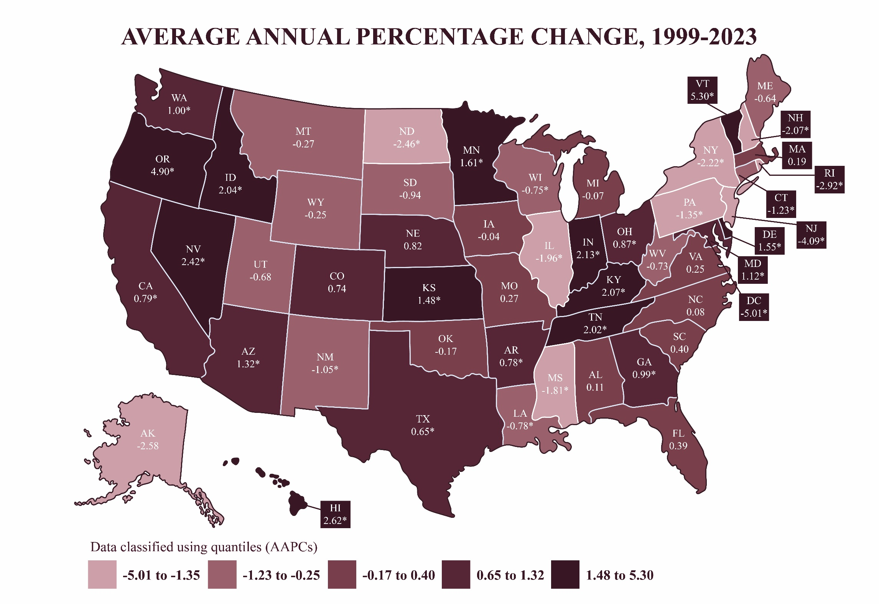
Statistically significant values have been represented by an asterisk “*”.

Supplementary Figure 9. Yearly trends in age-adjusted mortality rates per 100,000 for the three states with the highest and the three states with the lowest average annual percentage changes 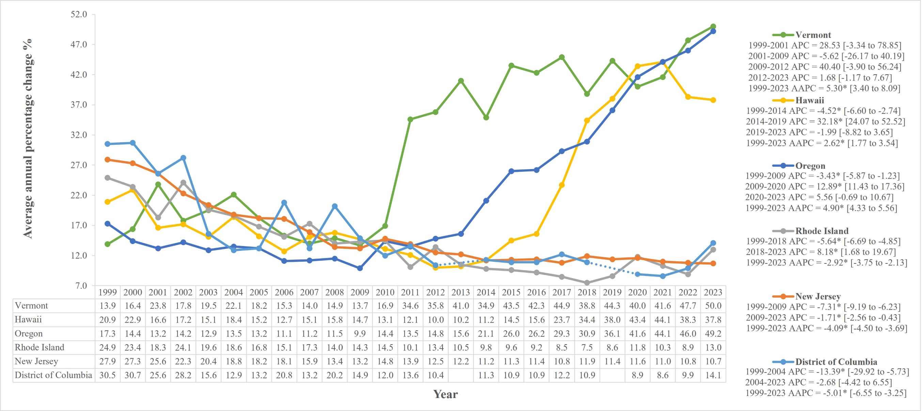
CDC suppresses the counts of fewer than 10 in CDC WONDER data to protect confidentiality, and death rates are marked unreliable for a count less than 20. Our data did have suppressed or unreliable data for subgroups with lower counts. This limitation has been indicated in the manuscript with “-” in the tables and dotted lines in figures. Statistically significant values have been represented by an asterisk “*”.

Supplementary Figure 10. Age-adjusted mortality rates per 100,000 stratified by region
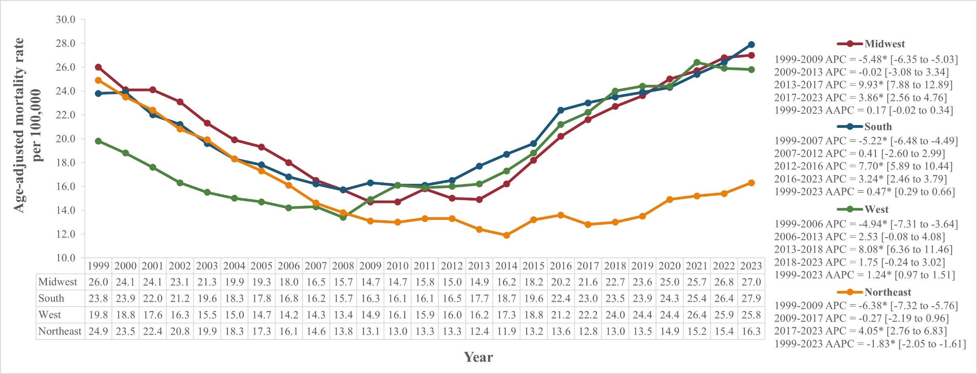
Statistically significant values have been represented by an asterisk “*”.

Supplementary Figure 11. Age-adjusted mortality rates per 100,000 stratified by urbanization status
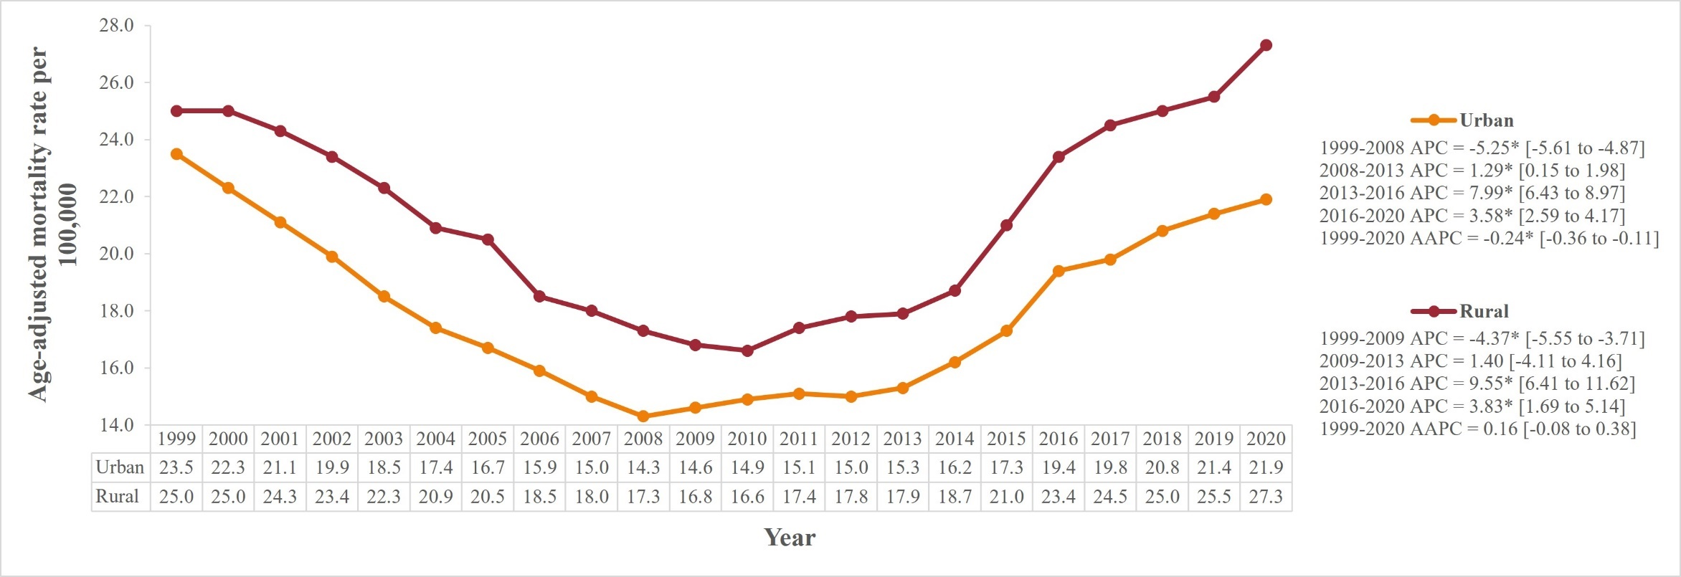
Statistically significant values have been represented by an asterisk “*”.

