Appendix A. Supplementary data

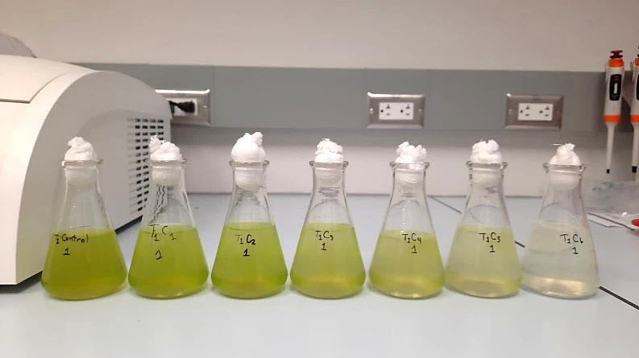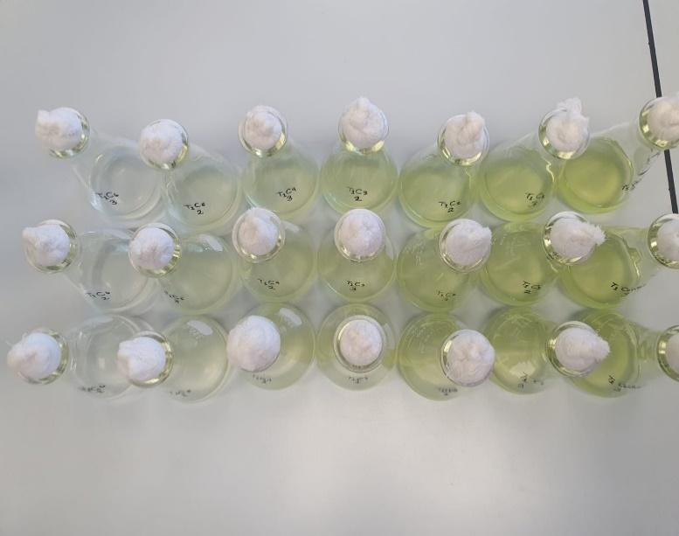
Figure S.P 1 Effect of combined sunscreen concentration and temperatures (24°C and 29°C) on growth response of R. subcapitata exposed to six concentrations of sunscreen at 96 h.

