Supporting Information
for
Metal Incorporated Mesoporous Silica for Hydrogen Isotope Gas Separation Application in Heavy Water Nuclear Power Plant

Daeuk Kang^{a,b}, Chan Woo Park^{b}, Hyung-Ju Kim^{a,b,*}

ªNuclear Science and Technology, University of Science and Technology, 217 Gajeong-ro, Yuseong-gu, Daejeon 34113, Republic of Korea
^{b}Nuclear Facility Cleanup Technology Division, Korea Atomic Energy Research Institute, 989-111 Daedeok-daero, Yuseong-gu, Daejeon 34057, Republic of Korea

Correspondence
H. J. Kim. E-mail: hyungjukim@kaeri.re.kr

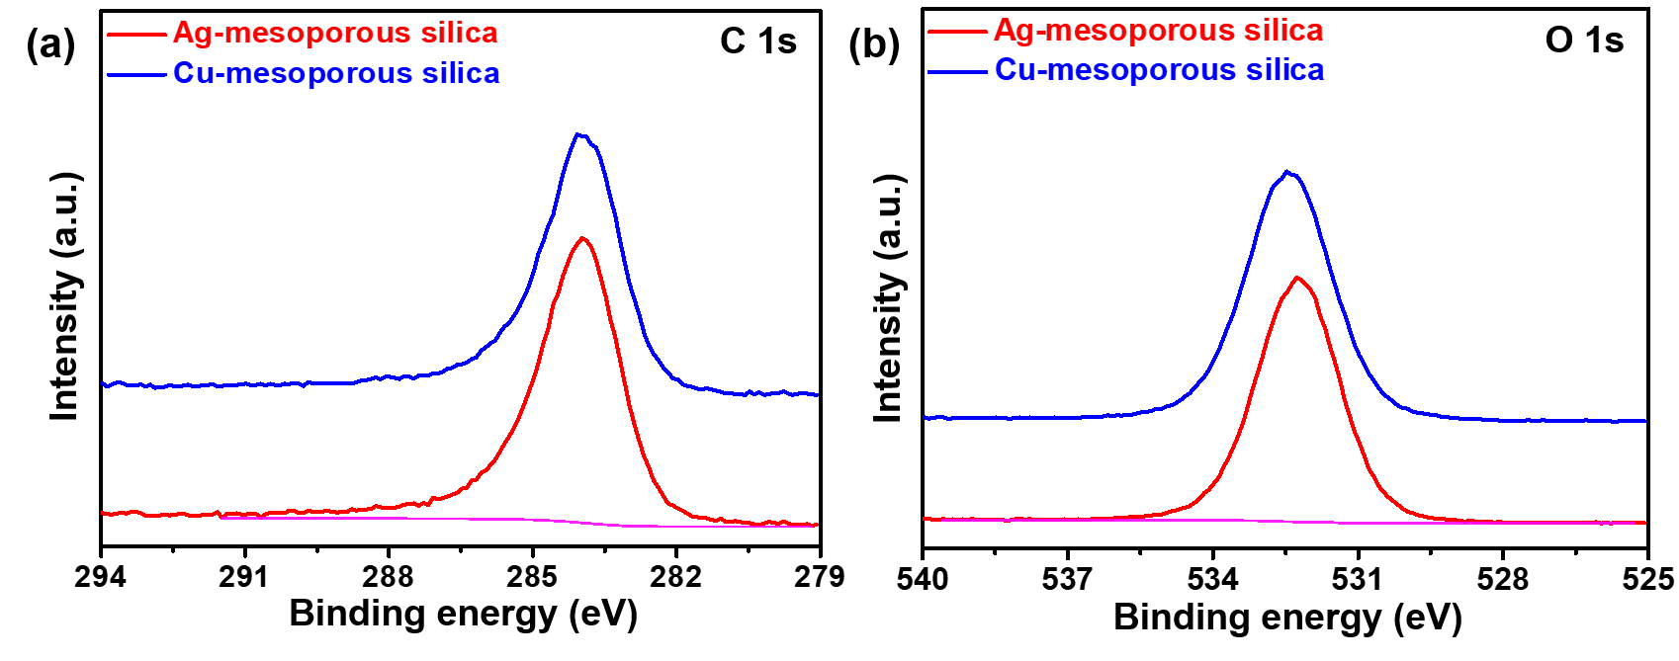
Fig. S1. XPS spectra of (a) C 1s and (b) O 1s spectra for Ag- and Cu-mesoporous silica.

Fig. S2. Langmuir-Freundlich isotherms from H₂ and D₂ adsorption isotherms at 77 K of (a) bare, (b) Ag- and (c) Cu-mesoporous silica.

