Supplementary Material
Supplementary Text
Conventional TACE procedure
TACE was performed by three interventional radiologists with 20, 18 and 6 years of experience. Patients were positioned supine on a digital subtraction angiography (DSA) machine. After standard disinfection and sterile draping of the right groin, local anesthesia was administered using 5 mL of 2% lidocaine. The right femoral artery was punctured using the Seldinger technique at the point of maximal pulsation. A 5-F RH catheter (Terumo Corporation, Tokyo, Japan) was advanced over a guidewire into the celiac artery, followed by angiography of the celiac or common hepatic artery. Comprehensive evaluation included vascular anatomy, tumor characteristics (location, size, and number), identification of all tumor-feeding arteries, and assessment for portal vein invasion or arteriovenous shunting. After confirmation, a 2.7-F microcatheter (Progreat Microcatheter System, Terumo Corporation, Tokyo, Japan) was super selectively advanced into the tumor-feeding artery. Initially, 20 mg of lobaplatin was infused, followed by observation for any adverse reactions. Subsequently, the mixed emulsion of 10 mL ethiodized poppyseed oil injection (Hengrui, Jiangsu, China) and 20 mL pirarubicin was injected for embolization. Reduced tumor staining on DSA indicated successful embolization. Additional embolization was performed with 300-500 μm gelatin sponge particle embolic agent (Alicon, Hangzhou, China) until complete stasis of the tumor-feeding artery was achieved.

Supplementary Figures

A  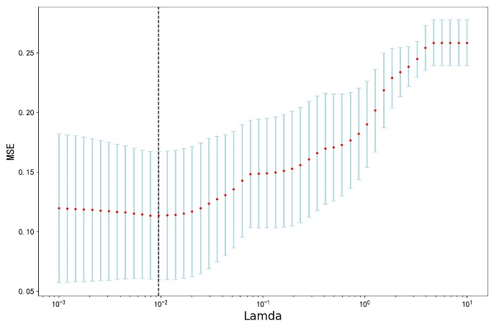 | B  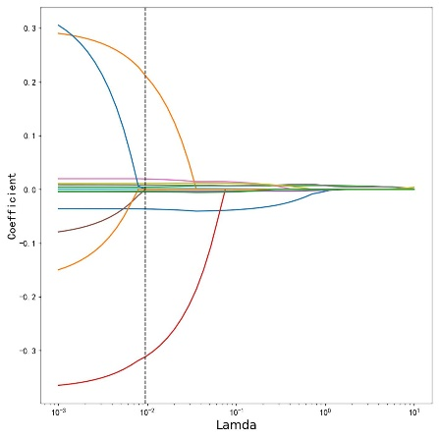
Supplementary Figure 1. Feature selection using the LASSO regression. The optimal Lambda was determined using 10-fold cross-validation, where the x-coordinate of the point with the minimum model bias corresponds to the optimal Lambda, as indicated by the dashed line (A). The non-zero coefficients are identified at the optional Lambda, and these features are then used for model construction (B)

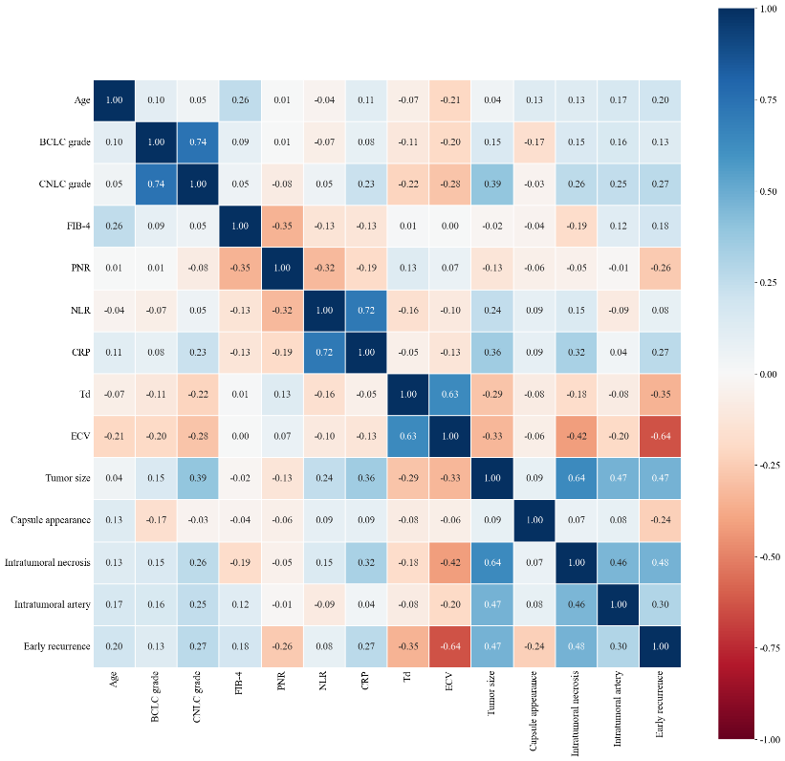
Supplementary Figure 2. Correlation coefficient matrix heatmap between 13 selected parameters and ER

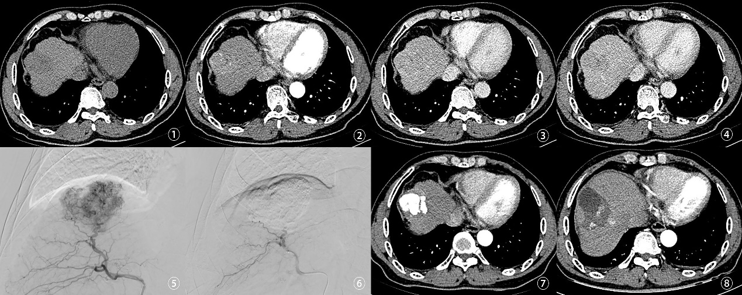
Supplementary Figure 3. Case presentation. The patient, a 62-year-old male, was pathologically diagnosed with HCC. Fig. ① to ④ present the baseline CECT images, including non-contrast, arterial phase, portal venous phase, and delayed phase scans. These images indicate that the HCC lesion was located in the right hepatic lobe near the dome of the liver. The non-contrast scan revealed a low-density area with poorly defined margins, while the arterial phase demonstrated mild, heterogeneous enhancement with a few identifiable feeding arteries. In the portal venous and delayed phases, the lesion exhibited rapid washout, appearing as a relatively hypodense region with the characteristic “fast-in, fast-out” enhancement pattern. Additionally, the liver surface appeared irregular, suggestive of cirrhosis. Fig. ⑤ illustrates the TACE procedure, during which DSA revealed a well-defined, nodular HCC lesion in the right lobe, surrounded by disorganized vascular structures. Fig. ⑥ shows the post-embolization imaging, confirming the disappearance of tumor staining, with visible iodized oil deposition in the portal venous end and complete occlusion of the tumor-feeding arteries—indicative of successful embolization. Fig. ⑦ displays a follow-up CECT scan obtained four weeks after TACE, showing dense iodized oil deposition within the tumor and absence of enhancement during the arterial phase, consistent with a radiological CR. However, Fig. ⑧, taken at a later follow-up, demonstrates a marked decrease in iodized oil retention and patchy abnormal enhancement at the tumor margin during the arterial phase, suggestive of local recurrence. The patient's RFS was 194 days, consistent with ER. The XGBoost-based predictive model correctly identified the case as ER. The Cox regression-based nomogram estimated the patient's 6-, 12-, and 18-month recurrence risks as 0.150, 0.745, and 0.930, respectively, classifying the patient into the high-risk group—consistent with the actual clinical outcome.

