Supplement information
Ultrastretchable adaptive epidermal bracelet based on integrated crosstalk-free dual-mode sensors for accurate human-machine interactions
Hao Wang^{1,6,7,11},† Yubin Zhou²,† Yibing Luo¹,† Wenxiong Shi⁵†, Jianye Li¹†, Mingxuan Xiao¹, Ruijie Xie³, Binghua Zou¹², Huizhi Chen,² Yan Wang¹⁰, Shaowu Pan⁹, Daohui Zhang⁶, Kai Tao⁸, Fei Liu¹, Fengwei Huo^{3,4}*, Jin Wu^{1,7}*

¹State Key Laboratory of Optoelectronic Materials and Technologies and the Guangdong Province Key Laboratory of Display Material and Technology, School of Electronics and Information Technology, Sun Yat-sen University, Guangzhou 510275, China. E-mail: wujin8@mail.sysu.edu.cn

²Dongguan Key Laboratory of Advanced Drug Delivery and Biosensing Research and Development, School of Pharmacy, and Dongguan Innovation Institute, Guangdong Medical University, Dongguan, 523808, China

³Institute of Flexible Electronics (IFE, Future Technologies), Xiang’an Campus, Xiamen University, Xiang’an South Road, Xiamen 361102, Fujian, China.
E-mail: ifefwhuo@xmu.edu.cn

⁴State Key Laboratory of Flexible Electronics (LoFE) & Institute of Advanced Materials (IAM), School of Flexible Electronics (Future Technologies), Nanjing Tech University (Nanjing Tech), Nanjing 211816, China.

⁵Institute for New Energy Materials and Low Carbon Technologies, State Key Laboratory of Crystal Materials, School of Materials Science and Engineering, Tianjin University of Technology, Tianjin 300384, China.

⁶State Key Laboratory of Robotics, Shenyang Institute of Automation, Chinese Academy of Sciences, Shenyang, China.

⁷State Key Laboratory of Transducer Technology, Shanghai 200050, People’s Republic of China

⁸The Ministry of Education Key Laboratory of Micro and Nano Systems for Aerospace, School of Mechanical Engineering, Northwestern Polytechnical University, 710072 Xi’an, P. R. China

⁹State Key Laboratory of Advanced Fiber Materials, College of Materials Science and Engineering, Donghua University, Shanghai 201620, China

¹⁰Department of Chemical Engineering, Guangdong Technion­Israel Institute of Technology, 241 Daxue Road, Shantou, Guangdong 515063, China

¹¹State Key Laboratory of Intelligent Manufacturing Equipment and Technology, Wuhan 430074, China

¹²School of Intelligent Manufacturing, Nanjing Vocational College of Information Technology, Nanjing 210023, China

†These authors contributed equally to this work.

Table-of-contents
Supplementary information contains:
- Description of Supplementary Movies 1-7
- Supplementary Fig. S1-48
- Supplementary Notes 1-8
- Supplementary Table. S1-2
- Supplementary References

- Movies S1: 0.015TA-0.1CA-PAM organohydrogel keeps the adhesion on the aluminum sheet even when placed under water.
- Movies S2: The detachment of PAM organohydrogel from an aluminum sheet when put in water.
- Movies S3: The wireless transmission system realizes real-time acquisition and processing of 8-channel EMG-FMG signals.
- Movies S4: Demonstration of the active rehabilitation robot for grasping objects by decoding the action intention
- Movies S5: Demonstration of contactless remote extraction of human oral saliva through HMI bracelet
- Movies S6: The control of the movement of a smart car with the HMI bracelet.
- Movies S7: The HMI bracelet controls the manipulator to imitate human motions.

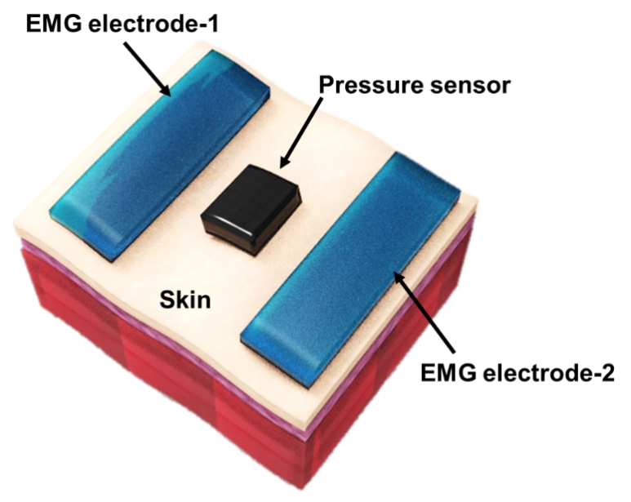
Fig. S1 Schematic diagram of device structure of conventional EMG-FMG dual-mode epidermal sensor.

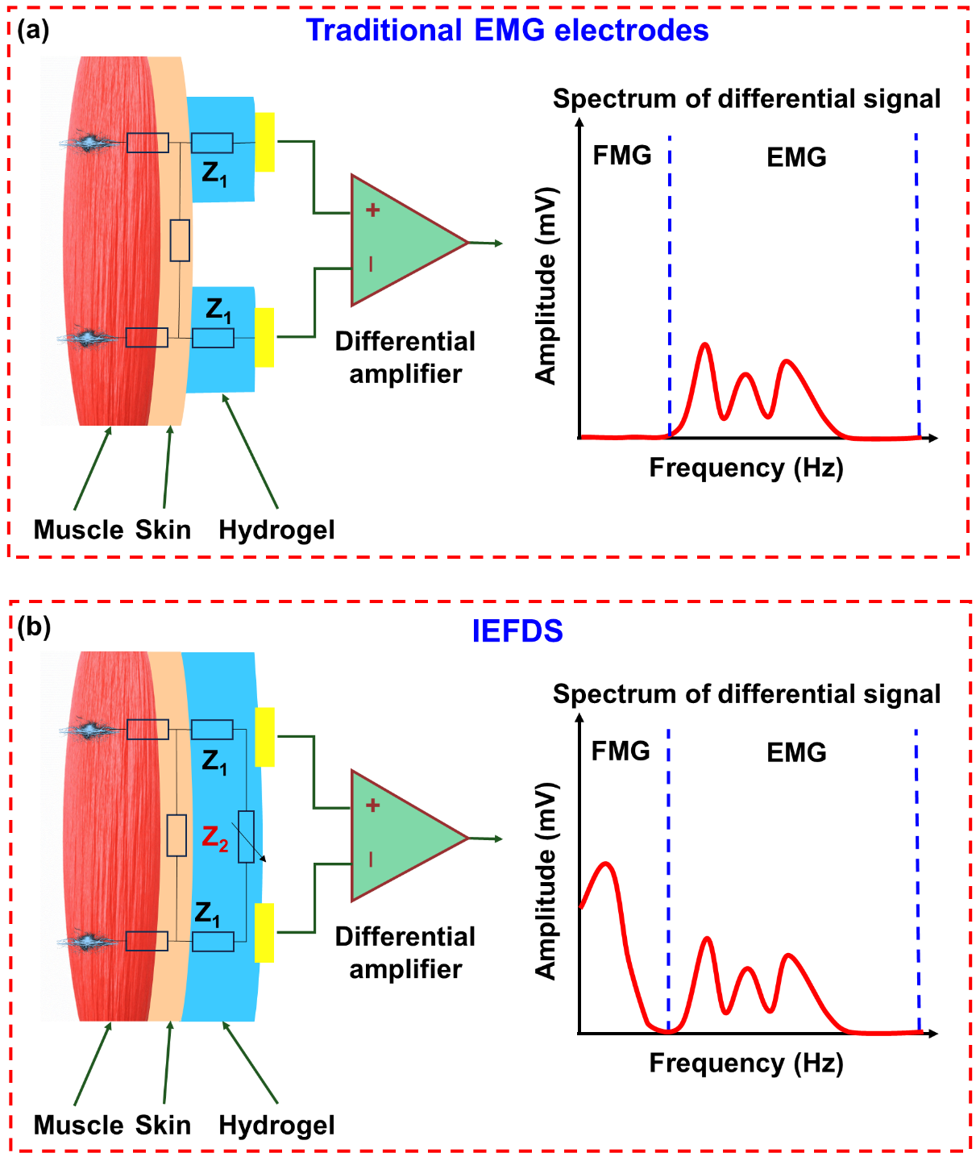
Fig. S2 (a) and (b) Schematics illustrating the device structures of traditional EMG electrodes and IEFDS, along with their signal frequency spectrums, respectively. Traditional EMG electrodes cannot obtain the low-frequency FMG signals, while IEFDS can.
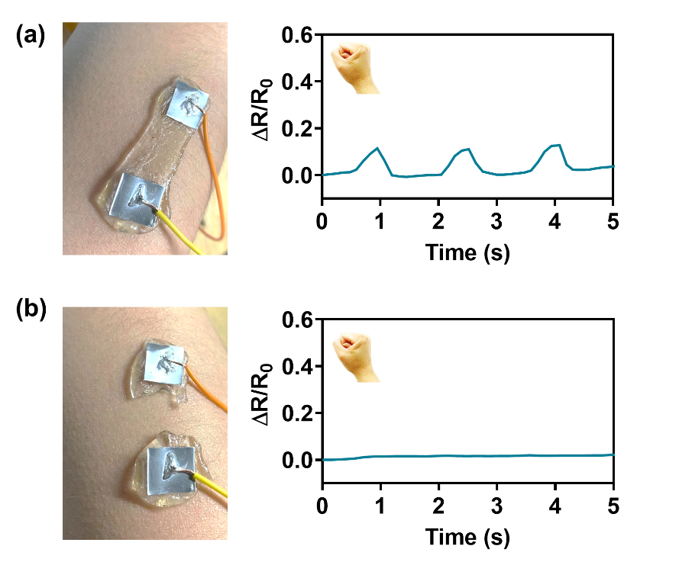
Fig. S3 (a) The dynamic relative resistance change (ΔR/R₀) of the proposed IEFDS with connected organohydrogel electrodes during the repeated fist clench and release process. (b) Time-dependent resistance change of the traditional EMG sensor with two discrete gel electrodes during the repeated fist clench-release process, showing negligible response.
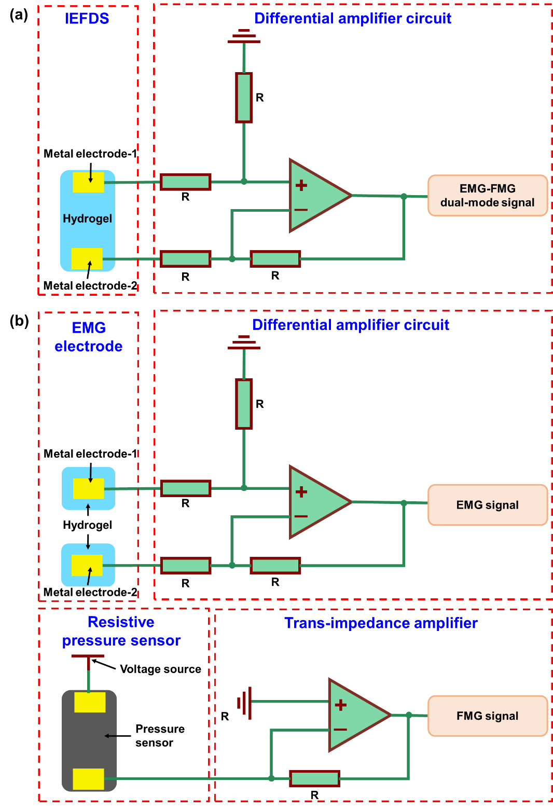
Fig. S4 (a) Sensor structure and circuit diagram of the EMG-FMG dual-mode signals obtained by IEFDS in this work. (b) Sensor structures and circuit diagram of the EMG-FMG dual-mode signals obtained by traditional method with discrete EMG sensor and FMG sensor powered by an external voltage source.
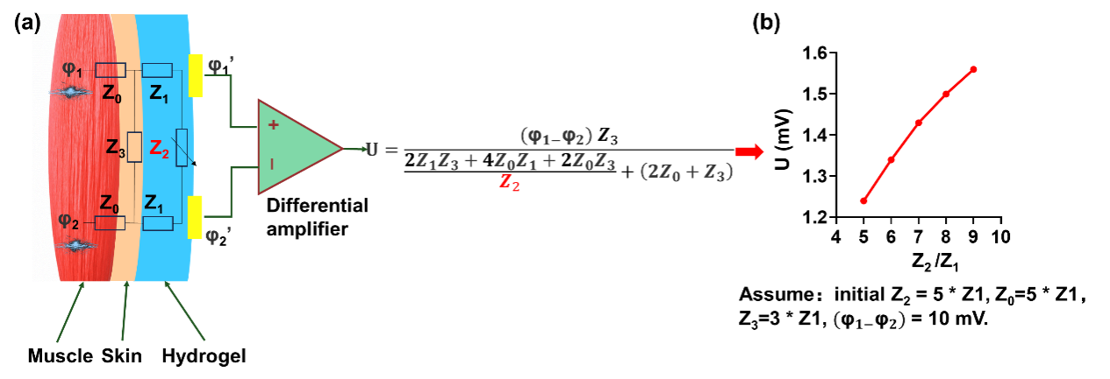
Fig. S5 Investigation of the sensing mechanism of IEFDS. (a) The equivalent circuit model of the IEFDS device and the derived equation depicting the dependence of the potential difference of IEFDS on the impedance of the hydrogel. In this equation, Z₀ stands for the impedance from the EMG source to the epidermis, Z₁ stands for the interfacial impedance between the skin, the electrode and the hydrogel, Z₂ stands for the impedance of the hydrogel sensing material between the two electrodes, Z₃ stands for the impedance of skin between the two electrodes, φ₁, φ₁’, φ₂, φ₂’ are the potentials of the corresponding points in this circuit, and U is the voltage signal output by the differential circuit of IEFDS. (b) Plot of the relationship between the potential difference U and Z₂/Z₁. In order to quantify this relationship, we assume that initially Z₂ =5*Z₁, Z₀=5*Z₁, Z₃=3*Z₁, φ₁-φ₂ =10 mV, and then the relationship between the potential difference U and Z₂ can be plotted in (b), in which the independent variable and dependent variable are Z₂ and U, respectively, and all other parameters are constant.
The correlation shows that the potential difference U increases with the increase of the Z₂, which is caused by the deformation of hydrogel during the muscle movements. Specifically, as Z₂ increases from 5*Z₁ to 9*Z₁, the potential difference U increases from 1.24 to 1.56 mV, providing the quantitative evidence for the change of potential difference (FMG related signals) with the deformation of muscle/skin.

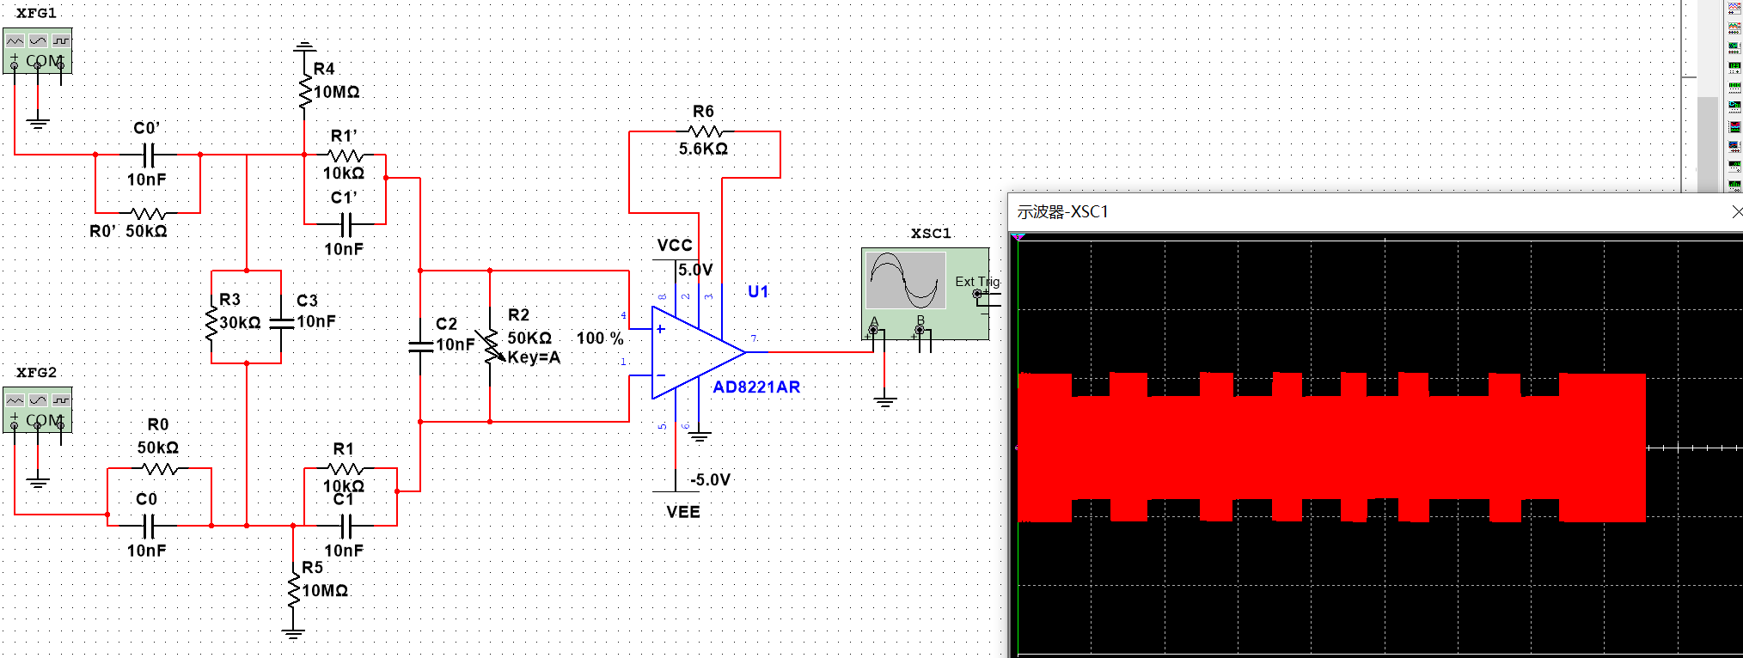
Fig. S6 Diagram of the Multisim simulation circuit with detailed parameters. Among them, C₀/R₀ and C₀’/R₀’ are the impedances from muscle tissues to the epidermis, C₁/R₁ and C₁’/R₁’ are the impedances from the skin to the electrodes, C₂/R₂ is the impedance of hydrogel between two metal electrodes, C₃/R₃ is the impedance of skin between the two electrodes, R₄ and R₅ are the resistances between the hydrogel and the reference electrode.

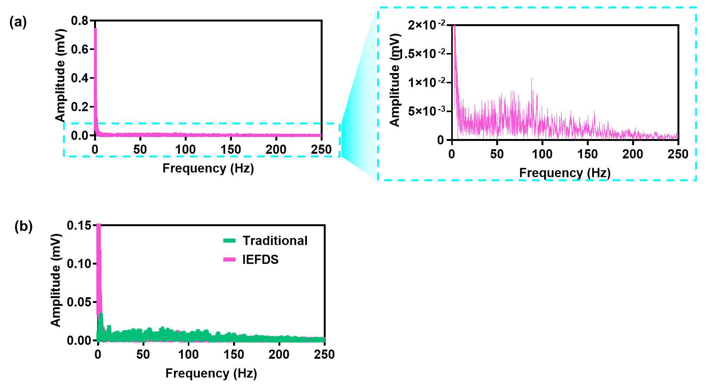
Fig. S7 (a) Frequency spectrum of the differential signal of IEFDS. (b) Comparison of the frequency spectrum of the differential signal obtained by IEFDS and the traditional method.

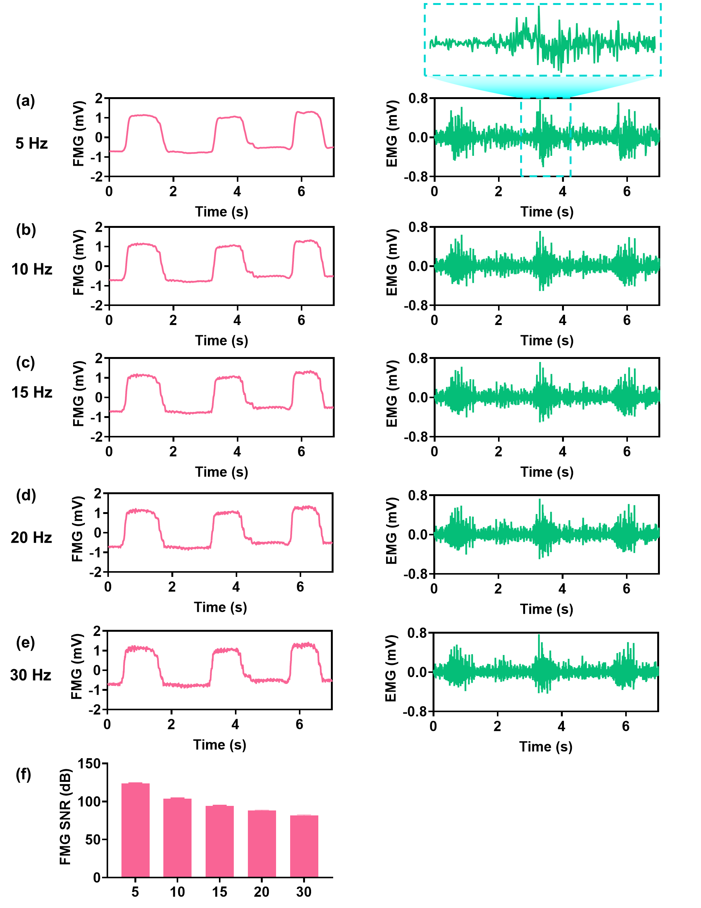
Fig. S8 FMG and EMG signals decoded by the Butterworth filter decoupling algorithm with different segmentation frequencies. (a) 5 Hz. (b) 10 Hz. (c) 15 Hz. (d) 20 Hz. (e) 30 Hz. (f) SNR of FMG signals decoded by the Butterworth filter decoupling algorithm with different segmentation frequencies.

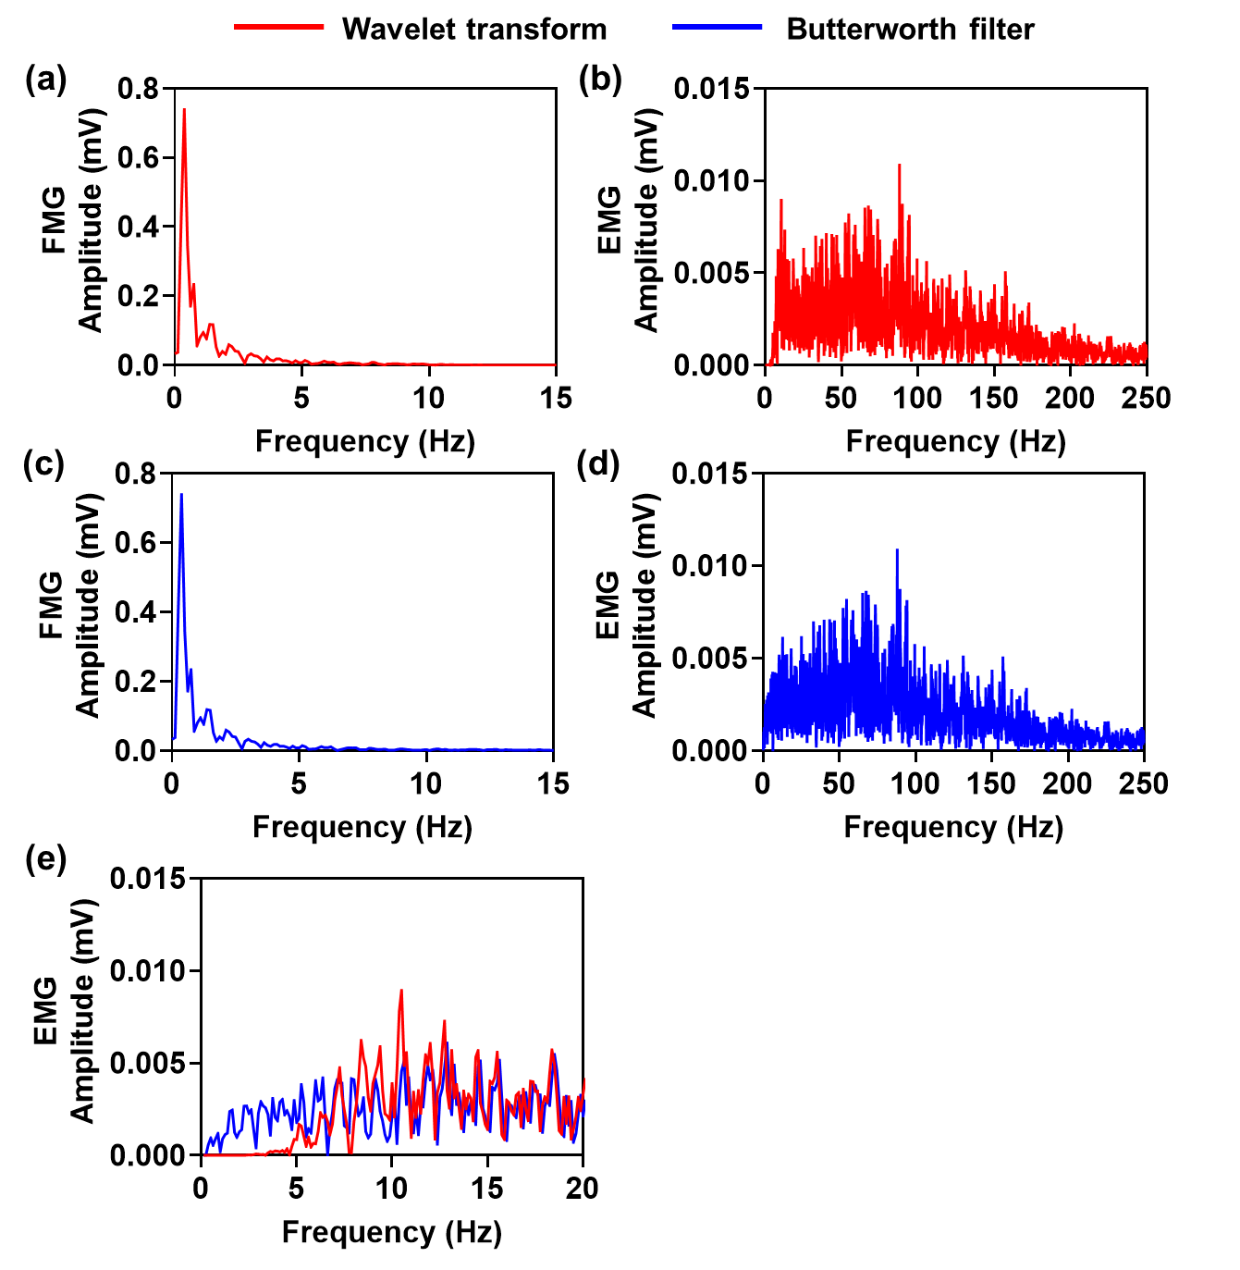
Fig. S9 (a) and (b) The frequency spectra of FMG and EMG decoupled by wavelet transform, respectively. (c) and (d) The frequency spectra of FMG and EMG decoupled by Butterworth filtering. (e) Comparison of EMG spectra obtained by wavelet transform and Butterworth filtering in the same figure within the frequency range of 0-20 Hz.

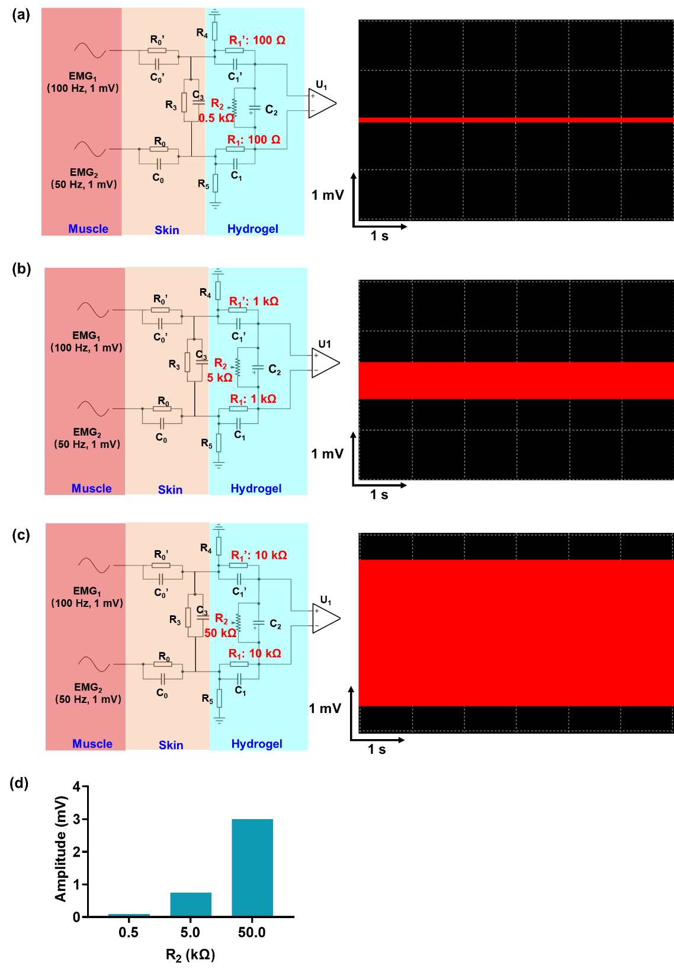
Fig. S10 Circuit simulation model used for analyzing the influence of the hydrogel impedance on the EMG signal amplitude. (a), (b) and (c) The EMG signals obtained when the hydrogel resistances (R₂) are 0.5, 5, and 50 kΩ, respectively. The R₁ and R₁’ change proportionally with R₂ during the simulation. (d) The relationship between R₂ and the EMG peak-to-peak output obtained by the simulation circuit.

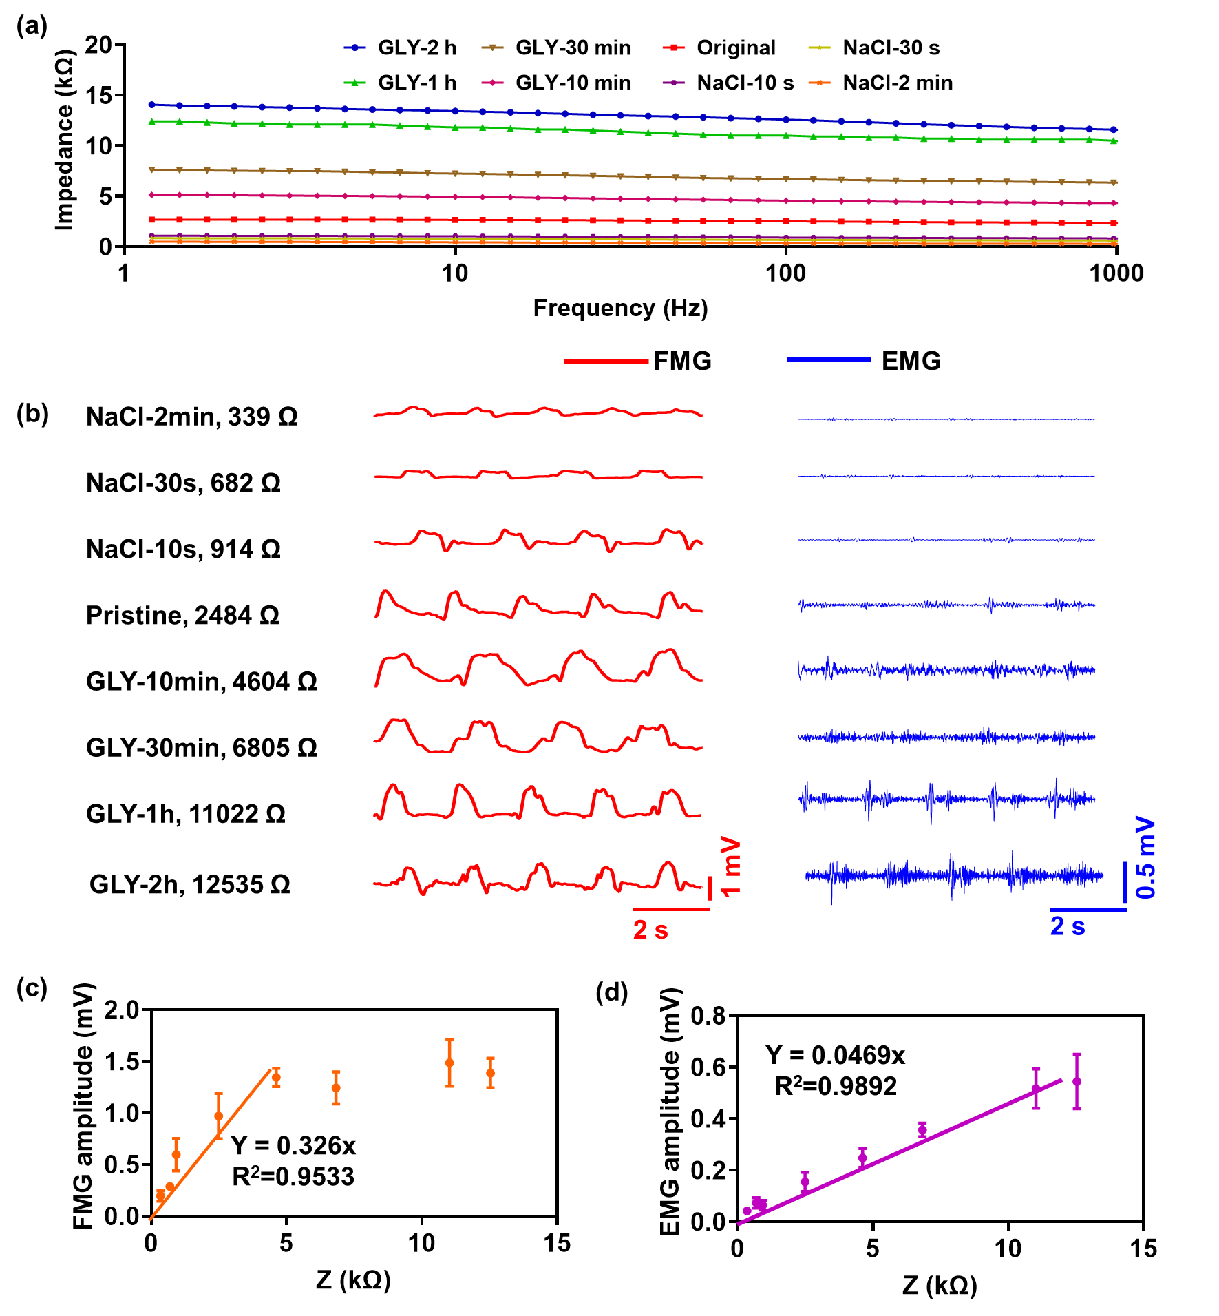
Fig. S11 Performance characterization of IEFDS prepared from hydrogels with different impedances. (a) The impedance of hydrogels prepared by different post-synthesis methods within a broad frequency range. The impedance values are arranged in descending order as follows: organohydrogels immersed in glycerol (GLY) solution (≥99%) for 2 h, 1 h, 30 min and 10 min, pristine hydrogel, and hydrogels immersed in NaCl solution (1 mol/L) for 10 s, 30 s and 2 min. This occurs because the addition of NaCl increases the ion concentration within the hydrogel, thereby enhancing its ionic conductivity. Conversely, the decrease in conductivity observed in the organohydrogel stems from the reduced ion concentration and the formation of a glycerol-water binary solvent. (b) The EMG-FMG dual-mode signals obtained by IEFDS prepared by different post-synthesis methods. (c) The relationship between the impedance of hydrogels and the FMG peak-to-peak value. (d) The correlation between the impedance of hydrogels and the EMG peak-to-peak value.
Supplementary Note 1: Discussion on the enhanced environmental stability of organohydrogel-based IEFDS
Note that the water retention capacity of organohydrogel is conspicuously superior to that of the pristine hydrogel, as its weight loss is much less than that of pristine hydrogel when placed in the same environment of 25 ℃ and 40% relative humidity (Fig. S12a). Furthermore, the water-glycerol binary solvent in the organohydrogel further reduces the freezing point of hydrogel from −19 to −39 °C, suggesting the better anti-freezing capacity of organohydrogel (Fig. S12b). This is because glycerol can form strong hydrogen bonds with water molecules in the solvent, which inhibit the formation of hydrogen bonds between water molecules. This prevents both the water evaporation at middle and high temperatures and the formation of ice crystals at subzero temperatures in organohydrogel, leading to enhanced drying and freezing tolerances, respectively. The enhanced environmental tolerance of organohydrogel endows the better stability of the fabricated IEFDS. Specifically, the organohydrogel IEFDS can operate stably for more than 3 months with relatively stable EMG and FMG signals, whereas the pristine hydrogel IEFDS can only work for two days (Fig. S13). With prolonged operation time, the pristine hydrogel IEFDS displays distorted signals due to serious dehydration.
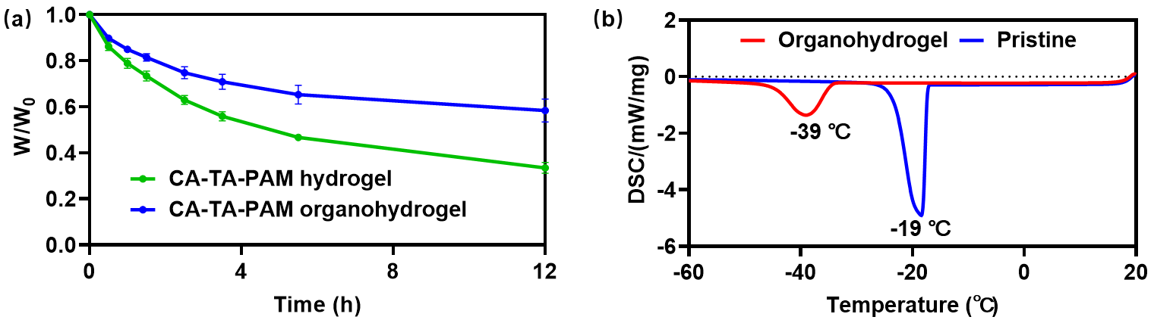
Fig. S12 (a) The weight evolutions of pristine TA-CA-PAM hydrogel and organohydrogel within 12 h when placed at 25 ℃ and 40% relative humidity for 12 h. (b) The DSC spectra of organohydrogel and pristine-hydrogel, on which the freezing points of organohydrogel and hydrogel located at −39 and −19 °C, respectively.

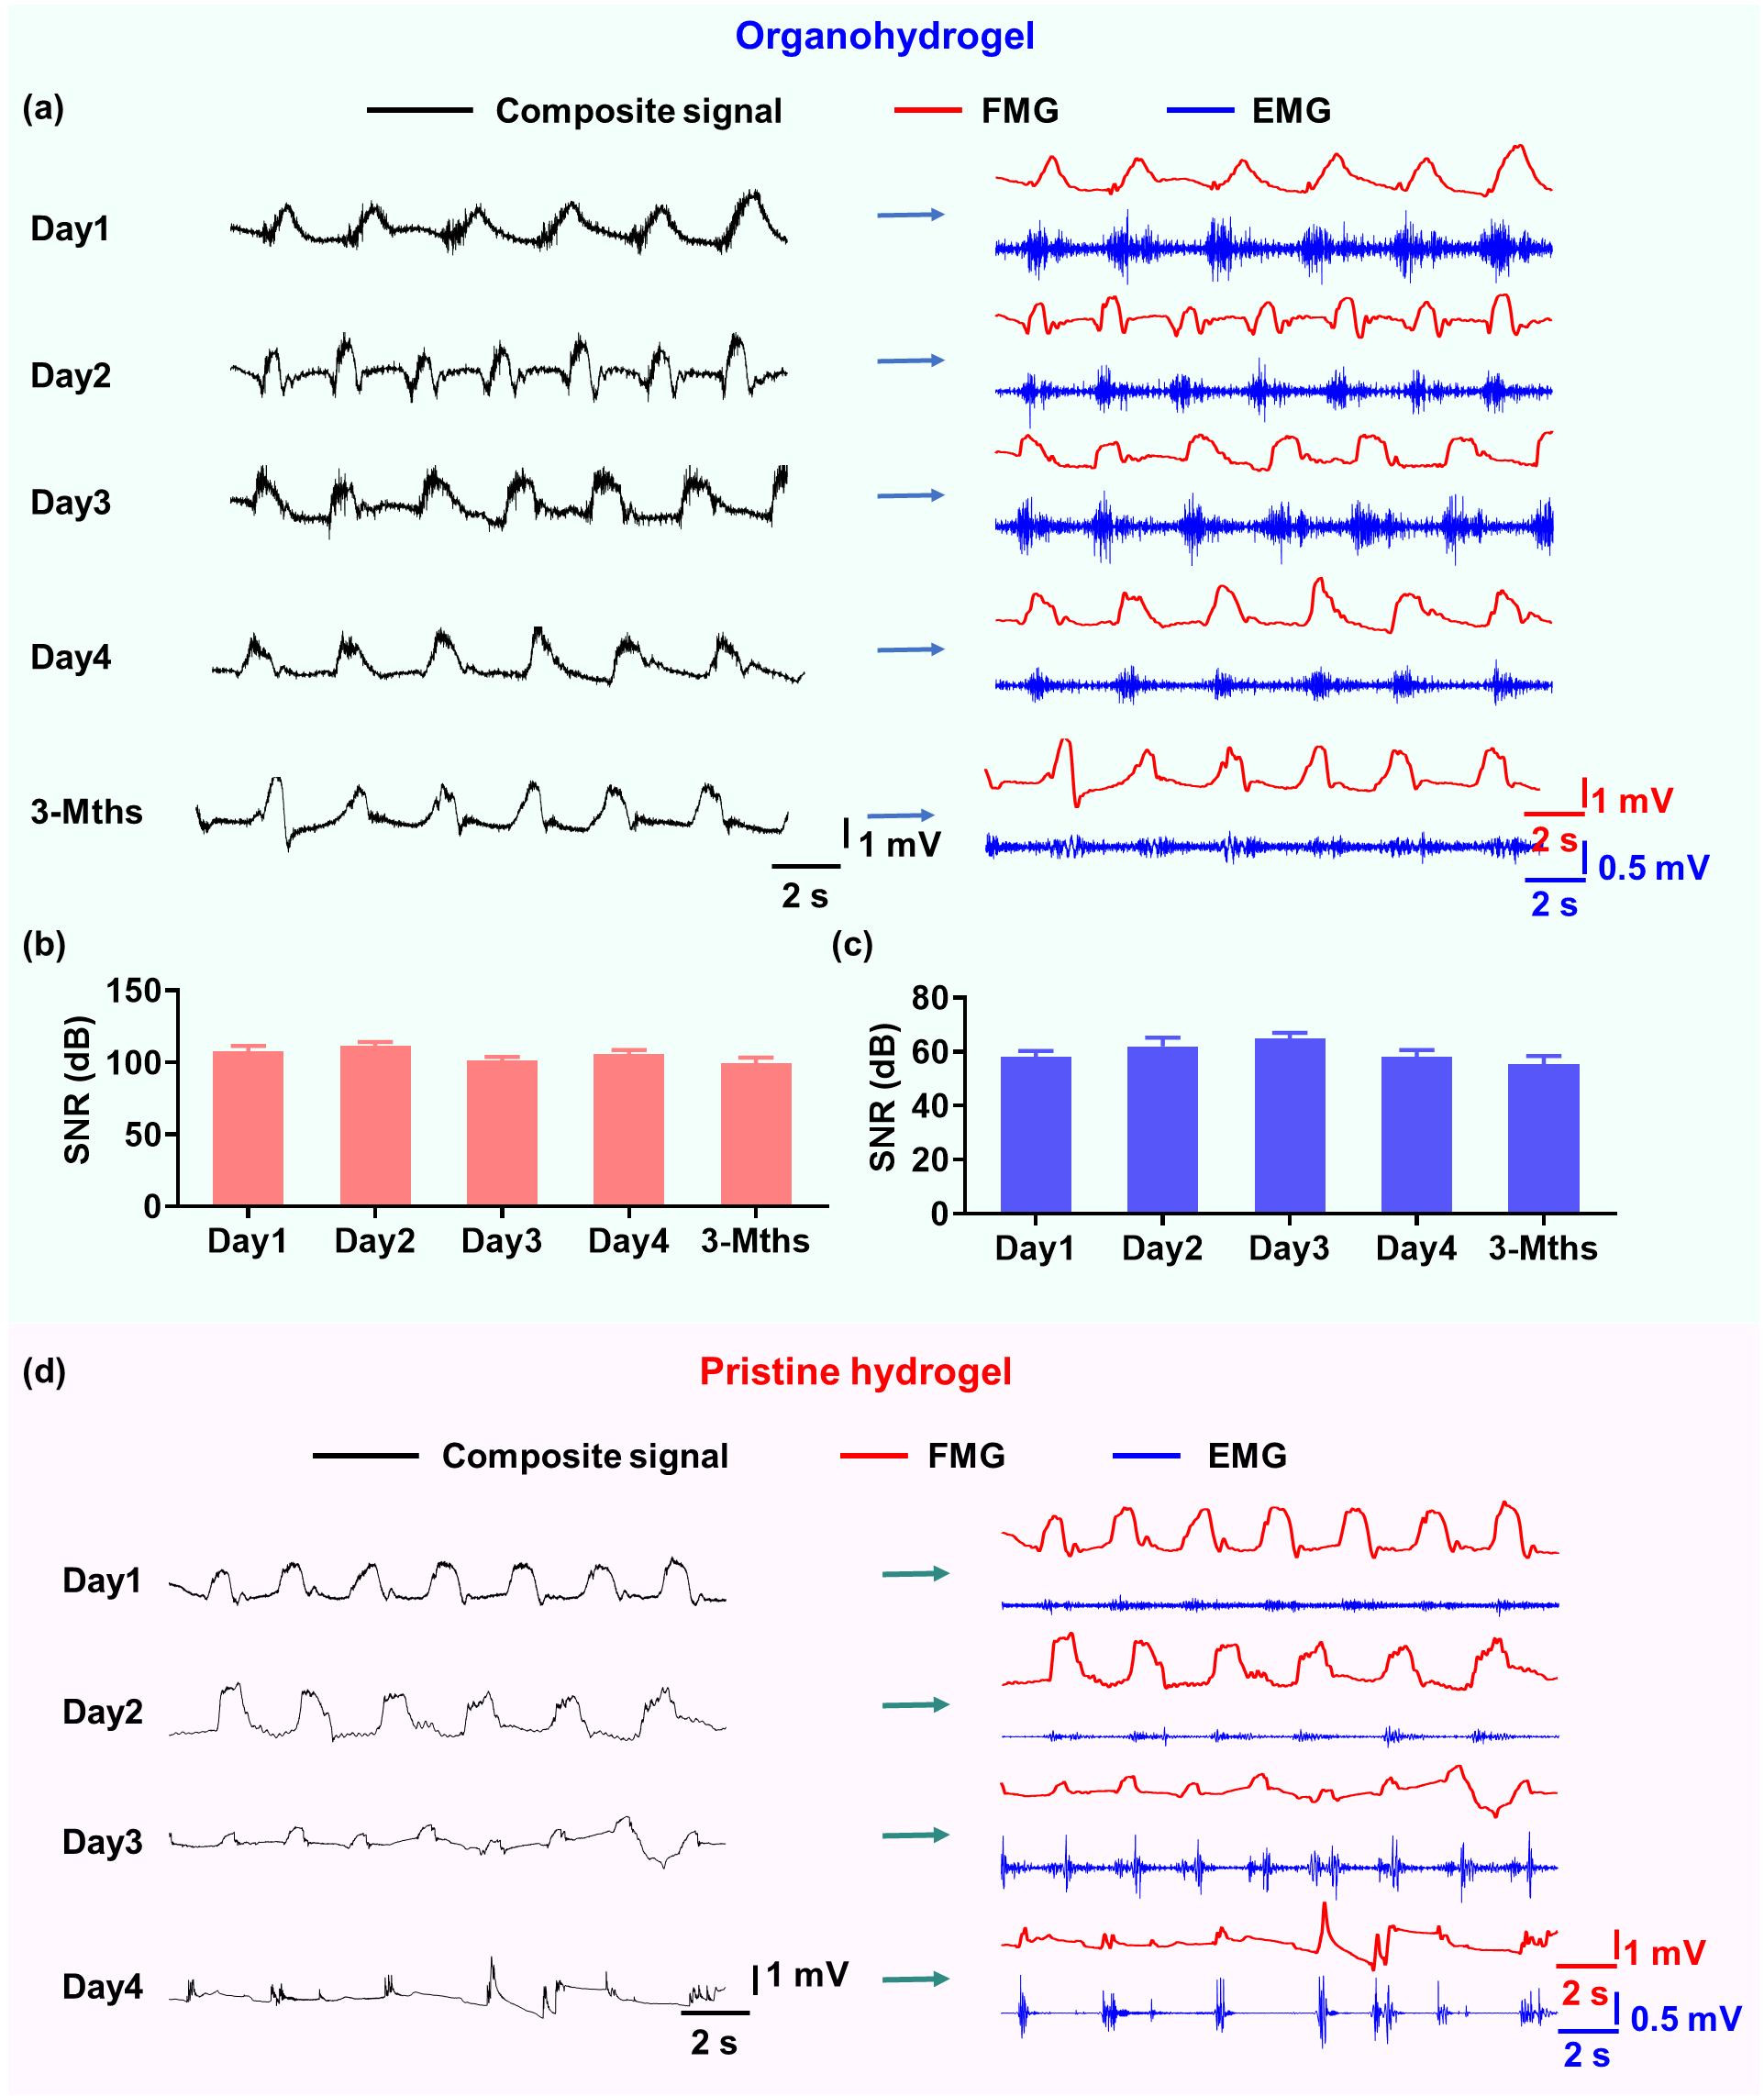
Fig. S13 (a) The EMG-FMG dual-mode signals obtained by the organohydrogel-based IEFDS after being used for different time. (b) and (c) The SNR of FMG and EMG signals in (a), respectively. (d) The EMG-FMG signals obtained from pristine hydrogel-based IEFDS after being used for different time.
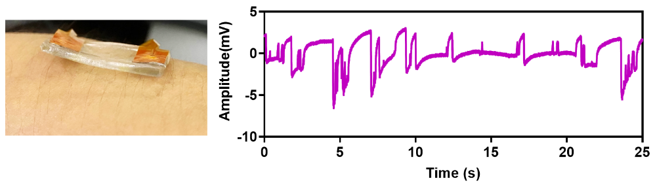
Fig. S14 Differential composite signals obtained by IEFDS constructed with the less adhesive 0.015TA-0.5CA-PAM organohydrogel.

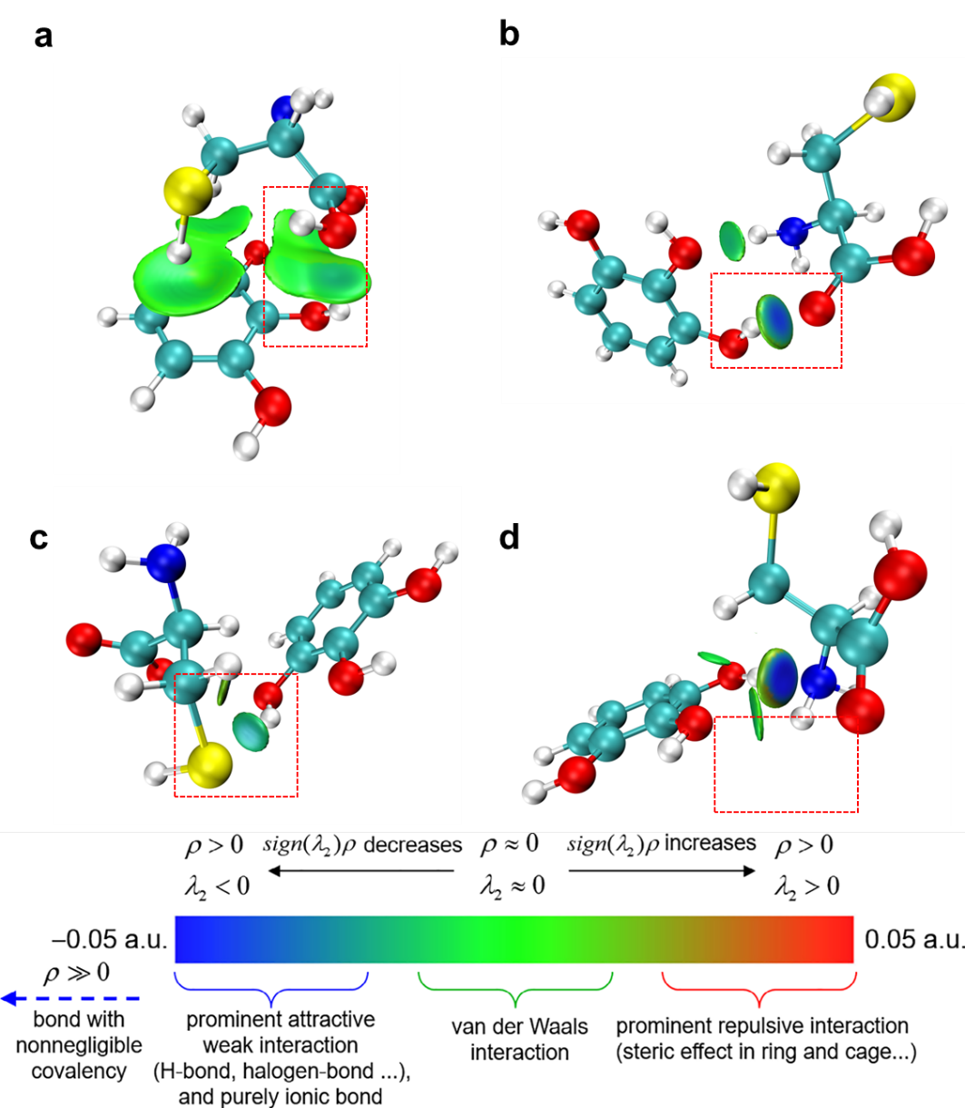
Fig. S15 Visualization of intermolecular interactions was performed using the independent gradient model based on Hirshfeld partition (IGMH) method. Light blue isosurfaces between the pyrogallol group of TA and the (a) hydroxyl, (b) carbonyl, (c) sulfhydryl (-SH), and (d) amino groups of cysteine characterize noncovalent interactions.

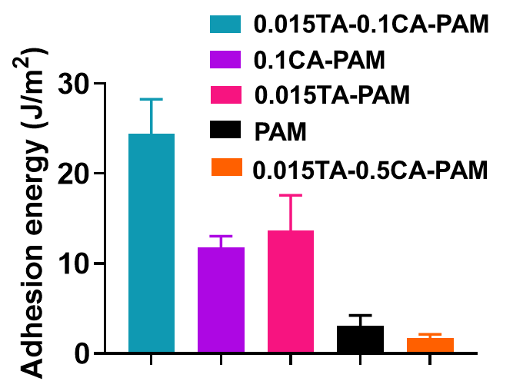
Fig. S16 Adhesion energy of organohydrogels with different components on pigskin.

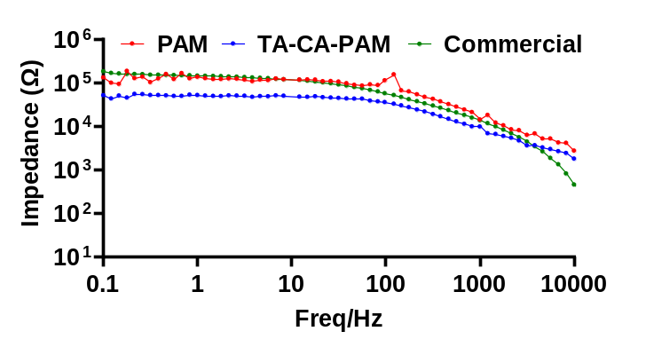
Fig. S17 Interface impedance between skin and PAM organohydrogel, 0.015TA-0.1CA-PAM organohydrogel and commercial Ag/AgCl electrophysiological electrode.

Supplementary Note 2: Discussion on the improved adhesion ability of TA-based hydrogels in wet environments
It should be noted that the performance of electrophysiological electrodes in moist environments, such as in the presence of sweat, is often compromised by the reduced adhesion of gel-based electrodes¹. To evaluate the performance of organohydrogel and commercial electrodes under humid environment, the devices are rinsed with water for 1 min before the measurement. Fig. S18a shows that the organohydrogel electrode remains secure adhesion on the skin with ECG signal quality that maintains nearly unchanged. In contrast, a noticeable air gap appears between the commercial ECG electrode and skin due to the significantly diminished self-adhesion of commercial gel, leading to an unstable baseline and degraded signal quality (Fig. S18b). The self-adhesion of 0.015TA-0.1CA-PAM organohydrogel in wet environment is also validated by using it to remove aluminum from underwater (Fig. S18c and Movie S1), a capability lacking in unmodified PAM (Fig. S18d and Movie S2).

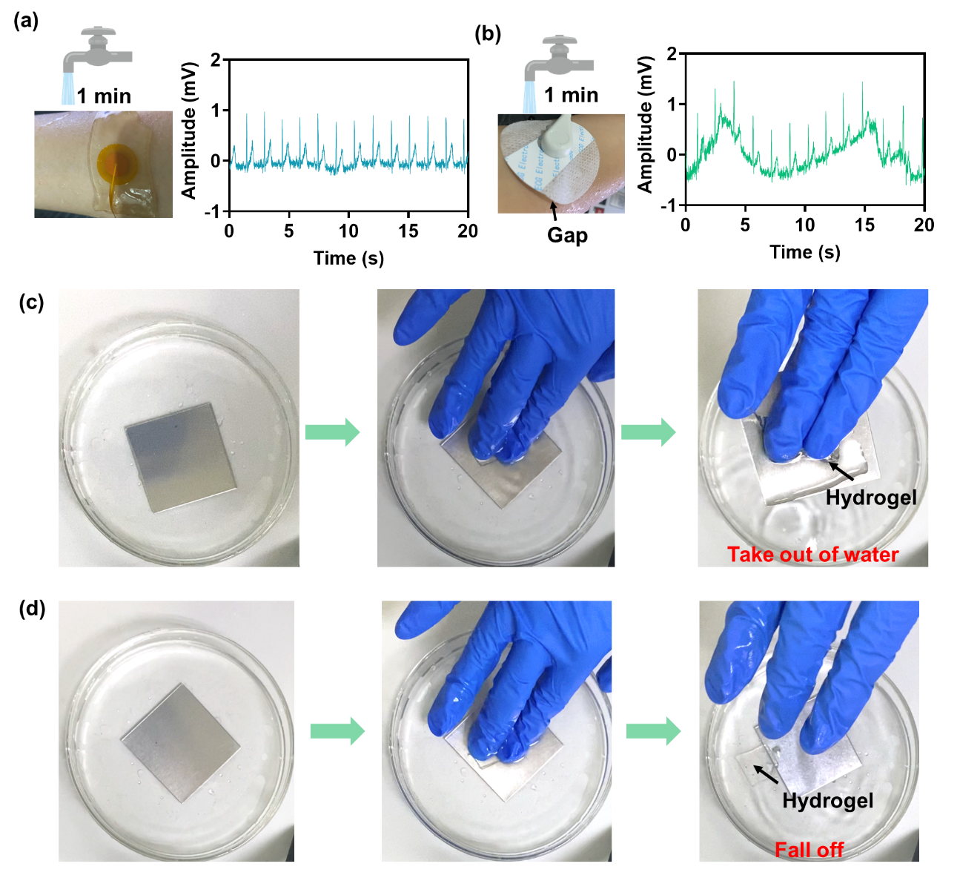
Fig. S18 (a) and (b) Stable and unstable ECG signals acquired by the organohydrogel electrode and commercial Ag/AgCl electrode, respectively, after being flushed with water for 1 min. (c) The adhesive 0.015TA-0.1CA-PAM organohydrogel attached on the glove can be employed to remove an aluminum sheet from underwater. (d) The PAM organohydrogel attached on the glove is unable to remove the aluminum sheet from underwater due to its poor adhesion underwater.
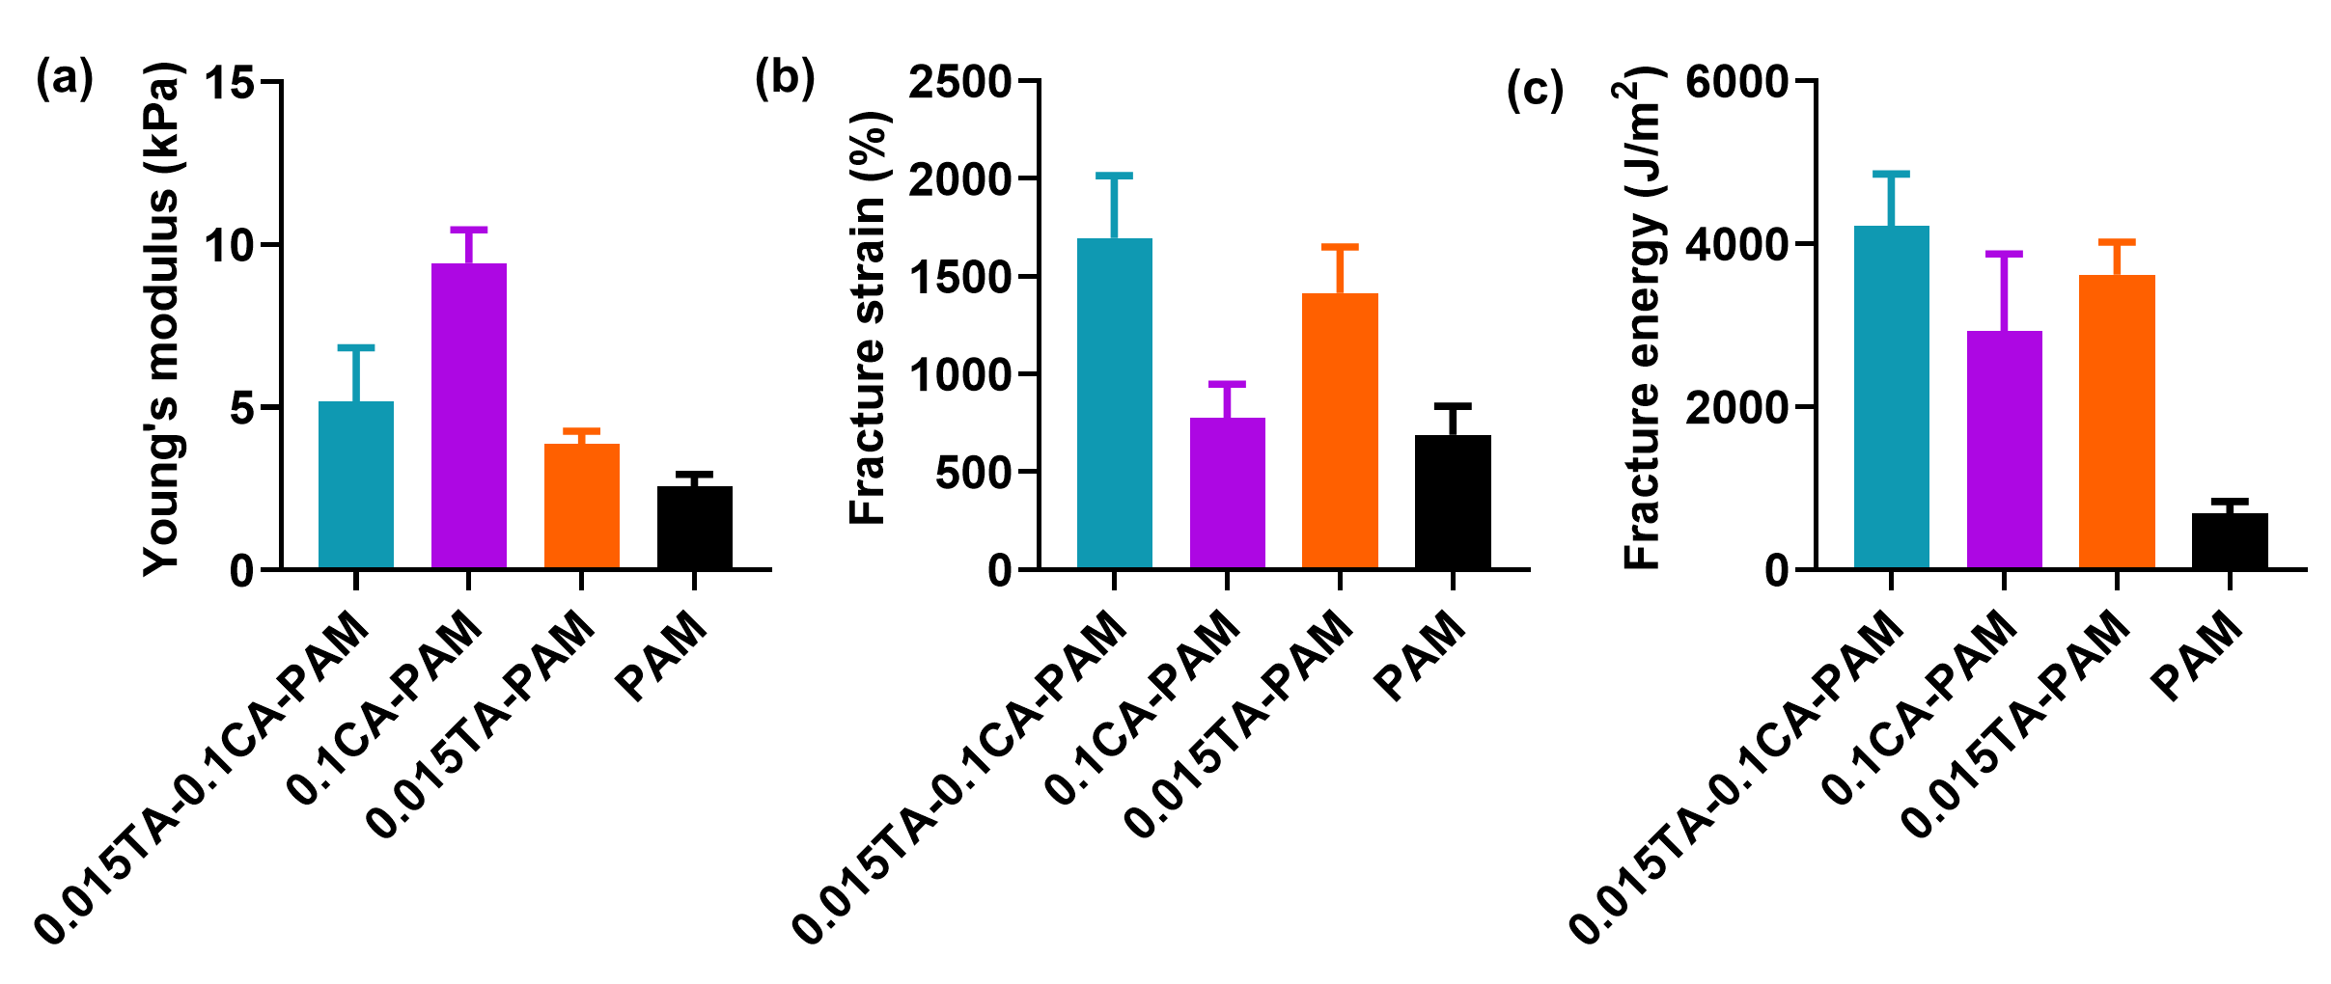
Fig. S19 (a), (b), and (c) The Young's modulus, fracture strain and energy of organohydrogels with different components, respectively.

Supplementary Note 3: Discussion on the long-term stability of adhesion and mechanical properties of organohydrogel
Prolonged operation may induce hydrogel dehydration, potentially compromising adhesion and mechanical integrity²⁻⁴. To characterize the long-term adhesion and mechanical stability of the 0.015TA-0.1CA-PAM organohydrogel, we stored the hydrogel samples in sealed bags and ambient air respectively, and measured the evolutions of their weight, self-adhesion performance, and mechanical properties within 30 days. Because the sealed bags prevent water loss, the hydrogel maintains more than 97% of its weight after 30 days of storage (Fig. S20a), and therefore also displaying good stability in both mechanical properties and self-adhesion performance (Fig. S20d-i). Although ambient temperature and humidity fluctuate with weather conditions, the organohydrogel maintains a water loss below 15% over 30 days due to glycerol's water-retaining capacity (Fig. S20a-c). The self-adhesion of organohydrogel exposed to air for extended periods also demonstrates good stability without significant degradation, as shown in Fig. S20j, l. However, with the increased dehydration, both the fracture strain and fracture energy decrease, but they can still reach 1097% and 2410 J/m² respectively (Fig. S20k and Fig. S20m-o). Meanwhile, the Young's modulus of the hydrogel increased, likely due to elevated glycerol content in the organohydrogel. To verify this hypothesis, we compared Young's modulus analyses of hydrogels with different glycerol immersion time. As shown in Fig. S21, the Young's modulus of the organohydrogel increases with the higher glycerol content, which is consistent with the previous phenomenon.

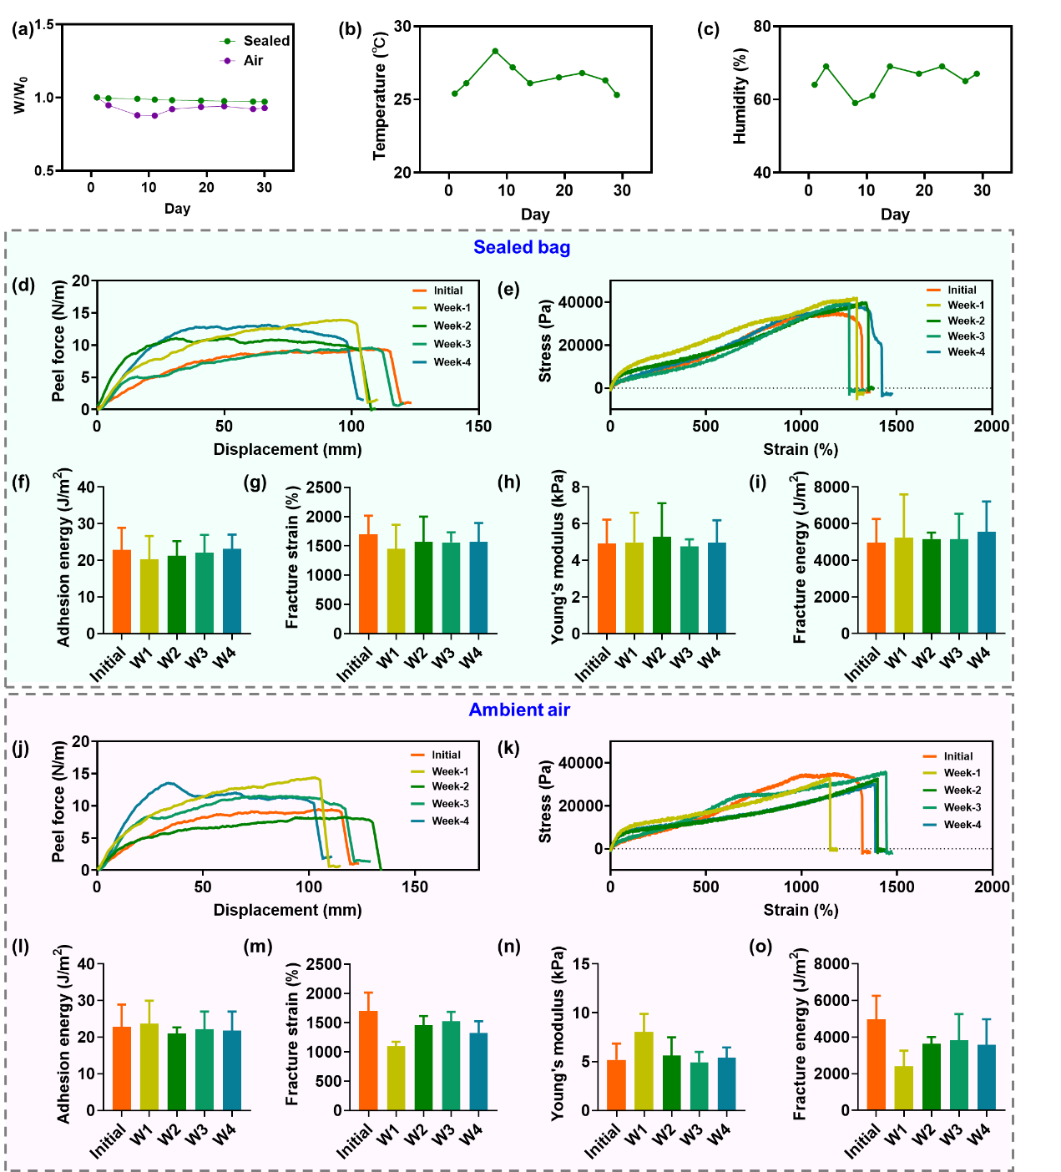
Fig. S20 Characterization of long-term mechanical and self-adhesive stability of 0.015TA-0.1CA-PAM organohydrogel when sealed in bags or exposed to ambient air. (a) Relative weight evolutions of organohydrogel within 30 days in sealed bag and ambient air. (b-c) The temperature and humidity of the air environment within the 30 days. (d) Vertical peeling force tests for hydrogels with different storage time in sealed bag. (e) Stress-strain curves of organohydrogels with different storage time in sealed bag. (f-i) Adhesion energy, fracture strain, Young's modulus, and fracture energy of organohydrogels with different storage time in sealed bag. (j) Vertical peeling force tests for hydrogels with different storage time in ambient air, respectively. (k) Stress-strain curves of organohydrogels with different storage time in air. (l-o) Adhesion energy, fracture strain, Young's modulus, and fracture energy of organohydrogels with different storage time in air.

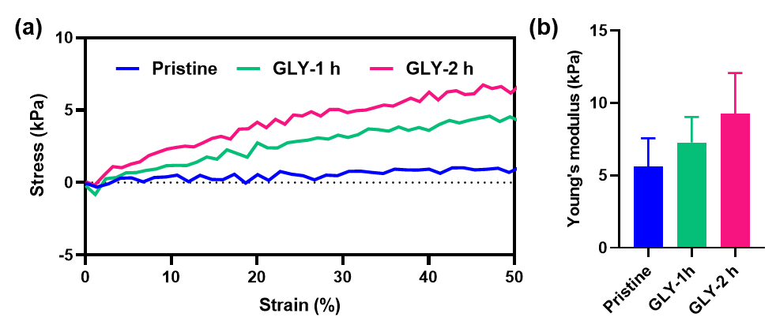
Fig. S21 (a) The stress-strain curves of pristine hydrogel, GLY-1h and GLY-2h organohydrogels within the range of 0-50% strain. (b) The Young's modulus of pristine hydrogel, GLY-1h and GLY-2h organohydrogels.

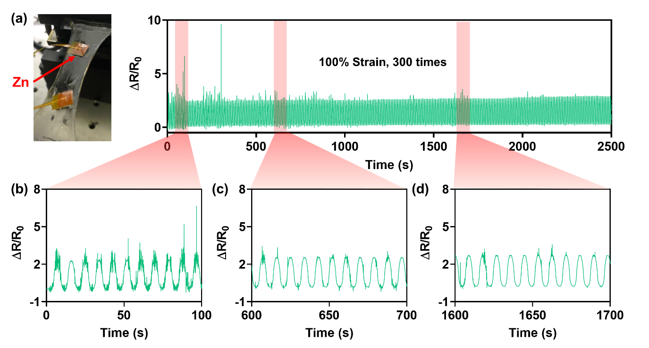
Fig. S22 (a) The resistance response (ΔR/R₀) between the two zinc electrodes without electrochemical treatment during 300 times stretching of the organohydrogel to 100% strain. (b-d) Magnified resistance response from 0-100 s, 600-700 s and 1600-1700 s in (a), respectively.

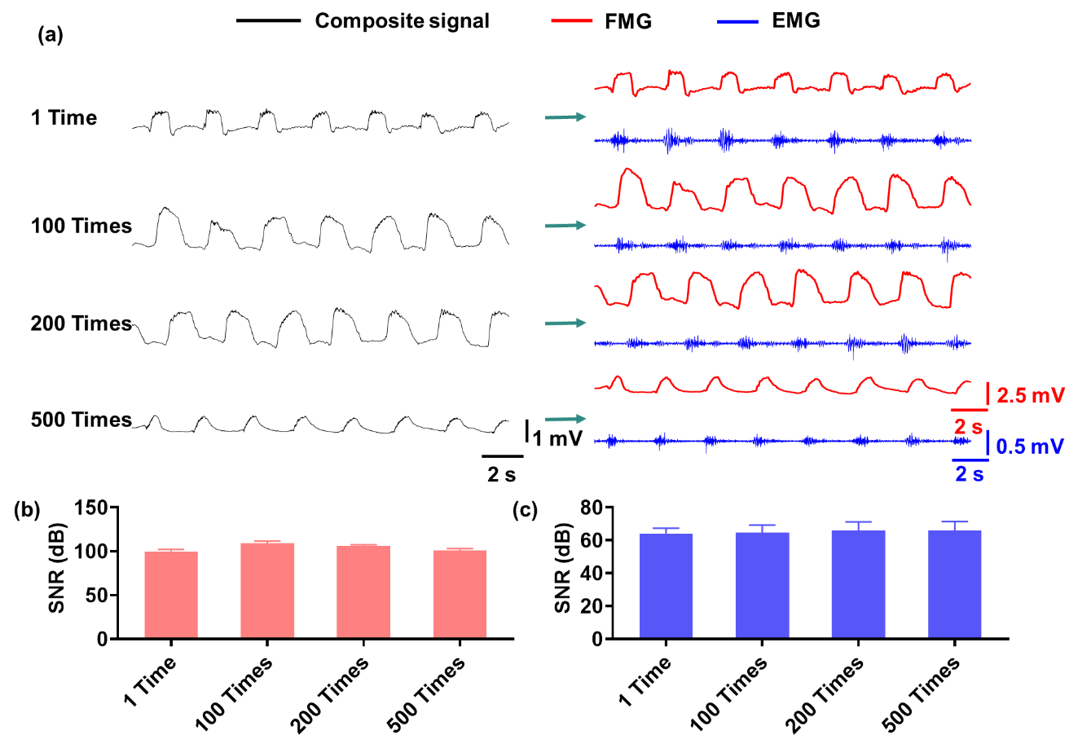
Fig. S23 (a) EMG-FMG dual-mode signals obtained by IEFDS with different times of repeated usage. (b) and (c) Plots of the SNR of FMG and EMG signals versus the times of repeated usage, respectively, which are extracted from (a). After 500 times of repeated paste-removal process from skin, the IEFDS still maintains good sensing performance with unimpaired SNR.

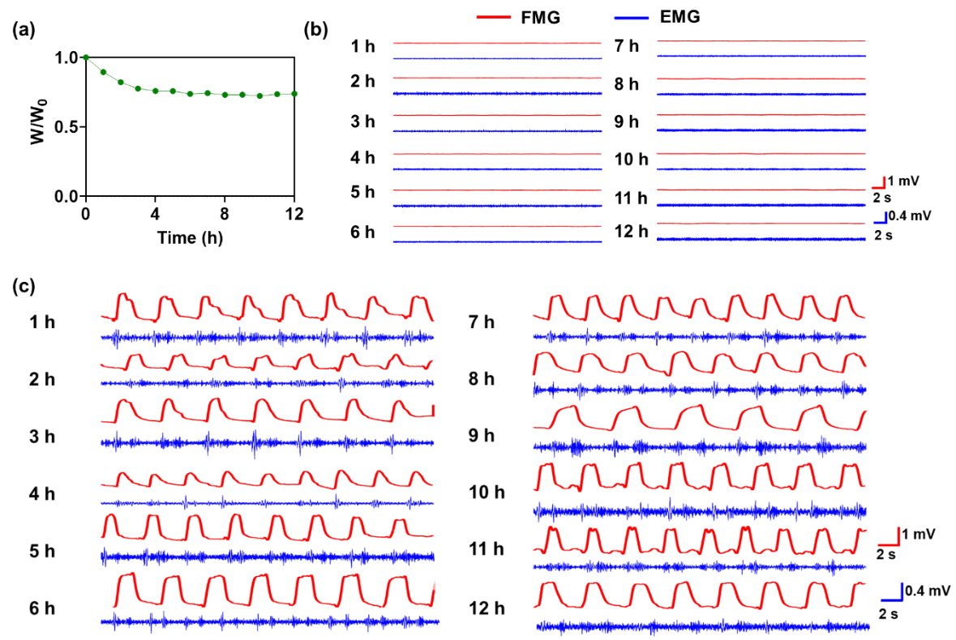
Fig. S24 Characterization of dehydration of organohydrogel and degradation of sensing signal quality for IEFDS worn on the skin for 12 h. (a) Relative weight change of IEFDS for 12 h. (b) Baseline evolution of IEFDS for 12 h. (c) EMG and FMG signals of fist-clenching obtained hourly by IEFDS.
Supplementary Note 4: Discussion on the biocompatibility of 0.015TA-0.1CA-PAM organohydrogel
The biocompatibility of epidermal electronics is essential since it is in direct and prolonged contact with the skin. We evaluate the cytotoxicity of 0.015TA-0.1CA-PAM organohydrogel using L929 cells. Live/dead staining is conducted on L929 cells co-cultured with the gel after 24 h. Consistent with the blank control group, there is no significant cell death induced by the gel, or inhibition of cell growth for the gel in the CCK-8 test, demonstrating the gel’s good cellular biocompatibility (Fig. S25a-b). Furthermore, the blood compatibility is evaluated using a hemolysis test with murine blood (Fig. S25c). Compared with the control hemolysis samples of distilled water (positive control) and PBS (negative control), the hemolysis ratio of organohydrogel is less than 1%, indicating excellent blood biocompatibility for biological applications. Furthermore, no skin irritation was observed after 12 h of organohydrogel wearing, demonstrating its practical applicability (Fig. S25d). Notably, TA can inhibit bacterial proliferation by blocking cell wall synthesis, destroying cell structure, preventing biofilm formation, and inhibiting enzyme activity and bacterial adhesion⁵. Therefore, the incorporation of TA also endows the organohydrogel with antibacterial property. Specifically, after co-incubation of the bacteria Escherichia coli (E. coli) with the gel sample, the bacteria colonies become significantly fewer than the control group, revealing the organohydrogel’s antibacterial capacity (Fig. S25e). This property is particularly advantageous for monitoring electrophysiological signals at wound sites. Considering its superior comprehensive properties, 0.015TA-0.1CA-PAM organohydrogel is selected for further analysis.

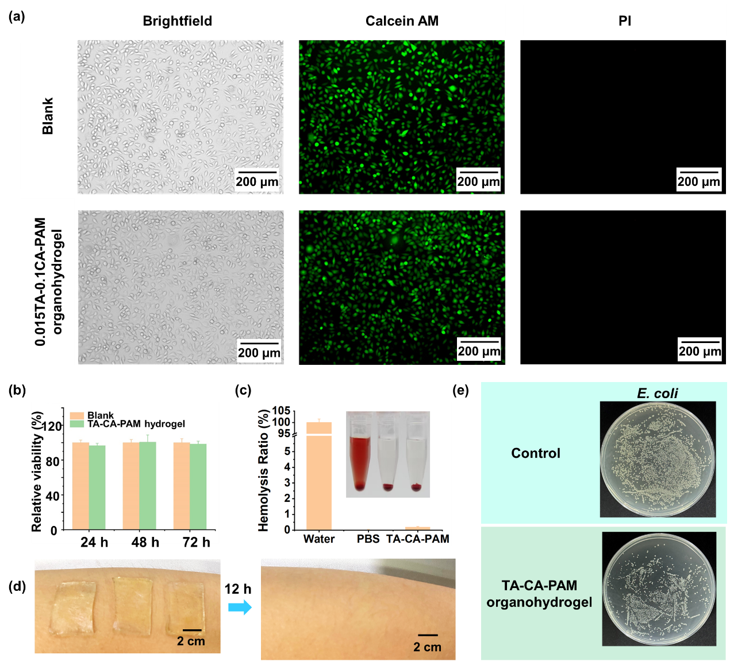
Fig. S25 (a) The biocompatibility test of 0.015TA-0.1CA-PAM organohydrogel for L929 cells. The live/dead staining was conducted on L929 cells co-cultured with the organohydrogel after 24 h. (b) Relative viability (%) is evaluated using CCK-8 test on L929 cells co-cultured with the TA-CA-PAM hydrogel after 24, 48, and 72 h, respectively. (c) Hemolysis test of organohydrogel. PBS and distilled water are used as the negative and positive controls, respectively. (d) Photographs show the skin when wearing the organohydrogel and after wearing it for 12 h. (e) In vitro antibacterial activities of the TA-CA-PAM organohydrogel are assessed against E. coli. Survival bacteria were cloned on agar plates.

Supplementary Note 5: Definitions of EMG and FMG signal feature parameters
FMG-PP: The resistance magnitude extracted from FMG signal.
FMG-DerMax: The maximum of the derivative of FMG signal.
FMG-DerMin: The minimum of the derivative of FMG signal.
EMG-Max: The maximum values of EMG signal.
EMG-Max10: Average of maximum 10 values of EMG signal.
EMG-Max50: Average of maximum 50 values of EMG signal.
EMG-Min10: Average of minimum 10 values of EMG signal.
EMG-Min50: Average of minimum 50 values of EMG signal.
EMG-PP: Peak-to-peak of EMG signal.
EMG-AbsAve: Absolute mean of EMG signal.
EMG-Rms: Root Mean Square of EMG signal.
EMG-Std: Standard deviation of EMG signal.
EMG-Var: Variance of EMG signal.
EMG-FreStd: Standard deviation of EMG signal in the frequency domain.
EMG-FrreMax: The maximum of EMG signal in the frequency domain.
EMG-AbsSum: Absolute sum of EMG signal.

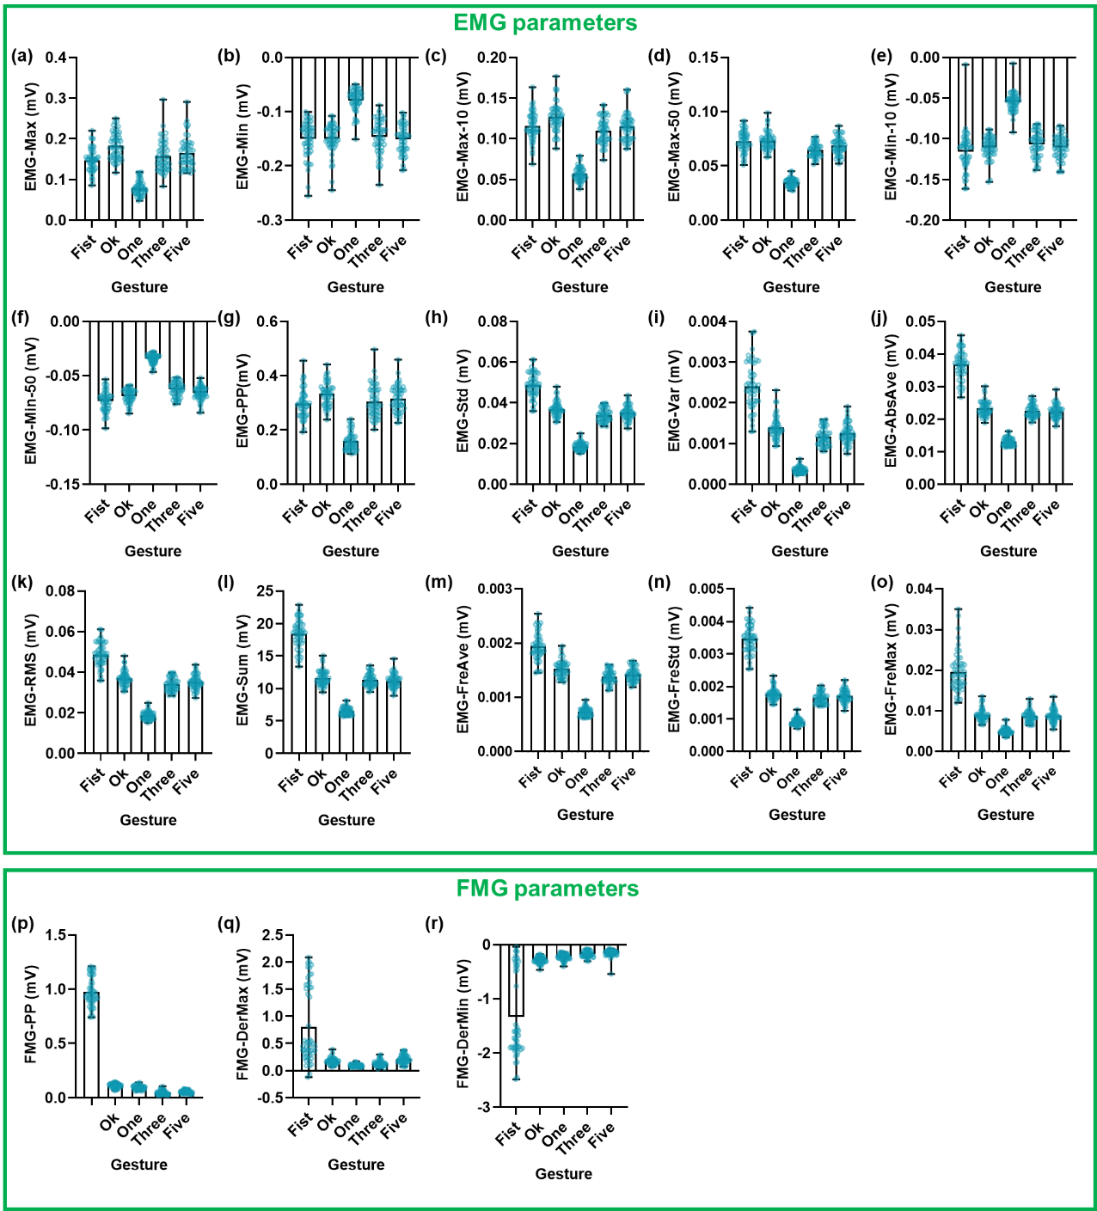
Fig. S26 Numerical distribution of different gestures (Gestures: Fist, Ok, One, Three, and Five) for each parameter when the IEFDS is employed. (a) EMG-Max, (b) EMG-Min, (c) EMG-Max10, (d) EMG-Max50, (e) EMG-Min10, (f) EMG-Min50, (g) EMG-PP, (h) EMG-Std, (i) EMG-Var, (j) EMG-AbsVar, (k) EMG-RMS, (l) EMG-Sum, (m) EMG-FreAve, (n) EMG-FreStd, (o) EMG-FreMax, (p) FMG-PP, (q) FMG-DerMax. (r) FMG-DerMin.

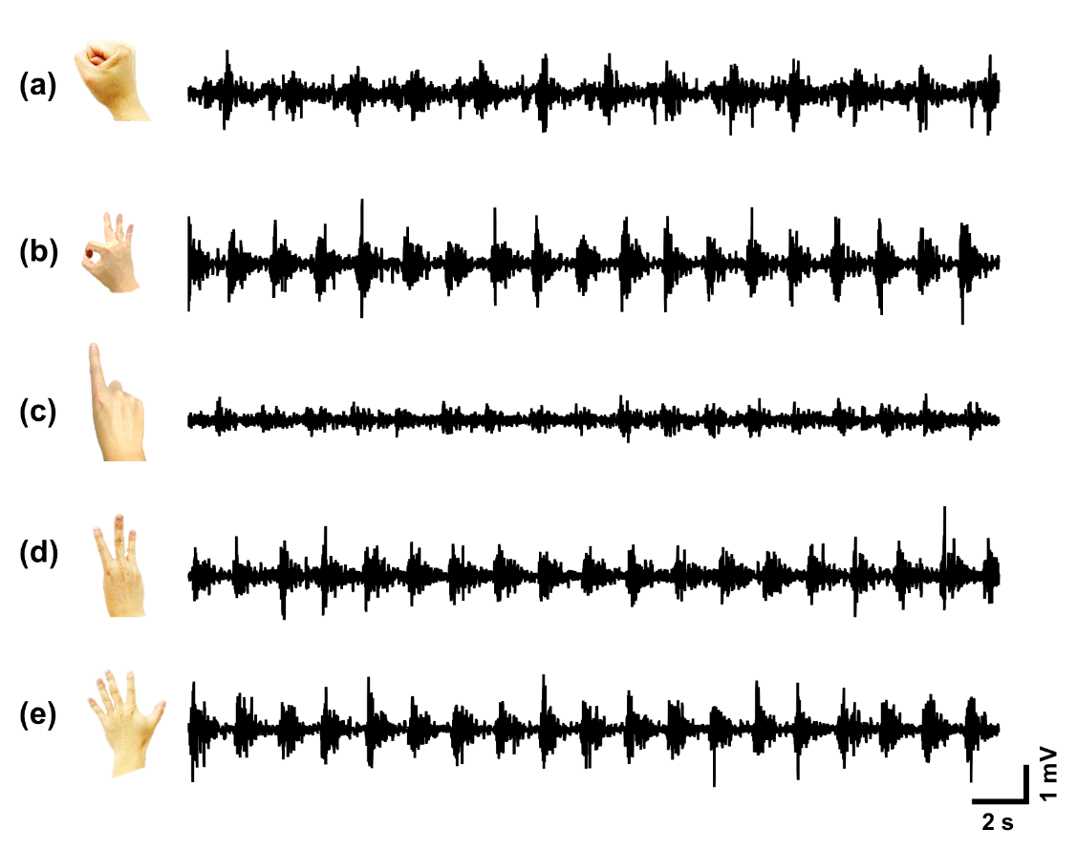
Fig. S27 EMG signals of different gestures obtained by commercial Ag/AgCl electrodes. (a) Fist. (b) Ok. (c) One. (d) Three. (e) Five.

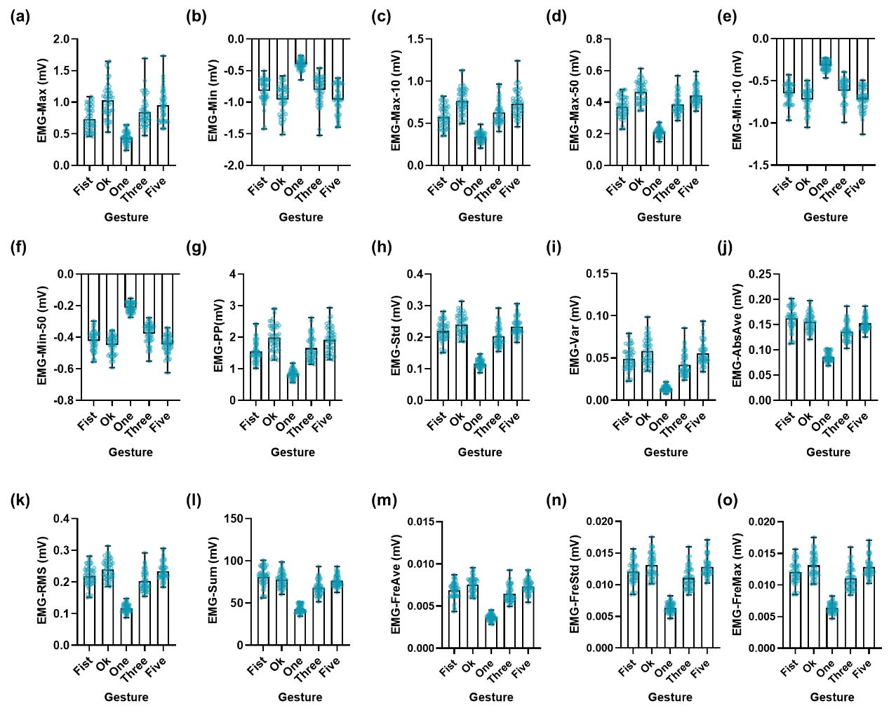
Fig. S28 Numerical distribution of different gestures (Gestures: Fist, Ok, One, Three, and Five) for each parameter, which are obtained by commercial EMG module. (a) EMG-Max, (b) EMG-Min, (c) EMG-Max10, (d) EMG-Max50, (e) EMG-Min10, (f) EMG-Min50, (g) EMG-PP, (h) EMG-Std, (i) EMG-Var, (j) EMG-AbsVar, (k) EMG-RMS, (l) EMG-Sum, (m) EMG-FreAve, (n) EMG-FreStd, (o) EMG-FreMax.
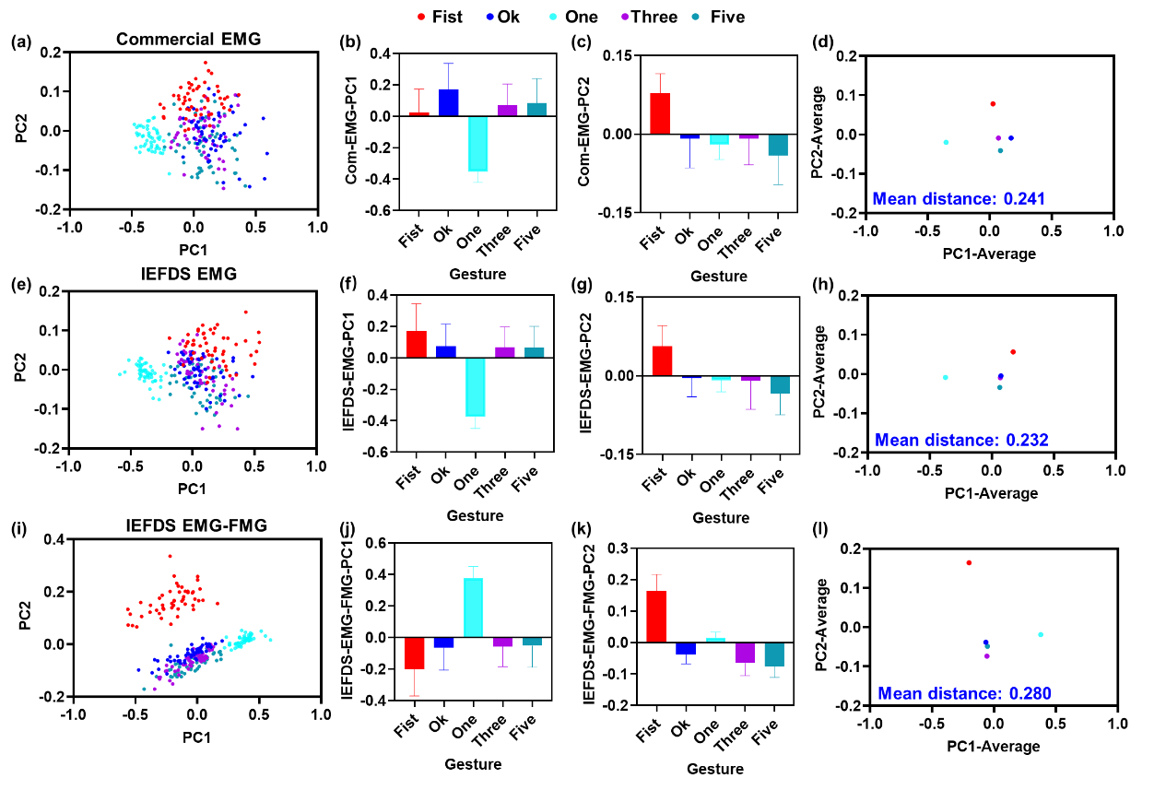
Fig. S29 (a) PCA of EMG signals obtained by commercial EMG electrodes. (b-c) Average PC1 and PC2 values for different gestures in commercial EMG model. (d) Average PC1-PC2 distribution of commercial EMG model. (e) PCA of EMG signals obtained by IEFDS. (f-g) Average PC1 and PC2 values for different gestures in IEFDS EMG model. (h) Average PC1-PC2 distribution of IEFDS EMG model. (i) PCA of EMG-FMG dual-mode signals obtained by IEFDS. (j-k) Average PC1 and PC2 values for different gestures in IEFDS EMG-FMG model. (l) Average PC1-PC2 distribution of IEFDS EMG-FMG model.
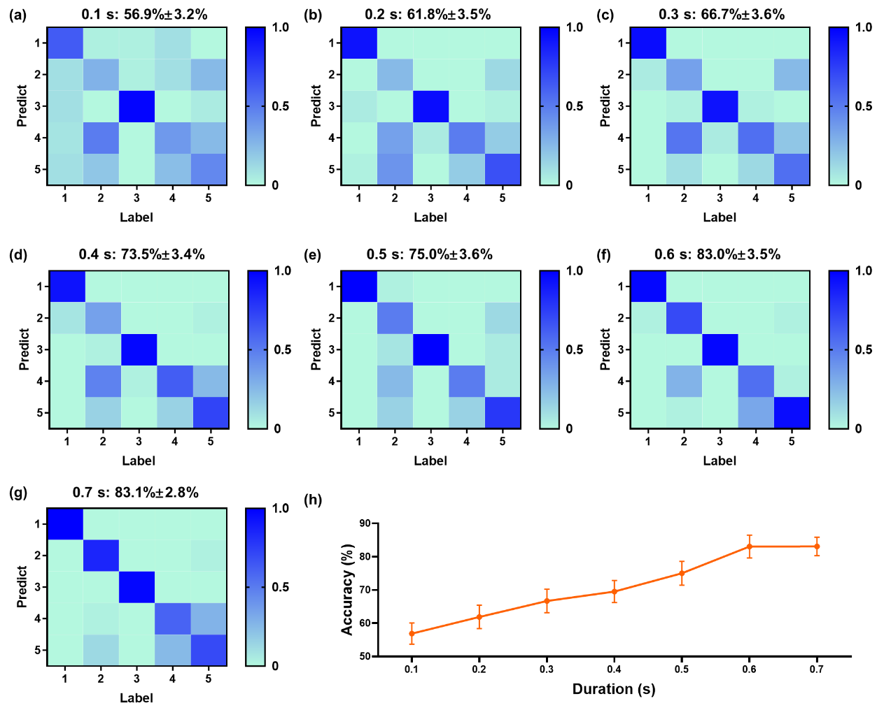
Fig. S30 Distribution and accuracy rates of recognition accuracy for the EMG-FMG dual-mode signals with different durations. (a) 0.1 s. (b) 0.2 s. (c) 0.3 s. (d) 0.4 s. (e) 0.5 s. (f) 0.6 s. (g) 0.7 s. (h) Duration-accuracy distribution curve. Labels 1 to 5 represent fist, ok, one, three and five respectively.
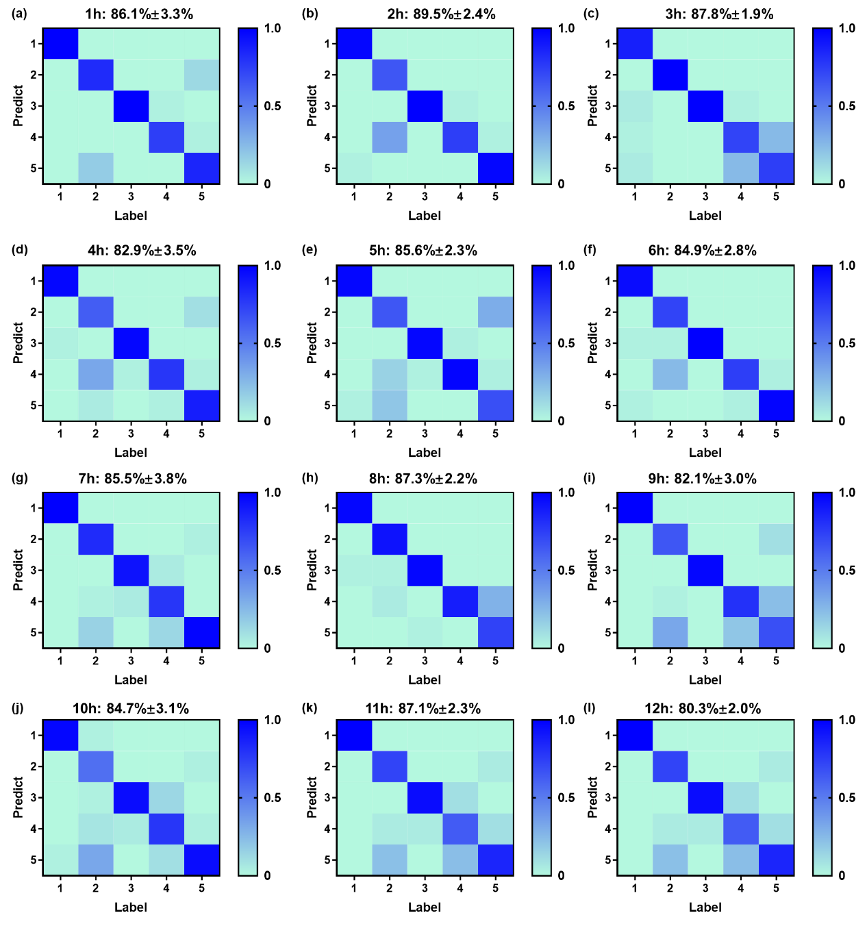
Fig. S31 The action recognition accuracy of IEFDS within 12 h when worn on the extensor muscles of the arm. (a) 1 h. (b) 2 h. (c) 3 h. (d) 4 h. (e) 5 h. (f) 6 h. (g) 7 h. (h) 8 h. (i) 9 h. (j) 10 h. (k) 11 h. (l) 12 h. Labels 1 to 5 represent the gestures of fist, ok, one, three and five respectively.
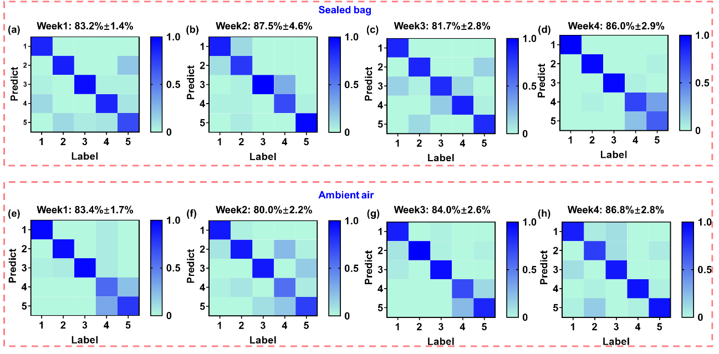
Fig. S32 The accuracy test of action recognition of IEFDS placed in a sealed bag and ambient air for different time. (a-d) The recognition accuracy of IEFDS after being placed in a sealed bag for one, two, three and four weeks, respectively. (e-h) The recognition accuracy of IEFDS after being exposed to air for one, two, three and four weeks, respectively.

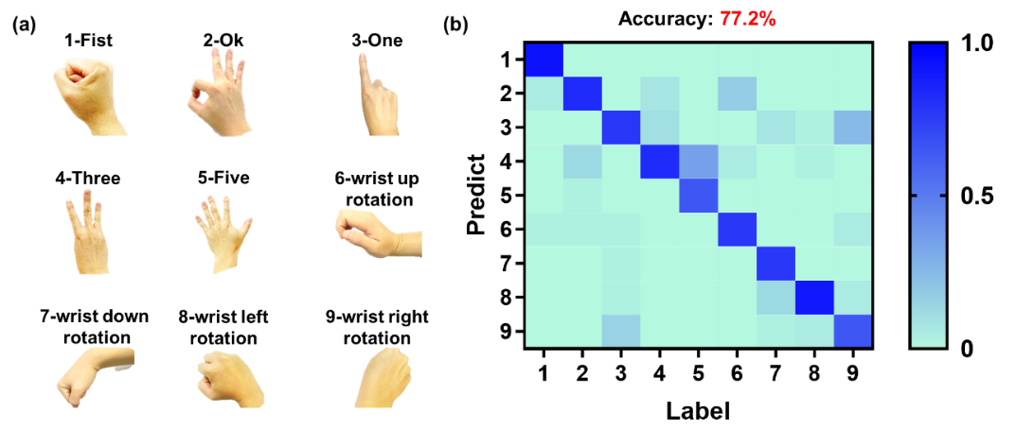
Fig. S33 (a) Photos showing nine different hand actions, including “1-Fist”, “2-Ok”, “3-One”, “4-Three”, “5-Five”, “6-wist up rotation”, “7-wist down rotation”, “8-wist left rotation” and “9-wist right rotation”, recognized by the IEFDS. (b) The recognition accuracy of single-channel IEFDS for the above 9 types of actions.

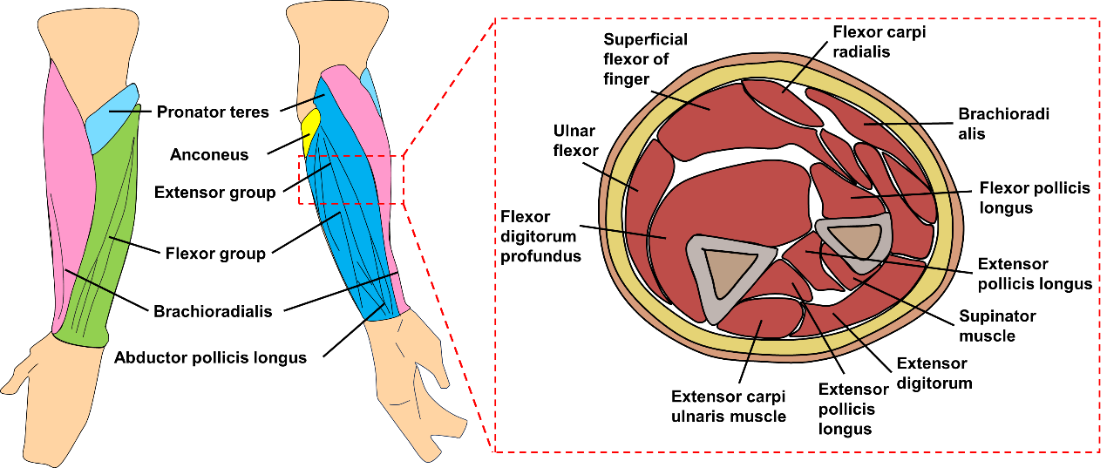
Fig. S34 Diagram illustrating the distribution of muscles on the arm.

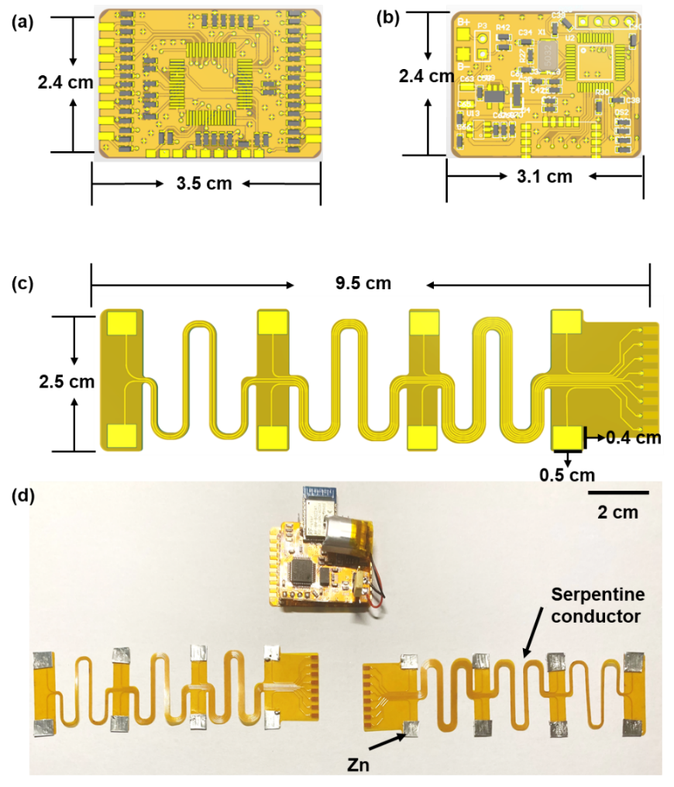
Fig. S35 (a), (b) and (c) Layouts and sizes of the 8-channel differential amplifier circuit, the wireless signal acquisition and transmission circuit, and the stretchable electrodes and leads, respectively. (d) Photograph showing the 8-channel differential signal acquisition circuit (above) and two 4-channel stretchable electrode arrays (below) of the HMI bracelet.
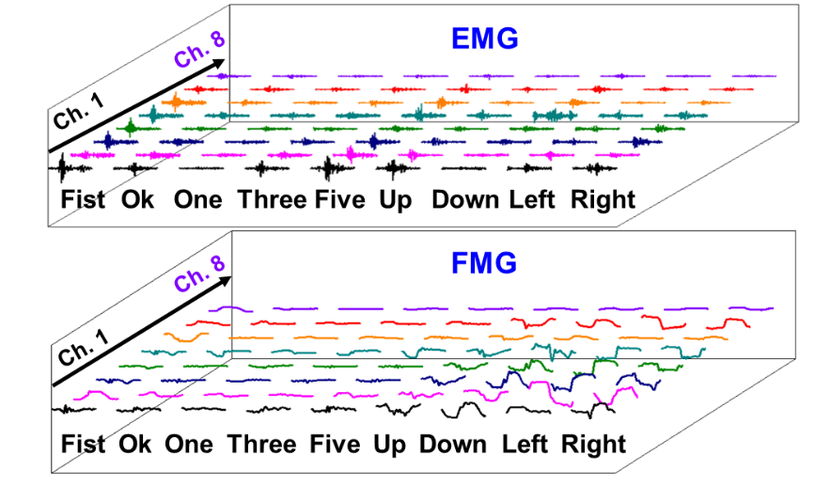
Fig. S36 EMG and FMG signals obtained by sensing channel from 1 to 8 on the multichannel bracelet for 9 distinct actions, respectively.

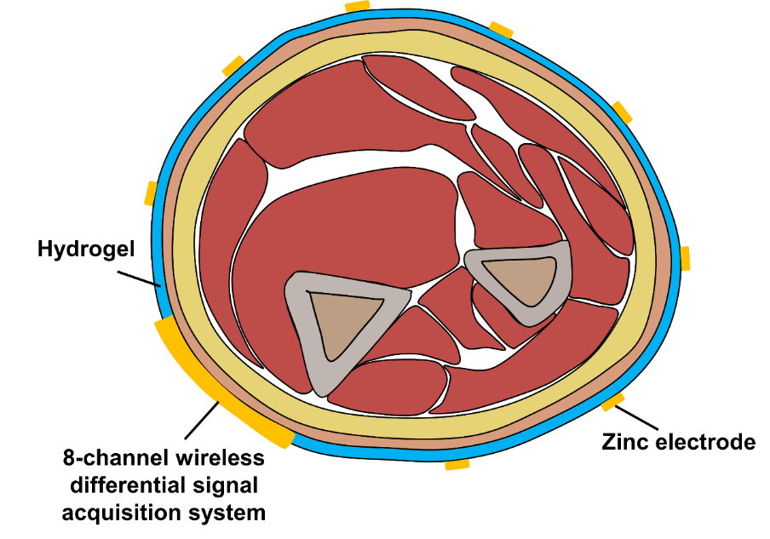
Fig. S37 The cross-section diagram of this HMI bracelet wearing on the arm. The bracelet can obtain comprehensive movement information of multiple muscles using the sensor array located around the arm, leading to a high action recognition accuracy.

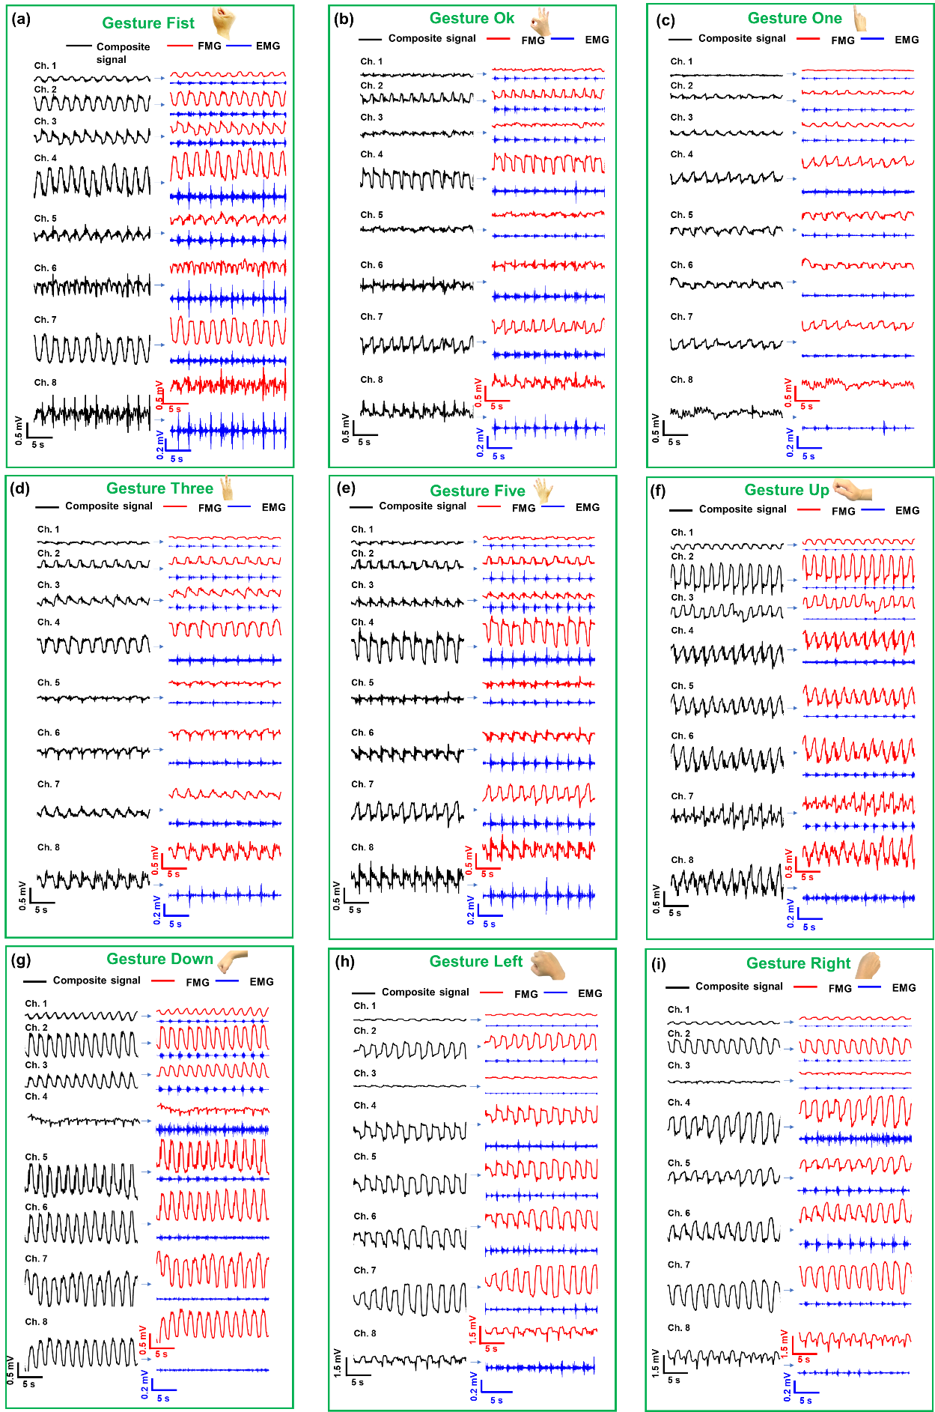
Fig. S38 8-channel repeatable EMG-FMG signals obtained by this adaptable bracelet corresponding to different repeated hand gestures: (a) Fist. (b) Ok. (c) One. (d) Three. (e) Five. (f) Up. (g) Down. (h) Left. (i) Right.
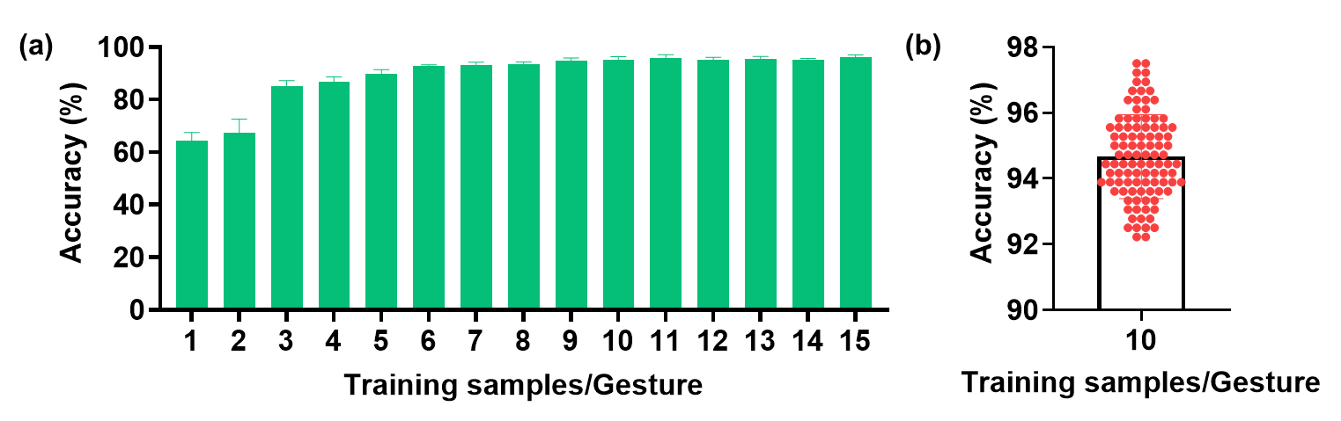
Fig. S39 (a) Plot of recognition accuracy versus the number of training samples for each gesture. (b) Distribution of recognition accuracy among different training samples and test samples after 100 different training-testing iterations.

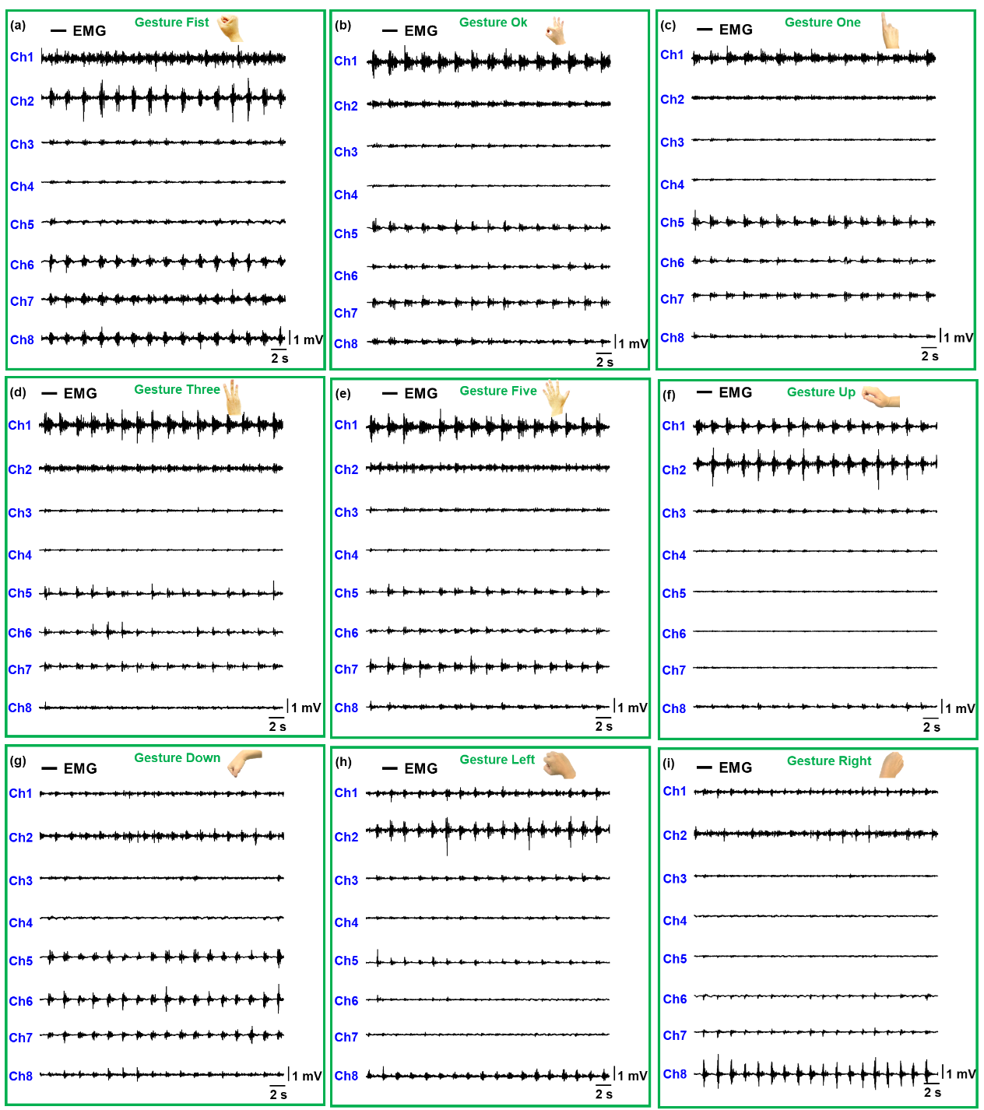
Fig. S40 8-channel EMG signals obtained by commercial EMG electrodes corresponding to different gesture actions. (a) Fist. (b) Ok. (c) One. (d) Three. (e) Five. (f) Up. (g) Down. (h) Left. (i) Right.

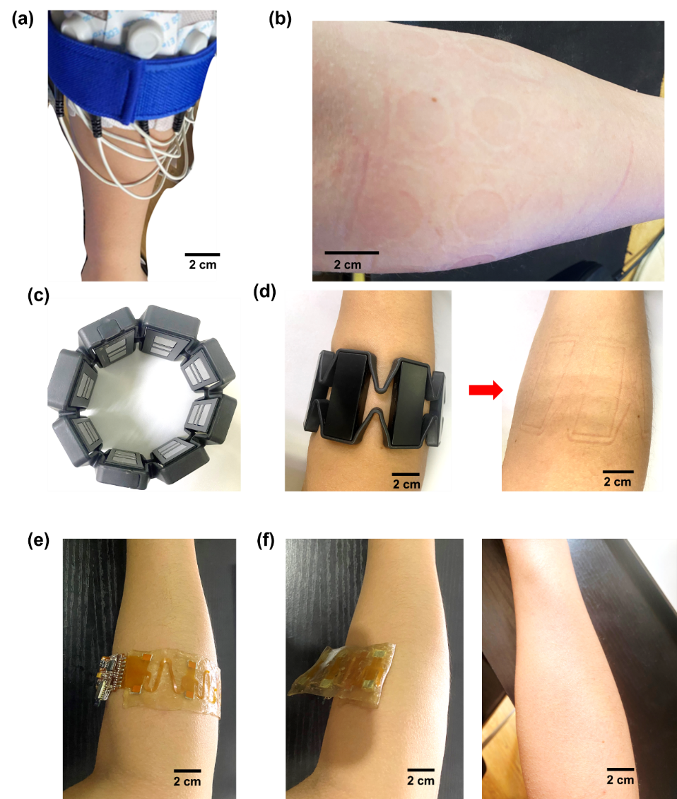
Fig. S41 (a) Photo of the 8-channel HMI system built with commercial discrete electrodes wearing on the forearm. (b) Photo of the forearm after wearing the HMI system for 2 h shows many red marks left on the arm. (c) Photograph of a commercial HMI bracelet (Myo armband). (d) Photograph of the arm after wearing the commercial HMI bracelet for 2 h, showing noteworthy concave imprints on the arm after the wearing. (e) Photograph showing the HMI bracelet wearing on the arm. (f) Photograph of the arm after wearing the HMI bracelet for 2 h. The bracelet does not cause any trace or discomfort on the skin and maintains good adhesion after 2 h.
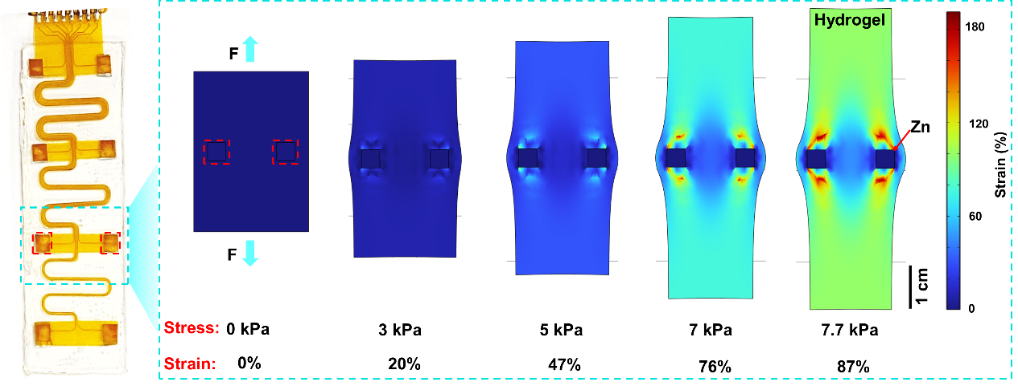
Fig. S42 Stress-strain simulation of single-channel IEFDS. The square regions define the locations of zinc electrodes.

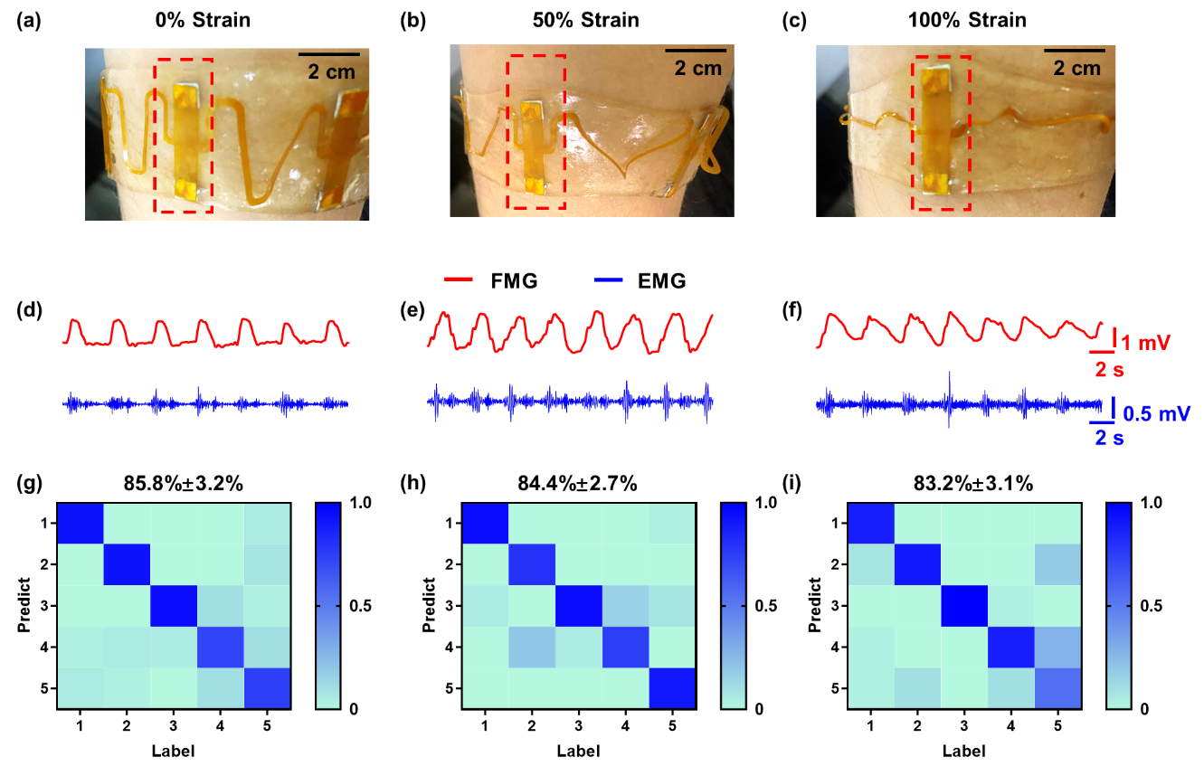
Fig. S43 Sensing performance of IEFDS under different strain states. (a-c) Photographs of IEFDS worn on arm under 0%, 50%, and 100% tensile strains. (d-f) EMG-FMG dual-mode signals of fist motions collected by IEFDS under 0%, 50%, and 100% strains. (g-i) Recognition accuracy of IEFDS for different motions (1: Fist, 2: Ok, 3: One, 4: Three, 5: Five) under 0%, 50%, and 100% strains.

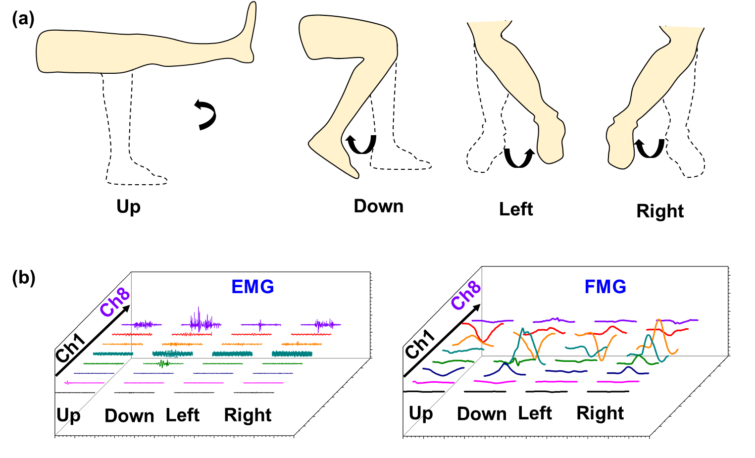
Fig. S44 (a) Action diagram of the calf. (b) EMG and FMG signals captured by the 8-channel HMI bracelet corresponding to various movements of the calf.

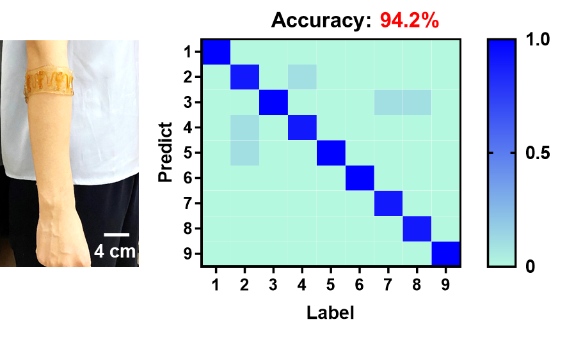
Fig. S45 Photograph and recognition accuracy of the HMI bracelet worn on a female arm with a circumference of 23 cm.

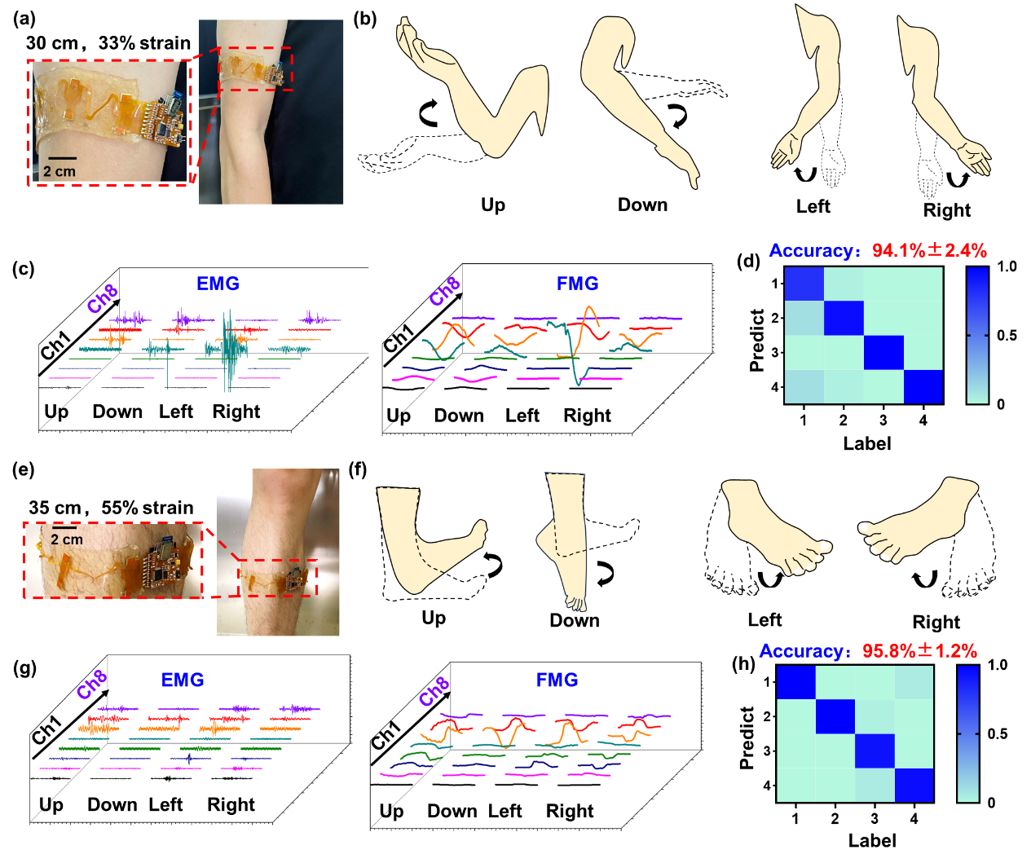
Fig. S46 (a) and (e) Photographs of the same bracelet interface worn on the upper arm and calf with the circumferences of 30 and 35 cm, respectively, in which the stretchable bracelet is at 33% and 55% tensile strains, respectively. (b) and (f) Action diagrams of arm and ankle, respectively. (c) and (g) EMG and FMG signals captured by the HMI bracelet corresponding to various movements of the upper arm and calf, respectively. (d) and (h) Recognition accuracies of the HMI bracelet for different movements of the upper arm and calf, respectively.
Table S1. Comparison of the performance of state-of-the-art HMI bracelets.
Sensor type/signals | Innovative sensing mechanism | Recognition  accuracy | self-adhesive | Stretchability | Wireless sensing | Applications | Number of channels | Refs.
Integrated EMG-FMG dual-mode sensing/EMG and FMG | Yes | 94.7%,  9 actions | Yes | 100% | Yes | Active rehabilitation, robotic arm/hands, intelligent vehicle | 8, 8 | ^{This work}
Electrophysiological electrode/EMG | No | 89%,  6 actions | Yes | 18% | Yes | Active rehabilitation | 8 | ⁶
Electrophysiological electrode, inertial measurement unit (IMU)/EMG and IMU | No | 92.6%,  8 actions | No | No | No | No | 4, 1 | ⁷
Triboelectric nanogenerators/FMG | No | 92.6%,  26 actions | No | No | Yes | No | 8 | ⁸
Air pressure sensor/FMG | No | 94%,  10 actions | No | No | No | No | 10 | ⁹
Electrophysiological electrode/EMG | No | 97.69%,  5 actions | Yes | No | No | No | 4 | ¹⁰
Electrophysiological electrode/EMG | No | 97.8%,  18 actions | No | 30% | No | No | 8 | ¹¹

Supplementary Note 6: Discussion on the research progress of active rehabilitation robots
With changes in lifestyle and diet, stroke becomes one of the major health issues worldwide^{12,13}. For stroke survivors, neural pathway damage will lead to severe motor dysfunction that greatly affects their daily life¹⁴. Fortunately, repetitive physical training has been recognized as an effective means for rehabilitation that enhances neural networks in frequently used areas of the brain, helping improve hemiplegic symptoms and promote recovery¹⁵. However, traditional passive rehabilitation methods require the involvement of medical professionals, which are expensive and have limited access during infectious disease pandemics¹⁶. To fill this gap, exoskeleton rehabilitation robots have emerged. These robots can assist patients with precise repetitive movements, and control the frequency and intensity of movement more accurately than manual methods, and therefore have been widely utilized in clinical settings^{17,18}. Nevertheless, the effect of passive rehabilitation is still limited because it fails to establish a closed neural circuit between the patient's intention and the execution of the movement¹⁹. In recent years, active rehabilitation strategy has increasingly received attention. It utilizes advanced HMI technology to capture patients' motion intention so that the patients can actively participate in the rehabilitation training^{14,20}. Despite the progress made in this area, existing active rehabilitation robots still need to be improved in terms of recognition accuracy, comfort, and portability in order to be better applied to home rehabilitation (Table S2).

Table S2. Comparison in the performance of state-of-the-art active rehabilitation equipment.
Sensor type/signals | Recognition Accuracy | Device stretchability | Self-adhesion | Wireless sensing | Flexible gloves | Refs.
Integrated EMG-FMG dual-mode sensing/EMG, FMG | 94.7% | Yes | Yes | Yes | Yes | ^{This work}
Electrophysiological electrode/EMG | 80.09% | No | No | Yes | Yes | ²¹
Force-sensitive  resistors/FMG | 95% | No | No | No | Yes | ²²
Piezoelectric sensors/FMG | 80% | No | No | No | No | ²³
Force-sensitive  resistors/FMG | 92.9% | No | No | No | Yes | ²⁴
Electrophysiological electrode/EMG | 84.1% | No | Yes | No | No | ²⁵
Electrophysiological electrode/EEG, EMG | 92.81% | No | Yes | No | No | ²⁶
Electrophysiological electrode/EEG | 95% | No | No | Yes | No | ²⁷
Electrophysiological electrode/EEG, EMG | 85.2% | No | Yes | No | No | ²⁸

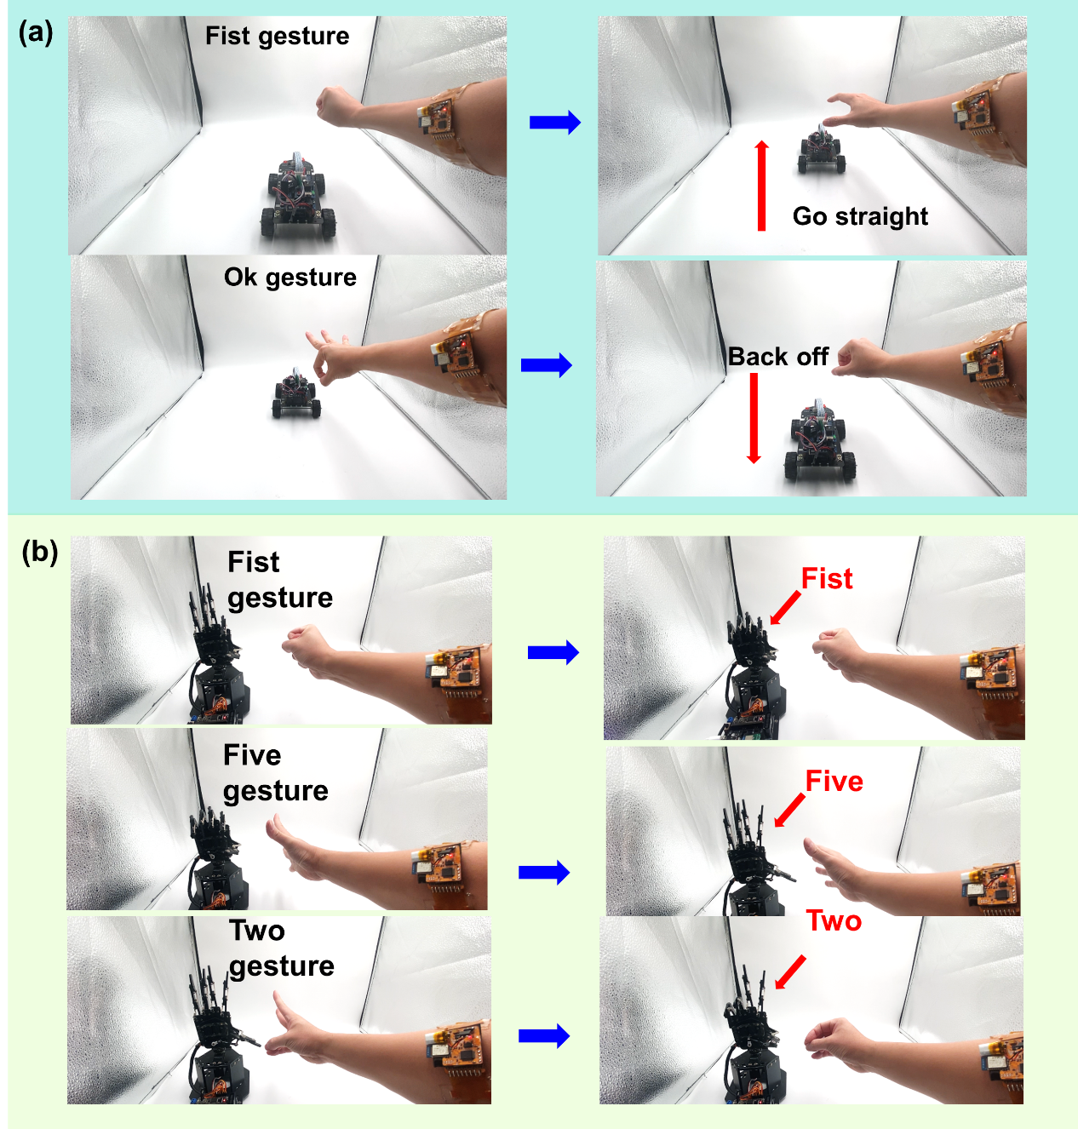
Fig. S47 The wireless HMI bracelet is exploited to remotely control the movement of an intelligent car. (b) The wireless HMI bracelet is exploited to remotely control the actions of robotic hands.

Supplementary Note 7: Biocompatibility testing methods
The blood compatibility was evaluated with hemolysis test using murine blood. Firstly, the whole blood in heparin tube was centrifuged at 3000 rpm for 5 min, and the erythrocytes were diluted with PBS to a final concentration of 5% (v/v). The 0.015TA-0.1CA-PAM organohydrogel (0.03 g) in 500 μL PBS was added into 500 μL diluted blood and kept at 37 ℃ for 30 min. The 540 nm absorbance of supernatant was measured after centrifuging at 3000 rpm for 5 min. Distilled water (500 μL) and PBS (500 μL) were added into 500 μL diluted blood and used as 100% hemolysis sample (positive control) and 0% hemolysis sample (negative control), respectively. The hemolysis ratio (HR) was calculated according to the equation: HR (%) = (As-An)/(Ap-An)×100%, where As, An, and Ap represent the absorbance values of supernatant resulted from the samples of organohydrogel, negative and positive controls, respectively.
The cytotoxicity of organohydrogel was assessed using L929 cells. The organohydrogel was sterilized with UV irradiation for 30 min and then soaked in a culture medium. L929 cells were seeded in a 24-well plate at a density of 2 × 10⁴ cells/well and co-cultured with organohydrogel (0.03 g). After 24 h, live/dead staining was conducted on L929. Consistent with blank control, there was no significant dead cell induced by the organohydrogel. In addition, CCK-8 tests were conducted after 24, 48, and 72 h of co-culture. The antibacterial properties of organohydrogel were investigated in vitro on E. coli. The bacteria were co-incubated with the UV sterilized organohydrogel (0.1 g) at 37 ℃ and 220 rpm for 6 h to a final concentration of 10⁷ CFU/mL, while PBS of the same weight was applied as control group. After that, the bacteria were diluted to 1000 times by PBS, and 20 μL bacteria were coated on LB agar plate and incubated at 37 ℃ for 16 h.

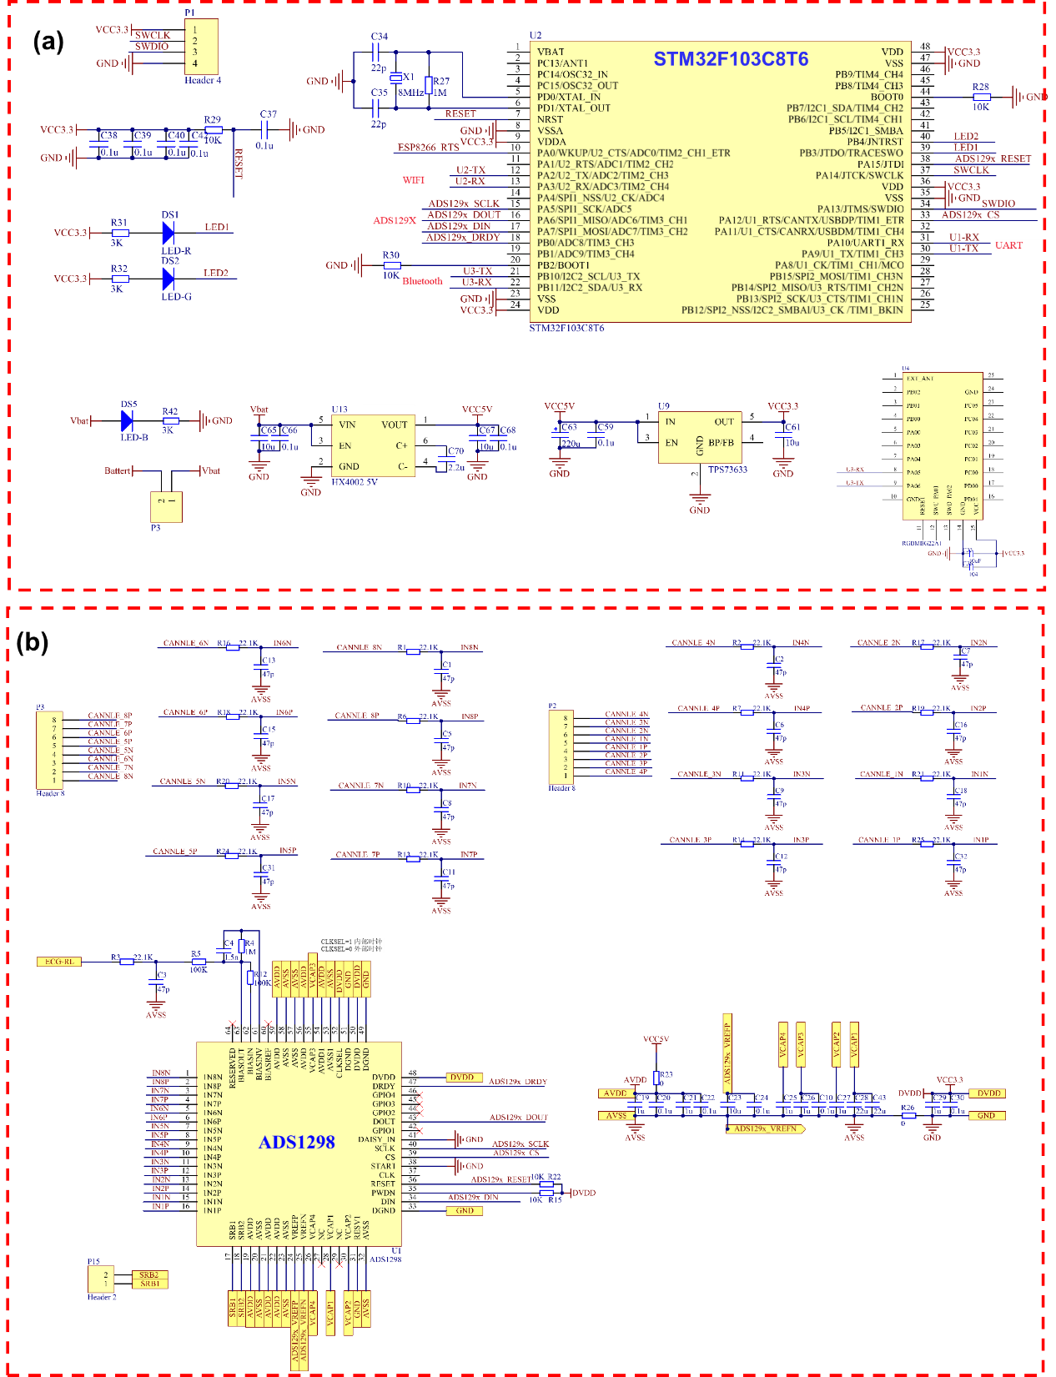
Fig. S48 (a) The schematic of wireless signal acquisition and transmission circuit. (b) The diagram of 8-channel differential amplifier circuit.

Supplementary Note 8: Actuator systems construction
Flexible active rehabilitation robot: The flexible active rehabilitation robot exploits an STM32F103C8T6 microcontroller to control the inflation and deflation of 5 air pumps, enabling finger flexion and extension. The EFR32BG22 Bluetooth module receives server instructions and forwards them to the MCU for execution.

Robotic arm control: The robotic arm is controlled by an STM32F103RBT6 microcontroller and performs actions using five LFD-01 anti-blocking rudders. The MCU outputs PWM signals through its I/O ports to adjust the manipulator's position. Additionally, the EFR32BG22 Bluetooth module receives server instructions and forwards them to the MCU for execution.

Intelligent car control: The STM32F103RCT6 microcontroller serves as the core control unit for the intelligent car. It sends PWM signals to the L293D driver to control the speed and direction of two direct current motors, thereby adjusting the car's driving direction. Additionally, the onboard EFR32BG22 Bluetooth module receives instructions from the server and transmits them to the MCU for processing.

Robotic arms/hands control: The manipulator adopts Jetson NanoB01 as the main controller to control 7 stepper motors to realize the movement of the manipulator with 7 degrees of freedom and complete various fine actions. The EFR32BG22 Bluetooth module receives server instructions and forwards them to the MCU for execution.

References
1 Ji, S. et al. Water‐resistant conformal hybrid electrodes for aquatic endurable electrocardiographic monitoring. Adv. Mater. 32, 2001496 (2020).
2 Guo, S. et al. Precisely manipulating polymer chain interactions for multifunctional hydrogels. Matter 8, 101785 (2025).
3 Li, P. et al. N-type semiconducting hydrogel. Science 384, 557-563 (2024).
4 Dai, Y. et al. Soft hydrogel semiconductors with augmented biointeractive functions. Science 386, 431-439 (2024).
5 Hosseini, M. et al. The Multifaceted Role of Tannic Acid: From Its Extraction and Structure to Antibacterial Properties and Applications. Prog. Polym. Sci. 160, 101908 (2024).
6 Tian, L. et al. Large-area MRI-compatible epidermal electronic interfaces for prosthetic control and cognitive monitoring. Nat. Biomed. Eng. 3, 194-205 (2019).
7 Jiang, S. et al. Feasibility of wrist-worn, real-time hand, and surface gesture recognition via sEMG and IMU sensing. IEEE T. Ind. Inform. 14, 3376-3385 (2017).
8 Tan, P. et al. Self‐powered gesture recognition wristband enabled by machine learning for full keyboard and multicommand input. Adv. Mater. 34, 2200793 (2022).
9 Shull, P. B., Jiang, S., Zhu, Y. & Zhu, X. Hand gesture recognition and finger angle estimation via wrist-worn modified barometric pressure sensing. IEEE Trans. Neural Syst. Rehabil. Eng 27, 724-732 (2019).
10 Yoon, H. et al. Adaptive epidermal bioelectronics by highly breathable and stretchable metal nanowire bioelectrodes on electrospun nanofiber membrane. Adv. Funct. Mater. 34, 2313504 (2024).
11 Lee, H. et al. Stretchable array electromyography sensor with graph neural network for static and dynamic gestures recognition system. npj Flexible Electron. 7, 20 (2023).
12 Atella, V. et al. Trends in age‐related disease burden and healthcare utilization. Aging cell 18, e12861 (2019).
13 Mishra, A. et al. Stroke genetics informs drug discovery and risk prediction across ancestries. Nature 611, 115-123 (2022).
14 Costandi, M. Rehabilitation: machine recovery. Nature 510, S8-S9 (2014).
15 Kumar, S., Selim, M. H. & Caplan, L. R. Medical complications after stroke. Lancet Neurol. 9, 105-118 (2010).
16 Vallés, M. et al. A 3-PRS parallel manipulator for ankle rehabilitation: towards a low-cost robotic rehabilitation. Robotica 35, 1939-1957 (2017).
17 Chen, X. et al. A wearable hand rehabilitation system with soft gloves. IEEE Trans. Ind. Informat. 17, 943-952 (2020).
18 Wang, D. et al. Toward whole-hand kinesthetic feedback: A survey of force feedback gloves. IEEE T. Haptics 12, 189-204 (2018).
19 Baniqued, P. D. E. et al. Brain–computer interface robotics for hand rehabilitation after stroke: a systematic review. J. NeuroEng. Rehabil. 18, 1-25 (2021).
20 Siviy, C. et al. Opportunities and challenges in the development of exoskeletons for locomotor assistance. Nat. Biomed. Eng. 7, 456-472 (2023).
21 Sierotowicz, M. et al. EMG-driven machine learning control of a soft glove for grasping assistance and rehabilitation. IEEE Rob. Autom. Lett. 7, 1566-1573 (2022).
22 Yap, H. K., Mao, A., Goh, J. C. & Yeow, C.-H. Design of a wearable FMG sensing system for user intent detection during hand rehabilitation with a soft robotic glove. in 2016 6th IEEE International Conference on Biomedical Robotics and Biomechatronics (BioRob). 781-786 (IEEE).
23 Ha, N., Withanachchi, G. P. & Yihun, Y. Performance of forearm FMG for estimating hand gestures and prosthetic hand control. J. Bionic. Eng. 16, 88-98 (2019).
24 Gantenbein, J., Ahmadizadeh, C., Heeb, O., Lambercy, O. & Menon, C. Feasibility of force myography for the direct control of an assistive robotic hand orthosis in non-impaired individuals. J. NeuroEng. Rehabil. 20, 101 (2023).
25 Lu, Z., Tong, K.-y., Zhang, X., Li, S. & Zhou, P. Myoelectric pattern recognition for controlling a robotic hand: a feasibility study in stroke. IEEE T. Biomed. Eng. 66, 365-372 (2018).
26 Chowdhury, A., Raza, H., Meena, Y. K., Dutta, A. & Prasad, G. An EEG-EMG correlation-based brain-computer interface for hand orthosis supported neuro-rehabilitation. J. Neurosci. Meth. 312, 1-11 (2019).
27 Li, M. et al. Attention-controlled assistive wrist rehabilitation using a low-cost EEG sensor. IEEE Sens. J. 19, 6497-6507 (2019).
28 Ferdiansyah, F. A., Prajitno, P. & Wijaya, S. K. EEG-EMG based bio-robotics elbow orthotics control. in J. Phys.: Conf. Ser.. 1528, 012033 (2020).

