Environmental Science and Pollution Research
Supplementary Material

Improved electrochemical oxidative degradation of Reactive Red 24 dye by BDD anodes coupled with nitrate: operating parameters, kinetics, and degradation pathways
Yining Tang, Deliang He*, Yanni Guo, Jun Shang, Lei Zhou, Rong Pan, Wei Dong, Mengli Liu
College of Chemistry and Chemical Engineering, Hunan University, Changsha, Hunan 410082, PR China.
* Corresponding authors at: College of Chemistry and Chemical Engineering, Hunan University, Changsha 410082, PR China.
E-mail addresses: lab223@163.com

Txt SM-1 RR24 standard curve and UV full spectrum scan
It can be seen from Fig. SM-1a that RR24 has 3 peaks in the ultraviolet region. The characteristic absorption peaks of the benzene ring at wavelengths of 238nm and 287 nm; the absorption peak of the naphthalene ring at 373 nm; there are 2 characteristic absorption peaks in the visible light region, 510 nm and 534 nm, which are the azo group or the absorption peak of the conjugated chromonic system formed by the azo group. The UV-Vis full spectrum scan of RR 24 at different concentrations shows that the peak heights at 510 nm and 534 nm decrease at the same time, and the trend is the same, while the peak at 534 nm is slightly higher, so 534 nm is used as the characteristic peak of Reactive Red. The absorbance of different concentrations of RR24 at a wavelength of 534 nm is linearly related to the concentration, y=0.03865+0.0109x, R²=0999, so the concentration of RR24 can be obtained from its absorbance value (Fig. SM-1b).

Fig. SM-1 RR24 standard curve and UV full spectrum scan
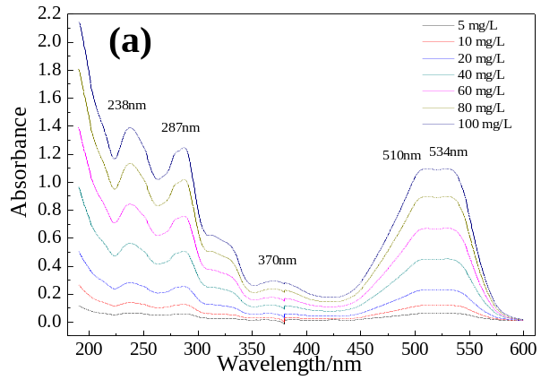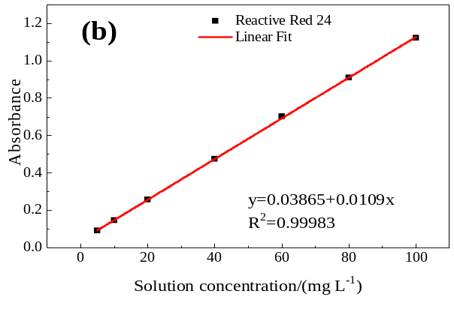
Fig SM-1 The different concentrations of RR24 UV-visible full spectrum (a); the relationship between different concentrations of RR24 and absorbance (b).

Fig.SM-2 The mass spectra of the main degradation products of RR24
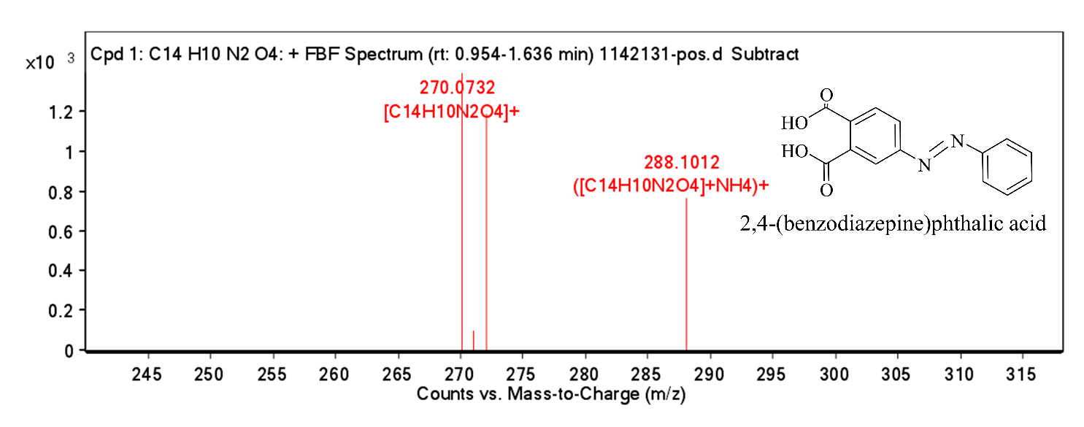
Fig. SM-2-The mass spectra of the main degradation products of reactive red 24. (a) 4-(Phenyldiazenyl) phthalic acid
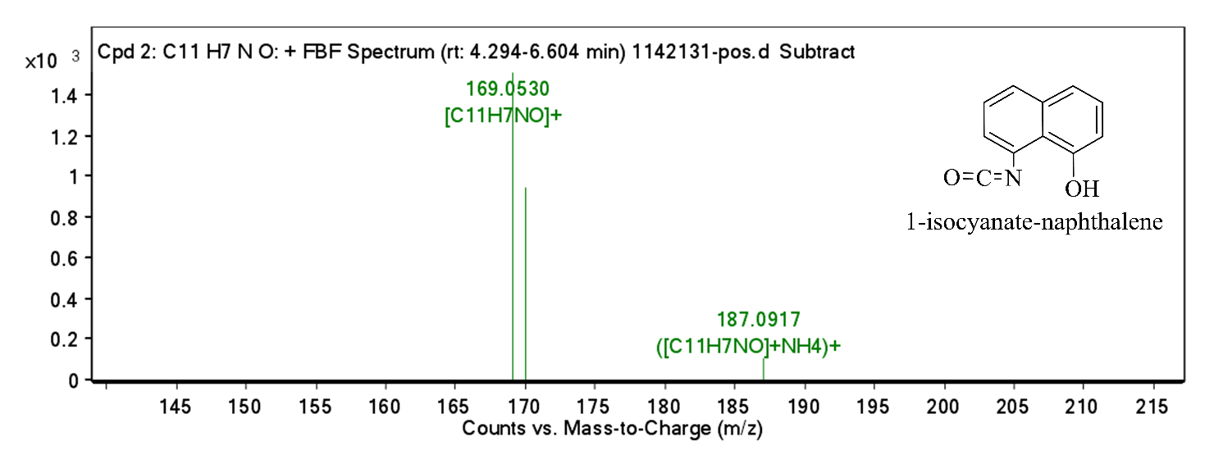Fig. SM-2- (b) 1-isocyanatonaphthalene.

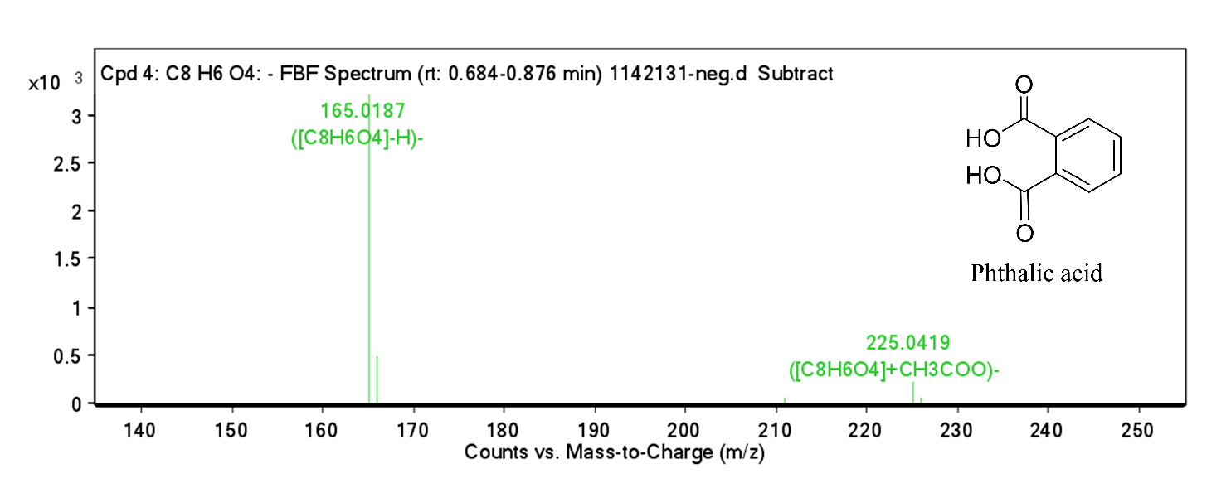
Fig. SM-2- (c) Phthalic acid.
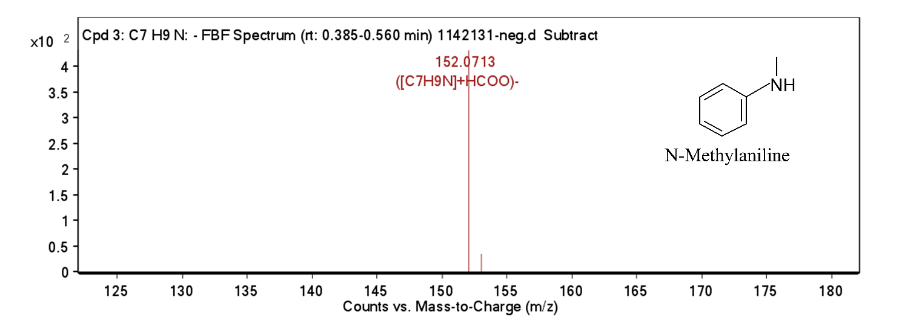
Fig. S3- (d) N-methylaniline.
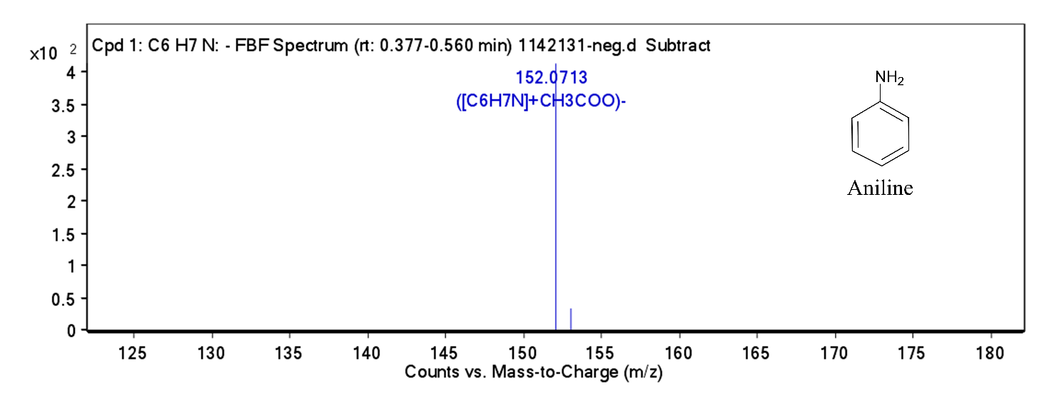
Fig. SM-2- (e) Aniline.

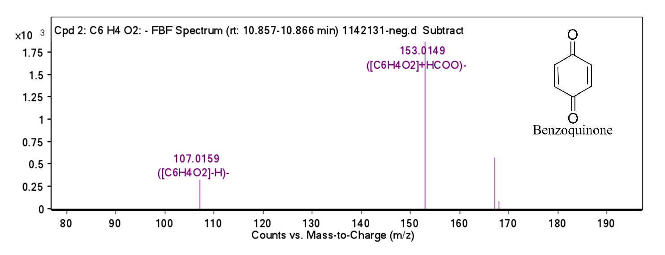
Fig. SM-2- (f) Benzoquinone.

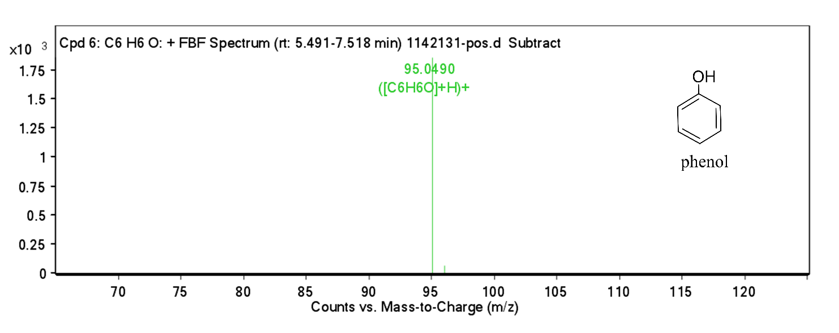
Fig. SM-2- (g) Phenol.

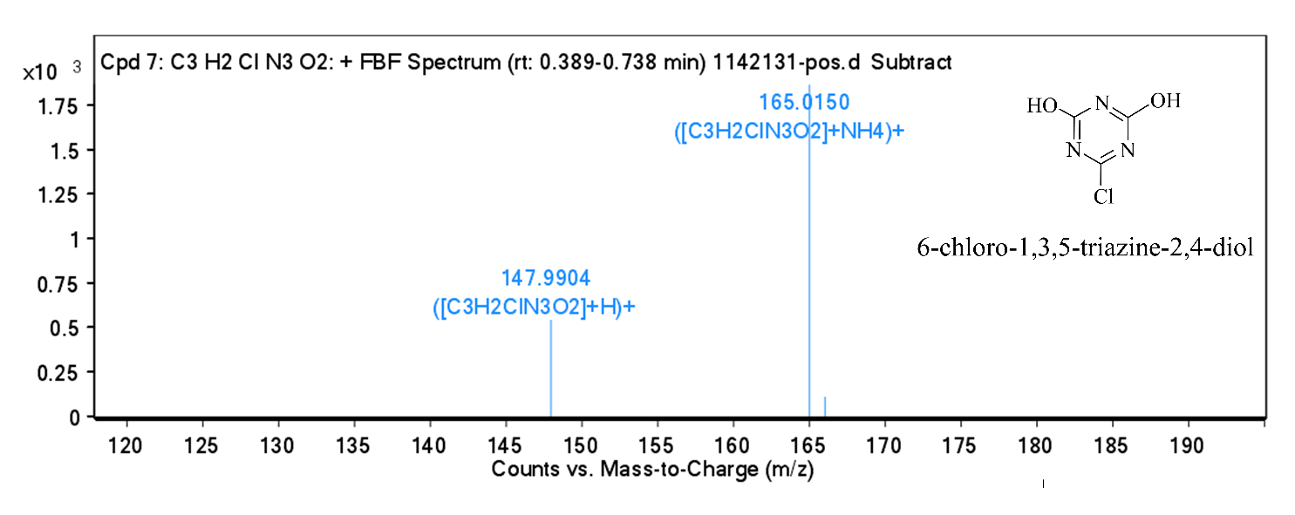
Fig. SM-2- (h) 6-Chloro-1,3,5-triazine-2,4-diol.

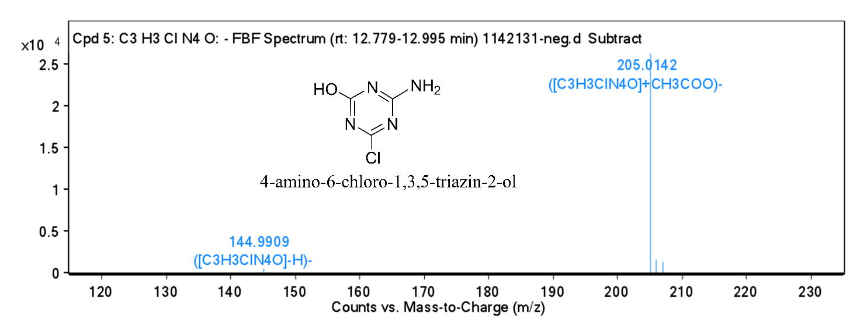
Fig. SM-2- (i) 4-amino-6-chloro-1,3,5-triazin-2-ol.

Table SM-1 Information of RR24
Commercial Name | Reactive Red 24
Chemical structure | 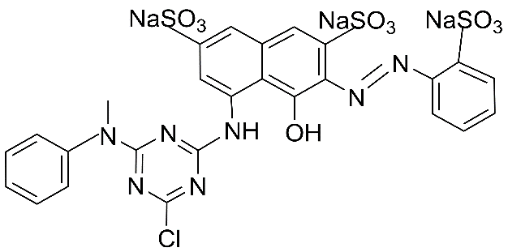
Molecular Formula | C₂₆H₁₇ClN₇Na₃O₁₀S₃
Molar Mass | 788.07g mol⁻¹
CAS Number | 70210-20-7

Table SM-2 Mass spectrum data of the main degradation products of RR24
No. | Molecular weight | Formula | Compound | Main prime ions (m/z)
1 | 270 | C₁₄H₁₀N₂O₄ | 2,4-(Phenyldiazenyl) phthalic acid | 270.0732, 271.0786, 272.0577, 288.1012
2 | 169 | C₁₁H₇NO | 1-Isocyanatonaphthalene | 169.053, 170.0576, 187.0917
3 | 166 | C₈H₆O₄ | Phthalic acid | 165.0187, 166.0203 211.0169
4 | 107 | C₇H₉N | N-methylaniline | 152.0713, 153.0759
5 | 93 | C₆H₇N | Aniline | 152.0713, 153.0759
6 | 108 | C₆H₄O₂ | Benzoquinone | 107.0159, 153.0149, 167.0383, 168.0402
7 | 94 | C₆H₆O | Phenol | 95.049, 96.0543
8 | 147 | C₃H₂ClN₃O₂ | 6-Chloro-1,3,5-triazine-2,4diol | 147.9904,165.015,166.0113
9 | 146 | C₃H₃ClN₄O | 4-amino-6-chloro-1,3,5-triazin-2-ol | 144.9909, 205.0142, 206.0179, 207.012

