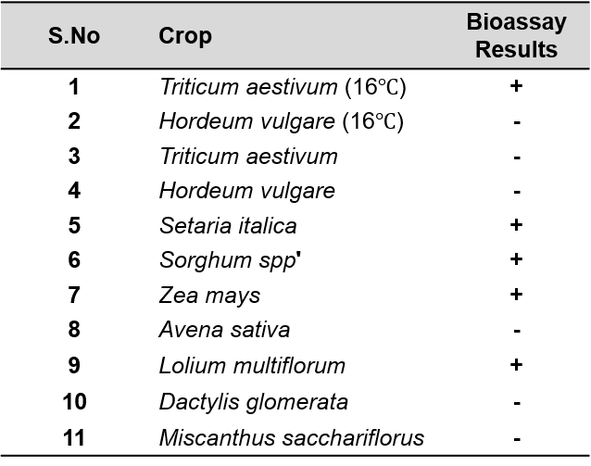
Supplementary Table 1: Bioassay to check for PaLV infectivity in different plants species

+ presence of infection; - lack of infection

Supplementary Table 2: Screening of Paspalum Germplasm to check for PaLV infection
Sample | Name | Species ^{(a)} | From | PaLV PCR | Origin ^{(a)}
1 | PI 576140 | P. distichum | UGA | + | Brazil
2 | PI 647922 | P. distichum | UGA | - | Australia
3 | PI 403999 | P. distichum | UGA | + | Australia
4 | Durban | P. vaginatum | UGA | + | South Africa
5 | PI 614679 01 | P. vaginatum | UGA | + | Bahamas
6 | PI 299042 | P. vaginatum | UGA | + | Zimbabwe
7 | PI 509018-3 | P. vaginatum | UGA | + | Argentina
8 | K9 | P. vaginatum | UGA | + | Hawaii, USA
9 | PI 647920 | P. vaginatum | UGA | + | Louisiana, USA
10 | PI 647912 | P. vaginatum | UGA | + | Georgia, USA
11 | PI 647918 | P. vaginatum | UGA | + | Florida, USA
12 | PI 645598 | P. vaginatum | UGA | + | Texas, USA
13 | PI 647916 | P. vaginatum | UGA | + | NK
14 | Azul | P. vaginatum | UGA | - | NK
15 | PI 614680 | P. vaginatum | UGA | + | Belize
16 | PI 508737 | P. vaginatum | UGA | + | Argentina
17 | PI647915 01 | P. vaginatum | UGA | + | Texas, USA
18 | PI 647915 | P. vaginatum | UGA | + | Texas, USA
19 | PI 509022 | P. vaginatum | UGA | + | Argentina
20 | Cuba 223 | P. vaginatum | UGA | + | Hawaii, USA
21 | Q36315 | P. vaginatum | UGA | + | Israel
22 | PI 647908 01 | P. vaginatum | UGA | + | Georgia, USA
23 | PI 377709 02 | P. vaginatum | UGA | + | South Africa
24 | Kim 1 | P. vaginatum | UGA | + | Georgia, USA
25 | PI 647901 | P. vaginatum | UGA | + | Guam
26 | Hyb 5 | P. vaginatum | UGA | + | NA
27 | Sea Dwarf | P. vaginatum | UGA | - | Florida, USA
28 | KC 9 | P. vaginatum | UGA | + | Texas, USA
29 | Spence | P. distichum ^{(b)} | UGA | + | Louisiana, USA
30 | HI 10 | P. vaginatum ^{(b)} | UGA | + | Hawaii, USA
- – The information on Paspalum species except for Spence and HI 10 and their origin were obtained from Eudy et al., 2017. NK and NA indicates not known and not applicable, respectively.
- – The information on Paspalum species were obtained from Spiekerman and Devos, 2020
+ Positive PCR result; - Negative PCR result

