Supplementary Information

for

How do initial concentrations, metal(loid)s types, and pH drive sustainable dendroremediation?
Zhongyu Du ª, Yan Jiang ª, Shufeng Wang ª, Jiang Xiao ª, Sylwia Budzyńska ^{b}, Guangcai Chen ^{a*}

ª Research Institute of Subtropical Forestry, Chinese Academy of Forestry, Hangzhou, 311400
^{b} Department of Chemistry, Faculty of Forestry and Wood Technology, Poznań University of Life Sciences, Wojska Polskiego 75, 60-625 Poznań, Poland

Corresponding author
Correspondence to: Prof. & Dr. Guangcai Chen
E-mail: guangcaichen@sohu.com; gcchen@caf.ac.cn
ORCID ID: 0000-0001-6564-1798

Supplementary Method 1
Literature selection process and effect size calculation
We began with an initial screening of titles and abstracts, excluding publications that were not relevant to our topic. Subsequently, we conducted a thorough review of the remaining papers. During this selection process, we included all plant species and HMs. We then evaluated potentially relevant records with accessible full texts to determine whether they met the following inclusion criteria:
(1) Studies must report results derived from primary data obtained through manipulative experiments, including potted, sterilized medium, hydroponic, and field experiments. The study should provide mean values, standard errors or standard deviations, and sample sizes or repetitions for each indicator in both treatment and control groups. If no control or uncontaminated soil was used, the treatment with the lowest HMs concentration and similar physicochemical properties was considered the control (Aponte et al., 2020).
(2) Experimental conditions must be clearly described. We collected information on the characteristics of the experimental site, plant materials, soil or culture fluid, and stress duration. Specific additives and non-valid controls, such as complexing agents (e.g., ethylene diamine tetraacetic acid (EDTA) and citric acid), amendments (e.g., biochar), and microbial components (e.g., arbuscular mycorrhizal fungi), were not considered in the study.
(3) The research must focus on trees and shrubs. At least one woody plant (tree or shrub) must be reported to have been contaminated by at least one HMs and to accumulate at least one HMs. If multiple woody plants accumulate one or more HMs, each plant is considered an independent data record. The source of the HMs and at least one of the target variables must be clearly described.
(4) Reviews, books, and articles that are repetitively published or reported (e.g., dissertations and journals) were excluded. Also excluded were studies with low data credibility, blurred images that hinder accurate data extraction, and other sources of unreliable data.
We extracted the mean, standard deviation (SD), and number of replicates for each target variable from the selected publications. These values were obtained from the text, supporting information, tables, and figures or calculated from raw data when available. If SD was not explicitly provided, it was calculated from the standard error (SE) using Eq. 1. The extracted data was then organized and coded using a Microsoft Excel spreadsheet.
(1)
As a measure of effect size, we calculated the magnitude of the HMs’ effect on plant species using the natural logarithm of the response ratio (LnRR) (Hedges et al., 1999) following Eq. 2:
(2)
Where and are the means of the target variables measured respectively in the treatments (with HMs) and control (without HMs) are calculated. A positive lnRR value indicates an increase in variables with HMs treatment. Its variances (v) of each effect size were calculated by Eq. 3:
(3)
To help visualize the results, the mean percentage of quality change was calculated (Gazzea et al., 2023) following Eq. 4:
(4)
In this study, we conducted only weighted meta-analyses and excluded effect sizes with missing variance. The combination of our two literature searches resulted in a total of 158 studies, which were used for subsequent analyses (Table S1 and References list).
To assess the HMs accumulation capacity of various plant species, we calculated several key indices from the existing meta-data: the tolerance index (TI) (Shi et al., 2011), bioconcentration factor (BCF), and translocation factor (TF) (Cao et al., 2022b). These metrics quantify a species’ resilience and ability to accumulate HMs. Higher values of TI, BCF, and TF indicate that plants can effectively absorb metals from soils or sterile mediums and accumulate higher concentrations in tissues. Plants with high BCF and TF values are considered effective for HMs remediation and suitable for cleaning metal-contaminated soils. Specifically, BCF values greater than 1 suggest that plants accumulate higher metal concentrations in their tissues compared to the soil or sterilized medium (Cao et al., 2022b). Additionally, we analyzed changes in the root-shoot (R/S) ratio before and after exposure to HMs stress, which helps elucidate how HMs stress affects plant growth strategies and resource allocation. The detailed formulas used in our study are provided below:
(5)
(6)
(7)
(8)
where Biomass and HMs represent the means of biomass dry weight and HMs concentration in plant organs (aboveground parts, underground parts, leaves, and stems), respectively.

Supplementary Figures 1 to 21

Supplementary Fig. 1 Preferred reporting items for systematic reviews and meta-analysis (PRISMA) flow chart showing the article search and data selection of data for inclusion in this study.
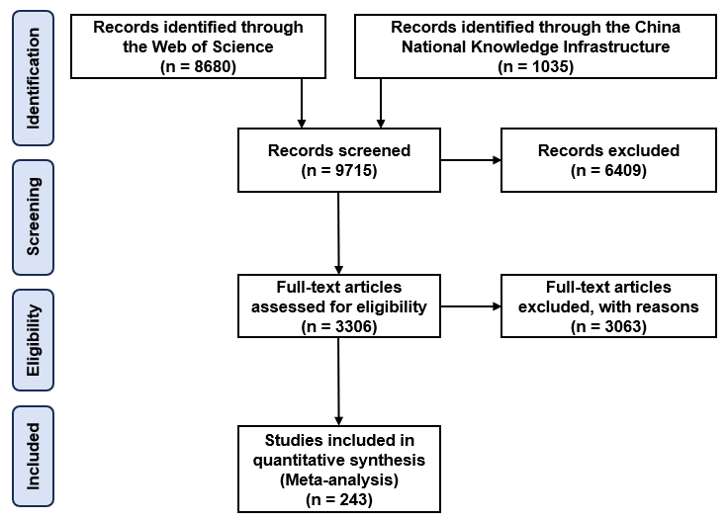

Supplementary Fig. 2 Frequency plots of stress time (days, d) in (a) tree and (b) shrub with hydroponics and soil or sterile medium in the meta-analysis.
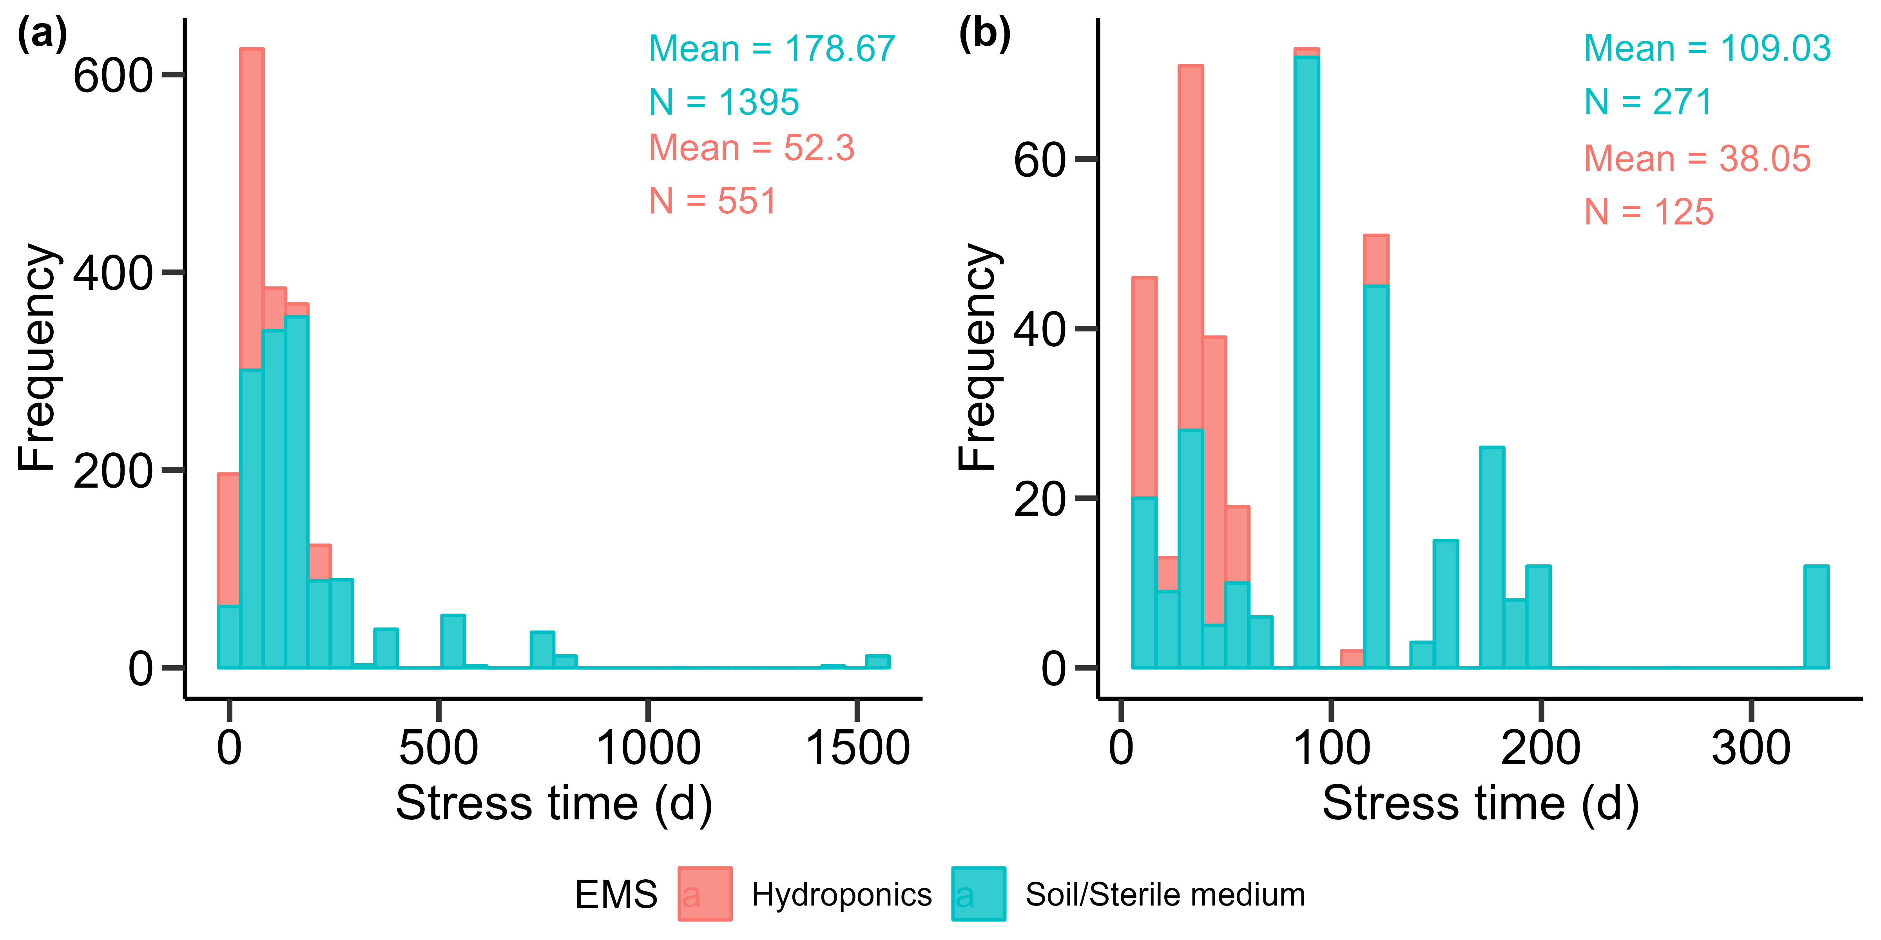

Supplementary Fig. 3 Density plots of the HMs concentration with hydroponics and soil or sterile medium in the meta-analysis.

Supplementary Fig. 4 The amount of data numbers of (a) country, (b) family, and (c) genus within the top 16 or 14 in the meta-analysis.
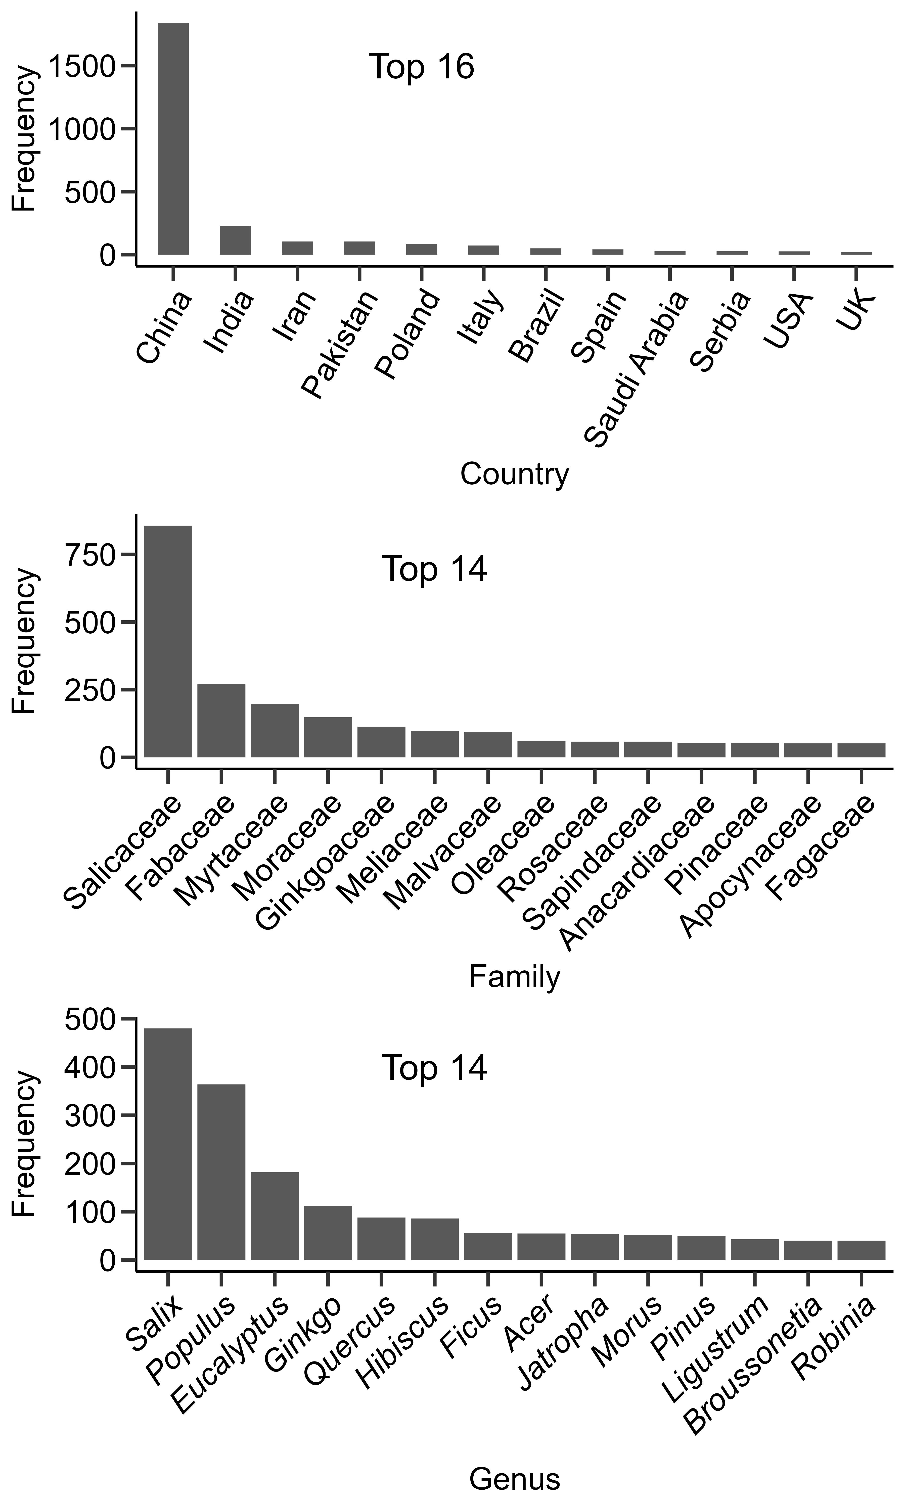

Supplementary Fig. 5 Biomass, metal(loid)s (HMs), and physiological parameters of woody plants under metal(loid) stress. (a) Changes in plant biomass; (b) Changes in plant HMs; (c) Changes in plant physiological parameters. Values in parentheses are sample size, pots are the effect size, and the lines are the percentage change ± 95 % confidence intervals (CIs) of the effect size. Effects are significant if CIs do not overlap the zero line; asterisks indicate significance. *, p < 0.05; **, p < 0.01 and ***, p < 0.001.
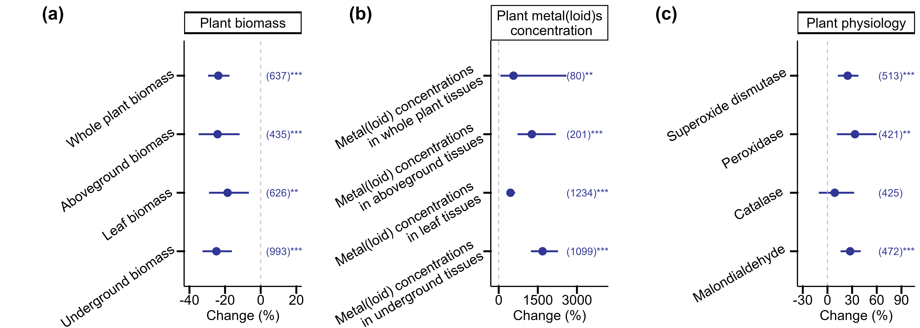

Supplementary Fig. 6 Plants biomass (whole plant, aboveground part, leaf, stem, and underground parts) responses to HM elements (Cd, Cu, Pb, Zn, Sb, As, and Ni). Dots and error bars represent the mean effect size and 95% confidence intervals (CIs), respectively. The numbers on the CIs indicate the sample size. ***, p < 0.001; **, p < 0.01; *, p < 0.05. (a), Total biomass; (b), Aboveground biomass; (c), Leaf biomass; (d), Underground biomass.
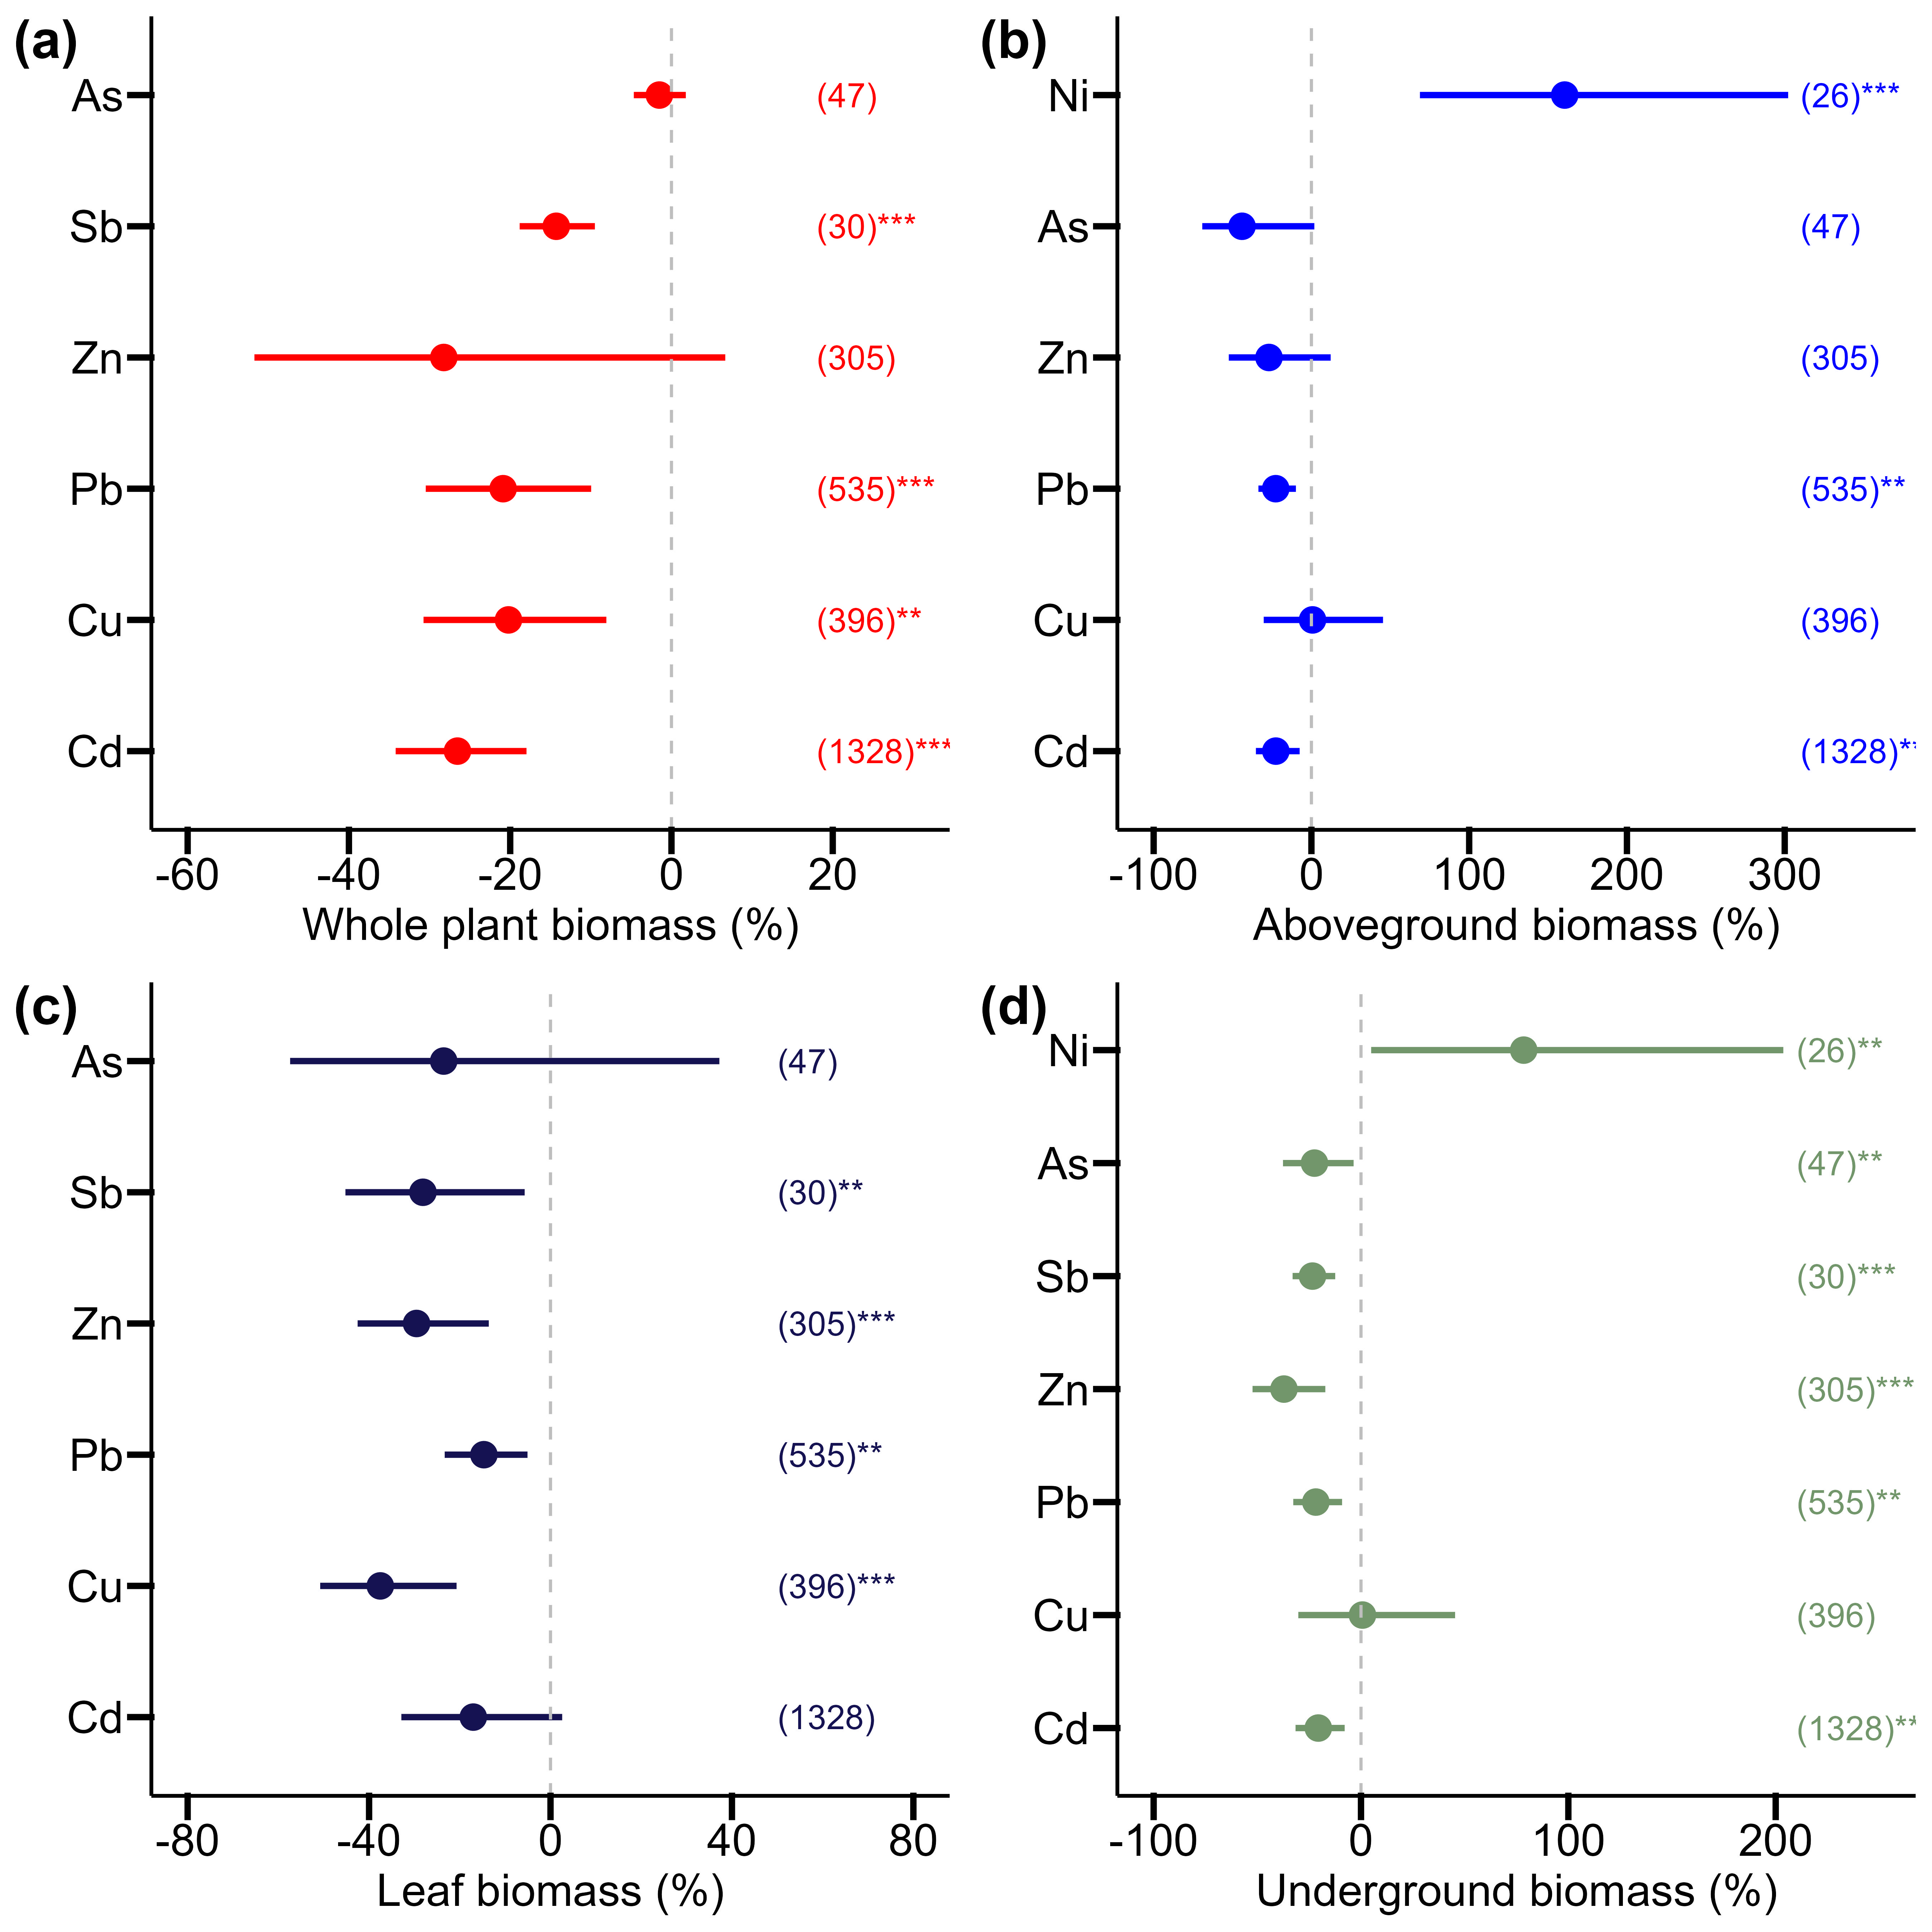

Supplementary Fig. 7 Boxplot shows the root-to-shoot ratio of different genera in (a) hydroponics and (b) soil or sterile medium in the study. Red pots represent mean value. Green and blue boxplots are Control and metal(loid) stress treatment, respectively. The dotted line indicates that the root-to-shoot ratio is 1.
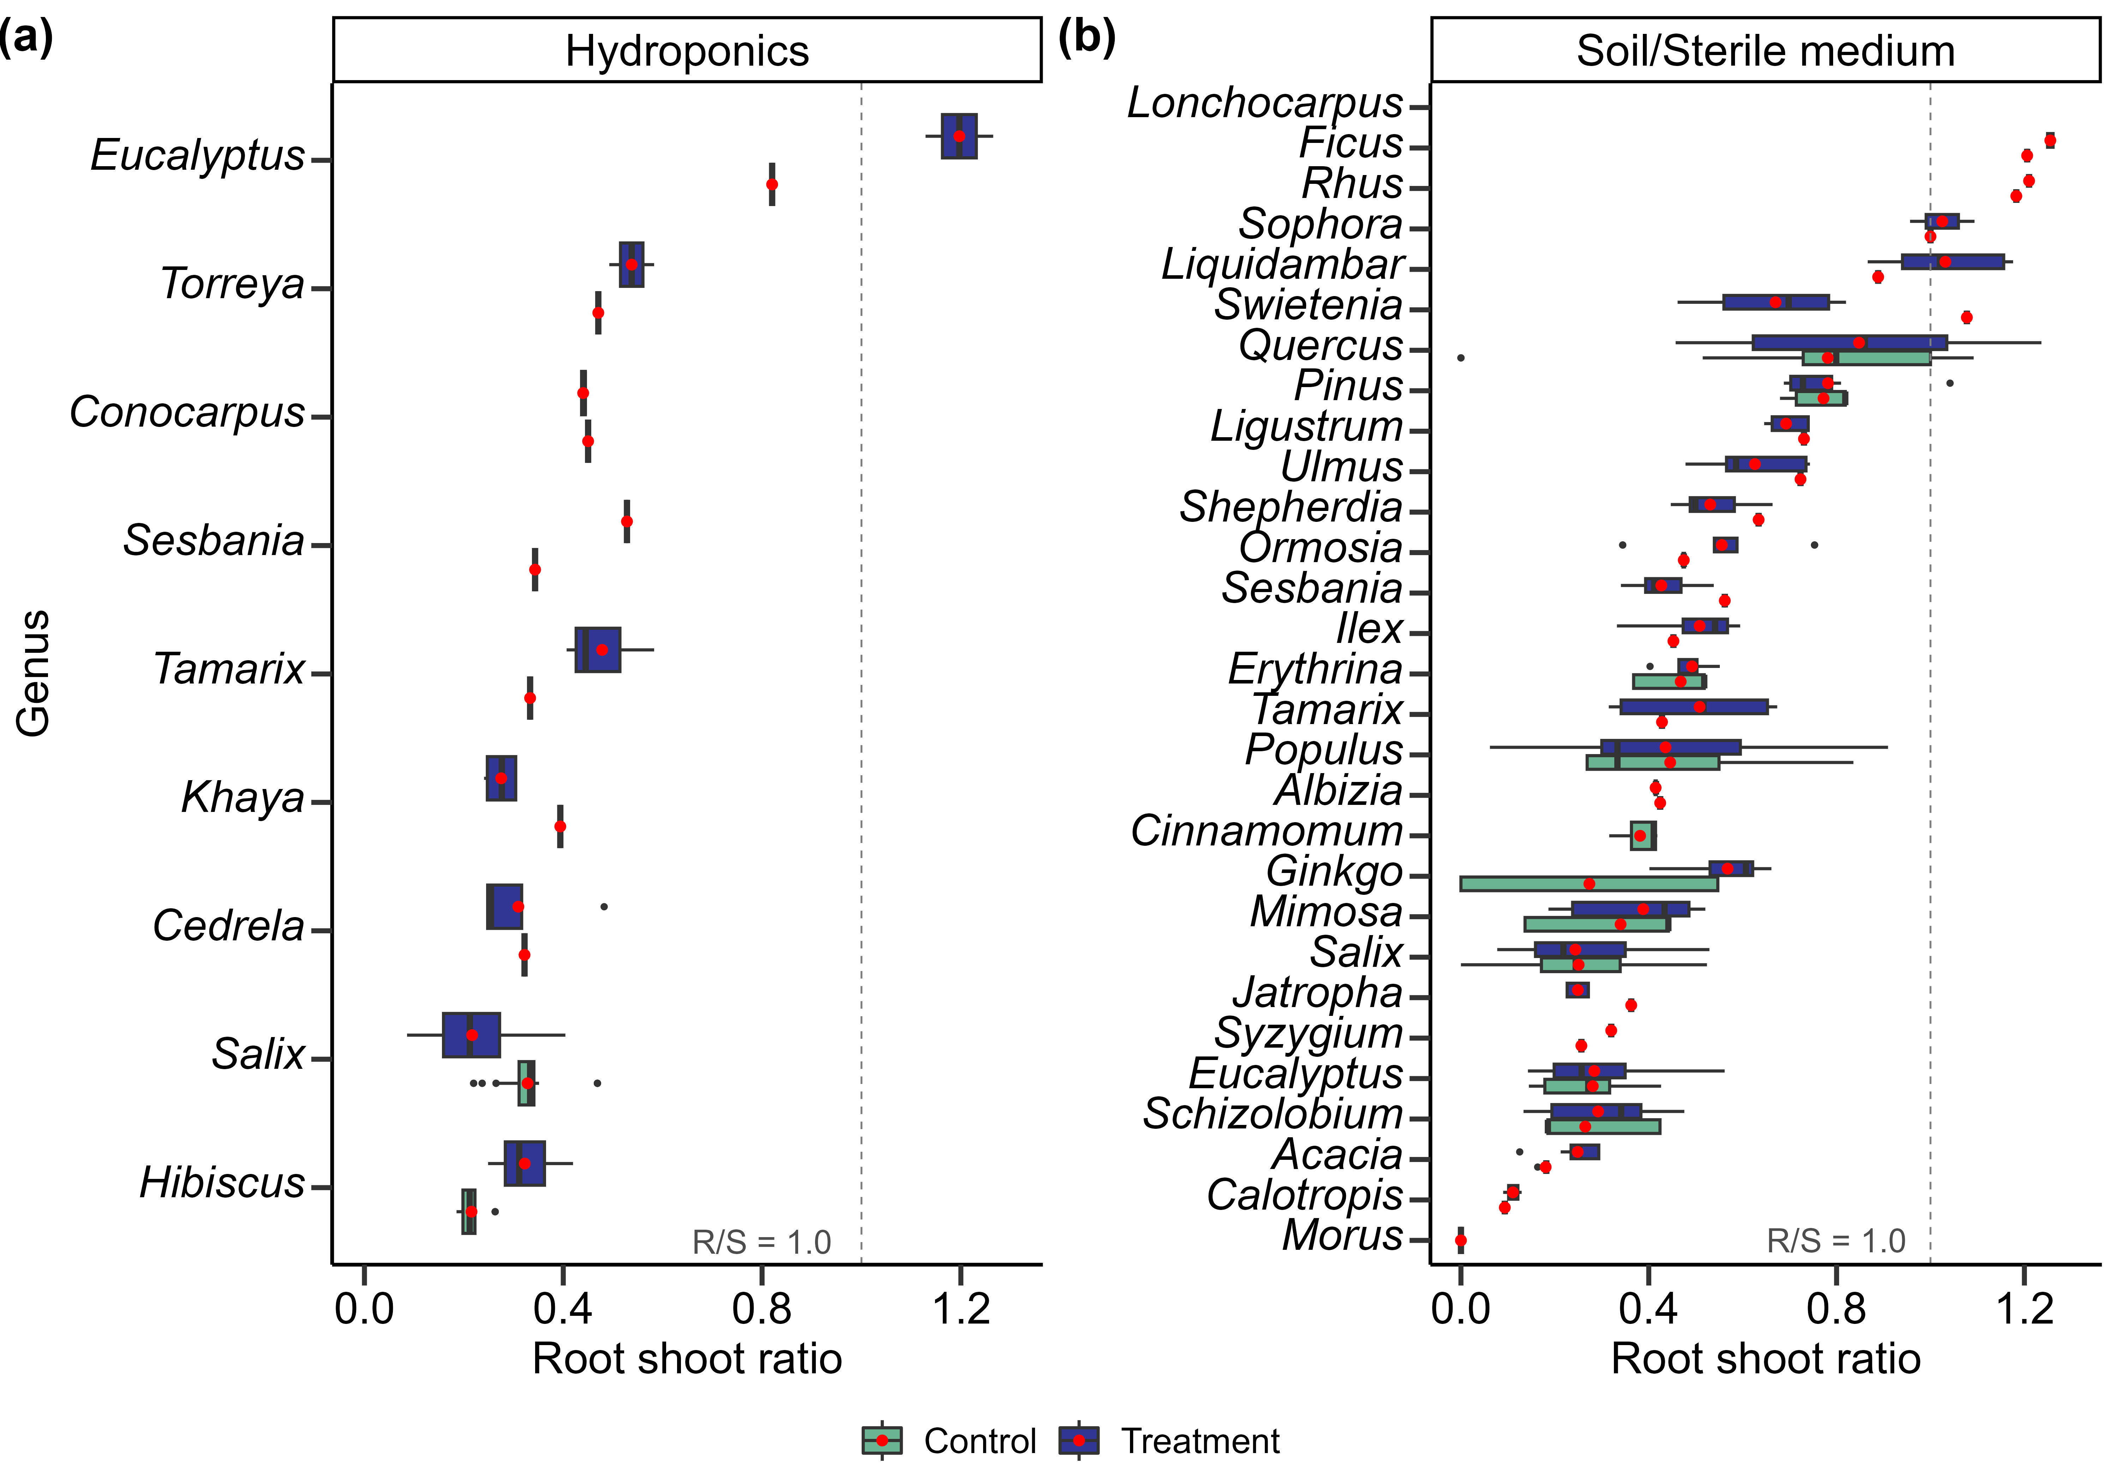

Supplementary Fig. 8 Boxplot shows the root-shoot ratio (R/S) of different plant genera under different HM types in hydroponics (a) and soil or sterile medium (b) types in the study. The red pots represent the mean value. The red and blue boxplots are CK and HMs addition treatments, respectively. Control, R/S of plant in control; Treatment, R/S of plant in HMs stress treatment.

Supplementary Fig. 9 Boxplot shows (a) the tolerance index (TI), (b) bioconcentration factor (BCF), and (c) transportation factor (TF) of different genera. Red pots represent the mean value. Red and blue boxplots are hydroponics and soil or sterile medium types, respectively.
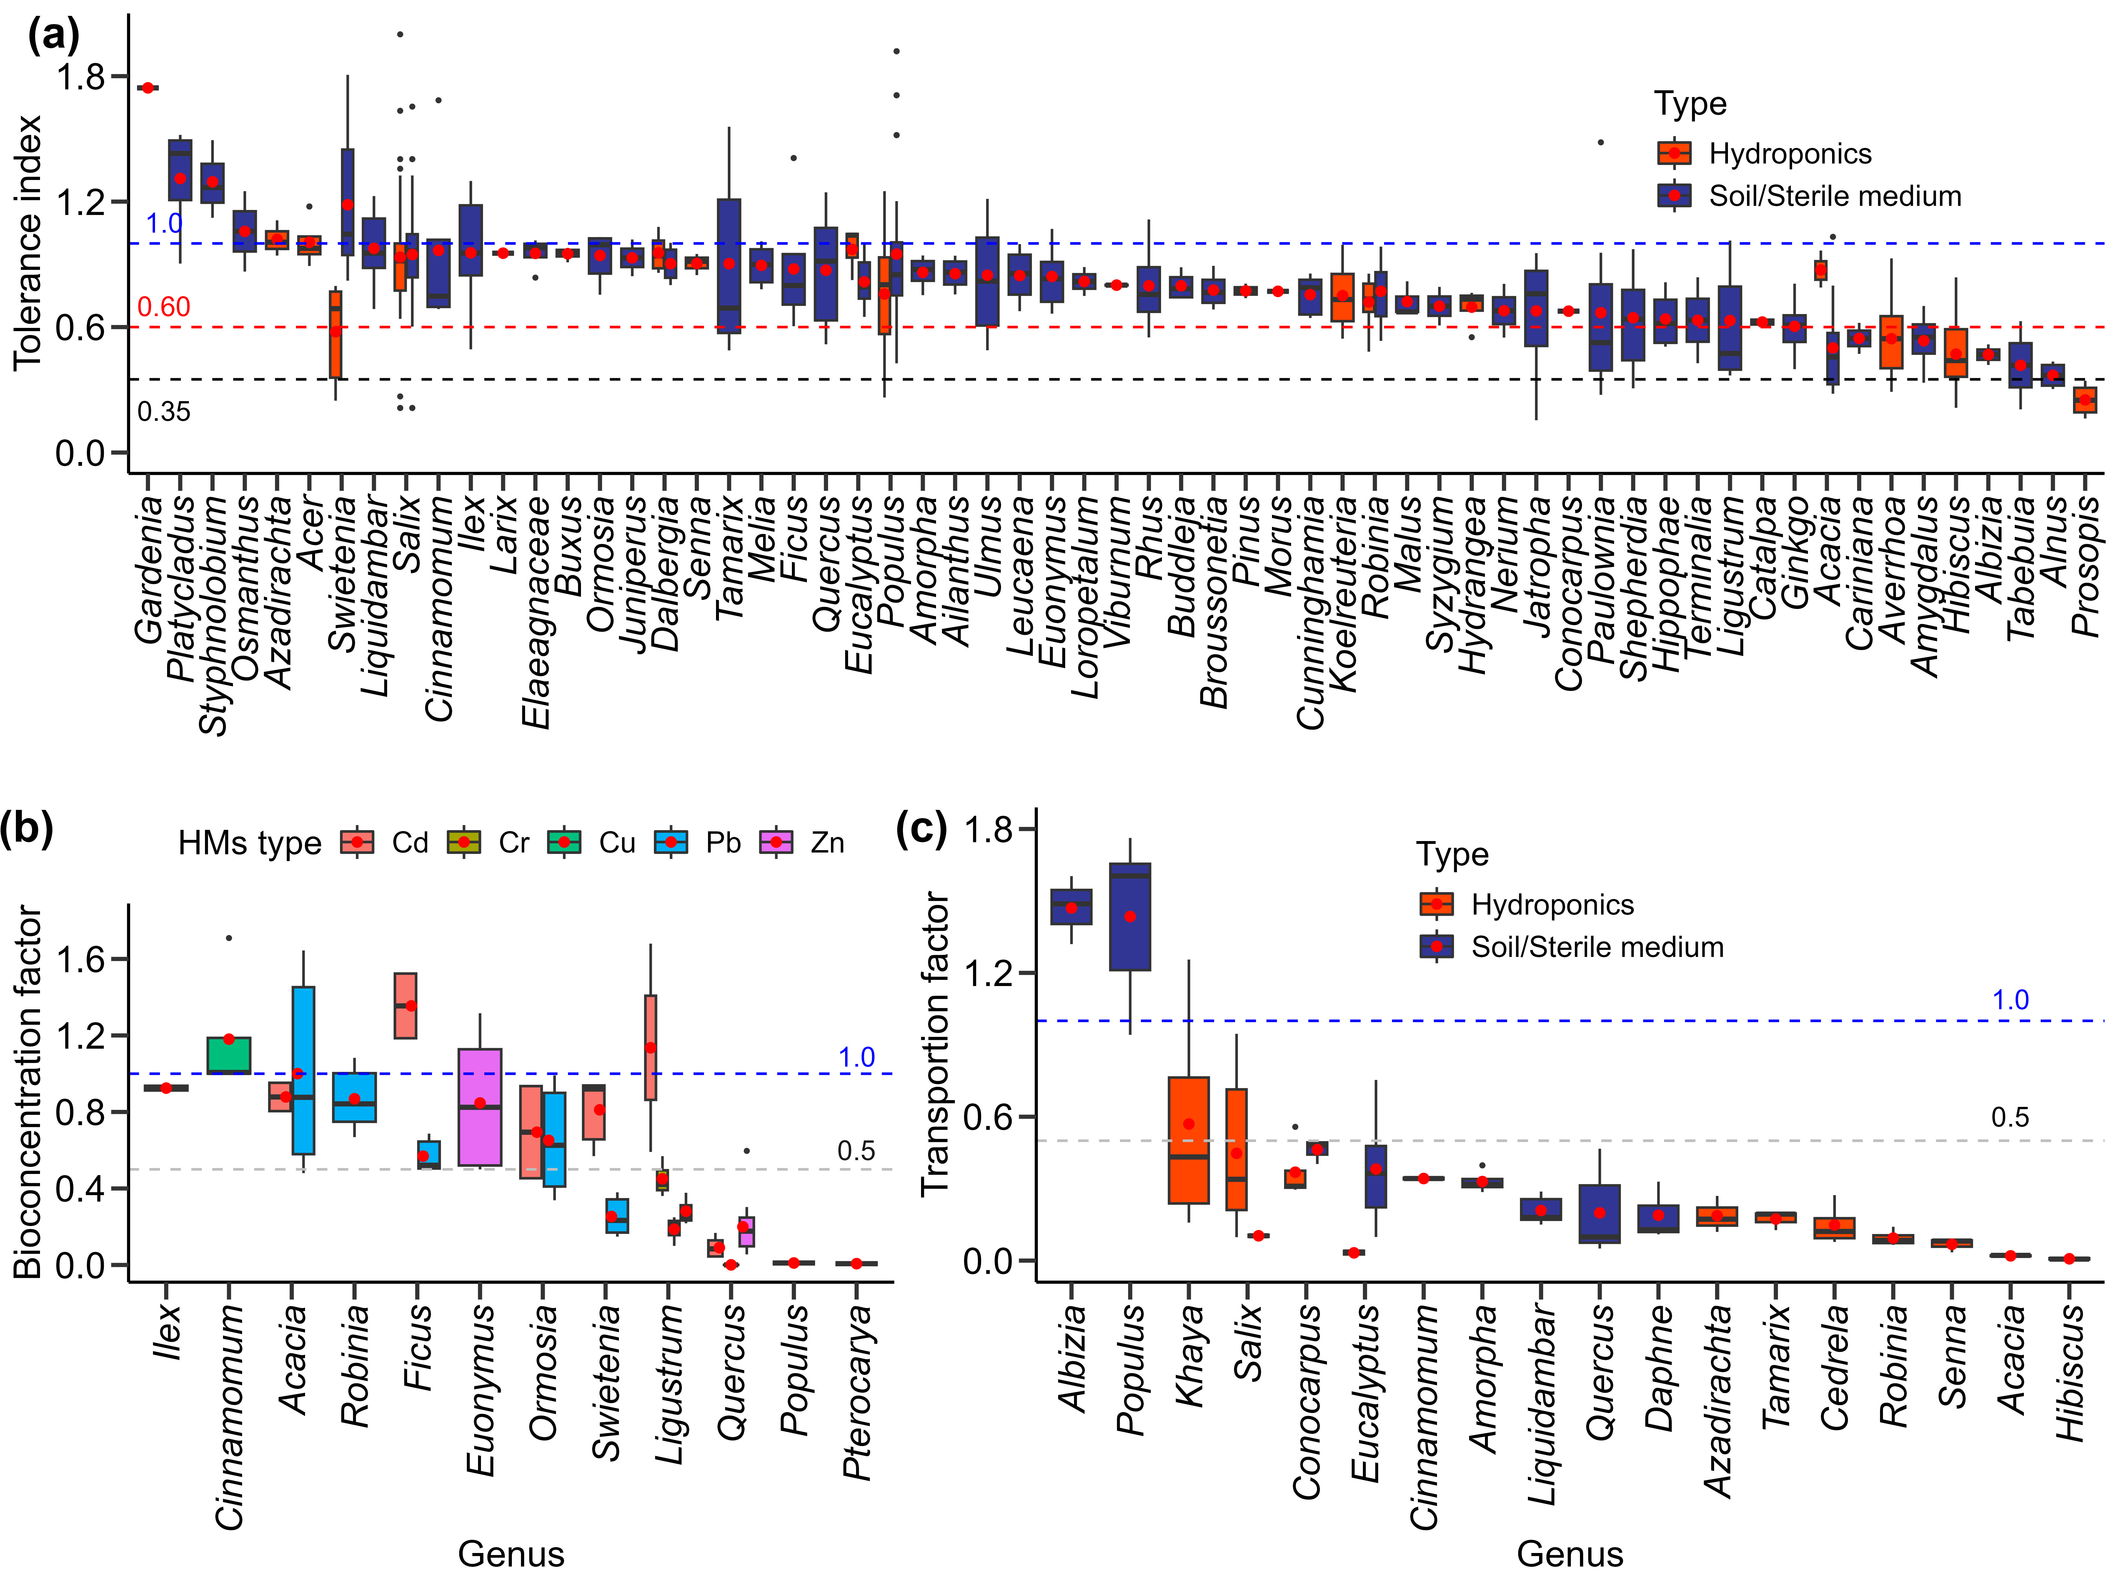

Supplementary Fig. 10 Boxplot shows the (a) tolerance index (TI), and (b) transportation factor (TF) of the different genera under different HM types in the meta-analysis. The red pots represent the mean value.

Supplementary Fig. 11 HMs concentration in plant organ (whole plant, aboveground part, leaf, stem and underground part) responses to metal elements (Cd, Cu, Pb, Zn, Sb, As, Ni and Cr). Dots and error bars represent the mean effect size and 95% confidence intervals (CIs), respectively. The numbers side the CIs indicate the sample size. ***, p < 0.001; **, p < 0.01; *, p < 0.05. (a), HMs concentration in whole plant; (b), HMs concentration in plant aboveground parts; (c), HMs concentration in plant underground parts; (d), HMs concentration in plant leaf part; (e), HMs concentration in plant stem part.
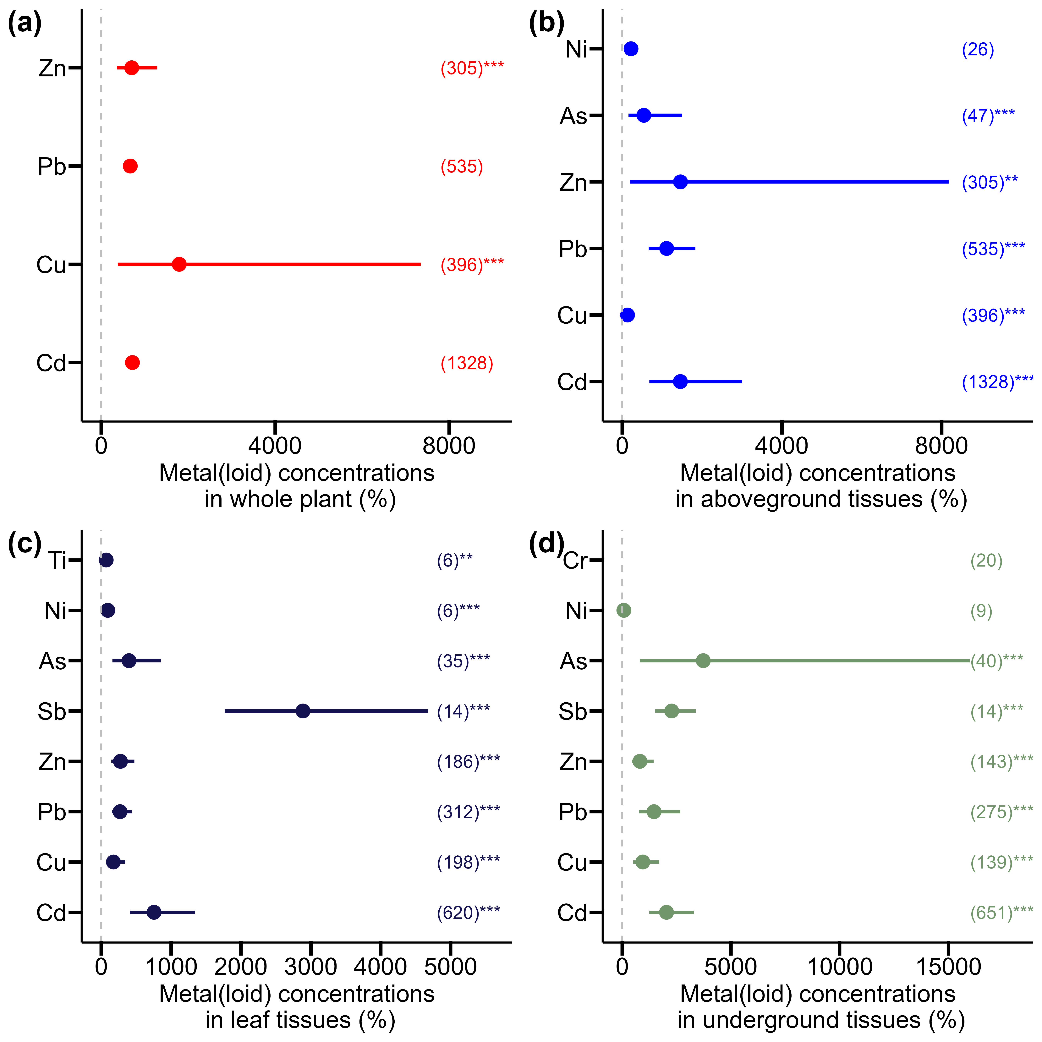

Supplementary Fig. 12 Boxplot shows the (a) plant leaf bioconcentration factor (LBCF) and (b) stem bioconcentration factor (SBCF) of the different genera under HMs in the meta-analysis. The red pots represent the mean value.

Supplementary Fig. 13 Physiological response of woody plant to metal(loid)s and associated influencing factors. (a) Changes in leaf SOD; (b) Changes in leaf POD; (c) Changes in leaf CAT; (d) Changes in leaf MDA. Values in parentheses are sample size, pots are the effect size, and the lines are the percentage change ± 95 % confidence intervals (CIs) of effect size. Effects are significant if CIs do not overlap the zero line; asterisks indicate significance. Qm and p values indicate the test of moderators and the significance of the differences between groups. *, p < 0.05; **, p < 0.01 and ***, p < 0.001.
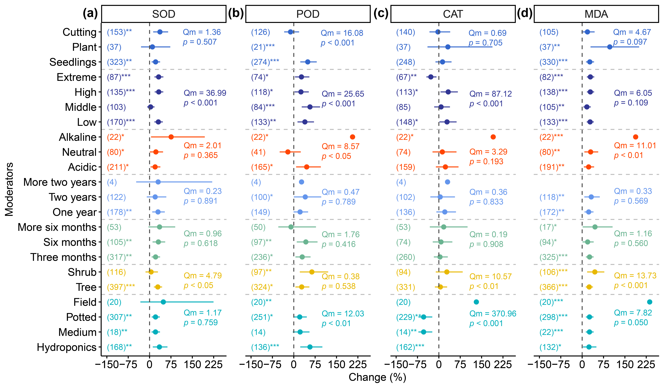

Supplementary Fig. 14 Leaf physiological responses (SOD, POD, CAT, and MDA) to metal(loid)s elements (Cd, Cu, Pb, Zn, and As). Dots and error bars represent the mean effect size and 95% confidence intervals (CIs), respectively. The numbers above the CIs indicate the sample size. SOD, superoxide dismutase; POD, peroxidase; CAT, catalase. (a), SOD; (b), POD; (c), CAT; (d), MDA. ***, p < 0.001; **, p < 0.01; *, p < 0.05.
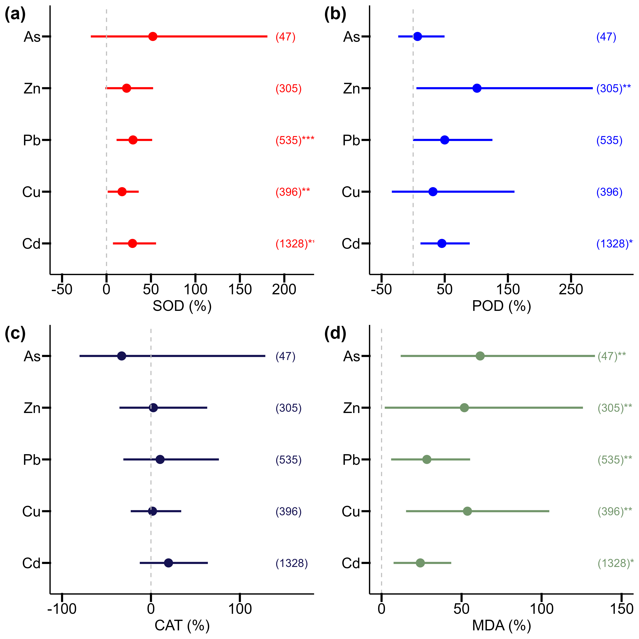

Supplementary Fig. 15 Boxplot shows the plant aboveground part bioconcentration factor (ABCF) of the different genera under HMs in the meta-analysis. The red pots represent the mean value.
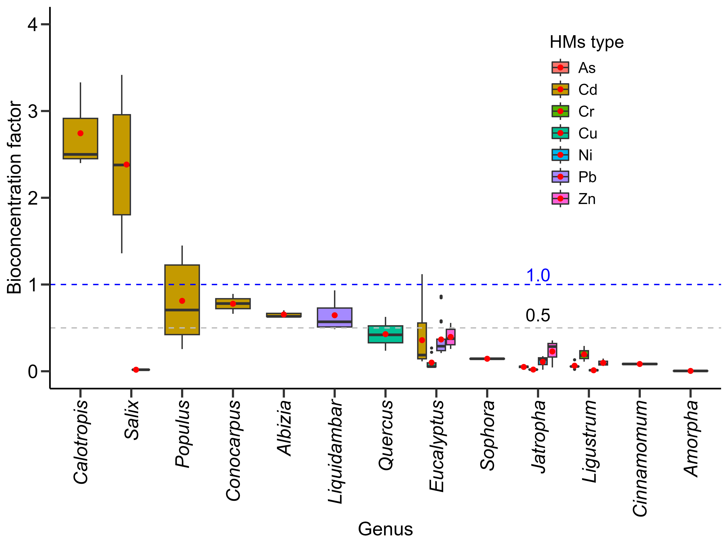

Supplementary Fig. 16 The correlations between the natural log response ratio (LnRR) of POD and pH of the environment under (a) Cd, (b) Cu, and (c) Pb stress.
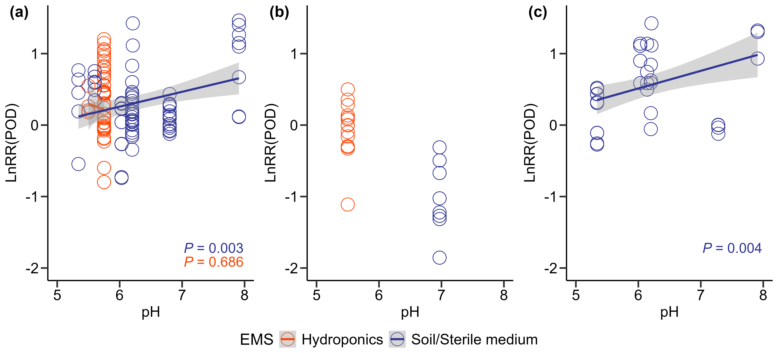

Supplementary Fig. 17 The correlations between the natural log response ratio (LnRR) of (a) SOD, (b) POD, (c) CAT, (d) MDA and HMs concentration in plant leaf under Cd, Cu, Pb, Sb, Ti, Zn, Ni, Cr, and As stress.
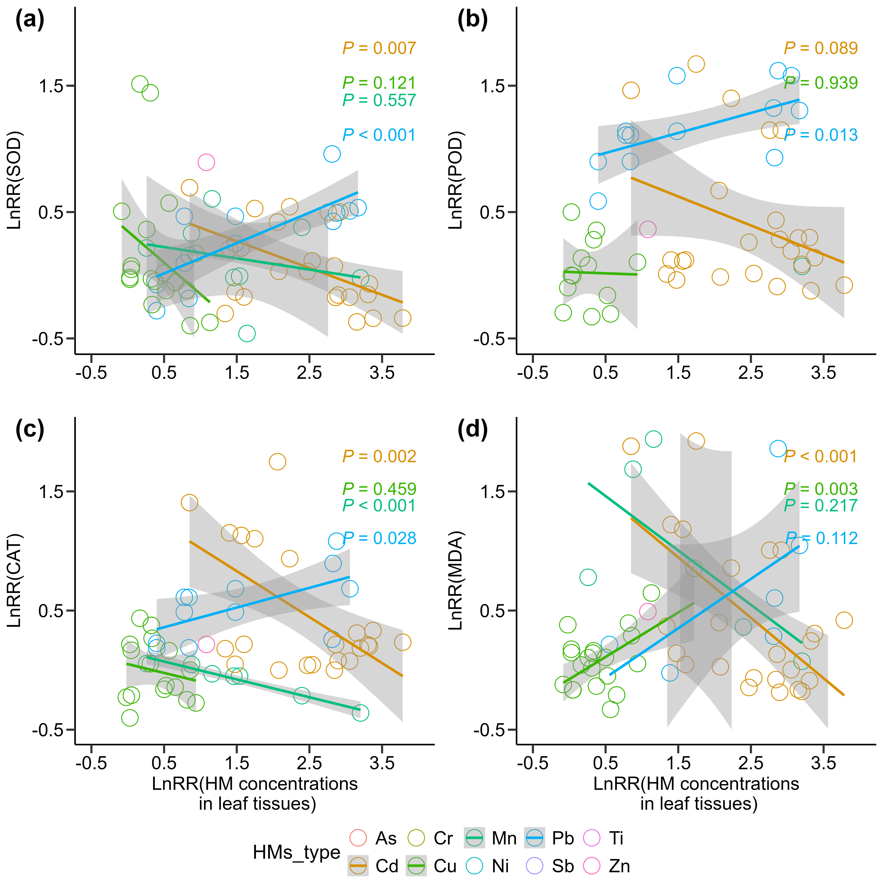

Supplementary Fig. 18 Relationship between pH of environment and tolerance index (TI), transportation factor (TF), and bioconcentration factor (BCF) of woody plants under hydroponics, soil, or sterile medium.
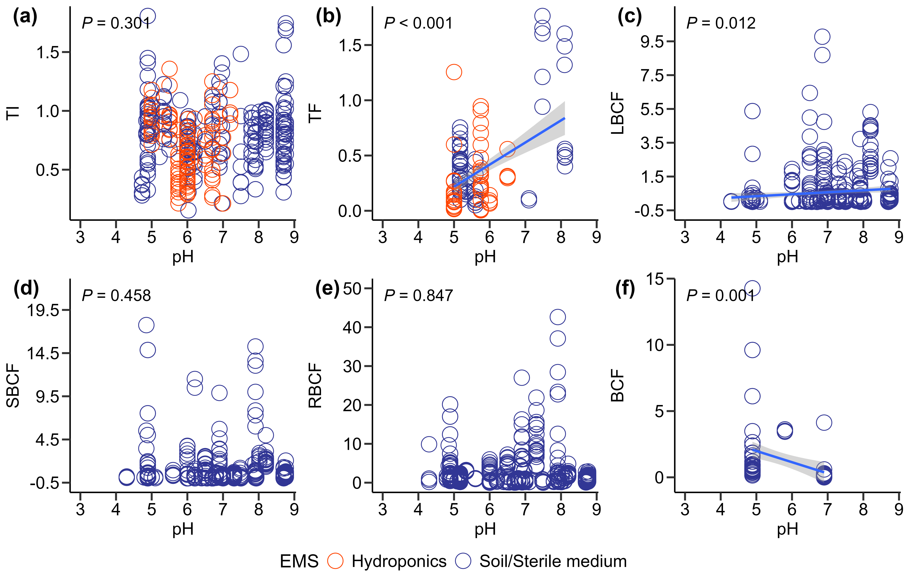

Supplementary Fig. 19 Funnel plots for the effect of different HMs (Cd, Cu, Pb, Zn, Sb, and As) stress on biomass (total biomass, aboveground biomass, and underground biomass).

Supplementary Fig. 20 Funnel plots for the effect of different HMs (Cd, Cu, Pb, Zn, Sb, and As) stress on metal concentration in plant parts (whole plant, leaf, aboveground, and underground parts).

Supplementary Fig. 21 Funnel plots for the effect of different HMs (Cd, Cu, Pb, and Zn) stress on SOD, POD, CAT, and MDA.

Supplementary Tables 1 to 7

Supplementary Table 1 Studies of climate zone, countries, plant families, genus, and species in phytoremediation of HMs pollution.
Climate zone | Country | Institution | Family | Genus | Species | HMs type
Tropical | Brazil | Federal Rural University of Amazon | Meliaceae | Cedrela | Cedrela fissilis | Cu
Tropical | Brazil | Department of Plant Biology of the UNICAMP in Campinas | Fabaceae | Erythrina | Erythrina speciosa | Pb
Tropical | Brazil | University of Campinas | Fabaceae | Erythrina | Erythrina speciosa | Zn
Tropical | Brazil | Federal Rural University of Amazon | Meliaceae | Khaya | Khaya ivorensis | Cu
Tropical | Brazil | Instituto Federal Goiano Campus Rio Verde | Fabaceae | Lonchocarpus | Lonchocarpus cultratus | Pb
Tropical | Brazil | Department of Plant Biology of the UNICAMP in Campinas | Fabaceae | Mimosa | Mimosa caesalpiniaefolia | Pb
Tropical | Brazil | University of Campinas | Fabaceae | Mimosa | Mimosa caesalpiniaefolia | Zn
Tropical | Brazil | Department of Plant Biology of the UNICAMP in Campinas | Fabaceae | Schizolobium | Schizolobium parahyba | Pb
Tropical | Brazil | University of Campinas | Fabaceae | Schizolobium | Schizolobium parahyba | Zn
Tropical | Brazil | Campus of Paragominas of the Universidade Federal Rural da Amazônia | Fabaceae | Schizolobium | Schizolobium parahyba | Zn
Tropical | Brazil | State University of Santa Cruz | Malvaceae | Theobroma | Theobroma cacao | Pb
Tropical | China | National Pingtung University | Meliaceae | Swietenia | Swietenia macrophylla | Cd
Tropical | Colombia | Palmira Research Station of AGROSAVIA | Malvaceae | Theobroma | Theobroma cacao | Cd
Tropical | India | Ravishankar Shukla University | Fabaceae | Dalbergia | Dalbergia sissoo | Pb
Tropical | Peru | Universidad Nacional Toribio Rodríguez de Mendoza de Amazonas | Fabaceae | Albizia | Albizia guachapele | Cd
Tropical | Peru | Universidad Nacional Toribio Rodríguez de Mendoza de Amazonas | Lecythidaceae | Cariniana | Cariniana pyriformis | Cd
Tropical | Peru | Universidad Nacional Toribio Rodríguez de Mendoza de Amazonas | Bignoniaceae | Tabebuia | Tabebuia rosea | Cd
Tropical | Peru | Universidad Nacional Toribio Rodríguez de Mendoza de Amazonas | Combretaceae | Terminalia | Terminalia superba | Cd
Tropical | Thailand | National Center for Genetic Engineering and Biotechnology, BIOTEC | Asteraceae | Cinnamomum | Pluchea indica | Cu
Temperate | Belgium | Hasselt University | Salicaceae | Salix | Salix atrocinerea | As
Temperate | Brazil | Universidade Federal de Lavras | Anacardiaceae | Schinus | Schinus molle | Cd
Temperate | China | South China Botanical Garden of the Chinese Academy of Science | Leguminosae | Acacia | Acacia auriculiformis | Cd
Temperate | China | College of Forestry, South China Agricultural University | Fabaceae | Acacia | Acacia confusa | Cd
Temperate | China | College of Forestry, South China Agricultural University | Fabaceae | Acacia | Acacia confusa | Pb
Temperate | China | Guangxi Academy of Forestry Sciences | Fabaceae | Acacia | Acacia Mangium × A. Auriculiformis | Cd
Temperate | China | Institute of Environmental Resources and Soil Fertilizer, Zhejiang Academy of Agricultural Sciences | Aceraceae | Acer | Acer plamatum | Cd
Temperate | China | College of Life Sciences, Guangxi Normal University | Myrsinaceae | Aegiceras | Aegiceras corniculatum | Cd
Temperate | China | Institute of Subtropical Forestry, Chinese Academy of Forestry | Simaroubaceae | Ailanthus | Ailanthus altissima | Sb
Temperate | China | Zhejiang Shuren University | Fabaceae | Albizia | Leucaena leucocephala | Cd
Temperate | China | Guangxi Academy of Forestry Sciences | Betulaceae | Alnus | Alnus formosana | Cd
Temperate | China | Northwest A&F University | Fabaceae | Amorpha | Amorpha fruticosa | Pb
Temperate | China | Institute of Subtropical Forestry, Chinese Academy of Forestry | Fabaceae | Amorpha | Amorpha fruticosa | Sb
Temperate | China | Southwest University | Rosaceae | Amygdalus | Amygdalus pedunculata | Cd
Temperate | China | Southwest University | Rosaceae | Amygdalus | Amygdalus pedunculata | Pb
Temperate | China | Institute of Environmental Resources and Soil Fertilizer, Zhejiang Academy of Agricultural Sciences | Aucubaceae | Aucuba | Aucuba japonica | Cd
Temperate | China | Sun Yat-sen University | Oxalidaceae | Averrhoa | Averrhoa carambola | Cd
Temperate | China | College of Life Sciences, Guangxi Normal University | Verbenaceae | Avicennia | Avicennia marina | Cd
Temperate | China | South China Botanical Garden | Lecythidaceae | Barringtonia | Barringtonia racemosa | Cd
Temperate | China | Southwest University | Phyllanthaceae | Bischofia | Bischofia javanica | Cd
Temperate | China | Foshan Botanical Garden | Moraceae | Broussonetia | Broussonetia papyrifera | Cd
Temperate | China | Central South University of Forestry and Technology | Moraceae | Broussonetia | Broussonetia papyrifera | Cd
Temperate | China | College of Forestry, Northwest A&F University | Moraceae | Broussonetia | Broussonetia papyrifera | Mn
Temperate | China | Institute of Subtropical Forestry, Chinese Academy of Forestry | Moraceae | Broussonetia | Broussonetia papyrifera | Sb
Temperate | China | Southwest University | Scrophulariaceae | Buddleja | Buddleja alternifolia | Cd
Temperate | China | Institute of Environmental Resources and Soil Fertilizer, Zhejiang Academy of Agricultural Sciences | Buxaceae | Buxus | Buxus megistophylla | Cd
Temperate | China | Institute of Subtropical Forestry, Chinese Academy of Forestry | Buxaceae | Buxus | Buxus megistophylla | Sb
Temperate | China | Institute of Environmental Engineering, School of Metallurgy and Environment, Central South University | Lauraceae | Cinnamomum | Cinnamomum camphora | Cd
Temperate | China | Zhejiang A & F University | Lauraceae | Cinnamomum | Cinnamomum camphora | Cd
Temperate | China | Sichuan Agricultural University | Taxodiaceae | Cunninghamia | Cunninghamia lanceolata | Cd
Temperate | China | Institute of Environmental Resources and Soil Fertilizer, Zhejiang Academy of Agricultural Sciences | Cupressaceae | Cupressus | Cupressus Blue | Cd
Temperate | China | Engineering Research Center of Chuanxibei Rural Human Settlement (RHS) | Hippophae | Elaeagnaceae | Hippophae rhamnoides | Pb
Temperate | China | Engineering Research Center of Chuanxibei Rural Human Settlement (RHS) | Hippophae | Elaeagnaceae | Hippophae rhamnoides | Zn
Temperate | China | Sichuan Agricultural University | Myrtaceae | Eucalyptus | Eucalyptus (clone) | Cd
Temperate | China | Sichuan Agricultural University | Myrtaceae | Eucalyptus | Eucalyptus (clone) | Cu
Temperate | China | Sichuan Agricultural University | Myrtaceae | Eucalyptus | Eucalyptus (clone) | Pb
Temperate | China | Sichuan Agricultural University | Myrtaceae | Eucalyptus | Eucalyptus (clone) | Zn
Temperate | China | Sichuan Agricultural University | Myrtaceae | Eucalyptus | Eucalyptus grandis | Cd
Temperate | China | Sichuan Agricultural University | Myrtaceae | Eucalyptus | Eucalyptus grandis | Pb
Temperate | China | College of Resources, Environment and Materials, Guangxi University | Myrtaceae | Eucalyptus | Eucalyptus grandis × E. uroph | Zn
Temperate | China | College of Resources, Environment and Materials, Guangxi University | Myrtaceae | Eucalyptus | Eucalyptus grandis x E. urophylla | Cd
Temperate | China | Sichuan Agricultural University | Myrtaceae | Eucalyptus | Eucalyptus grandis x E. urophylla | Cd
Temperate | China | College of Resources, Environment and Materials, Guangxi University | Myrtaceae | Eucalyptus | Eucalyptus grandis x E. urophylla | Pb
Temperate | China | College of Resources, Environment and Materials, Guangxi University | Myrtaceae | Eucalyptus | Eucalyptus grandis x E. urophylla | Zn
Temperate | China | College of Environment, Guangxi University | Myrtaceae | Eucalyptus | Eucalyptus robusta | As
Temperate | China | College of Environment, Guangxi University | Myrtaceae | Eucalyptus | Eucalyptus robusta | Cd
Temperate | China | Zhejiang Shuren University | Myrtaceae | Eucalyptus | Eucalyptus robusta | Cd
Temperate | China | College of Environment, Guangxi University | Myrtaceae | Eucalyptus | Eucalyptus robusta | Cu
Temperate | China | South China Institute of Environmental Science, Ministry of Ecology and Environment | Myrtaceae | Eucalyptus | Eucalyptus urophylla X E. grandis | Pb
Temperate | China | Institute of Environmental Resources and Soil Fertilizer, Zhejiang Academy of Agricultural Sciences | Celastraceae | Euonymus | Euonymus japonicus | Cd
Temperate | China | Institute of Environmental Engineering, School of Metallurgy and Environment, Central South University | Celastraceae | Euonymus | Euonymus japonicus | Cd
Temperate | China | College of Forestry, South China Agricultural University | Moraceae | Ficus | Ficus microcarpa | Cd
Temperate | China | College of Forestry, South China Agricultural University | Moraceae | Ficus | Ficus microcarpa | Pb
Temperate | China | Southwest University | Moraceae | Ficus | Ficus virens | Cd
Temperate | China | Institute of Environmental Engineering, School of Metallurgy and Environment, Central South University | Rubiaceae | Gardenia | Gardenia jasminoides | Cd
Temperate | China | Nanjing Forestry University | Ginkgoaceae | Ginkgo | Ginkgo biloba | Cd
Temperate | China | Nanjing Forestry University | Ginkgoaceae | Ginkgo | Ginkgo biloba | Pb
Temperate | China | Southwest University | Malvaceae | Hibiscus | Hibiscus hamabo | Cd
Temperate | China | Southwest University | Malvaceae | Hibiscus | Hibiscus mutabilis | Pb
Temperate | China | Southwest University | Malvaceae | Hibiscus | Hibiscus syriacus | Pb
Temperate | China | South China Botanical Garden | Malvaceae | Hibiscus | Hibiscus tiliaceus | Cd
Temperate | China | Southwest University | Elaeagnaceae | Hippophae | Hippophae rhamnoides | Cd
Temperate | China | Jiangxi University of Finance and Economics | Hydrangeaceae | Hydrangea | Hydrangea quercifolia | Cu
Temperate | China | College of Forestry, South China Agricultural University | Aquifoliaceae | Ilex | Ilex rotunda | Cd
Temperate | China | College of Forestry, South China Agricultural University | Aquifoliaceae | Ilex | Ilex rotunda | Pb
Temperate | China | Sichuan Agricultural University | Poaceae | Indocalamus | Indocalamus chishuiensis | Pb
Temperate | China | Sichuan Agricultural University | Poaceae | Indocalamus | Indocalamus hunanensis | Pb
Temperate | China | Sichuan Agricultural University | Poaceae | Indocalamus | Indocalamus lacunosus | Pb
Temperate | China | Sichuan Agricultural University | Poaceae | Indocalamus | Indocalamus latifolius | Pb
Temperate | China | College of Urban and Environmental Science, Xinyang Normal University | Euphorbiaceae | Jatropha | Jatropha curcas | Cd
Temperate | China | South China Agricultural University | Euphorbiaceae | Jatropha | Jatropha curcas | Cd
Temperate | China | Guangxi Institute of Botany, Chinese Academy of Sciences, Guangxi Zhuang Autonomous Region | Euphorbiacae | Jatropha | Jatropha curcas | Cd
Temperate | China | South China Agricultural University | Euphorbiaceae | Jatropha | Jatropha curcas | Cu
Temperate | China | Guangxi Institute of Botany, Chinese Academy of Sciences, Guangxi Zhuang Autonomous Region | Euphorbiacae | Jatropha | Jatropha curcas | Cu
Temperate | China | South China Agricultural University | Euphorbiaceae | Jatropha | Jatropha curcas | Ni
Temperate | China | College of Urban and Environmental Science, Xinyang Normal University | Euphorbiaceae | Jatropha | Jatropha curcas | Pb
Temperate | China | South China Agricultural University | Euphorbiaceae | Jatropha | Jatropha curcas | Zn
Temperate | China | Guangxi Institute of Botany, Chinese Academy of Sciences, Guangxi Zhuang Autonomous Region | Euphorbiacae | Jatropha | Jatropha curcas | Zn
Temperate | China | Institute of Environmental Engineering, School of Metallurgy and Environment, Central South University | Cupressaceae | Juniperus | Juniperus chinensis | Cd
Temperate | China | Southwest University | Sapindaceae | Koelreuteria | Koelreuteria bipinnata | Cd
Temperate | China | Hunan Academy of Forestry, | Sapindaceae | Koelreuteria | Koelreuteria paniculata | Mn
Temperate | China | Southwest University | Lythraceae | Lagerstroemia | Lagerstroemia indica | Pb
Temperate | China | Southwest University | Oleaceae | Ligustrum | Ligustrm lucidum | Cd
Temperate | China | Zhejiang A & F University | Oleaceae | Ligustrum | Ligustrum lucidum | Cd
Temperate | China | School of Agriculture and Biology, Shanghai Jiao Tong University | Oleaceae | Ligustrum | Ligustrum obtusifolium | Cd
Temperate | China | Southwest University | Oleaceae | Ligustrum | Ligustrum obtusifolium | Cd
Temperate | China | Southwest University | Oleaceae | Ligustrum | Ligustrum obtusifolium | Cr
Temperate | China | School of Agriculture and Biology, Shanghai Jiao Tong University | Oleaceae | Ligustrum | Ligustrum obtusifolium | Pb
Temperate | China | Southwest University | Oleaceae | Ligustrum | Ligustrum obtusifolium | Pb
Temperate | China | School of Agriculture and Biology, Shanghai Jiao Tong University | Oleaceae | Ligustrum | Ligustrum obtusifolium | Zn
Temperate | China | Southwest University | Oleaceae | Ligustrum | Ligustrum obtusifolium | Zn
Temperate | China | Institute of Environmental Engineering, School of Metallurgy and Environment, Central South University | Oleaceae | Ligustrum | Ligustrum vicaryi | Cd
Temperate | China | Institute of Environmental Resources and Soil Fertilizer, Zhejiang Academy of Agricultural Sciences | Oleaceae | Ligustrum | Ligustrum vicaryi | Cd
Temperate | China | Nanjing Forestry University | Altingiaceae | Liquidambar | Liquidambar formosana | Cd
Temperate | China | College of Forestry, Guangxi University | Altingiaceae | Liquidambar | Liquidambar formosana | Cd
Temperate | China | Guangxi University Forestry College nursery garden | Altingiaceae | Liquidambar | Liquidambar formosana | Pb
Temperate | China | College of Forestry, Guangxi University | Altingiaceae | Liquidambar | Liquidambar formosana | Pb
Temperate | China | Institute of Environmental Engineering, School of Metallurgy and Environment, Central South University | Hamamelidaceae | Loropetalum | Loropetalum chinense | Cd
Temperate | China | Sichuan Agricultural University | Rosaceae | Malus | Malus pumila | Cu
Temperate | China | Sichuan Agricultural University | Meliaceae | Melia | Melia azedarach | Cd
Temperate | China | Zhejiang Shuren University | Meliaceae | Melia | Melia azedarach | Cd
Temperate | China | Central South University | Moraceae | Morus | Morus alba | Cd
Temperate | China | Sichuan Agricultural University | Moraceae | Morus | Morus alba | Cd
Temperate | China | Institute of Subtropical Forestry, Chinese Academy of Forestry | Moraceae | Morus | Morus alba | Cd
Temperate | China | Central South University | Moraceae | Morus | Morus alba | Cd
Temperate | China | Jiangsu University of Science and Technology | Moraceae | Morus | Morus alba | Pb
Temperate | China | Institute of Environmental Engineering, School of Metallurgy and Environment, Central South University | Apocynaceae | Nerium | Nerium oleander | Cd
Temperate | China | College of Forestry, South China Agricultural University | Fabaceae | Ormosia | Ormosia pinnata | Cd
Temperate | China | College of Forestry, South China Agricultural University | Fabaceae | Ormosia | Ormosia pinnata | Pb
Temperate | China | Institute of Environmental Engineering, School of Metallurgy and Environment, Central South University | Oleaceae | Osmanthus | Osmanthus fragrans | Cd
Temperate | China | Central South Forestry University of Science and Technology | Paulowniaceae | Paulownia | Paulownia fortunei | Mn
Temperate | China | Central South University of Forestry and Technology | Paulowniaceae | Paulownia | Paulownia fortunei | Mn
Temperate | China | College of Agronomy, Sichuan Agricultural University | Lauraceae | Phoebe | Phoebe zhennan | Cd
Temperate | China | School of Energy and Mechanical Engineering, Jiangxi | Pinaceae | Pinus | Pinus elliottii | Cd
Temperate | China | School of Energy and Mechanical Engineering, Jiangxi | Pinaceae | Pinus | Pinus elliottii | Cu
Temperate | China | School of Energy and Mechanical Engineering, Jiangxi | Pinaceae | Pinus | Pinus elliottii | Pb
Temperate | China | School of Energy and Mechanical Engineering, Jiangxi | Pinaceae | Pinus | Pinus elliottii | Zn
Temperate | China | International Joint Laboratory of Forest Symbiology, College of Forestry, Fujian Agriculture and Forestry University, Fuzhou 350002, China | Pinaceae | Pinus | Pinus massoniana | Cd
Temperate | China | International Joint Laboratory of Forest Symbiology, College of Forestry, Fujian Agriculture and Forestry University, Fuzhou 350002, China | Pinaceae | Pinus | Pinus massoniana | Cr
Temperate | China | International Joint Laboratory of Forest Symbiology, College of Forestry, Fujian Agriculture and Forestry University, Fuzhou 350002, China | Pinaceae | Pinus | Pinus massoniana | Mn
Temperate | China | International Joint Laboratory of Forest Symbiology, College of Forestry, Fujian Agriculture and Forestry University, Fuzhou 350002, China | Pinaceae | Pinus | Pinus massoniana | Pb
Temperate | China | Northwest A&F University | Pinaceae | Pinus | Pinus tabulaeformis | Pb
Temperate | China | Institute of Environmental Resources and Soil Fertilizer, Zhejiang Academy of Agricultural Sciences | Pittosporaceae | Pittosporum | Pittosporum tobira | Cd
Temperate | China | Institute of Environmental Engineering, School of Metallurgy and Environment, Central South University | Cupressaceae | Platycladus | Platycladus orientalis | Cd
Temperate | China | College of Resources and Environment, Northwest A&F University | Cupressaceae | Platycladus | Platycladus orientalis | Pb
Temperate | China | Sichuan Agricultural University | Salicaceae | Populus | poplar | Cd
Temperate | China | Sichuan Agricultural University | Salicaceae | Populus | Populus alba × P. glandulosa | Cd
Temperate | China | Sichuan Agricultural University | Salicaceae | Populus | Populus alba × P. glandulosa | Cd
Temperate | China | Northwest A&F University | Salicaceae | Populus | Populus alba × P. glandulosa | Cd
Temperate | China | College of Life Sciences, Northwest A&F University | Salicaceae | Populus | Populus alba × P. glandulosa | Cu
Temperate | China | Sichuan Agricultural University | Salicaceae | Populus | Populus canadensis | Cd
Temperate | China | Northwest A&F University | Salicaceae | Populus | Populus canadensis | Zn
Temperate | China | College of Life Sciences, Fujian Agriculture and Forestry University, Fuzhou, China | Salicaceae | Populus | Populus canescens | Cd
Temperate | China | Northwest A&F University | Salicaceae | Populus | Populus canescens | Cu
Temperate | China | Sichuan Agricultural University | Salicaceae | Populus | Populus cathayana | Cd
Temperate | China | College of Life Sciences, Northwest A&F University | Salicaceae | Populus | Populus cathayana | Cu
Temperate | China | Key Laboratory of Mountain Surface Processes and Ecological Regulation, Institute of Mountain Hazards and Environment, Chinese Academy of Sciences | Salicaceae | Populus | Populus cathayana | Pb
Temperate | China | College of Forestry, Sichuan Agricultural University | Salicaceae | Populus | Populus deltoides | Cd
Temperate | China | Northwest A&F University | Salicaceae | Populus | Populus deltoides | Cd
Temperate | China | Sichuan Agricultural University | Salicaceae | Populus | Populus deltoides | Cd
Temperate | China | Anhui Agricultural University | Salicaceae | Populus | Populus deltoides | Cd
Temperate | China | College of Life Sciences, Northwest A&F University | Salicaceae | Populus | Populus deltoides | Cu
Temperate | China | College of Forestry, Sichuan Agricultural University | Salicaceae | Populus | Populus deltoides | Mn
Temperate | China | Zhejiang A&F University | Salicaceae | Populus | Populus deltoides × P. nigra | Cd
Temperate | China | Institute of Subtropical Forestry, Chinese Academy of Forestry | Salicaceae | Populus | Populus deltoids | Cd
Temperate | China | School of Metallurgy and Environment, Central South University | Salicaceae | Populus | Populus deltoids | Cd
Temperate | China | Sichuan Agricultural University | Salicaceae | Populus | Populus deltoids × P. nigra | Cd
Temperate | China | Northwest A&F University | Salicaceae | Populus | Populus euramericana | Cd
Temperate | China | Northwest A&F University | Salicaceae | Populus | Populus euramericana | Cd
Temperate | China | College of Life Sciences, Northwest A&F University | Salicaceae | Populus | Populus euramericana | Cu
Temperate | China | College of Life Sciences, Northwest A&F University | Salicaceae | Populus | Populus nigra | Cu
Temperate | China | College of Life Sciences, Northwest A&F University | Salicaceae | Populus | Populus popularis | Cu
Temperate | China | Sichuan Agricultural University | Salicaceae | Populus | Populus szechuanica x P. cathayana | Cd
Temperate | China | Sichuan Agricultural University | Salicaceae | Populus | Populus tomentosa | Cd
Temperate | China | School of Energy and Mechanical Engineering, Jiangxi | Salicaceae | Populus | Populus tomentosa | Cd
Temperate | China | Guizhou University | Salicaceae | Populus | Populus tomentosa | Cd
Temperate | China | School of Energy and Mechanical Engineering, Jiangxi | Salicaceae | Populus | Populus tomentosa | Cu
Temperate | China | School of Energy and Mechanical Engineering, Jiangxi | Salicaceae | Populus | Populus tomentosa | Pb
Temperate | China | School of Energy and Mechanical Engineering, Jiangxi | Salicaceae | Populus | Populus tomentosa | Zn
Temperate | China | Henan Agricultural University | Salicaceae | Populus | Populus tremula | Cd
Temperate | China | Sichuan Agricultural University | Salicaceae | Populus | Populus yunnanensis | Cd
Temperate | China | Sichuan Water Conservancy College | Salicaceae | Populus | Populus yunnanensis | Cd
Temperate | China | Chengdu University of Technology | Salicaceae | Populus | Populus yunnanensis | Cu
Temperate | China | Chengdu University of Technology | Salicaceae | Populus | Populus yunnanensis | Pb
Temperate | China | China West Normal University | Salicaceae | Populus | Populus cathayana | Cd
Temperate | China | China West Normal University | Salicaceae | Populus | Populus cathayana | Zn
Temperate | China | College of Forestry, Central South University of Forestry and Technology | Fagaceae Dumort | Quercus | Quercus acutissima | Cd
Temperate | China | College of Forestry, Central South University of Forestry and Technology | Fagaceae Dumort | Quercus | Quercus acutissima | Cu
Temperate | China | College of Forestry, Central South University of Forestry and Technology | Fagaceae Dumort | Quercus | Quercus acutissima | Zn
Temperate | China | College of Forestry, Central South University of Forestry and Technology | Fagaceae Dumort | Quercus | Quercus fabri | Cd
Temperate | China | College of Forestry, Central South University of Forestry and Technology | Fagaceae Dumort | Quercus | Quercus fabri | Cu
Temperate | China | College of Forestry, Central South University of Forestry and Technology | Fagaceae Dumort | Quercus | Quercus fabri | Zn
Temperate | China | College of Forestry, Central South University of Forestry and Technology | Fagaceae Dumort | Quercus | Quercus nuttallii | Cd
Temperate | China | College of Forestry, Central South University of Forestry and Technology | Fagaceae Dumort | Quercus | Quercus nuttallii | Cu
Temperate | China | College of Forestry, Central South University of Forestry and Technology | Fagaceae Dumort | Quercus | Quercus nuttallii | Zn
Temperate | China | College of Forestry, Central South University of Forestry and Technology | Fagaceae Dumort | Quercus | Quercus pagoda | Cd
Temperate | China | College of Forestry, Central South University of Forestry and Technology | Fagaceae Dumort | Quercus | Quercus pagoda | Cu
Temperate | China | College of Forestry, Central South University of Forestry and Technology | Fagaceae Dumort | Quercus | Quercus pagoda | Zn
Temperate | China | College of Forestry, Central South University of Forestry and Technology | Fagaceae Dumort | Quercus | Quercus phellos | Cd
Temperate | China | College of Forestry, Central South University of Forestry and Technology | Fagaceae Dumort | Quercus | Quercus phellos | Cu
Temperate | China | College of Forestry, Central South University of Forestry and Technology | Fagaceae Dumort | Quercus | Quercus phellos | Zn
Temperate | China | College of Forestry, Central South University of Forestry and Technology | Fagaceae Dumort | Quercus | Quercus virginiana | Cd
Temperate | China | College of Forestry, Central South University of Forestry and Technology | Fagaceae Dumort | Quercus | Quercus virginiana | Cu
Temperate | China | College of Forestry, Central South University of Forestry and Technology | Fagaceae Dumort | Quercus | Quercus virginiana | Zn
Temperate | China | Institute of Subtropical Forestry, Chinese Academy of Forestry | Anacardiaceae | Rhus | Rhus chinensis | Pb
Temperate | China | Northwest A&F University | Fabaceae | Robinia | Robinia pseudoacacia | Cd
Temperate | China | Central South University of Forestry and Technology | Fabaceae | Robinia | Robinia pseudoacacia | Cd
Temperate | China | School of Energy and Mechanical Engineering, Jiangxi | Fabaceae | Robinia | Robinia pseudoacacia | Cd
Temperate | China | School of Energy and Mechanical Engineering, Jiangxi | Fabaceae | Robinia | Robinia pseudoacacia | Cu
Temperate | China | Northwest A&F University | Leguminosae | Robinia | Robinia pseudoacacia | Pb
Temperate | China | Central South University of Forestry and Technology | Fabaceae | Robinia | Robinia pseudoacacia | Pb
Temperate | China | School of Energy and Mechanical Engineering, Jiangxi | Fabaceae | Robinia | Robinia pseudoacacia | Pb
Temperate | China | Southwest University | Fabaceae | Robinia | Robinia pseudoacacia | Pb
Temperate | China | School of Energy and Mechanical Engineering, Jiangxi | Fabaceae | Robinia | Robinia pseudoacacia | Zn
Temperate | China | Zhejiang University agricultural experiment station | Salicaceae | Salix | Salix (clone) | Cu
Temperate | China | Nanjing University | Salicaceae | Salix | Salix × aureo-pendula | Cd
Temperate | China | Guangdong University of Technology | Salicaceae | Salix | Salix × jiangsuensis | Pb
Temperate | China | Faculty of Environmental Science and Engineering, Kunming University of Science and Technology | Salicaceae | Salix | Salix alba | Cd
Temperate | China | Yangzhou University | Salicaceae | Salix | Salix albertii | Cd
Temperate | China | Yangzhou University | Salicaceae | Salix | Salix albertii × S. argyracea | Cd
Temperate | China | Yangzhou University | Salicaceae | Salix | Salix albertii × S. aurita | Cd
Temperate | China | Yangzhou University | Salicaceae | Salix | Salix albertii × S. integra | Cd
Temperate | China | Yangzhou University | Salicaceae | Salix | Salix albertii × S. argyracea | Cd
Temperate | China | Yangzhou University | Salicaceae | Salix | Salix argyracea × (S. suchowensis × S. integra) | Cd
Temperate | China | Yangzhou University | Salicaceae | Salix | Salix argyracea × (S. suchowensis × S. viminalis) | Cd
Temperate | China | Institute of Subtropical Forestry, Chinese Academy of Forestry | Salicaceae | Salix | Salix babylonica | Cd
Temperate | China | Zhejiang University agricultural experiment station | Salicaceae | Salix | Salix babylonica | Cd
Temperate | China | Institute of Subtropical Forestry, Chinese Academy of Forestry | Salicaceae | Salix | Salix babylonica | Pb
Temperate | China | Nanjing Normal University | Salicaceae | Salix | Salix babylonica × S. Leucopithecia | Cd
Temperate | China | Zhejiang University agricultural experiment station | Salicaceae | Salix | Salix babylonica × S. alba | Cd
Temperate | China | Yangzhou University | Salicaceae | Salix | Salix cinerea | Cd
Temperate | China | Yangzhou University | Salicaceae | Salix | Salix dasyclados | Cd
Temperate | China | Yangzhou University | Salicaceae | Salix | Salix eriocephala | Cd
Temperate | China | School of Environment and Resources, Zhejiang University | Salicaceae | Salix | Salix integra | Cd
Temperate | China | Institute of Subtropical Forestry, Chinese Academy of Forestry | Salicaceae | Salix | Salix integra | Cd
Temperate | China | Zhejiang University agricultural experiment station | Salicaceae | Salix | Salix integra | Cd
Temperate | China | Yangzhou University | Salicaceae | Salix | Salix integra | Cd
Temperate | China | Institute of Subtropical Forestry, Chinese Academy of Forestry | Salicaceae | Salix | Salix integra | Cd
Temperate | China | Institute of Subtropical Forestry, Chinese Academy of Forestry | Salicaceae | Salix | Salix integra | Cu
Temperate | China | Institute of Subtropical Forestry, Chinese Academy of Forestry | Salicaceae | Salix | Salix integra | Cu
Temperate | China | School of Metallurgy and Environment, Central South University | Salicaceae | Salix | Salix integra | Cu
Temperate | China | Institute of Subtropical Forestry, Chinese Academy of Forestry | Salicaceae | Salix | Salix integra | Pb
Temperate | China | Institute of Subtropical Forestry, Chinese Academy of Forestry | Salicaceae | Salix | Salix integra | Zn
Temperate | China | Institute of Subtropical Forestry, Chinese Academy of Forestry | Salicaceae | Salix | Salix integra | Zn
Temperate | China | Zhejiang University agricultural experiment station | Salicaceae | Salix | Salix integra | Zn
Temperate | China | Yangzhou University | Salicaceae | Salix | Salix integra × S. suchowensis | Cd
Temperate | China | Institute of Subtropical Forestry, Chinese Academy of Forestry | Salicaceae | Salix | Salix jiangsuensis | Cu
Temperate | China | Institute of Subtropical Forestry, Chinese Academy of Forestry | Salicaceae | Salix | Salix jiangsuensis | Pb
Temperate | China | Yangzhou University | Salicaceae | Salix | Salix leucopithecia | Cd
Temperate | China | MCC Huatian Nanjing Engineering Technology Co., LTD | Salicaceae | Salix | Salix matsudana | Cd
Temperate | China | Zhejiang University agricultural experiment station | Salicaceae | Salix | Salix matsudana | Cd
Temperate | China | Anhui Agricultural University | Salicaceae | Salix | Salix matsudana | Cu
Temperate | China | Institute of Subtropical Forestry, Chinese Academy of Forestry | Salicaceae | Salix | Salix matsudana | Cu
Temperate | China | College of Environmental Science and Engineering, Central South University of Forestry and Technology | Salicaceae | Salix | Salix matsudana | Pb
Temperate | China | Institute of Subtropical Forestry, Chinese Academy of Forestry | Salicaceae | Salix | Salix mongolica | Cu
Temperate | China | Yangzhou University | Salicaceae | Salix | Salix psammophila | Cd
Temperate | China | Chinese Academy of Forestry | Salicaceae | Salix | Salix psammophila | Cd
Temperate | China | Yangzhou University | Salicaceae | Salix | Salix purpurea | Cd
Temperate | China | Key Laboratory of Bio-Resource and Eco-Environment of Ministry of Education, College of Life Sciences, Sichuan University | Salicaceae | Salix | Salix rehderiana | Pb
Temperate | China | Yangzhou University | Salicaceae | Salix | Salix sinopurpurea × S. integra | Cd
Temperate | China | Yangzhou University | Salicaceae | Salix | Salix suchowensis | Cd
Temperate | China | Yangzhou University | Salicaceae | Salix | Salix suchowensis | Cd
Temperate | China | Yangzhou University | Salicaceae | Salix | Salix suchowensis × (S. suchowensis × (S. babylonica × S. erioclada) | Cd
Temperate | China | Yangzhou University | Salicaceae | Salix | Salix suchowensis × S. argyracea | Cd
Temperate | China | Yangzhou University | Salicaceae | Salix | Salix suchowensis × S. integra | Cd
Temperate | China | School of Environment and Resources, Zhejiang University | Salicaceae | Salix | Salix suchowensis × S. leucopithecia | Cd
Temperate | China | Zhejiang University agricultural experiment station | Salicaceae | Salix | Salix suchowensis × S. leucopithecia | Cd
Temperate | China | College of Environment and Resources, Zhejiang A & F University | Salicaceae | Salix | Salix triandroides | Cd
Temperate | China | Southwest University | Salicaceae | Salix | Salix variegata | Cd
Temperate | China | School of Life Sciences, Southwest University | Salicaceae | Salix | Salix variegata | Cd
Temperate | China | School of Life Sciences, Southwest University | Salicaceae | Salix | Salix variegata | Cd
Temperate | China | School of Environment and Resources, Zhejiang University | Salicaceae | Salix | Salix viminalis | Cd
Temperate | China | Yangzhou University | Salicaceae | Salix | Salix viminalis | Cd
Temperate | China | Nanjing University | Salicaceae | Salix | Salix × aureo-pendula | Cd
Temperate | China | Institute of Subtropical Forestry, Chinese Academy of Forestry | Salicaceae | Salix | Salix integra | Cd
Temperate | China | College of Environment and Resources, Zhejiang A & F University | Salicaceae | Salix | Salix sp. | Cd
Temperate | China | College of Environment and Resources, Zhejiang A & F University | Salicaceae | Salix | Salix sp. | Cd
Temperate | China | College of Environment and Resources, Zhejiang A & F University | Salicaceae | Salix | Salix sp. | Zn
Temperate | China | College of Life Sciences, Fujian Agriculture and Forestry University, Fuzhou, China | Crassulaceae | Sedum | Sedum plumbizincicola | Cd
Temperate | China | School of Agriculture and Biology, Shanghai Jiao Tong University | Elaeagnaceae | Shepherdia | Shepherdia argentea | Cd
Temperate | China | School of Agriculture and Biology, Shanghai Jiao Tong University | Elaeagnaceae | Shepherdia | Shepherdia argentea | Pb
Temperate | China | School of Agriculture and Biology, Shanghai Jiao Tong University | Elaeagnaceae | Shepherdia | Shepherdia argentea | Zn
Temperate | China | Henan | Fabaceae | Sophora | Sophora davidii | As
Temperate | China | College of Resources and Environment, Northwest A&F University | Fabaceae | Styphnolobium | Sophora japonica | Pb
Temperate | China | College of Forestry, South China Agricultural University | Meliaceae | Swietenia | Swietenia macrophylla | Cd
Temperate | China | College of Forestry, South China Agricultural University | Meliaceae | Swietenia | Swietenia macrophylla | Pb
Temperate | China | South China Botanical Garden of the Chinese Academy of Science | Myrtaceae | Syzygium | Syzygium hainanense | Cd
Temperate | China | School of Agriculture and Biology, Shanghai Jiao Tong University | Tamaricaceae | Tamarix | Tamarix chinensis | Pb
Temperate | China | School of Agriculture and Biology, Shanghai Jiao Tong University | Tamaricaceae | Tamarix | Tamarix chinensis | Zn
Temperate | China | School of Agriculture and Biology, Shanghai Jiao Tong University | Tamaricaceae | Tamarix | Tamarix ramosissima | Cd
Temperate | China | Hangzhou Normal University | Taxus | Taxaceae | Taxus medium | Cd
Temperate | China | South China Botanical Garden | Combretaceae | Terminalia | Terminalia neotaliala | Cd
Temperate | China | College of Environment and Resources, Zhejiang A & F University | Taxaceae | Torreya | Torrega grandis | Pb
Temperate | China | School of Agriculture and Biology, Shanghai Jiao Tong University | Ulmaceae | Ulmus | Ulmus pumila | Cd
Temperate | China | School of Agriculture and Biology, Shanghai Jiao Tong University | Ulmaceae | Ulmus | Ulmus pumila | Pb
Temperate | China | School of Agriculture and Biology, Shanghai Jiao Tong University | Ulmaceae | Ulmus | Ulmus pumila | Zn
Temperate | China | School of Agriculture and Biology, Shanghai Jiao Tong University | Viburnaceae | Viburnum | Viburnum odoratissimum | Cd
Temperate | China | Institute of Environmental Engineering, School of Metallurgy and Environment, Central South University | Viburnaceae | Viburnum | Viburnum odoratissimum | Cd
Temperate | China | School of Agriculture and Biology, Shanghai Jiao Tong University | Viburnaceae | Viburnum | Viburnum tinus | Cd
Temperate | Croatia | Jastrebarsko | Salicaceae | Populus | Populus nigra | Cd
Temperate | Denmark | Aarhus University | Fabaceae | Sesbania | Sesbania sesban | Cd
Temperate | Iran | Yasouj University | Asclepiadaceae | Calotropis | Calotropis procera | Cd
Temperate | Italy | Via Luca Ghini 5 | Amaranthaceae | Atriplex | Prunus cerasifera | Cu
Temperate | Italy | Monterotondo Scalo | Myrtaceae | Eucalyptus | Eucalypt hybrid | Cd
Temperate | Italy | countryside south of Florence | Myrtaceae | Myrtus | Myrtus communis | Cu
Temperate | Italy | Università degli Studi del Molise | Salicaceae | Populus | Populus alba | Cd
Temperate | Italy | Scuola Superiore Sant'Anna | Salicaceae | Populus | Populus alba | Cd
Temperate | Italy | Università degli Studi del Molise | Salicaceae | Populus | Populus alba | Cu
Temperate | Italy | Scuola Superiore Sant’Anna BioLabs Piazza Martiri della Libertà 33 I-56127 | Salicaceae | Populus | Populus alba | Cu
Temperate | Italy | University of Pisa | Salicaceae | Populus | Populus canadensis | Cd
Temperate | Italy | Institute of Agro-Environment and Forest Biology of National Research Council Monterotondo Scalo Roma | Salicaceae | Populus | Populus canadensis | Cd
Temperate | Italy | Scuola Superiore Sant’Anna BioLabs Piazza Martiri della Libertà 33 I-56127 | Salicaceae | Populus | Populus canadensis | Cu
Temperate | Italy | Institute of Agro-Environment and Forest Biology of National Research Council Monterotondo Scalo Roma | Salicaceae | Populus | Populus deltoides | Cd
Temperate | Italy | University of Pisa | Salicaceae | Populus | Populus deltoides × maximowiczii | Cd
Temperate | Italy | Scuola Superiore Sant’Anna BioLabs Piazza Martiri della Libertà 33 I-56127 | Salicaceae | Populus | Populus euramericana | Cu
Temperate | Italy | Institute of Agro-Environment and Forest Biology of National Research Council Monterotondo Scalo Roma | Salicaceae | Populus | Populus nigra | Cd
Temperate | Italy | Scuola Superiore Sant'Anna | Salicaceae | Populus | Populus nigra | Zn
Temperate | Italy | Institute of Agro-Environment and Forest Biology of National Research Council Monterotondo Scalo Roma | Salicaceae | Populus | Populus trichocarpa | Cd
Temperate | Italy | Dipartimento Agricoltura Ambiente e Alimenti Università degli Studi del Molise | Fagaceae | Quercus | Quercus pubescens | Cd
Temperate | Italy | Dipartimento Agricoltura Ambiente e Alimenti Università degli Studi del Molise | Fagaceae | Quercus | Quercus pubescens | Cu
Temperate | Japan | Nagoya University | Araliaceae | Gamblea | Gamblea innovans | Cd
Temperate | Mexico | Centro de Investigación en Biotecnología | Fabaceae | Gliricidia | Gliricidia sepium | Cu
Temperate | Mexico | Centro de Investigación en Biotecnología | Fabaceae | Gliricidia | Gliricidia sepium | Pb
Temperate | Mexico | Centro de Investigación en Biotecnología | Fabaceae | Gliricidia | Gliricidia sepium | Zn
Temperate | México | Benemérita Universidad Autónoma de Puebla | Fabaceae | Prosopis | Prosopis laevigata | Cr
Temperate | México | Benemérita Universidad Autónoma de Puebla | Fabaceae | Prosopis | Prosopis laevigata | Zn
Temperate | Pakistan | COMSATS University Islamabad | Combretaceae | Conocarpus | Conocarpus erectus | Cd
Temperate | Pakistan | COMSATS University Islamabad | Combretaceae | Conocarpus | Conocarpus erectus | Cd
Temperate | Pakistan | COMSATS University Islamabad | Myrtaceae | Eucalyptus | Eucalyptus camaldulensis | Cd
Temperate | Portugal | Universidade Católica Portuguesa | Pinaceae | Pinus | Pinus pinaster | Cd
Temperate | Republic of Argentina | Bernardino Rivadavia | Fabaceae | Sesbania | Sesbania virgata | Cr
Temperate | Serbia | Institute of Lowland Forestry and Environmental Protection in Novi Sad Serbia | Fabaceae | Acacia | Acacia mangium | Pb
Temperate | Serbia | Institute of Lowland Forestry and Environmental Protection in Novi Sad Serbia | Meliaceae | Azadirachta | Azadirachta indica | Pb
Temperate | Serbia | Institute of Lowland Forestry and Environmental Protection in Novi Sad Serbia | Myrtaceae | Eucalyptus | Eucalyptus camaldulensis | Pb
Temperate | Serbia | University of Novi Sad | Salicaceae | Populus | Populus deltoides | Cu
Temperate | Serbia | University of Novi Sad | Salicaceae | Populus | Populus eurameri | Cu
Temperate | Serbia | Institute of Lowland Forestry and Environmental Protection in Novi Sad Serbia | Fabaceae | Robinia | Robinia pseudoacacia | Cd
Temperate | Serbia | Institute of Lowland Forestry and Environmental Protection in Novi Sad Serbia | Fabaceae | Robinia | Robinia pseudoacacia | Pb
Temperate | Serbia | University of Belgrade | Salicaceae | Salix | Salix alba | As
Temperate | Serbia | University of Belgrade | Salicaceae | Salix | Salix alba | Cd
Temperate | Serbia | University of Belgrade | Salicaceae | Salix | Salix alba | Cr
Temperate | Serbia | University of Belgrade | Salicaceae | Salix | Salix alba | Cu
Temperate | Serbia | University of Belgrade44.80401 | Salicaceae | Salix | Salix alba | Ni
Temperate | Serbia | University of Belgrade | Salicaceae | Salix | Salix alba | Pb
Temperate | Serbia | University of Belgrade | Salicaceae | Salix | Salix viminalis | As
Temperate | Serbia | University of Belgrade | Salicaceae | Salix | Salix viminalis | Cd
Temperate | Serbia | University of Belgrade | Salicaceae | Salix | Salix viminalis | Cr
Temperate | Serbia | University of Belgrade | Salicaceae | Salix | Salix viminalis | Cu
Temperate | Serbia | University of Belgrade | Salicaceae | Salix | Salix viminalis | Ni
Temperate | Serbia | University of Belgrade | Salicaceae | Salix | Salix viminalis | Pb
Temperate | Serbia | Institute of Lowland Forestry and Environmental Protection in Novi Sad Serbia | Fabaceae | Senna | Senna siamea | Pb
Temperate | Spain | Universidad de Sevilla | Plumbaginaceae | Limoniastrum | Limoniastrum monopetalum | Cu
Temperate | Spain | Universidad de Sevilla | Plumbaginaceae | Limoniastrum | Limoniastrum monopetalum | Zn
Temperate | Spain | University of Seville | Anacardiaceae | Pistacia | Pistacia lentiscus | Cd
Temperate | Spain | Institute of Agrobiological Research of Galicia | Salicaceae | Populus | Populus tremula × P. tremuloides | Pb
Temperate | Spain | Guadiamar River Valley in southwest Spain | Fagaceae | Quercus | Quercus ilex | Cd
Temperate | Spain | University of Seville | Fagaceae | Quercus | Quercus ilex | Cd
Temperate | UK | Imperial College Silwood Park Campus | Pinaceae | Pinus | Pinus sylvestris | Cd
Temperate | UK | University of Reading | Salicaceae | Populus | Populus trichocarpa | Cd
Temperate | UK | University of Reading | Salicaceae | Populus | Populus trichocarpa | Zn
Temperate | UK | University of Portsmouth | Salicaceae | Salix | Salix viminalis | Cu
NA | Ecuador | Zamora-Chinchipe Province | Asteraceae | Erato | Erato polymnioides | Cd
NA | Ecuador | Zamora-Chinchipe Province | Asteraceae | Erato | Erato polymnioides | Pb
NA | Ecuador | Zamora-Chinchipe Province | Asteraceae | Erato | Erato polymnioides | Zn
NA | Ecuador | Zamora-Chinchipe Province | Melastomataceae | Miconia | Miconia | Cd
NA | Ecuador | Zamora-Chinchipe Province | Melastomataceae | Miconia | Miconia | Pb
NA | Ecuador | Zamora-Chinchipe Province | Melastomataceae | Miconia | Miconia | Zn
Cold | America | Santa Cruz State University | Fabaceae | Inga | Inga laurina | Cd
Cold | Canada | Université de Montréal | Moraceae | Morus | Morus alba | Cd
Cold | Canada | Université-de-Montréal | Salicaceae | Salix | Salix nigra | Cu
Cold | China | Institute of Forest Ecology, Environment and Nature Conservation | Simaroubaceae | Ailanthus | Ailanthus altissima | Cr
Cold | China | Institute of Forest Ecology, Environment and Nature Conservation | Simaroubaceae | Ailanthus | Ailanthus altissima | Cu
Cold | China | Institute of Forest Ecology, Environment and Nature Conservation | Simaroubaceae | Ailanthus | Ailanthus altissima | Mn
Cold | China | Institute of Forest Ecology, Environment and Nature Conservation | Simaroubaceae | Ailanthus | Ailanthus altissima | Pb
Cold | China | Institute of Forest Ecology, Environment and Nature Conservation | Simaroubaceae | Ailanthus | Ailanthus altissima | Zn
Cold | China | College of Landscape Architecture, Beijing Forestry University | Simaroubaceae | Ailanthus | Ailanthus altissima | Cd
Cold | China | College of Landscape Architecture, Beijing Forestry University | Simaroubaceae | Ailanthus | Ailanthus altissima | Zn
Cold | China | Institute of Forest Ecology, Environment and Nature Conservation | Moraceae | Broussonetia | Broussonetia papyrifera | Cr
Cold | China | Institute of Forest Ecology, Environment and Nature Conservation | Moraceae | Broussonetia | Broussonetia papyrifera | Cu
Cold | China | Institute of Forest Ecology, Environment and Nature Conservation | Moraceae | Broussonetia | Broussonetia papyrifera | Mn
Cold | China | Institute of Forest Ecology, Environment and Nature Conservation | Moraceae | Broussonetia | Broussonetia papyrifera | Pb
Cold | China | Institute of Forest Ecology, Environment and Nature Conservation | Moraceae | Broussonetia | Broussonetia papyrifera | Zn
Cold | China | Institute of Applied Ecology | Bignoniaceae | Catalpa | Catalpa ovata | Cd
Cold | China | College of Landscape Architecture, Beijing Forestry University | Celastraceae | Euonymus | Buxus sinica | Zn
Cold | China | College of Landscape Architecture, Beijing Forestry University | Celastraceae | Euonymus | Euonymus japonicus | Zn
Cold | China | College of Landscape Architecture, Beijing Forestry University | Ginkgoaceae | Ginkgo | Ginkgo biloba | Cd
Cold | China | College of Landscape Architecture, Beijing Forestry University | Ginkgoaceae | Ginkgo | Ginkgo biloba | Zn
Cold | China | College of Landscape Architecture, Beijing Forestry University | Sapindaceae | Koelreuteria | Koelreuteria paniculata | Cd
Cold | China | College of Landscape Architecture, Beijing Forestry University | Sapindaceae | Koelreuteria | Koelreuteria paniculata | Zn
Cold | China | Shenyang Institute of Applied Ecology | Pinaceae | Larix | Larix | Cd
Cold | China | Shenyang Institute of Applied Ecology | Pinaceae | Larix | Larix | Cu
Cold | China | Shenyang Institute of Applied Ecology | Pinaceae | Larix | Larix | Zn
Cold | China | College of Life Sciences, Shandong Agricultural University | Rosaceae | Malus | Malus hupehensis | Zn
Cold | China | College of Horticulture, Shandong Agricultural University | Rosaceae | Malus | Malus pumila | Cd
Cold | China | College of Horticulture, Shandong Agricultural University | Rosaceae | Malus | Malus pumila | Cu
Cold | China | Institute of Forest Ecology, Environment and Nature Conservation | Pinaceae | Pinus | Pinus tabuliformis | Cr
Cold | China | Institute of Forest Ecology, Environment and Nature Conservation | Pinaceae | Pinus | Pinus tabuliformis | Cu
Cold | China | Institute of Forest Ecology, Environment and Nature Conservation | Pinaceae | Pinus | Pinus tabuliformis | Mn
Cold | China | Institute of Forest Ecology, Environment and Nature Conservation | Pinaceae | Pinus | Pinus tabuliformis | Pb
Cold | China | Institute of Forest Ecology, Environment and Nature Conservation | Pinaceae | Pinus | Pinus tabuliformis | Zn
Cold | China | Lanzhou University | Salicaceae | Populus | Populus alba | Cd
Cold | China | Chinese Academy of Sciences | Salicaceae | Populus | Populus alba | Cu
Cold | China | Chinese Academy of Sciences | Salicaceae | Populus | Populus alba | Pb
Cold | China | Shenyang Institute of Applied Ecology | Salicaceae | Populus | Populus canadensis | Cd
Cold | China | Shenyang Institute of Applied Ecology | Salicaceae | Populus | Populus canadensis | Cu
Cold | China | Shenyang Institute of Applied Ecology | Salicaceae | Populus | Populus canadensis | Zn
Cold | China | Tianjin Normal University | Salicaceae | Populus | Populus canescens | Cd
Cold | China | Institute of Forestry, Chinese Academy of Forestry | Salicaceae | Populus | Populus deltoides | Cd
Cold | China | Tianjin Normal University | Salicaceae | Populus | Populus euramericana | Cd
Cold | China | Tianjin Normal University | Salicaceae | Populus | Populus nigra × P. ussuriensis | Cd
Cold | China | Northeast Forestry University | Salicaceae | Populus | Populus simonii | Zn
Cold | China | College of Landscape Architecture, Beijing Forestry University | Salicaceae | Populus | Populus tomentosa | Pb
Cold | China | School of Water Conservancy and Environment, Jinan University | Fagaceae | Quercus | Quercus acutissima | Cd
Cold | China | School of Water Conservancy and Environment, Jinan University | Fagaceae | Quercus | Quercus acutissima | Cd
Cold | China | Shenyang Agricultural University | Fagaceae | Quercus | Quercus mongolica | Cd
Cold | China | Research Institute of Forestry, Chinese Academy of Forestry, | Fagaceae | Quercus | Quercus variabilis | Sb
Cold | China | College of Horticulture, Jilin Agricultural University | Anacardiaceae | Rhus | Rhus typhina | Cd
Cold | China | Institute of Forest Ecology, Environment and Nature Conservation | Anacardiaceae | Rhus | Rhus typhina | Cr
Cold | China | College of Horticulture, Jilin Agricultural University | Anacardiaceae | Rhus | Rhus typhina | Cu
Cold | China | Institute of Forest Ecology, Environment and Nature Conservation | Anacardiaceae | Rhus | Rhus typhina | Cu
Cold | China | Institute of Forest Ecology, Environment and Nature Conservation | Anacardiaceae | Rhus | Rhus typhina | Mn
Cold | China | Institute of Forest Ecology, Environment and Nature Conservation | Anacardiaceae | Rhus | Rhus typhina | Pb
Cold | China | College of Horticulture, Jilin Agricultural University | Anacardiaceae | Rhus | Rhus typhina | Zn
Cold | China | Institute of Forest Ecology, Environment and Nature Conservation | Anacardiaceae | Rhus | Rhus typhina | Zn
Cold | China | Tianjin Normal University | Salicaceae | Salix | Salix babylonica | Cd
Cold | China | Research Institute of Forestry, Chinese Academy of Forestry | Salicaceae | Salix | Salix Caprea | Cd
Cold | China | University of Jinan | Salicaceae | Salix | Salix matsudana | Cd
Cold | China | Tianjin Normal University | Salicaceae | Salix | Salix matsudana | Cd
Cold | China | Tianjin Normal University | Salicaceae | Salix | Salix matsudana | Cd
Cold | China | University of Jinan | Salicaceae | Salix | Salix matsudana | Pb
Cold | China | Shandong Agricultural University | Salicaceae | Salix | Salix integra | Cd
Cold | Poland | Department of Chemistry Poznań University of Life Sciences | Aceraceae | Acer | Acer platanoides | As
Cold | Poland | Department of Chemistry Poznań University of Life Sciences | Aceraceae | Acer | Acer platanoides | Cd
Cold | Poland | Department of Chemistry Poznań University of Life Sciences | Aceraceae | Acer | Acer platanoides | Cu
Cold | Poland | Department of Chemistry Poznań University of Life Sciences | Aceraceae | Acer | Acer platanoides | Pb
Cold | Poland | Department of Chemistry Poznań University of Life Sciences | Aceraceae | Acer | Acer platanoides | Ti
Cold | Poland | Department of Chemistry Poznań University of Life Sciences | Aceraceae | Acer | Acer platanoides | Zn
Cold | Poland | Poznan University of Life Sciences | Sapindaceae | Acer | Acer pseudoplatanus | As
Cold | Poland | Poznan University of Life Sciences | Sapindaceae | Acer | Acer pseudoplatanus | As
Cold | Poland | Department of Chemistry Poznań University of Life Sciences | Aceraceae | Acer | Acer pseudoplatanus | Cd
Cold | Poland | Department of Chemistry Poznań University of Life Sciences | Aceraceae | Acer | Acer pseudoplatanus | Cu
Cold | Poland | Department of Chemistry Poznań University of Life Sciences | Aceraceae | Acer | Acer pseudoplatanus | Pb
Cold | Poland | Department of Chemistry Poznań University of Life Sciences | Aceraceae | Acer | Acer pseudoplatanus | Ti
Cold | Poland | Department of Chemistry Poznań University of Life Sciences | Aceraceae | Acer | Acer pseudoplatanus | Zn
Cold | Poland | Poznan University of Life Sciences | Sapindaceae | Acer | Betula pendula | As
Cold | Poland | Poznan University of Life Sciences | Sapindaceae | Acer | Betula pendula | As
Cold | Poland | Poznan University of Life Sciences | Sapindaceae | Acer | Quercus robur | As
Cold | Poland | Poznan University of Life Sciences | Sapindaceae | Acer | Quercus robur | As
Cold | Poland | Poznan University of Life Sciences | Sapindaceae | Acer | Ulmus laevis | As
Cold | Poland | Poznan University of Life Sciences | Sapindaceae | Acer | Ulmus laevis | As
Cold | Poland | Department of Chemistry Poznań University of Life Sciences | Betulaceae | Betula | Betula pendula | As
Cold | Poland | University of Agriculture in Kraków | Betulaceae | Betula | Betula pendula | Cd
Cold | Poland | Department of Chemistry Poznań University of Life Sciences | Betulaceae | Betula | Betula pendula | Cd
Cold | Poland | Department of Chemistry Poznań University of Life Sciences | Betulaceae | Betula | Betula pendula | Cu
Cold | Poland | University of Agriculture in Kraków | Betulaceae | Betula | Betula pendula | Pb
Cold | Poland | Department of Chemistry Poznań University of Life Sciences | Betulaceae | Betula | Betula pendula | Pb
Cold | Poland | Department of Chemistry Poznań University of Life Sciences | Betulaceae | Betula | Betula pendula | Ti
Cold | Poland | Department of Chemistry Poznań University of Life Sciences | Betulaceae | Betula | Betula pendula | Zn
Cold | Poland | University of Agriculture in Kraków | Thymelaeaceae | Daphne | Daphne jasminea | Cd
Cold | Poland | University of Agriculture in Kraków | Pinaceae | Larix | Larix decidua | Cd
Cold | Poland | University of Agriculture in Kraków | Pinaceae | Larix | Larix decidua | Pb
Cold | Poland | University of Agriculture in Kraków | Pinaceae | Pinus | Pinus sylvestris | Cd
Cold | Poland | University of Agriculture in Kraków | Pinaceae | Pinus | Pinus sylvestris | Pb
Cold | Poland | Institute of Dendrology Polish Academy of Sciences | Salicaceae | Populus | Populus nigra | Cu
Cold | Poland | Department of Chemistry Poznań University of Life Sciences | Fagaceae | Quercus | Quercus robur | As
Cold | Poland | Department of Chemistry Poznań University of Life Sciences | Fagaceae | Quercus | Quercus robur | Cd
Cold | Poland | Department of Chemistry Poznań University of Life Sciences | Fagaceae | Quercus | Quercus robur | Cu
Cold | Poland | Department of Chemistry Poznań University of Life Sciences | Fagaceae | Quercus | Quercus robur | Pb
Cold | Poland | Department of Chemistry Poznań University of Life Sciences | Fagaceae | Quercus | Quercus robur | Ti
Cold | Poland | Department of Chemistry Poznań University of Life Sciences | Fagaceae | Quercus | Quercus robur | Zn
Cold | Poland | Poznan University of Life Sciences | Salicaceae | Salix | Salix fragilis | Cu
Cold | Poland | Poznan University of Life Sciences | Salicaceae | Salix | Salix fragilis | Zn
Cold | Poland | Poznań University of Life Sciences | Salicaceae | Salix | Salix purpurea × viminalis | Cu
Cold | Poland | Department of Chemistry Poznań University of Life Sciences | Tiliaceae | Tilia | Tilia cordata Miller | As
Cold | Poland | Department of Chemistry Poznań University of Life Sciences | Tiliaceae | Tilia | Tilia cordata Miller | Cd
Cold | Poland | Department of Chemistry Poznań University of Life Sciences | Tiliaceae | Tilia | Tilia cordata Miller | Cu
Cold | Poland | Department of Chemistry Poznań University of Life Sciences | Tiliaceae | Tilia | Tilia cordata Miller | Pb
Cold | Poland | Department of Chemistry Poznań University of Life Sciences | Tiliaceae | Tilia | Tilia cordata Miller | Ti
Cold | Poland | Department of Chemistry Poznań University of Life Sciences | Tiliaceae | Tilia | Tilia cordata Miller | Zn
Cold | Poland | Department of Chemistry Poznań University of Life Sciences | Ulmaceae | Ulmus | Ulmus laevis | As
Cold | Poland | Department of Chemistry Poznań University of Life Sciences | Ulmaceae | Ulmus | Ulmus laevis | Cd
Cold | Poland | Department of Chemistry Poznań University of Life Sciences | Ulmaceae | Ulmus | Ulmus laevis | Cu
Cold | Poland | Department of Chemistry Poznań University of Life Sciences | Ulmaceae | Ulmus | Ulmus laevis | Pb
Cold | Poland | Department of Chemistry Poznań University of Life Sciences | Ulmaceae | Ulmus | Ulmus laevis | Ti
Cold | Poland | Department of Chemistry Poznań University of Life Sciences | Ulmaceae | Ulmus | Ulmus laevis | Zn
Cold | Russia | Bryansk State Technological University of Engineering | Pinus | Pinus | Pinus sylvestris | Zn
Cold | Slovakia | Institute of Botany Slovak Academy of Sciences | Salicaceae | Populus | Populus deltoides | Zn
Cold | Turkiye | Düzce University | Juglandaceae | Pterocarya | Pterocarya fraxinifolia | Cd
Cold | USA | greenhouse in Storrs Connecticut USA | Salicaceae | Salix | Salix (clone) | Pb
Cold | USA | greenhouse in Storrs Connecticut USA | Salicaceae | Salix | Salix lucida | Pb
Cold | USA | greenhouse in Storrs Connecticut USA | Salicaceae | Salix | Salix nigra | Pb
Cold | USA | greenhouse in Storrs Connecticut USA | Salicaceae | Salix | Salix serissima | Pb
Arid | Brazil | University of Campinas Institute of Biology | Myrtaceae | Eucalyptus | Eucalyptus tereticornis | Mn
Arid | China | Hebei Agricultural University | Rosaceae | Malus | Malus pumila | Cd
Arid | China | College of Environment, Beijing Normal University | Moraceae | Morus | Morus alba | Pb
Arid | China | Hebei Agricultural University | Pinaceae | Pinus | Pinus tabulaeformis | Cd
Arid | China | State Key Laboratory of Urban and Regional Ecology, Research Center for Eco-environmental Sciences | Cupressaceae | Platycladus | Platycladus orientalis | Cd
Arid | China | State Key Laboratory of Urban and Regional Ecology, Research Center for Eco-environmental Sciences | Cupressaceae | Platycladus | Platycladus orientalis | Cu
Arid | China | State Key Laboratory of Urban and Regional Ecology, Research Center for Eco-environmental Sciences | Cupressaceae | Platycladus | Platycladus orientalis | Mn
Arid | China | State Key Laboratory of Urban and Regional Ecology, Research Center for Eco-environmental Sciences | Cupressaceae | Platycladus | Platycladus orientalis | Pb
Arid | China | State Key Laboratory of Urban and Regional Ecology, Research Center for Eco-environmental Sciences | Cupressaceae | Platycladus | Platycladus orientalis | Zn
Arid | China | National Key Laboratory of Tree Genetics and Breeding, Research Institute of Forestry, Chinese Academy of Forestry | Salicaceae | Populus | Populus canadensis | Cd
Arid | China | Beijing Forestry Universit | Salicaceae | Populus | Populus euphratica | Cd
Arid | China | State Key Laboratory of Urban and Regional Ecology, Research Center for Eco-environmental Sciences | Cupressaceae | Sabina | Sabina chinensis | Cd
Arid | China | State Key Laboratory of Urban and Regional Ecology, Research Center for Eco-environmental Sciences | Cupressaceae | Sabina | Sabina chinensis | Cu
Arid | China | State Key Laboratory of Urban and Regional Ecology, Research Center for Eco-environmental Sciences | Cupressaceae | Sabina | Sabina chinensis | Mn
Arid | China | State Key Laboratory of Urban and Regional Ecology, Research Center for Eco-environmental Sciences | Cupressaceae | Sabina | Sabina chinensis | Pb
Arid | China | State Key Laboratory of Urban and Regional Ecology, Research Center for Eco-environmental Sciences | Cupressaceae | Sabina | Sabina chinensis | Zn
Arid | China | Chinese Academy of Forestry | Salicaceae | Salix | Salix caprea | Cd
Arid | China | HebeiAgriculturalUniversity | Salicaceae | Salix | Salix integra | Pb
Arid | Egypt | Faculty of Agriculture Kafrelsheikh University | Salicaceae | Populus | Populus nigra | Cd
Arid | Egypt | Faculty of Agriculture Kafrelsheikh University | Salicaceae | Populus | Populus nigra | Cu
Arid | Egypt | Faculty of Agriculture Kafrelsheikh University | Salicaceae | Populus | Populus nigra | Pb
Arid | India | University of Delhi | Fabaceae | Albizia | Albizia lebbeck | Cd
Arid | India | University of Delhi | Fabaceae | Albizia | Albizia lebbeck | Cu
Arid | India | University of Delhi | Fabaceae | Albizia | Albizia lebbeck | Pb
Arid | India | University of Delhi | Fabaceae | Albizia | Albizia lebbeck | Zn
Arid | India | University of Delhi | Apocynaceae | Alstonia | Alstonia scholaris | Cd
Arid | India | University of Delhi | Apocynaceae | Alstonia | Alstonia scholaris | Cu
Arid | India | University of Delhi | Apocynaceae | Alstonia | Alstonia scholaris | Pb
Arid | India | University of Delhi | Apocynaceae | Alstonia | Alstonia scholaris | Zn
Arid | India | University of Delhi | Meliaceae | Azadirachta | Azadirachta indica | Cd
Arid | India | University of Delhi | Meliaceae | Azadirachta | Azadirachta indica | Cu
Arid | India | University of Delhi | Meliaceae | Azadirachta | Azadirachta indica | Pb
Arid | India | University of Delhi | Meliaceae | Azadirachta | Azadirachta indica | Zn
Arid | India | University of Delhi | Myrtaceae | Callistemon | Callistemon viminalis | Cd
Arid | India | University of Delhi | Myrtaceae | Callistemon | Callistemon viminalis | Cu
Arid | India | University of Delhi | Myrtaceae | Callistemon | Callistemon viminalis | Pb
Arid | India | University of Delhi | Myrtaceae | Callistemon | Callistemon viminalis | Zn
Arid | India | University of Delhi | Apocynaceae | Cascabela | Cascabela thevetia | Cd
Arid | India | University of Delhi | Apocynaceae | Cascabela | Cascabela thevetia | Cu
Arid | India | University of Delhi | Apocynaceae | Cascabela | Cascabela thevetia | Pb
Arid | India | University of Delhi | Apocynaceae | Cascabela | Cascabela thevetia | Zn
Arid | India | University of Delhi | Fabaceae | Cassia | Cassia fistula | Cd
Arid | India | University of Delhi | Fabaceae | Cassia | Cassia fistula | Cu
Arid | India | University of Delhi | Fabaceae | Cassia | Cassia fistula | Pb
Arid | India | University of Delhi | Fabaceae | Cassia | Cassia fistula | Zn
Arid | India | University of Delhi | Fabaceae | Dalbergia | Dalbergia sissoo | Cd
Arid | India | University of Delhi | Fabaceae | Dalbergia | Dalbergia sissoo | Cu
Arid | India | Punjab Agricultural University | Leguminosae | Dalbergia | Dalbergia sissoo | Pb
Arid | India | University of Delhi | Fabaceae | Dalbergia | Dalbergia sissoo | Pb
Arid | India | University of Delhi | Fabaceae | Dalbergia | Dalbergia sissoo | Zn
Arid | India | Punjab Agricultural University | Myrtaceae | Eucalyptus | Eucalyptus tereticornis | Pb
Arid | India | University of Delhi | Moraceae | Ficus | Ficus benghalensis | Cd
Arid | India | University of Delhi | Moraceae | Ficus | Ficus benghalensis | Cu
Arid | India | University of Delhi | Moraceae | Ficus | Ficus benghalensis | Pb
Arid | India | University of Delhi | Moraceae | Ficus | Ficus benghalensis | Zn
Arid | India | University of Delhi | Moraceae | Ficus | Ficus religiosa | Cd
Arid | India | University of Delhi | Moraceae | Ficus | Ficus religiosa | Cu
Arid | India | University of Delhi | Moraceae | Ficus | Ficus religiosa | Pb
Arid | India | University of Delhi | Moraceae | Ficus | Ficus religiosa | Zn
Arid | India | University of Delhi | Apocynaceae | Holarrhena | Holarrhena pubescens | As
Arid | India | University of Delhi | Apocynaceae | Holarrhena | Holarrhena pubescens | Cr
Arid | India | University of Delhi | Apocynaceae | Holarrhena | Holarrhena pubescens | Ni
Arid | India | University of Delhi | Fabaceae | Leucaena | Leucaena leucocephala | Cd
Arid | India | University of Delhi | Fabaceae | Leucaena | Leucaena leucocephala | Cu
Arid | India | Punjab Agricultural University | Mimosaceae | Leucaena | Leucaena leucocephala | Pb
Arid | India | University of Delhi | Fabaceae | Leucaena | Leucaena leucocephala | Pb
Arid | India | University of Delhi | Fabaceae | Leucaena | Leucaena leucocephala | Zn
Arid | India | Punjab Agricultural University | Meliaceae | Melia | Melia azedarach | Pb
Arid | India | University of Delhi | Fabaceae | Millettia | Millettia pinnata | Cd
Arid | India | University of Delhi | Fabaceae | Millettia | Millettia pinnata | Cu
Arid | India | University of Delhi | Fabaceae | Millettia | Millettia pinnata | Pb
Arid | India | University of Delhi | Fabaceae | Millettia | Millettia pinnata | Zn
Arid | India | University of Delhi | Moraceae | Morus | Morus alba | Cd
Arid | India | University of Delhi | Moraceae | Morus | Morus alba | Cu
Arid | India | University of Delhi | Moraceae | Morus | Morus alba | Pb
Arid | India | University of Delhi | Moraceae | Morus | Morus alba | Zn
Arid | India | University of Delhi | Apocynaceae | Plumeria | Plumeria alba | Cd
Arid | India | University of Delhi | Apocynaceae | Plumeria | Plumeria alba | Cu
Arid | India | University of Delhi | Apocynaceae | Plumeria | Plumeria alba | Pb
Arid | India | University of Delhi | Apocynaceae | Plumeria | Plumeria alba | Zn
Arid | India | University of Delhi | Annonaceae | Polyalthaia | Polyalthaia longifolia | Cd
Arid | India | University of Delhi | Annonaceae | Polyalthaia | Polyalthaia longifolia | Cu
Arid | India | University of Delhi | Annonaceae | Polyalthaia | Polyalthaia longifolia | Pb
Arid | India | University of Delhi | Annonaceae | Polyalthaia | Polyalthaia longifolia | Zn
Arid | India | University of Delhi | Fabaceae | Prosopis | Prosopis juliflora | Cd
Arid | India | University of Delhi | Fabaceae | Prosopis | Prosopis juliflora | Cu
Arid | India | University of Delhi | Fabaceae | Prosopis | Prosopis juliflora | Pb
Arid | India | University of Delhi | Fabaceae | Prosopis | Prosopis juliflora | Zn
Arid | India | University of Delhi | Combretaceae | Terminalia | Terminalia arjuna | Cd
Arid | India | University of Delhi | Combretaceae | Terminalia | Terminalia arjuna | Cu
Arid | India | University of Delhi | Combretaceae | Terminalia | Terminalia arjuna | Pb
Arid | India | University of Delhi | Combretaceae | Terminalia | Terminalia arjuna | Zn
Arid | Iran | Islamic Azad University | Sapindaceae | Acer | Acer pseudoplatanus | Pb
Arid | Iran | Islamic Azad University | Sapindaceae | Acer | Acer pseudoplatanus | Zn
Arid | Iran | Islamic Azad University | Sapindaceae | Acer | Acer pseudoplatanus | Cd
Arid | Iran | Islamic Azad University | Sapindaceae | Acer | Acer pseudoplatanus | Pb
Arid | Iran | Islamic Azad University | Sapindaceae | Acer | Acer pseudoplatanus | Zn
Arid | Iran | state of Fars | Aceraceae | Acer | Acer spp. | Cd
Arid | Iran | state of Fars | Aceraceae | Acer | Acer spp. | Cr
Arid | Iran | state of Fars | Aceraceae | Acer | Acer spp. | Cu
Arid | Iran | state of Fars | Aceraceae | Acer | Acer spp. | Mn
Arid | Iran | state of Fars | Aceraceae | Acer | Acer spp. | Pb
Arid | Iran | state of Fars | Aceraceae | Acer | Acer spp. | Zn
Arid | Iran | Islamic Azad University | Simaroubaceae | Ailanthus | Ailanthus altissima | Cd
Arid | Iran | Islamic Azad University | Simaroubaceae | Ailanthus | Ailanthus altissima | Pb
Arid | Iran | Islamic Azad University | Simaroubaceae | Ailanthus | Ailanthus altissima | Zn
Arid | Iran | state of Fars | Myrtaceae | Eucalyptus | Eucalyptus (clone) | Cd
Arid | Iran | state of Fars | Myrtaceae | Eucalyptus | Eucalyptus (clone) | Cr
Arid | Iran | state of Fars | Myrtaceae | Eucalyptus | Eucalyptus (clone) | Cu
Arid | Iran | state of Fars | Myrtaceae | Eucalyptus | Eucalyptus (clone) | Mn
Arid | Iran | state of Fars | Myrtaceae | Eucalyptus | Eucalyptus (clone) | Pb
Arid | Iran | state of Fars | Myrtaceae | Eucalyptus | Eucalyptus (clone) | Zn
Arid | Iran | Islamic Azad University | Oleaceae | Fraxinus | Fraxinus excelsior | Cd
Arid | Iran | Islamic Azad University | Oleaceae | Fraxinus | Fraxinus excelsior | Pb
Arid | Iran | Islamic Azad University | Oleaceae | Fraxinus | Fraxinus excelsior | Zn
Arid | Iran | state of Fars | Platanaceae | Platanus | Platanus occidentalis | Cd
Arid | Iran | state of Fars | Platanaceae | Platanus | Platanus occidentalis | Cr
Arid | Iran | state of Fars | Platanaceae | Platanus | Platanus occidentalis | Cu
Arid | Iran | state of Fars | Platanaceae | Platanus | Platanus occidentalis | Mn
Arid | Iran | state of Fars | Platanaceae | Platanus | Platanus occidentalis | Pb
Arid | Iran | state of Fars | Platanaceae | Platanus | Platanus occidentalis | Zn
Arid | Iran | Islamic Azad University | Salicaceae | Populus | Populus alba | Cd
Arid | Iran | Islamic Azad University | Salicaceae | Populus | Populus alba | Cr
Arid | Iran | Islamic Azad University | Salicaceae | Populus | Populus alba | Ni
Arid | Iran | state of Fars | Salicaceae | Salix | Salix babylonica | Cd
Arid | Iran | state of Fars | Salicaceae | Salix | Salix babylonica | Cr
Arid | Iran | state of Fars | Salicaceae | Salix | Salix babylonica | Cu
Arid | Iran | state of Fars | Salicaceae | Salix | Salix babylonica | Mn
Arid | Iran | state of Fars | Salicaceae | Salix | Salix babylonica | Pb
Arid | Iran | state of Fars | Salicaceae | Salix | Salix babylonica | Zn
Arid | Italy | National Research Council | Salicaceae | Populus | Populus generosa × P. nigra | Cu
Arid | Morocco | University Mohammed VI Polytechnic | Myrtaceae | Eucalyptus | Eucalyptus globulus | Cd
Arid | Morocco | University Mohammed VI Polytechnic | Myrtaceae | Eucalyptus | Eucalyptus globulus | Cr
Arid | Morocco | University Mohammed VI Polytechnic | Myrtaceae | Eucalyptus | Eucalyptus globulus | Cu
Arid | Morocco | University Mohammed VI Polytechnic | Myrtaceae | Eucalyptus | Eucalyptus globulus | Ni
Arid | Morocco | University Mohammed VI Polytechnic | Myrtaceae | Eucalyptus | Eucalyptus globulus | Pb
Arid | Morocco | University Mohammed VI Polytechnic | Myrtaceae | Eucalyptus | Eucalyptus globulus | Zn
Arid | Morocco | University Mohammed VI Polytechnic | Anacardiaceae | Pistacia | Pistacia atlantica | Cd
Arid | Morocco | University Mohammed VI Polytechnic | Anacardiaceae | Pistacia | Pistacia atlantica | Cr
Arid | Morocco | University Mohammed VI Polytechnic | Anacardiaceae | Pistacia | Pistacia atlantica | Cu
Arid | Morocco | University Mohammed VI Polytechnic | Anacardiaceae | Pistacia | Pistacia atlantica | Ni
Arid | Morocco | University Mohammed VI Polytechnic | Anacardiaceae | Pistacia | Pistacia atlantica | Pb
Arid | Morocco | University Mohammed VI Polytechnic | Anacardiaceae | Pistacia | Pistacia atlantica | Zn
Arid | Morocco | University Mohammed VI Polytechnic | Anacardiaceae | Schinus | Schinus molle | Cd
Arid | Morocco | University Mohammed VI Polytechnic | Anacardiaceae | Schinus | Schinus molle | Cr
Arid | Morocco | University Mohammed VI Polytechnic | Anacardiaceae | Schinus | Schinus molle | Cu
Arid | Morocco | University Mohammed VI Polytechnic | Anacardiaceae | Schinus | Schinus molle | Ni
Arid | Morocco | University Mohammed VI Polytechnic | Anacardiaceae | Schinus | Schinus molle | Pb
Arid | Morocco | University Mohammed VI Polytechnic | Anacardiaceae | Schinus | Schinus molle | Zn
Arid | Pakistan | University of Agriculture | Leguminosae | Albizia | Albizia lebbeck | Cd
Arid | Pakistan | Faisalabad city | Meliaceae | Azadirachta | Azadirachta indica | Cd
Arid | Pakistan | Faisalabad city | Meliaceae | Azadirachta | Azadirachta indica | Cu
Arid | Pakistan | Faisalabad city | Meliaceae | Azadirachta | Azadirachta indica | Pb
Arid | Pakistan | Faisalabad city | Meliaceae | Azadirachta | Azadirachta indica | Zn
Arid | Pakistan | Institute of Forest Sciences, The Islamia University, Bahawalpur, Pakistan | Malvaceae | Bombax | Bombax ceiba | Pb
Arid | Pakistan | Faisalabad city | Fabaceae | Cassia | Cassia fistula | Cd
Arid | Pakistan | Faisalabad city | Fabaceae | Cassia | Cassia fistula | Cu
Arid | Pakistan | Faisalabad city | Fabaceae | Cassia | Cassia fistula | Pb
Arid | Pakistan | Faisalabad city | Fabaceae | Cassia | Cassia fistula | Zn
Arid | Pakistan | Faisalabad city | Combretaceae | Conocarpus | Conocarpus erectus | Cd
Arid | Pakistan | University of Agriculture Faisalabad | Combretaceae | Conocarpus | Conocarpus erectus | Cd
Arid | Pakistan | Faisalabad city | Combretaceae | Conocarpus | Conocarpus erectus | Cu
Arid | Pakistan | Faisalabad city | Combretaceae | Conocarpus | Conocarpus erectus | Pb
Arid | Pakistan | Faisalabad city | Combretaceae | Conocarpus | Conocarpus erectus | Zn
Arid | Pakistan | Department of Environmental Sciences COMSATS Institute of lnformation andTechnology | Combretaceae | Conocarpus | Conocarpus erectus | As
Arid | Pakistan | Department of Environmental SciencesCOMSATS Institute of lnformation andTechnology | Combretaceae | Conocarpus | Conocarpus erectus | As
Arid | Pakistan | Institute of Forest Sciences, The Islamia University, Bahawalpur, Pakistan | Combretaceae | Conocarpus | Conocarpus lancifolius | Pb
Arid | Pakistan | Faisalabad city | Myrtaceae | Eucalyptus | Eucalyptus camaldulensis | Cd
Arid | Pakistan | Faisalabad city | Myrtaceae | Eucalyptus | Eucalyptus camaldulensis | Cu
Arid | Pakistan | Faisalabad city | Myrtaceae | Eucalyptus | Eucalyptus camaldulensis | Pb
Arid | Pakistan | Institute of Forest Sciences, The Islamia University, Bahawalpur, Pakistan | Myrtaceae | Eucalyptus | Eucalyptus camaldulensis | Pb
Arid | Pakistan | University of Agriculture Faisalabad | Myrtaceae | Eucalyptus | Eucalyptus camaldulensis | Pb
Arid | Pakistan | Faisalabad city | Myrtaceae | Eucalyptus | Eucalyptus camaldulensis | Zn
Arid | Pakistan | Faisalabad city | Moraceae | Morus | Morus alba | Cd
Arid | Pakistan | University of Agriculture Faisalabad | Moraceae | Morus | Morus alba | Cd
Arid | Pakistan | Faisalabad city | Moraceae | Morus | Morus alba | Cu
Arid | Pakistan | Faisalabad city | Moraceae | Morus | Morus alba | Pb
Arid | Pakistan | Faisalabad city | Moraceae | Morus | Morus alba | Zn
Arid | Pakistan | Department of Environmental SciencesCOMSATS Institute of lnformation andTechnology | Salicaceae | Populus | Populus deltoides | As
Arid | Pakistan | University of Agriculture Faisalabad | Salicaceae | Populus | Populus deltoides | Cd
Arid | Pakistan | Faisalabad city | Salicaceae | Populus | Populus deltoids | Cd
Arid | Pakistan | Faisalabad city | Salicaceae | Populus | Populus deltoids | Cu
Arid | Pakistan | Faisalabad city | Salicaceae | Populus | Populus deltoids | Pb
Arid | Pakistan | Faisalabad city | Salicaceae | Populus | Populus deltoids | Zn
Arid | Pakistan | Department of Environmental Sciences, Government College University, F | Salicaceae | Salix | Salix alba | Ni
Arid | Pakistan | University of Agriculture Faisalabad | Myrtaceae | Syzygium | Syzygium cumini | Cd
Arid | Saudi Arabia | Taif University | Rosaceae | Rosa | Rosa damascena | Cd
Arid | Saudi Arabia | Taif University | Rosaceae | Rosa | Rosa damascena | Cr
Arid | Saudi Arabia | Taif University | Rosaceae | Rosa | Rosa damascena | Cu
Arid | Saudi Arabia | Taif University | Rosaceae | Rosa | Rosa damascena | Mn
Arid | Saudi Arabia | Taif University | Rosaceae | Rosa | Rosa damascena | Ni
Arid | Saudi Arabia | Taif University | Rosaceae | Rosa | Rosa damascena | Pb
Arid | Saudi Arabia | Taif University | Rosaceae | Rosa | Rosa damascena | Zn
Arid | Spain | Universidad Autonoma de Madrid | Fabaceae | Albizia | Acacia nilotica | Cd
Arid | Spain | Universidad Autonoma de Madrid | Amaranthaceae | Atriplex | Prunus cerasifera | Cd
Arid | Spain | Universidad Autonoma de Madrid | Oleaceae | Phillyrea | Phyllirea angustifolia | Cd
Arid | Spain | Department of Pomology Estación Experimental de Aula Dei Consejo Superior de Investigaciones Científicas (CSIC PO Box 13034 E-50080 Zaragoza Spain | Fagaceae | Quercus | Quercus suber | Cd
Arid | Spain | Universidad Autonoma de Madrid | Rhamnaceae | Rhamnus | Rhamnus alaternus | Cd
Arid | Spain | Universidad Autonoma de Madrid | Lamiaceae | Rosmarinus | Rosmarinus officinalis | Cd
Arid | Tunisia | University of Sfax | Oleaceae | Olea | Olea europaea | Cd
Arid | Tunisia | Université de Carthage | Tamaricaceae | Tamarix | Tamarix gallica | As
Arid | USA | University of Denver | Salicaceae | Salix | Salix drummondiana | Cd
Arid | USA | University of Denver | Salicaceae | Salix | Salix drummondiana | Pb
Arid | USA | University of Denver | Salicaceae | Salix | Salix monticola | Cd
Arid | USA | University of Denver | Salicaceae | Salix | Salix monticola | Pb
Arid | USA | University of Denver | Salicaceae | Salix | Salix planifolia | Cd
Arid | USA | University of Denver | Salicaceae | Salix | Salix planifolia | Pb

Supplementary Table 2 The basic information in the meta-analysis.
No. | Parameter | Frequency of observation
 | HMs type:
1 | Cd | 1328
2 | Pb | 535
3 | Cu | 396
4 | Zn | 305
5 | Cr | 51
6 | As | 47
7 | Mn | 42
8 | Sb | 30
9 | Ni | 26
 | Experiment type:
1 | Potted | 1586
2 | Hydroponics | 681
3 | Sterile medium | 87
4 | Field | 412
 | Family type:
1 | Salicaceae | 856
2 | Fabaceae | 270
3 | Myrtaceae | 198
4 | Moraceae | 148
5 | Ginkgoaceae | 112
6 | Meliaceae | 98
7 | Malvaceae | 93
8 | Oleaceae | 60
9 | Rosaceae | 58
10 | Sapindaceae | 58
11 | Anacardiaceae | 54
12 | Pinaceae | 53
13 | Apocynaceae | 52
14 | Fagaceae | 52
15 | Combretaceae | 42
16 | Fagaceae Dumort | 36
17 | Euphorbiaceae | 34
18 | Cupressaceae | 30
19 | Oxalidaceae | 28
20 | Aceraceae | 27
21 | Simaroubaceae | 25
22 | Altingiaceae | 24
23 | Viburnaceae | 22
24 | Elaeagnaceae | 20
25 | Euphorbiacae | 20
26 | Betulaceae | 18
27 | Leguminosae | 16
28 | Poaceae | 16
29 | Phyllanthaceae | 15
30 | Ulmaceae | 15
31 | Celastraceae | 13
32 | Simaroubaceae | 12
33 | Annonaceae | 12
34 | Aquifoliaceae | 12
35 | Asteraceae | 12
36 | Platanaceae | 12
37 | Tamaricaceae | 12
38 | Scrophulariaceae | 11
39 | Plumbaginaceae | 9
40 | Paulowniaceae | 8
41 | Amaranthaceae | 7
42 | Buxaceae | 7
43 | Lythraceae | 6
44 | Pinus | 6
45 | Tiliaceae | 6
46 | Lauraceae | 5
47 | Mimosaceae | 5
48 | Myrsinaceae | 5
49 | Taxodiaceae | 5
50 | Verbenaceae | 5
51 | Bignoniaceae | 4
52 | Hippophae | 4
53 | Hydrangeaceae | 4
54 | Lecythidaceae | 4
55 | Asclepiadaceae | 3
56 | Aucubaceae | 3
57 | Melastomataceae | 3
58 | Pittosporaceae | 3
59 | Taxus | 3
60 | Thymelaeaceae | 3
61 | Myrtaceae | 2
62 | Hamamelidaceae | 2
63 | Taxaceae | 2
64 | Araliaceae | 1
65 | Crassulaceae | 1
66 | Juglandaceae | 1
67 | Lamiaceae | 1
68 | Rhamnaceae | 1
69 | Rubiaceae | 1
 | Genus type:
1 | Salix | 480
2 | Populus | 364
3 | Eucalyptus | 182
4 | Ginkgo | 112
5 | Quercus | 88
6 | Hibiscus | 86
7 | Ficus | 56
8 | Acer | 55
9 | Jatropha | 54
10 | Morus | 52
11 | Pinus | 50
12 | Ligustrum | 43
13 | Broussonetia | 40
14 | Robinia | 40
15 | Swietenia | 36
16 | Rhus | 35
17 | Koelreuteria | 30
18 | Albizia | 28
19 | Averrhoa | 28
20 | Rosa | 28
21 | Acacia | 27
22 | Azadirachta | 27
23 | Melia | 27
24 | Conocarpus | 26
25 | Ailanthus | 25
26 | Cassia | 24
27 | Liquidambar | 24
28 | Viburnum | 22
29 | Dalbergia | 21
30 | Malus | 19
31 | Gliricidia | 18
32 | Leucaena | 17
33 | Ormosia | 17
34 | Indocalamus | 16
35 | Prosopis | 16
36 | Terminalia | 16
37 | Bischofia | 15
38 | Platycladus | 15
39 | Ulmus | 15
40 | Holarrhena | 14
41 | Schizolobium | 14
42 | Cinnamomum | 13
43 | Euonymus | 13
44 | Sesbania | 13
45 | Ailanthus | 12
46 | Alstonia | 12
47 | Amorpha | 12
48 | Betula | 12
49 | Callistemon | 12
50 | Cascabela | 12
51 | Fraxinus | 12
52 | Ilex | 12
53 | Millettia | 12
54 | Platanus | 12
55 | Plumeria | 12
56 | Polyalthaia | 12
57 | Salix | 12
58 | Tamarix | 12
59 | Amygdalus | 11
60 | Buddleja | 11
61 | Hippophae | 11
62 | Sabina | 10
63 | Schinus | 10
64 | Erythrina | 9
65 | Larix | 9
66 | Limoniastrum | 9
67 | Mimosa | 9
68 | Pistacia | 9
69 | Shepherdia | 9
70 | Paulownia | 8
71 | Atriplex | 7
72 | Buxus | 7
73 | Alnus | 6
74 | Lagerstroemia | 6
75 | Tilia | 6
76 | Aegiceras | 5
77 | Avicennia | 5
78 | Cunninghamia | 5
79 | Theobroma | 5
80 | Cedrela | 4
81 | Elaeagnaceae | 4
82 | Hydrangea | 4
83 | Khaya | 4
84 | Lonchocarpus | 4
85 | Myrtus | 4
86 | Aucuba | 3
87 | Calotropis | 3
88 | Cupressus | 3
89 | Daphne | 3
90 | Erato | 3
91 | Miconia | 3
92 | Pittosporum | 3
93 | Senna | 3
94 | Styphnolobium | 3
95 | Taxaceae | 3
96 | Barringtonia | 2
97 | Bombax | 2
98 | Cariniana | 2
99 | Catalpa | 2
100 | Inga | 2
101 | Juniperus | 2
102 | Loropetalum | 2
103 | Nerium | 2
104 | Olea | 2
105 | Osmanthus | 2
106 | Sophora | 2
107 | Syzygium | 2
108 | Tabebuia | 2
109 | Torreya | 2
110 | Gamblea | 1
111 | Gardenia | 1
112 | Phillyrea | 1
113 | Phoebe | 1
114 | Pterocarya | 1
115 | Rhamnus | 1
116 | Rosmarinus | 1
117 | Sedum | 1

Supplementary Table 3 The detailed search terms that were used on the Web of Science (WOS) and China National Knowledge Infrastructure (CNKI) database.
Database | Search terms
WOS  and  CNKI | TS = ((Metalloid* OR “Heavy metal*” OR metal* OR HMs OR Phytoremediation) AND (Tree* OR Shrub* OR “Woody plant*”)) OR ((Phytoremediation) AND (Salix OR Populus OR Morus OR Pinus OR Cupressus OR Quercus OR Ginkgo OR Ficus OR Sophora OR Styphnolobium OR Photinia OR Tree* OR Shrub* OR “Woody plant*”) AND (Cd OR Cadmium OR Cu OR Copper OR Zn OR Zinc OR Pb OR lead OR As OR Arsenic OR Sb OR Antimony))

Supplementary Table 4 Summary of model comparisons in meta-analysis.
Models | Random structure | K | AIC
res1 | list(~1|Study_ID/Co_ID) | 402 | 35686.85
res2 | list(~1|Study_ID/Co_ID, ~1|Country) | 402 | 35688.85
res3 | list(~1|Study_ID/Co_ID, ~1|Family/Genus) | 402 | 35646.56
res4 | list(~1|Country, ~1|Study_ID/Co_ID, ~1|Family/Genus/Species) | 402 | 35612.45
res5 | list(~1|Study_ID, ~1|Family/Genus/Species) | 402 | 36469.52
res6 | list(~1|Study_ID/Co_ID, ~1|Family/Genus/Species) | 402 | 35610.45
res7 | list(~1|Co_ID, ~1|Family/Genus/Species) | 402 | 35616.97
Note: the res6 model was used to analysis the plant response to HMs in the meta-analysis, and there are no significant differences between the res6 and res4 models (p > 0.05).

Supplementary Table 5 Classiﬁcation of the total concentration (mg kg⁻¹) of various HMs in soil into four contamination levels.
HMs | HMs concentration range mg kg⁻¹/mg mL⁻¹ |  |  |  | References
HMs | Low | Middle | High | Extreme | References
Cd | 0 ~ 5 | 5 ~ 20 | 20 ~ 100 | > 100 | (Aponte et al., 2020a; Aponte et al., 2020b;  Friedlová; 2010; Mijangos, 2010; Stazi, 2017; Zeng et al., 2024)
Pb | 0 ~ 100 | 100 ~ 500 | 500 ~ 1000 | > 1000 | (Aponte et al., 2020a; Aponte et al., 2020b;  Friedlová; 2010; Mijangos, 2010; Stazi, 2017; Zeng et al., 2024)
Cu | 0 ~ 100 | 100 ~ 500 | 500 ~ 2000 | > 2000 | (Aponte et al., 2020a; Aponte et al., 2020b;  Friedlová; 2010; Mijangos, 2010; Stazi, 2017; Zeng et al., 2024)
Zn | 0 ~ 200 | 200 ~ 500 | 500 ~ 1000 | > 1000 | (Aponte et al., 2020a; Aponte et al., 2020b;  Friedlová; 2010; Mijangos, 2010; Stazi, 2017; Zeng et al., 2024)
As | 0 ~ 50 | 50 ~ 100 | 100 ~ 1000 | > 1000 | (Aponte et al., 2020a; Aponte et al., 2020b;  Friedlová; 2010; Mijangos, 2010; Stazi, 2017; Zeng et al., 2024)
Sb | 0 ~ 5 | 5 ~ 50 | 50 ~ 1000 | > 1000 | (Zhou et al., 2017)
Ni | 0 ~ 20 | 20 ~ 150 | 150 ~ 1000 | > 1000 | (Wang et al., 2018; Geng et al., 2020)
Cr | 0 ~ 100 | 100 ~ 200 | 200 ~ 1000 | > 1000 | (Aponte et al., 2020a; Aponte et al., 2020b;  Friedlová; 2010; Mijangos, 2010; Stazi, 2017; Zeng et al., 2024)
Ti | 0 ~ 200 | 200 ~ 1000 | 1000 ~ 4000 | > 4000 | (Zhang et al., 2023)

References:
Aponte H, Meli P, Butler B, Paolini J, Matus F, Merino C, Cornejo P, Kuzyakov Y. 2020. Meta-analysis of heavy metal effects on soil enzyme activities[J]. Science of the Total Environment, 737, 139744. 10.1016/j.scitotenv.2020.139744.
Aponte H, Medina J, Butler B, Meier S, Cornejo P, Kuzyakov Y. Soil quality indices for metal(loid) contamination: An enzymatic perspective. Land Degradation Development. 2020; 31, 2700–2719. 10.1002/ldr.3630.
Friedlová, M. (2010). The influence of heavy metals on soil biological and chemical properties. Soil and Water Research, 2010, 21–27. 10.17221/11/2009-SWR.
Mijangos, I., Albizu, I., Epelde, L., Amezaga, I., Mendarte, S., & Garbisu, C. (2010). Effects of liming on soil properties and plant performance of temperate mountainous grasslands. Journal of Environmental Management, 91, 2066–2074. 10.1016/j.jenvman.2010.05.011.
Stazi, S. R., Moscatelli, M. C., Papp, R., Crognale, S., Grego, S., Martin, M., & Marabottini, R. (2017). A multi-biological assay approach to assess microbial diversity in arsenic (as) contaminated soils. Geomicrobiology Journal, 34, 183–192. 10.1080/01490451.2016.1189015.
Zeng K, Huang XC, Guo JJ, Dai CS, He CT, Chen H, Xin GR. 2024. Microbial-driven mechanisms for the effects of heavy metals on soil organic carbon storage: A global analysis[J]. Environment International, 184, 108467. 10.1016/j.envint.2024.108467.
Zhou JW, Wen B, Zhou AG, Liu CF, Li XQ. 2017. Review of antimony pollution and antimony isotopic tracer in the environment[J]. Chinese Journal of Nature, 39, 120-130. https://www.nature.shu.edu.cn/EN/Y2017/V39/I2/120.
Wang BS, Huang YZ, Wang N, et al. 2018. Advances in research on remediation technology of nickel-contaminated soil[J]. Journal of Agro-Environment Science, 37, 2392-2402. http://www.aes.org.cn/nyhjkxxb/ch/reader/view_abstract.aspx?doi=10.11654/jaes.2018-0862.
Geng KR, Sun SS, Huang Z, et al. 2020. Key processes and progress in phytomining of nickel contaminated soils: a review. China Journal of Biotechnology[J]. 36, 436–449. https://cjb.ijournals.cn/cjbcn/article/abstract/gc20030436.
Zhang T, Wang HR, Chen XY, Liang LY, Wang Y, Zhang Y. 2023. Risk Assessment and Characteristics of Vanadium and Titanium Pollution in Farmland of Panzhihua City[J]. Hunan Agricultural Sciences, 2, 47-51.

Supplementary Table 6 Results of Egger’s regression test and the Rosenberg fail-safe umber.
Response variable | Metals | Egger’s regression test |  | Rosenberg fail-safe number | 5k + 10
Response variable | Metals | z-value | p-value | Rosenberg fail-safe number | 5k + 10
Whole plant biomass | Cd | -2.101 | 0.036 | 3744560 | 1660
 | Cu | -2.265 | 0.024 | 5371 | 315
 | Pb | -1.195 | 0.232
 | Zn | -0.549 | 0.583
 | Sb | -2.369 | 0.018 | 6870 | 90
 | As | 0.258 | 0.797
Aboveground biomass | Cd | -2.491 | 0.013 | 60291 | 925
 | Cu | -2.024 | 0.043 | 5663 | 240
 | Pb | -1.611 | 0.107
 | Zn | -2.445 | 0.015 | 9651 | 290
 | As | 0.569 | 0.569
 | Ni | 0.012 | 0.990
Underground biomass | Cd | -2.975 | 0.003 | 12727199 | 2530
 | Cu | -1.053 | 0.293
 | Pb | -4.903 | <0.0001 | 164330 | 1185
 | Zn | -1.6870 | 0.092
 | As | -1.393 | 0.164
 | Sb | -1.393 | 0.164
 | Ni | -0.014 | 0.989
Metal(loid) concentration in whole plant | Cd | 20.933 | <0.0001 | 22535 | 185
 | Cu | 0.237 | 0.813
 | Pb | 0.562 | 0.574
 | Zn | 0.613 | 0.540
Metal(loid) concentration in aboveground tissues | Cd | 2.835 | 0.005 | 826661 | 490
 | Cu | 2.314 | 0.021 | 23813 | 130
 | Pb | 2.637 | 0.009 | 641044 | 260
 | Zn | 3.046 | 0.002 | 76522 | 125
 | As | 2.287 | 0.022 | 3257 | 35
 | Ni | -2.289 | 0.022 | 1819 | 25
Metal(loid) concentration in leaf tissues | Cd | 6.139 | <0.001 | 1210682 | 1230
 | Cu | 3.092 | 0.002 | 391591 | 1000
 | Pb | 3.640 | 0.000 | 3353421 | 1405
 | Zn | 2.224 | 0.026 | 992169 | 940
 | Sb | -2.969 | 0.003 | 1628 | 80
 | As | -2.644 | 0.008 | 84111 | 180
 | Ni | -3.765 | 0.000 | 250 | 40
 | Ti | 0.122 | 0.903 | 149 | 40
Metal(loid) concentration in underground tissues | Cd | 3.572 | 0.000 | 167726143 | 2520
 | Cu | 1.139 | 0.255
 | Pb | 2.296 | 0.022 | 47617117 | 1235
 | Zn | 1.679 | 0.093
 | Sb | -0.228 | 0.820
 | As | 0.127 | 0.899
 | Ni | -1.544 | 0.123
SOD | Cd | -1.345 | 0.179
 | Cu | 6.089 | <0.001 | 342419 | 505
 | Pb | 0.310 | 0.757
 | Zn | 0.519 | 0.604
POD | Cd | 1.614 | 0.106
 | Cu | 1.639 | 0.101
 | Pb | 1.373 | 0.169
 | Zn | 4.975 | <0.001 | 6026 | 95
CAT | Cd | -1.129 | 0.259
 | Cu | -1.219 | 0.223
 | Pb | -1.115 | 0.265
 | Zn | 1.552 | 0.121
MDA | Cd | -3.015 | 0.003
 | Cu | -1.752 | 0.079
 | Pb | 1.084 | 0.278
 | Zn | 3.016 | 0.003 | 3523 | 115
k indicates sample size.
Supplementary Table 7 The mobility and influencing factors, as well as the toxicity to plants with HM types.
HM types | Mobility and influencing factors | Toxicity to plants
Cadmium (Cd) | Cd is stable and resistant to decomposition in soil, with pH and Eh being the main factors affecting its availability (Husson et al., 2013). As Eh decreases and pH increases, the insoluble form of Cd rises while the soluble form decreases, and lower pH increases the desorption rate of Cd (Honma et al., 2016). | Excessive Cd in soil inhibits the development of plant roots and leaves, thus affecting the whole plant (Kukier et al., 2004). Under Cd stress, with reduced enzyme activity in the dark reaction of photosynthesis, limiting the photosynthetic rate (Burzyński and KlObus, 2004; Kola and Wilkinson, 2005).
Lead (Pb) | Pb mainly accumulates in the topsoil and is related to soil properties; acidic soils have lower lead concentration, while alkaline soils have higher Pb concentration (Khatik et al., 2006). Acidic water promotes Pb dissolution in water (Khatik et al., 2006). | Pb reaches the plant roots through transpiration pull and diffusion pathways. After entering the roots, it can be stored in the roots or transported to the above-ground parts (Mitra et al., 2020).
Copper (Cu) | Cu in soil mainly exists as insoluble precipitates and adsorbed forms. The concentration of Cu²⁺ in the soil solution decreases sharply with an increasing pH, whereas the concentration of organic Cu complexes in the soil solution is less dependent on soil pH. Higher pH may even promote the dissolution of organic Cu complexes (McBride 1989). | Cu mainly harms higher plants by affecting photosynthesis, cell structure, cell division, enzyme systems, and the absorption of other nutrients (Mir et al., 2021). Under Cu stress, significant changes in plant enzyme activity occur; low concentrations stimulate, while high concentrations cause reactive oxygen species accumulation, damaging cell structure and function and causing antioxidant enzyme system imbalance (Yruela 2009).
Zinc (Zn) | Zn mobility in soil depends on pH; in acidic soils, Zn mobility increases as insoluble ZnOH converts to easily leachable Zn²⁺ (Hale et al., 2012). | Zn continuously cycles in the soil-plant-environment system and bioaccumulates through the food chain, posing risks to human health (Kaur et al., 2021).
Arsenic (As) | Soil pH affects arsenic toxicity; as pH increases, As becomes more harmful in soil (Wang et al., 2006). | As reduces plant transpiration and chlorophyll concentration, inhibits photosynthesis, and causes nutrient imbalance and poor growth, leading to decreased root weight (Hafeez et al., 2023). As toxicity increases, CAT, SOD, and MDA levels, with plants showing blackened roots and stunted above-ground growth, with yellowing and falling leaves (Hafeez et al., 2023).
Antimony (Sb) | The mobility of Sb in soil is closely related to pH. Under acidic conditions, Sb exists in a dissolved form and has higher mobility, while under alkaline conditions, it forms insoluble compounds with lower mobility. Soil organic matter can form complexes with Sb, increasing its solubility and mobility (Diquattro et al., 2021). | Sb toxicity in plants primarily manifests as growth inhibition, root damage, impaired photosynthesis and mineral nutrient uptake, oxidative stress, and enzyme activity disruption, leading to physiological and biochemical dysfunction (Hafeez et al., 2023).
Nickel (Ni) | Ni mobility and transformation in soil depend on its physicochemical properties and can form exchangeable, carbonate-bound, iron-manganese oxide-bound, organic-bound, and residual forms (Tewari et al., 2010). Exchangeable Ni concentration is low, generally not exceeding 2% of total Ni. Iron-manganese oxide-bound nickel accounts for 20% to 30% of total Ni. Residual Ni constitutes over 50%, is stable, and is generally unavailable to plants (Tewari et al., 2010). | Ni in plants mainly exists in the divalent form and can form 4-, 5-, and 6-coordinate complexes, with certain organic acids acting as ligands (Poschenrieder et al., 2019; Ahmad et al., 2012). Trivalent Ni may also be present in some microbial cells. Plants primarily absorb Ni through their roots, but Ni applied to leaves can also be transported to the plant through the phloem (Poschenrieder et al., 2019; Ahmad et al., 2012).
Chromium (Cr) | Cr in soil has low mobility but strong toxicity to plants (Fonseca et al., 2011). The key factors affecting its aging are soil organic matter, pH, and active iron oxides (Fonseca et al., 2011). | Chromium compounds are highly toxic to plants and are detrimental to their growth and development. Although some crops are not affected by low Cr concentration (3.8×10−4 μM) (Huffman and Allaway, 1973a, Huffman and Allaway, 1973b), Cr is toxic to most higher plants at 100 μM·kg⁻¹ dry weight (Davies et al., 2002; Arun et al., 2005).
Titanium (Ti) | Ti in silicate-bound form is generally immobile, but under specific conditions (suitable acidity, temperature, and redox conditions), Ti from tailings and mining waste can be released into the soil due to surface weathering and leaching. Atmospheric thallium typically remains in the soil, with retention levels positively correlated with soil clay minerals, organic matter, and iron oxides (Cornu et al., 1999). | Ti is much more toxic to plants than Pb, Cd, and mercury and can replace essential elements such as K and Mg, antagonizing K (Kumar, et al., 2022). Ti, like K, moves freely in ionic form within the plant, inhibiting K transport and affecting growth, resulting in stunted growth, yellowing, and leaf curling (Kumar, et al., 2022).

References:
Burzyński, M., Kłobus, G. Changes of photosynthetic parameters in cucumber leaves under Cu, Cd, and Pb stress. Photosynthetica 42, 505–510 (2004). 10.1007/S11099-005-0005-2.
Wang, S., Mulligan, C.N. Effect of natural organic matter on arsenic release from soils and sediments into groundwater. Environ Geochem Health 28, 197–214 (2006). 10.1007/s10653-005-9032-y.
Husson, O. Redox potential (Eh) and pH as drivers of soil/plant/microorganism systems: a transdisciplinary overview pointing to integrative opportunities for agronomy. Plant Soil 362, 389–417 (2013). 10.1007/s11104-012-1429-7
Toshimitsu Honma, Hirotomo Ohba, Ayako Kaneko-Kadokura, Tomoyuki Makino, Ken Nakamura, and Hidetaka Katou. Optimal soil Eh, pH, and water management are needed to simultaneously minimize arsenic and cadmium concentrations in rice grains. Environmental Science & Technology 50 (8), 4178-4185 (2016) 10.1021/acs.est.5b05424
Kukier U, Peters CA, Chaney RL, Angle JS, Roseberg RJ. The effect of pH on metal accumulation in two Alyssum species. Journal of Environmental Quality. 33(6):2090-2102 (2004) https://doi.otg/10.2134/jeq2004.2090.
Heliana Kola and Kevin J. Wilkinson. Cadmium Uptake by a Green Alga Can Be Predicted by Equilibrium Modelling. Environmental Science & Technology 39 (9), 3040-3047 (2005). 10.1021/es048655d
Khatik S.K., Thakur Riskesh, Sharma G.D. Lead: the heavy metal in soil water and plant environment. Journal of Industrial Pollution Control 21(2), 233-244 (2006).
Kaur, H., Garg, N. Zinc toxicity in plants: a review. Planta 253, 129 (2021). 10.1007/s00425-021-03642-z
Mitra, A., Chatterjee, S., Voronina, A.V., Walther, C., Gupta, D.K. (2020). Lead Toxicity in Plants: A Review. In: Gupta, D., Chatterjee, S., Walther, C. (eds) Lead in Plants and the Environment. Radionuclides and Heavy Metals in the Environment. Springer, Cham. 10.1007/978-3-030-21638-2_6
McBride, M.B. (1989). Reactions Controlling Heavy Metal Solubility in Soils. In: Stewart, B.A. (eds) Advances in Soil Science. Advances in Soil Science, vol 10. Springer, New York, NY. 10.1007/978-1-4613-8847-0_1
Mir, A.R., Pichtel, J. & Hayat, S. Copper: uptake, toxicity and tolerance in plants and management of Cu-contaminated soil. Biometals 34, 737–759 (2021). 10.1007/s10534-021-00306-z
Yruela Inmaculada (2009). Copper in plants: acquisition, transport and interactions. Functional Plant Biology 36, 409-430. 10.1071/FP08288
Beverley Hale, L. Evans, R. Lambert. Effects of cement or lime on Cd, Co, Cu, Ni, Pb, Sb and Zn mobility in field-contaminated and aged soils. Journal of Hazardous Materials, 199–200, (2012): 119-127 10.1016/j.jhazmat.2011.10.065.
Arslan Hafeez, Rizwan Rasheed, Muhammad Arslan Ashraf, Freeha Fatima Qureshi, Iqbal Hussain, Muhammad Iqbal. Chapter 8 - Effect of heavy metals on growth, physiological and biochemical responses of plants. Editor(s): Azamal Husen, Plants and Their Interaction to Environmental Pollution, 2023, 139-159 10.1016/B978-0-323-99978-6.00006-6.
Stefania Diquattro, Paola Castaldi, Susie Ritch, Albert L. Juhasz, Gianluca Brunetti, Kirk G. Scheckel, Giovanni Garau, Enzo Lombi. Insights into the fate of antimony (Sb) in contaminated soils: Ageing influence on Sb mobility, bioavailability, bioaccessibility and speciation. Science of The Total Environment, 770, (2021), 145354 10.1016/j.scitotenv.2021.145354.
Tewari, G., Tewari, L., Srivastava, P. C., & Ram, B. (2010). Nickel chemical transformation in polluted soils is affected by metal sources and moisture regimes. Chemical Speciation &amp; Bioavailability, 22(3), 141–155. 10.3184/095422910X12826770835261
Poschenrieder, C.; Busoms, S.; Barceló, J. How Plants Handle Trivalent (+3) Elements. International Journal of Molecular Sciences, 2019, 20, 3984. 10.3390/ijms20163984
Ahmad, M.S.A., Ashraf, M. (2012). Essential Roles and Hazardous Effects of Nickel in Plants. In: Whitacre, D. (eds) Reviews of Environmental Contamination and Toxicology. Reviews of Environmental Contamination and Toxicology, vol 214. Springer, New York, NY. 10.1007/978-1-4614-0668-6_6
B. Fonseca, H. Figueiredo, J. Rodrigues, A. Queiroz, T. Tavares. Mobility of Cr, Pb, Cd, Cu and Zn in a loamy sand soil: A comparative study. Geoderma, 164, 3–4, (2011), 232-237 10.1016/j.geoderma.2011.06.016.
Edward W. D. Huffman Jr. and William H. Allaway. Chromium in plants. Distribution in tissues, organelles, and extracts and availability of bean leaf chromium to animals. Journal of Agricultural and Food Chemistry 1973 21 (6), 982-986 10.1021/jf60190a008
E. W. D. Huffman, W. H. Allaway, Growth of Plants in Solution Culture Containing Low Levels of Chromium , Plant Physiology, 52(1), 1973, 72–75, 10.1104/pp.52.1.72
Davies, F. T., Puryear, J. D., Newton, R. J., Egilla, J. N., & Saraiva Grossi, J. A. (2002). Mycorrhizal fungi increase chromium uptake by sunflower plants: influence on tissue mineral concentration, growth, and gas exchange. Journal of Plant Nutrition, 25(11), 2389–2407. 10.1081/PLN-120014702
Arun K. Shanker, Carlos Cervantes, Herminia Loza-Tavera, S. Avudainayagam. Chromium toxicity in plants. Environment International, 31, 5, 2005, 739-753 10.1016/j.envint.2005.02.003.
Kumar, P., Goud, E.L., Devi, P., Dey, S.R., Dwivedi, P. (2022). Heavy Metals: Transport in Plants and Their Physiological and Toxicological Effects. In: Kumar, K., Srivastava, S. (eds) Plant Metal and Metalloid Transporters. Springer, Singapore. 10.1007/978-981-19-6103-8_2
Sophie Cornu, Yves Lucas, Eric Lebon, J.P Ambrosi, Flavio Luizão, James Rouiller, Marianne Bonnay, Colin Neal. Evidence of titanium mobility in soil profiles, Manaus, central Amazonia. Geoderma, 91, 3–4, 1999, 281-295, 10.1016/S0016-7061(99)00007-5.

Supplementary Reference list
1 Du X., et al. Effets of heavy metals copper and zinc on growth and physiological indexes of Rhus typhina seedlings (In Chinese). Southwest China Journal of Agricultural Sciences 35, 1407-1414, doi:10.16213/j.cnki.scjas.2022.6.024 (2022).
2 Zhu C.H., et al. Effects of combines stress of heavy metals Cu, Zn and Cd on physiology and biochemistry of Jatropha curcas seedlings (In Chinese). Guihaia 39, 752-760 (2019).
3 Shi G.Y., Kang H., Duan W.F. Effect of Cadmium on physiological characteristics of mangrove Avicennia marina and Aegiceas corniculatium seedlings (In Chinese). Guihaia 29, 644-647 (2009).
4 Zhu Y.L. Study on the physiological response and resistance of Ginkgo biloba to cadmium, lead, and their combined pollution (In Chinese). Nanjing Forestry University (2006).
5 Shi X., et al. Physiological responses of Rhus chinensis under lead stress (In Chinese). Forest Research 29, 147-153, doi:10.13275/j.cnki.lykxyj.2016.01.021 (2016).
6 Tang M., Zhang X., Tan X.R., Liu Y., Wang M.X. Accumulation, subcellular distribution, and chemical forms of zinc in three tree species (In Chinese). Chinese Journal of Applied Ecology 32, 4298-4306, doi:10.13287/j.1001-9332.202112.033 (2021).
7 Zhang Y. Influence of zinc stress on physiological and biochemical characteristics in Populus × Canescens (In Chinese). Northwest A&F University, (2011).
8 Li L., Luo J.F., Tan L.S., Wang W.S. Effect of zinc stress on the contents of Sulfhydryl compounds and the activities of Antioxidant enzymes in Eucalyptus (In Chinese). Genomics and Applied Biology 39, 693-698, doi:10.13417/j.gab.039.000693 (2020).
9 Zhou C. Effects of exogenous organic acids on cadmium accumulation efficiency of Salix variegata Franch (In Chinese). Southwest University, (2018).
10 Chen H.C., et al. Effects of exogenous organic acids on the characteristics of Cd accumulation of Salix variegata under Cd stress (In Chinese). Acta Ecologica Sinica 39, 4510-4518 (2019).
11 Cao Y.N. Physiological and ecological mechanisms on suppressed root-shoot translocation of copper in willow by soil flooding (In Chinese). Chinese Academy of Forestry, (2020).
12 Zhuang Y.T. Effects of growth and elemental absorption of several garden woody plants under the lead and cadmium pollution soil (In Chinese). South China Agricultural University, (2019).
13 Hu G.T., et al. Uptake, accumulation, and translocation of cadmium in bamboo-willow plant (In Chinese). Acta Scientiae Circumstantiae 36, 1508-1514, doi:10.13671/j.hjkxxb. 2015.0615 (2016).
14 Chen X.M., et al. Heavy metal accumulation and physiological response of bamboo-willow plants to soil co-contaminated with Cd and Zn (In Chinese). Acta Scientiae Circumstantiae 37, 3968-3976, doi:10.13671/j.hjkxxb.2017.0116 (2017).
15 Wang Q.B., Chen G.C., Fang J., Lou C., Zhang J.F. Characteristics of soil lead tolerance, accumulation and distribution in Salix babylonica Linn. And Salix Jiangsuenisi J172 (In Chinese). Bulletin of Botanical Research 34, 626-633 (2014).
16 Xue L., et al. Physiological response and accumulation characters of four anti-pollution woody plants under antimony stress (In Chinese). Ecology and Environmental Sciences 23, 1344-1350, doi:10.16258/j.cnki.1674-5906.2014.08.014 (2014).
17 Cui Z. Studies on Tolerance and Accumulation Characteristics of Four Suitable Shurbs to Typical Heavy Metal Pollution in Arid and Semi-arid Region (In Chinese). Southwest University, (2017).
18 Zhong N., et al. Effect of interactive stress of drought and cadmium on antioxidant emzyme activity of Robinia pseudoacacia seedlings (In Chinese). Journal of Northwest Forestry University 25, 5-9 (2010).
19 Yang Y.T., Zeng S.C., Feng J.Y., Peng W.X., Wu D.M. Effects of sewage sludge and other wastes application on the growth and element uptake of Jatropha curcas in abandoned rare-earth mine soil (In Chinese). Chinese Journal of Applied Ecology 32, 609-617, doi:10.13287/j.1001-9332.202102.037 (2021).
20 Meng M., Huang X.F., Li L., Luo Y.C., Wang W.S. Effects of arsenic stress on activities of antioxidant enzymes of Eucalyptus (In Chinese). Genomics and Applied Biology 36, 5289-5295, doi:10.13417/j.gab.036.005289 (2017).
21 Chen J.P. Study on phytoremediation potential of Salix variegate in flooding-Cd contaminated soil (In Chinese). Southwest University (2016).
22 Zhou Q.Y. Study on the tolerance and accumulation characteristies of Bischofia javanica etc. under the combined polution of Pb and Cd (In Chinese). Southwest University, (2020).
23 Yu Y., An X.M., Hao R.Z., Wu J.Y., Jing Y.P. Effects of lead stress on biochemical characteristics and microtubule cytoskeleton organization of tissue seedlings of Populur tomentosa (In Chinese). Journal of Nuclear Agricultural Sciences 25, 1268-1273 (2011).
24 Wang S.F., et al. Variations in Lead Accumulation and Tolerance in Different Varieties of Salix integra and in Situ Distribution of Elements in Leaves under Pb Stress (In Chinese). Scientia Silvae Sinicae 52, 71-80 (2016).
25 Zhang L.Z., Lu K.G., Yang H.Q. The Distribution and accumulation of cuprum and cadmium in young apple tree (In Chinese). Acta Horticulturae Sinica 33, 111-114, doi:10.16420/j.issn.0513-353x.2006.01.023 (2006).
26 Sun B.H., Que S.H., Liu C.S., Zhang Y.Z., Wu J. Effects of agronomic measures on long-term toxicity of low-dose copper for apple trees and classification of amelioration (In Chinese). Journal of Agro-Environment Science 29, 251-257 (2010).
27 Zhu Y.D. Identification of ectomycorrhizal fungi to Cd tolerance and investigation of the mechanism in enhancing cadmium-tolerant of Quercus acutissima seedlings (In Chinese). University of Jinan (2020).
28 Huang Z.M. Study on Tolerance and AccumulationCharacteristics of Three Shrubs of Hibiscussyriacus etc. to Pb Stress (In Chinese). Southwest University (2020).
29 Shen J. The alleviates effect and mechanism of Magnesium on lead toxicof Torreya grandis seedlings (In Chinese). Zhejiang Agriculture & Forestry Universit (2016).
30 Li Q.F. Physiological tolerance of Jatropha curcas to lead stress (In Chinese). Journal of Ecology and Rural Environment 28, 72-76 (2012).
31 Li Q.F., Chou R.L. Cadmium physiological tolerance and accumulation characteristics of Jatropha curcas L. (In Chinese). Journal of Agro-Environment Science 31, 42-47 (2012).
32 Yang W.D. Preliminary studies on cadmium accumulation, tolerance and detoxification in Willows under Cd stress (In Chinese). Chinese Academy of Forestry (2008).
33 Wang W.W., Ye R.M. The effects of phosphorus on the growth characteristics and Cd accumulation of Salix matsudana (In Chinese). Environmental Science & Technology 43, 79-86, doi:10.19672/j.cnki.1003-6504.2020.S2.012 (2020).
34 Liu J.H. Cadmium, copper, lead and zinc tolerance and accumulation characteristics of two species of Eucalyptus (In Chinese). Sichuan Agricultural University (2016).
35 Zhao F.F., et al. Rehabilitation of cadmium-contaminated soil by different tree species such as Melia azedarach (In Chinese). Molecular Plant Breeding 20, 570-576, doi:10.13271/j.mpb.020.000570 (2022).
36 Zhong N. The Response to lead (Pb), copper (Cu) stress and Pb-accumulating characteristics of Hydrangea quercifolia (In Chinese). Jiangxi University of Finance and Economics (2014).
37 Liao Y.L. Physiological Response of M.azedarach to Cdand Acid Rain Stress (In Chinese). Sichuan Agricultural University (2016).
38 Jiang Y.B., et al. Lead tolerance and soil remediation potential of Liquidambar formosana hance-based on principal component analysis (In Chinese). Journal of Soil and Water Conservation 35, 369-376, doi:10.13870/j.cnki.stbcxb.2021.02.049 (2021).
39 Yang C.X., Guo W.Q., He W.Y., Wang M.X., Qu T.B. Effects of Cd²⁺ on the physiological response and accumulation characteristics of Rhus typhina (In Chinese). Journal of Fujian Agriculture and Forestry University(Natural Science Edition) 49, 334-340, doi: 10.13323/j.cnki.j.fafu(nat.sci.).2020.03.008 (2020).
40 Dai H.P. Unraveling the mechanisms of cadmium tolerance and detoxification in Populus × Canescens (In Chinese). Northwest A&F University (2012).
41 Zhou J.L. Study on the tolerance of Salix matsudana to heavy metals (In Chinese). Anhui Agricultural University (2013).
42 Wang X.X. Response to Cd stress of different families of Hibiscus hamabo Sieb.et Zucc (In Chinese). Southwest University (2012).
43 Feng J.Y., et al. Adaptability of Broussonetia papyrifera to sewage sludge and its characteristics of nutrient and heavy metal uptake and accumulation (In Chinese). Chinese Journal of Applied Ecology 33, 1629-1638, doi:10.13287/j.1001-9332.202206.030 (2022).
44 Tang M., Zhang X., Liu Y., Wang M.X. Accumulation, subcellular distribution and chemical forms of cadmium in three tree species (In Chinese). Acta Scientiae Circumstantiae 41, 2440-2447, doi:10.13671/j.hjkxxb.2020.0413 (2021).
45 Yi Z.R., et al. Physiological characteristies and Cd absorption and transportationin Salix integra under Cd stress (In Chinese). Pratacultural Science 38, 1900-1909 (2021).
46 Wang S.F., Shi X., Sun H.J., Chen Y.T., Yang X.E. Metal uptake and root morphological changes for two varieties of Salix integra under cadmium stress (In Chinese). Acta Ecologica Sinica 33, 6065-6073 (2013).
47 Du X., Shen X.H. Effects of cadmium stress on physiological and biochemical indices of Viburnum odoratissimum and V. tinus seedlings (In Chinese). Chinese Journal of Ecology 29, 899-904, doi:10.13292/j.1000-4890.2010.0141 (2010).
48 Zhang G.W. The stress effect of cadmium on Quercus mongolica seedling sand its alleviation by sulfur (In Chinese). Shenyang Agricultural University (2021).
49 Tan C.Q., et al. Effects of cadmium and nitrogen on growth and photosynthesis of Alnus formosana and Acacia mangium × Acacia auriculiformis (In Chinese). Journal of Northwest A & F University (Natural Science Edition) 46, 22-28, doi:10.13207/j.cnki.jnwafu.2018.02.004 (2018).
50 Wei T., Hu X.Z., Wang Y., Zhu P. Growth, Photosynthetic physiology and Cadmium enrichment of Populus cathayana of four Populations and their responses to Cadmium stresses (In Chinese). Journal of Sichuan Agricultural University 36, 52-59, doi:10.16036/j.issn.1000-2650.2018.01.008 (2018).
51 Yan J.W. Responses and potential remediation of three three xerophilous shrubs to Cd and Pb stress under drought condition (In Chinese). Southwest University (2018).
52 Zhang Q. The growth and accumulation of Pb of Amorpha fruticosa and platycladus orientalis under water and lead stresses (In Chinese). Northwest A&F University (2014).
53 Li X.X., Feng L.H., Li L. On absorption and accumulation characteristics of Koelreuteria Bipinnata Franch. under combined pollution of Cd²⁺ and Pb²⁺ (In Chinese). Artificial Intelligence Science and Engineering 45, 103-108, doi:10.13718/j.cnki.xsxb.2020.05.017 (2020).
54 Liao Y.J. Study on the Pb-, Zn- or Cd-tolerance mechanism of eucalyptus under the action of arbuscular mycorrhizal fungi (In Chinese). Guangxi Univerity (2015).
55 Yang W.D., Chen Y.T. Studies on cadmium uptake,accumulation and tolerance in Salix babylonica (In Chiese). Journal of Nanjing Forestry University(Natural Sciences Edition) 33, 17-20 (2009).
56 Yang W.D., Chen Y.T. Differences in uptake and tolerance to Cadmium in varieties of Salix integra (In Chiese). Forest Research 21, 857-861 (2008).
57 Yang W.D., Chen Y.T. Tolerance of different varieties of Salix integra to high zinc stress (In Chiese). Chinese Journal of Eco-Agriculture 17, 1182-1186 (2009).
58 Wei Y.Y., et al. Tolerance Mechanisms of Cu and Cd by Eucalyptus in Mine Contaminated Soil. Genomics and Applied Biology 35, 227-234, doi:10.13417/j.gab.035.000227 (2016).
59 Souza, S. C. R., Souza, L. A., Schiavinato, M. A., de Oliveira Silva, F. M. & de Andrade, S. A. L. Zinc toxicity in seedlings of three trees from the Fabaceae associated with arbuscular mycorrhizal fungi. Ecotoxicology and Environmental Safety 195, 110450, doi: 10.1016/j.ecoenv.2020.110450 (2020).
60 Li, Y. P. et al. Willow can be recommended as a strong candidate for the phytoremediation of cadmium and pyrene co-polluted soil under flooding condition. Environmental Science and Pollution Research 29, 41081-41092, doi:10.1007/s11356-021-18228-1 (2022).
61 Lamontagne, J. et al. Valuable alkaloids content is preserved in Camptotheca acuminata and Morus alba grown in trace elements contaminated soil. International Journal of Phytoremediation 24, 1533-1542, doi:10.1080/15226514.2022.2043238 (2022).
62 Yang, W. D. et al. Uptake and accumulation of cadmium in flooded versus non-flooded Salix genotypes: Implications for phytoremediation. Ecological Engineering 136, 79-88, doi:https: 10.1016/j.ecoleng.2019.06.001 (2019).
63 Xu, S. et al. Tropospheric ozone and cadmium do not have interactive effects on growth, photosynthesis and mineral nutrients of Catalpa ovata seedlings in the urban areas of Northeast China. Science of The Total Environment 704, 135307, doi: 10.1016/j.scitotenv.2019.135307 (2020).
64 De Oliveira, V. H. & Tibbett, M. Tolerance, toxicity and transport of Cd and Zn in Populus trichocarpa. Environmental and Experimental Botany 155, 281-292, doi: 10.1016/j.envexpbot.2018.07.011 (2018).
65 Stobrawa, K. & Lorenc-Plucińska, G. Thresholds of heavy-metal toxicity in cuttings of European black poplar (Populus nigra L.) determined according to antioxidant status of fine roots and morphometrical disorders. Science of The Total Environment 390, 86-96, doi: 10.1016/j.scitotenv.2007.09.024 (2008).
66 Peng, S. M. et al. The combined effects of Cu and Pb on the sex-specific growth and physiology of the dioecious Populus yunnanensis. Environmental Research 184, 109276, doi: 10.1016/j.envres.2020.109276 (2020).
67 Yang, Y. et al. The Combined Effects of Arbuscular Mycorrhizal Fungi (AMF) and Lead (Pb) Stress on Pb Accumulation, Plant Growth Parameters, Photosynthesis, and Antioxidant Enzymes in Robinia pseudoacacia L. PLOS ONE 10, e0145726, doi:10.1371/journal.pone.0145726 (2015).
68 Wang, X. & Jia, Y. Study on adsorption and remediation of heavy metals by poplar and larch in contaminated soil. Environmental Science and Pollution Research 17, 1331-1338, doi:10.1007/s11356-010-0313-3 (2010).
69 Chen, J., Han, Q., Duan, B., Korpelainen, H. & Li, C. Sex-specific competition differently regulates ecophysiological responses and phytoremediation of Populus cathayana under Pb stress. Plant and Soil 421, 203-218, doi:10.1007/s11104-017-3450-3 (2017).
70 Borghi, M., Tognetti, R., Monteforti, G. & Sebastiani, L. Responses of two poplar species (Populus alba and Populus x canadensis) to high copper concentrations. Environmental and Experimental Botany 62, 290-299, doi: 10.1016/j.envexpbot.2007.10.001 (2008).
71 Pietrini, F. et al. Screening of Poplar Clones for Cadmium Phytoremediation Using Photosynthesis, Biomass and Cadmium Content Analyses. International Journal of Phytoremediation 12, 105-120, doi:10.1080/15226510902767163 (2009).
72 Yang, W. et al. Screening of 19 Salix clones in effective phytofiltration potentials of manganese, zinc and copper in pilot-scale wetlands. International Journal of Phytoremediation 20, 1275-1283, doi:10.1080/15226514.2014.898020 (2018).
73 Fernández-Paz, J. et al. Rootstock-Mediated Genetic Variance in Cadmium Uptake by Juvenile Cacao (Theobroma cacao L.) Genotypes, and Its Effect on Growth and Physiology. Frontiers in Plant Science 12, doi:10.3389/fpls.2021.777842 (2021).
74 Dai, H.-P. et al. Responses to Cadmium Tolerance, Accumulation and Translocation in Populus × canescens. Water, Air, & Soil Pollution 224, 1504, doi:10.1007/s11270-013-1504-6 (2013).
75 Borghi, M., Tognetti, R., Monteforti, G. & Sebastiani, L. Responses of Populus×euramericana (P. deltoides×P. nigra) clone Adda to increasing copper concentrations. Environmental and Experimental Botany 61, 66-73, doi: 10.1016/j.envexpbot.2007.03.001 (2007).
76 Zhao, X. et al. Responses and acclimation of Chinese cork oak (Quercus variabilis Bl.) to metal stress: the inducible antimony tolerance in oak trees. Environmental Science and Pollution Research 22, 11456-11466, doi:10.1007/s11356-015-4304-2 (2015).
77 Liu, D., Liu, A.-H., He, C., Wang, J.-H. & Wang, Y.-A. Response of Organic Acids to Zinc Homeostasis in Zinc-Deficient and Zinc-Toxic Apple Rootstock Roots. Pedosphere 22, 803-814, doi:10.1016/S1002-0160(12)60066-6 (2012).
78 Domínguez, M. T., Marañón, T., Murillo, J. M. & Redondo-Gómez, S. Response of Holm oak (Quercus ilex subsp. ballota) and mastic shrub (Pistacia lentiscus L.) seedlings to high concentrations of Cd and Tl in the rhizosphere. Chemosphere 83, 1166-1174, doi:10.1016/j.chemosphere.2011.01.002 (2011).
79 El-Mahrouk, E.-S. M., Eisa, E. A. E.-H., Ali, H. M., Hegazy, M. A. E.-n. & Abd El-Gayed, M. E.-S. Populus nigra as a Phytoremediator for Cd, Cu, and Pb in Contaminated Soil. BioResources 15, 869-893 (2020).
80 Rafati, M. et al. Phytoremediation Potential of Populus Alba and Morus alba for Cadmium, Chromuim and Nickel Absorption from Polluted Soil. International Journal of Environmental Research 5, 961-970, doi:10.22059/ijer.2011.453 (2011).
81 Covre, W. P. et al. Phytoremediation potential of Khaya ivorensis and Cedrela fissilis in copper contaminated soil. Journal of environmental management 268, 110733, doi:10.1016/j.jenvman.2020.110733 (2020).
82 Romeo, S., Francini, A., Ariani, A. & Sebastiani, L. Phytoremediation of Zn: Identify the Diverging Resistance, Uptake and Biomass Production Behaviours of Poplar Clones Under High Zinc Stress. Water, Air, & Soil Pollution 225, 1813, doi:10.1007/s11270-013-1813-9 (2013).
83 Kersten, G., Majestic, B. & Quigley, M. Phytoremediation of cadmium and lead-polluted watersheds. Ecotoxicology and Environmental Safety 137, 225-232, doi: 10.1016/j.ecoenv.2016.12.001 (2017).
84 Hu, Y., Nan, Z., Jin, C., Wang, N. & Luo, H. Phytoextraction Potential of Poplar (Populus alba L. var. pyramidalis Bunge) from Calcareous Agricultural Soils Contaminated by Cadmium. International Journal of Phytoremediation 16, 482-495, doi:10.1080/15226514.2013.798616 (2014).
85 Mleczek, M. et al. Phytoextraction of potentially toxic elements by six tree species growing on hazardous mining sludge. Environmental Science and Pollution Research 24, 22183-22195, doi:10.1007/s11356-017-9842-3 (2017).
86 Tapia, Y. et al. Phytoextraction of Cadmium by Four Mediterranean Shrub Species. International Journal of Phytoremediation 13, 567-579, doi:10.1080/15226514.2010.495152 (2011).
87 Guo, Z., Zeng, P., Xiao, X. & Peng, C. Physiological, anatomical, and transcriptional responses of mulberry (Morus alba L.) to Cd stress in contaminated soil. Environmental Pollution 284, 117387, doi: 10.1016/j.envpol.2021.117387 (2021).
88 Zeng, P. et al. Physiological stress responses, mineral element uptake and phytoremediation potential of Morus alba L. in cadmium-contaminated soil. Ecotoxicology and Environmental Safety 189, 109973, doi: 10.1016/j.ecoenv.2019.109973 (2020).
89 Zhang, F. et al. Physiological and related anthocyanin biosynthesis genes responses induced by cadmium stress in a new colored-leaf plant “Quanhong Poplar”. Agroforestry Systems 88, 343-355, doi:10.1007/s10457-014-9687-4 (2014).
90 Cao, Y., Ma, C., Chen, G., Zhang, J. & Xing, B. Physiological and biochemical responses of Salix integra Thunb. under copper stress as affected by soil flooding. Environmental Pollution 225, 644-653, doi: 10.1016/j.envpol.2017.03.040 (2017).
91 Wei X.D. Effects of Pb-Cd stress on growth and physiological characteristics of Liquidambar formosana seedlings (In Chinese). Guangxi University, (2021).
92 Wang, L., Wang, N. & Ji, G. Pb contaminated soil influence on aboveground biomass and bioactive compounds in leaves of mulberry. International Journal of Phytoremediation 24, 1100-1106, doi:10.1080/15226514.2021.2002808 (2022).
93 Gąsecka, M. et al. Organic acid profile and phenolic and sugar content in Salix purpurea × viminalis L. cultivated with different spent mushroom substrate and copper additions. Chemistry and Ecology 35, 191-203, doi:10.1080/02757540.2018.1540610 (2019).
94 Oliveira, D. G. et al. Lonchocarpus cultratus, a Brazilian savanna tree, endures high soil Pb levels. Environmental Science and Pollution Research 28, 50931-50940, doi:10.1007/s11356-021-15856-5 (2021).
95 Romè, C., Romeo, S., Francini, A., Andreucci, A. & Sebastiani, L. Leaves position in Populus alba Villafranca clone reveals a strategy towards cadmium uptake response. Plant Growth Regulation 79, 355-366, doi:10.1007/s10725-015-0139-6 (2016).
96 Pereira, M. P., Corrêa, F. F., de Castro, E. M., de Oliveira, J. P. V. & Pereira, F. J. Leaf ontogeny of Schinus molle L. plants under cadmium contamination: the meristematic origin of leaf structural changes. Protoplasma 254, 2117-2126, doi:10.1007/s00709-017-1103-2 (2017).
97 Ribeiro de Souza, S. C., Adrián López de Andrade, S., Anjos de Souza, L. & Schiavinato, M. A. Lead tolerance and phytoremediation potential of Brazilian leguminous tree species at the seedling stage. Journal of environmental management 110, 299-307, doi: 10.1016/j.jenvman.2012.06.015 (2012).
98 Kaur, I., Jadhav, S. K., Tiwari, K. L. & Quraishi, A. Lead Tolerance and its Accumulation by a Tree Legume: Dalbergia sissoo DC. Bulletin of Environmental Contamination and Toxicology 101, 506-513, doi:10.1007/s00128-018-2419-0 (2018).
99 Peng, X. C., Yang, B., Deng, D. M., Dong, J. H. & Chen, Z. L. Lead tolerance and accumulation in three cultivars of Eucalyptus urophylla XE.grandis: implication for phytoremediation. Environmental Earth Sciences 67, 1515-1520, doi:10.1007/s12665-012-1595-1 (2012).
100 Zhou, L. Y., Zhao, Y., Wang, S. F., Han, S. S. & Liu, J. Lead in the soil–mulberry (Morus alba L.)–silkworm (Bombyx mori) food chain: Translocation and detoxification. Chemosphere 128, 171-177, doi: 10.1016/j.chemosphere.2015.01.031 (2015).
101 Zhang Q. Effects of complex pollution of LAS/CTAB and Cd²⁺ on the growth of Chinese sweetgum (Liquidambar formosana Hance) seedlings (In Chinese). Nanjing Forestry University, (2012).
102 Pietrini, F. et al. Investigation on metal tolerance and phytoremoval activity in the poplar hybrid clone “Monviso” under Cu-spiked water: Potential use for wastewater treatment. Science of The Total Environment 592, 412-418, doi: 10.1016/j.scitotenv.2017.03.101 (2017).
103 Dai, Z. Y., Shu, W. S., Liao, B., Wan, C. Y. & Li, J. T. Intraspecific variation in cadmium tolerance and accumulation of a high-biomass tropical tree Averrhoa carambola L.: implication for phytoextraction. Journal of Environmental Monitoring 13, 1723-1729, doi:10.1039/C1EM10054H (2011).
104 Yang, W. et al. Interactions between cadmium and zinc in uptake, accumulation and bioavailability for Salix integra with respect to phytoremediation. Int J Phytoremediation 22, 628-637, doi:10.1080/15226514.2019.1701981 (2020).
105 Navazas, A., Hendrix, S., Cuypers, A. & González, A. Integrative response of arsenic uptake, speciation and detoxification by Salix atrocinerea. Science of The Total Environment 689, 422-433, doi: 10.1016/j.scitotenv.2019.06.279 (2019).
106 Eller, F. & Brix, H. Influence of low calcium availability on cadmium uptake and translocation in a fast-growing shrub and a metal-accumulating herb. AoB PLANTS 8, doi:10.1093/aobpla/plv143 (2015).
107 Zouari, M. et al. Impact of proline application on cadmium accumulation, mineral nutrition and enzymatic antioxidant defense system of Olea europaea L. cv Chemlali exposed to cadmium stress. Ecotoxicology and Environmental Safety 128, 195-205, doi: 10.1016/j.ecoenv.2016.02.024 (2016).
108 Zhivotovsky, O. P. et al. Hydroponic Screening of Willows (Salix L.) for Lead Tolerance and Accumulation. International Journal of Phytoremediation 13, 75-94, doi:10.1080/15226511003671361 (2010).
109 Yongpisanphop, J., Babel, S., Kruatrachue, M. & Pokethitiyook, P. Hydroponic Screening of Fast-growing Tree Species for Lead Phytoremediation Potential. Bulletin of Environmental Contamination and Toxicology 99, 518-523, doi:10.1007/s00128-017-2157-8 (2017).
110 Župunski, M. et al. Hydroponic screening of black locust families for heavy metal tolerance and accumulation. Int J Phytoremediation 18, 583-591, doi:10.1080/15226514.2015.1086302 (2016).
111 Cao, Y. N. et al. Growth, physiological responses, and copper accumulation in seven willow species exposed to Cu—a hydroponic experiment. Environmental Science and Pollution Research 25, 19875-19886, doi:10.1007/s11356-018-2106-z (2018).
112 Sghaier, D. B., Duarte, B., Bankaji, I., Caçador, I. & Sleimi, N. Growth, chlorophyll fluorescence and mineral nutrition in the halophyte Tamarix gallica cultivated in combined stress conditions: Arsenic and NaCl. Journal of Photochemistry and Photobiology B: Biology 149, 204-214, doi: 10.1016/j.jphotobiol.2015.06.003 (2015).
113 Zhou, F. R., Wang, J. X. & Yang, N. Growth responses, antioxidant enzyme activities and lead accumulation of Sophora japonica and Platycladus orientalis seedlings under Pb and water stress. Plant Growth Regulation 75, 383-389, doi:10.1007/s10725-014-9927-7 (2015).
114 Couselo, J. L., Navarro-Aviñó, J. & Ballester, A. Expression of the Phytochelatin Synthase TaPCS1 in Transgenic Aspen, Insight into the Problems and Qualities in Phytoremediation of Pb. International Journal of Phytoremediation 12, 358-370, doi:10.1080/15226510902968134 (2010).
115 Tang, C. F. et al. Exogenous spermidine enhanced Pb tolerance in Salix matsudana by promoting Pb accumulation in roots and spermidine, nitric oxide, and antioxidant system levels in leaves. Ecological Engineering 107, 41-48, doi: 10.1016/j.ecoleng.2017.06.065 (2017).
116 Cambrollé, J. et al. Evaluation of zinc tolerance and accumulation potential of the coastal shrub Limoniastrum monopetalum (L.) Boiss. Environmental and Experimental Botany 85, 50-57, doi: 10.1016/j.envexpbot.2012.08.007 (2013).
117 Ivanov, Y. V., Kartashov, A. V., Ivanova, A. I., Savochkin, Y. V. & Kuznetsov, V. V. Effects of zinc on Scots pine (Pinus sylvestris L.) seedlings grown in hydroculture. Plant Physiology and Biochemistry 102, 1-9, doi: 10.1016/j.plaphy.2016.02.014 (2016).
118 Kim, C. G., Bell, J. N. B. & Power, S. A. Effects of soil cadmium on Pinus sylvestris L. seedlings. Plant and Soil 257, 443-449, doi:10.1023/A:1027380507087 (2003).
119 Cambrollé, J. et al. Effects of copper sulfate on growth and physiological responses of Limoniastrum monopetalum. Environmental Science and Pollution Research 20, 8839-8847, doi:10.1007/s11356-013-1833-4 (2013).
120 Hayakawa, N., Tomioka, R. & Takenaka, C. Effects of calcium on cadmium uptake and transport in the tree species Gamblea innovans. Soil Science and Plant Nutrition 57, 691-695, doi:10.1080/00380768.2011.608196 (2011).
121 Gogorcena, Y. et al. Effects of cadmium on cork oak (Quercus suber L.) plants grown in hydroponics. Tree physiology 31, 1401-1412, doi:10.1093/treephys/tpr114 (2011).
122 Yao, X. et al. Effect of water cadmium concentration and water level on the growth performance of Salix triandroides cuttings. Environmental Science and Pollution Research 25, 8002-8011, doi:10.1007/s11356-017-1158-9 (2018).
123 Rehman, S. et al. Effect of salinity on cadmium tolerance, ionic homeostasis and oxidative stress responses in conocarpus exposed to cadmium stress: Implications for phytoremediation. Ecotoxicology and Environmental Safety 171, 146-153, doi: 10.1016/j.ecoenv.2018.12.077 (2019).
124 Sun, W. et al. Ectomycorrhizal fungi enhance the tolerance of phytotoxicity and cadmium accumulation in oak (Quercus acutissima Carruth.) seedlings: modulation of growth properties and the antioxidant defense responses. Environmental science and pollution research international 29, 6526-6537, doi:10.1007/s11356-021-16169-3 (2022).
125 Nawaz, M. F. et al. Ecophysiological response of Eucalyptus camaldulensis to dust and lead pollution. New Zealand Journal of Forestry Science 51 (2021).
126 Yousaf, M. T. B. et al. Ecophysiological response of early stage Albizia lebbeck to cadmium toxicity and biochar addition. Arabian Journal of Geosciences 12, 134, doi:10.1007/s12517-019-4296-1 (2019).
127 Di Baccio, D., Castagna, A., Tognetti, R., Ranieri, A. & Sebastiani, L. Early responses to cadmium of two poplar clones that differ in stress tolerance. Journal of plant physiology 171, 1693-1705, doi:10.1016/j.jplph.2014.08.007 (2014).
128 Shi, W. et al. Dissecting MicroRNA–mRNA Regulatory Networks Underlying Sulfur Assimilation and Cadmium Accumulation in Poplar Leaves. Plant and Cell Physiology 61, 1614-1630, doi:10.1093/pcp/pcaa084 (2020).
129 Kebert, M. et al. Copper-Induced Responses in Poplar Clones are Associated with Genotype- and Organ-Specific Changes in Peroxidase Activity and Proline, Polyamine, ABA, and IAA Levels. Journal of Plant Growth Regulation 36, 131-147, doi:10.1007/s00344-016-9626-x (2017).
130 Lombardi, L. & Sebastiani, L. Copper toxicity in Prunus cerasifera: growth and antioxidant enzymes responses of in vitro grown plants. Plant Science 168, 797-802, doi: 10.1016/j.plantsci.2004.10.012 (2005).
131 Massenet, A., Bonet, A., Laur, J. & Labrecque, M. Co-planting Brassica napus and Salix nigra as a phytomanagement alternative for copper contaminated soil. Chemosphere 279, 130517, doi: 10.1016/j.chemosphere.2021.130517 (2021).
132 Rong, G., Chu, Y., Liu, S. Q., Kataweteetham, L. & Zhu, J. Comparison of Cadmium Accumulation in Upright and Leaning Poplar Trees. Bioresources 16, 3422-3436 (2021).
133 Ashraf, F. et al. Comparative tolerance and phytostabilization potential of conocarpus erectus and eucalyptus camaldulensis grown in cadmium contaminated soil. Pakistan Journal of Agricultural Sciences 55, 521-529 (2018).
134 Wiszniewska, A., Hanus-Fajerska, E., Muszyńska, E. & Smoleń, S. Comparative Assessment of Response to Cadmium in Heavy Metal-Tolerant Shrubs Cultured In Vitro. Water, Air, & Soil Pollution 228, 304, doi:10.1007/s11270-017-3488-0 (2017).
135 Zeng P., et al. Potential of ornamental plants for remediating soil polluted with cadmium (In Chinese). Journal of Agro-Environment Science 35, 691-698 (2016).
136 Marzilli, M. et al. Cd and Cu accumulation, translocation and tolerance in Populus alba clone (Villafranca) in autotrophic in vitro screening. Environmental Science and Pollution Research 25, 10058-10068, doi:10.1007/s11356-018-1299-5 (2018).
137 Ge, W. et al. Cadmium-mediated oxidative stress and ultrastructural changes in root cells of poplar cultivars. South African Journal of Botany 83, 98-108, doi: 10.1016/j.sajb.2012.07.026 (2012).
138 He, J. L. et al. Cadmium tolerance in six Poplar species. Environmental Science and Pollution Research 20, 163-174, doi:10.1007/s11356-012-1008-8 (2013).
139 Shabir, R. et al. Cadmium tolerance and phytoremediation potential of acacia (Acacia nilotica L.) under salinity stress. International Journal of Phytoremediation 20, 739-746, doi:10.1080/15226514.2017.1413339 (2018).
140 Guo, B. et al. Cadmium stabilization with nursery stocks through transplantation: A new approach to phytoremediation. Journal of Hazardous Materials 199-200, 233-239, doi: 10.1016/j.jhazmat.2011.11.001 (2012).
141 Ouyang, J., Li, B., Li, C., Shang, X. & Zou, J. Cadmium Effects on Mineral Accumulation and Selected Physiological and Biochemical Characters of Salix babylonica L. Pol. J. Environ. Stud. 26, 2667-2676, doi:10.15244/pjoes/71554 (2017).
142 Domínguez, M. T., Madrid, F., Marañón, T. & Murillo, J. M. Cadmium availability in soil and retention in oak roots: Potential for phytostabilization. Chemosphere 76, 480-486, doi: 10.1016/j.chemosphere.2009.03.026 (2009).
143 Fan, K. C., Hsi, H. C., Chen, C. W., Lee, H. L. & Hseu, Z. Y. Cadmium accumulation and tolerance of mahogany (Swietenia macrophylla) seedlings for phytoextraction applications. Journal of environmental management 92, 2818-2822, doi: 10.1016/j.jenvman.2011.06.032 (2011).
144 Yang, W. D. et al. Cadmium Accumulation and Tolerance in Seven Ornamental Willow Genotypes. Bulletin of Environmental Contamination and Toxicology 101, 644-650, doi:10.1007/s00128-018-2434-1 (2018).
145 Wu, F. Z., Yang, W. Q., Zhang, J. & Zhou, L. Q. Cadmium accumulation and growth responses of a poplar (Populus deltoids×Populus nigra) in cadmium contaminated purple soil and alluvial soil. Journal of Hazardous Materials 177, 268-273, doi: 10.1016/j.jhazmat.2009.12.028 (2010).
146 Mokaram-Kashtiban, S., Hosseini, S. M., Kouchaksaraei, M. T. & Younesi, H. Biochar improves the morphological, physiological and biochemical properties of white willow seedlings in heavy metal-contaminated soil. Archives of Biological Sciences 71, 281-291 (2019).
147 Pietrini, F. et al. Assessment of physiological and biochemical responses, metal tolerance and accumulation in two eucalypt hybrid clones for phytoremediation of cadmium-contaminated waters. Journal of environmental management 162, 221-231, doi:10.1016/j.jenvman.2015.07.053 (2015).
148 Singh, B., Kaur, B. & Singh, D. Assessment of different multipurpose tree species for phytoextraction of lead from lead-contaminated soils. Bioremediation Journal 24, 215-230, doi:10.1080/10889868.2020.1811634 (2020).
149 Budzyńska, S., Krzesłowska, M., Niedzielski, P., Goliński, P. & Mleczek, M. Arsenite phytoextraction and its influence on selected nutritional elements in one-year-old tree species. Microchemical Journal 133, 530-538, doi: 10.1016/j.microc.2017.04.022 (2017).
150 Hussain, S. et al. Arsenic tolerance and phytoremediation potential of Conocarpus erectus L. and Populus deltoides L. Int J Phytoremediation 19, 985-991, doi:10.1080/15226514.2017.1303815 (2017).
151 Budzyńska, S., Krzesłowska, M., Niedzielski, P., Goliński, P. & Mleczek, M. Arsenate phytoextraction abilities of one-year-old tree species and its effects on the nutritional element content in plant organs. International Journal of Phytoremediation 21, 1019-1031, doi:10.1080/15226514.2019.1594684 (2019).
152 Stoláriková-Vaculíková, M. et al. Anatomical, biochemical and morphological responses of poplar Populus deltoides clone Lux to Zn excess. Environmental and Experimental Botany 109, 235-243, doi: 10.1016/j.envexpbot.2014.07.001 (2015).
153 Jakovljević, T. et al. Adaptive response of poplar (Populus nigra L.) after prolonged Cd exposure period. Environmental Science and Pollution Research 21, 3792-3802, doi:10.1007/s11356-013-2292-7 (2014).
154 Cao, Y. N. et al. Accumulation and spatial distribution of copper and nutrients in willow as affected by soil flooding: A synchrotron-based X-ray fluorescence study. Environmental Pollution 246, 980-989, doi: 10.1016/j.envpol.2018.12.025 (2019).
155 Di Santo, P. et al. A quick screening to assess the phytoextraction potential of cadmium and copper in Quercus pubescens plantlets. iForest - Biogeosciences and Forestry 10, 93-98, doi:10.3832/ifor1999-009 (2017).
156 Sousa, N. R., Ramos, M. A., Marques, A. P. G. C. & Castro, P. M. L. A genotype dependent-response to cadmium contamination in soil is displayed by Pinus pinaster in symbiosis with different mycorrhizal fungi. Applied Soil Ecology 76, 7-13, doi: 10.1016/j.apsoil.2013.12.005 (2014).
157 Mant, C., Peterkin, J., May, E. & Butler, J. A feasibility study of a Salix viminalis gravel hydroponic system to renovate primary settled wastewater. Bioresource Technology 90, 19-25, doi: 10.1016/S0960-8524(03)00100-7 (2003).
158 Pan S.Z., Tang M., Tan X.R., Liu Y., Wang M.X. Zinc accumulation characteristics and tolerance mechanism of two common garden shrubs (In Chinese). Environmental Science & Technology 45, 154-163, doi:10.19672/j.cnki.1003-6504.2464.21.338 (2022).
159 Rahman, S. U. et al. Evaluation of heavy metal phytoremediation potential of six tree species of Faisalabad city of Pakistan during summer and winter seasons. Journal of Environmental Management 320, 115801, doi: 10.1016/j.jenvman.2022.115801 (2022).
160 Chamba-Eras, I., et al. Native Hyperaccumulator Plants with Differential Phytoremediation Potential in an Artisanal Gold Mine of the Ecuadorian Amazon. Plants 11, 1186, doi: 10.3390/plants11091186 (2022).
161 Javanmardi, E., et al. Biomonitoring efforts to evaluate the extent of heavy metals pollution induced by cement industry in Shiraz, Iran. International Journal of Environmental Science and Technology 19, 11711-11728, doi:10.1007/s13762-022-04307-4 (2022).
162 Patel, K., et al. Heavy metal accumulation in leaves of selected plant species in urban areas of Delhi. Environmental Science and Pollution Research 30, 27622-27635, doi:10.1007/s11356-022-24157-4 (2023).
163 Cui, N., Qu, L. & Wu, G. Heavy metal accumulation characteristics and physiological response of Sabina chinensis and Platycladus orientalis to atmospheric pollution. Journal of Environmental Sciences 112, 192-201, doi: 10.1016/j.jes.2021.05.013 (2022).
164 Liu, Y., et al. Biomonitoring and phytoremediation potential of the leaves, bark, and branch bark of street trees for heavy metal pollution in urban areas. Environmental Monitoring and Assessment 194, 344, doi:10.1007/s10661-022-10004-z (2022).
165 Galal, T. M. et al. Taif’s Rose (Rosa damascena Mill var. trigentipetala) Wastes Are a Potential Candidate for Heavy Metals Remediation from Agricultural Soil. Agriculture 12, 1319, doi: 10.3390/agriculture12091319 (2022).
166 Guo, N. et al. Comparison of two willow genotypes reveals potential roles of iron-regulated transporter 9 and heavy-metal ATPase 1 in cadmium accumulation and resistance in Salix suchowensis. Ecotoxicology and Environmental Safety 244, 114065, doi: 10.1016/j.ecoenv.2022.114065 (2022).
167 Wang, D., et al. Responses of photosynthesis and antioxidant activities in Koelreuteria paniculata young plants exposed to manganese stress. South African Journal of Botany 147, 340-348, doi: 10.1016/j.sajb.2021.12.040 (2022).
168 Li, M., et al. The Influence of Iron Application on the Growth and Cadmium Stress Tolerance of Poplar. Forests 13, 2023, doi: 10.3390/f13122023 (2022).
169 Zhang, S., et al. Effects of a heavy metal (cadmium) on the responses of subtropical coastal tree species to drought stress. Environmental Science and Pollution Research 30, 12682-12694, doi:10.1007/s11356-022-22696-4 (2023).
170 Li, X., et al. Different responses to joint exposure to cadmium and zinc depends on the sex in Populus cathayana. Ecotoxicology and Environmental Safety 248, 114297, doi: 10.1016/j.ecoenv.2022.114297 (2022).
171 Lin, T. et al. Soil cadmium stress reduced host plant odor selection and oviposition preference of leaf herbivores through the changes in leaf volatile emissions. Science of The Total Environment 814, 152728, doi: 10.1016/j.scitotenv.2021.152728 (2022).
172 Capuana, M. et al. In vitro and in vivo copper-treated Myrtus communis L.: terpene profiles and evidence for potential cultivation on metal-contaminated soils. Environmental Science and Pollution Research 30, 33101-33112, doi:10.1007/s11356-022-24484-6 (2023).
173 Zafar, Z. et al. The Change in Growth, Osmolyte Production and Antioxidant Enzymes Activity Explains the Cadmium Tolerance in Four Tree Species at the Saplings Stage. Forests 13, 1343, doi: 10.3390/f13091343 (2022).
174 Zhang, Q. et al. Rhizophagus intraradices improves arsenic tolerance in Sophora viciifolia Hance. Annals of Microbiology 72, 8, doi: 10.1186/s13213-022-01668-6 (2022).
175 Zhang, X. et al. Contrasting responses in growth, photosynthesis and hydraulics of two subtropical tree species to cadmium contamination as affected by elevated CO₂ and nitrogen addition. Science of The Total Environment 837, 155858, doi: 10.1016/j.scitotenv.2022.155858 (2022).
176 Callegari, D. M. et al. Physiological, biochemical and nutritional aspects in Schizolobium parahyba var. amazonicum (Huber ex Ducke) plants under different zinc supplies. Brazilian Journal of Botany 45, 845-855, doi:10.1007/s40415-022-00812-5 (2022).
177 Wu, X. et al. A WRKY transcription factor, PyWRKY75, enhanced cadmium accumulation and tolerance in poplar. Ecotoxicology and Environmental Safety 239, 113630, doi: 10.1016/j.ecoenv.2022.113630 (2022).
178 Zhang, C. et al. Metal tolerance capacity and antioxidant responses of new Salix spp. clones in a combined Cd-Pb polluted system. PeerJ 10, e14521, doi:10.7717/peerj.14521 (2022).
179 Li, Y. et al. Willow can be recommended as a strong candidate for the phytoremediation of cadmium and pyrene co-polluted soil under flooding condition. Environmental Science and Pollution Research 29, 41081-41092, doi:10.1007/s11356-021-18228-1 (2022).
180 Tian, F. et al. PscCYP716A1-Mediated Brassinolide Biosynthesis Increases Cadmium Tolerance and Enrichment in Poplar. Frontiers in Plant Science 13, doi:10.3389/fpls.2022.919682 (2022).
181 Zou, J. et al. Cytological and physiological tolerance of transgenic tobacco to Cd stress is enhanced by the ectopic expression of SmZIP8. Plant Science 319, 111252, doi: 10.1016/j.plantsci.2022.111252 (2022).
182 Yi, L. et al. Enhanced cadmium phytoremediation capacity of poplar is associated with increased biomass and Cd accumulation under nitrogen deposition conditions. Ecotoxicology and Environmental Safety 246, 114154, doi: 10.1016/j.ecoenv.2022.114154 (2022).
183 Qiu, W. et al. The influence of phosphorus on leaf function, cadmium accumulation and stress tolerance of poplar leaves under cadmium exposure. Environmental and Experimental Botany 204, 105087, doi: 10.1016/j.envexpbot.2022.105087 (2022).
184 Zhang, M. et al. The potential of Paulownia fortunei seedlings for the phytoremediation of manganese slag amended with spent mushroom compost. Ecotoxicology and Environmental Safety 196, 110538, doi: 10.1016/j.ecoenv.2020.110538 (2020).
185 Galvis, D. A., et al. Cadmium up Taking and Allocation in Wood Species Associated to Cacao Agroforestry Systems and Its Potential Role for Phytoextraction. Plants 12, 2930 doi: 10.3390/plants12162930 (2023).
186 Rodriguez, N. et al. Effect of stabilization time and soil chromium concentration on Sesbania virgata growth and metal tolerance. Journal of Environmental Management 345, 118701, doi: 10.1016/j.jenvman.2023.118701 (2023).
187 Luo, X.-F. et al. Physiological tolerance of black locust (Robinia pseudoacacia L.) and changes of rhizospheric bacterial communities in response to Cd and Pb in the contaminated soil. Environmental Science and Pollution Research 31, 2987-3003, doi:10.1007/s11356-023-31260-7 (2024).
188 Song, X. et al. Assessment of the capability of cadmium accumulation and translocation among 31 willows: four patterns of willow biomass variation response to cadmium. Environmental Science and Pollution Research 30, 76735-76745, doi:10.1007/s11356-023-27393-4 (2023).
189 Xu, Z. et al. Physiological dynamics as indicators of plant response to manganese binary effect. Frontiers in Plant Science 14, doi:10.3389/fpls.2023.1145427 (2023).
190 Cao, Y. et al. Dopamine alleviates cadmium stress in apple trees by recruiting beneficial microorganisms to enhance the physiological resilience revealed by high-throughput sequencing and soil metabolomics. Horticulture Research 10, doi:10.1093/hr/uhad112 (2023).
191 Zou, J., et al. Ca alleviated Cd-induced toxicity in Salix matsudana by affecting Cd absorption, translocation, subcellular distribution, and chemical forms. Journal of Plant Physiology 281, 153926, doi: 10.1016/j.jplph.2023.153926 (2023).
192 Cao, W., Arif, M., Cui, Z. & Li, C. Effects of Different Trace Elements on Ecophysiological Characteristics of Ligustrum obtusifolium Saplings. Forests 14, 972 doi: 10.3390/f14050972 (2023).
193 Tisarum, R. et al. Toxicity, physiological, and morphological alterations of Indian camphorweed (Pluchea indica) in response to excess copper. Environmental Geochemistry and Health 45, 7637-7649, doi:10.1007/s10653-023-01679-5 (2023).
194 Du, L. et al. Physiological and biochemical response of P. fortunei to Mn exposure. Environmental Science and Pollution Research 30, 52646-52657, doi:10.1007/s11356-023-25311-2 (2023).
195 Chen, X. et al. A WRKY transcription factor, PyWRKY71, increased the activities of antioxidant enzymes and promoted the accumulation of cadmium in poplar. Plant Physiology and Biochemistry 205, 108163, doi: 10.1016/j.plaphy.2023.108163 (2023).
196 Cao, Y. et al. Dendroremediation Potential of Six Quercus Species to Polluted Soil in Historic Copper Mining Sites. Forests 14, 62 doi: 10.3390/f14010062 (2023).
197 Yang, C., et al. Hexaploid Salix rehderiana is more suitable for remediating lead contamination than diploids, especially male plants. Chemosphere 333, 138902, doi: 10.1016/j.chemosphere.2023.138902 (2023).
198 Xu, Z. et al. Natural fermentation of plant tissues as environmental remediation materials to improve soil and enhance plant resistance to cadmium stress. Restoration Ecology 32, e14065, doi: 10.1111/rec.14065 (2024).
199 Cheng, Y. et al. Homolog of Human placenta-specific gene 8, PcPLAC8-10, enhances cadmium uptake by Populus roots. Journal of Hazardous Materials 460, 132349, doi: 10.1016/j.jhazmat.2023.132349 (2023).
200 Wang, X. et al. Effects of Nitrogen Addition on the Growth and Physiology of Populus deltoides Seedlings under Cd and Mn Pollution. Forests 14, 1707 doi: 10.3390/f14091707 (2023).
201 Virk, Z. A. et al. Inducing Rhizosphere Acidification in White Willow with Bacillus sp. ZV6 Enhances Ni Phytoextraction from Soil and Soil Quality. Minerals 13, 1178 doi: 10.3390/min13091178 (2023).
202 Zhang, T. et al. Increased Tolerance of Massion’s Pine to Multiple-Toxic-Metal Stress Mediated by Ectomycorrhizal Fungi. Plants 12, 3179 doi: 10.3390/plants12183179 (2023).
203 Mussali-Galante, P. et al. The bioaccumulation potential of heavy metals by Gliricidia sepium (Fabaceae) in mine tailings. Environmental Science and Pollution Research 30, 38982-38999, doi:10.1007/s11356-022-24904-7 (2023).
204 He, F. et al. UVB-Pretreatment-Enhanced Cadmium Absorption and Enrichment in Poplar Plants. International Journal of Molecular Sciences 24, 52 doi: 10.3390/ijms24010052 (2023).
205 Lopes, N. G. M. et al. Soil flooding and its outcome on cadmium and nutrient uptake affect photosynthetic activity in Inga laurina plants. Ecotoxicology 32, 73-81, doi:10.1007/s10646-022-02615-6 (2023).
206 Kumar, D., et al. Modulation in the enzymatic antioxidants, MDA level and elicitation in conessine biomolecule in Holarrhena pubescens (medicinal tree) cultures exposed to different heavy metals: Ni, Co, Cr and As. 3 Biotech 13, 307, doi:10.1007/s13205-023-03697-7 (2023).
207 Sabir, M. A. et al. Assessing the effects of limestone dust and lead pollution on the ecophysiology of some selected urban tree species. Frontiers in Plant Sciences 14, doi:10.3389/fpls.2023.1144145 (2023).
208 Gao, L., et al. Effects of Zn Exposure on Populus simonii Seedling Growth and Its Resistance to Leaf Rust. Forests 14, 783 doi: 10.3390/f14040783 (2023).
209 Shi, Y.-J. et al. Overexpression of PtrAREB3 improved cadmium enrichment and tolerance in poplar. Environmental and Experimental Botany 210, 105343, doi: 10.1016/j.envexpbot.2023.105343 (2023).
210 Feng, S. et al. Investigation of the role of TmMYB16/123 and their targets (TmMTP1/11) in the tolerance of Taxus media to cadmium. Tree Physiology 43, 1009-1022, doi:10.1093/treephys/tpad019jTree Physiology (2023).
211 Zhao, Z. et al. Increased soil cadmium concentrations enhanced poplar defence against a leaf pathogenic fungus infection. 171, 401-408, doi: 10.1111/jph.13197 (2023).
212 De Oliveira, V. H. et al. Tissue-level distribution and speciation of foliar manganese in Eucalyptus tereticornis by µ-SXRF and µ-XANES shed light on its detoxification mechanisms. Journal of Hazardous Materials 461, 132555, doi: 10.1016/j.jhazmat.2023.132555 (2024).
213 Li, Y., et al. Exploring phytoremediation potential of willow NJU513 for cadmium-contaminated soil with and without epibrassinolide treatment. Plant Physiology and Biochemistry 215, 109044, doi: 10.1016/j.plaphy.2024.109044 (2024).
214 Zhang, J. et al. Boosting cadmium tolerance in Phoebe zhennan: the synergistic effects of exogenous nitrogen and phosphorus treatments promoting antioxidant defense and root development. Frontiers in Plant Sciences 15, doi:10.3389/fpls.2024.1340287 (2024).
215 Urošević, J. et al. Phytoremediation Potential of Different Genotypes of Salix alba and S. viminalis. Plants 13, 735 doi: 10.3390/plants13050735 (2024).
216 Zhao, Z., et al. Experimental study on different phytoremediation of heavy metal pollution in HDS sediment of copper mines. Plant and Soil, doi:10.1007/s11104-024-06886-2 (2024).
217 Fang, L. et al. Physiological response and phytoremediation potential of dioecious Hippophae rhamnoides inoculated with arbuscular mycorrhizal fungi to Pb and Zn pollution. Frontiers in Plant Sciences 14, doi:10.3389/fpls.2023.1321885 (2024).
218 Jin, X. et al. The combined application of arbuscular mycorrhizal fungi and biochar improves the Cd tolerance of Cinnamomum camphora seedlings. Rhizosphere 31, 100939, doi: 10.1016/j.rhisph.2024.100939 (2024).
219 Chen, P. et al. Recruitment of beneficial microbes and differential metabolites promoted Pb transport in Salix integra Thunb. after inoculation with Bacillus megaterium B6. Plant and Soil, doi:10.1007/s11104-024-06954-7 (2024).
220 Li, A. et al. Integrated physiological, transcriptomic and metabolomic analyses provide insights into phosphorus-mediated cadmium detoxification in Salix caprea roots. Plant Physiology and Biochemistry 211, 108677, doi: 10.1016/j.plaphy.2024.108677 (2024).
221 Yan, C. et al. Populus euphratica R2R3-MYB transcription factor RAX2 binds ANN1 promoter to increase cadmium enrichment in Arabidopsis. Plant Science 344, 112082, doi: 10.1016/j.plantsci.2024.112082 (2024).
222 Cao, Y., et al. Flooding regimes alleviate lead toxicity and enhance phytostabilization of salix: Evidence from physiological responses and iron-plaque formation. Journal of Environmental Management 354, 120153, doi: 10.1016/j.jenvman.2024.120153 (2024).
223 Hu, J. et al. Importance of abscisic acid and zeatin nucleosides for the nitrate-induced cadmium hyperaccumulation in Populus roots. Environmental and Experimental Botany 220, 105714, doi: 10.1016/j.envexpbot.2024.105714 (2024).
224 Dai, D. et al. Cunninghamia lanceolata (Lambert) Hooker: A Promising Candidate for Phytoremediation of Cd-Contaminated Soils. Forests 15, 115 doi: 10.3390/f15010115 (2024).
225 Xue, C. et al. Sulfur availability and nodulation modify the response of Robinia pseudoacacia L. to lead (Pb) exposure. Journal of Hazardous Materials 478, 135612, doi: 10.1016/j.jhazmat.2024.135612 (2024).
226 Gai, X., et al. Divergent responses of rhizosphere soil phosphorus fractions and biological features of Salix psammophila to fertilization strategies under cadmium contamination. Science of The Total Environment 929, 172554, doi: 10.1016/j.scitotenv.2024.172554 (2024).
227 Li, M. et al. Phytoremediation efficiency of poplar hybrid varieties with diverse genetic backgrounds in soil contaminated by multiple toxic metals (Cd, Hg, Pb, and As). Ecotoxicology and Environmental Safety 283, 116843, doi: 10.1016/j.ecoenv.2024.116843 (2024).
228 Song, X. et al. High cadmium-accumulating Salix ecotype shapes rhizosphere microbiome to facilitate cadmium extraction. Environment International 190, 108904, doi: 10.1016/j.envint.2024.108904 (2024).
229 Yin, M. et al. Interspecific variations in growth, physiology and Cd accumulation between Populus deltoides and P. × canadensis in response to Cd pollution under two soil types. Ecotoxicology and Environmental Safety 271, 115951, doi: 10.1016/j.ecoenv.2024.115951 (2024).
230 Cheng, K., et al. Suillusgrevillei and Suillus luteus promote lead tolerance of Pinus tabulaeformis and biomineralize lead to pyromorphite. Frontiers in Microbiology 15, doi:10.3389/fmicb.2024.1296512 (2024).
231 Drzewiecka, K. et al. Drought Differently Modifies Tolerance and Metal Uptake in Zn- or Cu-Treated Male and Female Salix × fragilis L. Forests 15, 562 doi: 10.3390/f15030562 (2024).
232 Su, J., Zeng, Q., Li, S., Wang, R. & Hu, Y. Comparison of organic and synthetic amendments for poplar phytomanagement in copper and lead-contaminated calcareous soil. Journal of Environmental Management 355, 120553, doi: 10.1016/j.jenvman.2024.120553 (2024).
233 Liao, J. et al. Lead Tolerance and Remediation Potential of Four Indocalamus Species in Lead-Contaminated Soil. Plants 13, 1823, doi: 10.3390/plants13131823 (2024).
234 Guéablé, Y. K. D. et al. Sustainable strategy for rehabilitating phosphate mining sites and valorisation of phosphate industry by-products and sludge using pistachio tree (Pistacia atlantica), false pepper (Schinus molle), and eucalyptus (Eucalyptus globulus) trees. Science of The Total Environment 937, 173485, doi: 10.1016/j.scitotenv.2024.173485 (2024).
235 Ramírez, V. et al. Ionomic analysis of Prosopis laevigata response to heavy metals: phytoremediation potential determined by wavelength-dispersive X-ray fluorescence. International Journal of Environmental Science and Technology 21, 4705-4714, doi:10.1007/s13762-023-05297-7 (2024).
236 Daghestani, M. & Kolahi, M. Phytoremediation potential of seedlings: comparing heavy metal accumulation in Ailanthus, Acer, and Fraxinus species. Environmental Monitoring and Assessment 196, 920, doi:10.1007/s10661-024-13054-7 (2024).
237 Zhou, Y., et al. Ectomycorrhizal fungi and dark septate endophyte inoculation improve growth and tolerance of Pinus tabulaeformis under cadmium stress. Pedosphere 34, 473-483, doi: 10.1016/j.pedsph.2023.09.003 (2024).
238 Świątek, B., et al. Adaptation of Betula pendula Roth., Pinus sylvestris L., and Larix decidua Mill. to environmental stress caused by tailings waste highly contaminated by trace elements. Environmental Monitoring and Assessment 196, 52, doi:10.1007/s10661-023-12134-4 (2023).
239 Silva, J. P. L. et al. Physiological responses of young cacao trees to soil water deficiency as affected by Pb pollution and Fe availability. Environmental and Experimental Botany 223, 105777, doi: 10.1016/j.envexpbot.2024.105777 (2024).
240 Li, T. et al. Synergistic effects of arbuscular mycorrhizal fungi and biochar are highly beneficial to Ligustrum lucidum seedlings in Cd-contaminated soil. Environmental Science and Pollution Research 31, 11214-11227, doi:10.1007/s11356-024-31870-9 (2024).
241 Li, A. et al. Phosphorus deficiency-induced cell wall pectin demethylesterification enhances cadmium accumulation in roots of Salix caprea. Journal of Environmental Management 357, 120691, doi: 10.1016/j.jenvman.2024.120691 (2024).
242 Saberifard, S., et al. S. Effects of cadmium and nickel interaction on growth and some physio-biochemical indices of Calotropis procera (Aiton) W.T.Aiton. International Journal of Environmental Science and Technology 22, 2709-2718, doi:10.1007/s13762-024-05988-9 (2025).
243 Torun, H., et al. Salicylic acid alleviates the effects of cadmium and drought stress by regulating water status, ions, and antioxidant defense in Pterocarya fraxinifolia. Frontiers in Plant Sciences 14, doi:10.3389/fpls.2023.1339201 (2024).

