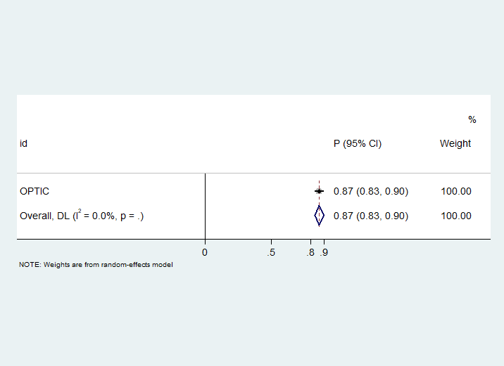
Figure S1. The forest plot of probability of early clinical response for omadacycline
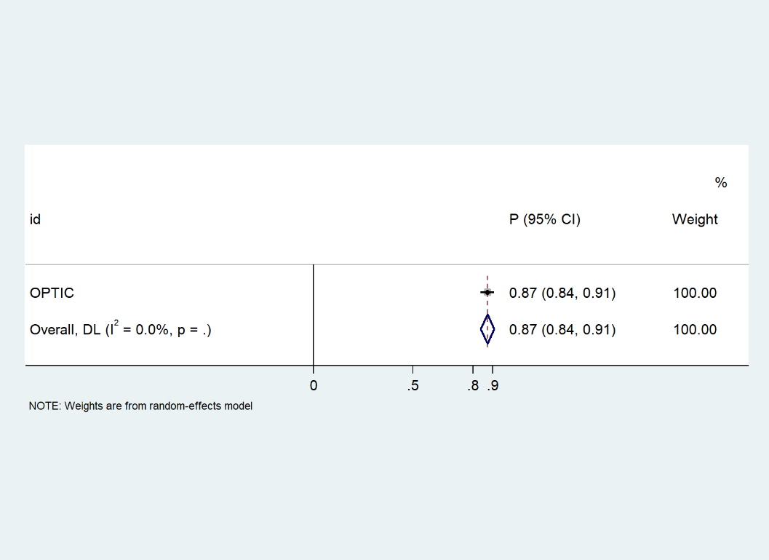

Figure S2. The forest plot of probability of early clinical response for moxifloxacin

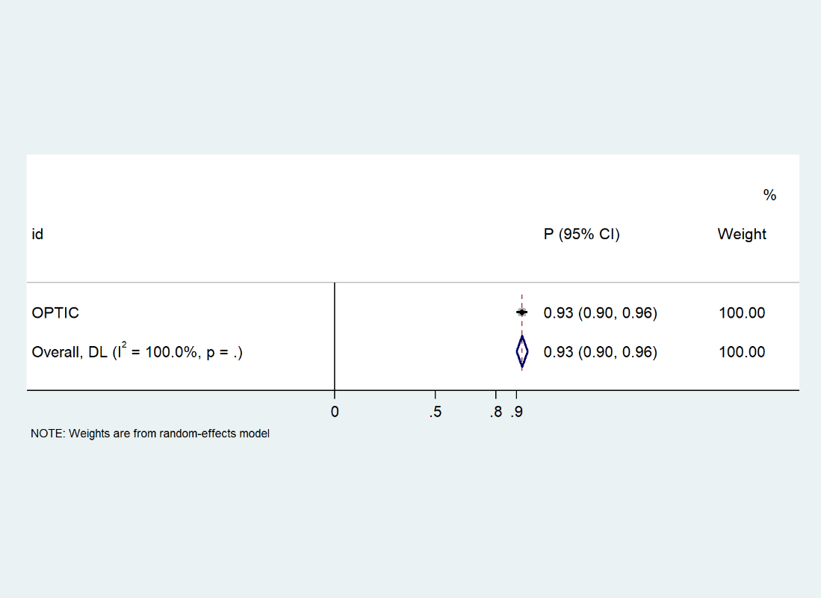

Figure S3. The forest plot of probability of clinical cure for omadacycline
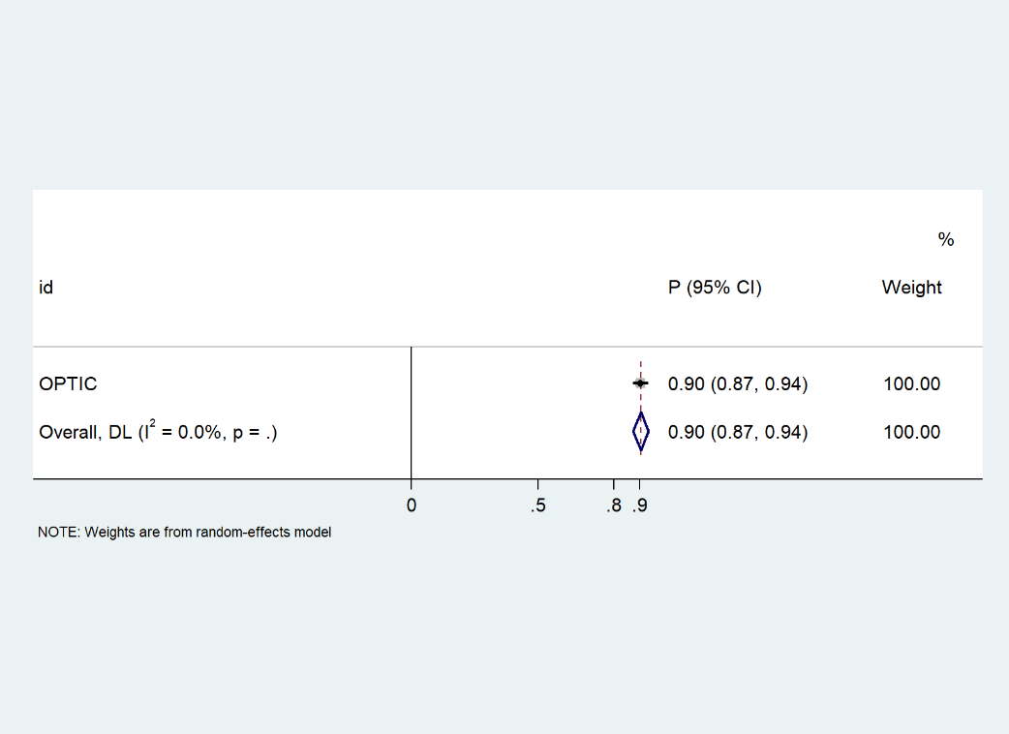

Figure S4. The forest plot of probability of clinical cure for moxifloxacin

Table S1. Baseline Demographics (microITT Population).
Characteristicª | Omadacycline(N=204) | Moxifloxacin(N=182)
Age, years
Median age (range) | 60 (19–87) | 63 (26–86)
>65 years, n (%) | 77 (37.7) | 79 (43.4)
Male, n (%) | 113 (55.4) | 103 (56.6)
Body mass index, kg/m^{2 b} | 27.3±5.6 | 27.0±5.8
Creatinine clearance, n (%)
>80 mL/min | 95 (46.6) | 96 (52.7)
>50–80 mL/min | 73 (35.8) | 56 (30.8)
30–50 mL/min | 36 (17.6) | 30 (16.5)
<30 mL/min | 0 | 0
PORT Score ^{b} | 82.5±15.6 | 82.8±15.3
PORT Risk Class, n (%) ^{c}
II (51 ≤ PORT Score ≤70) | 28 (13.7) | 25 (13.7)
III (71 ≤ PORT Score ≤90) | 126 (61.8) | 112 (61.5)
IV (91 ≤ PORT Score ≤130) | 49 (24.0) | 44 (24.2)

Abbreviations: microITT, microbiological intent-to-treat.
ª There were no significant differences (p < 0.05) between treatment groups using Fisher’s exact test (for
categorical variables) or Wilcoxon Rank Sum test (for continuous variables).
^{b} Mean ± standard deviation.
^{c} 5 patients were randomized but were found to have non-qualifying PORT Risk Class I or V.
Table S2. Baseline Demographics (non-microITT Population)
Characteristicª | Omadacycline(N=182) | Moxifloxacin(N=206)
Age, years
Median age (range) | 61 (22–97) | 64 (19–94)
>65 years, n (%) | 75 (41.2) | 93 (45.1)
Male, n (%) | 95 (52.2) | 116 (56.3)
Body mass index, kg/m^{2 b} | 27.2±5.9 | 27.8±5.8
Creatinine clearance, n (%)
>80 mL/min | 92 (50.5) | 111 (53.9)
>50 – 80 mL/min | 55 (30.2) | 63 (30.6)
30 – 50 mL/min | 34 (18.7) | 32 (15.5)
<30 mL/min | 1 (0.5)
PORT Score ^{b} | 84.0±17.4 | 85.0±16.6
PORT Risk Class, n (%) ^{c}
II (51 ≤ PORT Score ≤70) | 27 (14.8) | 29 (14.1)
III (71 ≤ PORT Score ≤90) | 101 (55.5) | 104 (50.5)
IV (91 ≤ PORT Score ≤130) | 53 (29.1) | 71 (34.5)

Abbreviations: non-microITT, non-microbiological intent-to-treat.
The non-microITT population consisted of all randomized patients without at least 1 causative pathogen identified at baseline from a culture of a respiratory specimen, or culture of blood, or from a culture-independent method.
ª There were no significant differences (p < 0.05) between treatment groups using Fisher’s exact test (for categorical variables) or Wilcoxon Rank Sum test (for continuous variables).
^{b} Mean ± standard deviation.
^{c} 5 patients were randomized but were found to have non-qualifying PORT Risk Class I or V.

Table S3. Baseline Demographics (Microbiologically Evaluable Population at End
of Treatment).
Characteristicª | Omadacycline(N=193) | Moxifloxacin(N=172)
Age, years
Median age (range) | 60 (19–87) | 63 (26–86)
>65 years, n (%) | 73 (37.8) | 74 (43.0)
Male, n (%) | 105 (54.4) | 97 (56.4)
Body mass index, kg/m^{2 b} | 27.4±5.6 | 27.0±5.8
Creatinine clearance, n (%)
>80 mL/min | 91 (47.2) | 91 (52.9)
>50 – 80 mL/min | 71 (36.8) | 53 (30.8)
30 – 50 mL/min | 31 (16.1) | 28 (16.3)
<30 mL/min | 0 | 0
PORT Score ^{b} | 82.2±14.8 | 82.8±14.4
PORT Risk Class, n (%) ^{c}
II (51 ≤ PORT Score ≤70) | 26 (13.5) | 21 (12.2)
III (71 ≤ PORT Score ≤90) | 123 (63.7) | 109 (63.4)
IV (91 ≤ PORT Score ≤130) | 44 (22.8) | 42 (24.4)
ª There were no significant differences (p < 0.05) between treatment groups using Fisher’s exact test (for categorical variables) or Wilcoxon Rank Sum test (for continuous variables).
^{b} Mean ± standard deviation.
^{c} 5 patients were randomized but were found to have non-qualifying PORT Risk Class I or V.

Table S4. Baseline Demographics (Microbiologically Evaluable Population at Post-treatment Evaluation).
Characteristicª | Omadacycline(N=188) | Moxifloxacin(N=169)
Age, years
Median age (range) | 60 (19–87) | 63 (26–86)
>65 years, n (%) | 73 (38.8) | 74 (43.8)
Male, n (%) | 102 (54.3) | 95 (56.2)
Body mass index, kg/m^{2 b} | 27.3±5.4 | 27.0±5.8
Creatinine clearance, n (%)
>80 mL/min | 88 (46.8) | 88 (52.1)
>50 – 80 mL/min | 70 (37.2) | 54 (32.0)
30 – 50 mL/min | 30 (16.0) | 27 (16.0)
<30 mL/min | 0 | 0
PORT Score ^{b} | 82.4±14.9 | 82.4±14.3
PORT Risk Class, n (%) ^{c}
II (51 ≤ PORT Score ≤70) | 25 (13.3) | 22 (13.0)
III (71 ≤ PORT Score ≤90) | 119 (63.3) | 107 (63.3)
IV (91 ≤ PORT Score ≤130) | 44 (23.4) | 40 (23.7)

ª There were no significant differences (p < 0.05) between treatment groups using Fisher’s exact test (for categorical variables) or Wilcoxon Rank Sum test (for continuous variables).
^{b} Mean ± standard deviation.
^{c} 5 patients were randomized but were found to have non-qualifying PORT Risk Class I or V.

Model Calculations:
Cost Calculation of ECR for omadacycline:
Cost of IV omadacycline first day+(Cost of IV omadacycline)*2 days+ (Cost of hospital per day)*3 days +(Cost of inpatient examination per day)* 3 days +(Cost of nursing care per day)* 3 days +(Cost of PO omadacycline) * 7 days) +Cost of laboratory examinations*2 times+(Cost of diarrhea)*(Probability of omadacycline diarrhea)
Cost Calculation of No ECR for omadacycline:
Cost of IV omadacycline first day+(Cost of IV omadacycline)*2 days + (Cost of hospital per day)*10 days +(Cost of inpatient examination per day)* 10 days +(Cost of nursing care per day)* 10 days + (Cost of IV omadacycline) * 7 days +(Cost of laboratory examinations) *5 times+(Cost of diarrhea)*(Probability of omadacycline diarrhea)
Cost Calculation of ECR for Moxifloxacin:
(Cost of IV moxifloxacin) * 3 days + (Cost of hospital per day)*3 days +(Cost of inpatient examination per day)* 3 days +(Cost of nursing care per day) * 3 days +(Cost of PO moxifloxacin) * 7 days) +Cost of laboratory examinations*2 times+(Cost of diarrhea)*(Probability of moxifloxacin diarrhea)
Cost Calculation of No ECR for Moxifloxacin:
Cost of IV moxifloxacin *10 days + (Cost of hospital per day)*10 days +(Cost of inpatient examination per day)* 10 days +(Cost of nursing care per day)* 10 days +(Cost of laboratory examinations) *5 times+(Cost of diarrhea)*(Probability of moxifloxacin diarrhea)
QALYs:
(Probability of success) * (Utility of treatment succuss) + (Probability of failure) * (Utility of treatment failure)

