Supplementary Data
UPLC-QTOF-MS analysis
Drug compounds were dissolved in HPLC-grade methanol or acetonitrile (Sigma-Aldrich) followed by 10 min of sonication at 25°C. The solutions were filtered through 0.22 μm nylon membrane filters (Millipore) prior to analysis. For complex biological matrices, solid-phase extraction (Oasis HLB cartridges, Waters) was performed using established protocols [1,2]. The method combines the high separation efficiency of UPLC with the mass accuracy (<5 ppm) and resolution (>30,000) of Q-TOF-MS, enabling comprehensive drug component analysis.

Supplementary Figure
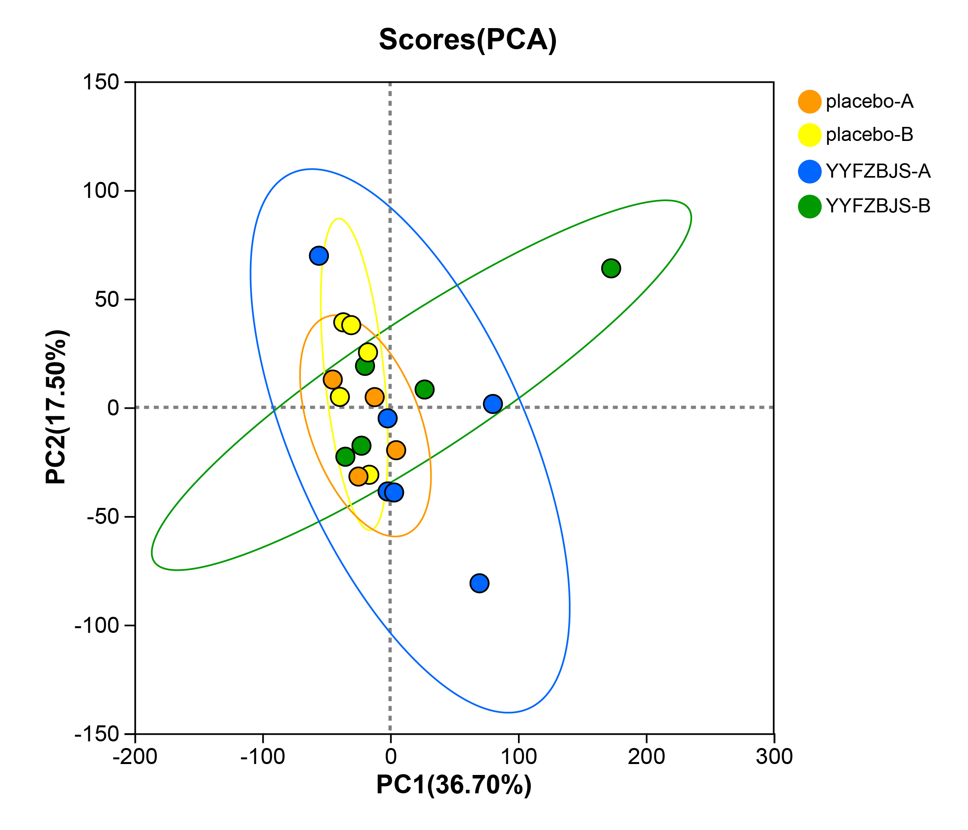
Supplementary Figure 1 Principal component analysis (PCA) of Metabolites in different group

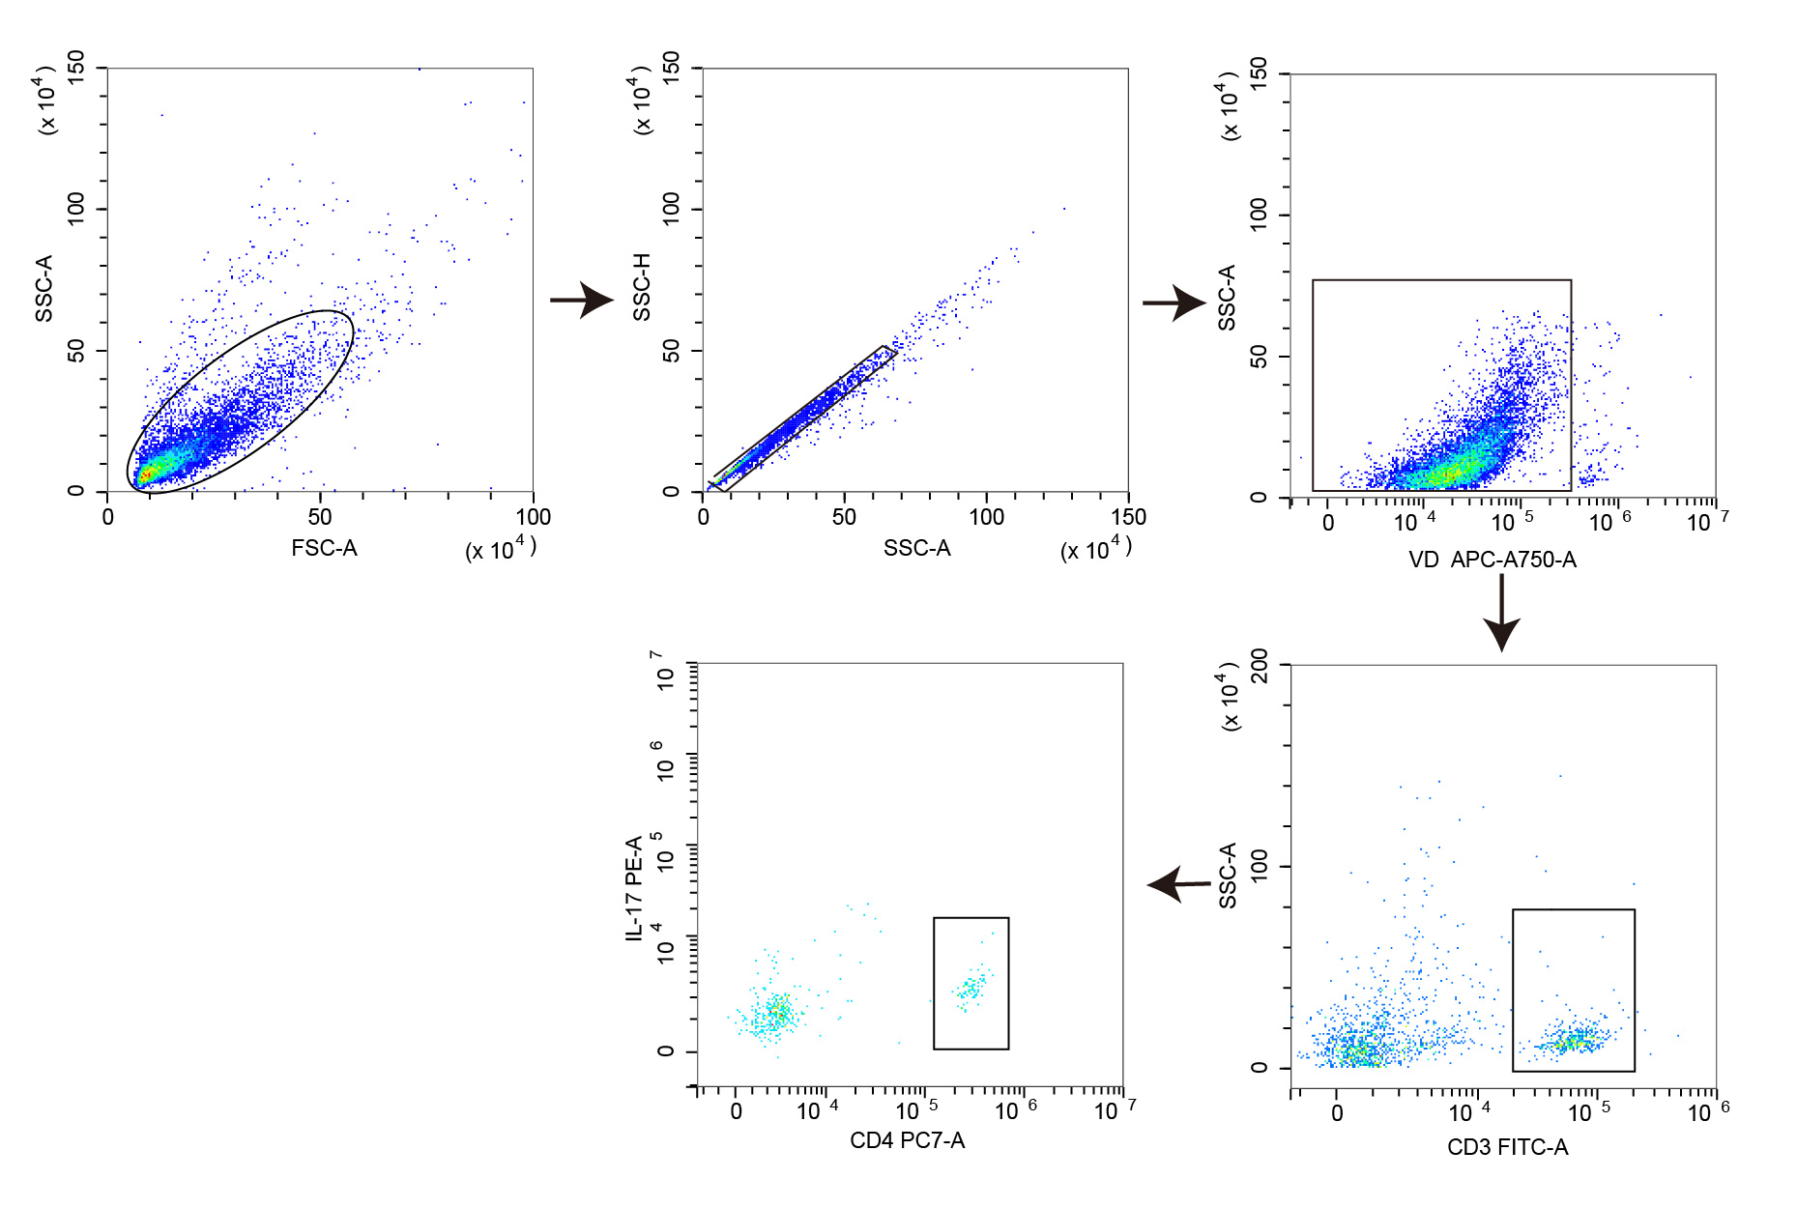
Supplementary Figure 2 The representative flow cytometry and population of CD4⁺ IL-17⁺ T cells in PBMC of CRA patients.
Incubate cells with fluorescently labeled FITC anti-CD3, then staining with anti-CD4 (PC7) and anti-IL-17A (PE)
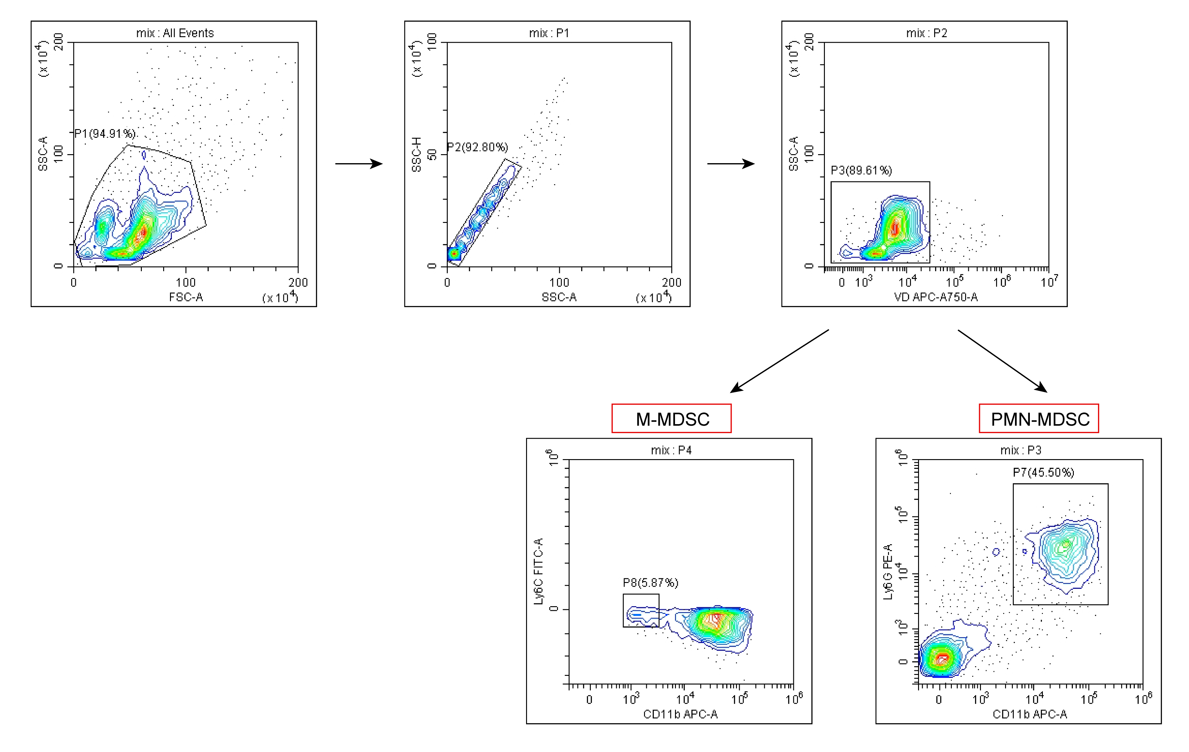
Supplementary Figure 3 The representative flow cytometry and population of M-MDSC and PMN-MDSC cells in PBMC of CRA patients.
Representative flow cytometry plots of myeloid-derived suppressor cells (MDSCs) showing the viable MDSCs gate on CD11b⁺Ly6C⁺ or CD11b⁺Ly6G⁺ cells.
A
B
Supplementary Figure 4 Phytochemicals analysis of YYFZBJS in granule extract.
(A) The base peak chromatogram (BPC) of YYFZBJS obtained by Ultra-performance liquid chromatography-quadrupole-time of ﬂight-mass spectrometry (UPLC-QTOF-MS) analysis in positive-ion mode. (B) BPC of YYFZBJS obtained by UPLC-QTOF-MS analysis in negative-ion mode.

Reference
- Zhai L, Zheng Y, Lo CW, Xu S, Jiang X, Liu Q, Ching JY, Ning Z, Bao G, Yang W, Zhang Q, Cheng CW, Lam WC, Chan KL, Zhang X, Lam PY, Wu XY, Zhong LLD, Cao PH, Koh M, Cheong PK, Lin Z, Lin C, Zhao L, Wong XHL, Wu JC, Bian Z. Butyrate-producing commensal bacteria mediates the efficacy of herbal medicine JCM-16021 on abdominal pain in diarrhea-predominant irritable bowel syndrome: a randomized clinical trial. Phytomedicine. 2025 Jul 1;145:157040. doi: 10.1016/j.phymed.2025.157040.
- Zhang Y, Chai N, Wei Z, et al. YYFZBJS inhibits colorectal tumorigenesis by enhancing Tregs-induced immunosuppression through HIF-1α mediated hypoxia in vivo and in vitro. Phytomedicine 2022; 98: 153917. doi:10.1016/j.phymed.2021.153917
