Annexure 1 Figure: Hypertension Care Research in Primary Care

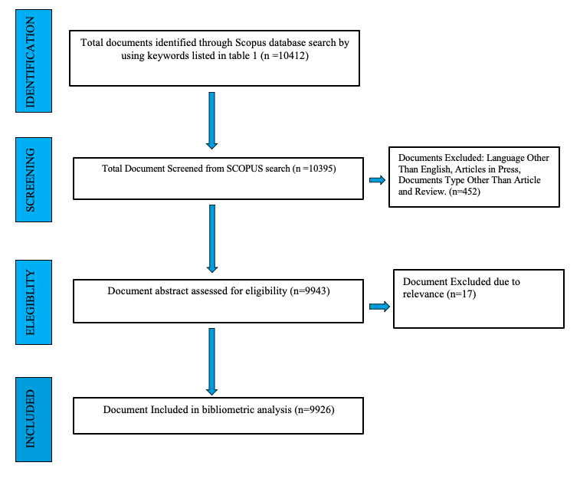

Annex Figure 1: Results of keyword search as per PRISMA guidelines

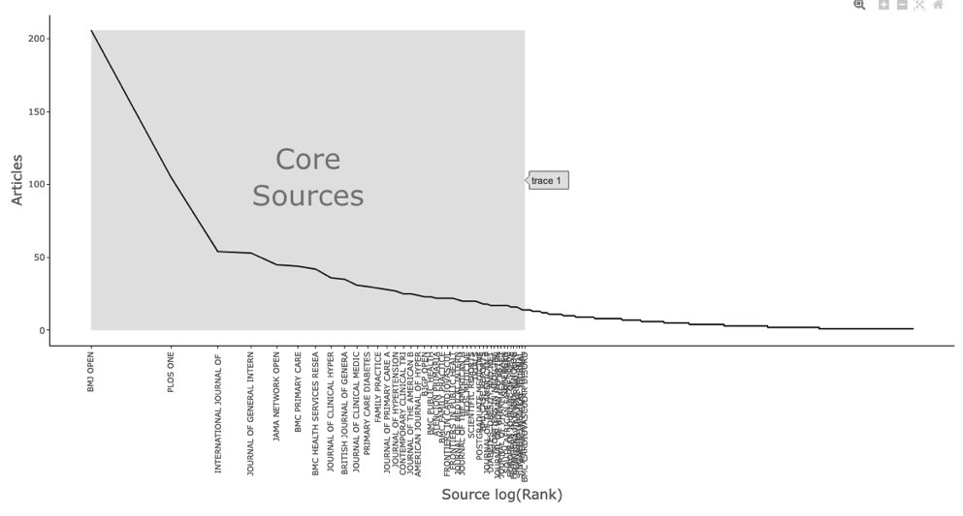

Annex Figure 5: Bradford law

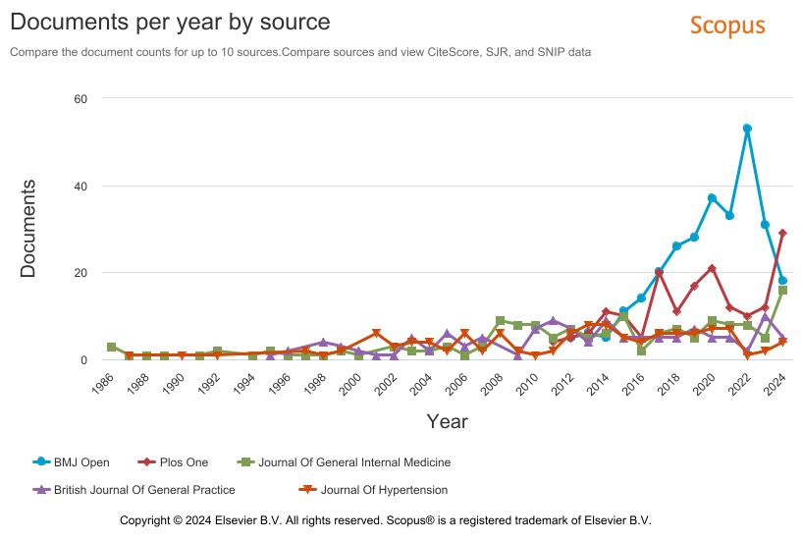
Annex Figure 6: Documents per year by top journals (Source: SCOPUS)

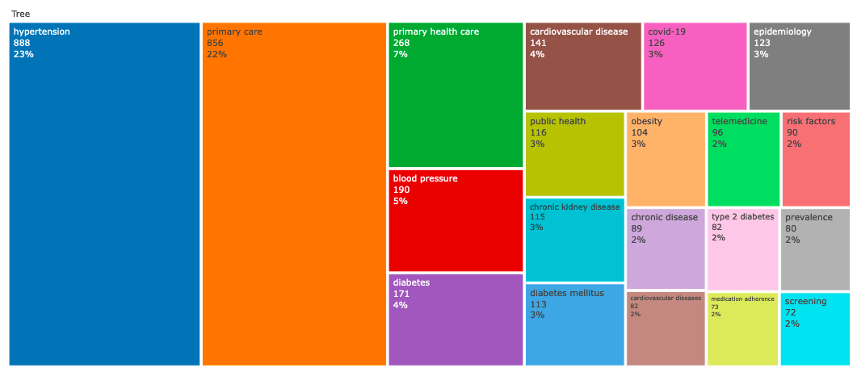
Annex Figure 7: Tree map of Authors Keywords

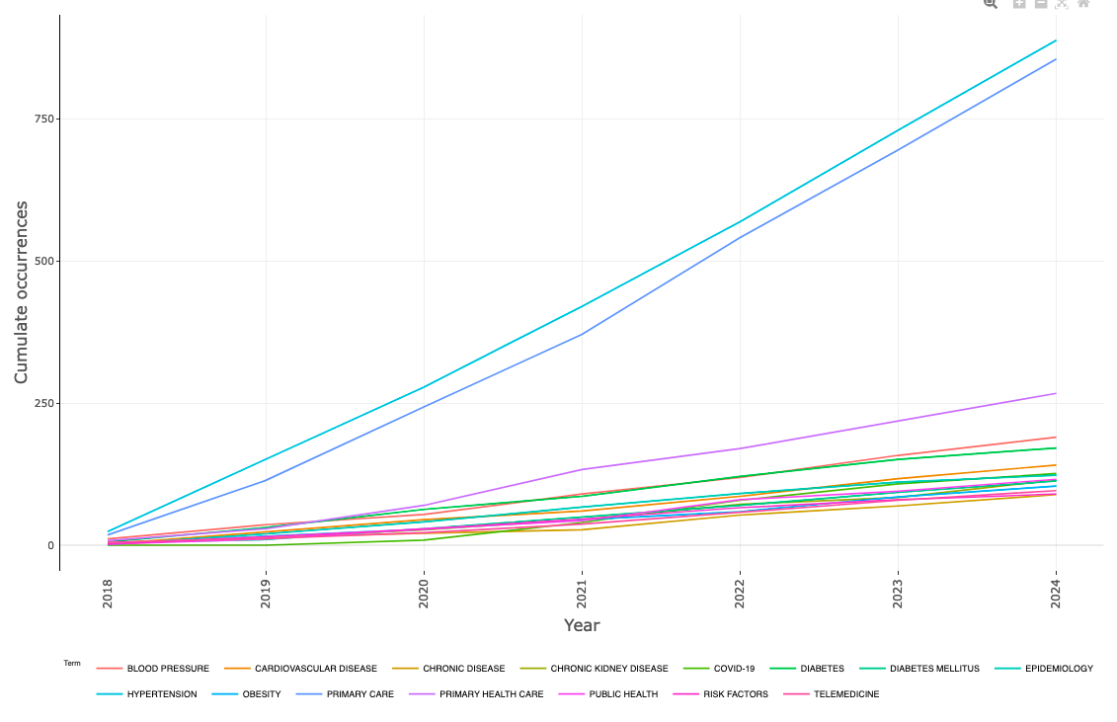
Annex Figure 8: Word frequency over time
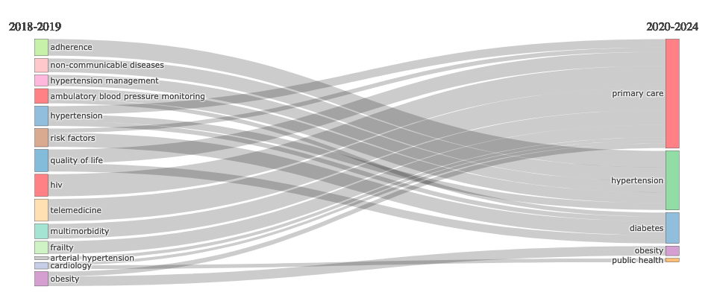
Annex Figure 10: Sankey diagram

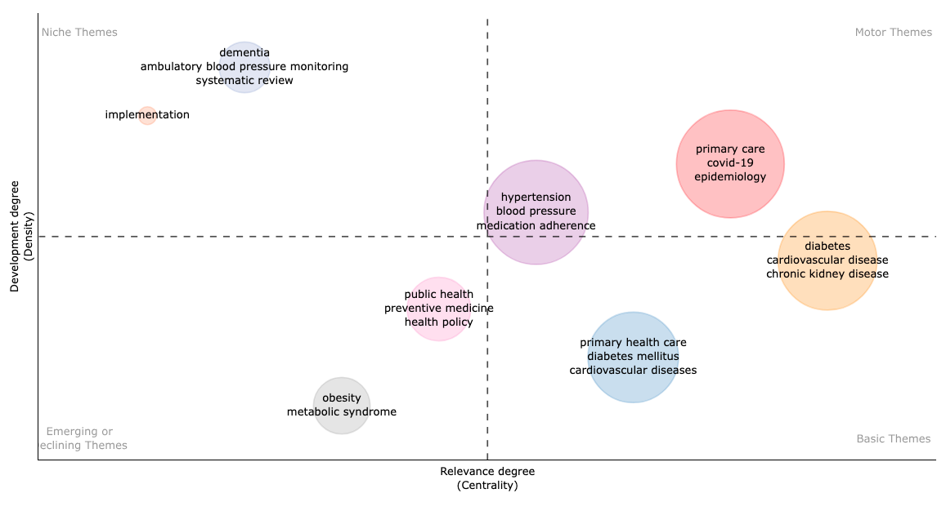
Annex Figure 11: Thematic map

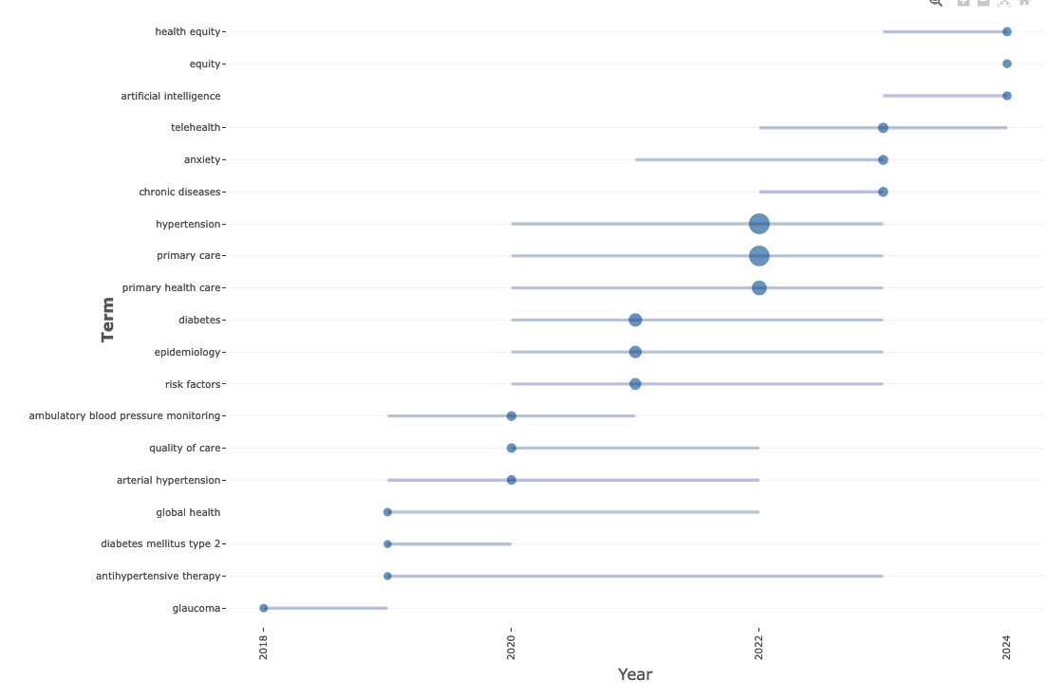
Annex Figure 12: Trending topics

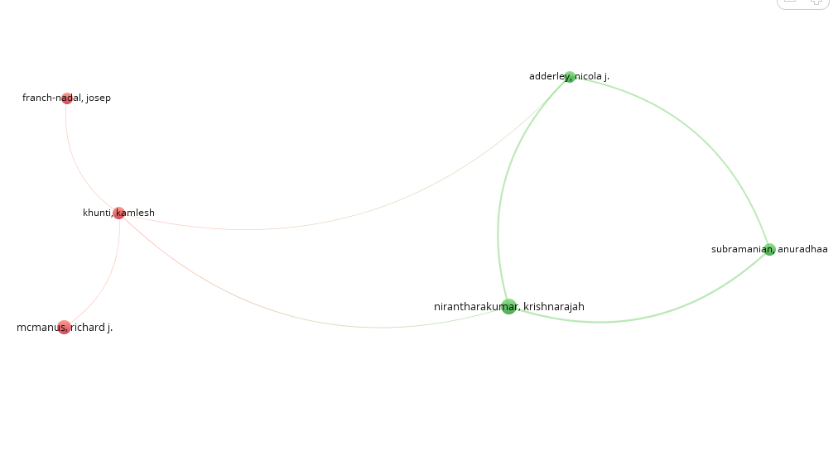
Annex Figure 13: The network visualisation of co-authorship between the authors

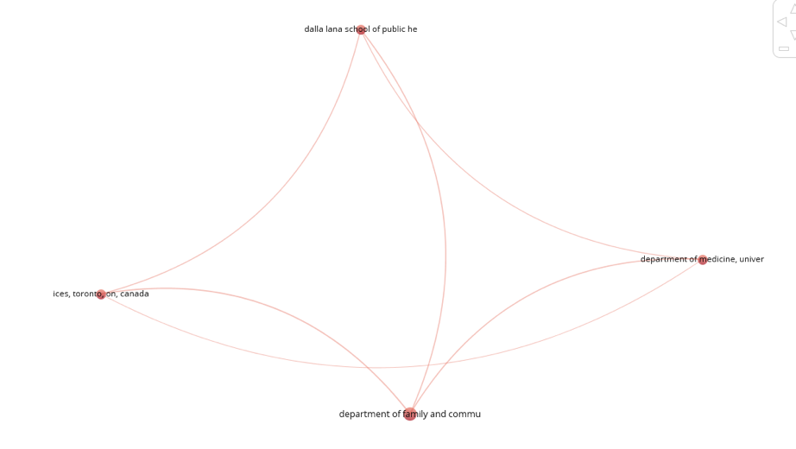
Annex Figure 14: The network visualisation of co-authorship between the institutions

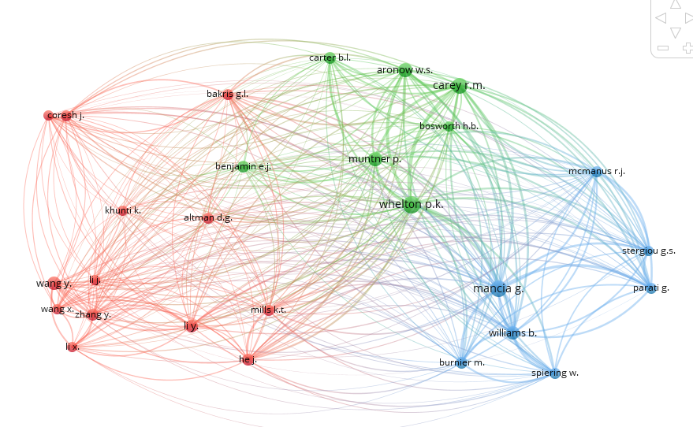

Annex Figure 16: The network visualisation map of co-cited Authors
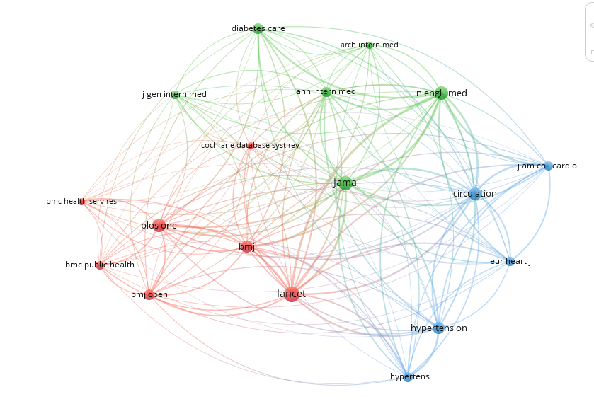

Annex Figure 17: The network visualisation map of co-cited Sources

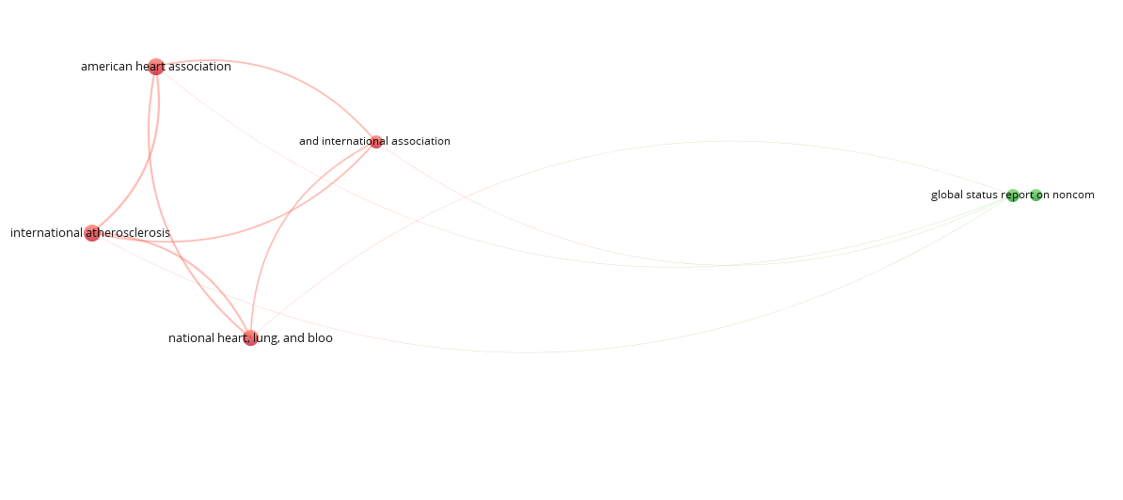

Annex Figure 18: The network visualisation map of co-cited References

Annexure 2 Table- Hypertension Care Research in Primary Care

( TITLE-ABS-KEY ( hypertension ) AND TITLE-ABS-KEY ( "primary care" ) ) AND PUBYEAR > 1983 AND PUBYEAR < 2025 AND ( LIMIT-TO ( SRCTYPE , "j" ) ) AND ( LIMIT-TO ( PUBSTAGE , "final" ) ) AND ( LIMIT-TO ( DOCTYPE , "ar" ) OR LIMIT-TO ( DOCTYPE , "re" ) ) AND ( LIMIT-TO ( LANGUAGE , "English" ) )

Annex Table 1: List of Keywords used

Sl No | Research Questions | Knowledge  structure  covered | Bibliometric techniques
 | What are the publishing trends of the research publication in Hypertension Care in Primary Care ? | Intellectual  structure | Annual Scientific Production.
 | Who are the most contributing authors,  journals, organisations, funding agencies and countries and cited papers in Hypertension Care Research in Primary Care? | Intellectual  structure | Three field plots, Most relevant  Authors, Organisations, journal, funding agencies, Co-citation of author, journal and references
 | What are the publication patterns and  most frequently used keywords of the  articles published in Hypertension Care Research in Primary Care ? | Conceptual  structure | Network Analysis, Thematic mapping, and Thematic evolution and trending topics.
 | What are the collaboration networks in  Hypertension Care Research in Primary Care? | Social structure | Authors collaboration network, Institution collaboration network, and Country Collaboration network
 | What are the thematic trends of the  Hypertension Care Research in Primary Care? | Conceptual  structure | Thematic mapping, Thematic  Evolution.
 | What are the main open areas of  challenges and the corresponding  solutions for future research work in Hypertension Care Research in Primary Care ? | Conceptual  structure | Thematic mapping, Thematic  evolution, and Factorial  analysis

Annex Table 2: Mapping of Research questions with knowledge structure, bibliometric and statistical techniques
AUTHOR NAME | Country | Documents
McManus, R.J. | Jichi Medical University, Kawachi District, Japan | 59
Bosworth, H.B. | Duke University School of Medicine, Durham, United States | 43
Hobbs, F.D.R. | University of Oxford Medical Sciences Division, Oxford, United Kingdom | 36
Mant, J. | St George's University Hospitals NHS Foundation Trust, London, United Kingdom | 36
Tan, N.C. | Singapore Health Services, Singapore City, Singapore | 36
Cooper, L.A. | Johns Hopkins University School of Medicine, Baltimore, United States | 33
Khunti, K. | University of LeicesterThe institution will open in a new tab, Leicester, United Kingdom | 33
Carter, B.L. | American College of Clinical Pharmacy, Lenexa, United States | 31
Nirantharakumar, K. | NIHR Birmingham Biomedical Research CentreThe institution will open in a new tab, Birmingham, United Kingdom | 29
Bramlage, P. | Institute for Pharmacology and Preventive Medicine, Cloppenburg, Germany | 28
 |  | 305

Annex Table 3: Most productive authors.

Affiliation | Country | Documents
Harvard Medical School | United States (USA) | 226
VA Medical Center | United States (USA) | 207
University of Toronto | Canada | 192
University of Oxford | United Kingdom (UK) | 184
University of California, San Francisco | United States (USA) | 159
University of Oxford Medical Sciences Division | United Kingdom (UK) | 149
Brigham and Women's Hospital | United States (USA) | 144
University of Birmingham | United Kingdom (UK) | 137
Johns Hopkins University School of Medicine | United States (USA) | 122
University College London | United Kingdom (UK) | 122
 |  | 1642

Annex Table 4: Top Contributing Organisations

COUNTRY | Documents
United States | 4065
United Kingdom | 1595
Spain | 661
Canada | 616
Australia | 409
Germany | 356
Netherlands | 314
Sweden | 301
China | 268
Brazil | 264

Annex Table 5: Country scientific production

Journals | Country | Quartile | H index | Documents
BMJ Open | United Kingdom (UK) | Q1 | 160 | 287
Plos One | United States (USA) | Q1 | 435 | 173
Journal Of General Internal Medicine | United States (USA) | Q1 | 214 | 156
British Journal Of General Practice | United Kingdom (UK) | Q1 | 118 | 126
Journal Of Hypertension | United States (USA) | Q1 | 192 | 116
Family Practice | United Kingdom (UK) | Q1 | 114 | 107
BMC Family Practice | United Kingdom (UK) | - | - | 105
BMC Health Services Research | United Kingdom (UK) | Q1 | 146 | 97
Journal Of Clinical Hypertension | United States (USA) | Q2 | 81 | 86
American Journal Of Hypertension | United Kingdom (UK) | Q2 | 150 | 82
Total |  |  |  | 1335

Annex Table 6: Most prolific journals

Title | Year | Source title | Cited by | DOI
Factors associated with COVID-19-related death using OpenSAFELY | 2020 | Nature | 4324 | 10.1038/s41586-020-2521-4
The global epidemiology of NAFLD and NASH in patients with type 2 diabetes: A systematic review and meta-analysis | 2019 | Journal of Hepatology | 1469 | 10.1016/j.jhep.2019.06.021
Chronic Kidney Disease Diagnosis and Management: A Review | 2019 | JAMA - Journal of the American Medical Association | 951 | 10.1001/jama.2019.14745
American Association of Clinical Endocrinology Clinical Practice Guideline for the Diagnosis and Management of Nonalcoholic Fatty Liver Disease in Primary Care and Endocrinology Clinical Settings: Co-Sponsored by the American Association for the Study of Liver Diseases (AASLD) | 2022 | Endocrine Practice | 497 | 10.1016/j.eprac.2022.03.010
Quality of primary health care in China: challenges and recommendations | 2020 | The Lancet | 496 | 10.1016/S0140-6736(20)30122-7
Risk factors for SARS-CoV-2 among patients in the Oxford Royal College of General Practitioners Research and Surveillance Centre primary care network: a cross-sectional study | 2020 | The Lancet Infectious Diseases | 415 | 10.1016/S1473-3099(20)30371-6
Standards of medical care in diabetes—2019 abridged for primary care providers | 2019 | Clinical Diabetes | 391 | 10.2337/cd18-0105
Hypertension Canada's 2020 Comprehensive Guidelines for the Prevention, Diagnosis, Risk Assessment, and Treatment of Hypertension in Adults and Children | 2020 | Canadian Journal of Cardiology | 390 | 10.1016/j.cjca.2020.02.086
Standards of Medical Care in Diabetes—2022 Abridged for Primary Care Providers | 2022 | Clinical Diabetes | 373 | 10.2337/cd22-as01
Mechanisms of Cardiorenal Effects of Sodium-Glucose Cotransporter 2 Inhibitors: JACC State-of-the-Art Review | 2020 | Journal of the American College of Cardiology | 353 | 10.1016/j.jacc.2019.11.031
Annex Table 7: Highly cited research publications in Hypertension Care research in Primary Care.

Funding Bodies | Country | Documents
National Institutes of Health | United States (USA) | 744
U.S. Department of Health and Human Services | United States (USA) | 540
National Heart, Lung, and Blood Institute | United States (USA) | 384
Medical Research Council | United Kingdom (UK) | 180
National Institute for Health Research | United Kingdom (UK) | 173
National Institute of Diabetes and Digestive and Kidney Diseases | United States (USA) | 162
National Institute for Health and Care Research | United Kingdom (UK) | 160
National Center for Advancing Translational Sciences | United States (USA) | 138
UK Research and Innovation | United Kingdom (UK) | 137
National Institute on Aging | United States (USA) | 105
 |  | 2723

Annex Table 8: Top funding bodies

Cluster number /no of Items /Colour | Keywords of the clusters | Key Theme
Cluster 1  (11 items)  Red Colour | Cardiovascular disease, Cardiovascular risk  Chronic kidney diseas, Diabetes, Elderly, Heart failure, Metabolic syndrome, Mortality, Obesity, Prevention, Type 2 diabetes
Cluster 2  (11 items)  Green Colour | Atrial fibrillation, Dementia, Depression, Electronic health recor, Epidemiology, Prevalence, Primary healthcare, Risk factors, Screening, Stroke,  Type 2 diabetes mellit
Cluster 3  (8 items)  Blue Colour | Chronic disease, Covid-19, Diagnosis, General practice, Medication adherence, Multimorbidity, Primary care, Telemedicine
Cluster 4  (6 items)  Yellow Colour | blood pressure, cardiovascular disease, diabetes mellitus, hypertension, primary health care, quality improvement
Cluster 5  (3 items)  Purple Colour | Preventive medicine, Public health, Qualitative research
Annex Table 9: Details of keywords in different clusters of network co-occurrence of authors keywords and key themes.

Cluster Number, Items and Colour | Authors
Cluster 1 (03 items),Red | Wang, xin , Wang,yang and Zhang,Yan
Cluster 2 (03 items),Green
Cluster 3 (02 items),Blue

Annex Table 10:Details of Authors in different clusters of co-authorship network.

Cluster Number, Items and Colour | Organisation
Cluster 1,3 Items (Red) | Dalla Lana School of Public Health, University of toronto, Canada (Document=11,Citations=83,Total Link Strength=12)  Department of family and Community Medicine , University of toronto, Canada  (Document=20 ,Citations=252,Total Link Strength=16)  Department of Medicine, University of toronto, Canada  (Document=10 ,Citations=91,Total Link Strength=10)  ICES , Toronto, Canada  (Document=11 ,Citations=46,Total Link Strength=12)

Annex Table 11: Details of organisations in different clusters of institution collaboration network analysis.

Cluster Number, Items and Colour | Country
Cluster 1, (6 items), Red | Germany, Italy, Netherlands, Spain, Sweden, United kingdom
Cluster 2, (5 items), Green | Brazil, Canada, India, Switzerland, United states
Cluster 3, (3 items), | Australia, China, Singapore

Annex Table 12: Details of the country in different clusters of country collaboration network map

Author | Co Citations
Whelton, Paul K. | 493
Mancia, Giuseppe | 461
Carey r.m | 410
Muntner, Paul | 315
Aronow, Wilbert S | 314
Williams B. | 302
Wang Y | 284
Li Y | 252
He J | 244
Carter, Ben | 244
Total Co Citations | 3319

Annex Table 13: Top 10 Co-cited authors in the field of Hypertension Care Research in Primary Care.
Source | Co-Citations | Total Link Strength | Quartile | Subject Area
The Lancet | 2735 | 26262 | Q1 | Medicine
JAMA | 2327 | 22983 | Q1 | Medicine and Nursing
Plos One | 2106 | 14672 | Q1 | Multidisciplinary
New England Journal of Medicine | 2082 | 25921 | Q1 | Medicine
Circulation | 1774 | 20448 | Q1 | Medicine
The BMJ | 1730 | 16337 | Q1 | Medicine
Hypertension | 1694 | 17434 | Q1 | Medicine
BMJ Open | 1340 | 10197 | Q1 | Medicine
Diabetes Care | 1282 | 11952 | Q1 | Medicine
Journal Of Hypertension | 1164 | 13481 | Q1 | Medicine

Annex Table 14: Top 10 Co-cited sourcec in the field of Hypertension Care Research in Primary Care.
Sl.No | Cited Article | Citations | Total Link Strength
 | American Heart Association | 37 | 93
 | International Heart Society | 36 | 93
 | National heart,Lung,and blood institute | 32 | 84
 | The International Association for the Study of Obesity | 22 | 68
 | Global status report on noncommunicable diseases 2014 | 22 | 5
 | Data Resource Profile: Clinical Practice Research Datalink (CPRD) | 27 | 1
 | Improved blood pressure control associated with a large-scale hypertension program | 18 | 1
 | WHO package of essential noncommunicable (PEN) disease interventions for primary health care | 21 | 1
 | 2018 ESC/ESH Guidelines for the management of arterial hypertension | 18 | 1
 | Worldwide trends in hypertension prevalence and progress in treatment and control from 1990 to 2019: a pooled analysis of 1201 population-representative studies with 104 million participants | 22 | 1
Annex Table 15: Top 10 references in the field of Hypertension Care Research in Primary Care.

