Supplementary material

Generic strategy for high-performance bio-based imprinted membranes free of non-specific adsorption: machine learning-assisted sensing
Ouarda El Hani, Khalid Digua, Aziz Amine*
Laboratory of Process Engineering and Environment, Faculty of Sciences and Techniques, Hassan II University of Casablanca, B.P. 146 Mohammedia, Morocco
*Corresponding author : aziz.amine@fstm.ac.ma (A. Amine)

Table S1. Removal of TC and Caf templates from Cs-MIM (GA)
Elution agents | Template | Removal time
Acetic acid: Methanol (1:9) | TC | 8 h
Acetic acid: Methanol (1:9) | Caf | 6 h
Methanol | TC | 10 h
Methanol | Caf | 8 h
Complexation with FC | TC | 20 min
Complexation with FC | Caf | 20 min
PLS regression model
The first crucial step in PLS multivariate analysis is the selection of principal components (PCs), as they play a fundamental role in capturing the variance within the dataset. In Fig. S1A, the explained variance (Exp(Var)) corresponding to each PC was analyzed to determine the optimal number of components for further analysis. The cumulative explained variance increases rapidly with the first few PCs and stabilizes around PC_5, which was therefore selected. The explained variance for PC_5 reached approximately 95.6 % in calibration and 87.6 % in validation, indicating that the selected components effectively retain the most relevant information from the dataset while minimizing noise.
Once the PCs were selected, the next step was to evaluate the calibration and validation performance of the PLS model. Fig. S1B presents the scatter plot of predicted vs measured responses for both calibration and validation datasets. The regression equations showed slope values close to 1 and intercepts near zero, indicating a strong correlation between predicted and measured values, confirming the model's reliability. Additionally, the Root Mean Square Error (RMSE) values for both calibration and validation were low (RMSEC=0.09 and RMSEV=0.21), signifying minimal prediction error and a well-fitted model. The high R² and R² adj values (above 0.95) further validate the effectiveness of the PLS model for calibration, demonstrating its strong predictive capability with minimal variance.
To further understand the significance of different spectral variables, the raw regression coefficients were analyzed, as shown in Fig. S1C. The most spectral variables of RGB were significant, exhibiting strong contributions to the predictive performance of the model, indicating that the PLS algorithm effectively captured relevant spectral information for Caf quantification.
Finally, to assess the predictive performance of the developed PLS model in real samples, the model was used to predict Caf concentration in pear, plum, and apple. The scatter plot of Y predicted vs. Y measured (Fig. S1D) showed a strong goodness prediction fit with R² and R² adj values (above 0.86) and a remarkable accuracy with RMSEP=0.23. Among the tested samples, plum exhibited the highest Caf concentration, followed by pear, while apple had the lowest concentration. The four prepared membranes (Cs-MIM (Cu²⁺), Cs-MIM (GA), CMC-MIM (Cu²⁺/PB), and CMC-MIM (EDC/NHS/PDA)) showed excellent performance in real sample prediction. Their ability to prevent matrix effects through NSA elimination ensured selective detection of Caf, further validating the effectiveness of the PLS model.
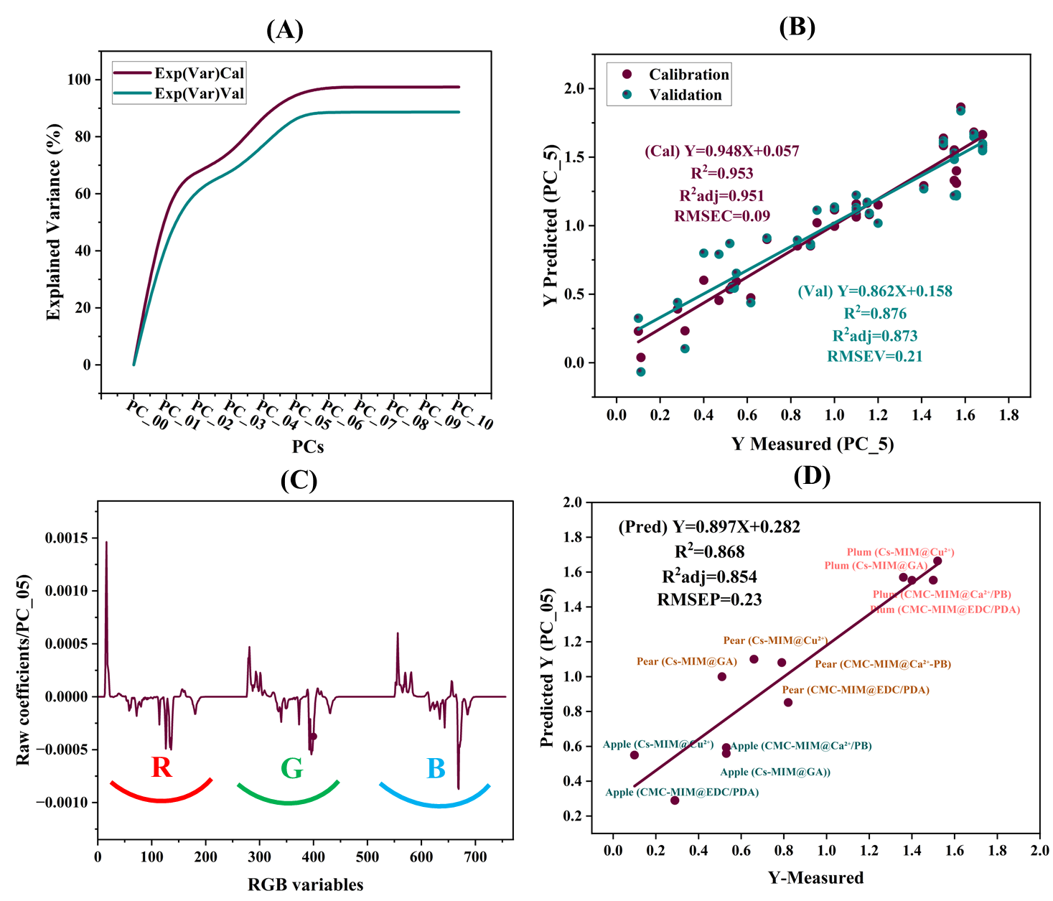
Fig. S1. Explained variance in calibration and validation for PCs (A); Y-predicted Vs Y measured for PC_5 (B); importance of RGB spectral variables for PC_5 (C); Y-predicted by PLS Vs Y-Measured in plum, pear, and apple for PC_5 (D).

