Supplementary information
Green-Synthesized Iron Oxide-Chitosan Nanocomposite for Chromium and Nanoplastics Remediation

Shouvik Mahanty^{1,2}, Gopala Krishna Darbha^{2,3*}, Richard Paul⁴, Ramin Boroujerdi⁴, Eugenia Valsami-Jones⁵, Santanu Majumder^{4*}

¹Department of Atomic Energy, Saha Institute of Nuclear Physics, Sector 1, AF Block, Bidhannagar, Kolkata 700064, West Bengal, India
²Environmental Nanoscience Laboratory, Department of Earth Sciences, IISER Kolkata, Mohanpur, West Bengal, Pincode- 741246, India
³Center for Climate & Environmental Studies, IISER Kolkata, Mohanpur, West Bengal, Pincode- 741246, India
⁴Department of Life and Environmental Sciences, Bournemouth University (Talbot Campus), Fern Barrow, Poole BH12 5BB, UK
⁵School of Geography, Earth and Environmental Sciences, University of Birmingham, Edgbaston, Birmingham B15 2TT, UK

*Corresponding Authors
Dr. Gopala Krishna Darbha, Associate Professor, Indian Institute of Science Education and Research (IISER) Kolkata, Mohanpur, West Bengal, Pin- 741246, India
Email: gkdarbha@iiserkol.ac.in
Dr. Santanu Majumder, Department of Life and Environmental Sciences, Bournemouth University (Talbot Campus), Fern Barrow, Poole BH125BB, UK
Email: smajumder@bournemouth.ac.uk

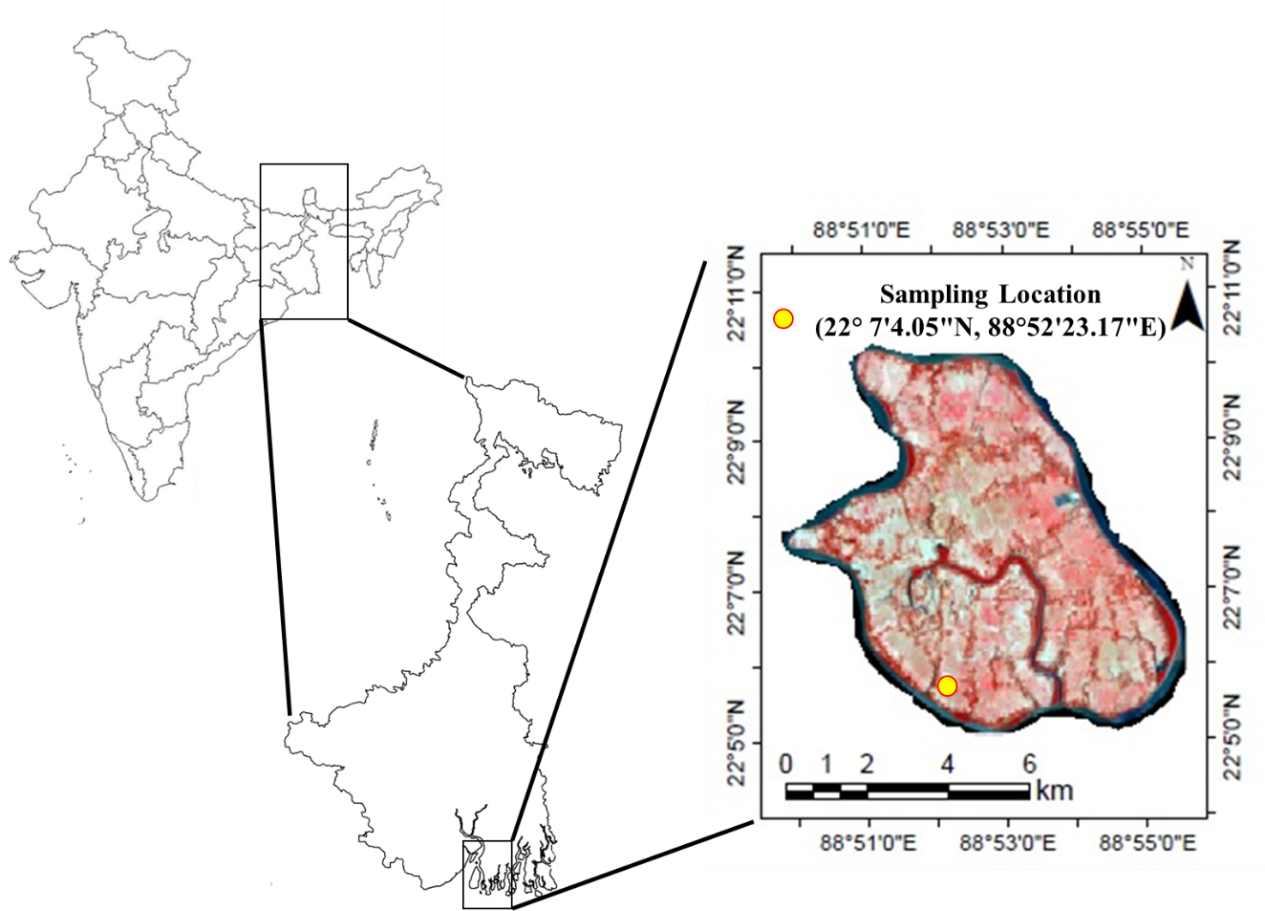
Fig S1: Sampling location

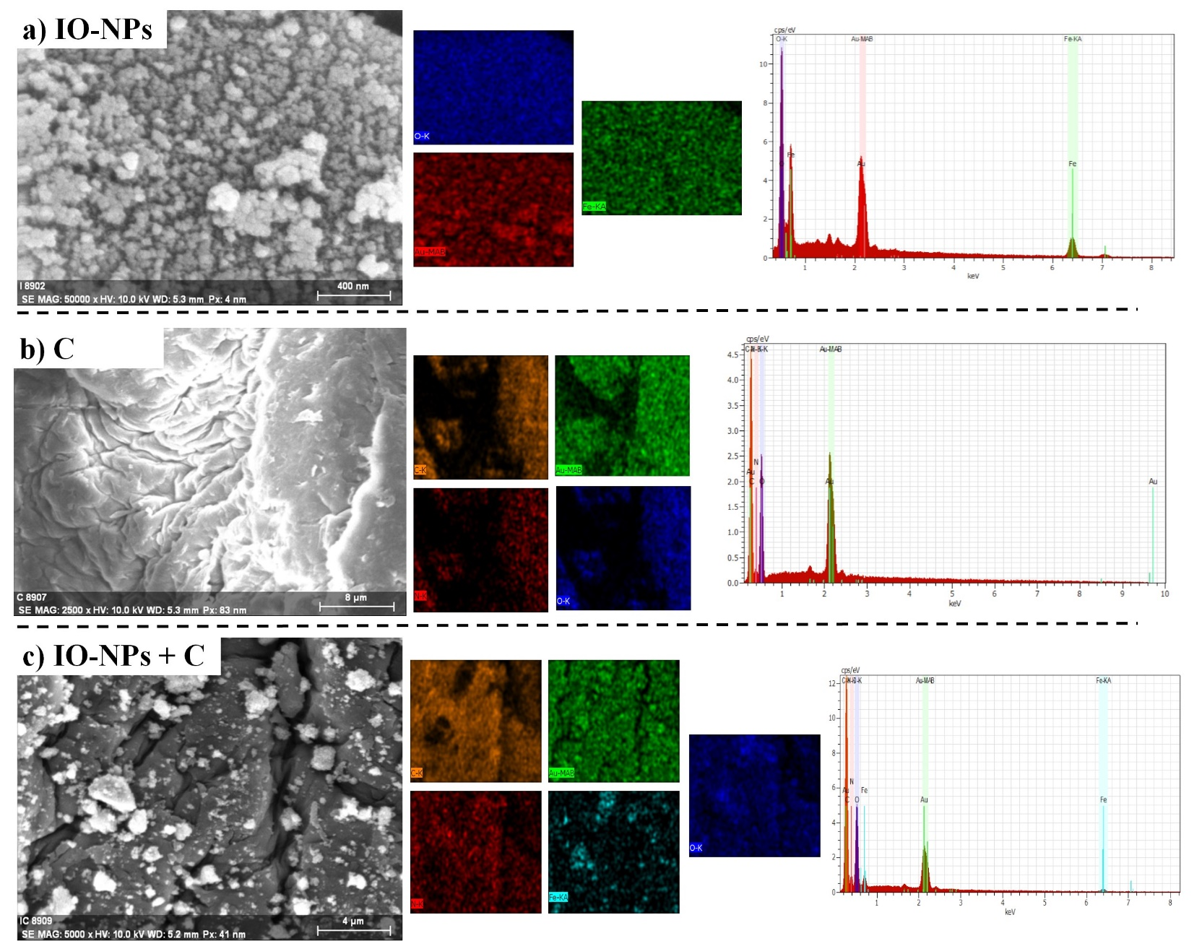
Fig S2: SEM-EDX mapping of a) IO-NPs b) C – Chitosan c) IO-NPs+C

Fitted models | Equation | Parameters and significance
Kinetic models
Pseudo 1st order |  | q_{e} = Equilibrium sorption capacity (mg/g)  q_{t} = Sorption capacity at time= t (mg/g)  K₁, K₂ are respective rate constants  c= resistance in mass transfer
Pseudo 2nd order
Isotherm models
Langmuir |  | C_{i} (mg/L)= Initial concentration  C_{e} (mg/L) = equilibrium concentration,  q_{e} = sorption capacity at equilibrium (mg/g),  q_{m} = obtained maximum sorption capacity (mg/g) and  K_{L}, K_{f} are Langmuir (L/mg), Freundlich (mg/g) (L/mg)^{1/n}
Freundlich | $$q_{e}=K_{F}C_{e}^{n}$$
Thermodynamic equations
Gibbs free energy | ΔG= -RTlnK_{L} | R is the universal gas constant (8.314 J K⁻¹ mol⁻¹); T is the absolute temperature (Kelvin)  K_{L=} C_{a}/C_{e}  C_{a}= (C_{e}-C_{i})/C_{e}  ΔG= Gibbs free energy  ΔS= entropy  ΔH= enthalpy of system
Vent Hoff’s equation | lnK_{L}= ΔS/R-ΔH/RT
Table S1- Fitted kinetic, isotherm and thermodynamic models (1-6).

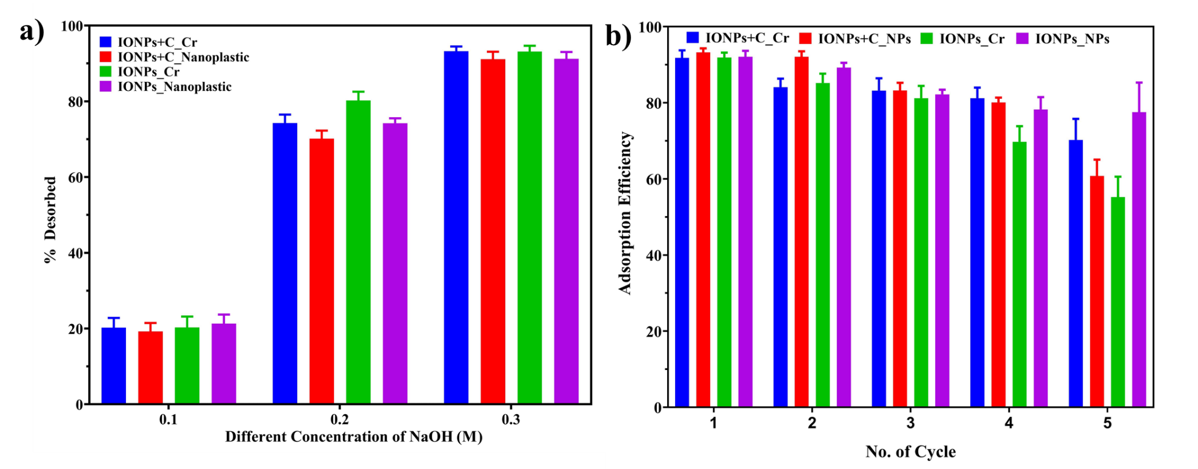
Fig. S3: a) Desorption of NPs and Cr ions in different concentration of NaOH d) adsorption efficiency of IO-NPs and IO-NPs+C for the adsorption of NPs and Cr ions. For all the experiments (p < 0.0001; two-way ANOVA and Tukey’s multiple comparisons test)

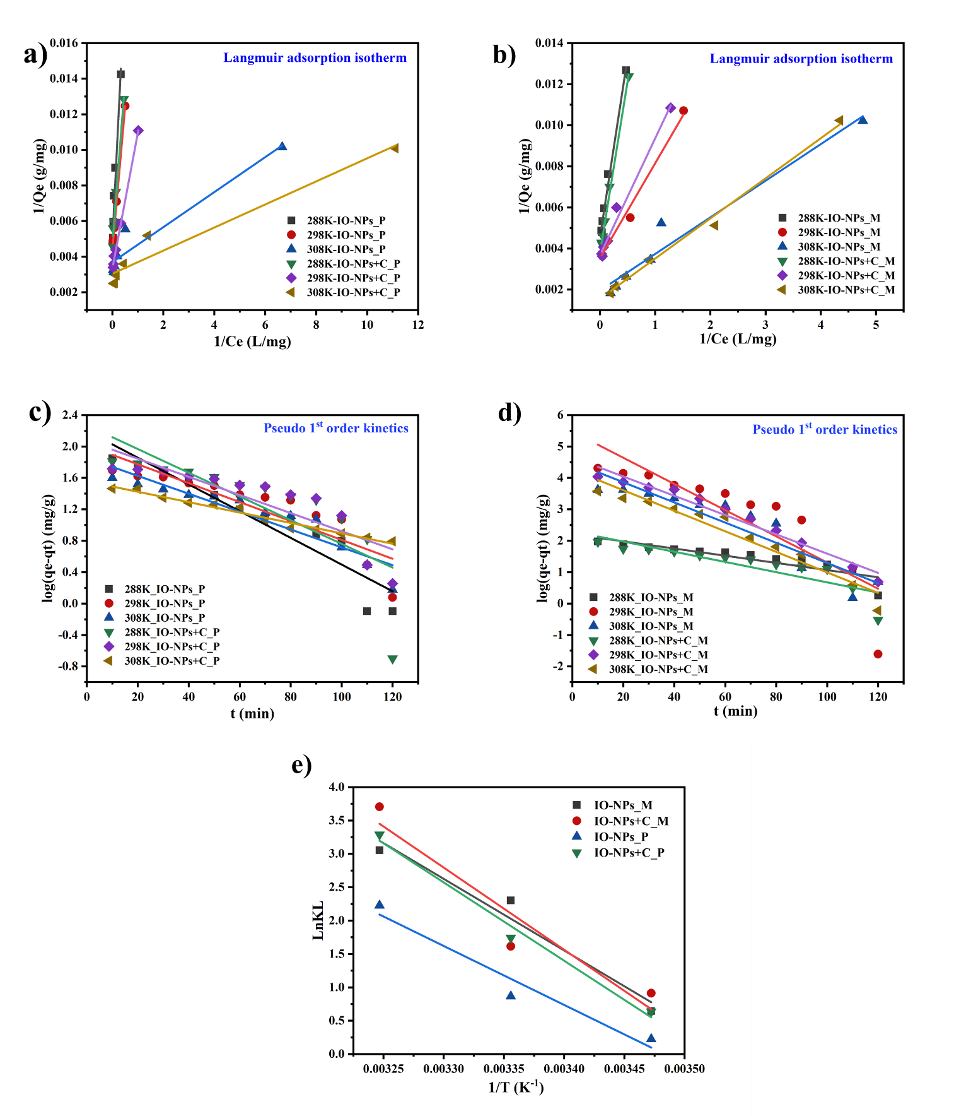
Fig S4: Comparative analysis of the Isotherm, Kinetics and Thermodynamics parameters for the adsorption of NPs and Cr ions by mycosynthesized IO-NPs and IO-NPs+C

Table S2: CCD for adsorption of NPs and Cr by IO-NPs+C.
Sl No | Variables |  |  |  | Response 1 |  | Response 2
Sl No |  |  |  |  | Actual | Predicted | Actual | Predicted
Sl No | A:  adsorbent dose  (mg/L) | B:  temp  (°C) | C:  pH | D:  time  (min) | % Cr removed |  | % NPs removed
1 | 75 | 25 | 5.5 | 90 | 85.21 | 85.47841 | 93.12 | 93.15991
2 | 100 | 15 | 3 | 120 | 60.78 | 61.84763 | 63.21 | 62.57896
3 | 100 | 15 | 8 | 120 | 35.23 | 34.99773 | 36.14 | 36.81021
4 | 50 | 15 | 8 | 60 | 5.12 | 5.274534 | 13.22 | 12.85679
5 | 75 | 25 | 5.5 | 90 | 85.21 | 85.47841 | 93.12 | 93.15991
6 | 50 | 35 | 3 | 60 | 89.21 | 89.20703 | 91.22 | 91.33974
7 | 75 | 25 | 5.5 | 90 | 85.21 | 85.47841 | 93.12 | 93.15991
8 | 100 | 35 | 8 | 120 | 76.13 | 76.27533 | 78.15 | 77.64441
9 | 50 | 35 | 8 | 60 | 65.11 | 64.47213 | 69.86 | 69.88599
10 | 75 | 5 | 5.5 | 90 | 1.11 | 0.989908 | 2.23 | 2.611215
11 | 100 | 35 | 3 | 120 | 98.12 | 97.73023 | 99.11 | 100.2632
12 | 75 | 25 | 5.5 | 90 | 85.21 | 85.47841 | 93.12 | 93.15991
13 | 75 | 25 | 5.5 | 30 | 21.11 | 21.72496 | 28.23 | 28.25448
14 | 50 | 15 | 3 | 120 | 47.12 | 46.92858 | 45.53 | 45.55148
15 | 50 | 35 | 8 | 120 | 70.23 | 70.22128 | 71.26 | 71.60193
16 | 100 | 15 | 8 | 60 | 20.11 | 19.41358 | 22.23 | 21.83928
17 | 75 | 25 | 10.5 | 90 | 38.22 | 38.57551 | 41 | 40.89491
18 | 50 | 35 | 3 | 120 | 90.11 | 91.23618 | 91.23 | 91.01568
19 | 100 | 15 | 3 | 60 | 50.21 | 49.98348 | 49.2 | 49.64803
20 | 50 | 15 | 3 | 60 | 35.12 | 35.40443 | 37.56 | 37.46054
21 | 75 | 25 | 5.5 | 150 | 40.12 | 39.33826 | 43.11 | 42.90135
22 | 100 | 35 | 8 | 60 | 70.23 | 70.18618 | 70.32 | 71.08848
23 | 75 | 45 | 5.5 | 90 | 96.12 | 96.07011 | 97.89 | 97.32462
24 | 100 | 35 | 3 | 60 | 95.23 | 95.36108 | 96.12 | 95.74723
25 | 75 | 25 | 5.5 | 90 | 85.21 | 85.47841 | 93.12 | 93.15991
26 | 50 | 15 | 8 | 120 | 20.22 | 20.51868 | 23.22 | 22.98773
27 | 75 | 25 | 5.5 | 90 | 85.21 | 85.47841 | 93.12 | 93.15991
28 | 25 | 25 | 5.5 | 90 | 78.92 | 78.51846 | 80.12 | 80.41293
29 | 125 | 25 | 5.5 | 90 | 98.92 | 99.15156 | 99.12 | 98.6429
30 | 75 | 25 | 3 | 90 | 95.21 | 93.09698 | 98.12 | 97.8021

1. Final euation in terms of coded factor the removal of NPs and Cr by IO-NPs analysed in RSM interface:
%Cr Removed = +85.47+5.16 × A+23.77 × B-12.90 × C+4.40 × D-2.11 × A × B -0.11 × A × C +0.085 × A × D +1.35 × B ×C -2.37 × B × D +0.93 × C × D +0.84 × A² -9.24 × B² -5.28 × C² - 13.74 × D² (S 3)

%NPs Removed = +93.16 +4.56 × A +23.68 × B -11.81 × C +3.66 × D -1.94 × A × B -0.80 × A × C +1.21 × A × D +0.79 × B × C -2.10 × B × D + 0.51 × C × D - 0.91 × A² -10.80 × B² -7.16 × C² -14.40 × D² (S 4)

Where A is IO-NPs+C dose, B is temperature, C is pH, and D is time.

Table S3: ANOVA for the interacting factors of RSM for NPs and Cr by IO-NPs+C
Adsorbent | Source | Sum of Squares | df | Mean Square | F Value | p-value Prob > F
Cr | Model | 26302.48 | 14 | 1878.749 | 2797.979 | < 0.0001
Cr | A-Adsorbent Concentration | 638.6017 | 1 | 638.6017 | 951.0554 | < 0.0001
Cr | B-Temp | 13560.31 | 1 | 13560.31 | 20195.07 | < 0.0001
Cr | C-pH | 3120.165 | 1 | 3120.165 | 4646.794 | < 0.0001
Cr | D-time | 464.816 | 1 | 464.816 | 692.2403 | < 0.0001
Cr | AB | 70.98063 | 1 | 70.98063 | 105.7099 | < 0.0001
Cr | AC | 0.1936 | 1 | 0.1936 | 0.288324 | 0.5992
Cr | AD | 0.1156 | 1 | 0.1156 | 0.172161 | 0.6841
Cr | BC | 29.10603 | 1 | 29.10603 | 43.34696 | < 0.0001
Cr | BD | 90.15503 | 1 | 90.15503 | 134.2659 | < 0.0001
Cr | CD | 13.8384 | 1 | 13.8384 | 20.60922 | 0.0004
Cr | A² | 19.6619 | 1 | 19.6619 | 29.28204 | < 0.0001
Cr | B² | 2382.434 | 1 | 2382.434 | 3548.106 | < 0.0001
Cr | C² | 455.8179 | 1 | 455.8179 | 678.8395 | < 0.0001
Cr | D² | 5269.138 | 1 | 5269.138 | 7847.212 | < 0.0001
NPs | Model | 26798.61 | 14 | 1914.187 | 5939.756 | < 0.0001
NPs | A-Adsorbent Concentration | 498.4994 | 1 | 498.4994 | 1546.853 | < 0.0001
NPs | B-Temp | 13455.92 | 1 | 13455.92 | 41753.98 | < 0.0001
NPs | C-pH | 2614.695 | 1 | 2614.695 | 8113.449 | < 0.0001
NPs | D-time | 321.7873 | 1 | 321.7873 | 998.5119 | < 0.0001
NPs | AB | 60.5284 | 1 | 60.5284 | 187.8207 | < 0.0001
NPs | AC | 10.27202 | 1 | 10.27202 | 31.87428 | < 0.0001
NPs | AD | 23.4256 | 1 | 23.4256 | 72.69007 | < 0.0001
NPs | BC | 9.9225 | 1 | 9.9225 | 30.7897 | < 0.0001
NPs | BD | 70.81222 | 1 | 70.81222 | 219.7316 | < 0.0001
NPs | CD | 4.1616 | 1 | 4.1616 | 12.91352 | 0.0027
NPs | A² | 23.0207 | 1 | 23.0207 | 71.43367 | < 0.0001
NPs | B² | 3255.635 | 1 | 3255.635 | 10102.3 | < 0.0001
NPs | C² | 839.755 | 1 | 839.755 | 2605.775 | < 0.0001
NPs | D² | 5786.323 | 1 | 5786.323 | 17955.07 | < 0.0001

Table S4: R² and Adequate Precision for RSM model for NPs and Cr by IO-NPs+C
IO-NPs from  fungal isolates | Adsorbent | R² | Adjusted R² | Predicted R² | Adequate Precision
Aspergillus iranicus  (STSP9) | Cr | 0.999 | 0.999 | 0.998 | 169.41
Aspergillus iranicus  (STSP9) | NPs | 0.999 | 0.999 | 0.998 | 243.26
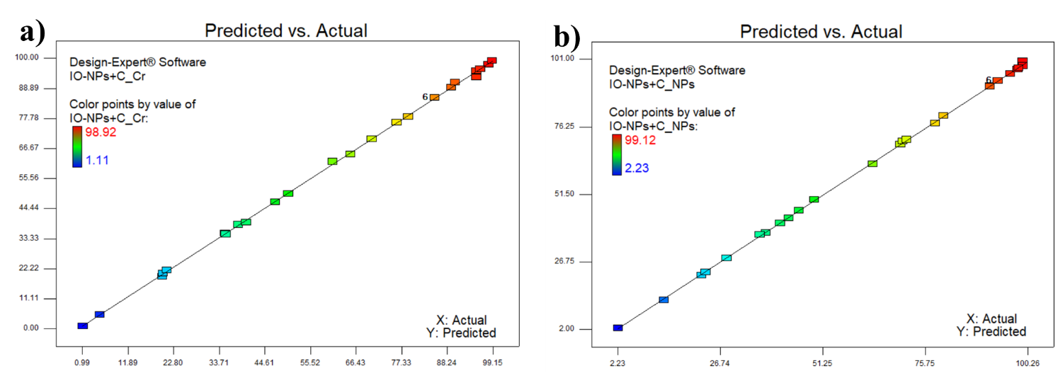
Fig. S5: RSM optimization of Cr ions and NPs adsorption (a - b) on IO-NPs+C shows predicted % removal vs experimental % removal as calculated from RSM analysis.

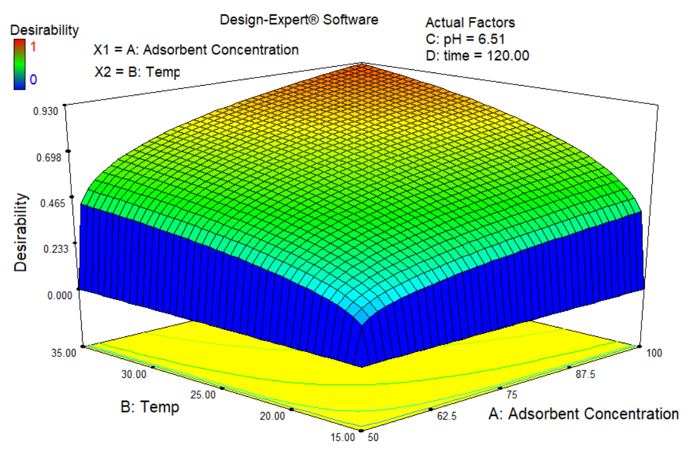
Fig. S6: RSM optimization of Cr ions and NPs adsorption using desirability function.

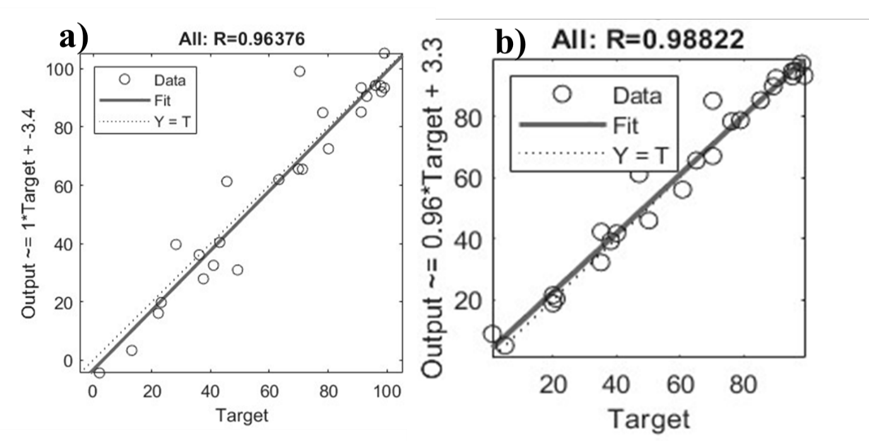Fig. S7: ANN modelling of NPs and Cr ions adsorption (a - b) on IO-NPs+C shows predicted % removal vs. experimental % removal as calculated from ANN analysis.

Table S5: R² of ANN model for simultaneous NPs and Cr ion removal using IO-NPs+C
Algorithm selected for hidden layer | Selected Functions |  |  | IO-NPs  from  fungal isolates | Correlation coefficient (R²) for heavy metal ion adsorption
Algorithm selected for hidden layer | Output Layer | Transfer 1 | Transfer 2 | IO-NPs  from  fungal isolates | NP | Cr
Algorithm selected for hidden layer | Levenberg-Marquardt backpropagation | Trainlm | Poslin | Aspergillus iranicus  (STSP9) | 0.963 | 0.988

2. COPR water quality

Table S6: General characteristics of COPR Cr-contaminated groundwater
pH | 7.6 | Temperature (°C) | 21.8
ORP (mV) | -38.3 | EC (µs/cm²) | 1368
TDS (mg/L) | 684
Cr(total) (mg/L) | 12.68± 1.2 | Cr(VI) (mg/L) | 10.96± 1.01
Borewell Depth | 40 ft
SO₄ (mg/L) | 172 | NO₃ (mg/L) | 5.26
Total Alkalinity (mg/L) | 210 | Total Hardness (mg/L) | 170
Other Metal/metalloid content (mg/L)
Na | 129.48 ± 1.2 | Mg | 52.68 ± 0.3
K | 12.46 ± 0.1 | Mn | 0.018 ± 0.01
Co | 0.015 ± 0.01 | Cu | 0.003 ± 0.001
Zn | 0.037 ± 0.01 | As | 0.003 ± 0.001
Ca | 81.54 ± 1.9 | Pb | 0.011 ± 0.001
Fe | 0.015 ± 0.01 | Hg | 0.007 ± 0.001

References:
- Simonin, J. P., & Bouté, J. (2016). Intraparticle diffusion-adsorption model to describe liquid/solid adsorption kinetics. Revista mexicana de ingeniería química, 15(1), 161-173.
- Wamba, A. G., Lima, E. C., Ndi, S. K., Thue, P. S., Kayem, J. G., Rodembusch, F. S., & De Alencar, W. S. (2017). Synthesis of grafted natural pozzolan with 3-aminopropyltriethoxysilane: preparation, characterization, and application for removal of Brilliant Green 1 and Reactive Black 5 from aqueous solutions. Environmental Science and Pollution Research, 24, 21807-21820.
- Liu, Y., & Shen, L. (2008). A general rate law equation for biosorption. Biochemical Engineering Journal, 38(3), 390-394.
- Boparai, H. K., Joseph, M., & O’Carroll, D. M. (2011). Kinetics and thermodynamics of cadmium ion removal by adsorption onto nano zerovalent iron particles. Journal of hazardous materials, 186(1), 458-465.
- Ayawei, N., Ebelegi, A. N., & Wankasi, D. (2017). Modelling and interpretation of adsorption isotherms. Journal of chemistry, 2017(1), 3039817.
- Chen, X. (2015). Modeling of experimental adsorption isotherm data. information, 6(1), 14-22.

