Harnessing Bacillus inaquosorum AGSP2 for Enhancing ω-Transaminase Production Through Classical and AI-Supported Statistical Design

Shreya Pandya¹, Urvish Chhaya^{1*}, Akshaya Gupte²
¹Department of Microbiology, Natubhai V. Patel College of Pure and Applied Sciences
The Charutar Vidya Mandal (CVM) University Vallabh Vidyanagar-388120, Gujarat, India.

² Post Graduate Department of Biosciences, Sardar Patel University, Vadtal Bakrol Road, Satellite Campus, Bakrool, 388315

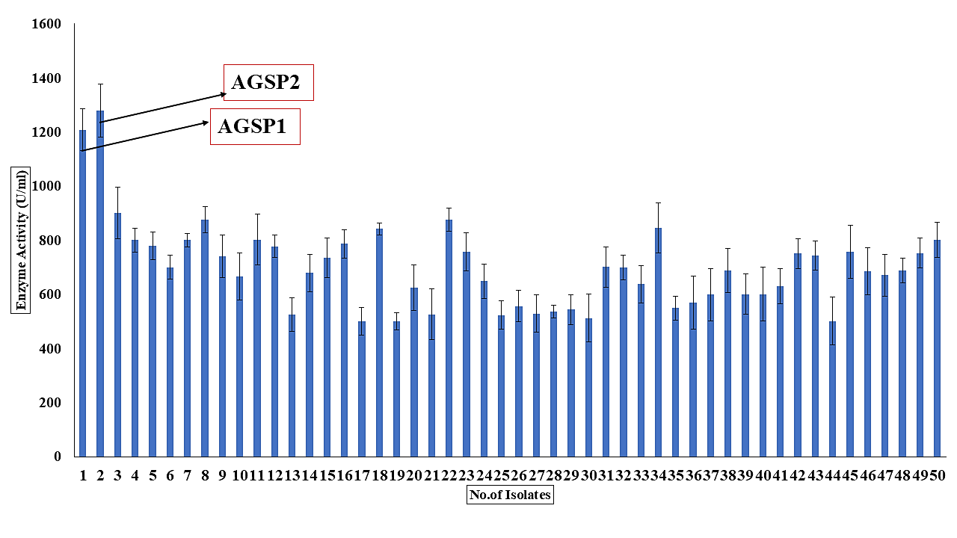
Figure S1 Screening of Transaminase producing bacteria

Figure S2: Time course study

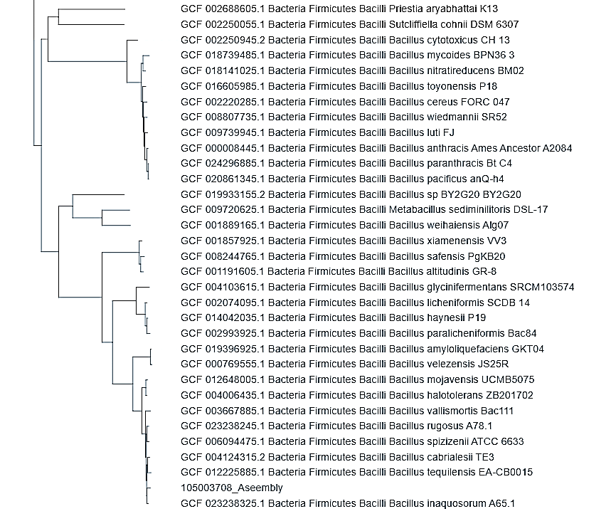
Figure S3: Phylogenetic tree constructed for AGSP2 (Bacillus inaquosorum)

Figure S4 Comparison of ω-transaminase production in unoptimized and optimized media

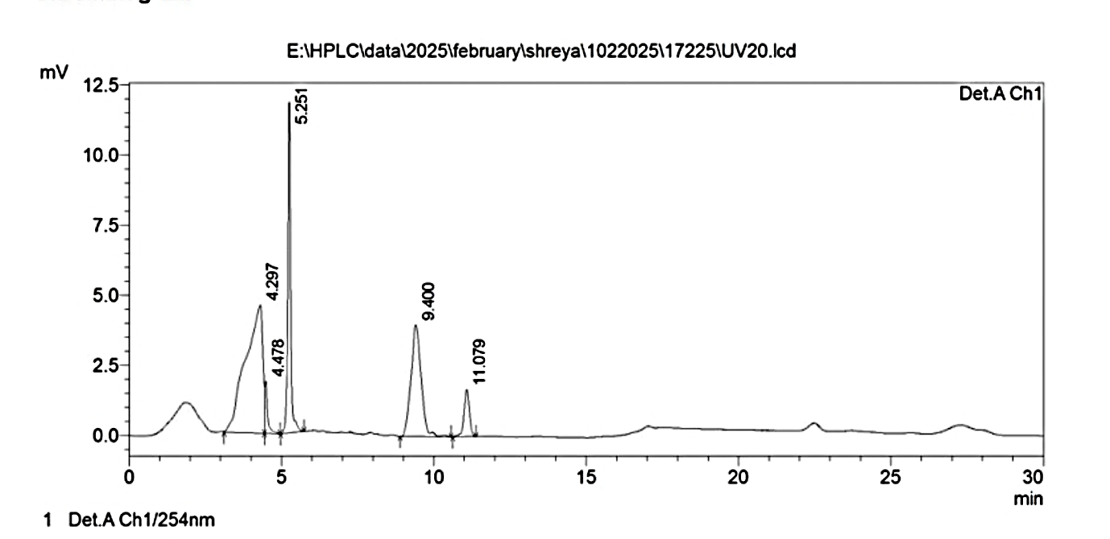
Figure S5 Chromatogram of acetophenone

Table S1- Morphological and biochemical characteristics of AGSP2
Sr.No. | Tests | Results
1 | Gram’s Nature | Gram-positive
2  3 | Shape  Colony morphology | Bacilli rod shape  White, irregular margin, opaque, raised, mucoid, and rough texture
4 | Endospore test | Positive
5 | Citrate test | Negative
7 | Urease test | Negative
8 | TSI test | Acidic slant and butt (Yellow color)
9 | Hemolytic activity | Positive
10 | Aerobic/Anaerobic | Aerobic

Table S2- Biochemical Tests of AGSP2

D-Amygdalin | - | Beta Galacto Pyranosidase Resorufine | - | Alanine Arylamidase | - | N-Acetyl-D-Glucosamine | -
Phosphatidylinositol  Phospholipase C | - | Alpha-Mannosidase | - | Tyrrosine Arylamidase | - | D-Maltose | -
D-Xylose | - | Phosphatase | - | D-Sorbitol | + | Bacitracin Resistance | +
Arginine Dihydrolase | - | Leusine Arylamidase | - | Urease | - | Novobiocin Resistance | -
Beta Galasidase | - | L-Proline Arylamidase | - | Polymixin B Resistance | - | Growth in 6.5% NaCl | -
Alpha Glucosidase | - | Beta Glucuronidase | - | D-Galactose | - | D-Mannitol | +
Ala-Phe-Pro Arylamidase | - | Alpha Galactosidase | - | D-Ribose | - | D-Mannose | +
Cyclo-Dextrin | - | L-Pyrolydonyl Arylamidase | - | L-Lactate alkalinisation | - | Methyl-B-D-Glucopyranosidase | +
L- Aspartate Arylamidase | - | Beta Glucuronidase | - | Lactose | - | Pullulane | -
D-Raffinose | - | Salicin | + | D-Trehalose | + | Optochin Resistance | +
O/129 Resistance (comp.vibrio) | - | Saccharose/Sucrose | + | Arginine Dihydrolase 2 | -
[(-) negative and (+) positive]

Table S3 RSM-CCD design model with AI validation
Std | Run | (A)yeast extract  (g/L) | (B)NaCl  (g/L) | (C)fructose  (g/L) | (D)peptone  (g/L) | Transaminase Activity  (U/ml) | RSM  Predicted value | SVM Predicted
4 | 1 | 10 | 10 | 8 | 8 | 3325.78 | 3606.09 | 3699.2
11 | 2 | 5 | 10 | 8 | 16 | 3411.28 | 3549.33 | 3118.238
15 | 3 | 5 | 10 | 16 | 16 | 2568.45 | 2891.51 | 3156.857
16 | 4 | 10 | 10 | 16 | 16 | 3521.45 | 3564.35 | 3479.87
26 | 5 | 7.5 | 7.5 | 12 | 12 | 6012.41 | 5820.73 | 5533.166
17 | 6 | 2.5 | 7.5 | 12 | 12 | 1511.56 | 1207.41 | 3161.727
9 | 7 | 5 | 5 | 8 | 16 | 3678.45 | 3807.72 | 3092.072
14 | 8 | 10 | 5 | 16 | 16 | 3554.12 | 3651.19 | 3453.704
18 | 9 | 12.5 | 7.5 | 12 | 12 | 2202.57 | 2087.95 | 3161.727
7 | 10 | 5 | 10 | 16 | 8 | 3514.78 | 3656.42 | 3414.806
2 | 11 | 10 | 5 | 8 | 8 | 3688.35 | 3322.99 | 3673.034
19 | 12 | 7.5 | 2.5 | 12 | 12 | 4395.14 | 4135.6 | 4846.036
28 | 13 | 7.5 | 7.5 | 12 | 12 | 6121.88 | 5820.73 | 5533.166
13 | 14 | 5 | 5 | 16 | 16 | 2858.78 | 3039.54 | 3130.69
8 | 15 | 10 | 10 | 16 | 8 | 4699.71 | 4528.15 | 3737.819
20 | 16 | 7.5 | 12.5 | 12 | 12 | 4429.91 | 4270.68 | 4530.344
5 | 17 | 5 | 5 | 16 | 8 | 3488.63 | 3324.13 | 3388.639
6 | 18 | 10 | 5 | 16 | 8 | 3811.66 | 4134.68 | 3711.652
3 | 19 | 5 | 10 | 8 | 8 | 3476.57 | 3337.2 | 3376.187
22 | 20 | 7.5 | 7.5 | 20 | 12 | 4460.12 | 4283.31 | 4560.554
29 | 21 | 7.5 | 7.5 | 12 | 12 | 5714.25 | 5820.73 | 5533.166
10 | 22 | 10 | 5 | 8 | 16 | 3497.12 | 3816.54 | 3415.085
21 | 23 | 7.5 | 7.5 | 4 | 12 | 4371.4 | 4129.44 | 4861.141
27 | 24 | 7.5 | 7.5 | 12 | 12 | 5721.44 | 5820.73 | 5533.166
24 | 25 | 7.5 | 7.5 | 12 | 20 | 4515.23 | 4048.25 | 4615.107
25 | 26 | 7.5 | 7.5 | 12 | 12 | 5721.24 | 5820.73 | 5533.166
12 | 27 | 10 | 10 | 8 | 16 | 3497.12 | 3619.33 | 3441.252
23 | 28 | 7.5 | 7.5 | 12 | 4 | 4271.4 | 4319.61 | 4888.417
1 | 29 | 5 | 5 | 8 | 8 | 2697.12 | 3115.29 | 3350.02
30 | 30 | 7.5 | 7.5 | 12 | 12 | 5633.14 | 5820.73 | 5533.166

