Supplemental
Figure S1. Risk of Bias Assessment for Included Randomized Controlled Trials Using the Cochrane RoB 2 Tool

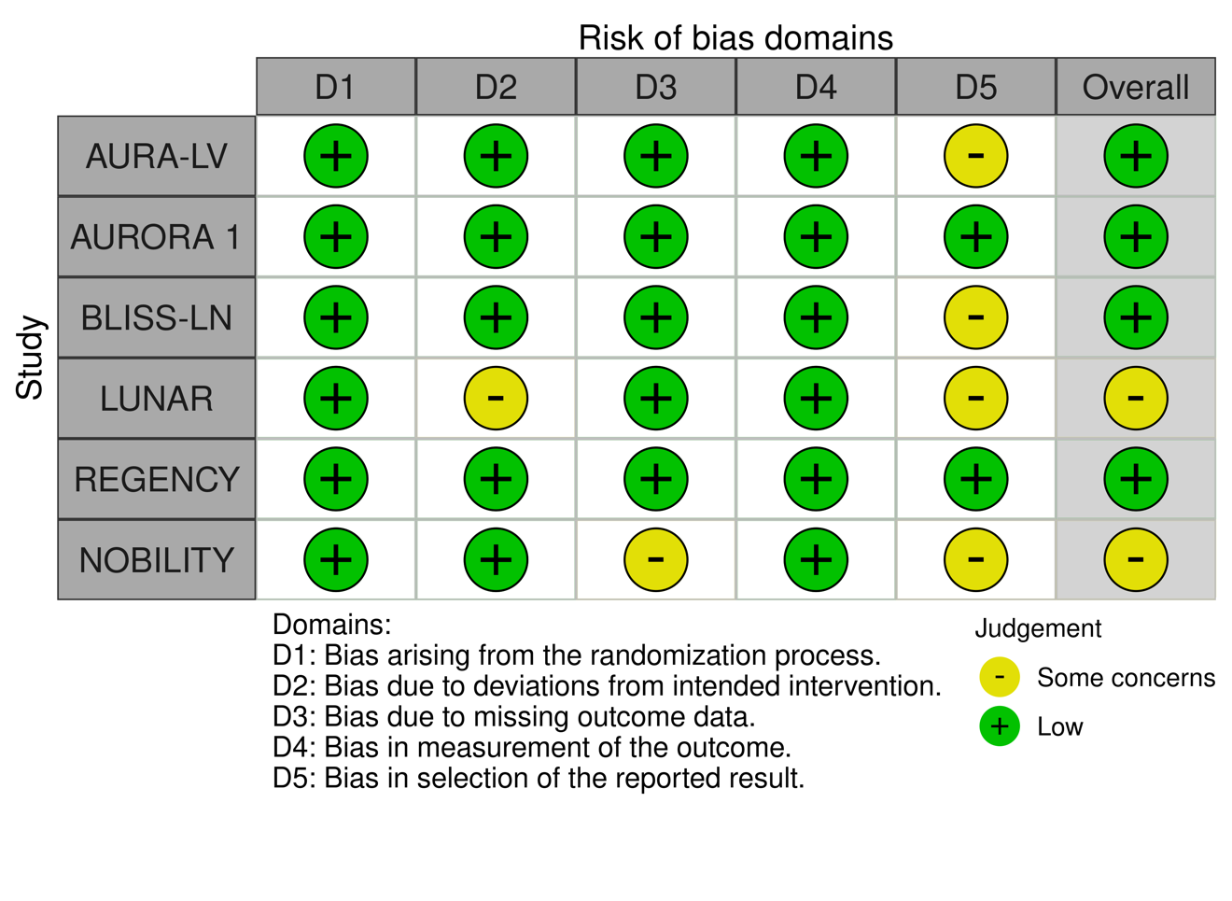
Figure S1. Each study was assessed across five domains using the Cochrane Risk of Bias 2 tool: D1 (randomization process), D2 (deviations from intended interventions), D3 (missing outcome data), D4 (measurement of the outcome), and D5 (selection of the reported result). Green (+) indicates low risk of bias, and yellow (−) indicates some concerns. No study was judged to have high risk of bias. Overall judgments were determined by the most severe domain-level rating per study.

