Supplementary table.

Table S1. The neuronal database
 | NHP/Structure | VA | CM | VA+CM
Nights | Md | 11 | 7 | 18
 | Wh | 9 | 9 | 18
 | Md+Wh | 20 | 16 | 36
Neurons | Md | 220 | 100 | 320
 | Wh | 176 | 164 | 340
 | Md+Wh | 396 | 264 | 660
Bursts (MI detection method) | Md | 135,434 | 111,392 | 246,826
 | Wh | 167,352 | 284,744 | 452,096
 | Md+Wh | 302,786 | 396,136 | 698,922
This neuronal database shows the number of recording sessions (nights), well isolated (isolation quality ≥ 0.85) recorded neurons and detected (using the MI method) bursts in the ventral anterior and centromedian (VA and CM) thalamic nuclei of the two NHPs (Md and Wh) that participated in the study. Abbreviations. NHP – non-human primate; MI – maximum interval burst detection method. Related to Table 1.

Supplementary figures (Fig. S1 to S9)

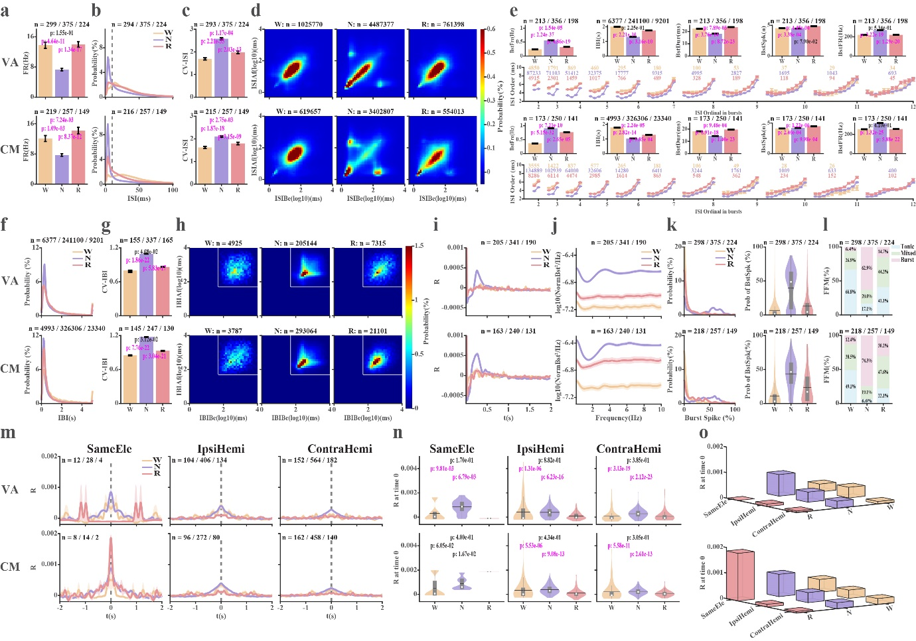

Figure S1. Discharge properties of spikes and bursts in thalamic neurons with Isolation quality ≥ 0.85. a-d. spike properties. e-o. Burst properties. a, Firing rate. b, Inter spike interval (ISI) histogram. The vertical dashed lines are located at 10 ms. c, Coefficient of variation of the ISIs (CV-ISI). d, ISI return map of ISI(n+1) (ISIAf) versus ISI(n) (ISIBe). e, Burst features. Row 1st, from left to right: Burst frequency (BstFre), Inter-burst interval (IBI), burst duration (BstDur), number of spikes in bursts (BstSpk), intra-burst spike discharge rate (BstFR). Row 2nd, ordinal inter-spike intervals in bursts of different lengths. Only bursts with fewer than 12 intervals are shown. f, Inter-burst interval (IBI) histogram. g, CV-IBI. h, IBI return map (IBI(n+1) (IBIAf) vs. IBI(n) (IBIBe)). Fifty milliseconds are the minimum silent time before a burst in the maximum interval burst detection method. Therefore, there are no IBIs below and to the left of the horizontal and vertical white lines (log10(50) ms). The dark blue pixels in this region indicate NaN (Not a Number). i, Auto-correlation histograms of burst trains. j, Power spectrum densities of burst trains. k, Fraction of spikes within bursts out of total spikes (left), and distribution of the burst spikes fraction (right). l, The percentage of 10-second segments with burst, mixed, and tonic firing modes. m, Cross-correlation histograms of burst trains simultaneously recorded from the same electrode, the ipsilateral hemisphere or contralateral hemisphere (SameEle, IpsiHemi, and ContraHemi). n, The distribution of R values at time 0 in m. The number of R values at time 0 is the same as that of neuron pairs with repetition in m. o, 3D-bar plots of the average R values at time zero as a function of wake-sleep state and distance. Note: n = 2 neuron-pairs with repetition is the outlier of CM R value at time 0 recorded from the same electrode during REM sleep. In all subplots: Up-VA, bottom-CM. Abbreviations. W-Wakefulness, N-NREM, R-REM. Colour coding: Yellow-Wakefulness, Purple-NREM, Pink-REM. Data are shown as average ± SEM (standard error of the mean) in a, c, e, g, i, j, and m. The n indicates the number of ISI pairs in d, IBIs in subplot e-2nd column and f, IBI pairs in h, bursts in 2nd and 4th rows of e, neuron pairs with repetition in m, and neurons in the rest of the subplots. A Bonferroni-corrected Wilcoxon rank sum test was used to calculate the statistical significance of the difference in the FR (a), CV-ISI (c), burst features (e and g), and R values at time zero (n) between different vigilance stages (p < 0.05/3). P values marked in magenta indicate a significant difference; otherwise, they are black. Related to Figures 1, 2, and 3.

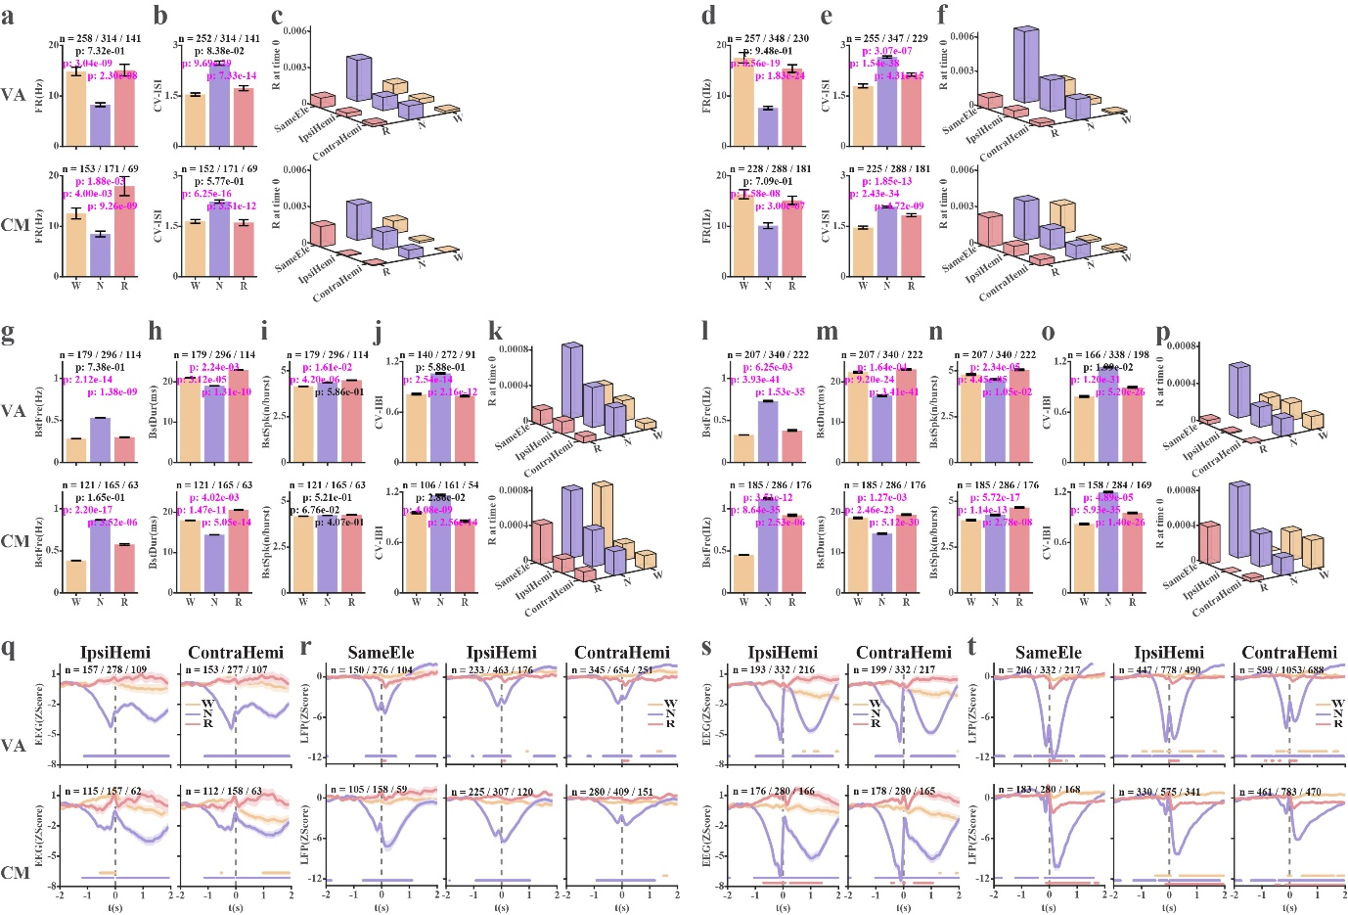

Figure S2. Neuron activity of two NHPs (Monkey Md and Wh). The left panel shows the results of Md, and the right panel shows the results of Wh. a and d, Firing rate (FR) of single unit activity (SUA). b and e, Coefficient of variation of the inter-spike interval (CV-ISI) of SUA. c and f, 3D-bar plots of cross-correlation R values at time zero (bin width = 0.7ms) of SUA, presented as a function of vigilance stages and distance. g and l, Burst frequency (BstFre). h and m, Burst duration (BstDur). i and n, The average number of spikes per burst (BstSpk). j and o, Coefficient of variation of the inter-burst interval (CV-IBI). k and p, 3D-bar plots of cross-correlation R values at time zero (bin width = 0.7ms) of burst trains, presented as a function of vigilance states and distance. q and s, Burst-triggered frontal EEG from the ipsilateral or contralateral hemisphere. r and t, Burst triggered thalamic LFP simultaneously recorded from the same electrode, or different electrodes in the ipsilateral or contralateral hemisphere. Data is shown in mean ± SEM, and n indicates the number of neurons in a, b, d, e, g-j, l-o, and q-t. A Bonferroni-corrected Wilcoxon rank sum test was used to calculate the statistically significant difference. P-value indicating a statistically significant difference is marked in magenta; otherwise, it is marked in black in a, b, d, e, g-j, and l-o (p < 0.05/3). In q-t, the colored circles show the statistically significant difference (p < 0.05/1375). Abbreviations and color coding as in Fig. S1. Related to Figs 1g, h and n, 2b and d, 3d, and 4g and h.

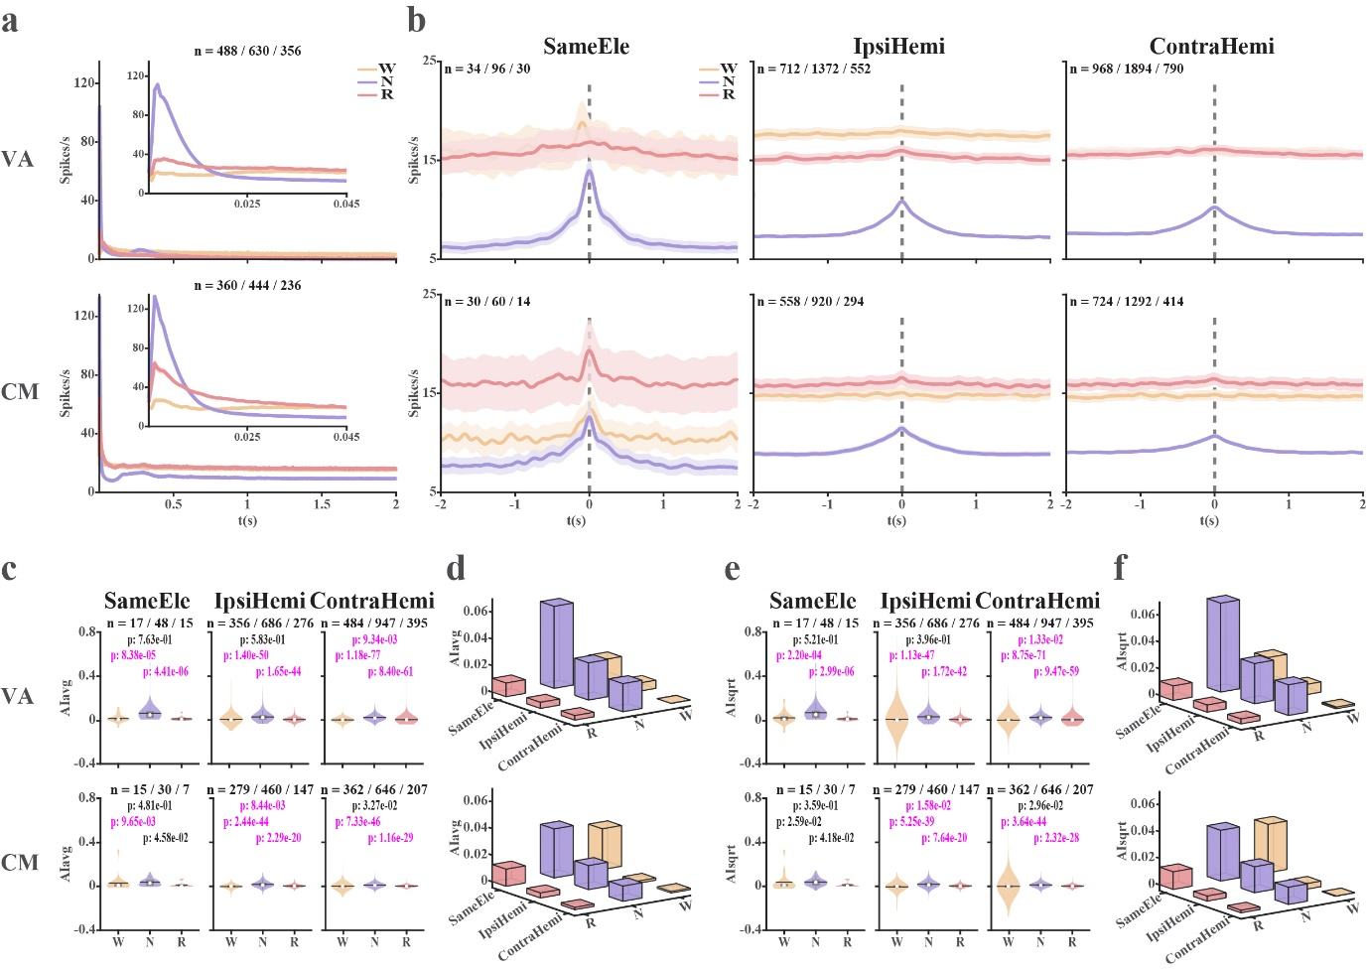

Figure S3. Auto- and cross-correlation conditional discharge rate histograms of thalamic single unit activity. a, Auto-correlation histograms of spike trains (lag = 2 s). The insets provide a magnified view of the auto-correlation histograms at a lag 50 ms. b, Cross-correlation histograms of spike trains. c, Violin plots of the distribution of Association Indices (AI, fraction of spike train contributed by common-input mechanism) calculated as AI_{avg} (equation 1). d, 3D-bar plots of average AI_{avg} values as a function of the vigilance stage and distance. e, AI calculated as AI_{sqrt} (equation 2). Violin plots of the distribution of AI_{sqrt} values, f, 3D-bar plots of average AI_{sqrt} values as a function of the vigilance stage and distance. Data in a and b are shown in mean ± SEM. The n indicates the number of neurons in a, neuron pairs with repetition in b, and the neuron pairs without repetition in c and e. The Wilcoxon rank sum test was used to calculate the statistically significant differences of AI (c and e) among different vigilance stages. The statistically significant difference was corrected by the Bonferroni method (p < 0.05/3). The p-values indicating a significant difference are marked in magenta. Otherwise, they are in black. Abbreviations and colour coding as in Fig. S1. Related to Fig. 1.

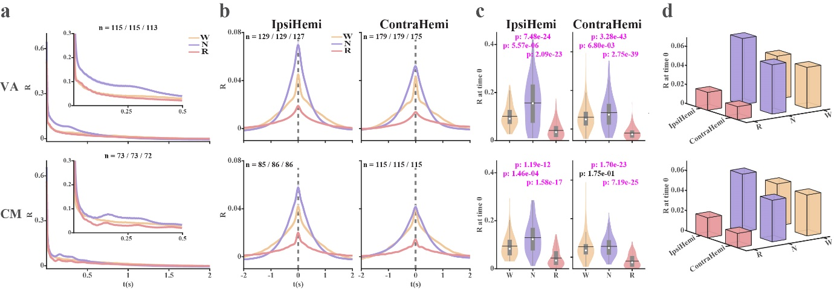

Figure S4. Auto- and cross-correlation histograms of thalamic multi-unit activity (SPK-MUA). Spiking activity (300 - 6000 Hz, SPK is rectified by the absolute operator, and its mean is subtracted, to represent the multi-unit-activity, MUA). a, Auto-correlation histograms of the spiking activity. The insets provide a magnified view of the auto-correlation histograms at a lag of 0.5 s. b, Cross-correlation histograms of the MUA. c, The distribution of R values at time zero. The number of R values at time zero is the same as the number of electrode pairs, as shown in b. d, 3D-bar plots of average R values as a function of vigilance state and distance. The broadband spiking activity measures the summated activity of all units near the electrode; therefore, it does not enable correlation analysis of different units recorded by the same electrode. Data in a and b are shown in mean ± SEM. The n means the number of electrodes in a and the number of electrode pairs in b. The Wilcoxon rank sum test was used to calculate the statistically significant difference of R values at time zero, which was corrected using the Bonferroni method, p < 0.05/3. P values marked in magenta show a statistically significant difference; otherwise, in black. Abbreviations and colour coding as in Fig. S1. Related to Fig. 1.

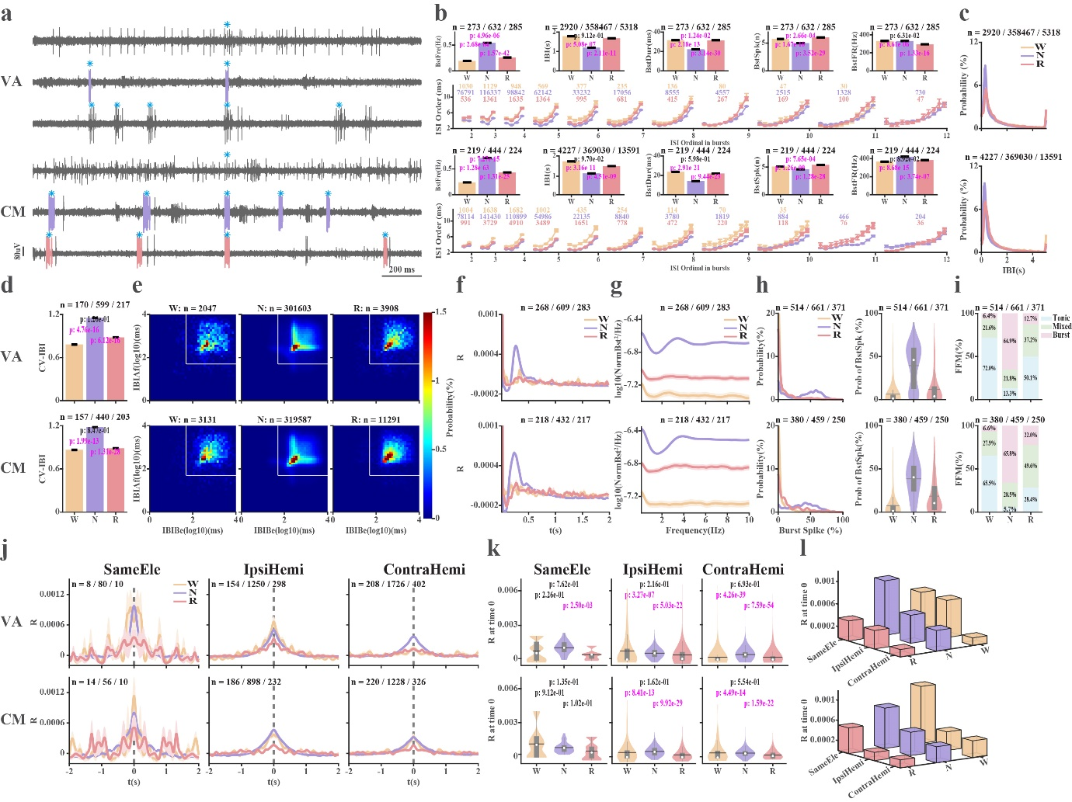

Figure S5. Burst properties analysis for bursts detected by the Poisson Surprise method. Bursts were detected from VA and CM neurons with an isolation quality larger than 0.7 using the Poisson Surprise (PS) method. a, the same examples as shown in Figure 2. Bursts marked in color (color code of sleep stages) are detected by the PS method, marked in cyan stars are bursts detected by MI methods. From top to bottom, the examples are from W, N, and R in VA, and CM. b, Burst features. Row 1st: Burst frequency (BstFre), Inter-burst interval (IBI), burst duration (BstDur), number of spikes in bursts (BstSpk), and intra-burst discharge rate (BstFR). Row 2nd, ordinal inter-spike intervals in bursts of different lengths. Only bursts with fewer than 12 intervals are shown. c, IBI histogram. d, CV-IBI. e, IBI return map (IBI(n+1) (IBIAf) vs IBI(n) (IBIBe)). The white line indicates log₁₀(50) ms for comparison with the IBI return map of the burst detected by the maximum interval method (Fig. 2e and Fig. S1h). Notably, there is no limitation on silent time before a burst for the PS method. f, Auto-correlation histograms of burst trains. g, PSD of burst trains. h, Fraction of burst spikes out of total spikes (left), and distribution of fraction of burst spikes out of total spikes (right). i, Percentage of burst/mixed/ tonic firing modes across vigilance stages. j, Cross-correlation histograms of burst trains of neuronal pairs recorded from the same electrode, the ipsilateral hemisphere, or contralateral hemisphere (SameEle, IpsiHemi, and ContraHemi). k, violin plots of the distribution of R values at time 0 in j. The number of R values at time 0 is the same as that of neuron pairs with repetition shown on the cross-correlation histogram (j). l, 3D-bar plots of the average R values at time zero as a function of vigilance state and distance. Data are shown as average ± SEM in b, d, f, g, and j. The n indicates the number of IBIs in subplot b-2nd column and c, IBI pairs in e, bursts in 2nd and 4th rows of b, neuron pairs with repetition in j, and neurons in the rest of the subplots. A Bonferroni-corrected Wilcoxon rank sum test was used to calculate the statistically significant differences in burst features (b and d) and R values at time 0 (k) among different vigilance stages (p < 0.05/3). P values marked in magenta indicate a significant difference; otherwise, they are marked in black. Abbreviations and colour coding as in Fig. S1. Related to Figs. 2 and 3.

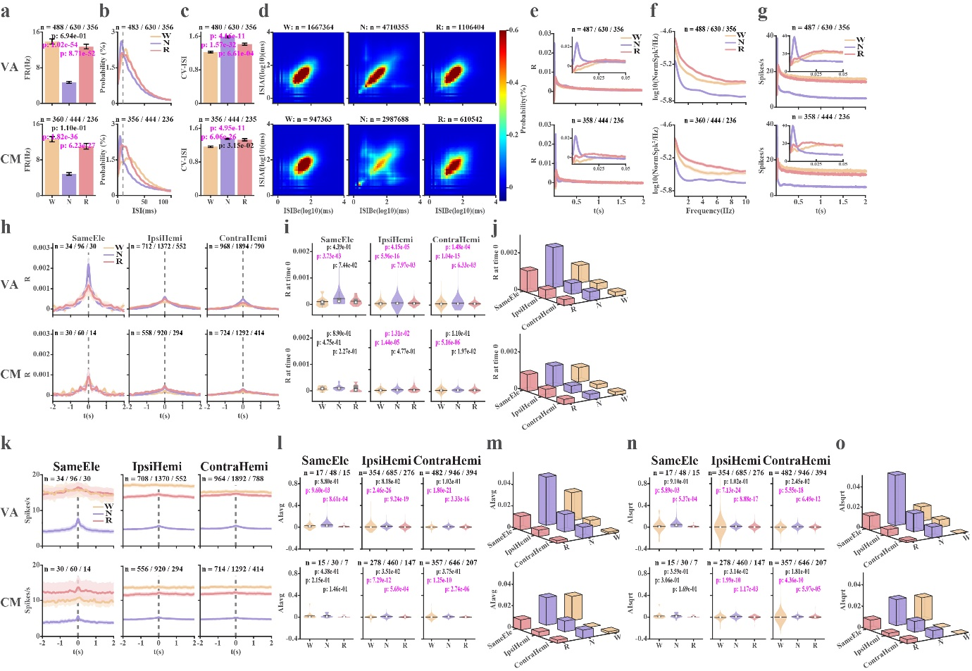

Figure S6. Analysis of thalamic spike trains after removing bursts (tonic activity). Binary (0/1) spike (isolation quality > 0.7) trains after removing detected bursts (by the maximum interval method). a, Firing rate (FR). b, inter spike interval (ISI). c, coefficient of variation of ISI (CV-ISI). d, ISI return map (ISIAf, ISI(n+1) vs ISIBe, ISI(n)). e, Average correlation coefficient (R) auto-correlation histograms for VA and CM tonic spike trains (lag = 2 s). The inset zooms in on the auto-correlation histograms near time zero (lag = 50 ms). f, Power spectrum density of tonic activity. g, Average conditional discharge rate (spikes/s) auto-correlation histograms for VA and CM tonic spike trains (lag = 2 s). Insets – autocorrelation histograms with a lag of 50 ms. h, Average correlation coefficient (R) cross-correlation histograms for thalamic neuron pairs recorded by the same electrode (SameEle), different electrodes in the ipsi- and contra-lateral hemisphere (IpsiHemi and ContraHemi). i, Violin plots illustrating the distribution of R values at time zero. The number of R values at time zero is the same as that of neuron pairs with repetition shown in h. j, 3D-bar plots showing the average R value at time zero as a function of vigilance state and distance. k, Average conditional discharge rate cross-correlation histograms of thalamic neuron pairs from the same electrode, ipsilateral hemisphere, or contralateral hemisphere. l, Violin plots illustrating the distribution of AI_{avg} values (equation 1). m, 3D-bar plots demonstrating the average AI_{avg} value as a function of vigilance state and distance. n, Violin plots showing the distribution of AI_{sqrt} values (equation 2). o, 3D-bar plots illustrating the average AI_{sqrt} values as a function of vigilance state and distance. Data is shown as mean ± SEM in subplots e-h, and k. The n indicates the number of neurons in a-c and e-g, ISI pairs in d, neuron pairs with repetition in h and k, and neuron pairs without repetition in l and n. A Bonferroni-corrected (p < 0.05/3) Wilcoxon rank sum test was used to calculate the statistical significance of different R values at time 0 (Subplot i) and AI (Subplots l and n). P-value indicating statistically significant difference is marked in magenta. Otherwise, it is marked in black. Abbreviations and color coding as in Fig. S1. Related to Figs 1, 2, and 3.

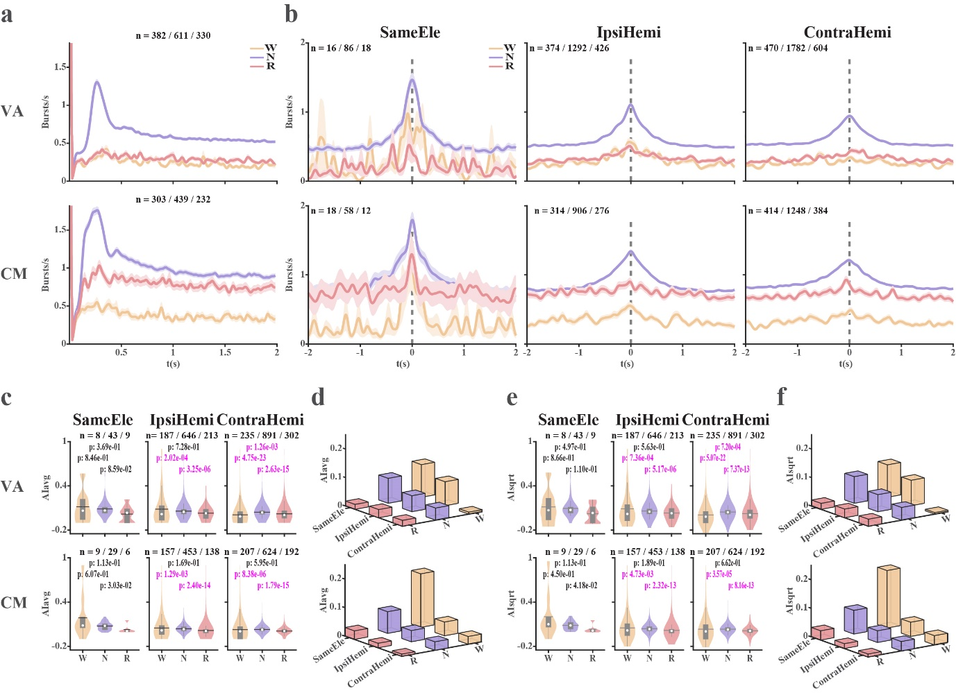

Figure S7. Auto- and cross-correlation conditional discharge rate histograms, and association indices of thalamic bursts. Bursts (detected by the maximum interval method) are treated as a single event at the time of their first spike. Auto and cross-correlation histograms of thalamic binary (0/1) burst trains are calculated as the conditional discharge rate following a burst at time zero. a, Conditional discharge rate auto-correlation histograms of burst trains. b, Conditional discharge rate cross-correlation histograms of burst trains. c, Association-index (AI, Fraction of bursts contributed by common-input mechanism out of total bursts) – average method (equation 1). Distributions of AI values are shown in violin plots. d, 3D-bar plots show average AI_{avg} values as a function of the vigilance stage and distance. e, AI of thalamic bursts – Sqrt method (equation 2). Same conventions as in subplot c. f, 3D-bar plots show average AI_{sqrt} values as a function of the vigilance stage and distance. Data is shown in mean ± SEM in a and b. The n indicates the number of neurons in a, neuron pairs with repetition in b, and neuron pairs without repetition in c and e. The Wilcoxon rank sum test was used to calculate the statistical significance of different AI values (Subplots c and e). The statistical significance of differences is corrected by the Bonferroni method, p < 0.05/3. The p-values indicating significant difference are marked in magenta. Otherwise, they are marked in black. Abbreviations and colour coding as in Fig. S1. Related to Figs. 2 and 3.

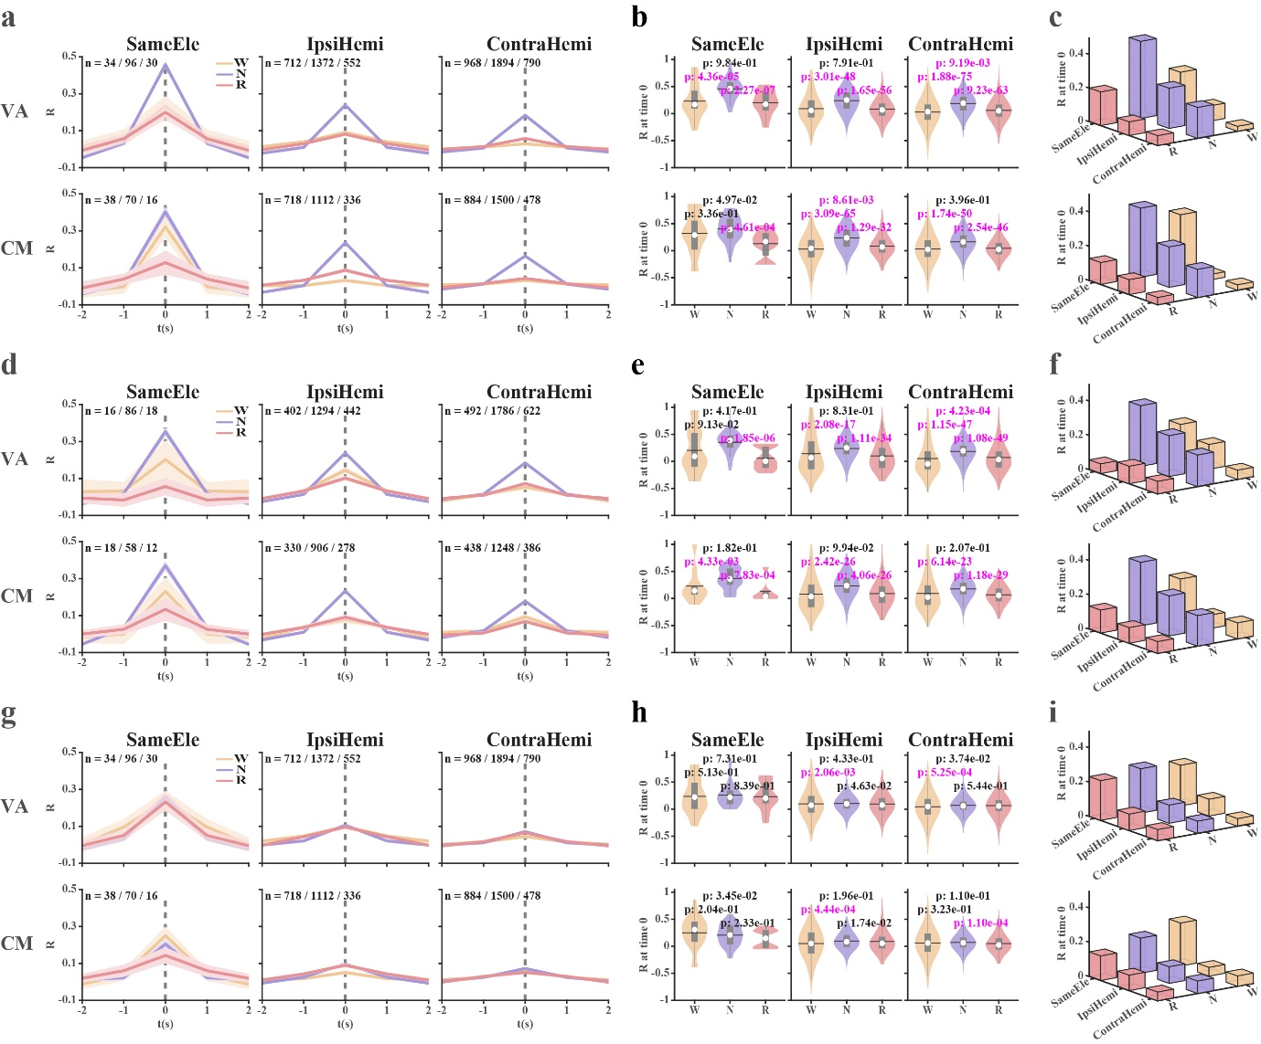

Figure S8. Cross-correlation histograms of spike trains, burst trains, and tonic activity (Time resolution = 1 s) across vigilance states. The isolation score of neural activity is larger than 0.7, and bursts are detected with the maximum interval (MI) method. a-c, All spike trains (single unit activity) are analysed. The average cross-correlation histograms of neuron pairs recorded from the same electrode, or different electrodes in the ipsilateral or contralateral hemisphere, are shown in a. Violin plots of the distribution of R values at time 0 gained from a are demonstrated in b. The number of time-zero R values is the same as that of neuron pairs with repetition shown in a. 3D-bar plots of the average R values at time zero as a function of vigilance states and distance (c). d-f and g-i show the same analysis for burst trains and for tonic activity (spike trains after removal of detected bursts), respectively. Data is shown in mean ± SEM, and n indicates the number of neuron pairs with repetition in a, d, and g. The statistically significant differences in R values at time zero among vigilance stages in b, e, and h are tested by Bonferroni-corrected Wilcoxon rank sum test (p<0.05/3). P values marked in magenta indicate significant differences; otherwise, they are black. Abbreviations and color coding as in Fig. S1. Related to Figs. 1l-n, 3b-d and S6c-e.

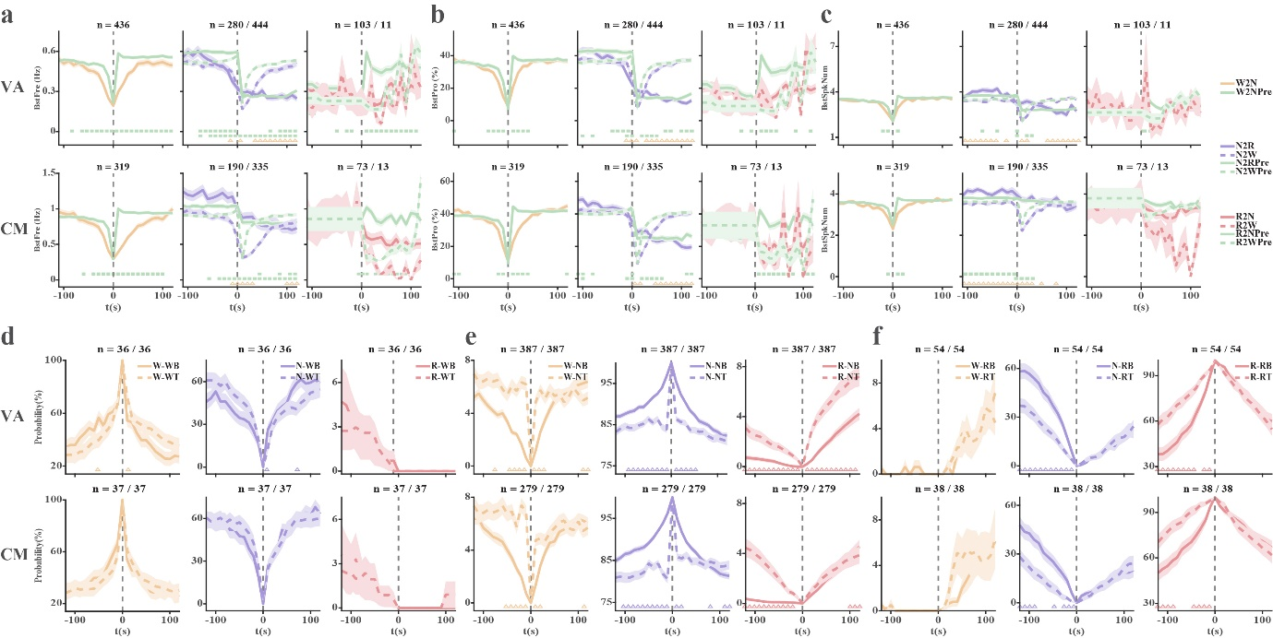

Figure S9. Basic analysis for vigilance stage transitions aligned with burst features and vigilance states aligned with firing mode (burst/tonic). a-c, The burst frequency (BstFre, a), fraction of spikes in bursts per 10 s total spikes (BstPro, b), and the average number of spikes per burst (BstSpkNum, c) aligned to different vigilance stages transition (e.g., W2N is the transition from wakefulness to NREM, and its corresponding predicted burst feature is W2NPre). There is no available data on the transition from wakefulness to REM sleep. The statistical difference between the actual and predicted values is tested using a Bonferroni-corrected Wilcoxon signed rank (p<0.05/24). Significant difference is marked by a green square (It indicates a significant difference between solid lines in the first row, and a significant difference between dashed lines in the second row). The statistical significance of differences between the transition to different vigilance stages from the same state is tested by Bonferroni corrected Wilcoxon rank sum (p<0.05/24), and their significant differences are marked by triangles coloured by corresponding sleep stages at time 0. d-f, The vigilance stages are aligned to segments with tonic or bursting segments combined with sleep states (Wakefulness in d, NREM in e and REM in f), e.g., NREM-burst (NB), NREM-Tonic (NT); W-NB indicates the percentage of wake aligned with NREM-Burst combination segment. The Bonferroni-corrected (p < 0.05/25) Wilcoxon signed rank is used to calculate the statistical significance of the difference. The values at time 0 are not compared. The significant difference is marked in color-coded triangles. Data is shown as mean ± SEM. The n indicates the number of neurons. The number of the predicted burst features is the same as that of their corresponding actual burst features. Abbreviations and color coding as in Fig. S1. Related to Fig. 4a, b.

