Supplementary Information
Cellulose Carbamate Synthesis and Dissolution from Wheat Straw: Influence of Biomass Origin and Inorganic Removal Compared to Softwood Dissolving Pulps
Ryen M. Frazierª, Mariana Lendewigª, Fernando Urdanetaª, Jorge Francoª, Jannatun Nayeemª, Alfonso Dominguezª, Ericka Ford^{b}, Joel J. Pawlakª, Richard Vendittiª, Orlando J. Rojas^{c,d,e}, Ronalds Gonzalez^{a,*}
ª Department of Forest Biomaterials, North Carolina State University, Raleigh, NC 27695, USA.
^{b} Department of Textile Engineering, Chemistry and Science, The Nonwovens Institute, North Carolina State University, Raleigh, NC 27695, USA.
^{c} Bioproducts Institute, Department of Chemical & Biological Engineering, The University of British Columbia, Vancouver, BC Canada V6T 1Z3.
^{d} Department of Wood Science, Faculty of Forestry, The University of British Columbia, 2900–2424 Main Mall Vancouver, BC Canada V6T 1Z4.
^{e} Department of Chemistry, 2036 Main Mall. Vancouver, The University of British Columbia, Vancouver, BC Canada V6T 1Z1.

*Corresponding author, rwgonzal@ncsu.edu, Department of Forest Biomaterials, North Carolina State University, Raleigh, NC 27695, USA, phone number: 919-802-5219.

S.1 ZnO / sodium hydroxide solvent preparation
A 0.7% ZnO / 8% NaOH solution was prepared and left in a freezer overnight to cool to -10 to -5°C. To achieve this solution, first a 20% NaOH aqueous solution was mixed with the ZnO until transparent, then diluted with the remaining water to reach 8% NaOH.
Immediately after adding CC samples to the cold alkali, they were stirred using a vortex mixer for 1 minute, then placed in a freezer. After 30 minutes, the samples were stirred again for 1 minute on the vortex mixer, then placed into a freezer overnight. Agitation and freezing were repeated 24 hours later, for three more cycles, with 1 minute agitation time and 30-minute freezing time.
S.2 Pulp fiber analysis
Table S.1 Fiber quality analysis of softwood and WS DPs, including fiber length, width, and fines content
DP | Length Weighted Fibers (mm) | Width Arithmetic (um) | Length Weighted % Fines | Arithmetic % Fines
Softwood | 0.546 | 23.5 | 38 | 65.5
WS PHK | 0.283 | 18.9 | 53.5 | 75.9
WS PHK + EDTA | 0.263 | 17.4 | 60 | 80.2

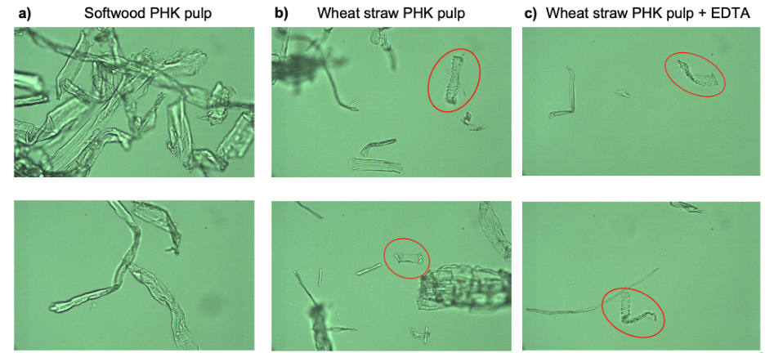
Fig. S.1 Microscopic images of the a) softwood, b) WS, and c) WS + EDTA DPs prior to derivatization and dissolution. Epidermis cells are present in the WS pulps with and without EDTA

Table S.2 Experimental results of softwood and WS carbamates
DP biomass | Pulping | Experiment (replicates) | Derivatization time (h) | Avg. DS | Soluble fraction (%) in %0.7 ZnO / 8% NaOH
Softwood | PHK | 1S(1, 2, 3) | 0 | 0.07 +/- 0.04 | 85.3 +/- 0.92
Softwood | PHK | 1S(1, 2, 3) | 1 | 0.17 +/- 0.02 | 86.9 +/- 1.95
Softwood | PHK | 1S(1, 2, 3) | 2 | 0.29 +/- 0.10 | 90.4 +/- 2.04
Softwood | PHK | 1S(1, 2, 3) | 4 | 0.46 +/- 0.06 | 87.5 +/- 1.34
Softwood | PHK | 1S(1, 2, 3) | 6 | 0.86 +/- 0.16 | 75.0 +/- 6.20
WS | PHK | 1W(1, 2, 3) | 0 | 0.03 +/- 0.01 | 82.2 +/- 0.85
WS | PHK | 1W(1, 2, 3) | 1 | 0.09 +/- 0.01 | 89.6 +/- 1.23
WS | PHK | 1W(1, 2, 3) | 2 | 0.17 +/- 0.01 | 91.3 +/- 2.06
WS | PHK | 1W(1, 2, 3) | 4 | 0.43 +/- 0.18 | 81.1 +/- 4.67
WS | PHK | 1W(1, 2, 3) | 6 | 0.76 +/- 0.20 | 77.9 +/- 4.15
WS | PHK + EDTA | 2W(1, 2, 3) | 0 | 0.04 +/- 0.02 | 82.9 +/- 2.12
WS | PHK + EDTA | 2W(1, 2, 3) | 1 | 0.16 +/- 0.05 | 88.3 +/- 1.12
WS | PHK + EDTA | 2W(1, 2, 3) | 2 | 0.27 +/- 0.08 | 89.1 +/- 0.21
WS | PHK + EDTA | 2W(1, 2, 3) | 4 | 0.53 +/- 0.13 | 80.1 +/- 1.66
WS | PHK + EDTA | 2W(1, 2, 3) | 6 | 0.64 +/- 0.20 | 76.0 +/- 1.46

Fig. S.2 FTIR Spectra of a) 1,3,5-Triazine-2,4,6-Triol (C₃H₃N₃O₃, Cyanuric Acid) and b) 1,3,5-Triazine (C₃H₃N₃) (ChemicalBook, 2017a; ChemicalBook, 2017b)
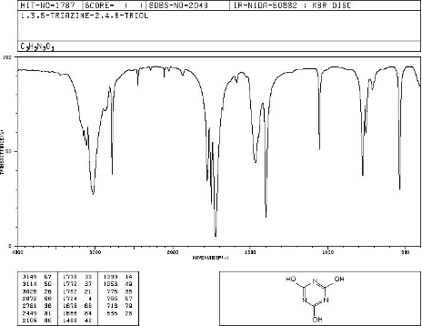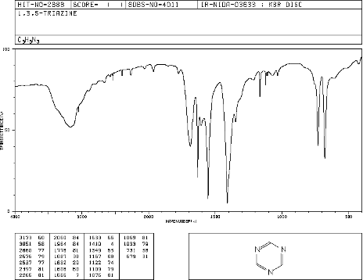
a)
b)

S.3 References
ChemicalBook, 2017a. 1,3,5-Triazine(290-87-9) IR1. https://www.chemicalbook.com/SpectrumEN_108-80-5_IR1.htm
ChemicalBook, 2017b. Cyanuric acid(108-80-5) IR1. https://www.chemicalbook.com/SpectrumEN_290-87-9_IR1.htm

