Table:

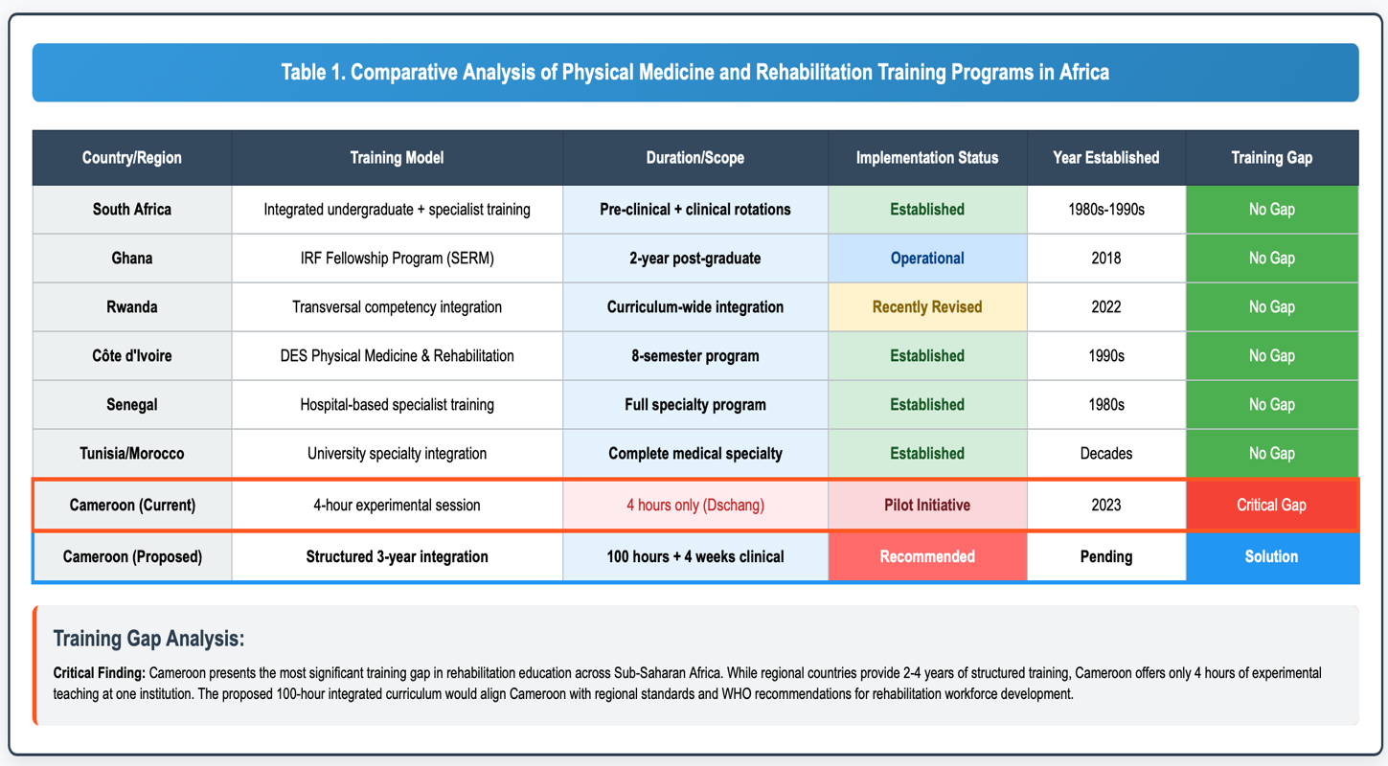

Table 1. Comparative Analysis of Physical Medicine and Rehabilitation Training Programs in Africa. This table presents a systematic comparison of rehabilitation education integration across major Sub-Saharan African countries, highlighting training models, program duration, implementation status, establishment dates, and current training gaps. The analysis reveals that while most regional countries have established comprehensive rehabilitation training programs—ranging from integrated undergraduate curricula (South Africa) to specialized post-graduate fellowships (Ghana) and complete medical specialties (Côte d'Ivoire, Senegal)—Cameroon presents the most significant educational deficit with only minimal experimental exposure (4 hours) at a single institution. The proposed 100-hour structured curriculum represents an evidence-based solution to align Cameroon with regional standards and WHO Rehabilitation 2030 recommendations, addressing the critical gap in rehabilitation workforce development that currently compromises professional recognition and healthcare delivery quality.

