Supplementary Files

Materials and methods of scRNA-seq analysis
Single-cell solution preparation
Liver tissues were cut into about 1-2mm³ pieces and digested in SoloTM Tumor Dissociation Kit (Sinotech Genomics Co. Ltd., Shanghai, China, JZ-SC-58201) at 37°C for 30-60 minutes. Then we stopped enzymatic digestion with excess RPMI-1640 medium, and filtered cell with 40 μm cell strainer. During enzymatic hydrolysis, HCs undergo breakage and apoptosis, and the assay process automatically filters out low-quality single cells; therefore, only NPCs were available in final single-cell analysis. Single cell solution was kept on ice before loading to BD Rhapsody cartridge for single cell transcriptome capture (Sinotech Genomics Co. Ltd., Shanghai, China). Samples from MCD induced NASH and control groups were pooled separately for scRNA-seq analysis.

Single-cell transcriptome, library construction and sequencing
Cells were loaded in one BD Rhapsody microwell cartridge and lysed with lysis buffer, and the cell capture beads were retrieved and washed prior to performing reverse transcription. The microbead-captured single-cell transcriptome was converted into a cDNA library containing cell labels and UMI information. Cell concentration and viability were determined via a BD Rhapsody™ Scanner (BD Biosciences, San Jose, CA, USA). All procedures were performed with a BD Rhapsody cDNA Kit and BD Rhapsody Targeted mRNA & AbSeq Amplification Kit (BD Biosciences). All the libraries were sequenced in PE150 mode (pair-end for 150 bp reads) on the NovaSeq platform (Illumina, San Diego, CA, USA).

Sequencing data processing
Raw sequencing reads of the cDNA library were processed through the BD Rhapsody Whole Transcriptome Assay Analysis Pipeline (v1.8), which included filtering by read quality, annotating reads, annotating molecules, determining putative cells and generating a single-cell expression matrix. Among all the output files, the matrix of UMI counts for each gene per cell was used for downstream analysis. Genome Reference Consortium Mouse Build 38 (GRCm38) was used as a reference for the BD pipeline.

Dimensionality reduction, clustering and visualization
The Seurat v4.0 package was utilized for subsequent clustering analysis and visualization. Gene expression matrices for each sample were read and converted to Seurat objects. Cells with more than 5% mitochondrial unique molecular identifier (UMI) or less than 500 UMI or 200 genes were excluded from the downstream analysis. After log normalization based on the total cellular UMI count, a principal component analysis (PCA) was performed based on the top 2000 highly variable features after scaling the data with respect to UMI counts. Fifty principal components were used for clustering (nPC=50). We then performed clustering at a resolution of 0.6 and visualized the data using either t-distributed stochastic neighbor embedding (t-SNE) or uniform manifold approximation and projection (UMAP). Feature plots, violin plots and heatmaps were used to visualize the expression of the indicated genes in each cluster.

Cell type annotation and differentially expressed gene (DEG) analysis
Specific marker genes for each cluster were calculated using the FindAllMarkers function with the Wilcoxon test [criteria: log2-fold change > 0.25, minimum (min.) percentage (pct) > 0.25]. To perform unbiased identification of cell types in filtered sample datasets and the combined dataset, we used the R package SingleR (v1.4.1), a computational framework that references bulk transcriptomes and helps annotate cell types for each cluster. The built-in Mouse RNAseq Data (MRD) in SingleR was used as the reference dataset. To identify DEGs in scRNA-seq, we used FindMarkers (Seurat R Package) with the Wilcoxon test and Bonferroni correction (criteria: min. pct > 0.25). Genes were regarded as upregulated or downregulated with a log2-fold change > 0.25 or <-0.25 (adjusted p-value < 0.05). The ClusterProfiler package was utilized to detect enriched Kyoto Encyclopedia of Genes and Genome pathways (KEGG) or Gene Ontology (GO) biological functions from each set of DEGs. GO analysis included biological processes (BP), cell components (CC) and molecular functions (MF). We used the default parameters built into ClusterProfiler.
Supplementary Tables
Table S1 Clinical, biochemical and histologic features of human
Variable |  | Mild NAFLD group |  |  | Advanced NASH group |  |  | p-value
 |  | 1 | 2 | 3 | 1 | 2 | 3 | p-value
Age (years) |  | 41 | 32 | 50 | 45 | 41 | 33 | 0.392
Gender(F/M) |  | M | F | F | F | M | F | 0.431
ALT(U/L) |  | 48 | 64 | 50 | 43 | 108 | 86 | 0.137
AST(U/L) |  | 43 | 36 | 69 | 44 | 38 | 50 | 0.163
Cr(μmol/L) |  | 78 | 50 | 68 | 55 | 80 | 88 | 0.383
BUN (mmol/L) |  | 4 | 6 | 6 | 4 | 4 | 4 | 0.497
Pathological score | inflammation grade | 0 | 1 | 1 | 2 | 2 | 2 | 0.048
Pathological score | fibrosis stage | 0 | 0 | 0 | 1 | 1 | 1 | 0.223
Pathological score | steatosis scores | 1 | 1 | 1 | 3 | 3 | 3 | 0.013
ALT, alanine transaminase; AST, aspartate transaminase; Cr, creatinine; BUN, blood urea nitrogen; RBC, red blood cell; WBC, white blood cell; PLT, platelet

Table S2 Primers used in qRT-PCR
Gene | species | Primer Sequence (5'-3')
Fcer2α | human | F: CCAGGAATTGAACGAGAGGAAC  R: TTGATCCACTTTTCAGGGCAC
Cd22 | human | F: GTTCCTGCAAGTGCAGTATCCTC  R: CGCCATGGGGTTTCCATTC
Cr2 | human | F: CCATGAACGGAAACAAGTCTGT  R:TGTGGATCATAGGAAGTGCTGG
Fcmr | human | F: TACGAGCCATCATGGGAAGAG  R: GCTTGTCACCTGCTACTGAAGAT
Tnfrsf17 | human | F: GAACGAATGCGATTCTCTGGA  R: TCATCACCAGTCCTGCTCTTT
Dnah3 | human | F: CAGATCGCCAAAAGTGACTCC  R: GTTCCTCATTAGCAGAAGCAGG
Prdm1 | human | F: TAAAGCAACCGAGCACTGAGA  R: ACGGTAGAGGTCCTTTCCTTTG
Derl3 | human | F: AGGTCTGGAGGCTCGTCAC  R: GCAGTAGCGGAACACGAAGAG
Chdh | human | F: CCCCGGACAATCACAAAGAG  R: CTGATCCACGGAGGGGAATG
Dntt | human | F: GACTGGCTCCCGGTTTGAG  R: ACCCCAAACTCTCCTATGGC
Klk1 | human | F: TGTGTGGACCTCAAAATCCTGC  R: GTAGCCCCATGATGTGACACC
Apol1 (Apol7c) | human | F: TGGACTACGGAAAGAAGTGGT  R: CCTCCTTCAATTTGTCAAGGCTT
Lad1 | human | F: CCTCACCCACACAGCGAAC  R: GCACTGCGAGTTAGGGTTGTT
Arhgap22 | human | F: GAGTTGGCTAAACAAGTGAGCA  R: CCAAAAACGGTTGCCAGATTC
IL-10 | human | F: GAGAACCAAGACCCAGACATCA  R: GTTTTCACAGGGAAGAAATCGA
IL-35 | human | F: ATCATCAAGCCCGACCCTC  R: CAGCTCCCTGACGCTTGTAAC
IFN-γ | human | F: CGAGATGACTTCGAAAAGCTGA  R: ACTGGGATGCTCTTCGACCT
TNF-α | human | F: GCTGCACTTTGGAGTGATCG  R: ATGAGGTACAGGCCCTCTGA
IL-17 | human | F: CTGTCCCCATCCAGCAAGAG  R: AGGCCACATGGTGGACAATC
GAPDH | human | F: GGAAGCTTGTCATCAATGGAAATC  R: TGATGACCCTTTTGGCTCCC
* The used concentration of primers in the table was 10 μmol/L. The amplification efficiency of primers is between 90% and 110%.

Table S3 Antibodies used in IF
Antibody | Species | Manufacturer | Catalog # | Application
CD79a | mouse | Affinity | BF8329 | IF
Fcer2α | mouse | Abcam | ab315289 | IF
Tnfrsf17 | mouse | ABclonal | A10707 | IF
YSFluorTM488 F(ab')2 Fragment Goat Anti-Rat lgG(H+L) | mouse | Yeasen | 33316ES60 | IF
YSFluorTM594 Doneky Anti-Rabbit lgG(H+L) | Rabbit | Yeasen | 34212ES60 | IF

Table S4 Top 10 DEGs of B cells of cluster 3
No | DEG | avg_logFC | pct.1 | pct.2 | p_val_adj | pct_FC
1 | Fcer2α | 2.84 | 0.60 | 0.00 | 7.72E-44 | 5.99E+07
2 | Cr2 | 2.49 | 0.50 | 0.01 | 1.57E-31 | 5.50E+01
3 | Fcmr | 3.04 | 0.71 | 0.01 | 4.32E-58 | 5.10E+01
4 | Cd22 | 3.29 | 0.77 | 0.02 | 1.27E-65 | 4.03E+01
5 | Cxcr5 | 1.54 | 0.32 | 0.01 | 3.29E-15 | 2.27E+01
6 | Bank1 | 3.39 | 0.81 | 0.04 | 3.48E-72 | 2.14E+01
7 | B3gnt5 | 2.01 | 0.43 | 0.02 | 1.71E-23 | 1.87E+01
8 | Serpinb1α | 1.90 | 0.39 | 0.02 | 5.67E-20 | 1.67E+01
9 | Zfp318 | 2.43 | 0.52 | 0.06 | 7.32E-30 | 8.48E+00
10 | Ighd | 4.13 | 0.90 | 0.11 | 4.86E-86 | 8.31E+00
*pct, percentage; avg_logFC, average of log fold change; adj p-val, adjust p-value; pct-FC, percentage-fold change

Table S5 Top 10 DEGs of B cells of cluster 14
No | DEG | avg_log2FC | pct.1 | pct.2 | p_val_adj | pct_FC
1 | Asns | 0.51 | 0.28 | 0.00 | 3.46E-56 | 2.81E+07
2 | Pycr1 | 0.62 | 0.41 | 0.00 | 1.10E-82 | 4.12E+02
3 | Dnm3 | 0.74 | 0.40 | 0.00 | 6.69E-81 | 4.04E+02
4 | Ccr10 | 0.81 | 0.38 | 0.00 | 5.34E-75 | 3.77E+02
5 | Tnfrsf17 | 1.83 | 0.72 | 0.00 | 4.70E-151 | 3.59E+02
6 | Dnah3 | 0.86 | 0.57 | 0.00 | 9.82E-116 | 2.85E+02
7 | Cpeb3 | 0.51 | 0.33 | 0.00 | 2.86E-61 | 1.62E+02
8 | Prdm1 | 1.72 | 0.78 | 0.01 | 3.29E-159 | 1.56E+02
9 | Derl3 | 2.80 | 0.90 | 0.01 | 1.60E-187 | 1.51E+02
10 | Selenom | 0.36 | 0.28 | 0.00 | 8.39E-52 | 1.40E+02

Table S6 Top 10 DEGs of B cells of cluster 16
No | DEG | avg_log2FC | pct.1 | pct.2 | p_val_adj | pct_FC
1 | Klk1 | 3.05 | 0.71 | 0.00 | 2.22E-155 | 7.11E+07
2 | Chdh | 1.52 | 0.58 | 0.00 | 6.31E-125 | 5.79E+07
3 | Dntt | 1.73 | 0.55 | 0.00 | 6.65E-119 | 5.53E+07
4 | Paqr5 | 1.31 | 0.54 | 0.00 | 6.70E-116 | 5.39E+07
5 | Gm21762 | 1.38 | 0.50 | 0.00 | 6.33E-107 | 5.00E+07
6 | Klk1b27 | 1.51 | 0.42 | 0.00 | 4.00E-89 | 4.21E+07
7 | Cd209d | 1.53 | 0.38 | 0.00 | 2.69E-80 | 3.82E+07
8 | Obscn | 0.74 | 0.25 | 0.00 | 3.25E-51 | 2.50E+07
9 | Atp2a1 | 1.98 | 0.71 | 0.00 | 1.74E-152 | 7.11E+02
10 | Smim5 | 1.74 | 0.66 | 0.00 | 4.61E-140 | 6.58E+02

Table S7 Top 10 DEGs of B cells of cluster 20
No | DEG | avg_log2FC | pct.1 | pct.2 | p_val_adj | pct_FC
1 | Apol7c | 4.05 | 0.57 | 0.00 | 8.01E-125 | 5.65E+07
2 | Lad1 | 2.36 | 0.57 | 0.00 | 8.01E-125 | 5.65E+07
3 | Arhgap22 | 1.06 | 0.52 | 0.00 | 6.36E-115 | 5.22E+07
4 | Arhgap28 | 0.84 | 0.39 | 0.00 | 2.52E-85 | 3.91E+07
5 | Gm10851 | 0.91 | 0.35 | 0.00 | 1.71E-75 | 3.48E+07
6 | Il12b | 2.93 | 0.30 | 0.00 | 1.12E-65 | 3.04E+07
7 | H2-M2 | 2.31 | 0.30 | 0.00 | 1.12E-65 | 3.04E+07
8 | Dnah2 | 1.07 | 0.30 | 0.00 | 1.12E-65 | 3.04E+07
9 | Avpi1 | 0.70 | 0.30 | 0.00 | 1.12E-65 | 3.04E+07
10 | Lpar3 | 0.56 | 0.30 | 0.00 | 1.12E-65 | 3.04E+07

Supplmental Figure
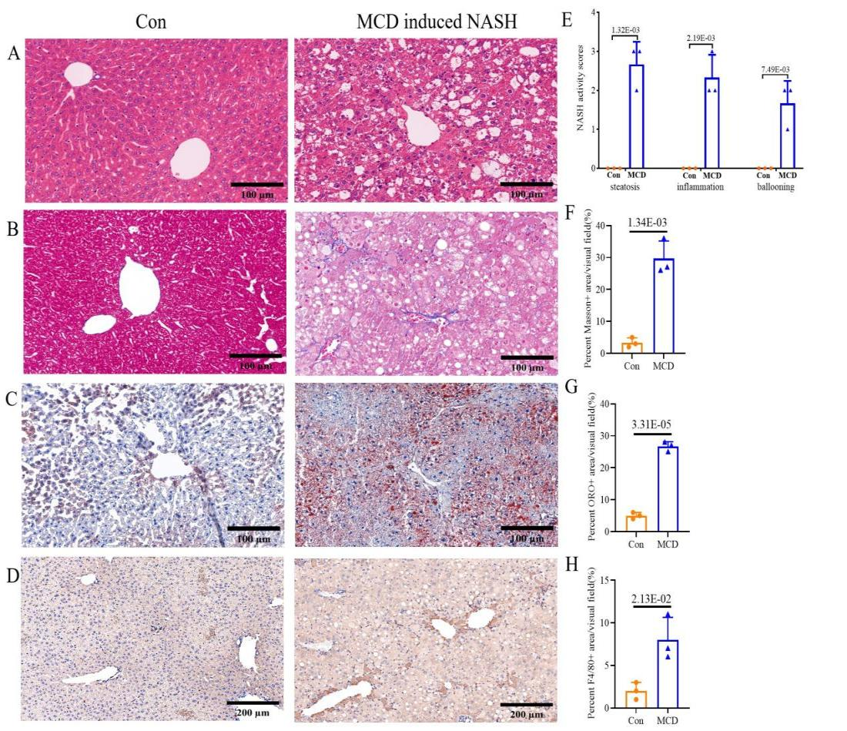
Figure S1 Histological examination of mice model
Representative images of H&E staining (A), Masson (B), ORO (C) and IHC of F4/80 staining (D) of livers from control mice (n=3) and MCD fed mice (n=3). NASH activity scores including steatosis, inflammation and ballooning (E), Masson (F), ORO (G) and IHC F4/80 (H) in liver sections were calculated between 2 groups. Scale bar=100 μm in (A-C); Scale bar=200 μm in (D).
Data were showed as the mean ± SEM. The p-values were calculated using an unpaired Student’s t test. p-value means the statistical significance compared to control (Con) mice.

