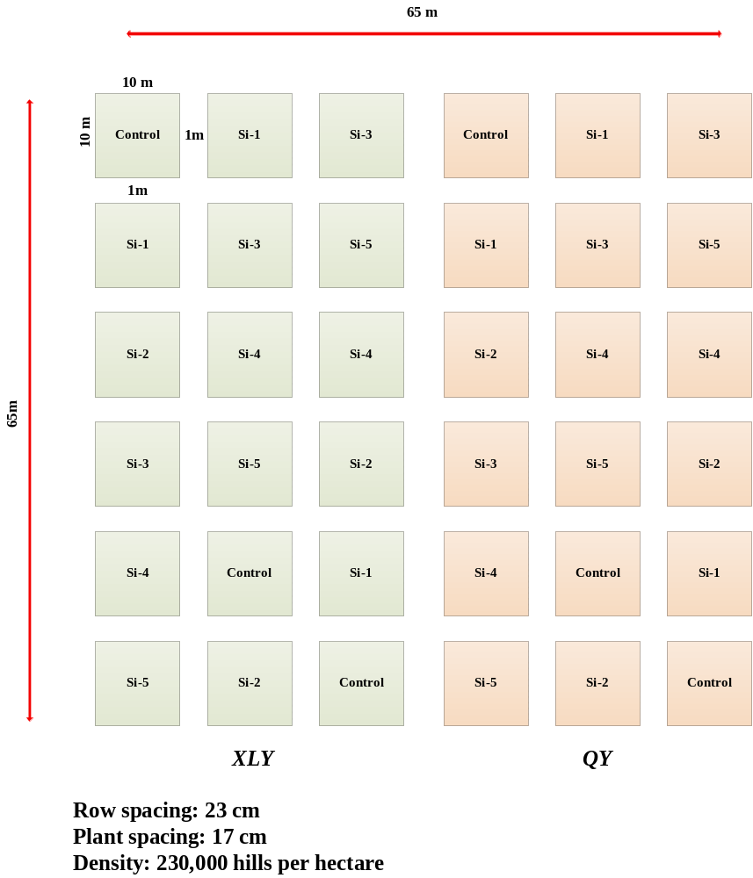
Figure S 1 This study field cultivation diagram. XLY: Xinliangyou-223, QY: Quanyouefengsimiao.

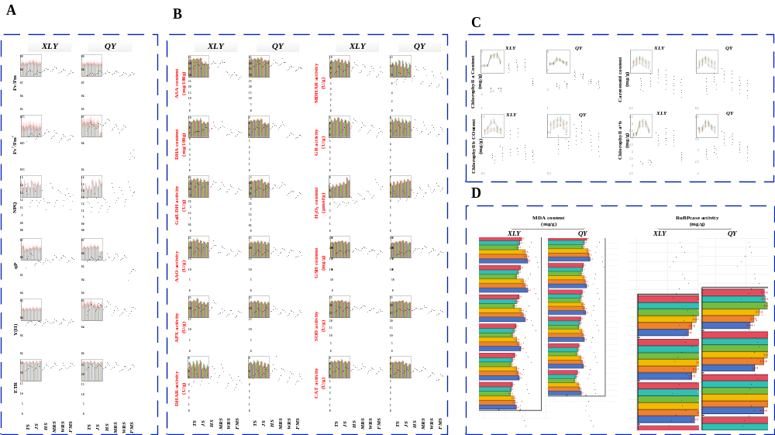
Figure S 2 Changes of chlorophyll fluorescence parameters, antioxidant properties, photosynthetic pigment content, enzyme and membrane system in rice leaves under the regulation of silicon. (A) Effects of different amounts of silicon on chlorophyll fluorescence parameters of rice leaves at different periods. (B) Effects of different amounts of silicon on antioxidant properties of rice leaves at different periods. (C) Effects of different supplemental amounts of silicon on photosynthetic pigment content in rice leaves at different periods. (D) Effects of different silicon additions on MDA content and photosynthetic enzyme activity in rice leaves at different periods. Note: Value represent mean±standard deviation (SD) of ten replicates for each treatment. The different small letters indicate significant difference at P≤0.05. XLY: Xinliangyou-223, QY: Quanyouefengsimiao.
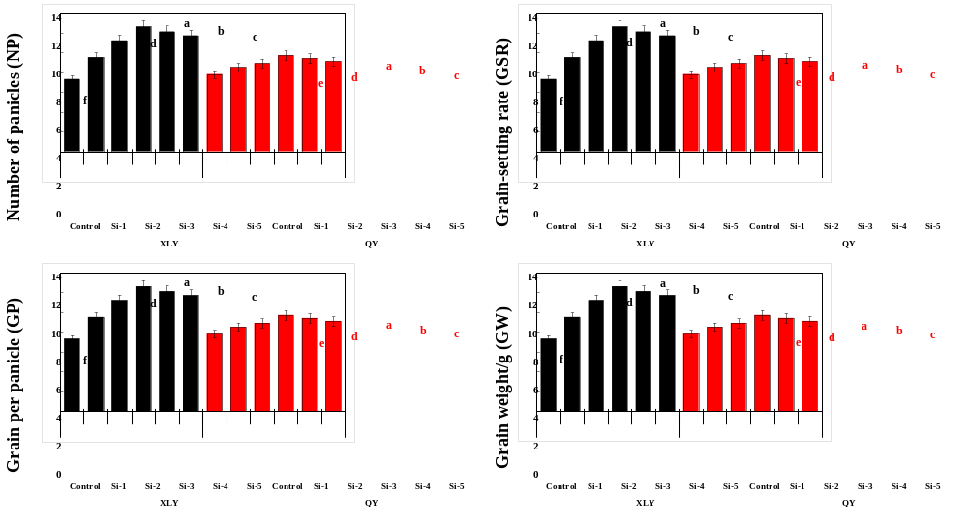
Figure S 3 The influence of silicon on the constituent factors of rice yield. Note: Value represent mean±standard deviation (SD) of ten replicates for each treatment. The different small letters indicate significant difference at P≤0.05. XLY: Xinliangyou-223, QY: Quanyouefengsimiao.
Table S1. Physical and chemical properties of soil in this study
pH | Total Porosity  % | Aerated Porosity  % | Soil Bulk Density  (g/cm³) | Organic Carbon  (g/kg) | Nitrogen  (g/kg) | Phosphorus  (mg/kg) | Potassium  (mg/kg)
6.14±0.15 | 55.2±0.35 | 11.2±0.22 | 1.51±0.07 | 12.15±0.34 | 1.5±0.04 | 2.6±0.12 | 98.97±5.62

