Supplementary Material for
Optimizing Spirulina’s Nutritional Value: The Transformative Role of Iron Biofortification
Fatemeh Gholizadehª, Fatemeh Zarinkamar ^{a*}
ªDepartment of Plant Biology, Faculty of Biological Sciences, Tarbiat Modares University, Tehran, Iran
*Corresponding author: Fatemeh Zarinkamar, PhD, Email: zarinkamar@modares.ac.ir

Figure S1 the growth curve of Arthrospira platensis in the modified Zarrouk’s medium supplemented with varying iron concentrations

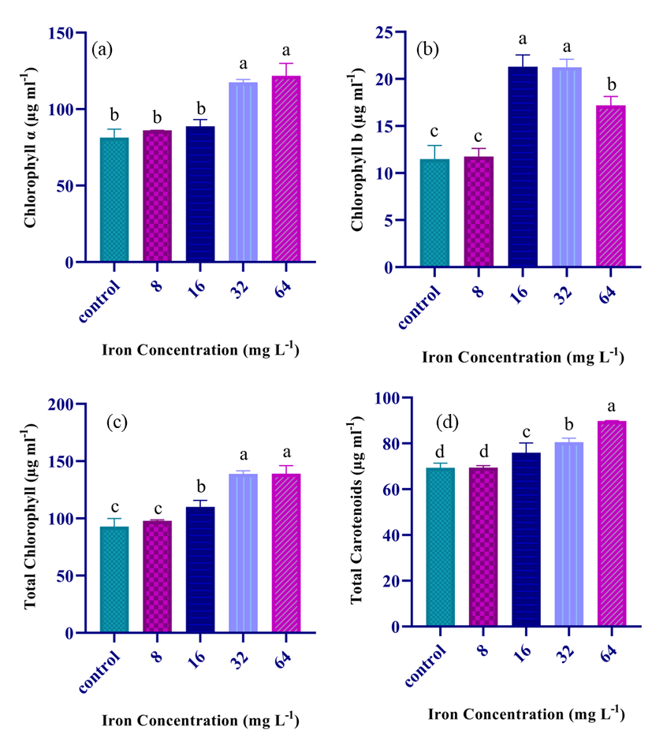
Figure S2 Effect of varying iron concentrations in the culture media on the chl a (a), chl b (b), total chl (c) and total carotenoids (d) of A. platensis

