Table 1 Test results of main indicators of asphalt
Evaluation indicators | High elasticity modifier | Virgin asphalt | H-asphalt
Penetration (25℃)/0.1mm | 10 | 65 | 40.5
Ductility (15℃)/cm | — | ＞100 | 60.6
Softening point/◦C | 128 | 52.5 | 78
60℃ Dynamic viscosity/Pa•s | — | 186.8 | 9700
Density (15℃) g/cm³ | 0.98 | 1.033 | 1.042
Mass loss after thin  film oven test /% | — | -0.01 | -0.10
Flash point/℃ | 236 | 270 | 275
Morphology | 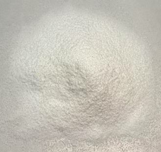 |  | 