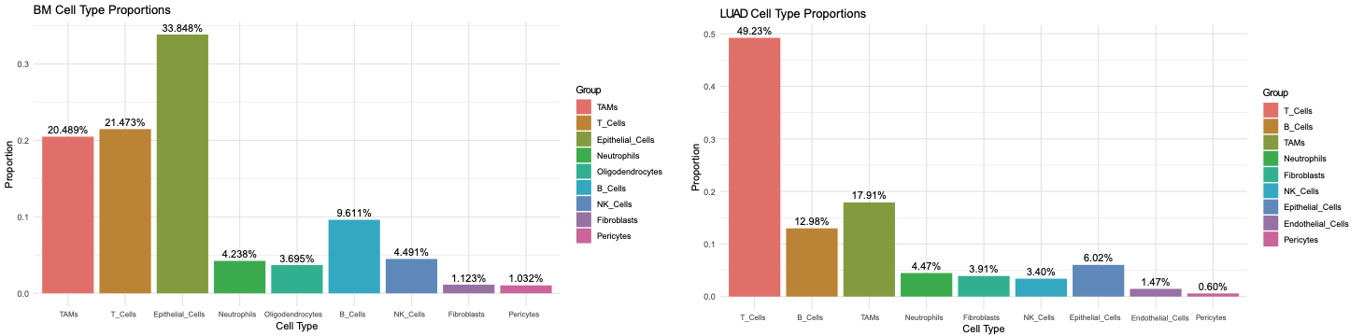
Figure S1. Bar plot showing the proportions of cellular subclusters in BM and LUAD
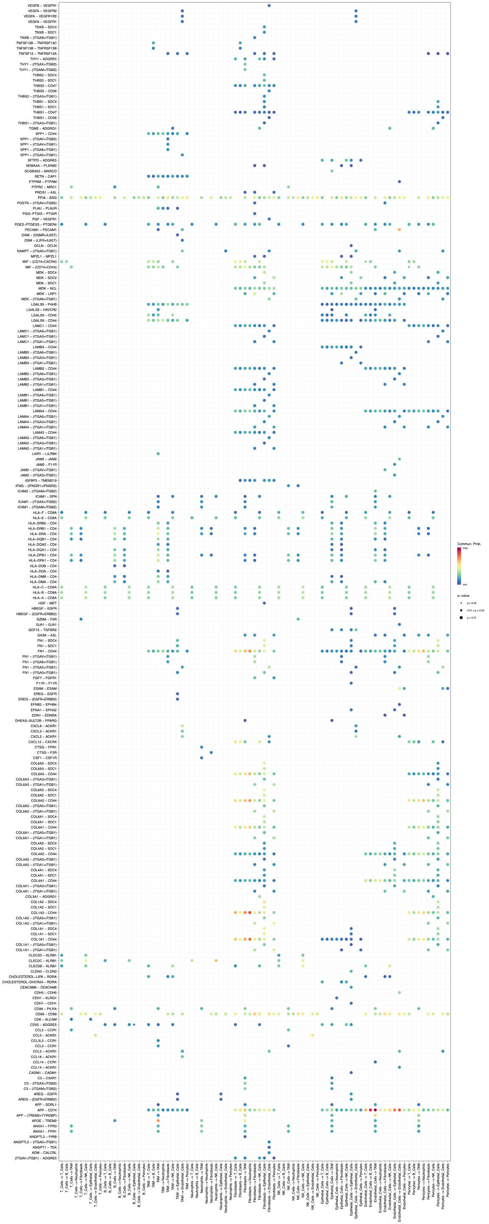
Figure S2. CellChat analysis revealing intercellular communication networks in LUAD

