(Supplementary)

Tunnel-redesigned O₂-tolerant CO dehydrogenase for removal of CO in real flue gas

Suk Min Kim^{1†}, Jinhee Lee^{1†}, Sung Heuck Kang^{1,2†}, Yoonyoung Heo^{3†}, Ji Sook Hanh², Hyung Ho Lee^{3*} and Yong Hwan Kim^{1*}
¹School of Energy and Chemical Engineering, Ulsan National Institute of Science and Technology (UNIST), 50 UNIST-gil, Ulsan 44919, Republic of Korea
²School of Chemical and Biological Engineering, Seoul National University, 1 Gwanak-ro, Gwanak-gu, Seoul 08826, Republic of Korea
³Department of Chemistry, College of Natural Sciences, Seoul National University, 1 Gwanak-ro, Gwanak-gu, Seoul 08826, Republic of Korea

†These are co-first authors.
*Corresponding authors:
Hyung Ho Lee, e-mail: hyungholee@snu.ac.kr
Yong Hwan Kim, e-mail: metalkim@unist.ac.kr
Supplementary Tables S1‒S6
Supplementary Table S1 | Structural alignments of CODHs
Despite amino acid differences (40–57% identities of amino acids) and evolutionary plasticity²⁶ of Ni–Fe CODHs, we noticed that these proteins with TM-scores of 0.92–0.98 have very similar structures.
CODH | Organism | Protein family  (EC number) | PDB id | ChCODH-II (PDB: 3B53)
 |  |  |  | TM-score* (chain) | Amino acid identity (%)
ChCODH-IV | C. hydrogenoformans | Ni–Fe CODH  (EC 1.2.7.4) | 6ELQ | 0.98085 (A)  0.98548 (B) | 54.1
DvCODH | Desulfovibrio vulgaris | Ni–Fe CODH  (EC 1.2.7.4) | 6ONC | 0.95690 (A)  0.96898 (B) | 46.7
 | D. vulgaris str. Hildenborough | Ni–Fe CODH  (EC 1.2.7.4) | 6VWY | 0.95965 (A)  0.97024 (B) | 47.1
RrCODH | Rhodospirillum rubrum | Ni–Fe CODH  (EC 1.2.7.4) | 1JQK | 0.94977 (A)  0.98531 (B) | 57.8
MtCODH | Moorella thermoacetica  (Clostridium thermoacetica) | Acetyl-CoA synthase /Ni–Fe CODH  (EC 1.2.7.4) | 1MJG | 0.98197 (A)  0.92555 (B) | 49.1
* TM-score is calculated using the structural alignment program of TM-align for assessment of the topological similarity of protein structures²⁷. TM-score has values in 0–1 range, where 1 indicates a perfect match between two structures.
Supplementary Table S2 | Interactions of non-conserved residues in ChCODH-IV structure (PDB: 1ELQ)
We analyzed residue interactions in ChCODH-IV, in order to infer potential roles of the relevant non-conserved residues by assigning a particular type of non-covalent bond.
Residue | Counterpart | Distance  (Å) | Interaction | Putatively functional role
D94 | Arg187 | 5.35 | attractive charge | increase stability of structure
 | Arg190 | 2.73 | salt bridge
 | His194 | 2.78 | conventional hydrogen bond
E101 | Arg187 | 3.55 | salt bridge | increase stability of structure
R187 | Asp94 | 5.35 | attractive charge | increase stability of structure
 | Asp98 | 4.87 | attractive charge
 | Glu101 | 3.55 | salt bridge
Y558 | Val51 | 4.67 | pi-alkyl | substrate transfer
Q559 | C-cluster | 3.23 | conventional hydrogen bond | substrate transfer
 | Val51 | 2.74 | conventional hydrogen bond
 | Met198 | 3.55 | conventional hydrogen bond

Supplementary Table S3 | The primer list for this study
Mutation | Primer (5' to 3') | Vector | Host*
Ch2_S312F | F-tgcacccacttcgttagccaggaaatggcgat, R-ctggctaacgaagtgggtgcacgccggaatac | pET28a | E. coli BL21
Ch2_A559C | F-cgcggcggaatgcatgcatgagaaggcggtg, R-tctcatgcatgcattccgccgcgctcgcaacc | pET28a | E. coli BL21
Ch2_A559D | F-cgcggcggaagatatgcatgagaaggcggtgg, R-tctcatgcatatcttccgccgcgctcgcaacc | pET28a | E. coli BL21
Ch2_A559E | F-cgcggcggaagagatgcatgagaaggcgg, R-tctcatgcatctcttccgccgcgctcgcaa | pET28a | E. coli BL21
Ch2_A559F | F-cgcggcggaatttatgcatgagaaggcggtgg, R-tctcatgcataaattccgccgcgctcgcaacc | pET28a | E. coli BL21
Ch2_A559H | F-cgcggcggaacacatgcatgagaaggcggtgg, R-tctcatgcatgtgttccgccgcgctcgcaacc | pET28a | E. coli BL21
Ch2_A559M | F-cgcggcggaaatgatgcatgagaaggcggtgg, R-tctcatgcatcatttccgccgcgctcgcaacc | pET28a | E. coli BL21
Ch2_A559N | F-gcgcggcggaaaacatgcatgagaaggcggtgg, R-tctcatgcatgttttccgccgcgctcgcaacc | pET28a | E. coli BL21
Ch2_A559P | F-gcggcggaaccgatgcatgagaaggcggtg, R-atgcatcggttccgccgcgctcgcaa | pET28a | E. coli BL21
Ch2_A559Q | F-cgcggcggaacaaatgcatgagaaggcggtgg, R-tctcatgcatttgttccgccgcgctcgcaacc | pET28a | E. coli BL21
Ch2_A559S | F-cgcggcggaaagcatgcatgagaaggcggtgg, R-tctcatgcatgctttccgccgcgctcgcaacc | pET28a | E. coli BL21
Ch2_A559T | F-gcgcggcggaaaccatgcatgagaaggcggtgg, R-tctcatgcatggtttccgccgcgctcgcaacc | pET28a | E. coli BL21
Ch2_A559W | F-gcgcggcggaatggatgcatgagaaggcggtgg, R-tctcatgcatccattccgccgcgctcgcaacc | pET28a | E. coli BL21
Ch2_A559Y | F-gcgcggcggaatacatgcatgagaaggcggtgg, R-tctcatgcatgtattccgccgcgctcgcaacc | pET28a | E. coli BL21
Ch2_M560E | F-gcggaagcggaacatgagaaggcggtgg, R-cttctcatgttccgcttccgccgcgc | pET28a | E. coli BL21
Ch2_M560H | F-gcggaagcgcatcatgagaaggcggtgg, R-cttctcatgatgcgcttccgccgcgc | pET28a | E. coli BL21
Ch2_M560Q | F-cggaagcgcagcatgagaaggcggtggcgat, R-cttctcatgctgcgcttccgccgcgctcgcaa | pET28a | E. coli BL21
Ch2_I586D | F-ctgccgccggataccggcagcctgccggtgac, R-gctgccggtatccggcggcagcacaccaatg | pET28a | E. coli BL21
Ch2_I586H | F-ctgccgccgcacaccggcagcct, R-ctgccggtgtgcggcggcagcacaccaatg | pET28a | E. coli BL21
Ch2_I586S | F-tgccgccgagcaccggcagcct, R-ctgccggtgctcggcggcagcacaccaat | pET28a | E. coli BL21
Ch2_T593A | F-agcctgccggtggcgcaaatcctgaccagcag, R-tcaggatttgcgccaccggcaggctgccggtgat | pET28a | E. coli BL21
Ch2_T593S | F-cctgccggtgagccaaatcctgaccagca, R-aggatttggctcaccggcaggctgccggtgat | pET28a | E. coli BL21
Ch2_T597A | F-cccaaatcctggcgagcagcgttaaagatattac, R-tttaacgctgctcgccaggatttgggtcaccggca | pET28a | E. coli BL21
Ch2_T597S | F-cccaaatcctgagcagcagcgttaaagatattac, R-tttaacgctgctgctcaggatttgggtcaccggca | pET28a | E. coli BL21
Ch2_V610A | F-gctacttcatcgcggaactggacccggagacc, R-ggtccagttccgcgatgaagtagccaccgg | pET28a | E. coli BL21
Ch2_V610S | F-gctacttcatcagcgaactggacccggagacc, R-ggtccagttcgctgatgaagtagccaccgg | pET28a | E. coli BL21
Ch4_Y558A | F-tgcacctgaagcccagcatgaaaaggctttga, R-ttcatgctgggcttcaggtgcagaagccg | pET28a | E. coli BL21
Ch4_Y558H | F-cgcggcggaatgcatgcatgagaaggcggtg, R-tctcatgcatgcattccgccgcgctcgcaacc | pET28a | E. coli BL21
Ch4_Y558S | F-cgcggcggaatttatgcatgagaaggcggtgg, R-tctcatgcataaattccgccgcgctcgcaacc | pET28a | E. coli BL21
Ch4_Y558W | F-cgcggcggaaatgatgcatgagaaggcggtgg, R-tctcatgcatcatttccgccgcgctcgcaacc | pET28a | E. coli BL21
Dv_W552A | F-ttcaccagaagcctattccgagaaagcagc, R-tctcggaataggcttctggtgaactggccc | pET28a | E. coli BL21
* The host E. coli BL21 strain contains pRKISC plasmid carrying Fe–S cluster assembly proteins.
Supplementary Table S4 | Summary of O₂ tolerances in all tested variants*
Group | Related residues | Specific Activity  (U⋅mg⁻¹) | O₂ tolerance  (µM)
ChCODH-II | A559/V565/I580 | 1,200 | 1
ChCODH-IV | Y558/L564/L579 | ~ 120 | 25
DvCODH | W552/A568/L573 | ~ 7 | <10
Bottleneck point | A559C | ~700 | <2.5
Bottleneck point | A559D | ~ 400 | <5
Bottleneck point | A559E | ~ 350 | <5
Bottleneck point | A559F | ~1,600 | <25
Bottleneck point | A559H | 2,200 | >50
Bottleneck point | A559M | ~1,000 | <10
Bottleneck point | A559N | ~ 240 | <5
Bottleneck point | A559P | ~700 | <10
Bottleneck point | A559Q | ~ 450 | <1
Bottleneck point | A559S | ~ 1,200 | 50
Bottleneck point | A559T | <0.1 | 0
Bottleneck point | A559Y | 1,200 ~ 1,600 | 10-25
Bottleneck point | A559Y/I580L | ~ 1,400 | <1
Bottleneck point | A559Y/I580L/V565L | 1,500 | 10
Bottleneck point | A559W | 2,200 | <50
Bottleneck point | A559W/V565A | ~ 90 | 0
Bottleneck point | A559W/V565S | ~ 500 | <10
* Enzymatic activities are displayed as the mean of three independent measurements. High values (~50 μM O₂) are shown in bold.
Supplementary Table S5 | Identified 37 structures of Ni‒Fe CODHs
Name (EC number) | Complex | Origin | Host | Crystallized condition | PDB ID*
ChCODH-II (1.2.7.4) | homodimer | Carboxydothermus hydrogenoformans | C. hydrogenoformans | Anaerobic | 1SU6²⁸, 1SU7, 1SU8, 1SUF
ChCODH-II (1.2.7.4) | homodimer | Carboxydothermus hydrogenoformans | Escherichia coli | Anaerobic | 3B51²³, 3B52, 3B53, 3I39²⁹, 5FLE³⁰, 2YIV³¹, 4UDX³², 4UDY
 |  |  |  | Aerobic | 7ERR
ChCODH-IV (1.2.7.4) | homodimer | C. hydrogenoformans | E. coli | Anaerobic | 6ELQ⁷
DvCODH (1.2.7.4) | homodimer | Desulfovibrio vulgaris | D. fructosivorans | Anaerobic | 6B6V³³, 6B6W, 6B6X, 6B6Y, 6DC2, 6ONC³⁴, 6OND, 6ONS, 6VWY³⁵, 6VWZ, 6VX0, 6VX1
RrCODH (1.2.7.4) | homodimer | Rhodospirillum rubrum | R. rubrum | Anaerobic | 1JQK³⁶
TsCODH (1.2.7.4) | homodimer | Thermococcus sp. AM4 | D. fructosivorans | Anaerobic | 6T7J³⁷
CaCODH (1.2.7.4)/  ACS β (2.3.1.169) | heterotetramer | Clostridium autoethanogenu | C. autoethanogenu | Anaerobic | 6YTT³⁸, 6YU9, 6YUA
MtCODH (1.2.7.4)/  ACS β (2.3.1.169) | heterotetramer | Moorella thermoacetica | M. thermoacetica | Anaerobic | 3I01³⁹, 3I04, 1MJG⁴⁰, 1OAO⁴¹, 6X5K⁴², 2Z8Y⁴³
* Reference structures in this study are in bold. ChCODH-II A559W is highlighted in magenta. Abbreviation: ACS, acetyl-CoA synthase; CODH, carbon monoxide dehydrogenase
Supplementary Table S6 | Statistics for data collection and refinement
Data set | ChCODH-Ⅱ (A559W variant)
A. Data collection
X-ray source | PLS 5C
X-ray wavelength (Å) | 1.0000
Space group | C2
Unit-cell length (a, b, c, Å) | 112.1, 75.1, 70.8
Unit-cell angle (α, β, γ, °) | 90, 111.2, 90
Resolution range (Å) | 50-2.16
Total / unique reflections | 96,278/28,936
Completeness (%) | 98.1 (86.1)*
Average I/σ (I) | 9.0 (1.1)*
R_{merge}† (%) | 10.7 (63.3)*
B. Model refinement statistics
Resolution range (Å) | 50-2.16
R_{work} / R_{free}‡(%) | 13.5 / 18.7
Number / average B-factor (Å²)
Protein nonhydrogen atoms | 4,662/ 36.0
Cluster atoms | 22/ 52.6
Water oxygen atoms | 273/ 40.1
R.m.s. deviations from ideal geometry
Bond lengths (Å) | 0.020
Bond angles (°) | 2.116
Protein-geometry analysis
Ramachandran preferred (%) | 96.4
Ramachandran allowed (%) | 2.5
Ramachandran outliers (%) | 1.1
* Values in parentheses refer to the highest-resolution shell (2.20–2.16 Å).
† R_{merge} = Σ_{hkl}Σ_{i} | I_{i}(hkl) – <I(hkl)> | / Σ_{hkl}Σ_{i} I_{i}(hkl)_{i}, where I(hkl) is the intensity of reflection hkl, Σ_{hkl} is the sum over all reflections, and Σ_{i} is the sum over i measurements of reflection hkl.
‡ R = Σ_{hkl} | |F_{obs}| – |F_{calc}| | / Σ_{hkl} |F_{obs}|, where R_{free} was calculated for a randomly chosen 10% of reflections, which were not used for structural refinement, and R_{work} was calculated for the remaining ones.
Supplementary Figures (S1‒S7)

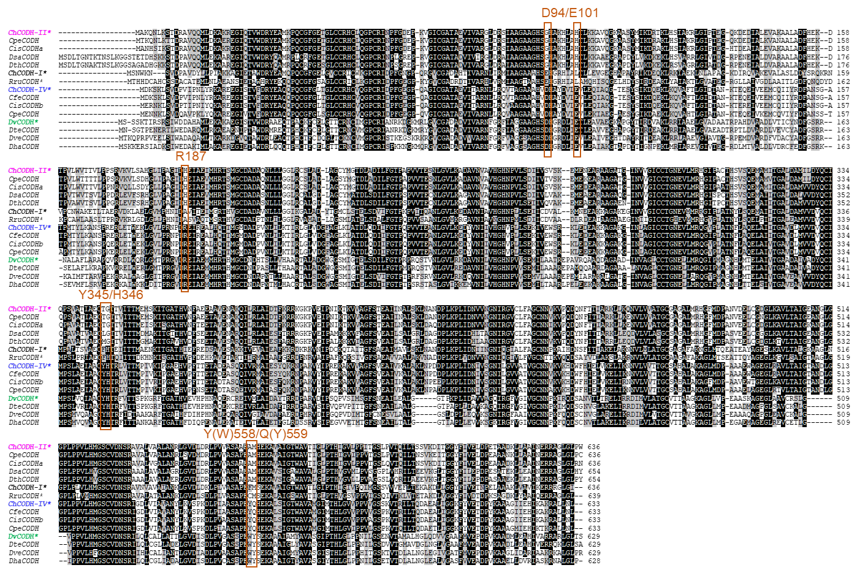
Supplementary Figure S1 | Multiple alignments of ChCODH-related sequences. In amino acid alignment of ChCODHs, the conserved amino acid residues are displayed by black shading with white letters (identity of 100%) and gray shading with black letters (>60%). The characterized CODHs are marked with asterisks (*). The boxes indicate residues that are present only on sequences of ChCODH-IV and DvCODH with O₂ tolerance. The CODHs are as follows: ChCODH-I (W011344718), ChCODH-II (WP011343033), ChCODH-IV (W011343666) from Carboxydothermus hydrogenoformans; CfeCODH from C. ferrireducens (W028051453); CpeCODHs from C. pertinax (W075858402 and WP075859348); CisCODHs from C. islandicus (WP075865383 and W075866622); DsaCODH from Desulfofundulus salinum (WP121452276); DthCODH from D. thermocisternus (WP084327079); RruCODH from Rhodospirillum rubrum (W011389181); DvCODH from Desulfovibrio vulgaris (WP010939375); DteCODH from D. termitidis (WP035067836); DveCODH from Desulfocurvus vexinensis (WP028588641); DhaCODH from Desulfofaba hansenii (WP100393885).

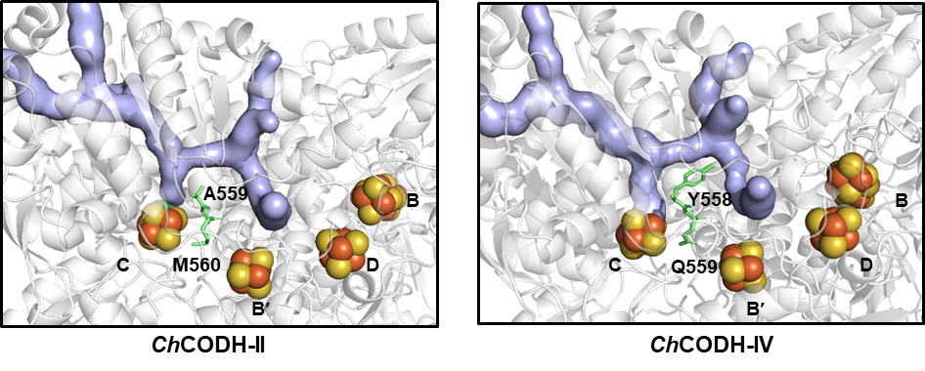
Supplementary Figure S2 | Distinctive residues of ChCODH-II and IV. The crystal structure of ChCODH-IV manifests that two residues Y558 and Q559 are discriminatingly located near the C-cluster of the active site and coordinate the ends of the substrate tunnels, whereas the other residues likely appear for structural stability (Supplementary Table S2). Both residues of Y558 and Q559 next to the active site are deeply buried, and exist at the tunnels’ junction for putative substrate transfer of CO and water molecules in ChCODH-IV, in a similar way as ChCODH-II’s channels⁴⁴. Especially, the side chain at A559 in ChCODH-II (Y558 in ChCODH-IV) points to the substrate tunnel, whereas the M560 residue in ChCODH-II (Q559 in ChCODH-IV) shows the opposite orientation, regardless of tunnels.

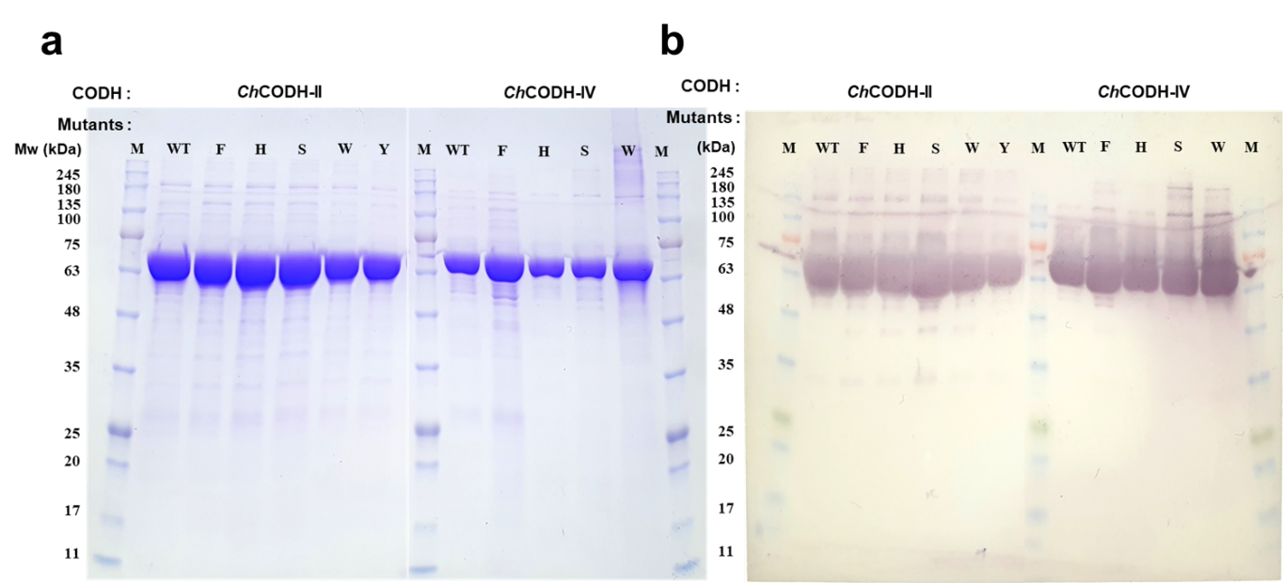
Supplementary Figure S3 | SDS-PAGE of ChCODH-II and variants. The Ni-NTA-purified CODHs were loaded on 12% SDS-PAGE (a) in order to check the soluble expressions of the ChCODH-II (A559F, A559H, A559S, A559W, A559Y, and A559H) and ChCODH-IV (Y558F, Y558H, Y559S, and Y558W) variants. To confirm the purified proteins with His₆-tags, Western blotting was additionally conducted with anti-His Ab (b).

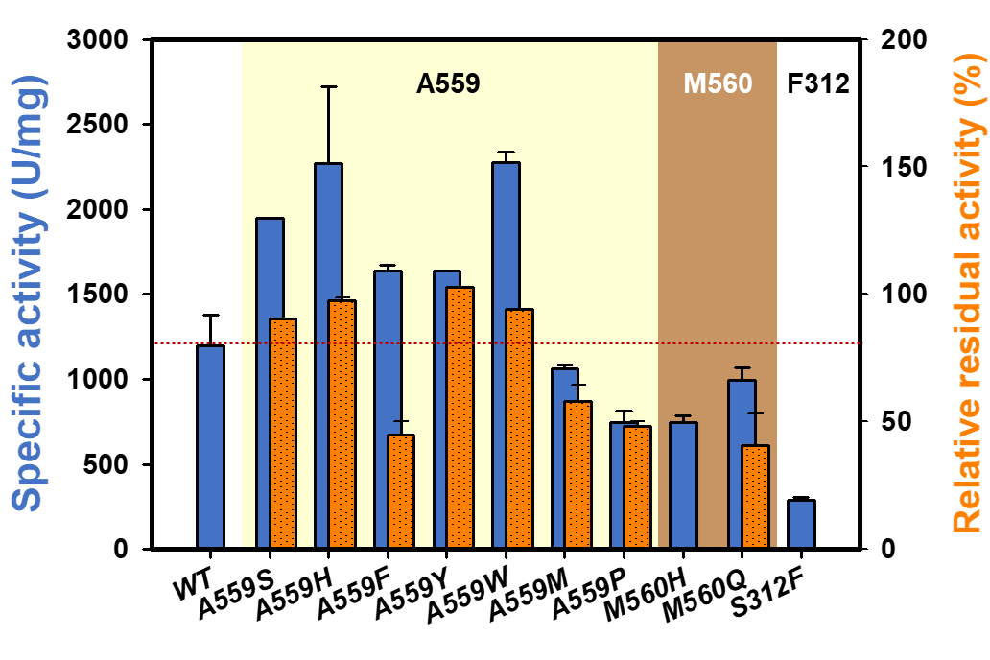
Supplementary Figure S4 | Residual activities of M560 and S312 variants in presence/absence of O₂.

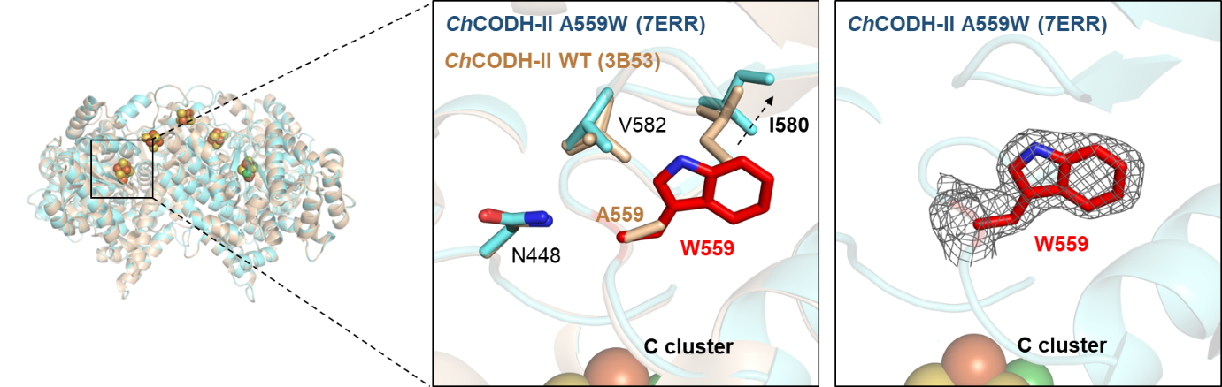
Supplementary Figure S5 | Structural comparison of ChCODH-Ⅱ WT and A559W variant around Trp559. The electron density map of Trp559 was drawn with a 1 σ contour (2Fo-Fc map). The neighboring residues around Trp559 are shown in sticks, and Trp559 is colored in red.

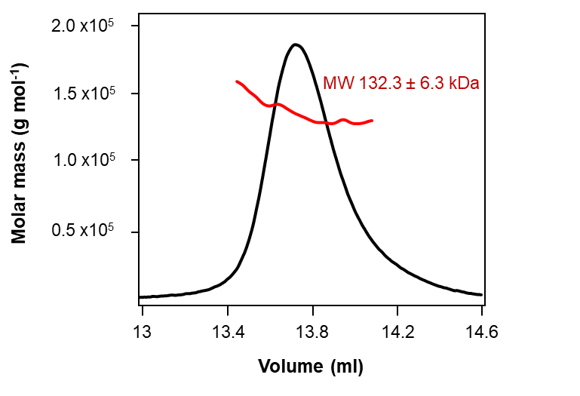
Supplementary Figure S6 | Oligomeric state of ChCODH-Ⅱ A559W variant in solution as analyzed by SEC-MALS. The thick horizontal line (red) represents the measured molecular mass (132.3 ± 6.3 kDa). The expected molecular mass for dimeric ChCODH-II A559W was 138 kDa.

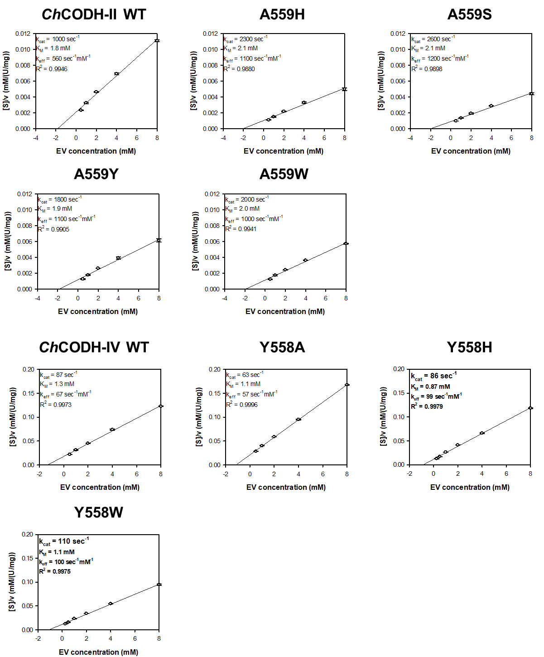
Supplementary Figure S7 | Hanes–Woolf plots of ChCODH-II and IV variants.

