Supplementary Information
Supplementary Text 1 – Sensitivity tests of future scenarios
Although our projections for 2021–2050 show an overall increase in annual burned area (Figs. 4c–d), there is a pronounced discontinuity between 2020 and 2021 (Fig. S16). This jump reflects a sudden drop in the number of grid cells experiencing extreme fires (Fig. S17), suggesting that the classification of extreme versus regular fire cells critically influences our results. Therefore, to ensure reliability and robustness of future prediction, we conducted sensitivity tests on the classification models, varying both the historical climate datasets used for training and the methods for harmonizing future land‐use change (Table S5).

1.1 Sensitivity test using historical climate data from ISIMIP3b
In the Main Text, we used the climate data from the observation-based CRUJRA data to train the model during the historical period, and we then predicted the future burned area using the future climate projections from five climate models (GFDL-ESM4, IPSL-CM6A-LR, MPI-ESM1-2-HR, MRI-ESM2-0, and UKESM1-0-LL) in ISIMIP3b. However, there are considerable differences in the climate variables during the historical period between CRUJRA and ISIMIP3b (Fig. S40, S41). There is also a jump in the climate variables when switching from CRUJRA in 2020 to ISIMIP3b in 2021 (Fig. S40). In this sensitivity test, therefore, we re-trained the machine-learning model using the historical climate data from ISIMIP3b to be consistent with the climate data used in the prediction of future burned area.
To isolate the effect of climate data inconsistencies on the sudden drop in extreme fire grid cells, we held the land-use map in 2021 the same as in 2020 and then predicted 2021 extremes using two different climate‐data setups (No. 1 and 5 in Table S6). Across three of the four burned‐area datasets (MODIS, GABAM, and MapBiomas), switching climate inputs alone produced only minor changes in the number of extreme grid cells (No. 1 vs. No. 5). This demonstrates that discrepancies in climate training data by themselves cannot explain the gap of extreme fire grid cells between 2020 and 2021.

1.2 Sensitivity test of different harmonization methods of future land use change
Because historical (MapBiomas) and future (LUHv2f, LuccMEBR) land use products differ substantially, we harmonized land use before forecasting burned area. To assess their impacts on the 2020-2021 gap, we tested another two alternative harmonization methods in addition to “spatial difference” in the Main Text. The first tested method (“business-as-usual change”) extrapolates the current linear trends of each land use type observed in MapBiomas forward through 2050. Specifically, we calculated the linear trends of each land use type from 2011 to 2020 in each grid cell based on the MapBiomas data, and then assumed these trends to be constant from 2021 to 2050 to derive the future land use maps. In the second tested method (“regional net change”), we first calculated the regional net area gain and loss of each land use type between the adjacent two years in each 0.5°×0.5° grid cell during 2021-2050. We then allocated the regional net gain and loss to each grid cell proportionally based on the positive and negative trends of each land use type across grid cells from 2011 to 2020. We limited these sensitivity tests to LuccMEBR (excluding LUHv2f), since the annual net gain and loss area for each land use type in 0.5°×0.5° grid cells are minor in LUHv2f compared with those in LuccMEBR (Fig. S43).
The comparison of future harmonized land use datasets and MapBiomas is shown in Fig. S38 and S39. Temporally, the most intense area changes locate in forest and pasture for all future harmonization (Fig. S38a, S38c). Spatially, the difference patterns among varied harmonization methods are similar (Fig. S39). The major different land use types between MapBiomas and future harmonization are forest (Fig. S39a-S39e) and pasture (Fig. S39k-S39o), which are essential variables for distinguishing extreme grid cells and predicting extreme burned area (Fig. 2a, 2c).
While using consistent climate data for model training and prediction (No. 6-8 in Table S6), the number of extreme grid cells (averaged across results from the five climate models in ISIMIP3b) varied in a large range among different land use harmonization methods (22.6-52.4 grid cells for “spatial difference”, 47.8-64.0 for “business‐as‐usual”, 52.6-62.0 for “regional net change”). Even under inconsistent climate data for model training and prediction (No. 2-4 in Table S6), considerable difference exists in the number of extreme grid cells among different land use harmonization methods (5-17 for “spatial difference”, 19-54 for “business‐as‐usual”, 22-62 for “regional net change”). Harmonization with most increase in pasture and most decrease in forest in the future (“business-as-usual change”, grey lines in Fig. S38) exhibits higher extreme burned area (grey solid lines in the third column of Fig. S44), comparing to other harmonization with reduced pasture expansion and slowing deforestation (“spatial difference” and “regional net change”, orange and red lines in Fig. S38). Thus, the choice of land-use harmonization exerts a dominant influence on the 2020–2021 gap, irrespective of climate data consistency.

Supplementary Text 2 – Effects on Extreme Burned Area in Sensitivity Tests
Across all tests using two climate datasets and three harmonized land use datasets, the climatic effect on future extreme burned area remains consistently negative (Fig. S45a, S45d). The two climate datasets, CRUJRA (lighter bars in Fig. S45) and ISIMIP3b (darker bars in Fig. S45), both produce similar negative effects, suggesting that dataset consistency is not the primary driver of this pattern. In contrast, among different land use harmonization methods, the anthropogenic (standard deviation across harmonization methods = 0.14~0.28, Fig. S45b, S45e) and climatic-anthropogenic interaction (standard deviation = 0.14~0.72, Fig. S45c, S45f) effects on extreme burned area vary more intensely than climatic effects (standard deviation = 0.05~0.06, Fig S45a, S45d), with “business-as-usual change” (bars filled with dots in Fig. S45) differing greatly from “spatial difference” (bars without filling in Fig. S45) and “regional net change” (bars filled with slashes in Fig. S45) harmonization methods. The intense difference of land use harmonization methods mainly locates in the area of pasture and forest (Fig. S38). These discrepancies can influence the climatic effect via interactions between climate and anthropogenic variables in the machine learning models. Thus, the negative climatic effect on extreme burned area likely stems from inconsistencies between historical and future land use datasets. However, the availability of reliable future land use datasets for the Brazilian Amazon remains limited, and those available may not align well with satellite-based observations.

Table S1 Selected variables in the feature selection of random forest classification by recursive feature elimination cross validation using the four burned area datasets, respectively. Variables in Rank 1 (shaded) indicates that variables are relatively more important, and removing lower ranking variables does not affect results but can improve the running speed.

FireCCI |  |  | GABAM |  |  | MapBiomas |  |  | MODIS
Rank | variables |  | Rank | variable |  | Rank | variable |  | Rank | variable
1 | Daily Maximum Temperature |  | 1 | Daily Maximum Temperature |  | 1 | Daily Maximum Temperature |  | 1 | Daily Maximum Temperature
1 | Daily Minimum Temperature |  | 1 | Daily Minimum Temperature |  | 1 | Daily Minimum Temperature |  | 1 | Daily Minimum Temperature
1 | Precipitation |  | 1 | Precipitation |  | 1 | Precipitation |  | 1 | Precipitation
1 | Wind Speed |  | 1 | Wind Speed |  | 1 | Wind Speed |  | 1 | Wind Speed
1 | Vapor Pressure Deficit |  | 1 | Vapor Pressure Deficit |  | 1 | Vapor Pressure Deficit |  | 1 | Vapor Pressure Deficit
1 | Cumulative Water Deficit |  | 1 | Cumulative Water Deficit |  | 1 | Cumulative Water Deficit |  | 1 | Cumulative Water Deficit
1 | Fire Weather Index |  | 1 | Fire Weather Index |  | 1 | Fire Weather Index |  | 1 | Fire Weather Index
1 | Forest Fraction |  | 1 | Forest Fraction |  | 1 | Forest Fraction |  | 1 | Forest Fraction
1 | Natural Non-Forest Vegetation Fraction |  | 1 | Natural Non-Forest Vegetation Fraction |  | 1 | Natural Non-Forest Vegetation Fraction |  | 1 | Natural Non-Forest Vegetation Fraction
1 | Pasture Fraction |  | 1 | Pasture Fraction |  | 1 | Pasture Fraction |  | 1 | Pasture Fraction
1 | Crop Fraction |  | 1 | Crop Fraction |  | 1 | Crop Fraction |  | 1 | Crop Fraction
1 | ΔForest Fraction |  | 1 | ΔForest Fraction |  | 1 | ΔForest Fraction |  | 1 | ΔForest Fraction
1 | ΔPasture Fraction |  | 1 | ΔNatural Non-Forest Vegetation Fraction |  | 1 | ΔNatural Non-Forest Vegetation Fraction |  | 1 | ΔPasture Fraction
2 | ΔNatural Non-Forest Vegetation Fraction |  | 1 | ΔPasture Fraction |  | 1 | ΔPasture Fraction |  | 1 | ΔCrop Fraction
3 | ΔCrop Fraction |  | 1 | ΔCrop Fraction |  | 2 | ΔCrop Fraction |  | 2 | ΔNatural Non-Forest Vegetation Fraction

Table S2 Selected variables in the feature selection of random forest quantile regression for non-extreme fires by recursive feature elimination cross validation using the four burned area datasets, respectively. Variables in Rank 1 (shaded) indicates that variables are relatively more important, and removing lower ranking variables does not affect results but can improve the running speed.

FireCCI |  |  | GABAM |  |  | MapBiomas |  |  | MODIS
Rank | variable |  | Rank | variable |  | Rank | variable |  | Rank | variable
1 | Daily Maximum Temperature |  | 1 | Daily Maximum Temperature |  | 1 | Daily Maximum Temperature |  | 1 | Daily Maximum Temperature
1 | Daily Minimum Temperature |  | 1 | Daily Minimum Temperature |  | 1 | Daily Minimum Temperature |  | 1 | Daily Minimum Temperature
1 | Precipitation |  | 1 | Precipitation |  | 1 | Precipitation |  | 1 | Precipitation
1 | Wind Speed |  | 1 | Wind Speed |  | 1 | Wind Speed |  | 1 | Vapor Pressure Deficit
1 | Vapor Pressure Deficit |  | 1 | Vapor Pressure Deficit |  | 1 | Vapor Pressure Deficit |  | 1 | Cumulative Water Deficit
1 | Cumulative Water Deficit |  | 1 | Cumulative Water Deficit |  | 1 | Cumulative Water Deficit |  | 1 | Fire Weather Index
1 | Fire Weather Index |  | 1 | Fire Weather Index |  | 1 | Fire Weather Index |  | 1 | Forest Fraction
1 | Forest Fraction |  | 1 | Forest Fraction |  | 1 | Forest Fraction |  | 1 | Natural Non-Forest Vegetation Fraction
1 | Natural Non-Forest Vegetation Fraction |  | 1 | Natural Non-Forest Vegetation Fraction |  | 1 | Natural Non-Forest Vegetation Fraction |  | 1 | Pasture Fraction
1 | Pasture Fraction |  | 1 | Pasture Fraction |  | 1 | Pasture Fraction |  | 1 | Crop Fraction
1 | Crop Fraction |  | 1 | Crop Fraction |  | 1 | Crop Fraction |  | 1 | ΔForest Fraction
1 | ΔForest Fraction |  | 1 | ΔForest Fraction |  | 1 | ΔForest Fraction |  | 1 | ΔPasture Fraction
1 | ΔNatural Non-Forest Vegetation Fraction |  | 1 | ΔNatural Non-Forest Vegetation Fraction |  | 1 | ΔPasture Fraction |  | 1 | ΔCrop Fraction
1 | ΔPasture Fraction |  | 1 | ΔPasture Fraction |  | 2 | ΔNatural Non-Forest Vegetation Fraction |  | 2 | Wind Speed
1 | ΔCrop Fraction |  | 2 | ΔCrop Fraction |  | 3 | ΔCrop Fraction |  | 3 | ΔNatural Non-Forest Vegetation Fraction

Table S3 Same as Table S2, but for extreme fires.

FireCCI |  |  | GABAM |  |  | MapBiomas |  |  | MODIS
rank | variable |  | rank | variable |  | rank | variable |  | rank | variable
1 | Daily Maximum Temperature |  | 1 | Daily Maximum Temperature |  | 1 | Daily Maximum Temperature |  | 1 | Daily Maximum Temperature
1 | Daily Minimum Temperature |  | 1 | Daily Minimum Temperature |  | 1 | Daily Minimum Temperature |  | 1 | Daily Minimum Temperature
1 | Precipitation |  | 1 | Precipitation |  | 1 | Precipitation |  | 1 | Precipitation
1 | Wind Speed |  | 1 | Wind Speed |  | 1 | Wind Speed |  | 1 | Wind Speed
1 | Vapor Pressure Deficit |  | 1 | Vapor Pressure Deficit |  | 1 | Vapor Pressure Deficit |  | 1 | Vapor Pressure Deficit
1 | Cumulative Water Deficit |  | 1 | Cumulative Water Deficit |  | 1 | Cumulative Water Deficit |  | 1 | Cumulative Water Deficit
1 | Fire Weather Index |  | 1 | Fire Weather Index |  | 1 | Fire Weather Index |  | 1 | Fire Weather Index
1 | Forest Fraction |  | 1 | Forest Fraction |  | 1 | Forest Fraction |  | 1 | Forest Fraction
1 | Natural Non-Forest Vegetation Fraction |  | 1 | Natural Non-Forest Vegetation Fraction |  | 1 | Natural Non-Forest Vegetation Fraction |  | 1 | Natural Non-Forest Vegetation Fraction
1 | Pasture Fraction |  | 1 | Pasture Fraction |  | 1 | Pasture Fraction |  | 1 | Pasture Fraction
1 | Crop Fraction |  | 1 | Crop Fraction |  | 1 | Crop Fraction |  | 1 | Crop Fraction
1 | ΔForest Fraction |  | 1 | ΔForest Fraction |  | 1 | ΔForest Fraction |  | 1 | ΔForest Fraction
1 | ΔNatural Non-Forest Vegetation Fraction |  | 1 | ΔNatural Non-Forest Vegetation Fraction |  | 1 | ΔNatural Non-Forest Vegetation Fraction |  | 1 | ΔNatural Non-Forest Vegetation Fraction
1 | ΔPasture Fraction |  | 1 | ΔPasture Fraction |  | 1 | ΔPasture Fraction |  | 1 | ΔPasture Fraction
1 | ΔCrop Fraction |  | 1 | ΔCrop Fraction |  | 2 | ΔCrop Fraction |  | 1 | ΔCrop Fraction

Table S4 Burned area trends during 2021~2050 for all fires, non-extreme and extreme fires with contributions from climate and anthropogenic activities under the SSP1 & RCP2.6 and SSP5 & RCP8.5 scenarios. Values indicate the linear slopes of the time series of burned area. Significant trends with p<0.05 are marked with asterisks, and orange and blue shaded colors represent positive and negative trends. Time series data are shown in Fig. 4 and Fig. S19.
 | SSP1 & RCP2.6 |  |  |  |  | SSP5 & RCP8.5
(million·  ha·yr⁻²) | Total | Climatic | Anthropogenic | Climatic-anthropogenic interaction |  | Total | Climatic | Anthropogenic | Climatic-anthropogenic interaction
All fires | 0.018* | 0.020* | -0.005* | 0.003* |  | 0.072* | 0.031* | 0.017* | 0.024*
Non-extreme fires | 0.011* | 0.012* | -0.004* | 0.002* |  | 0.018* | 0.021* | 0.005* | -0.007*
Extreme fires | 0.008* | 0.008* | -0.002 | 0.001 |  | 0.054* | 0.010* | 0.013* | 0.031*

Table S5 Set-up of sensitivity tests for future scenarios using different climate data and land use harmonization methods.
 | Model Training (1985-2020) |  | Model Prediction (2021-2050)
Experiment No. | Climate | Land Use | Climate | Land Use
1 | CRUJRA | MapBiomas | ISIMIP3b | spatial difference from LuccMEBR
2 | CRUJRA | MapBiomas | ISIMIP3b | business-as-usual change
3 | CRUJRA | MapBiomas | ISIMIP3b | regional net change from LuccMEBR
4 | ISIMIP3b | MapBiomas | ISIMIP3b | spatial difference from LuccMEBR
5 | ISIMIP3b | MapBiomas | ISIMIP3b | business-as-usual change
6 | ISIMIP3b | MapBiomas | ISIMIP3b | regional net change from LuccMEBR

Table S6 Number of 0.5°×0.5° grid cells with predicted extreme fires in 2021 in the sensitivity tests for future scenarios. Note that results for No. 2-4 and 6-8 are directly extracted from Fig. S44, whereas No. 1 and 5 represent prediction in 2021 using the 2020 MapBiomas land use to isolate the impact of land use changes. FireCCI, MODIS, GABAM, and MapBiomas in the column names denote that machine learning models trained with different burned area datasets. The three different land use change harmonization methods are elaborated in Supplementary Text 1.2. All results are the averages over the five climate models in ISIMIP3b.
No. | Model Training | Land Use | Climate |  | FireCCI |  | MODIS |  | GABAM |  | MapBiomas
1 | CRUJRA | MapBiomas 2020 | SSP126 2021 |  | 26 |  | 66 |  | 70 |  | 70
1 | CRUJRA | MapBiomas 2020 | SSP585 2021 |  | 30 |  | 81 |  | 72 |  | 79
2 | CRUJRA | spatial difference 2021 | SSP126 2021 |  | 5 |  | 6 |  | 10 |  | 17
2 | CRUJRA | spatial difference 2021 | SSP585 2021 |  | 7 |  | 9 |  | 10 |  | 16
3 | CRUJRA | business-as-usual 2021 | SSP126 2021 |  | 19 |  | 45 |  | 40 |  | 51
3 | CRUJRA | business-as-usual 2021 | SSP585 2021 |  | 22 |  | 48 |  | 41 |  | 54
4 | CRUJRA | regional net change 2021 | SSP126 2021 |  | 22 |  | 53 |  | 54 |  | 59
4 | CRUJRA | regional net change 2021 | SSP585 2021 |  | 26 |  | 61 |  | 59 |  | 62
5 | ISIMIP3b | MapBiomas 2020 | SSP126 2021 |  | 87.2 |  | 78.4 |  | 76.4 |  | 77
5 | ISIMIP3b | MapBiomas 2020 | SSP585 2021 |  | 88 |  | 81.6 |  | 78 |  | 81.2
6 | ISIMIP3b | spatial difference 2021 | SSP126 2021 |  | 28.8 |  | 36.2 |  | 23.8 |  | 22.6
6 | ISIMIP3b | spatial difference 2021 | SSP585 2021 |  | 32.6 |  | 52.4 |  | 32.6 |  | 33
7 | ISIMIP3b | business-as-usual 2021 | SSP126 2021 |  | 54.8 |  | 63 |  | 47.8 |  | 49.8
7 | ISIMIP3b | business-as-usual 2021 | SSP585 2021 |  | 56.4 |  | 64 |  | 50.8 |  | 61
8 | ISIMIP3b | regional net change 2021 | SSP126 2021 |  | 53 |  | 60.6 |  | 52.8 |  | 56.2
8 | ISIMIP3b | regional net change 2021 | SSP585 2021 | 54.4 |  | 62 |  | 52.6 |  | 61.4

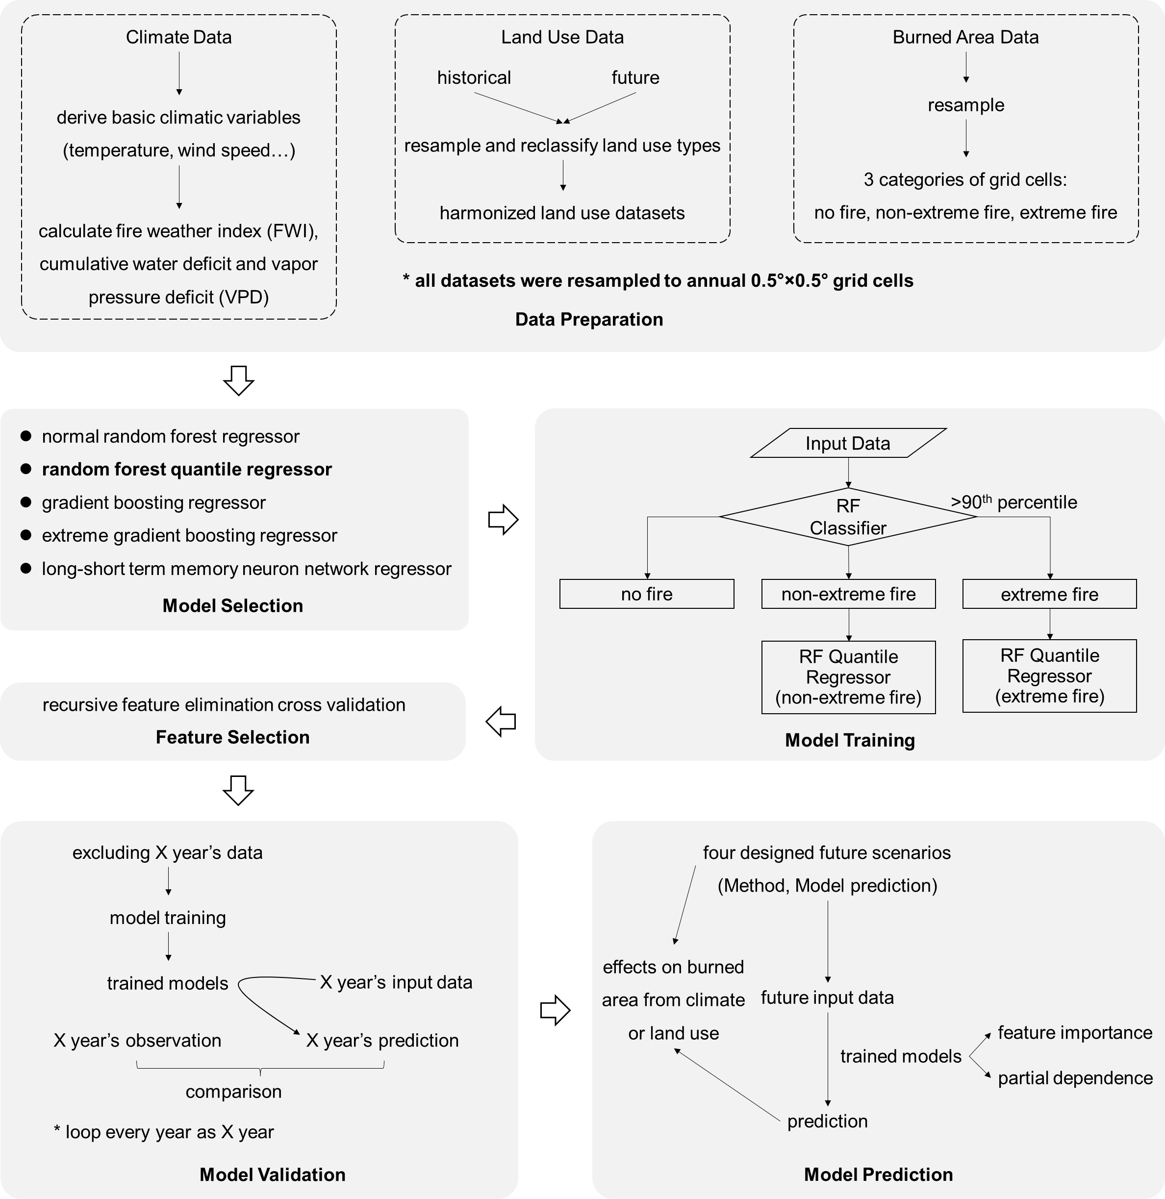
Fig. S1 Workflow of random forest modeling in this study.

a  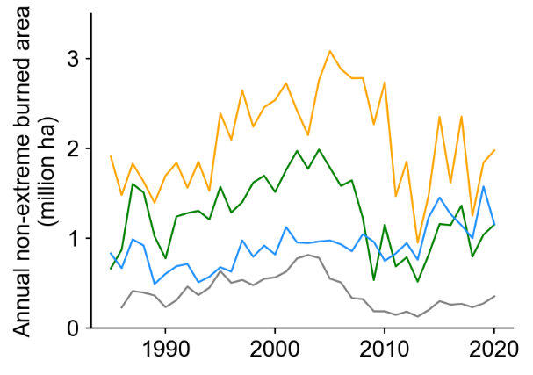 | b  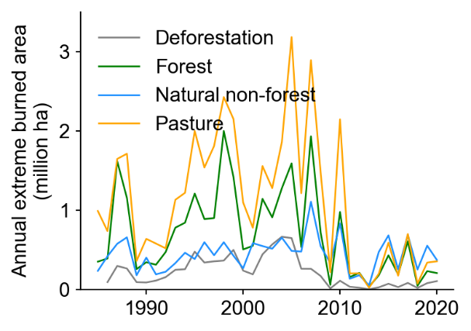
c  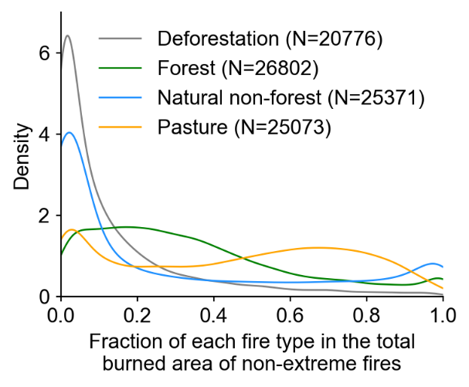 | d  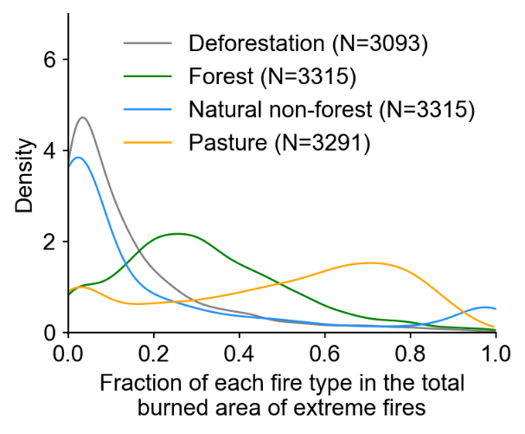
Fig. S2 Annual burned area of non-extreme (a) and extreme fires (b) for different fire types, and distribution of fraction of each fire type in the total burned area of non-extreme (c) and extreme (d) fires. N denotes the number of 0.5°×0.5° grid cells with a given fire type. Fire types were identified by overlapping burned area and land use at 30 m resolution in the MapBiomas Land Use Collection and Fire Collection during 1985-2020. Note that deforestation represents forest loss with fire occurrence in adjacent two years.

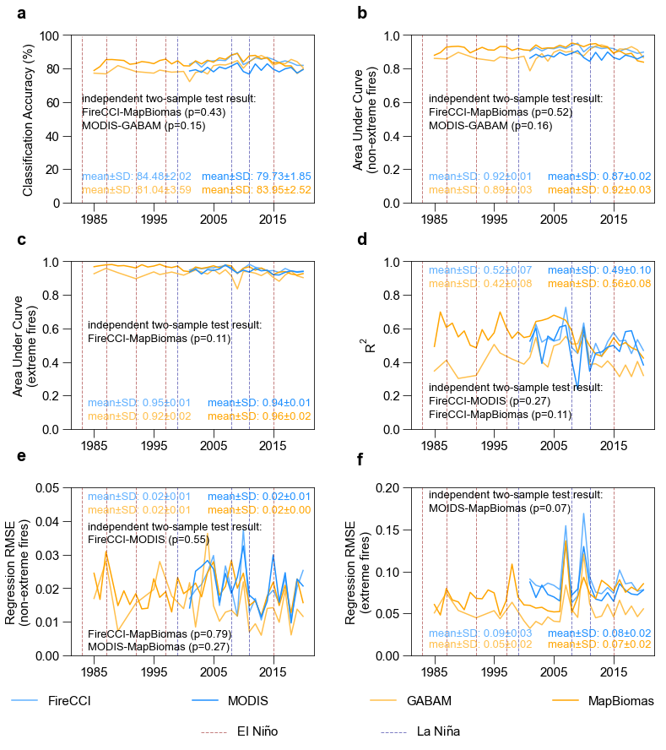
Fig. S3 Model evaluation using burned area data from an independent year (data from the other years for model training) for different burned area datasets. Classification accuracy indicates the proportion of correctly classified samples among all samples (a). Area under curve (AUC, ranging between 0~1) is the area under the Receiver Operator Characteristic (ROC) curve, and a higher AUC indicates the better performance of classification models (c, d). The coefficient of determination (R²) between the observations and the predictions from the random forest quantile regressions (b). Root-mean-square-error (RMSE) indicates the dispersion degree between the observation and random forest quantile regressions’ prediction (c, d).

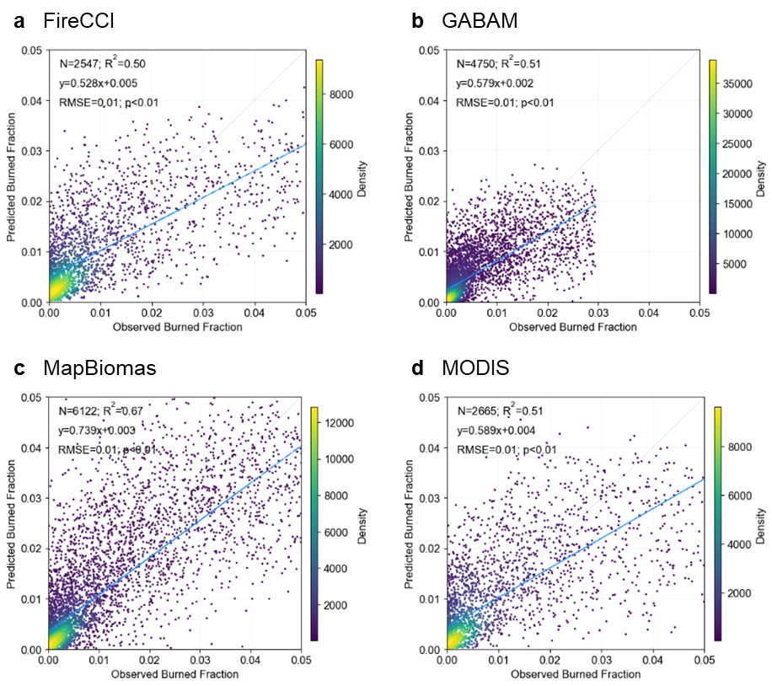
Fig. S4 Comparison of annual burned area fractions in each 0.5°×0.5° grid cell between observation and prediction for non-extreme fires during the observation years using 80% data for training and the remaining 20% for testing. a-d, the four burned area datasets (a. FireCCI; b. GABAM; c. MapBiomas; d. MODIS). Blue lines denote the linear regression lines, and grey lines are the 1:1 ratio lines.

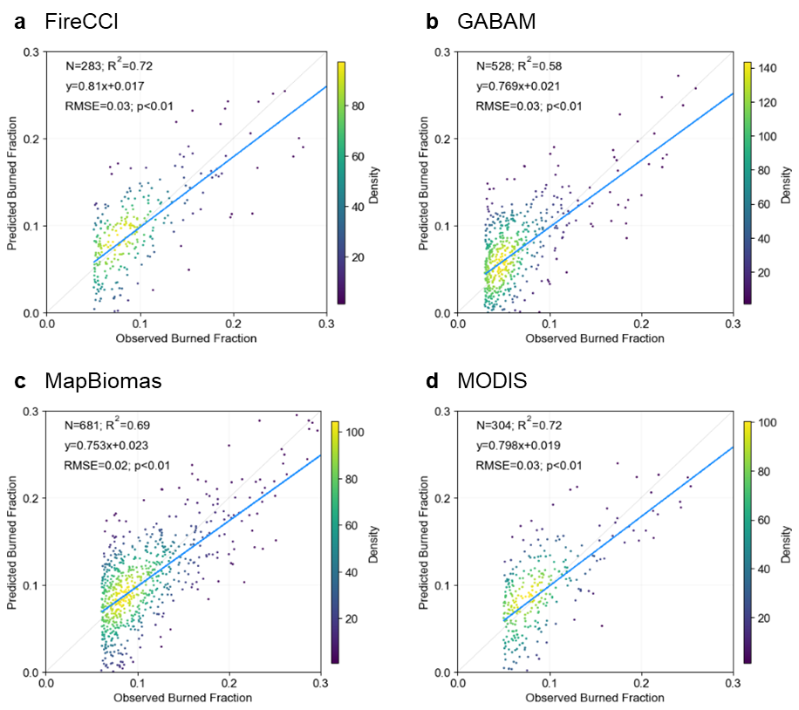
Fig. S5 Same as Fig. S4, but for extreme fires.

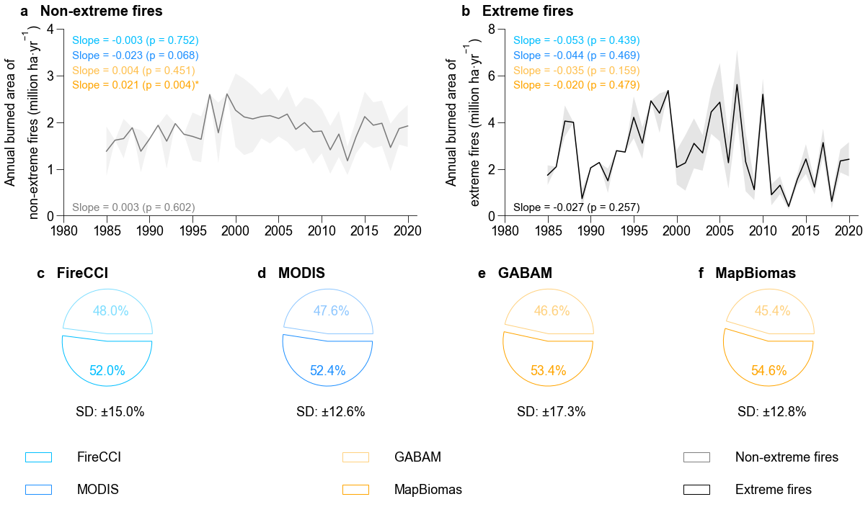
Fig. S6 Time series and proportions of non-extreme and extreme fires based on the four burned area observation datasets (FireCCI, MODIS, GABAM and MapBiomas). Lines and shaded area represent the average and standard deviation across the four burned area datasets for non-extreme (a) and extreme fires (b). Pie plots indicate mean annual burned area proportions of non-extreme (light color) and extreme (dark color) fires for the four burned area datasets, respectively (c, d, e, f). The standard deviation in the pie plots is the same for non-extreme and extreme fires since the sum of the proportions equals 1. Slopes and p-values of linear trends over the whole observation period of burned area for non-extreme and extreme fires are annotated. Note that there are some missing years (1986, 1988, 1990, 1991, 1993, 1994, 1997 and 1999) in the GABAM dataset.

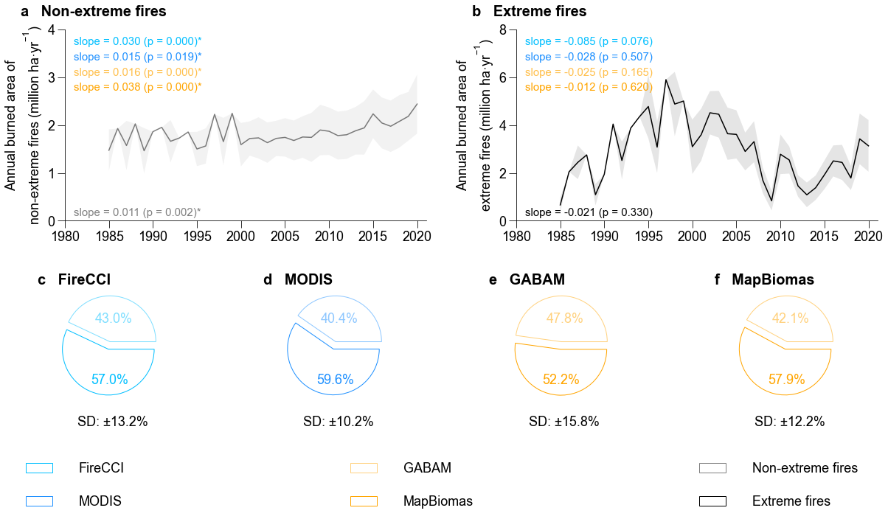
Fig. S7 Same as Fig. S6 but for historical predictions.

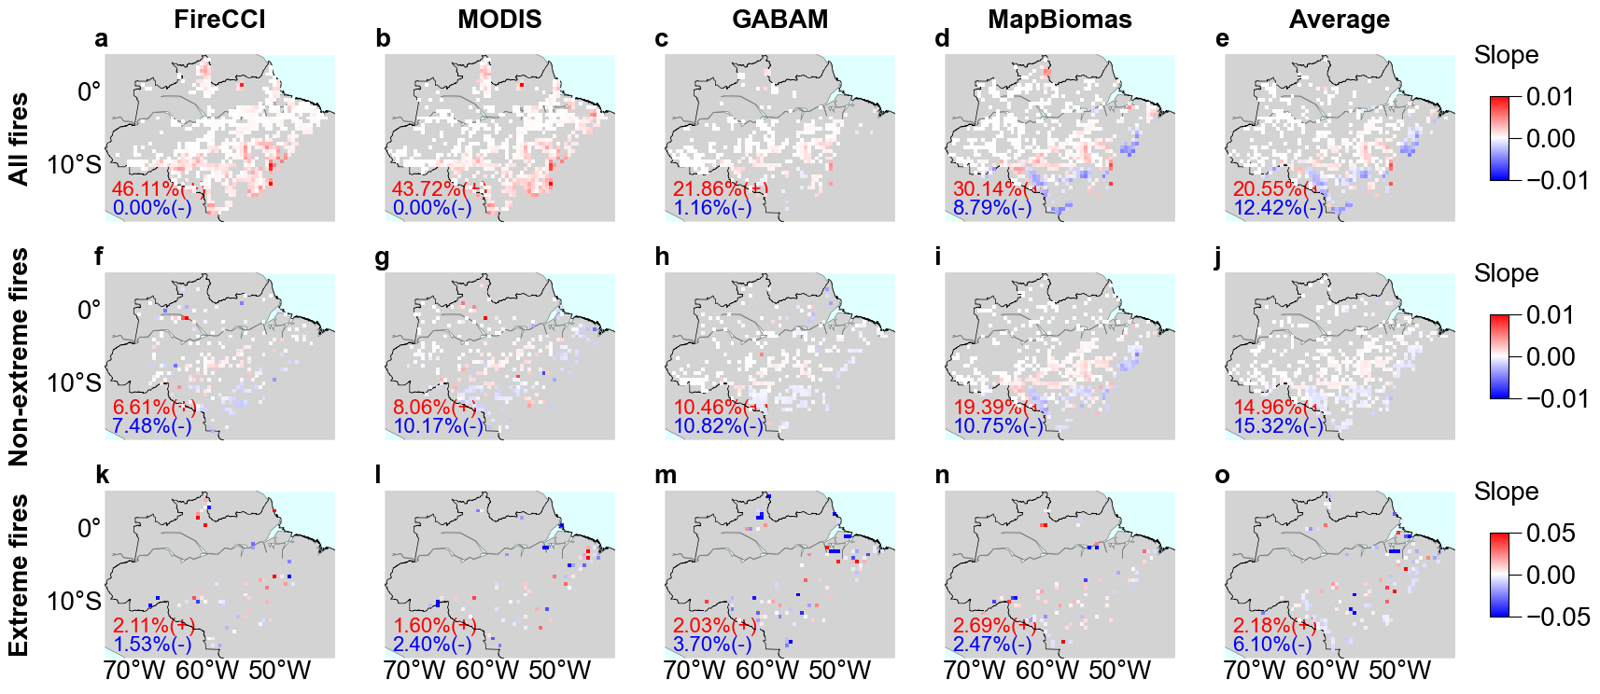
Fig. S8 Trends of annual burned area (p<0.05) during the observation years for all fires, non-extreme and extreme fires from the four burned area datasets (FireCCI, MODIS, GABAM and MapBiomas) and their average. Fraction of grid cells with positive (red) or negative (blue) trends in the total number of grid cells is annotated.

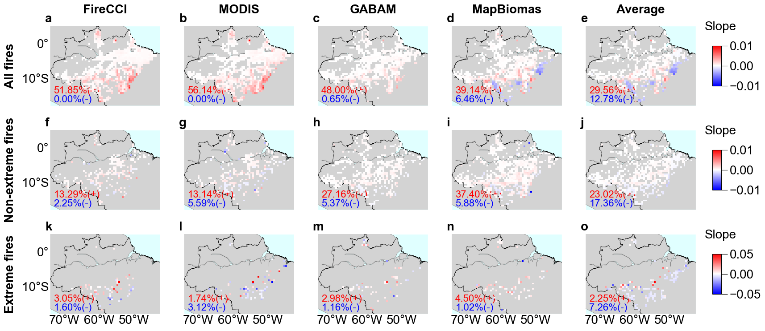
Fig. S9 Same as Fig. S8 but for model predicted burned areas during the observation years.

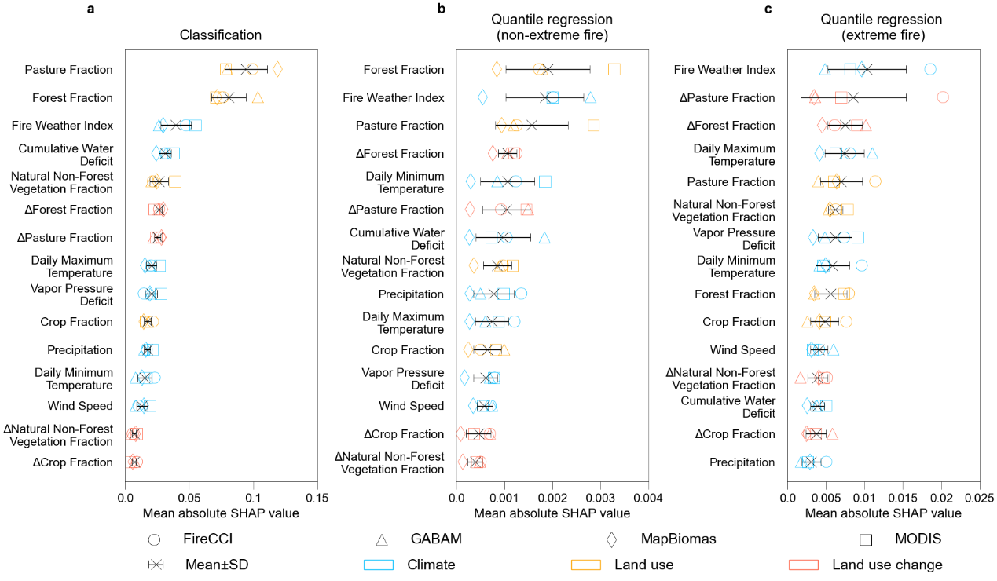
Fig. S10 Mean absolute SHAP value of separating grid cells with non-extreme and extreme fires (random forest classification, a) and of predicting burned area for non-extreme (random forest quantile regression, b) and extreme fires (c). Colors represent explanatory variables related to climate (blue), land use (orange), and land use change (red), respectively. Symbols indicate results for different burned area datasets (FireCCI, MODIS, GABAM and MapBiomas), and crosses and error bars indicate the mean and standard deviation across the four datasets.

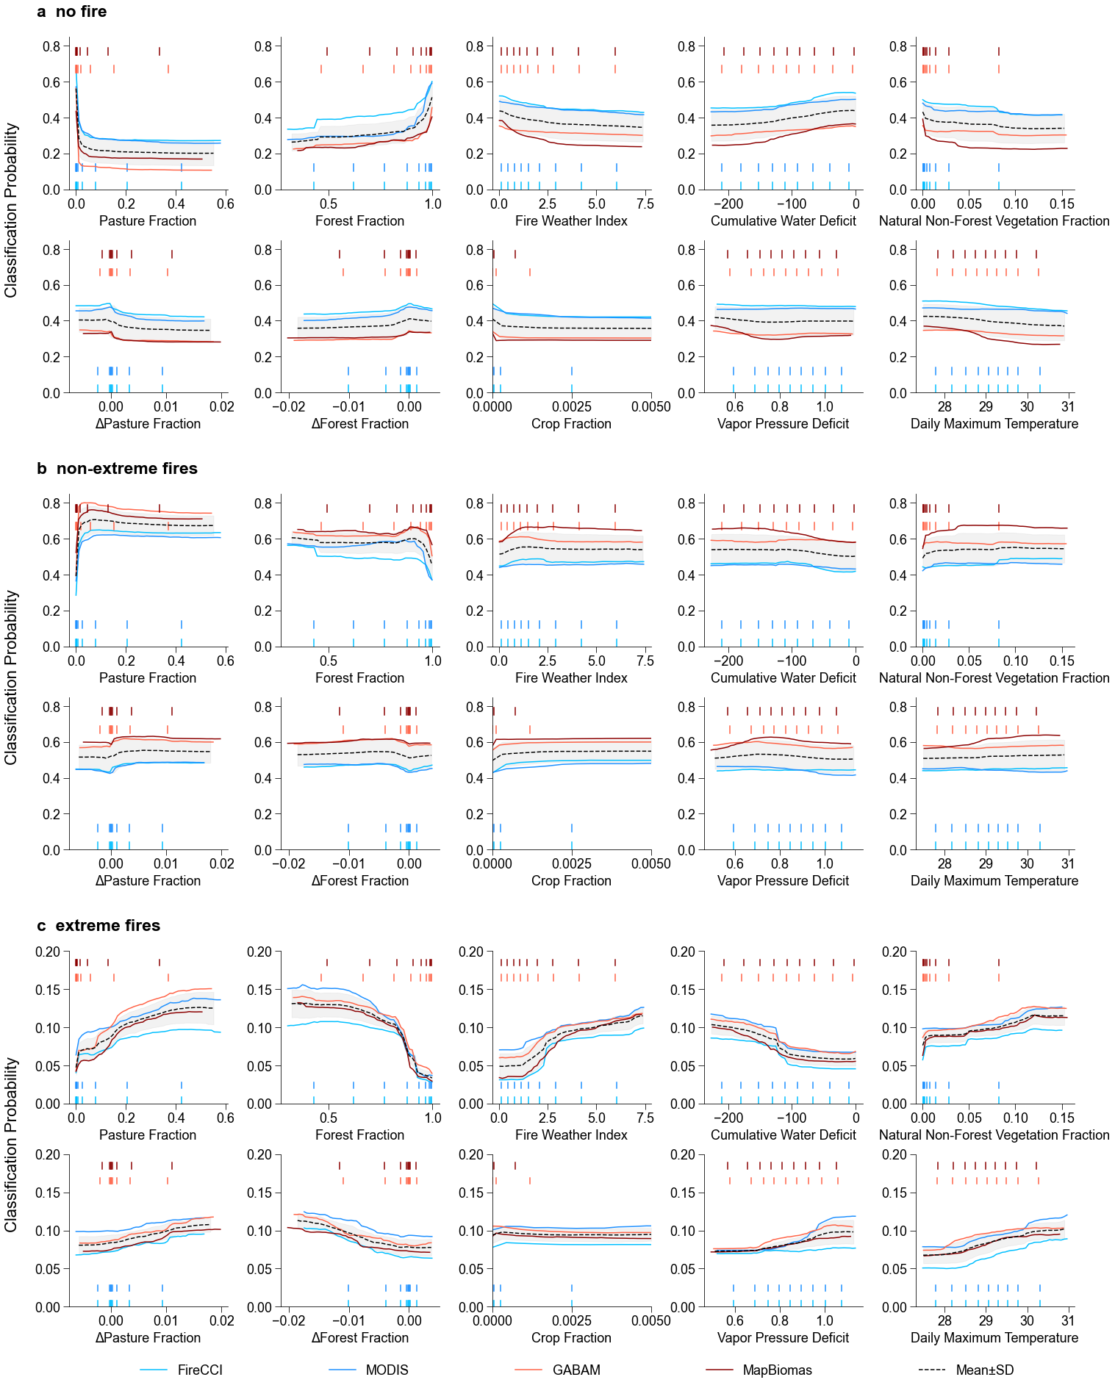
Fig. S11 Partial dependence for the 10 most important variables in the random forest classification of separating grid cells with non-extreme and extreme fires. There are three types of grid cells: no fire (a), non-extreme fires (b) and extreme fires (c). Different colors indicate results for different burned area datasets, and the dashed line and shaded area represent the average and standard deviation across the four burned area datasets. Rugs show the deciles of the corresponding input variables.

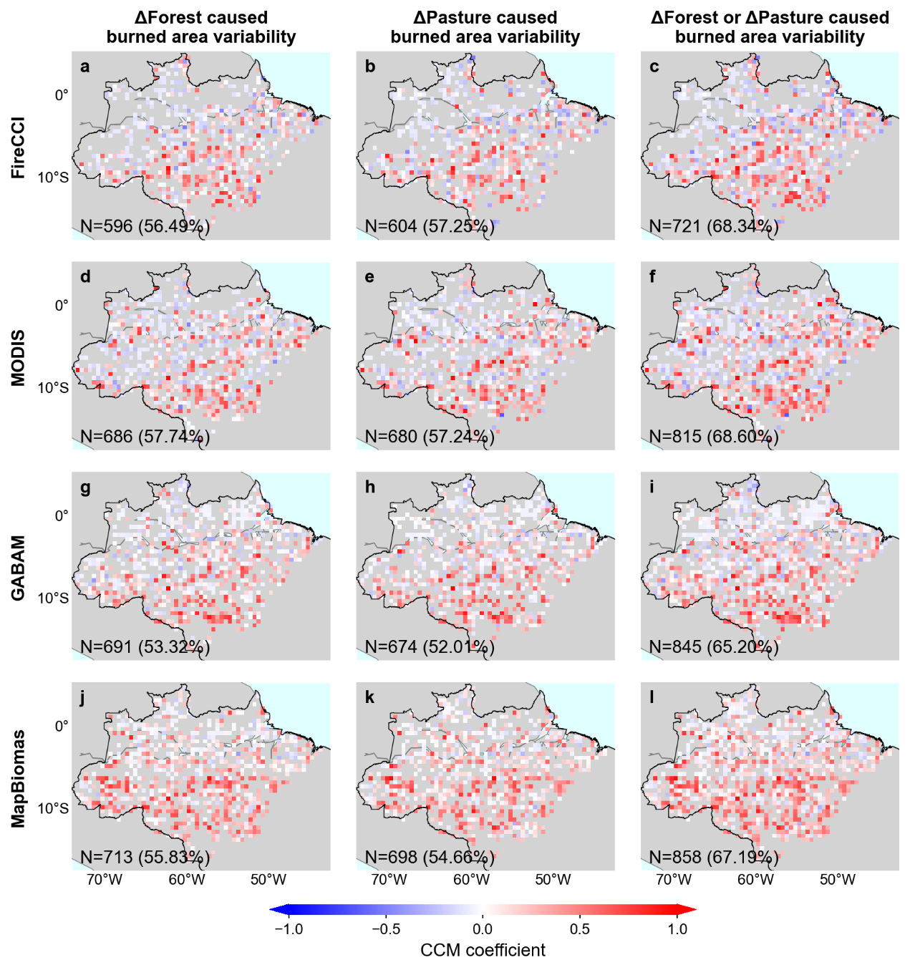
Fig. S12 Convergent Cross Mapping (CCM) coefficient maps calculated from the four burned area datasets (FireCCI, MODIS, GABAM, and MapBiomas) within the observation period for each 0.5°×0.5° grid cell. Larger absolute CCM coefficients indicate stronger causal effects. Land use change is considered a driver of burned area interannual variability when the absolute CCM coefficients of land use change on burned area variability exceed those of the reverse direction. The first and second columns of subplots show the causal effects of ΔForest and ΔPasture, respectively, on burned area interannual variability. For each grid cell, the larger absolute CCM coefficient between these two is selected and displayed in the third column. The number of displayed grid cells and their proportion relative to all ever-burned grid cells during the observation period are indicated in the lower left corner of each subplot.

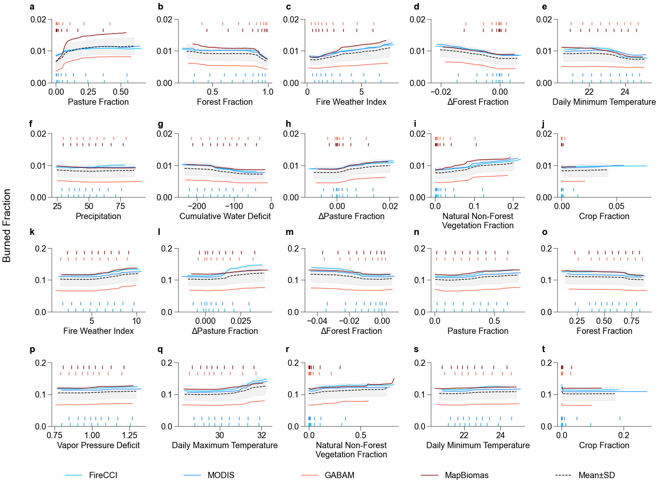
Fig. S13 Same as Fig. S11, but for the random forest quantile regressions for non-extreme fires (a~j) and extreme fires (k~t).

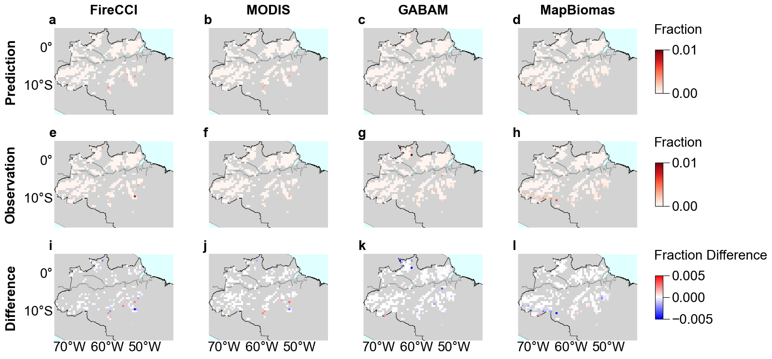
Fig. S14 Maps of burned area fraction in each 0.5°×0.5° grid cell with a forest fraction > 99% from observations, model predictions and their differences (prediction – observation) during 1985~2020.

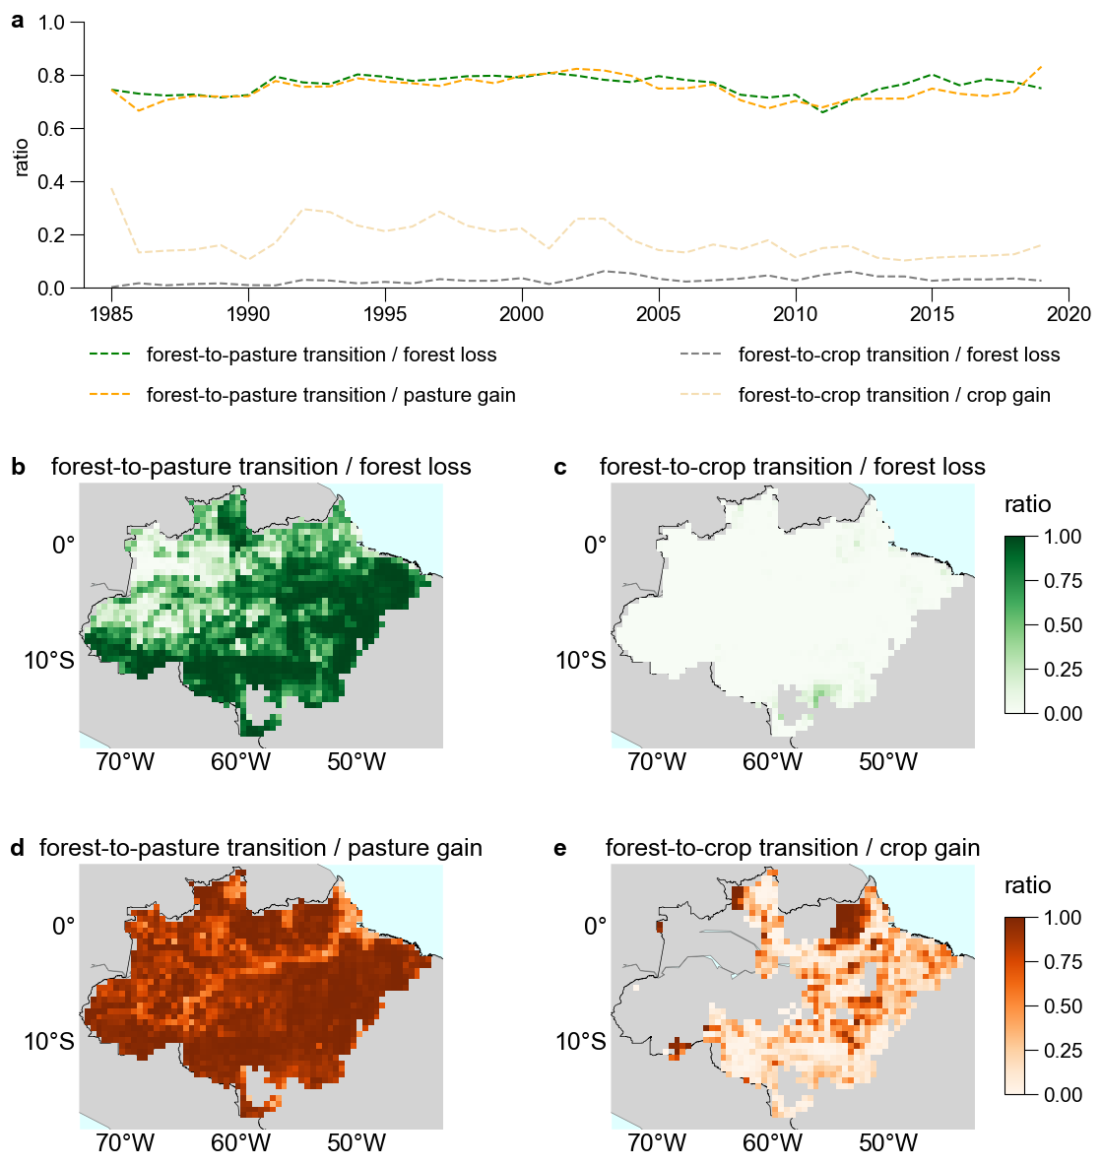
Fig. S15 Proportion of forest-to-pasture transition respectively in the total forest loss and pasture gain, and that of forest-to-crop transition in the total forest loss and crop gain between adjacent two years using MapBiomas Collection 6 Land Cover Map (1985~2020). a. Time series; b,c,d,e spatial pattern (averaged over 1985~2020).

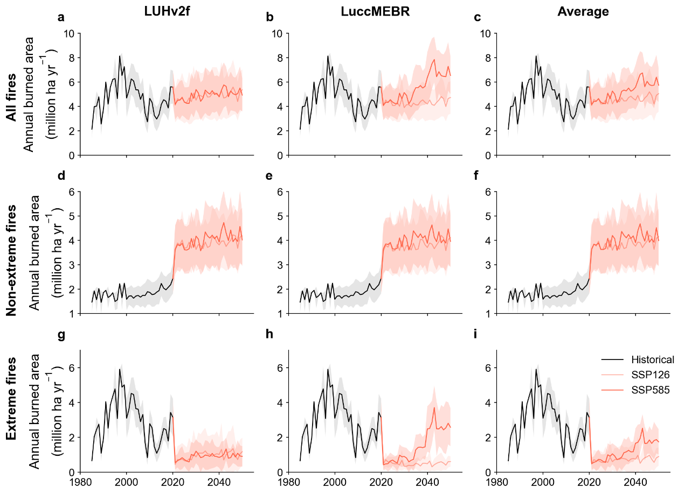
Fig. S16 Time series of predicted annual total burned area for all fires, non-extreme fires and extreme fires using LUHv2f (a,d,g) and LuccMEBR (b,e,h) land use projections, respectively and their average (c,f,i).

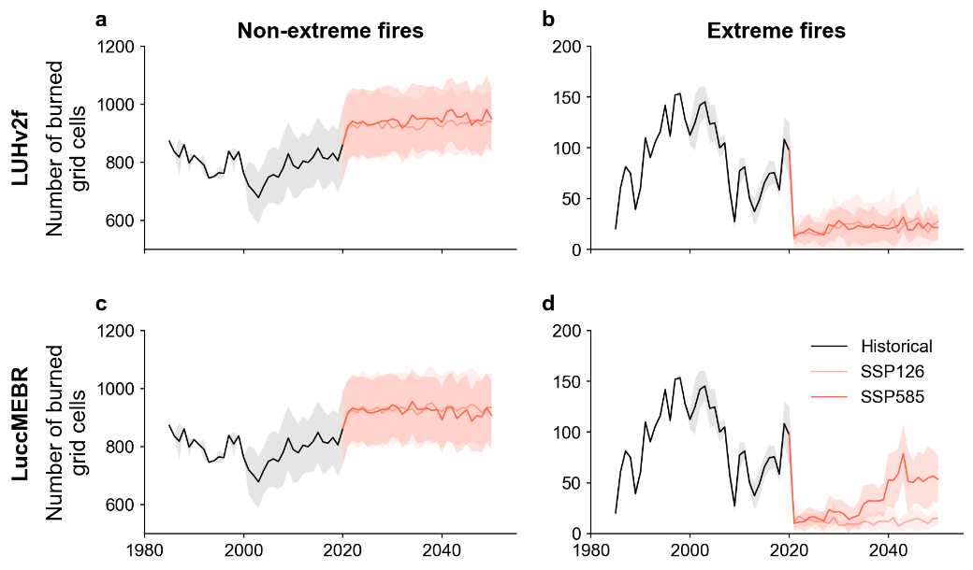
Fig. S17 Time series of the number of burned grid cells with non-extreme (a, c) and extreme fires (b, d) from the classification results averaged over the four burned area datasets (FireCCI, MODIS, GABAM and MapBiomas) using LUHv2f (a, b) and LuccMEBR (c, d) land use projections respectively.

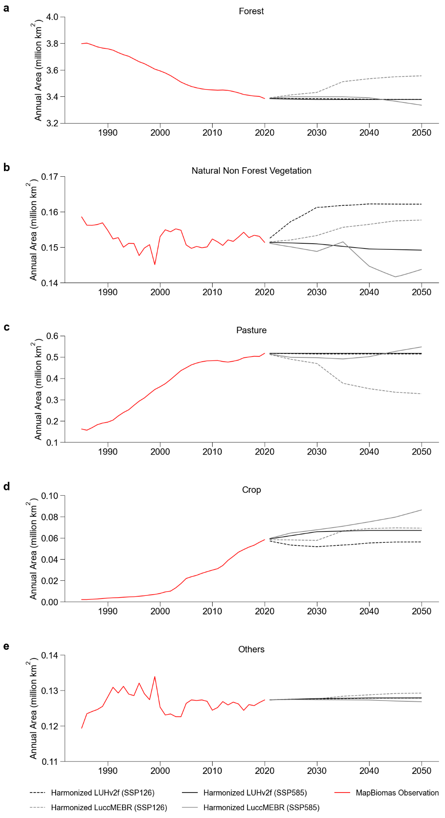
Fig. S18 Time series of future annual total area of different land use types in the harmonized land use dataset and the original land use dataset (a. forest, b. natural non-forest vegetation, c. pasture, d. crop, e. others). Note that “Others” consists of unburnable land use types (e.g., baresoil, urban and water). Here, the harmonization method of future land use change is the “spatial difference” method.
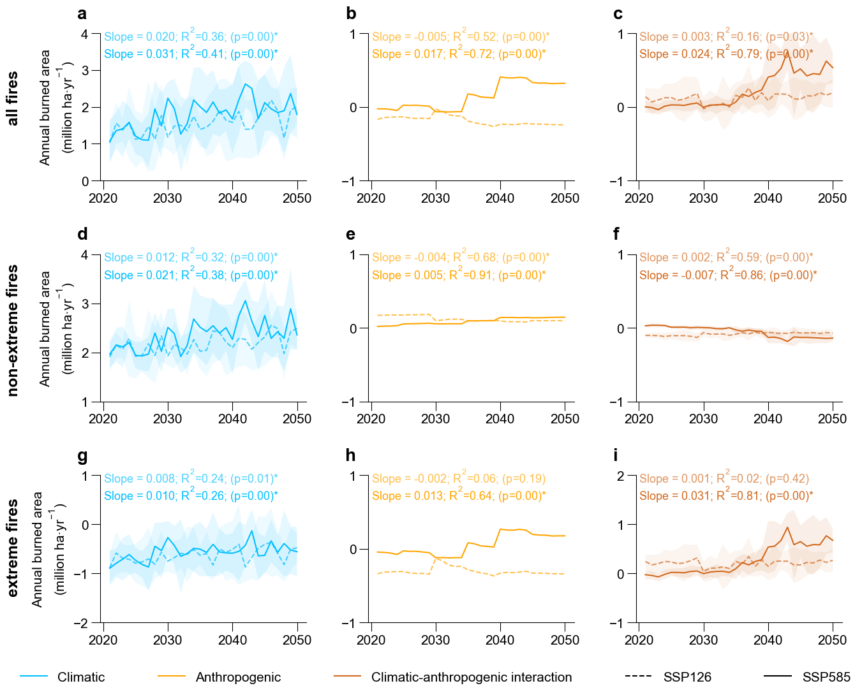
Fig. S19 Time series of contributions of climate, land use and their interactions to the total annual burned area during 2021-2050 under the SSP1 & RCP2.6 and SSP5 & RCP8.5 scenarios respectively. Line and shaded area represent the average and standard deviation propagated across the four burned area datasets (FireCCI, MODIS, GABAM and MapBiomas), the five climate models (GFDL-ESM4, IPSL-CM6A-LR, MPI-ESM1-2-HR, MRI-ESM2-0, and UKESM1-0-LL) in ISIMIP3b and the two land use datasets (LUHv2f and LuccMEBR). Trends with p-value less than 0.05 are marked with *.

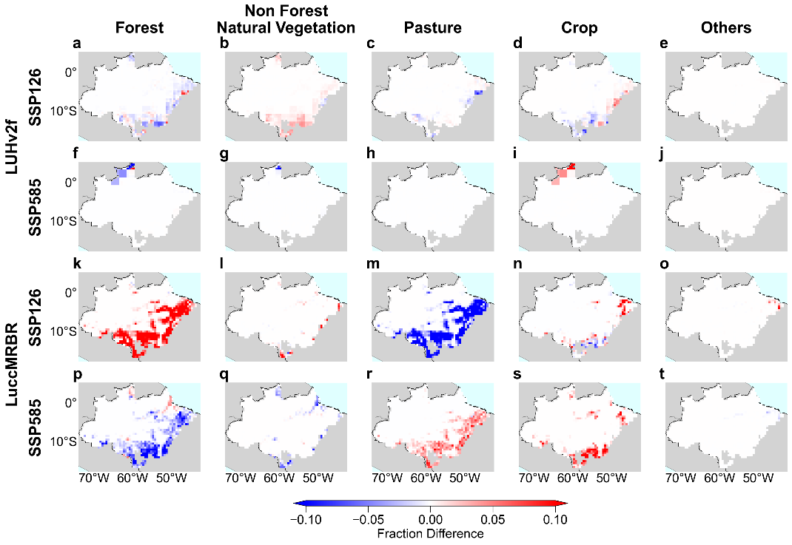
Fig. S20 Fraction difference (2050 minus 2021) in each 0.5°×0.5° grid cell for the five land use types in the SSP126 and SSP585, respectively. Note that “Others” consists of unburnable land use types (e.g., baresoil, urban and water).

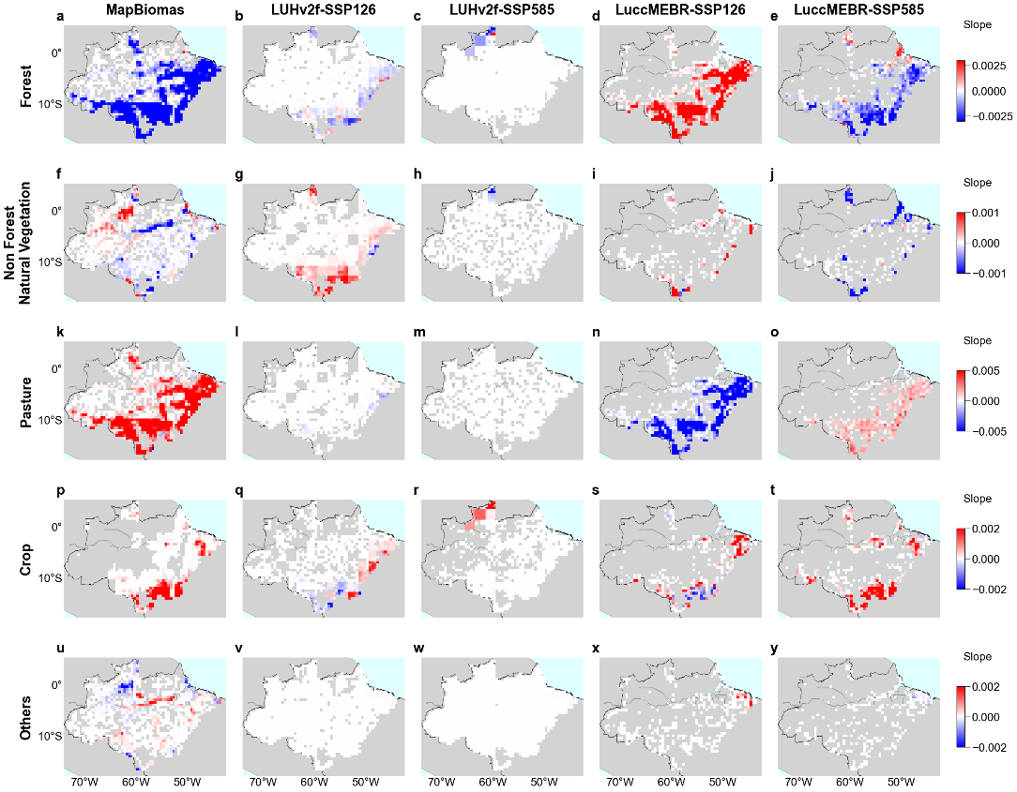
Fig. S21 Trends of area fraction of forest, non-forest natural vegetation, pasture, crop and others based on MapBiomas (1985~2020), LUHv2f (2021~2050) and LuccMEBR (2021~2050) respectively. Only significant trends with p<0.05 are shown. Note that “Others” consists of unburnable land use types (e.g., baresoil, urban and water).

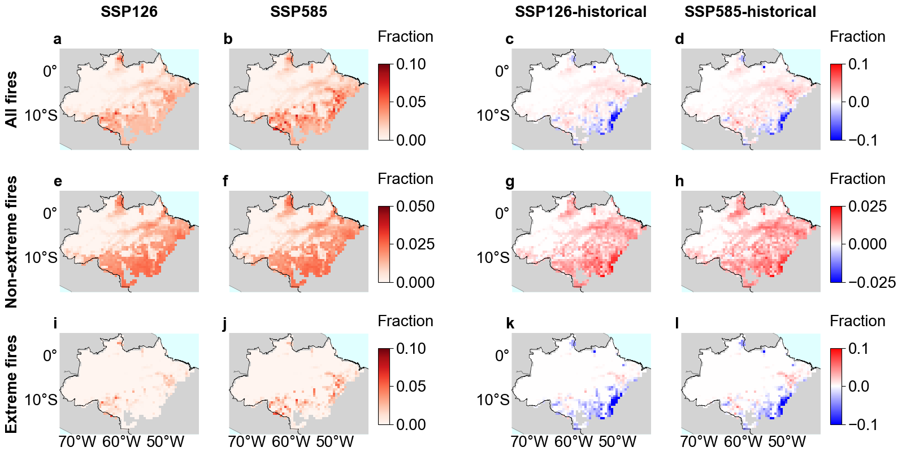
Fig. S22 Spatial patterns of future predicted mean annual burned area fraction for all fires, non-extreme fires and extreme fires during 2031-2050 under the SSP1 & RCP2.6 and SSP5 & RCP8.5 scenarios and their differences from the historical predictions during 2001-2020. a,b, Mean annual burned area fraction in each 0.5°×0.5° grid cell across the four burned area datasets for all fires during 2031-2050 averaged over the four burned area datasets (FireCCI, MODIS, GABAM and MapBiomas), the five climate models (GFDL-ESM4, IPSL-CM6A-LR, MPI-ESM1-2-HR, MRI-ESM2-0, and UKESM1-0-LL) in ISIMIP3b and the two land use datasets (LUHv2f and LuccMEBR). c,d, Spatial differences between the mean predicted annual burned area fraction of all fires during 2031-2050 and the historical predictions during 2001-2020. e-h, the same as a-d but for non-extreme fires. i-l, the same as a-d but for extreme fires. Since the four burned area datasets have an overlapping time span during 2001-2020, twenty-year averaged spatial map is used to calculate the difference.

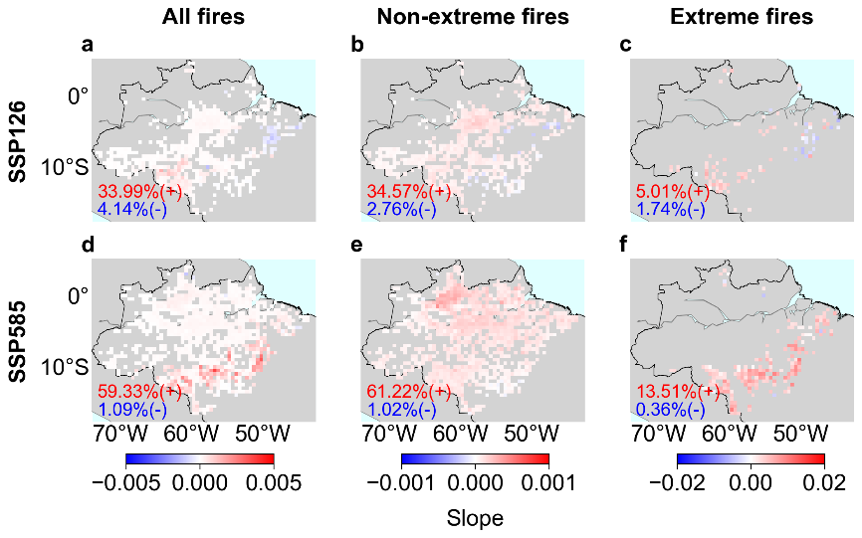
Fig. S23 Trends of burned area fraction in each 0.5°×0.5° grid cell during 2021~2050 for all fires, non-extreme and extreme fires averaged over the four burned area datasets (FireCCI, MODIS, GABAM and MapBiomas), the five climate models (GFDL-ESM4, IPSL-CM6A-LR, MPI-ESM1-2-HR, MRI-ESM2-0, and UKESM1-0-LL) in ISIMIP3b and the two land use datasets (LUHv2f and LuccMEBR). Only significant trends with p<0.05 are shown. Fraction of grid cells with positive (red) or negative (blue) trends in the total number of grid cells is annotated.
a FireCCI  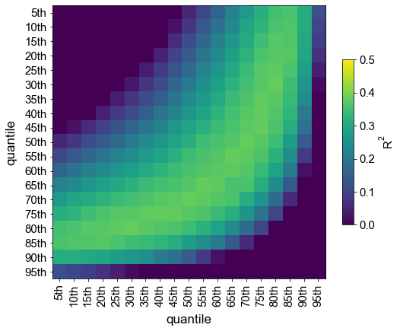 | b GABAM  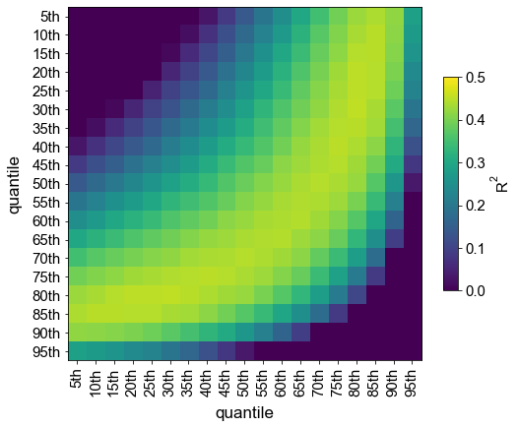
c MapBiomas  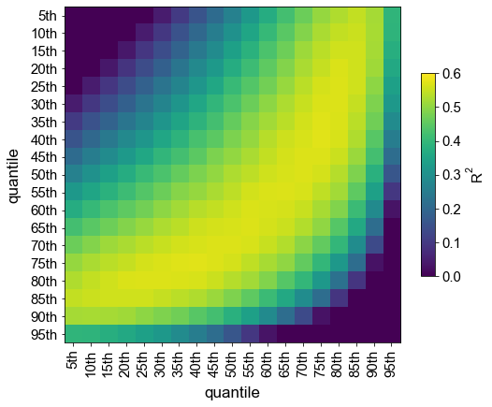 | d MODIS  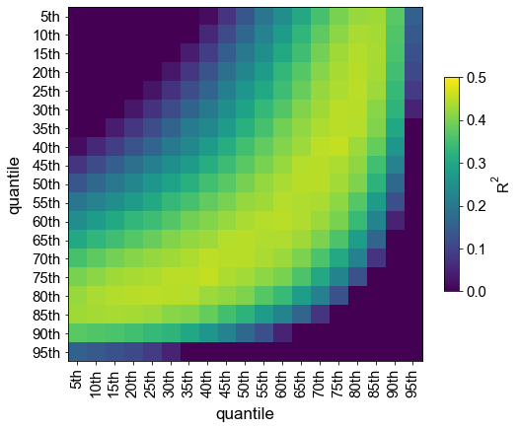
Fig. S24 R² between burned area observations and predictions in the validation dataset using different combinations of two quantile outputs for the non-extreme fires. a-d, the 4 burned area datasets (a. FireCCI, b. GABAM, c. MapBiomas, d. MODIS). The grid with the highest R² suggests that the corresponding combination of quantiles can best capture the observation, and this combination is used for further predictions.

a FireCCI  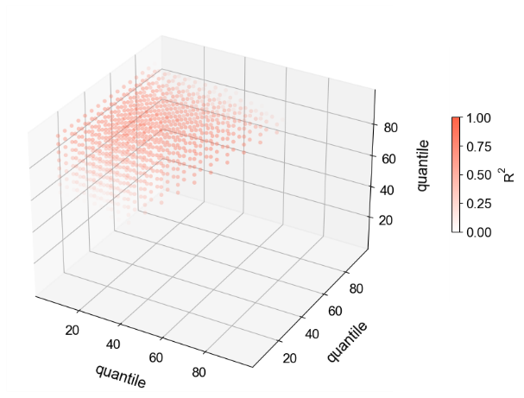 | b GABAM  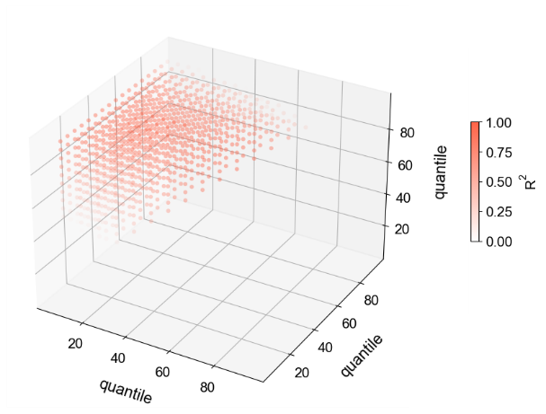
c MapBiomas  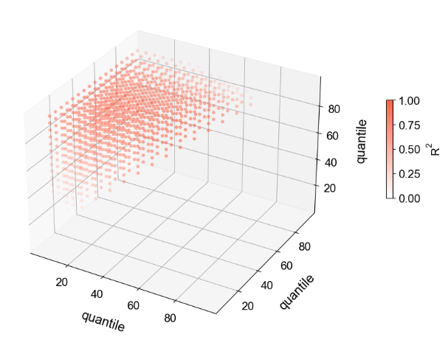 | d MODIS  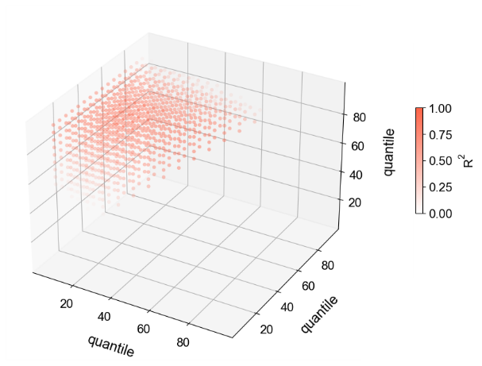
Fig. S25 Similar to Fig. S24 but using a combination of three quantiles.

a FireCCI  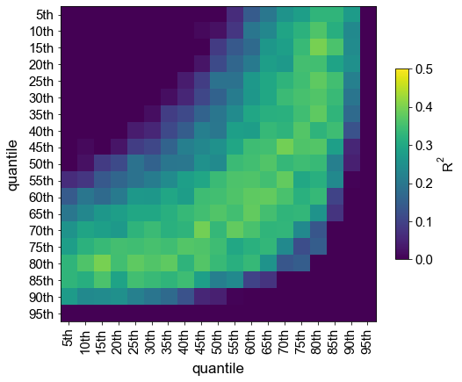 | b GABAM  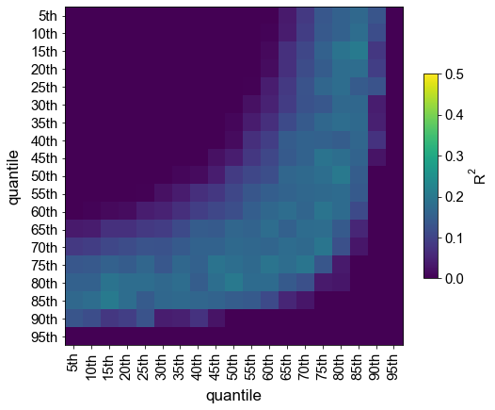
c MapBiomas  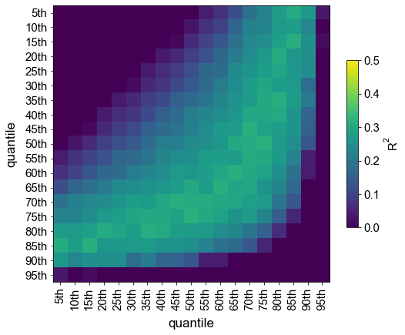 | d MODIS  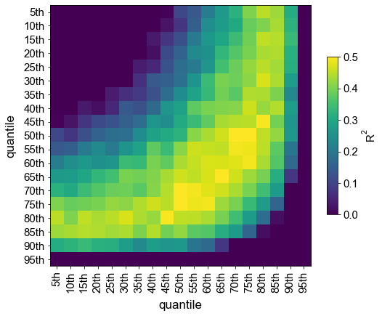
Fig. S26 Same as Fig. S24, but for the extreme fires.

a FireCCI  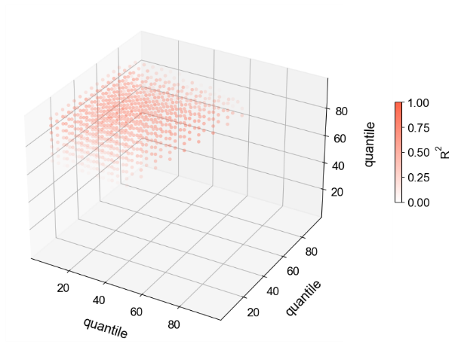 | b GABAM  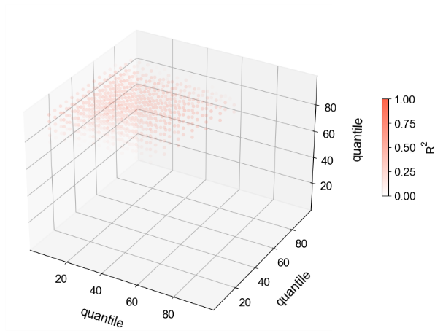
c MapBiomas  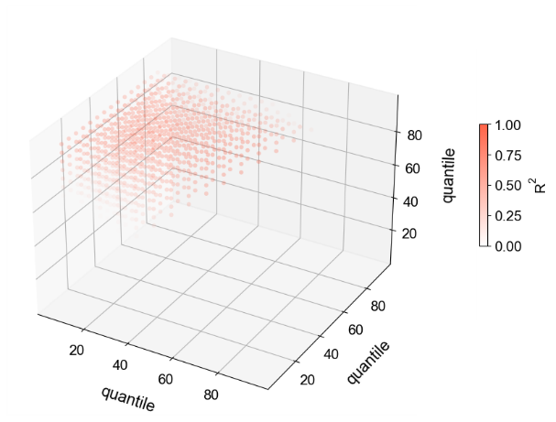 | d MODIS  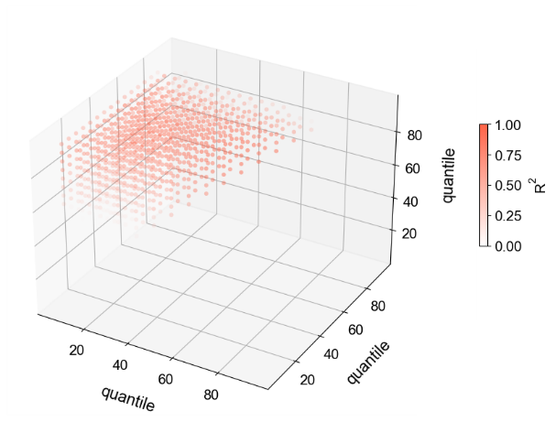
Fig. S27 Same as Fig. S25, but for the extreme fires.

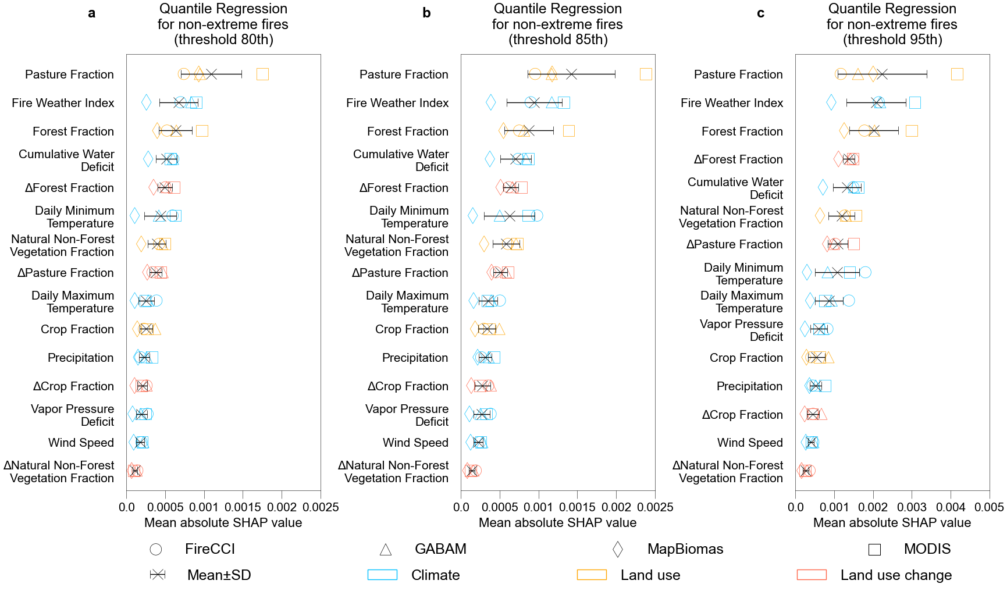
Fig. S28 Mean absolute SHAP value for the random forest quantile regression for non-extreme fires. a,b,c, Results for different thresholds (80th (a), 85th (b), 95th (c) percentiles) to define grid cells (0.5°×0.5°) with extreme fires. Blue, orange and red colors represent explanatory variables related to climate, land use, and land use change, respectively. Symbols indicate results for different burned area datasets (FireCCI, MODIS, GABAM and MapBiomas), while the cross and error bar indicate the mean and standard deviation across the four datasets.

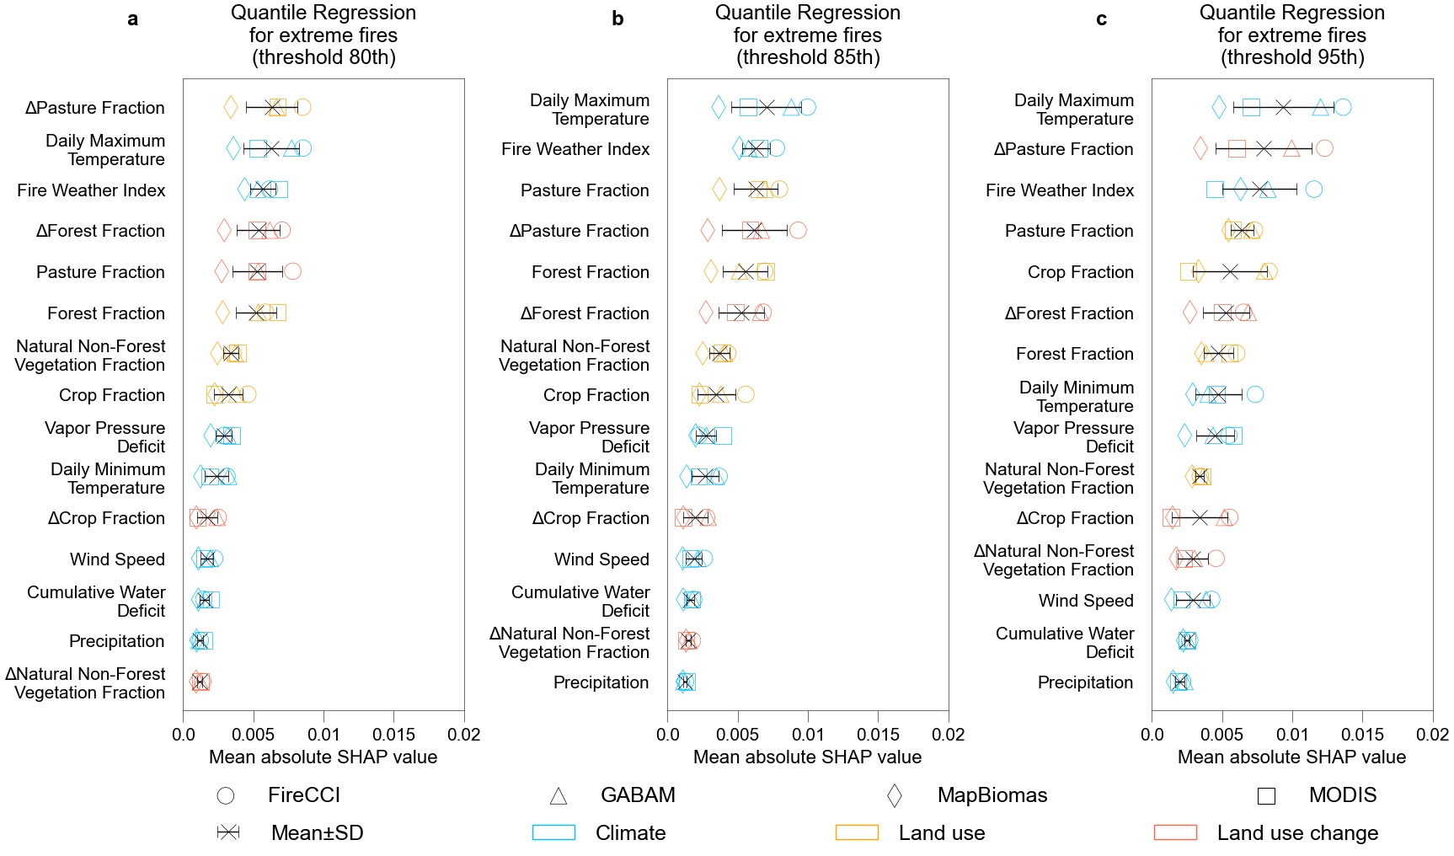
Fig. S29 Same as Fig. S28, but for extreme fires.

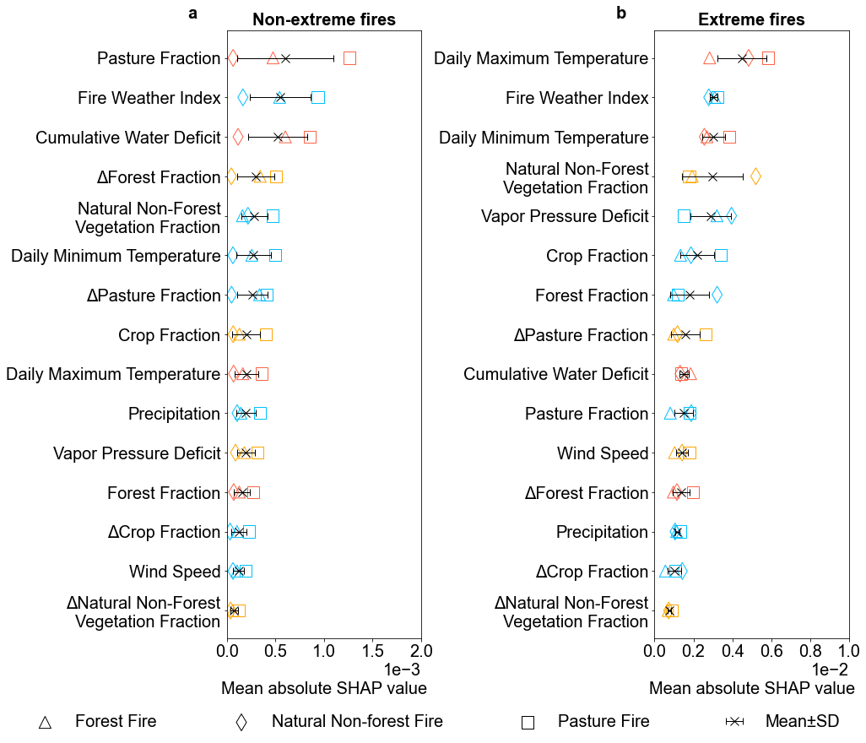
Fig. S30 Mean absolute SHAP value from the random forest quantile regressions for (a) non-extreme and (b) extreme fires overlapped with different land use types.

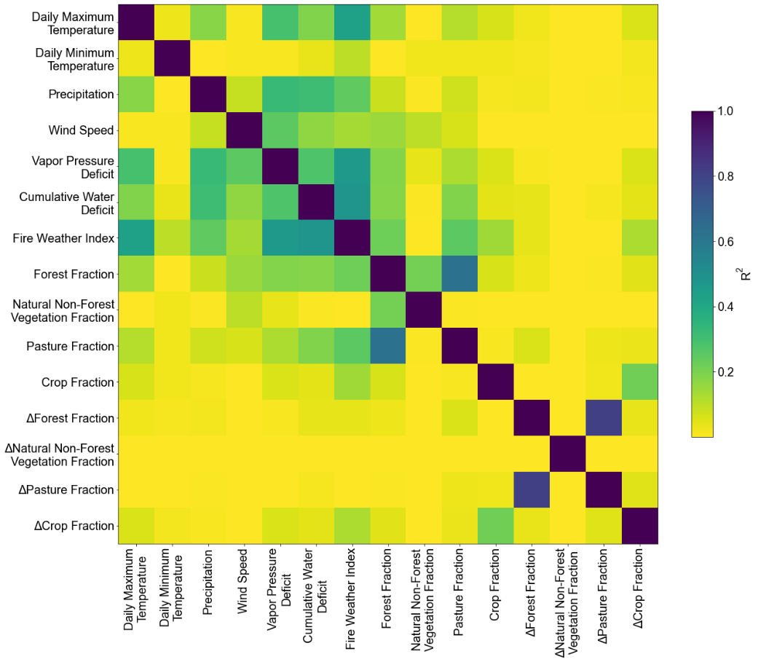
Fig. S31 Collinearity of the 15 explanatory variables used in the random forest models.

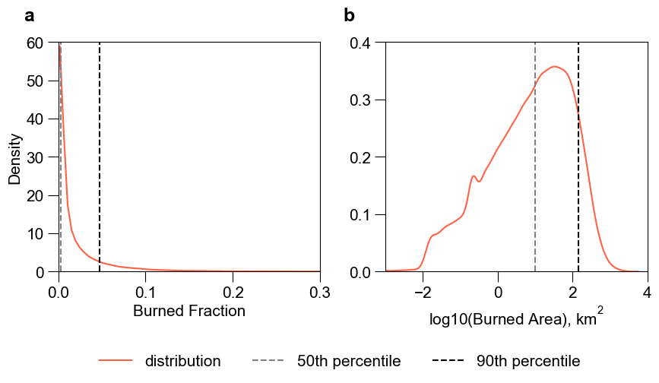
Fig. S32 Kernel density distribution of burned area (averaged over the four burned area datasets) in all available years in the Brazilian Amazon for (a) the original values and (b) the log-transformed values.

a  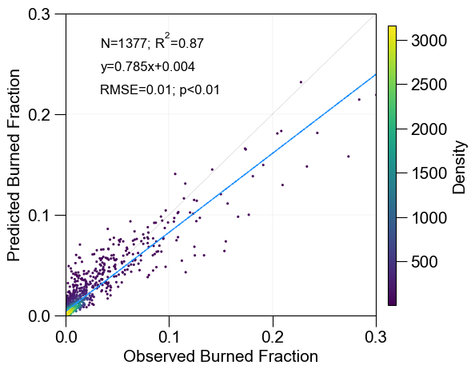 | b  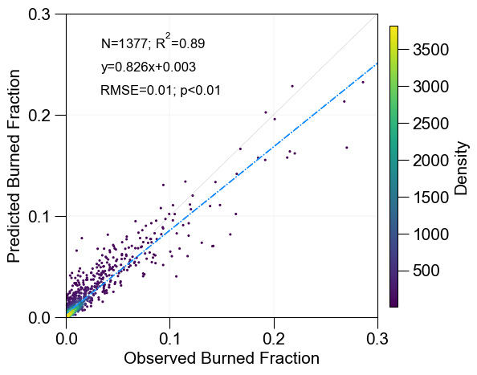
c  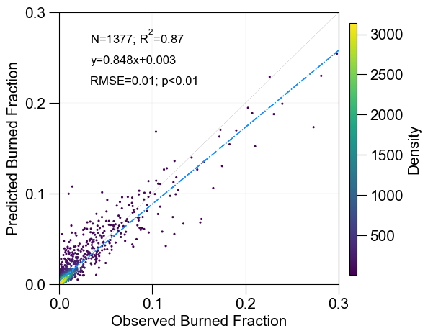 | d  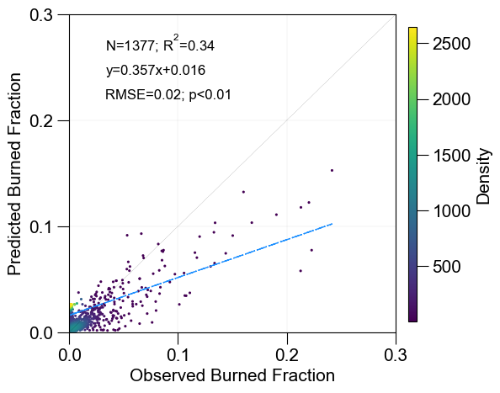
Fig. S33 Comparison of mean annual burned area fractions in each 0.5°×0.5° grid cell between observation and prediction averaged over 2001~2020 using normal random forest regression (a), gradient boosting regression (b), extreme gradient boosting regression (c), long short term memory neuron network regression (d).

a FireCCI  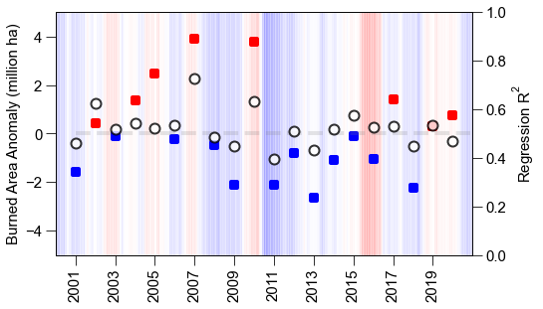 | b GABAM  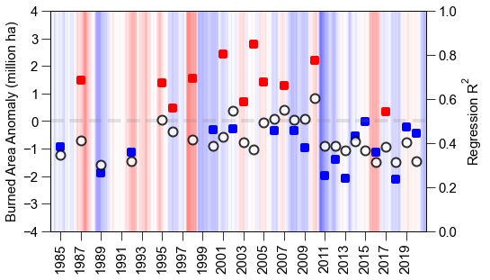
c MapBiomas  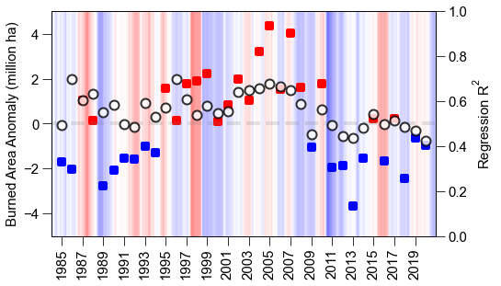 | d MODIS  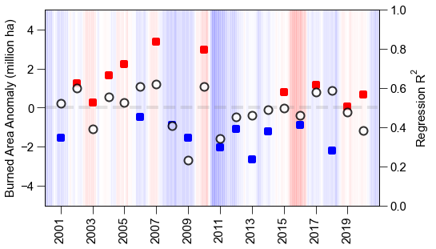
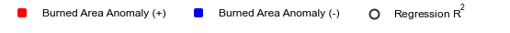
Fig. S34 Anomalies in annual burned area and the regression R² from model validation using data from an independent year (same as Fig. S3d). Red and blue squares indicate positive and negative burned area anomalies, respectively. Background colors indicate La Niña events (blue) and El Niño events (red), and darker color means stronger event intensity. a-d, the 4 burned area datasets (a. FireCCI; b. GABAM; c. MapBiomas; d. MODIS).

a FireCCI  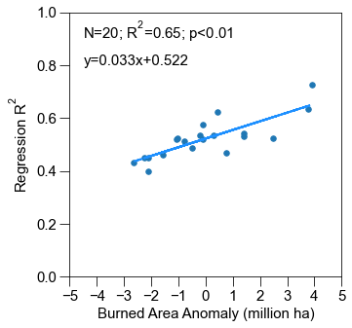 | b GABAM  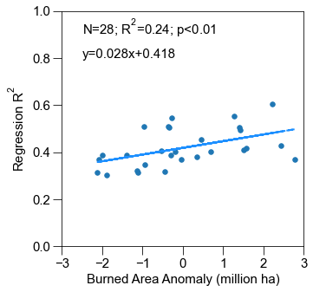
c MapBiomas  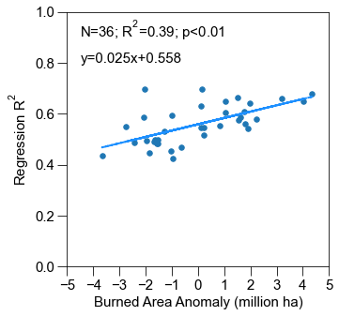 | d MODIS  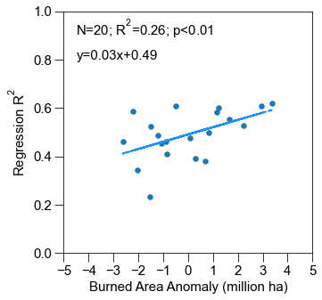
Fig. S35 Relationship between the burned area anomalies and the regression R² from model validation using data from an independent year (Fig. S34). a-d, the 4 burned area datasets respectively (a. FireCCI; b. GABAM; c. MapBiomas; d. MODIS). Significant linear relationship is found, indicating that years with higher positive anomalies of burned area tend to have higher regression R².

a
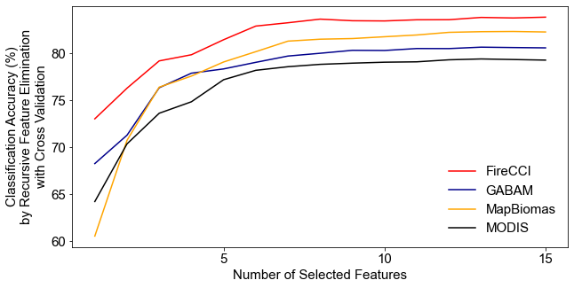
b
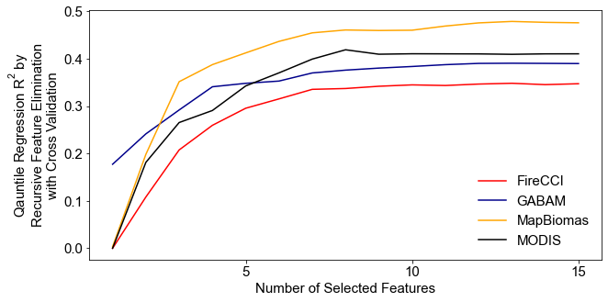
c
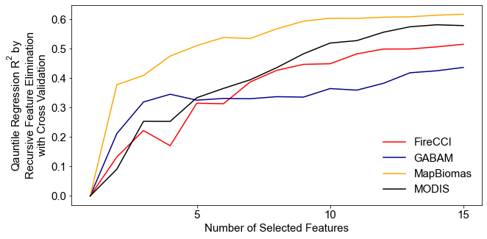
Fig. S36 Feature selection of random forest models (a. classification; b. quantile regression for non-extreme fires; c. quantile regression for extreme fires) by recursive feature elimination cross validation using different burned area datasets, respectively.

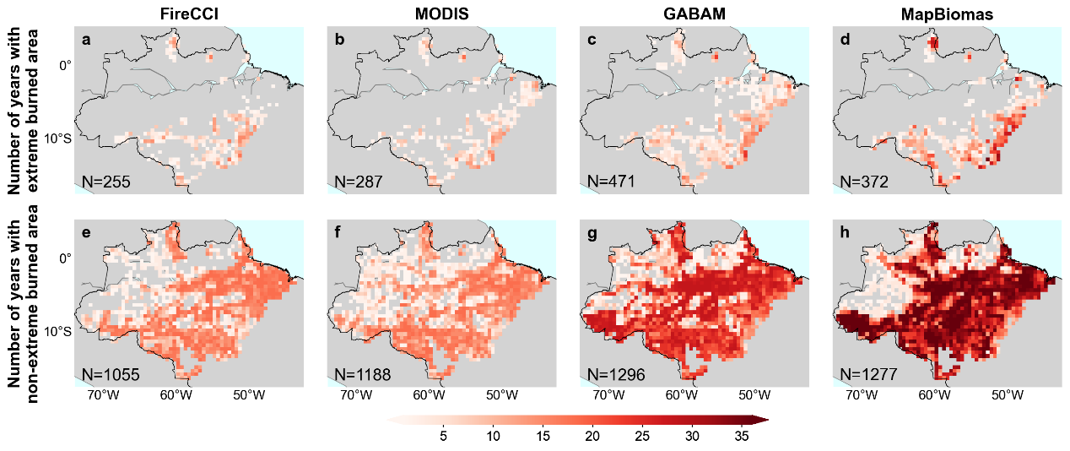
Fig. S37 Maps of number of years with extreme (a-d) and non-extreme (e-h) burned area from the four burned area datasets (FireCCI, MODIS, GABAM, and MapBiomas) within the observation period (2003-2020 for FireCCI and MODIS, 1985-2020 for GABAM and MapBiomas). N denotes the number of 0.5°×0.5° grid cells in each subplot.

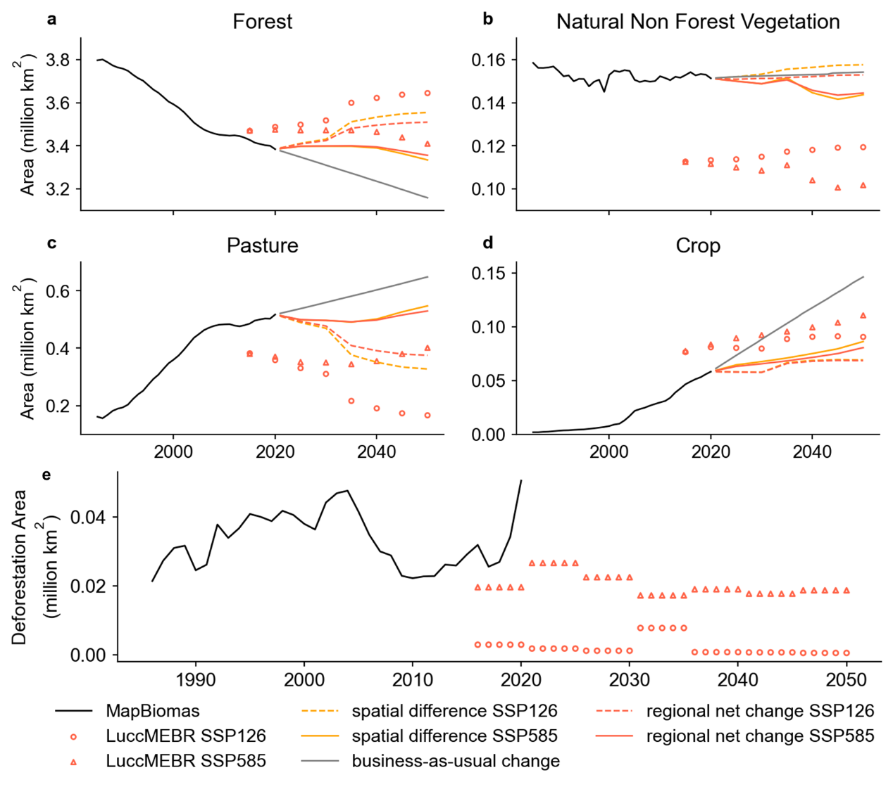
Fig. S38 Time series of future annual total area of different land use types (a. forest, b. natural non-forest vegetation, c. pasture, d. crop, e. deforestation) in MapBiomas (black lines, 1985-2020), the original land use dataset of LuccMEBR (scatters, 2015-2050) and the harmonized land use datasets using the “spatial difference” (orange lines, 2021-2050), “regional net change” (red lines, 2021-2050) and “business-as-usual change” (grey lines, 2021-2050) methods, respectively (Supplementary Text 1.2). The deforestation refers to transition from forest to any other land use types in adjacent two years. Note that the temporal resolution of the original LuccMEBR data is 5 years, and the land use area within the 5 years is assumed to change linearly and uniformly.

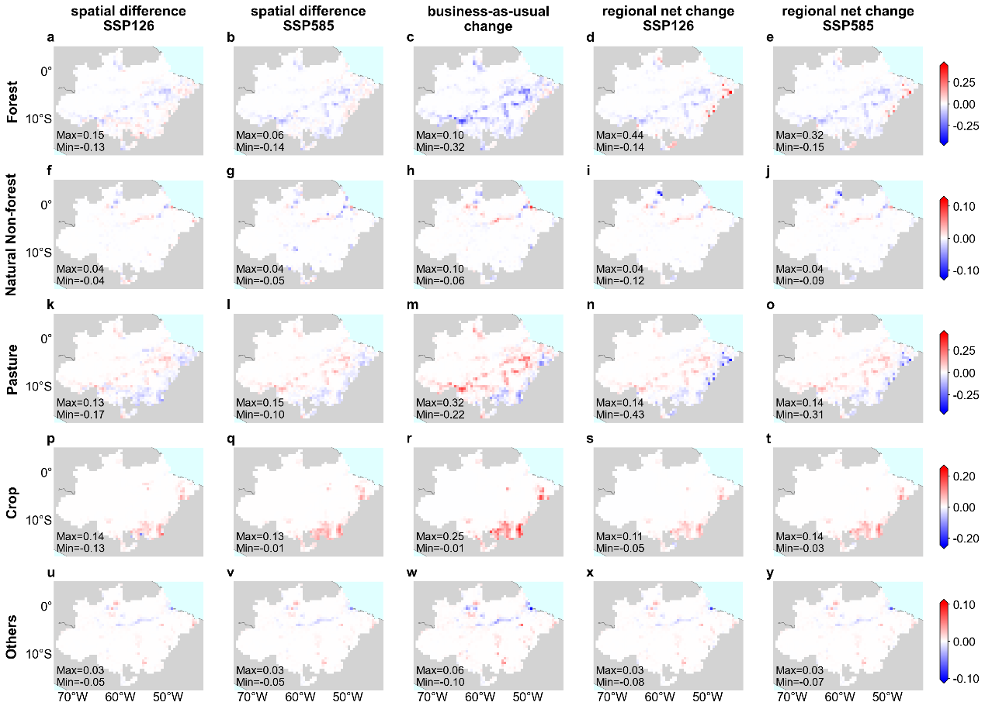
Fig. S39 Multi-year average difference (2021-2030 minus 2011-2020) for various land use types (forest, natural non-forest, pasture, crop, and others) between the harmonized future land use data (2021-2030) and MapBiomas (2011-2020) in each 0.5°×0.5° grid cell. Note that “spatial difference”, “business-as-usual change” and “regional net change” represent three adaptation measures (Supplementary Text 1.2) for harmonizing land use datasets. “Others” consists of unburnable land use types (e.g., baresoil, urban and water).

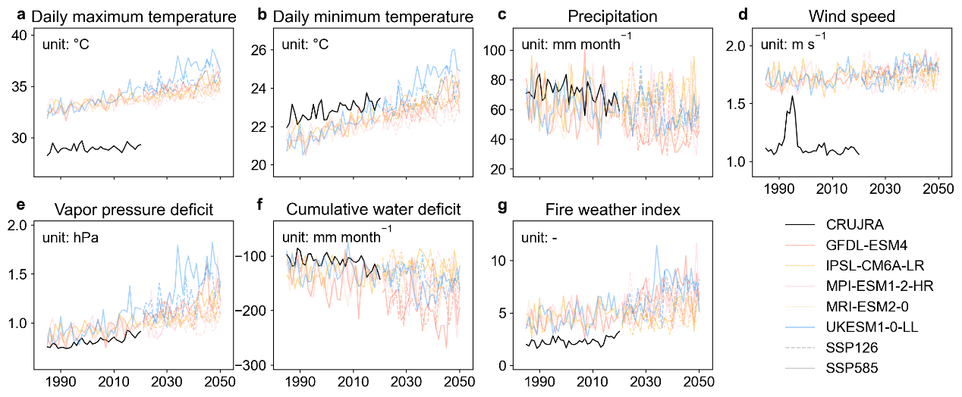
Fig. S40 Time series of dry-season averaged climatic variables extracted from CRUJRA (1985-2020) and five climate models (GFDL-ESM4, IPSL-CM6A-LR, MPI-ESM1-2-HR, MRI-ESM2-0, and UKESM1-0-LL) in ISIMIP3b (1985-2050). Dashed lines represent SSP126, and solid lines for SSP585 during the future period of 2021-2050.

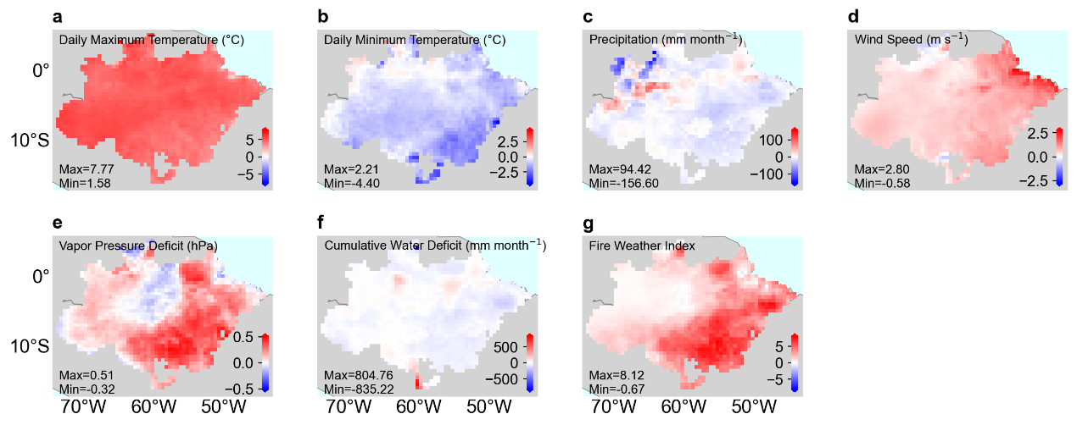
Fig. S41 Multi-year average difference (ISIMIP3b – CRUJRA) of the dry-season mean climatic variables between CRUJRA and ISIMIP3b (2011-2020) in each 0.5°×0.5° grid cell. Note that the variables from ISIMIP3b represent the average value of the five climate models (GFDL-ESM4, IPSL-CM6A-LR, MPI-ESM1-2-HR, MRI-ESM2-0, and UKESM1-0-LL).

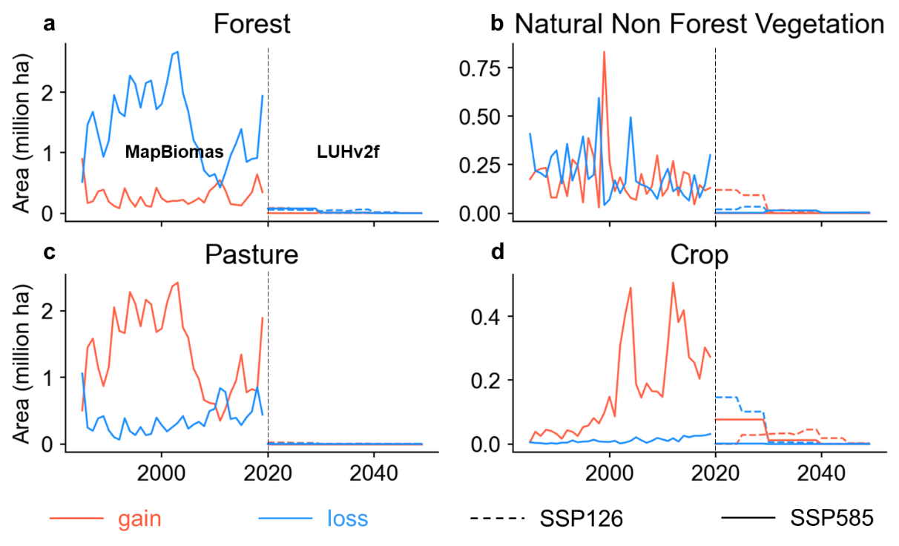
Fig. S42 Time series of future annual net gain (red lines) and loss area (blue lines) from 0.5°×0.5° grid cells for different land use types (a. forest, b. natural non-forest vegetation, c. pasture, d. crop) in MapBiomas (1985-2020) and LUHv2f (2021-2050).

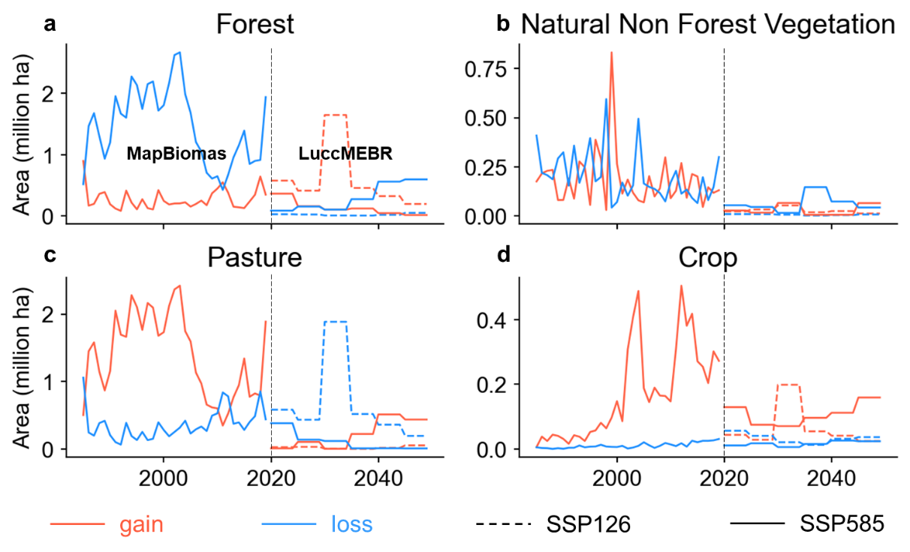
Fig. S43 Same as Fig. S42 but for LuccMEBR.

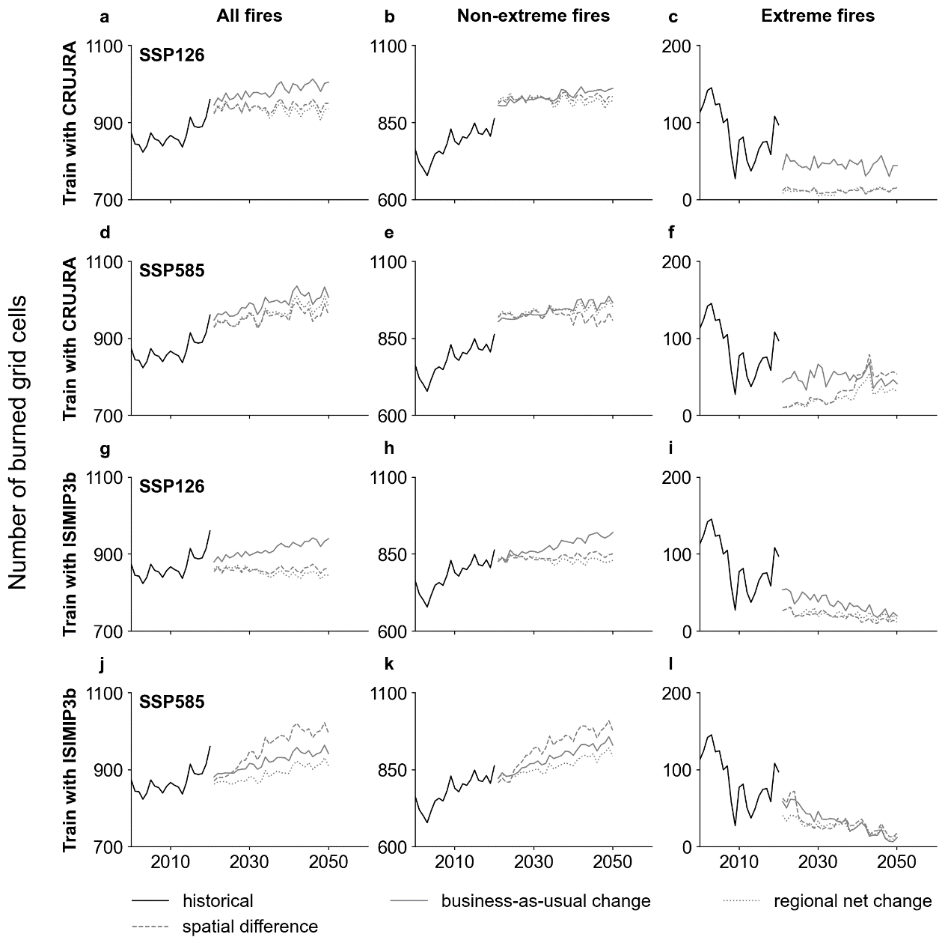
Fig. S44 Time series of predicted number of burned grid cells for all fires, non-extreme fires and extreme fires averaged over the four burned area datasets (FireCCI, MODIS, GABAM, and MapBiomas) and five climate models from ISIMIP3b (GFDL-ESM4, IPSL-CM6A-LR, MPI-ESM1-2-HR, MRI-ESM2-0, and UKESM1-0-LL). Note that the historical climate data from CRUJRA (a-f) and ISIMIP3b (g-l) are used separately to train the machine learning model. “spatial difference”, “business-as-usual change” and “regional net change” are varied methods (Supplementary Text 1.2) used in harmonizing future land use datasets for the machine learning model prediction process.

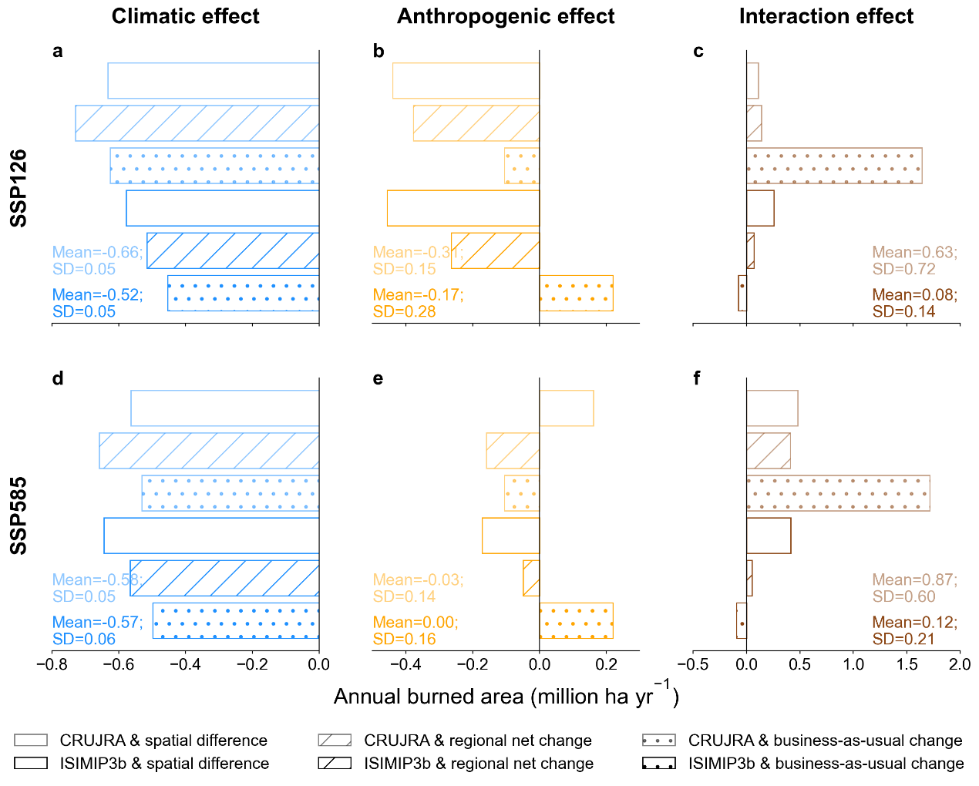
Fig. S45 Predicted multi-year average (2021-2050) contribution to the annual extreme burned area averaged over the four burned area datasets (FireCCI, MODIS, GABAM, and MapBiomas) and the five climate models (GFDL-ESM4, IPSL-CM6A-LR, MPI-ESM1-2-HR, MRI-ESM2-0, and UKESM1-0-LL) from ISIMIP3b by climate, anthropogenic activities and their interaction. Note that the historical climate data from CRUJRA (lighter bars) and ISIMIP3b (darker bars) are used separately to train the machine learning model. “spatial difference”, “business-as-usual change” and “regional net change” are varied methods (Supplementary Text 1.2) used in harmonizing future land use datasets for the machine learning model prediction process. “Mean” and “SD” are the average and standard deviation of lighter bars or darker bars.

