Supplementary Information
Prognostic Effect of a Tumor Invasion Pattern Mimicking Crawling Between Muscle Fibers in Oral Tongue Carcinoma

Daisuke Baba, M.D.^{1,2,3}, Naoya Sakamoto, M.D., Ph.D.⁴, Motohiro Kojima, M.D., Ph.D.⁵, Masashi Wakabayashi, M.Sc.⁶, Tetsuya Nakatsura, M.D., Ph.D.¹, Ryuichi Hayashi, M.D. , Ph.D.⁷, Genichiro Ishii, M.D., Ph.D.^{3,8}, Shingo Sakashita, M.D., Ph.D.^{4*}

Supplementary Figures

Supplemental Figure 1. WPOI classification.
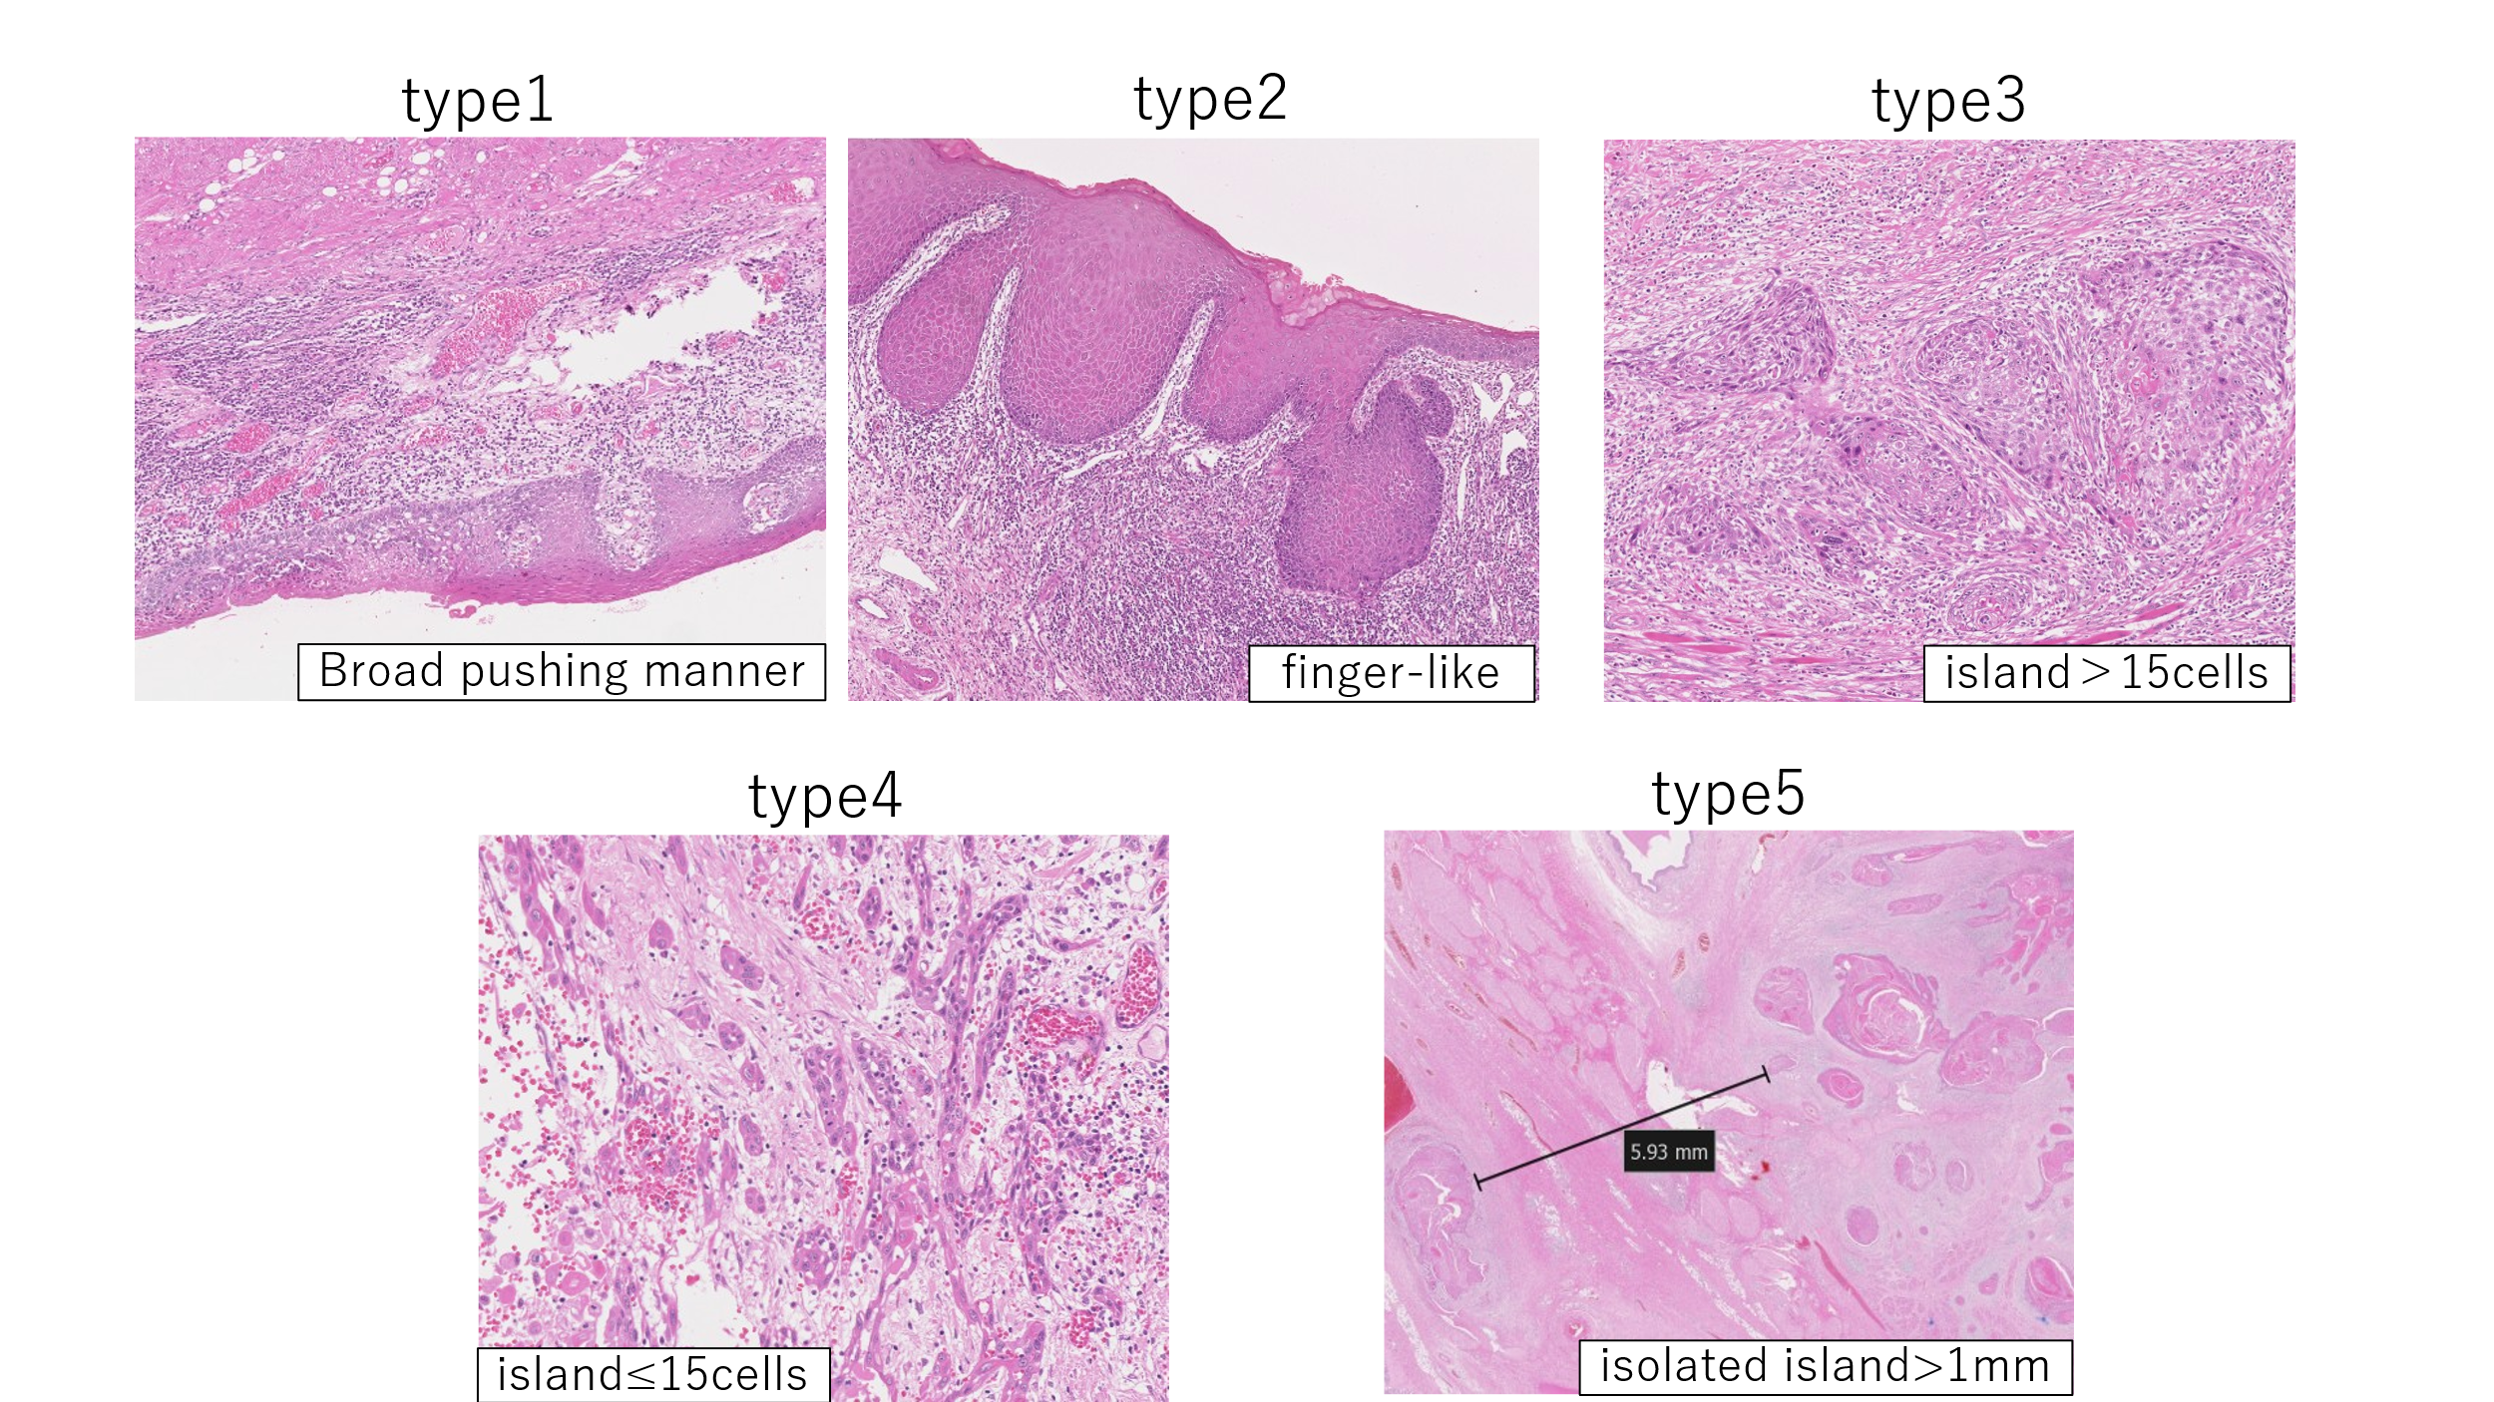
WPOI, worst pattern of invasion.

Supplemental Figure 2. The conceptual figures of BABA.
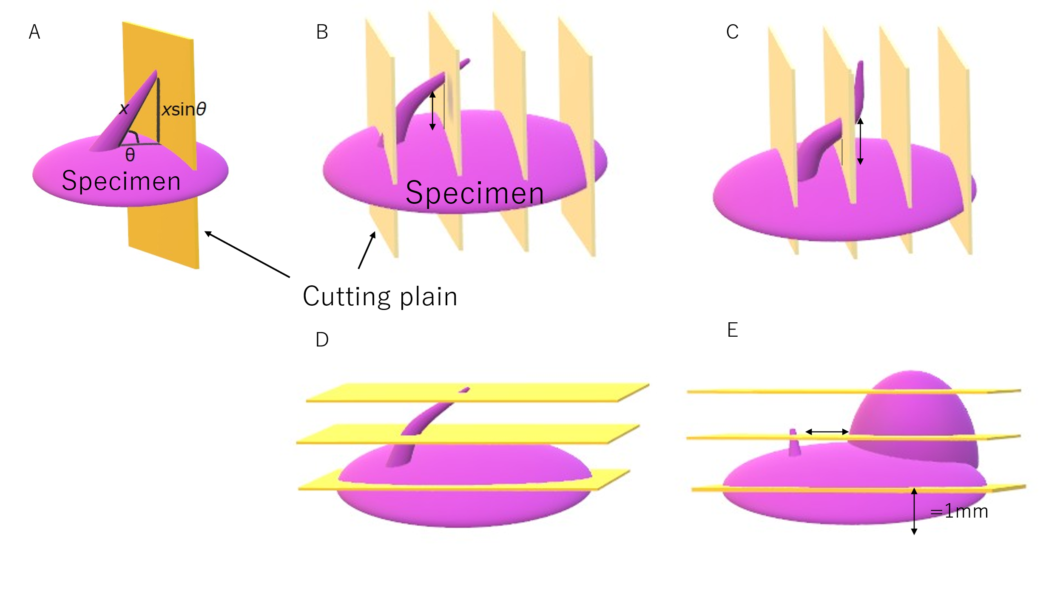
BABA, Broadening Amoeboid Behavior of Advancing tumor cells.

Supplemental Figure 3. Patient selection flow chart.
