SUPPLEMENTARY MATERIAL FOR:

Irreversible climate changes driven by degree-years of temperature overshoot

Mitchell Dickau¹, Kirsten Zickfeld² and H. Damon Matthews¹

¹Department of Geography, Planning and Environment, Concordia University, Montréal, Quebec, Canada
²Department of Geography, Simon Fraser University, Vancouver, British Columbia, Canada.

CONTENTS OF THIS FILE:
Figures SM1 to SM3
Tables SM1 and SM2

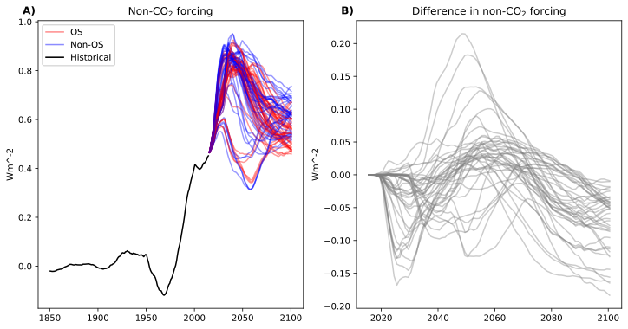
Figure 1 – Figure A) shows the evolution of non-CO₂ forcing (i.e., non-CO₂ GHGs and aerosols) for the historical, OS, and non-OS simulations. Figure B) shows the difference between the non-CO₂ forcing in OS and non-OS scenarios (i.e., OS non-CO₂ forcing subtracted by non-OS non-CO₂ forcing). Figure B) demonstrates that non-CO₂ forcing in the OS scenarios is equal to or lower than non-CO₂ forcing in non-OS scenarios by 2090.

Table 1 – The 5th and 95th percentiles, interquartile range (IQR), and median values of reversibility of climate variables in the UVic-ESCM. IQR above 10% of reversibility are highlighted in red.

 | Variable | 5th_p | 95th_p | IQR | median
A_co2 | global average CO2 concentration | 84.02 | 131.43 | 18.60 | 120.33
A_sat | global average surface air temperature | 100.00 | 100.00 | 0.00 | 100.00
A_satL | average surface air temperature over land | 100.09 | 101.78 | 0.90 | 100.89
A_satN | NH average surface air temperature | 100.36 | 102.59 | 1.07 | 101.49
A_satO | average surface air temperature over ocean | 99.05 | 99.95 | 0.47 | 99.52
A_satS | SH average surface air temperature | 96.62 | 99.54 | 1.42 | 98.05
L_permacarb | global total permafrost carbon pool | 0.00 | 6.10 | 1.22 | 0.10
L_PFGLOBAL | Permafrost area global | 3.93 | 74.89 | 29.05 | 41.42
L_PFregcarb | permafrost region total soil carbon | 0.00 | 9.58 | 2.25 | 0.73
L_soilcarb | global total soil carbon | 2.44 | 74.00 | 33.30 | 47.27
L_squedcarb | global total sequestered (frozen) carbon | 20.17 | 76.23 | 20.38 | 46.88
L_totcarb | global total land carbon | 11.90 | 72.26 | 29.37 | 50.47
L_vegcarb | global total vegetation carbon | 24.25 | 83.58 | 25.08 | 58.00
O_alk | global average ocean alkalinity | 61.44 | 171.35 | 43.95 | 118.62
O_alksur | global average sea surface alkalinity | 35.82 | 49.18 | 4.50 | 45.24
O_dic | global average ocean dic | 18.64 | 52.69 | 13.18 | 44.19
O_dicsur | global average sea surface dic | 65.85 | 118.88 | 22.36 | 107.64
O_dsealev | relative sea level height | 22.01 | 31.15 | 2.20 | 25.05
O_icearea | global sea ice area | 75.32 | 91.84 | 8.87 | 83.24
O_icevol | global sea ice volume | 76.23 | 88.80 | 4.05 | 82.08
O_motmax | maximum meridional overturning streamfunction | 0.00 | 9.77 | 5.96 | 3.35
O_o2 | global average ocean oxygen | 14.86 | 24.22 | 3.85 | 20.26
O_o2sur | global average sea surface oxygen | 90.88 | 98.32 | 2.59 | 95.66
O_phsur | global average sea surface pH | 67.74 | 113.10 | 18.43 | 104.12
O_sal | global average ocean salinity | 0.00 | 192.50 | 47.93 | 29.45
O_salsur | global average sea surface salinity | 31.13 | 42.64 | 4.71 | 35.87
O_snovol | global snow volume | 18.70 | 61.44 | 23.93 | 39.02
O_temp | global average ocean temperature | 14.98 | 22.06 | 1.64 | 17.10
O_tempsur | global average sea surface temperature | 97.09 | 99.21 | 0.93 | 98.48
O_totcarb | global average total ocean carbon | 18.65 | 52.69 | 13.21 | 44.20

Variable | Peak temp. | Peak CO2 | Return temp. | Return CO2 | Rate temp. | Rate CO2 | Avg. temp. | Avg. CO2
A_co2 | 0.49 | 0.55 | 0.96 | 1.00 | 0.42 | 0.18 | 0.65 | 0.73
L_PFGLOBAL | 0.91 | 0.79 | 0.73 | 0.60 | 0.09 | 0.00 | 0.95 | 0.83
L_soilcarb | 0.40 | 0.70 | 0.66 | 0.72 | 0.42 | 0.03 | 0.47 | 0.78
L_squedcarb | 0.88 | 0.80 | 0.85 | 0.73 | 0.17 | 0.01 | 0.97 | 0.88
L_totcarb | 0.49 | 0.75 | 0.77 | 0.80 | 0.43 | 0.04 | 0.58 | 0.85
L_vegcarb | 0.61 | 0.78 | 0.90 | 0.89 | 0.39 | 0.06 | 0.73 | 0.91
O_alk | 0.13 | 0.06 | 0.32 | 0.29 | 0.20 | 0.12 | 0.20 | 0.15
O_dic | 0.73 | 0.87 | 0.86 | 0.82 | 0.29 | 0.02 | 0.81 | 0.94
O_dicsur | 0.53 | 0.62 | 0.96 | 0.99 | 0.42 | 0.14 | 0.68 | 0.79
O_phsur | 0.57 | 0.65 | 0.97 | 0.99 | 0.41 | 0.13 | 0.72 | 0.82
O_sal | 0.89 | 0.88 | 0.65 | 0.54 | 0.08 | 0.01 | 0.90 | 0.87
O_snovol | 0.89 | 0.81 | 0.87 | 0.75 | 0.19 | 0.01 | 0.95 | 0.89
O_totcarb | 0.73 | 0.87 | 0.86 | 0.82 | 0.29 | 0.02 | 0.81 | 0.94
Table 2 – This table shows UVic-ESCM variables with high uncertainty in reversibility and the R² values of the linear correlation between the absolute values of these variables at the return year in individual OS and non-OS scenarios (i.e., not taking the difference between OS and non-OS) against peak and return year temperatures and atmospheric CO₂ concentrations, the rate of temperature and atmospheric CO₂ concentration change during the OS period, and the average temperature and atmospheric CO₂ concentration during the OS period. Values with a strikethrough indicate that these R² were not statistically significant (i.e., p value > 0.05). Values in red indicate the highest R² value that is statistically significant for each UVic-ESCM variable.

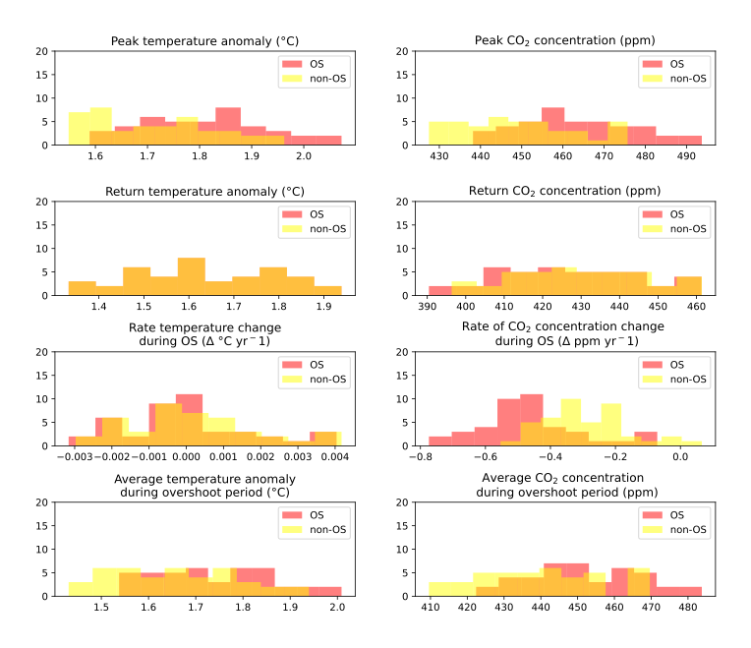
Figure 2 – The distributions of independent variables from SM Table 2 across 84 individual OS and non-OS scenarios.

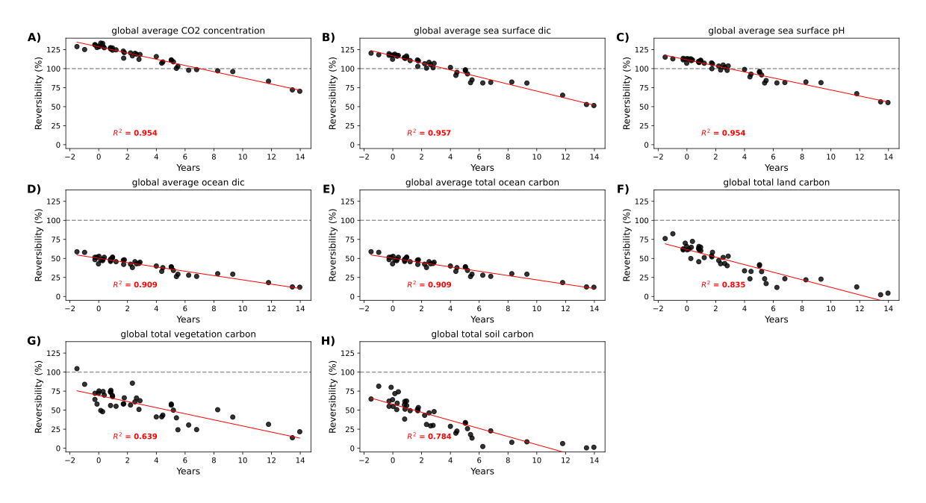
Figure 3 – Reversibility of atmospheric CO₂ concentration and other carbon cycle variables relative to the difference between the return year – when temperature in the OS scenario reaches that of the non-OS scenario – and the year that cumulative CO₂ emissions in the OS scenario become equal to cumulative emissions in the non-OS scenario. When the return year and the cumulative emissions year are nearly equal (i.e., values of near zero on the x-axis), there is high reversibility. However, reversibility declines when cumulative CO₂ emissions in the OS scenario reach cumulative CO₂ emissions of the non-overshoot scenario after

