Supporting Information for
Climate change exacerbates water affordability crisis

Jennifer Skerkerª*, Christian Klassert^{b}, Baptiste Francois^{c}, Aniket Vermaª, Casey Brown^{c}, Sarah Fletcher^{a,d}*

ªCivil and Environmental Engineering Department, Stanford University
^{b}Helmholtz Centre for Environmental Research, UFZ
^{c}Department of Civil and Environmental Engineering, University of Massachusetts
^{d}Woods Institute for the Environment, Stanford University

*Jennifer B. Skerker, Sarah Fletcher
Email: jskerker@stanford.edu , sfletcher@stanford.edu

This PDF file includes:

Supporting text S1 to S18
Figures S1 to S23
Tables S1 to S11
SI References

Supporting Information Text
Section S1. Additional information on climate scenario generation and utilized scenarios
Climate scenario generation involves two key steps: first, developing stochastic weather simulations that reflect historical climate characteristics; and second, altering these simulations to capture different climate change impacts using the anomalies from climate models. The resulting simulations capture both short-term stochastic variability and long-term climate impacts and are used to force a hydrological model to develop streamflow scenarios (see SI Section S10).
First, the data for stochastic simulations includes monthly temperature and precipitation records (raw and reconstructed) spanning 1936 to 2015 from an extended version of a previous dataset.^{1,2} The spatial resolution of the data is ⅛ of a degree and grid cells within the San Lorenzo River watershed were averaged to obtain one temperature and one precipitation time series.^{1,2} Since raw gridded data is only available from 1949-2000, k-nearest neighbors (KNN) resampling (K=1) with nearby gage data is used to reconstruct missing data for 1936-1949 and 2001-2015. Trends are removed prior to resampling. A wavelet auto-regressive model is then applied to reproduce low-frequency signals from the observed record, generating 100-year long annual time series, following a simplified version of a previously developed method.³ Monthly-scale data are subsequently resampled from the annual data using a KNN approach (K=3) based on resampling from a given calendar month to obtain thousands of 100-year monthly stochastic simulations. From these, ten simulations are selected that best match the historical climate based on a KNN approach using sixteen statistical metrics for precipitation and temperature. These metrics capture long-term averages, seasonal variability, persistence, frequency of water year types, and annual rainfall distribution.
Second, Global Coupled Model Intercomparison Project phase 6 (CMIP6) climate projections are used to inform the range of likely climate change anomalies in temperature and precipitation which are used to alter the stochastic simulations developed above to capture climate change impacts.⁴ Climate projections focus on Global Circulation Model (GCM) shared socioeconomic pathways (SSPs) 5-8.5, which results in the greatest warming and may also have the largest impacts on precipitation. Data is extracted for the rectangular area encompassing the San Lorenzo River watershed (latitude: [37.4; 36.9]; longitude [-121.9; -122.2]), which includes one to four grid cells depending on the GCM resolution. When multiple grid cells were obtained, we computed the average across cells. A full list of the climate models, which come from both CMIP6 directly and Cal-Adapt, is included in Table S1. Cal-Adapt is a state-supported climate data and analytics platform developed and maintained by Eagle Rock Analytics; the Geospatial Innovation Facility at the University of California, Berkeley; and Lawrence Berkeley National Lab that downscales GCM ensemble (primarily CMIP6) outputs using dynamic and hybrid-statistical downscaling.⁵ We restrict our analysis to LOCA2-Hybrid, a hybrid-statistical downscaled dataset, in which dynamically downscaled climate simulations are used to train the Localized Construct Analogs (LOCA) at Scripps Institution of Oceanography.⁶ We use LOCA2 data because it includes more GCMs, more SSP scenarios, and the temporal resolution is daily. Since LOCA-2-Hybrid data only contains minimum and maximum temperature (not average), we estimate average daily temperature from the minimum and maximum values. We aggregate all daily data to the monthly timescale (average for temperature and sum for precipitation). The CMIP6 GCM ensemble estimates that precipitation may change from -20% to 20% compared to baseline values (1971-2000), and that temperatures may rise by 2-5℃ by 2070 (Figure S1).
Table S1. CMIP6 and Cal-Adapt climate models utilized in assessing future climate scenarios
GCM | Dataset |  | GCM | Dataset
ACCESS-CM2 | CMIP6 |  | INM-CM5-0 | CMIP6
AWI-CM-1-1-MR | CMIP6 |  | IPSL-CM6A-LR | CMIP6
BCC-CSM2-MR | CMIP6 |  | MCM-UA-1-0 | CMIP6
CAMS-CSM1-0 | CMIP6 |  | MIROC-ES2L | CMIP6
CESM2 | CMIP6 |  | MIROC6 | CMIP6
CESM2-WACCM | CMIP6 |  | MPI-ESM1-2-LR | CMIP6
CMCC-CM2-SR5 | CMIP6 |  | MRI-ESM2-0 | CMIP6
CMCC-ESM2 | CMIP6 |  | NESM3 | CMIP6
CNRM-CM6-1 | CMIP6 |  | NorESM2-MM | CMIP6
CNRM-CM6-1-HR | CMIP6 |  | TaiESM1 | CMIP6
CNRM-ESM2-1 | CMIP6 |  | UKESM1-0-LL | CMIP6
CanESM5 | CMIP6 |  | ACCESS-CM2 | Cal-Adapt
CanESM5-CanOE | CMIP6 |  | CNRM-ESM2-1 | Cal-Adapt
E3SM-1-1 | CMIP6 |  | EC-Earth3 | Cal-Adapt
EC-Earth3-CC | CMIP6 |  | EC-Earth3-Veg | Cal-Adapt
FGOALS-f3-L | CMIP6 |  | FGOALS-g3 | Cal-Adapt
FGOALS-g3 | CMIP6 |  | GFDL-ESM4 | Cal-Adapt
FIO-ESM-2-0 | CMIP6 |  | INM-CM5-0 | Cal-Adapt
GFDL-ESM4 | CMIP6 |  | IPSL-CM6A-LR | Cal-Adapt
HadGEM3-GC31-LL | CMIP6 |  | KACE-1-0-G | Cal-Adapt
HadGEM3-GC31-MM | CMIP6 |  | MIROC6 | Cal-Adapt
IITM-ESM | CMIP6 |  | MPI-ESM1-2-HR | Cal-Adapt
INM-CM4-8 | CMIP6 |  | MRI-ESM2-0 | Cal-Adapt

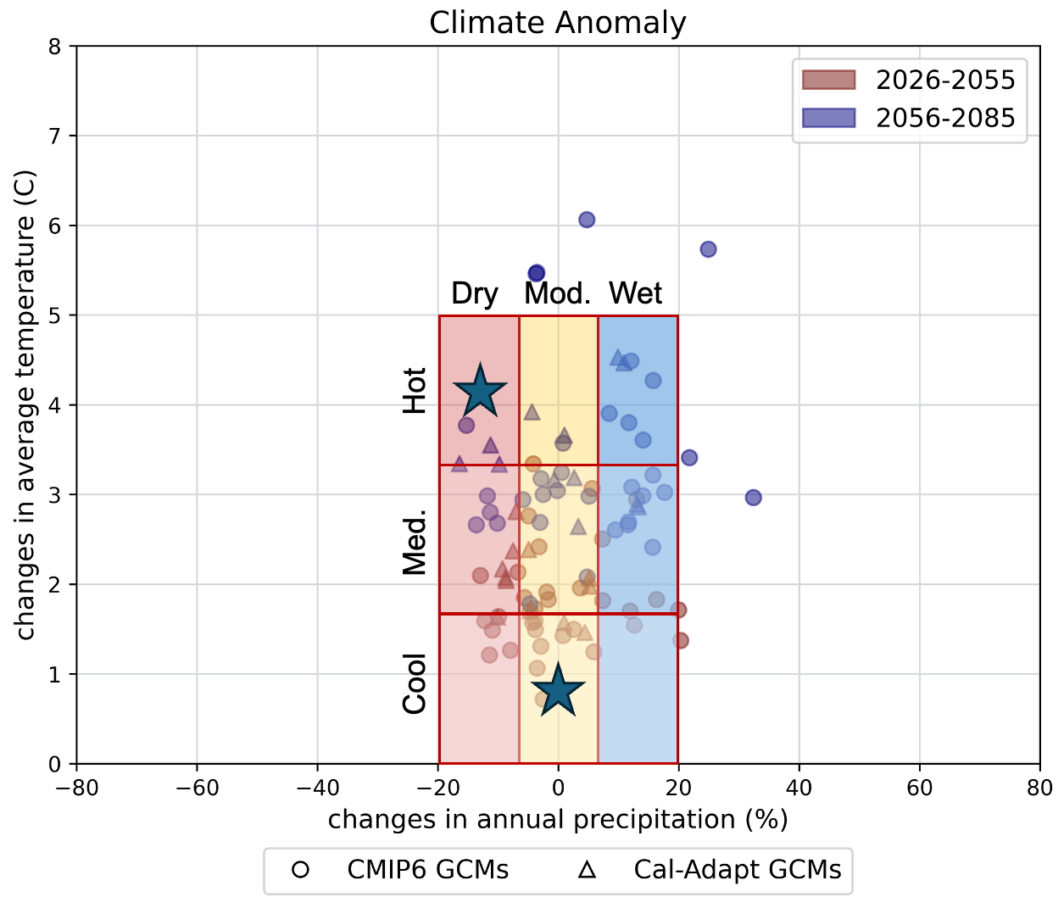
Fig. S1. Assessment of projected changes in precipitation and temperature in the San Lorenzo River watershed. Projected changes shown for the 2040s (2026-2055) and 2070s (2056-2085) from Cal-Adapt and CMIP6.^{4–6} Colored gridded boxes show the delineation into nine climate scenarios. In this work, we test multiple climate scenarios: the moderate, cool climate (0-1℃ of temperature increase and 100% of average annual precipitation) and dry, hot climate (4-5℃ of temperature increase and 80-90% of average annual precipitation), both of which are highlighted with stars, as well as the whole range of anomalies in our “all climate simulations” scenario. This figure is adapted from previous work.²

Since the goal is to understand how the range of possible climates may impact water system vulnerability, the moderate, cool scenario reflects moderate precipitation (100% of historical), historical precipitation variability (factor of 1.0), and cool temperatures (+0 to 1℃); while the dry, hot scenario reflects decreased precipitation (80-90% of historical), higher precipitation variability (factor of 1.2), and increased temperatures (+4 to +5℃). We also test the sensitivity across all climate perturbations. The full range of analysis includes average annual precipitation changes between 60 and 120%, precipitation variability between 1.0 and 1.2, and average annual temperature changes ranging from 0 to +5℃.⁷ Stochastic realizations are combined with climate scenarios using multiplicative and additive factors for average precipitation and temperature, respectively, and quantile mapping and downscaling for precipitation variability.
The selected simulations are run through a lumped water balance model, described in Section S10, to generate corresponding streamflow time series and compared to historical USGS streamflow gage data (ID: 11160500)⁸ to ensure performance aligns with the observed records.⁷

Section S2. Infrastructure deployment timing and frequency under all scenarios analyzed with adaptation
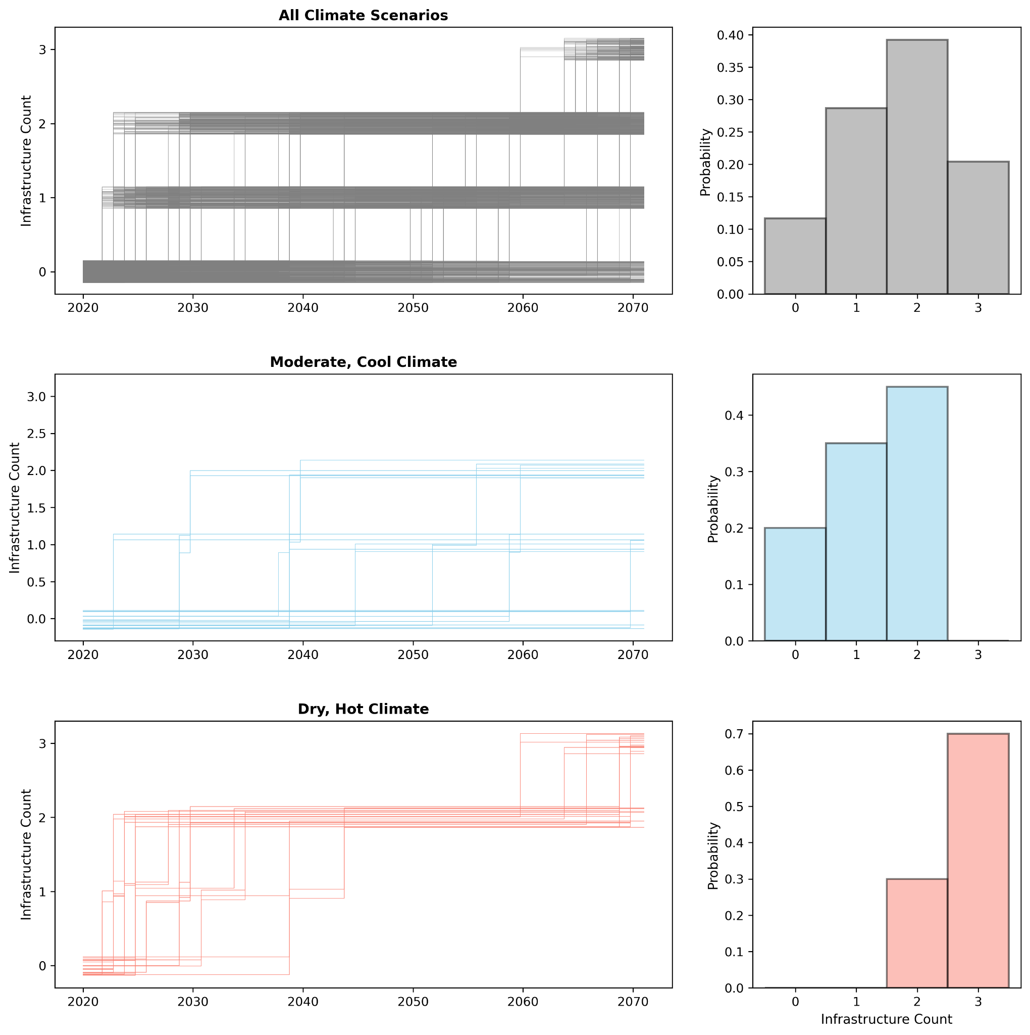
Fig. S2. Time series and histograms illustrating the timing and frequency of infrastructure investment decisions under all scenarios analyzed with adaptation. Left columns: each trace represents the timing of and number of infrastructure additions over the 50-year planning period in a single simulation. Right columns: histograms showing the number of infrastructure additions across climate simulations.

Section S3. Sensitivity analysis
We perform sensitivity analysis on the optimization and simulation steps to understand the impacts of various assumptions, using a one-at-a-time approach for the optimization analysis for computational efficiency and a full factorial approach for the simulation analysis.
For the optimization, we test one uncertain parameter for each category of our model framework as shown in Table S2 below. Our results are shown in Figure S3. Here we can compare the added water supply costs and unmet demands for each optimal strategy found (each point) for each uncertainty tested (each subplot). Across all six experiments, we see that the portfolios of optimal infrastructure planning strategies remain similar across the tested uncertain parameters, as the shapes of the scatter points denoting the first infrastructure option of the strategy remain similar to the baseline scenario. In the deployment time and infrastructure cost scenarios (panels b-e), the objective values for both utility cost and unmet demand remain very close to the baseline values, also. In the high (low) demand scenarios in panel f (g), the curve shifts right (left), reflecting higher (lower) unmet demand when household demand increases (decreases). However, the impacts on cost are relatively small, reflecting that cost in our case study is more driven by supply deficits than demand.
Figure S4 includes the hypervolumes for each uncertainty test to confirm the optimization was run for an adequate number of function evaluations and that the results converge.
Table S2. Model uncertainties tested in optimization sensitivity analysis
Module | Uncertainties to test
Water supply balance | Desalination deployment time- 5, 15 years
Infrastructure financing & rate designs | Infrastructure option capital costs (represents future political uncertainties like permitting challenges)
Household water use | Household water demands- multiplicative factors of 0.9 and 1.1

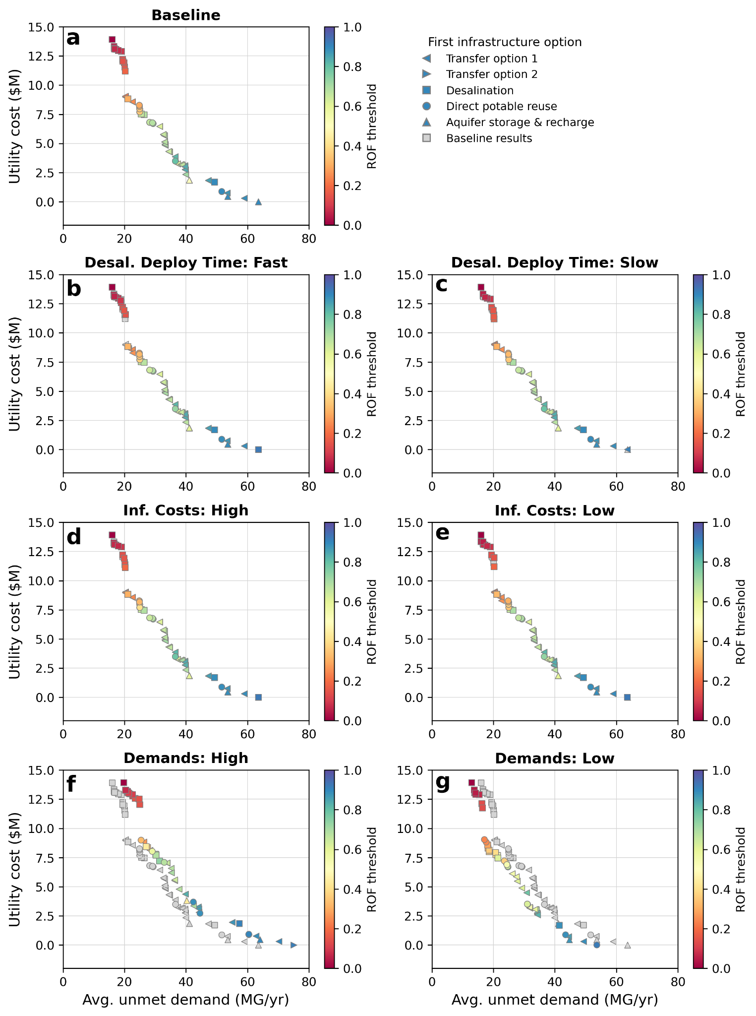
Fig. S3. Scatter plots comparing average added water supply costs and unmet demands for each optimal strategy (each point) for all tested uncertainties compared to a) the baseline, including b-c) desalination deployment time, d-e) infrastructure costs, and f-g) single-family residential demands. Shading indicates optimal risk-of-failure (ROF) threshold and shape indicates the first infrastructure option deployed. All strategies are optimized over twenty climate simulations representing the range in our analysis.
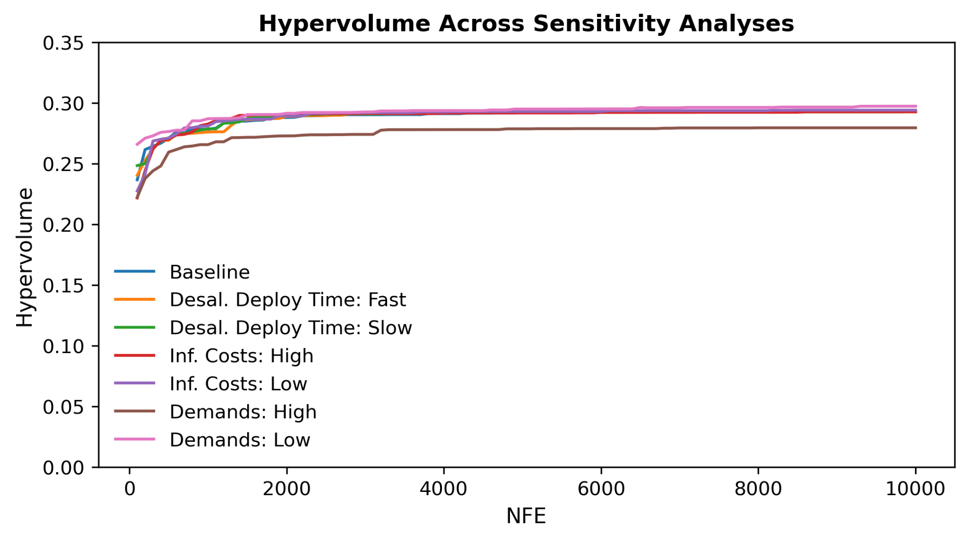
Fig. S4. Hypervolume vs. number of function evaluations (NFEs). Hypervolume shown for each sensitivity test converge by around 6,000 function evaluations
We conduct a more comprehensive sensitivity analysis for the simulation analysis because these results are more sensitive to input assumptions and more computationally efficient to produce. We utilize a fractional factorial sampling approach, where each parameter is tested at a minimum of two discrete levels of values and then all parameter combinations are evaluated.^{9,10} This approach is commonly used for extreme values to assess the best- and worst-case scenarios.
We perform three separate sensitivity analyses: first, on climate scenarios, running all perturbations of temperature and precipitation impacts; second, on infrastructure financing and rate design system characteristics; and third, on demand and demographic assumptions. The climate scenarios sensitivity analysis utilizes 900 stochastic simulations with all combinations of mean temperature (six different values from 0-5℃), mean precipitation (five different values from -20% to 20%), both shown in Figure S1, and precipitation variability (three different values from 1.0-1.2) across 10 stochastic simulations. The results are shown in Figures 2 and 3 in the main text. For the infrastructure financing/rate design and demand/demographic analyses, we utilize 20 stochastic climate simulations, from both wet and dry climate scenarios.
Table S3 lists the parameter scenarios and values utilized in the infrastructure financing and rate design and demand and demographic analyses. The low and high values in the table are used in the sensitivity analysis, while the baseline values are utilized in the main results. The one exception to this is rate structure: the sensitivity analysis compares the three-tiered structure currently used in Santa Cruz and in the model with a one-tier volumetric rate. We design the single tier to produce the same total revenue under historical conditions, by simulating ten stochastic historical climate simulations and computing an equivalent single-tier rate for each scenario. The calculated rates are nearly identical across simulations; they are $8.04/CCF and $2.91/CCF for the quantity and IRF charges, respectively.
High and low values for the interest rate (50%), desalination deployment time (50%), single-family demands scaling factor (15%), number of single-family households (15%), and single-family income shift (20%) are determined by scaling up or down baseline values by a realistic percentage indicated in parenthesis. The infrastructure cost and multi-family demand scenarios are based on the range of values from SCWD and 2020 Urban Water Management Plan.¹¹ The infrastructure cost ranges are listed in Table S6. The price elasticity values are based on the range of values in the literature, with -0.5 chosen as the extreme end of average values found in meta analyses and 0.0 chosen to assess the impact of no price response.^{12–14} Twenty climate simulations are used for both sensitivity analyses encompassing ten stochastic simulations at the wet and dry extremes of our climate parameter ranges.
Table S3. Parameter values used in infrastructure financing/rate design and demand/ demographics sensitivity analyses
Parameter | Sensitivity Analysis (SA) | Values/Scenarios |  |  | No. of scenarios in SA
Parameter | Sensitivity Analysis (SA) | Baseline | Low | High
Interest Rate (%) | Inf. Financing & Rate Design | 3 | 1.5 | 4.5 | 2
Desalination deployment time (years) | Inf. Financing & Rate Design | 10 | 5 | 15 | 2
Infrastructure Costs | Inf. Financing & Rate Design | Average | Low | High | 2
Rate Design | Inf. Financing & Rate Design | 3 tiers | 1 tier |  | 2
Price elasticity | Demand & Demographics | -0.246 | 0 | -0.5 | 2
Multi-family demands | Demand & Demographics | Moderate | Low | High | 2
Single-family demands (scaling factor) | Demand & Demographics | 1 | 0.85 | 1.15 | 2
Number of single-family households  (# households) | Demand & Demographics | 21,370 | 18,164 | 24,575 | 2
Single-family income shift (more low-/high-income households) (%) | Demand & Demographics | 23% LI, 30% HI | 28% LI | 36% HI | 2
Climate scenarios | Both | Multiple | P=120%, T=0℃, CV=1.0, real=10 | P=80%, T=5℃, CV=1.2, real=10 | 20

The simulation sensitivity results are shown in Figures S5 and S6. In both figures, we can see the full distributions of reservoir storage levels, new water supply costs, household water bills, and household affordability ratios. For both analyses, we include best and worst extreme scenarios that combine combinations of parameters likely contributing to the best or worst outcomes. For the infrastructure financing and rate design analysis, the extreme worst (best) scenario includes a high (low) interest rate, high (low) infrastructure costs, and dry (wet) climate simulations. For the demand and demographics analysis, the extreme worst (best) scenario includes low (high) price elasticity, high (low) multi-family demands, high (low) single-family demands, a high (low) number of single-family households, more low (high) income households, and dry (wet) climate simulations.
In the infrastructure financing analysis (Figure S5), high infrastructure costs have the largest impact on higher water bills and affordability ratios, comparable to the range of the across the climate scenarios, through increasing the required revenue. When comparing rate structures, although the rates are revenue-neutral, the single-tiered structure leads to higher bills and affordability impacts. Other infrastructure financing factors have minimal impacts on bill and affordability.
In the demand and demographics analysis (Figure S6), we can see that the price elasticity scenario has the largest changes. When households are more sensitive to price changes (high scenario), demands decrease significantly, leading to less necessary infrastructure, mitigating affordability impacts. In contrast, when households are not sensitive to price changes (low scenario), the impacts on reservoir storage and required infrastructure investments are as large as under the dry climate scenario. However, we note that the input ranges are much larger than the other parameters: the high price elasticity is 100% greater than the baseline, while other parameters are varied 15-20%. We chose this wide range to reflect the wide range of values found in the literature, but the comparison shown here does not necessarily mean the model is more sensitive to price elasticity than other drivers of demand change. Looking at the other parameters, we see that greater multi-family and single-family demands slightly worsen affordability impacts, mainly due to higher revenue requirements and more infrastructure. However, more single-family households, although also increasing infrastructure needs, allow the costs to be spread more broadly, actually decreasing affordability impacts. Overall, with the exception of price elasticity which used a very wide range, changes in the demand parameters have a relatively small impact on model results compared to climate parameters. This demonstrates that in our case study, infrastructure development is primarily driven by supply deficits rather than changes in demand.
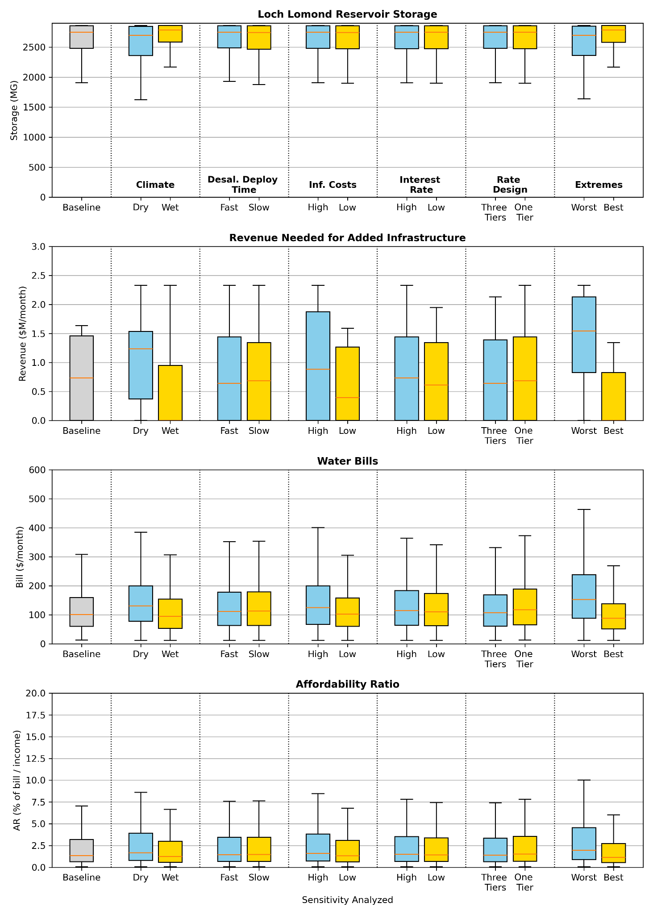
Fig. S5. Boxplots comparing infrastructure financing and rate design sensitivity analysis scenarios for all metrics in Figure 2, including (a) Loch Lomond Reservoir storage levels, (b) revenue needed for added infrastructure, (c) water bills, and (d) affordability ratios.
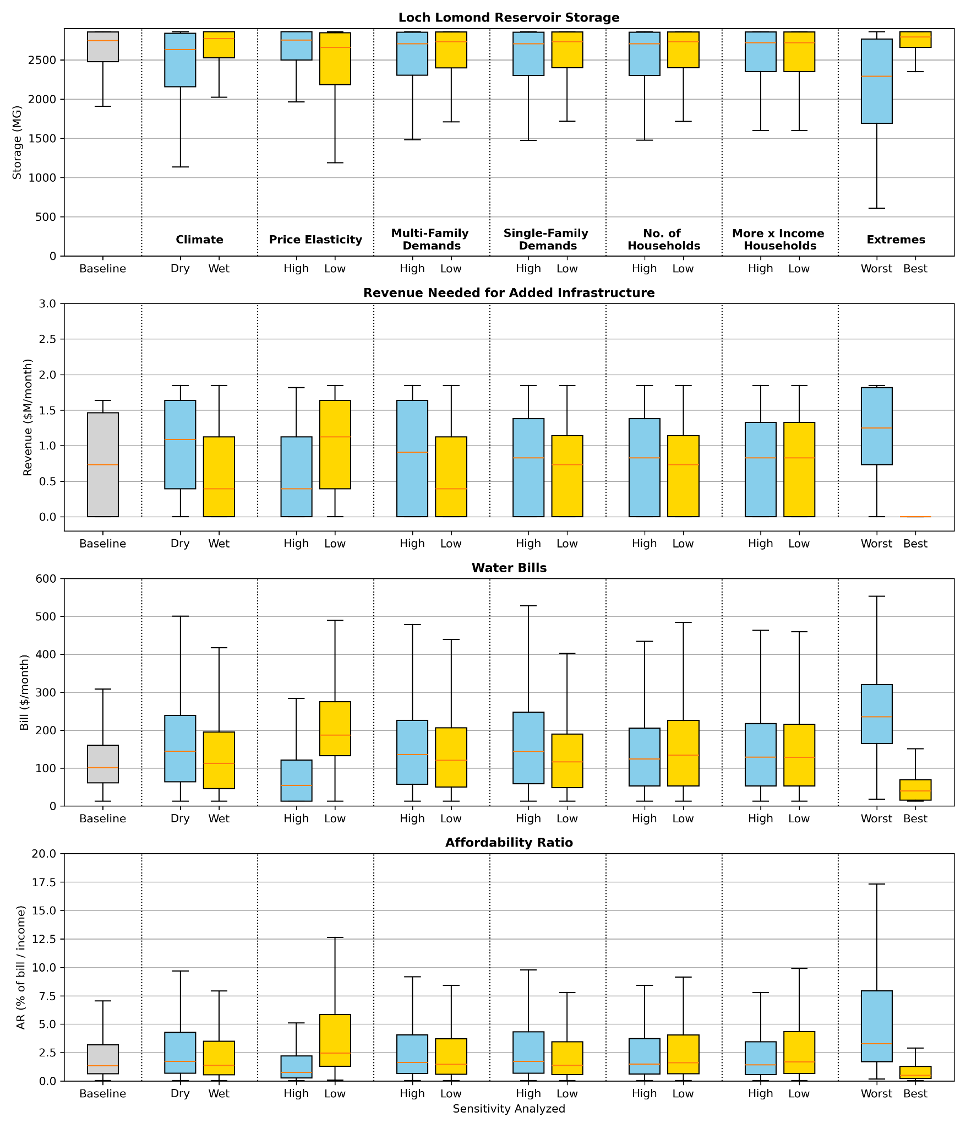
Fig. S6. Boxplots comparing demand and demographic sensitivity analysis scenarios for all metrics in Figure 2, including (a) Loch Lomond Reservoir storage levels, (b) revenue needed for added infrastructure, (c) water bills, and (d) affordability ratios.

Section S4. Boxplots highlighting water supplies, demands, and bills under individual climate impacts
The two figures below compare the distributions of water supplies, demands, and bills under the baseline scenario vs varying climate impacts with adaptation to provide additional context for Figure 4 in the text.
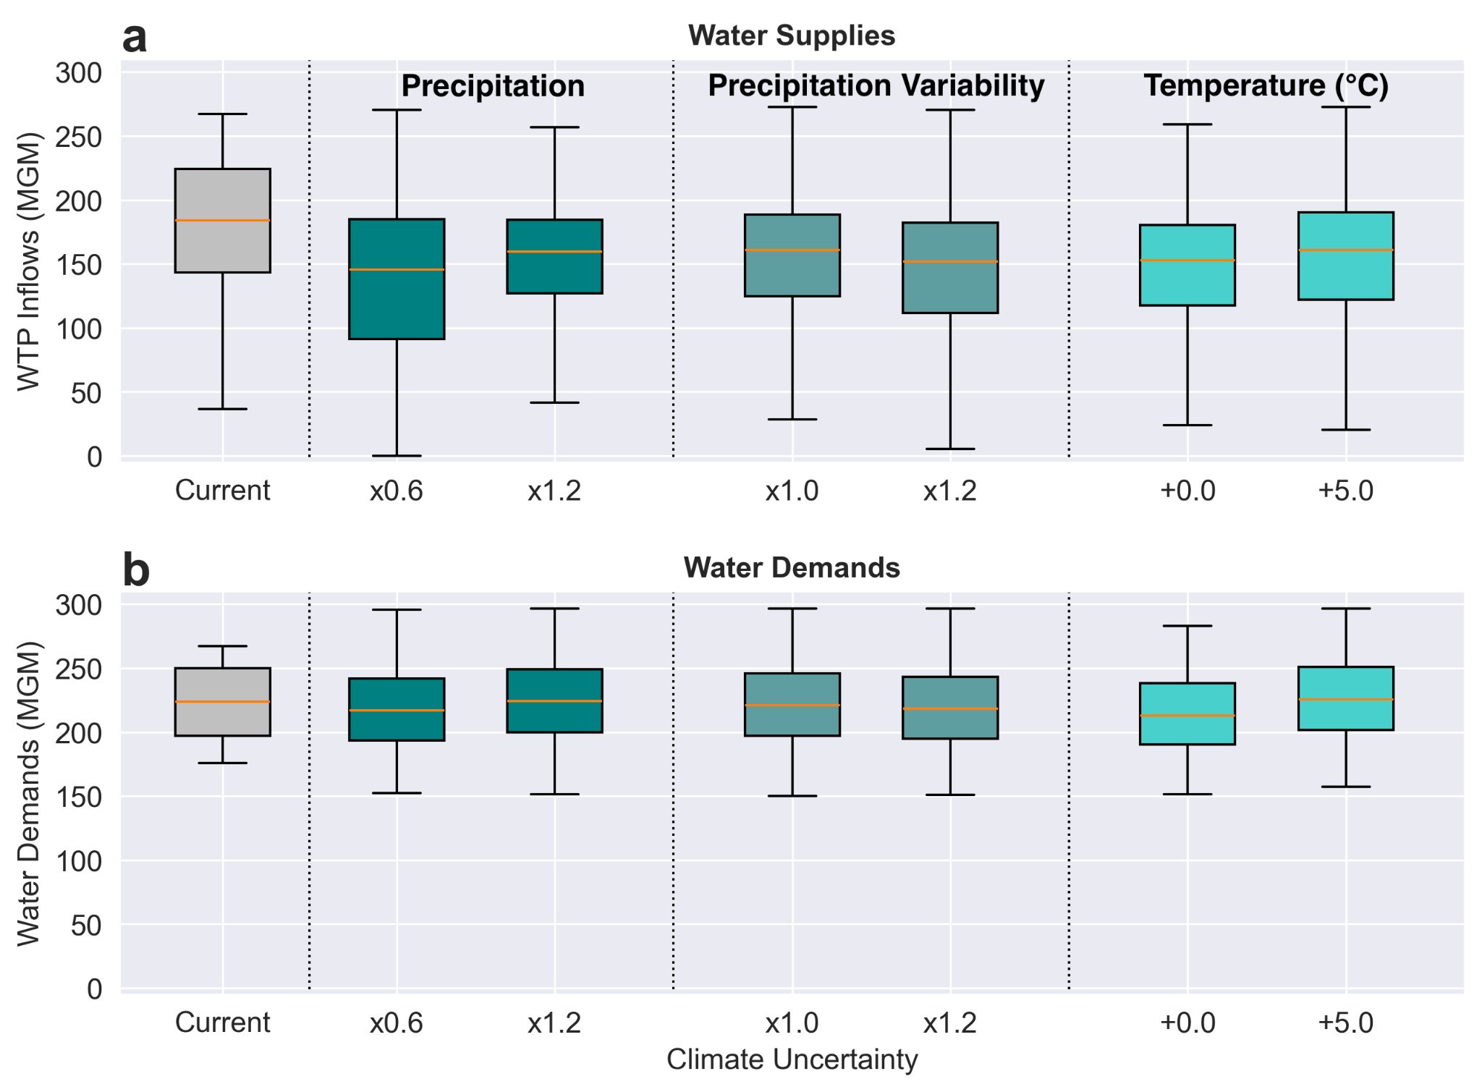
Fig. S7. Boxplots comparing the distribution of a) available inflows to the Graham Hill Water Treatment Plant and b) total water demands under the baseline scenario vs varying climate impacts with adaptation. Climate impacts include: average precipitation (percentage of historical average), precipitation variability (multiplier relative to historical average), and temperature (change from historical average in degrees Celsius). Distributions show monthly values across each subset of sampled climate simulations.
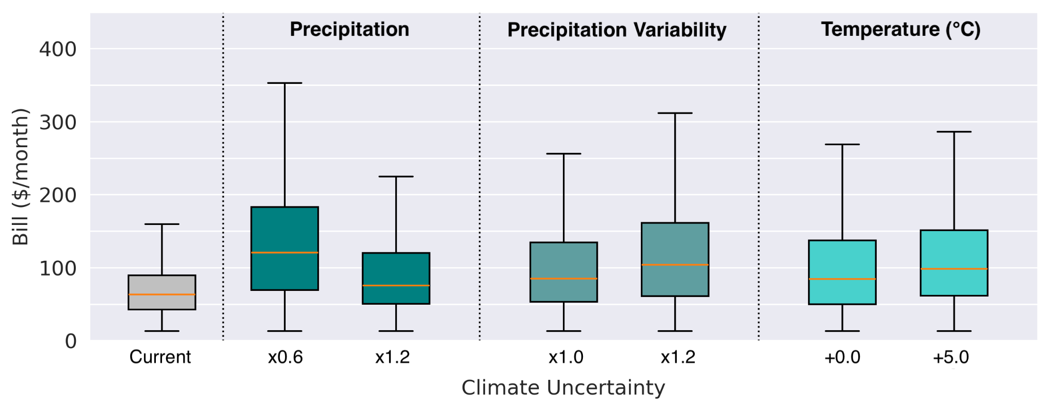
Fig. S8. Boxplots comparing the distribution of monthly water bills between the baseline scenario vs varying climate impacts with adaptation. Climate impacts include: average precipitation (percentage of historical average), precipitation variability (multiplier relative to historical average), and temperature (change from historical average in degrees Celsius). Distributions show monthly values for all households across each subset of sampled climate simulations.
Section S5. Details on choosing the baseline infrastructure investment planning strategy
As discussed in the Results, our findings are dependent on the infrastructure investment strategy used to determine what new infrastructure is built and when we build it. We choose a baseline planning strategy (“Strategy A” in Figure 5) where a 4-MGD desalination plant is built first with a moderate risk-of-failure threshold value, as detailed in Table S4. While building a desalination plant may face social acceptance concerns, we use this baseline investment strategy for three reasons.
Table S4. Infrastructure planning strategy parameters
Strategy Name | ROF Value (between 0 and 1) | Infrastructure Deployment Order
Strategy Name | ROF Value (between 0 and 1) | First | Second | Third | Fourth | Fifth
Strategy A: Baseline | 0.65 | Desalination | Direct potable reuse (DPR) | Aquifer Storage & Recharge (ASR) | Transfer option 1 | Transfer option 2
Strategy B: Risk-averse | 0.05 | Desalination | Transfer option 1 | DPR | ASR | Transfer option 2
Strategy C: Risk-tolerant | 0.89 | ASR | Transfer option 2 | DPR | Desalination | Transfer option 1

First, the desalination plant is the only single infrastructure option that avoids large deficits in some climate scenarios. We model and assess this by checking the reservoir storage, total water demands, unmet demands, and reliability under ten climate simulations with historical climate characteristics (Figure S9). We find that this planning strategy matches historic water reliability levels in Santa Cruz, where reliability almost always stays near or above 70%, consistent with reliability levels during the 2013 California drought.¹¹ Other infrastructure options with similar reliability deploy infrastructure multiple times (e.g., DPR and then desalination), leading to even higher costs and worse affordability outcomes. This is shown in Figure S10, where, since the DPR plant has a smaller capacity, more infrastructure is likely to be triggered, increasing utility costs and hence, household water bills and affordability outcomes.
Second, given that we use a multi-objective optimization approach to explore infrastructure options that give different priorities to reliability and cost, the two objectives we optimize for, we wanted to choose a baseline that roughly prioritizes these objectives equally. This infrastructure option does exactly that: its risk-of-failure threshold is close to the median of all the optimized thresholds, and its simulated reliability and cost values are close to the median across all simulated portfolios of infrastructure options. Third, the Santa Cruz Water Department has identified desalination as a preferred option for the same reason that our analysis identified: it is the most cost effective way to ensure long-term climate resilience. So while public acceptance is a potential concern, it is something the city government is actively addressing.

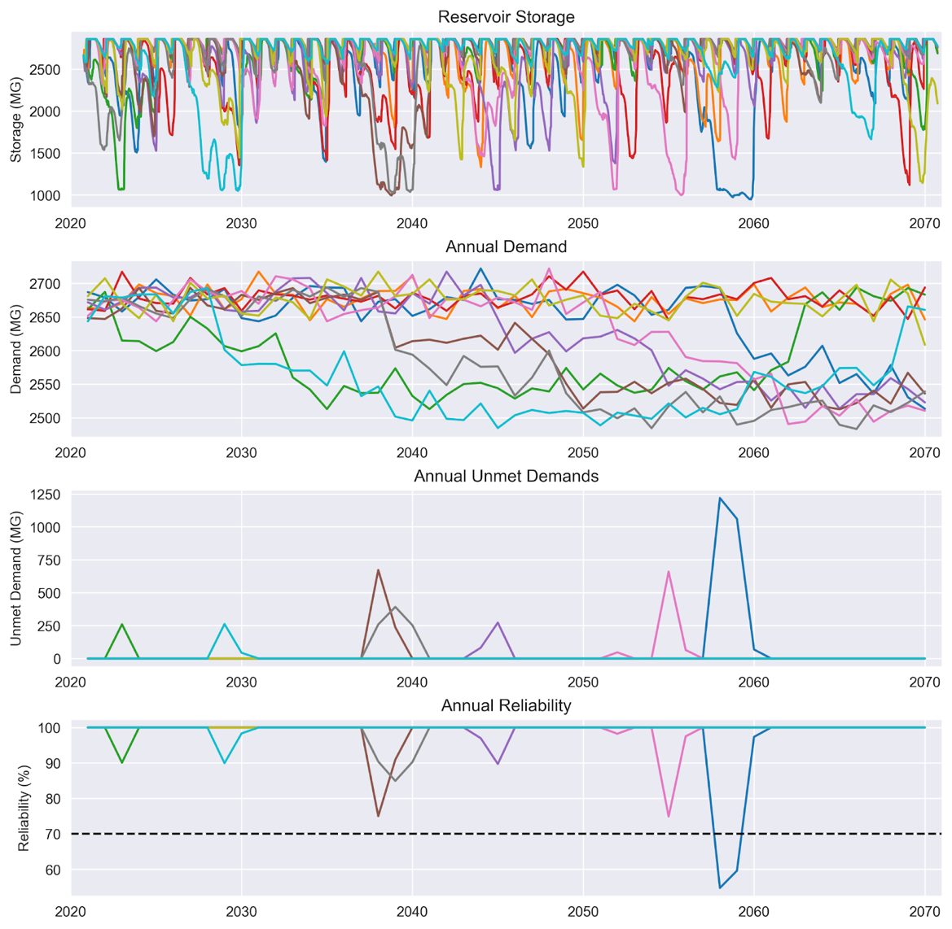
Fig. S9. Baseline infrastructure planning strategy water supply results. The baseline infrastructure planning strategy utilizes an ROF threshold of 0.65 and deploys the desalination plant first. Includes reservoir storage, total water demands, unmet demands, and reliability under historical climate characteristics. Each color represents a different realization reflecting short-term stochastic variability. The black dashed line indicates a reliability level of 70%, which is consistent with reliability levels during the 2013 California drought.^{11,15}
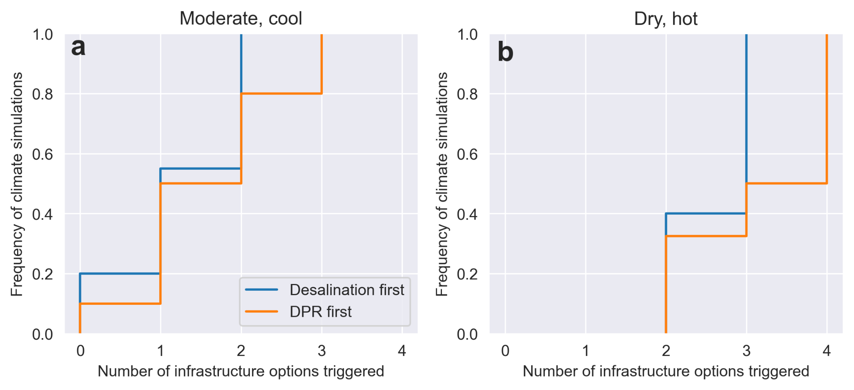
Fig. S10. Cumulative distribution functions comparing the number of infrastructure options triggered under (a) moderate, cool and (b) dry, hot climate scenarios, for desalination first (blue) and DPR first (orange) planning strategies.
Section S6. Comparison of minimum annual reliability levels across infrastructure planning strategies
The below figure compares the distribution of minimum annual reliability levels across the three infrastructure planning strategies compared in Figure 5.
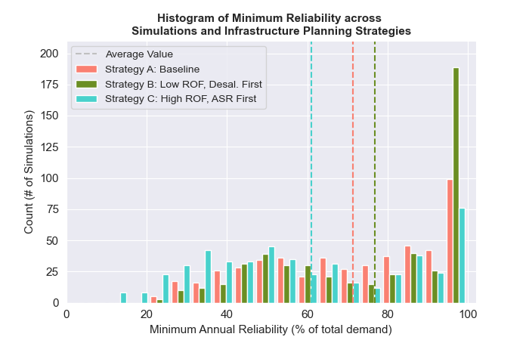
Fig. S11. Histogram of minimum annual reliability levels. Plotted across 500 climate simulations for three infrastructure planning strategies. Dashed lines indicate the average minimum annual reliability level for each planning strategy.

Section S7. Watershed map for study area
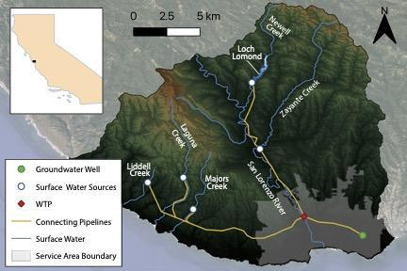
Fig. S12. Watershed map for study area in Santa Cruz, California. Reproduced from a previous study.¹⁶
Section S8. Details on water billing dataset processing and model data
We use a subset of accounts for household water demand model parameterization based on data quality. We use only single-family dwellings, as the majority of multi-family units are not submetered and do not pay their own bills. We remove outliers in water use including bills and water use below zero and use above 55 ccf/month (the 99.9th percentile). We only use bills with lengths between 28 and 31 days to more accurately capture monthly usage patterns. We merge water billing data with housing characteristics from the tax assessors’ database and sociodemographic information from the American Community Survey, as listed in Table S5. Since the tax assessor database was not designed for geospatial analysis, we occasionally encounter edge cases, mainly related to recently developed multi-family properties classified as single-family. These instances only comprise about 1% of households and do not materially affect our results. We remove duplicate bills and accounts with incomplete or outlier housing characteristics data, such as values less than zero or having greater than ten bathrooms. We deidentify account holder names, as well as billing and service addresses.
For developing a set of accounts to use in the household water demand component of the simulation model, we use a similar process to that for parameterization with one exception: we only keep households with at least 12 bills to ensure we capture seasonal variability in computing each household’s direct bias correction factor. We compute the direct bias correction factor as the average difference between measured and modeled water use (in real scale) for each household. When we merge accounts with complete housing characteristics and at least 12 bills, we obtain 12,685 single-family households from 56,613. The water billing dataset is included in our list of all data sources in Table S5.

Table S5. A list of data sources and attributes
Data Sources | Purpose | Attributes | Units | Source
Water Billing Dataset | Household water demand model | Bill start and end dates | Date | Santa Cruz Water Department
Water Billing Dataset | Household water demand model | Water quantity consumed by tier | CCF | Santa Cruz Water Department
Water Billing Dataset | Household water demand model | Volumetric costs, including consumption, infrastructure reinvestment, rate stabilization, and elevation surcharge costs | $/CCF | Santa Cruz Water Department
Housing Characteristics | Household water demand model | Home tax value | $ | 2021 property and tax data from the County of Santa Cruz tax assessor's database
Housing Characteristics | Household water demand model | Home Main Area | Square Feet
Housing Characteristics | Household water demand model | Number of bathrooms | -
Housing Characteristics | Household water demand model | Number of bedrooms | -
Housing Characteristics | Household water demand model | Pool presence/absence | Boolean
Environmental Data | Household water demand model | Monthly precipitation | mm | National Land Data Assimilation System
Environmental Data | Household water demand model | Monthly average temperature | deg. Celsius | National Land Data Assimilation System
Environmental Data | Household water demand model | Monthly actual evapotranspiration | mm | Global Land Data Assimilation System
Census data | Household income estimation | Block group income distributions | 16 bins, ranging from $10,000/yr to $250,000/yr | 2019 5-year American Community (ACS) Survey Data
Public use microdata | Household income estimation | Income | $ | 2019 5-year ACS Public Use Microdata Sample (PUMS) data
Public use microdata | Household income estimation | Property value | $ | 2019 5-year ACS Public Use Microdata Sample (PUMS) data
Public use microdata | Household income estimation | Number of bedrooms | - | 2019 5-year ACS Public Use Microdata Sample (PUMS) data
Public use microdata | Household income estimation | Annual water costs | $ | 2019 5-year ACS Public Use Microdata Sample (PUMS) data
Utility long-range financial planning attributes | Infrastructure financing and rate design | Water Rates | $/CCF | 2016 and 2020 Santa Cruz Long-Range Financial Report
Utility long-range financial planning attributes | Infrastructure financing and rate design | Operational costs | $ | 2016 and 2020 Santa Cruz Long-Range Financial Report
Utility long-range financial planning attributes | Infrastructure financing and rate design | Loan interest rates | % | 2016 and 2020 Santa Cruz Long-Range Financial Report
Utility long-range financial planning attributes | Infrastructure financing and rate design | Loan payback periods | years | 2016 and 2020 Santa Cruz Long-Range Financial Report
Utility long-range financial planning attributes | Infrastructure financing and rate design | Loan principal amounts | $ | 2016 and 2020 Santa Cruz Long-Range Financial Report
Systemwide water use data | Household and other water demands | Annual water use by user type | MG | 2020 Santa Cruz Urban Water Management Plan
Gridded temperature and precipitation data for water resources model | Water supply balance model | Temperature daily minimum and maximum | deg. Celsius | Maurer et al. 2002
 | Water supply balance model | Precipitation | mm | Maurer et al. 2002
Streamflow data | Hydrology model | Streamflow | cfs | USGS Streamflow Gage Data
Climate projections data | Climate change scenarios | Temperature | deg. Celsius | Cal-Adapt
Climate projections data | Climate change scenarios | Precipitation | % difference | Cal-Adapt

Section S9. Details on water supply balance model
We use the Santa Cruz Water System Model (SCWSM) to estimate water allocations. SCWSM is the Santa Cruz Water Department (SCWD)’s new water supply planning model that replaced the Confluence model the SCWD used for planning for over three decades.¹⁷ SCWSM runs at a daily timestep to accurately represent the system operations (including the water rights and water quality constraints). We run the model for 50 years, for water years 2021-2070. The model uses linear programming to determine water allocations based on a least-cost approach, where we assign costs to each water supply source based on realistic operating conditions (the costs assigned to each water source and stored in Loch Lomond are used to set the dispatch order, or the priority to which each source is used to supply demand). The model includes important system facilities, including Loch Lomond, the only reservoir; water diversions; pump stations; treatment plants; and groundwater wells. Loch Lomond falls last in the dispatch order when providing water to the service area, although reservoir water is used to satisfy local transfers and minimum flow requirements below the dam. The model captures various water rights, which dictate the system’s operation mainly to ensure adequate ecological flows and maximum annual and daily diversions from the different sources. Additionally, the model includes new plausible water supply infrastructure options, with the ability to turn various options on or off within a single simulation. Model boundary conditions include the inflow hydrology, precipitation and evaporation rates over the reservoir, and water demands. Model outputs include reservoir volumes; water supplies through major pumps, pipelines, and diversions; and water deliveries.⁷ The model has been validated against the Confluence model using historical data from 1937-2015.⁷
Section S10. Details on hydrological model
We use a lumped hydrological model based on a single streamflow location within SCWD’s watershed area, shown in Figure S13 and discussed in detail in Appendix D-1 of the Santa Cruz Water Rights Project’s Environmental Impact Report.¹⁸ The base streamflow location is on the San Lorenzo River at Big Trees utilizing USGS streamflow gage data (ID: 11160500) and is chosen because it has the longest continuous streamflow record from 1936 to the present and is a primary water source for the city. Overlapping flow records are used to develop regression models between the San Lorenzo River and other important streamflow locations. Other streamflow data comes from USGS gages and the city with streamflow records ranging from 7 to 28 years. Streamflow is modeled at a daily timestep to provide a reasonable measure of ecological conditions and to more realistically evaluate water supply reliability. Accurate representation of the system diversion operations also requires daily resolution to ensure compliance with water rights. Flow withdrawals are made to account for ecological requirements for fish habitation. Calibration periods have daily streamflow errors less than 5%. While this model does not capture all of the variance in historical data, it does calculate low flow periods to an acceptable level (<10% relative error), which is the goal of the model.^{18,19} Full validation data are available on page 6 in Appendix D-1.¹⁸ To use the hydrological model under climate change scenarios, the time series generated in Section S1 are input into the hydrological model.¹⁸
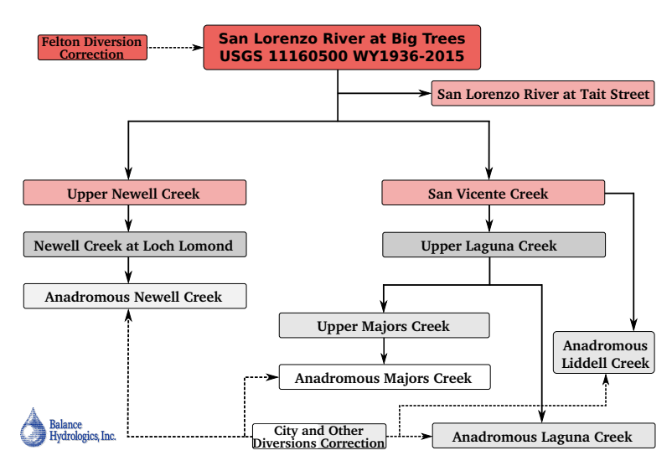
Fig. S13. Workflow for base hydrology model. Illustrates the regression relationships between streamflow locations. Solid lines between boxes indicate regression relationships and dashed lines indicate flow correction estimates. Adapted from a previous report.¹⁸

Section S11. Details on risk-of-failure (ROF) table development and utilization
We develop risk-of-failure (ROF) lookup tables by running hundreds of two-year simulations to approximate the risk of reservoir levels dropping below a minimum operating level in the upcoming two-year period.²⁰ The ROF triggers are based on three dimensions: initial reservoir storage level, annual water demand levels, and infrastructure options that have already been planned or implemented. First, we choose ranges of these three dimensions to include. For initial storage levels, we use values between 40% and 100% of total storage capacity, as SCWD’s target for minimum operating level is ~36%. For annual total water demands, we look at a range of 2300-3100 MG/year (in 100 MG increments; Santa Cruz’s 2020 water usage is 2,606 MG¹¹). For infrastructure options, we look at all combinations of options between zero and three of the five options. We determine this range by testing the sensitivity of residential demands in our econometric model and by randomly sampling from our multi-family and non-residential demand scenarios.
After defining the ranges, we estimate the two-year risk of failure for each possible combination of system conditions (i.e., initial reservoir storage, annual water demand, and infrastructure options). To do this, we randomly sample ten climate simulations across all climate perturbations and divide the 100-year scenarios into 99 two-year segments, running hundreds of simulations for each combination of system conditions. Figure S14 illustrates, for one reservoir storage level, the estimated risk-of-failure for every combination of annual water demands and planned or deployed infrastructure options. We analyze all infrastructure portfolios that include 0-3 infrastructure options.
Once the ROF lookup tables (comparable to Figure S14 but for all reservoir storage levels and infrastructure options) are developed, we incorporate them into our simulation. Each simulation uses a ROF trigger threshold (chosen in the optimization analysis); if the ROF for the current system state is above the threshold, that triggers the development of new infrastructure. We evaluate ROF triggers annually, in October at the start of the water year. Figure S15 illustrates how reservoir storage levels and annual water demands impact ROF values, and how the threshold triggers new infrastructure projects when it is exceeded.

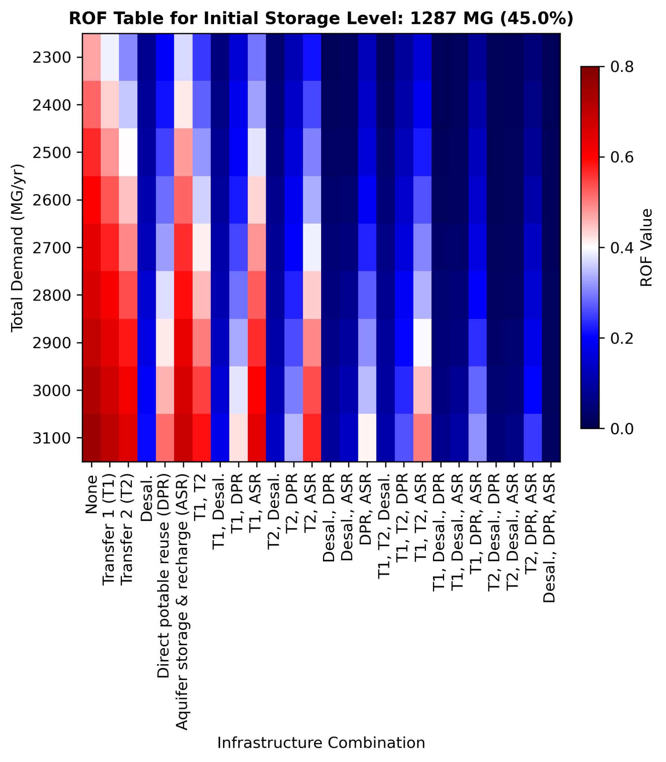
Fig. S14. Risk-of-failure (ROF) lookup table for an initial storage level of 1287 MG (45% of reservoir capacity) across annual demand and infrastructure combinations analyzed. Higher ROF values indicate a greater likelihood of reservoir storage dropping below deadpool levels in the next two years.
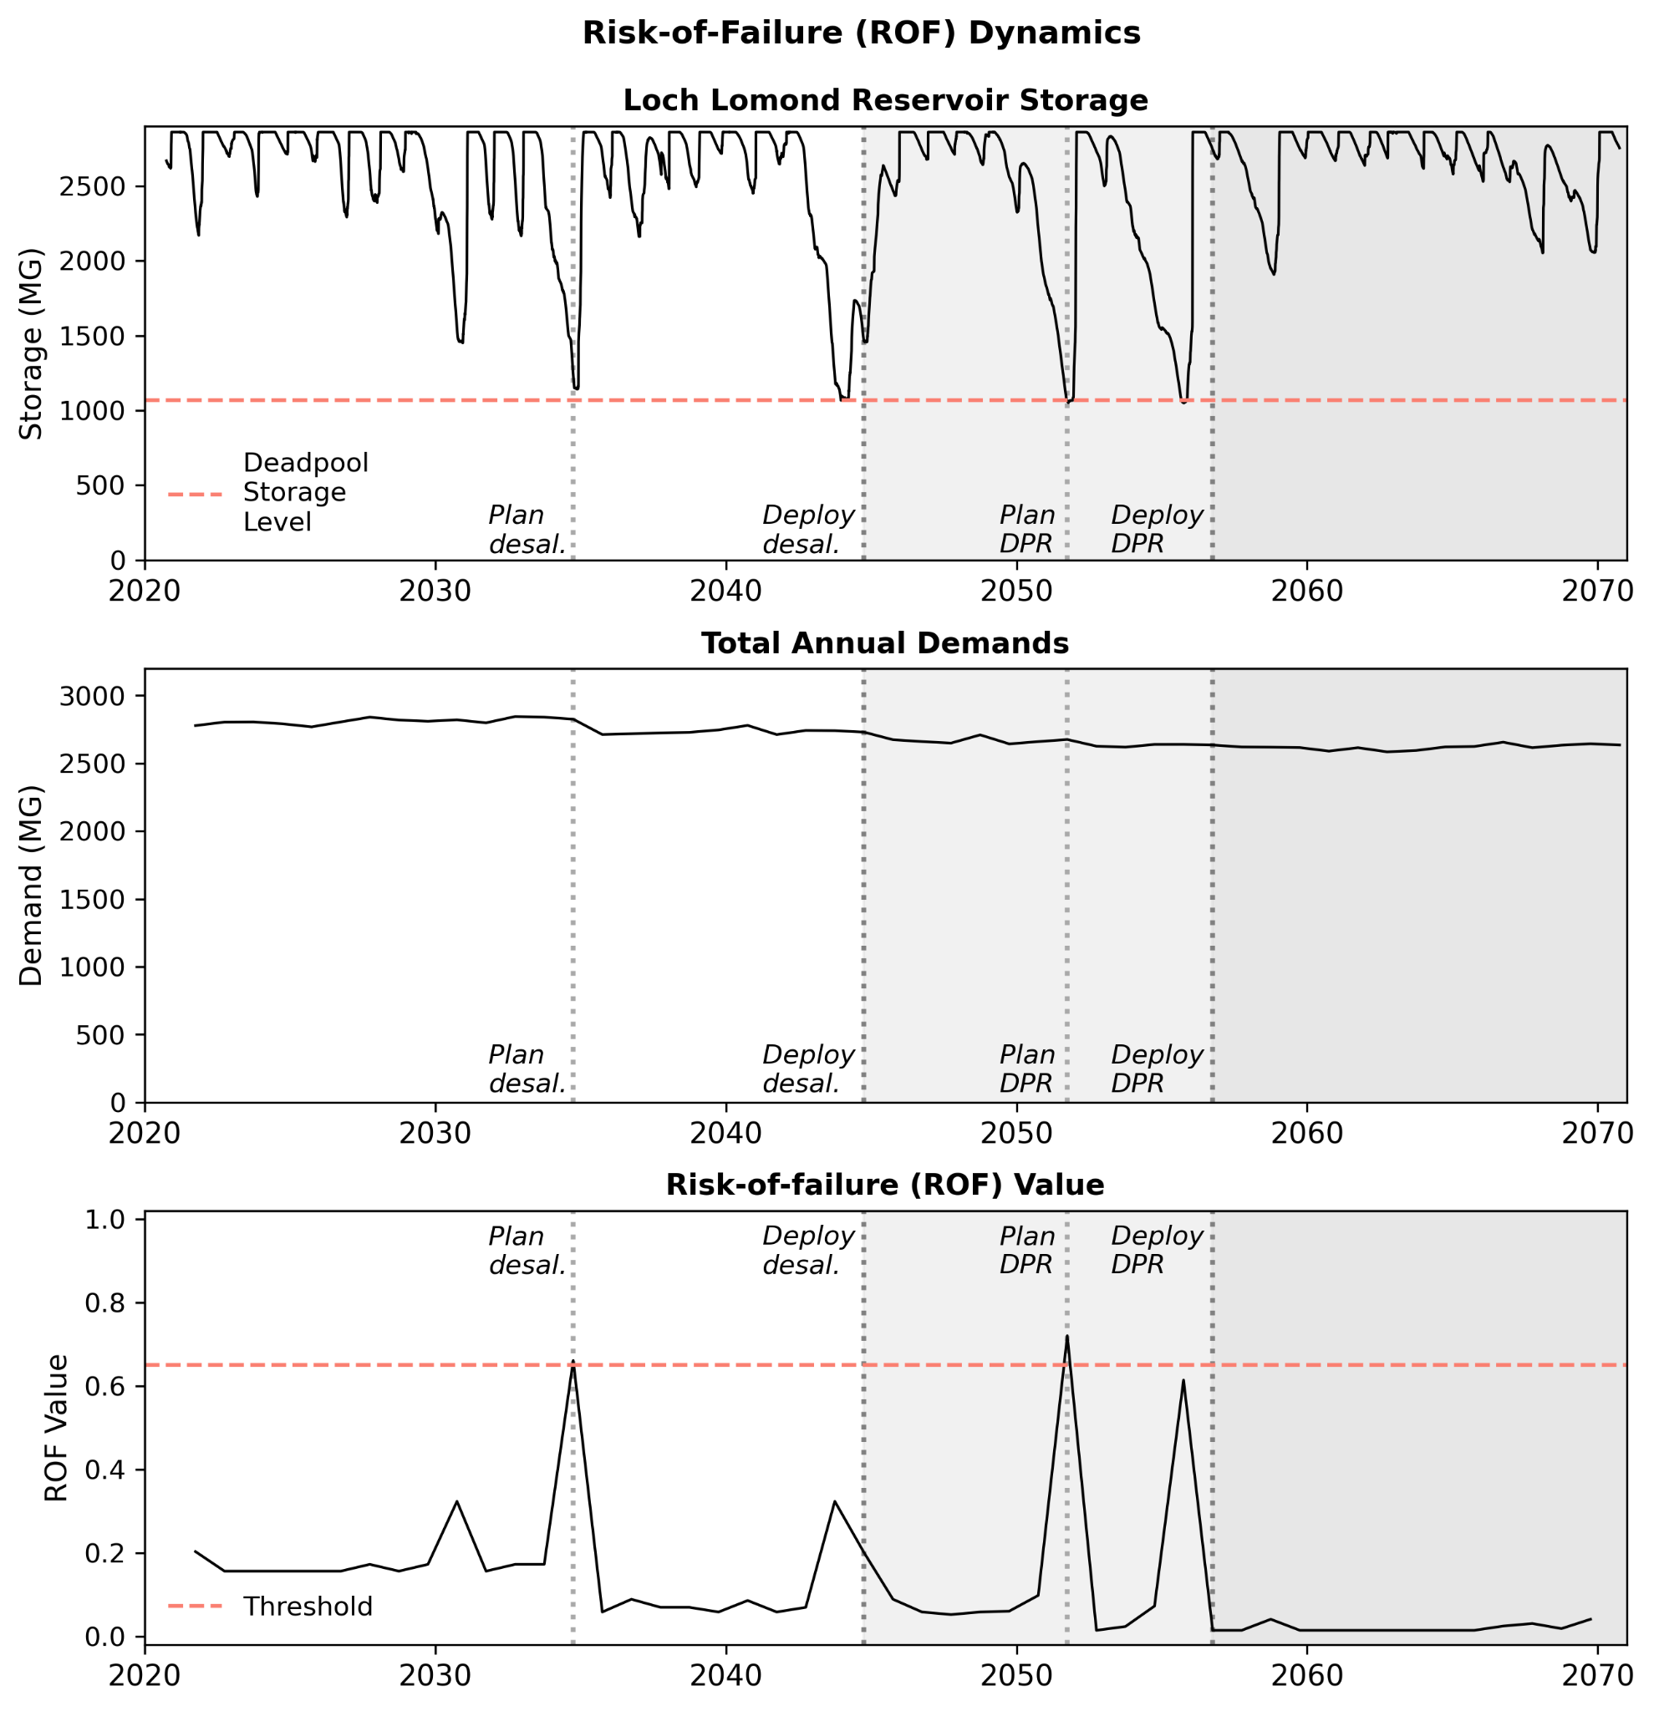
Fig. S15. An illustrative example, chosen because the simulation implements multiple infrastructure additions, showing how (a) Loch Lomond Reservoir storage levels and (b) total annual demands influence (c) ROF values and infrastructure investments when ROF values exceed a given threshold. Dashed lines indicate relevant thresholds for this example.

Section S12. Techno-economic details on infrastructure costs
Table S6. Infrastructure options, operations, and cost assumptions. All costs are in 2020 real dollars (converted from 2024 real dollars). Capital cost ranges reflect uncertainty in future infrastructure costs utilized by SCWD.
Supply Option | Capacity (MGD) | Capital Cost ($M) (range) | Annual Operating Cost ($M/yr) | Max. capacity (MGD) | Operating conditions description | Deployment time (years)
Aquifer storage and recovery (Mid-county GWB) | 2.3 (5 wells) | 56  (28-112) | 1.3 | 2.3 extract, 1.6 inject | Inject Nov.-April, except dry months  Extract May-Nov. | 2
Transfers to/from Soquel Water District | 0.5 | 0 | 0.6 | To city: 0.5  To Soquel: 0 | Constant supply, as needed | 1
Transfers to/from Scotts Valley Water District (SVWD) | 1.0 | 3.3  (3.0-3.8) | 0.2 | To city: 1.0 To SV: 1.0 | Constant supply, as needed; no transfers to SVWD during dry months | 1
DPR | 2.0 | 1454.7 (73-347) | 3.8 | 2.0 | Winter capacity: 1 MGD  Summer capacity: 2 MGD | 5
Desalination Plant | 4.0 | 212.4 (106-426) | 10.0 | 4.0 | Winter capacity: 1.33 MGD; Summer capacity: 2.67 MGD;  Drought: 4.0 MGD | 10

Section S13. Details on Borg multiobjective evolutionary algorithm
We use the Multi-master Borg multiobjective evolutionary algorithm to determine Pareto-approximate infrastructure strategies.²¹ We run Borg on Sherlock, a High-Performance Computing cluster, using 50 nodes and 10 tasks per node. Using four random seeds and 25,000 function evaluations, the model converges in approximately five days per seed. Figure S16 shows optimization performance across seeds, ensuring that the function is run for enough iterations to enable confidence that we obtain both optimal infrastructure planning strategies and optimized objective values.
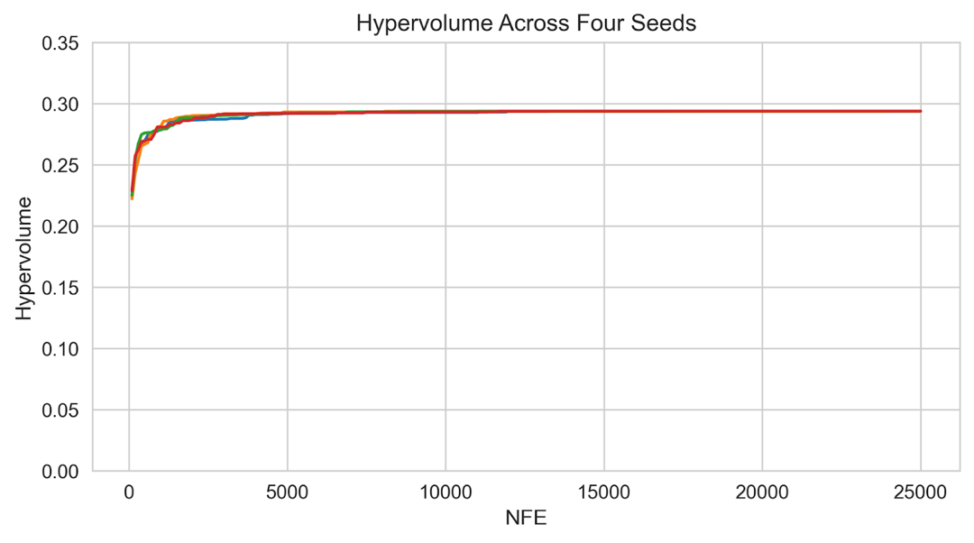
Fig. S16. Hypervolume vs. number of function evaluations (NFEs). Hypervolume shown for four seeds shows convergence by around 10,000 function evaluations, ensuring we obtain optimal infrastructure planning solutions and objective values.

Section S14. Details on water demand econometric model
A Discrete/Continuous Choice (DCC) model is used to estimate residential water demand under the increasing block tariff (IBT) prevailing in Santa Cruz. Water demand estimation under an IBT faces the challenge of price endogeneity, where the quantity demanded depends on the price of water, but the price of water under the tariff structure in turn depends on the consumption quantity. The approach addresses this challenge by simultaneously modeling the discrete selection of a tariff block and the continuous choice of a water demand consumption quantity. The approach uses maximum likelihood estimation (MLE) to determine demand function coefficients. The full set of MLE equations can be found in previous work.^{22,23} The model includes the following housing characteristics as coefficients: home tax value, main area size, number of bathrooms (and bathrooms squared), and pool presence. We use home tax value as a proxy for household wealth instead of income,²⁴ since tax value data is available at the household level. We assume all housing characteristics are constant over the billing data and model simulation periods. In addition, the model includes environmental characteristics, which vary monthly, including: precipitation, average temperature, and actual evapotranspiration.²⁵ Besides coefficients reflecting housing and environmental characteristics, the model also estimates the price elasticity of water demand. The underlying marginal water prices (in dollars per hundred cubic feet of water) for every bill are determined based on the tariff rate applicable in the highest used tier of the IBT. As an error term, we add a direct bias correction factor for each household, which we compute as the average residual between measured (billing) and modeled data. All model coefficients are in Table S7.
Table S7. DCC model estimated coefficient values
Parameter Name (Unit) | Coefficient Value
Intercept (-) | 0.516
Log(marginal price) ($) | -0.246
Log(home tax value) ($) | 0.058
Home main area (sqft.) | 1.97E-04
Number of bathrooms (count) | 0.071
Number of bathrooms squared (count²) | -5.09E-03
Pool presence/absence (boolean) | 0.212
Monthly actual evapotranspiration (mm) | -7.50E-05
Monthly precipitation (mm) | -5.20E-06
Monthly temperature (°C) | 0.031
Eta error term (-) | 0.580
Epsilon error term (-) | 0.458

At the household scale, model performance is r²=0.36 at the household scale with the direct bias correction factor. At the income group scale, which is our unit of analysis, model performance is much higher, where r²=0.76 when averaged across all ten income estimates. One sample income estimate is shown in Figure S17.

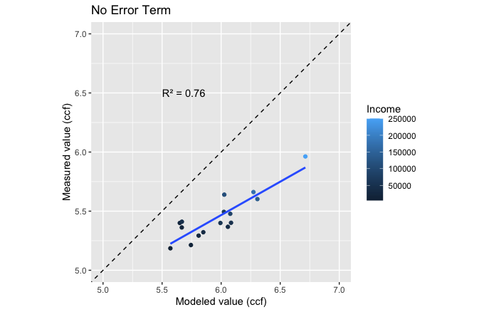
Fig. S17. Correlation plots between measured and modeled water demands for each income group for one of the ten income estimates. Plot shows model estimates before bias correction is applied.
Section S15. Details on household income estimation
To estimate household affordability ratios, we develop household-level income estimates, ensuring that the number of households in each income class matches census block group data on household income distribution. Our approach uses multivariate regression to estimate household-level income based on housing characteristics and then assigns those income estimates to one of sixteen income bin based on census block group level data, similar to estimation methods in other studies.^{26,27} Since the regression error is large, we confirm that the impact of error at the household scale is negligible when we aggregate to the income class estimates by testing and comparing ten different versions of our estimation approach.
Our approach involves four main steps and multiple datasets, including household-level water utility billing data, tax assessor housing characteristics data, American Community Survey (ACS) Public Use Microdata Sample (PUMS) data for housing units, and ACS block group-level income data. First, we develop a log-log multivariate regression model using all available single-family PUMS data (1009 single-family households) to predict household-level income given the number of bedrooms, property value, and total annual water cost (R² = 0.072). Second, we use this model to predict household-level income for all households in Santa Cruz. For each household, we extract total annual water cost from the water utility billing data, and number of bedrooms and property value from the housing characteristic data. Third, to model uncertainty given the low R², we sample the regression model error term ten times and add the error term to the predicted income values, resulting in ten household-level income estimates. Fourth, we use quantile mapping to ensure that household-level income estimates match city-level income distributions. Here, we assign each household-level predicted income to one of sixteen discrete census block group income bins based on the rank order from our estimations. We ensure that different income estimates negligibly impact our results, summarized in Table S8 and shown in Figures S18-S21.

Table S8. Comparison of median and 80th percentile affordability ratios across income estimates under moderate, cool and dry, hot climate scenarios
Income Estimate | Moderate, Cool Climate |  | Dry, Hot Climate
Income Estimate | Median | 80th percentile | Median | 80th percentile
1 | 1.09 | 3.34 | 1.55 | 4.61
2 | 1.08 | 3.32 | 1.53 | 4.60
3 | 1.08 | 3.33 | 1.52 | 4.63
4 | 1.08 | 3.26 | 1.53 | 4.49
5 | 1.09 | 3.33 | 1.53 | 4.60
6 | 1.09 | 3.38 | 1.55 | 4.65
7 | 1.09 | 3.23 | 1.55 | 4.43
8 | 1.08 | 3.28 | 1.53 | 4.51
9 | 1.09 | 3.31 | 1.55 | 4.61
10 | 1.09 | 3.24 | 1.55 | 4.47

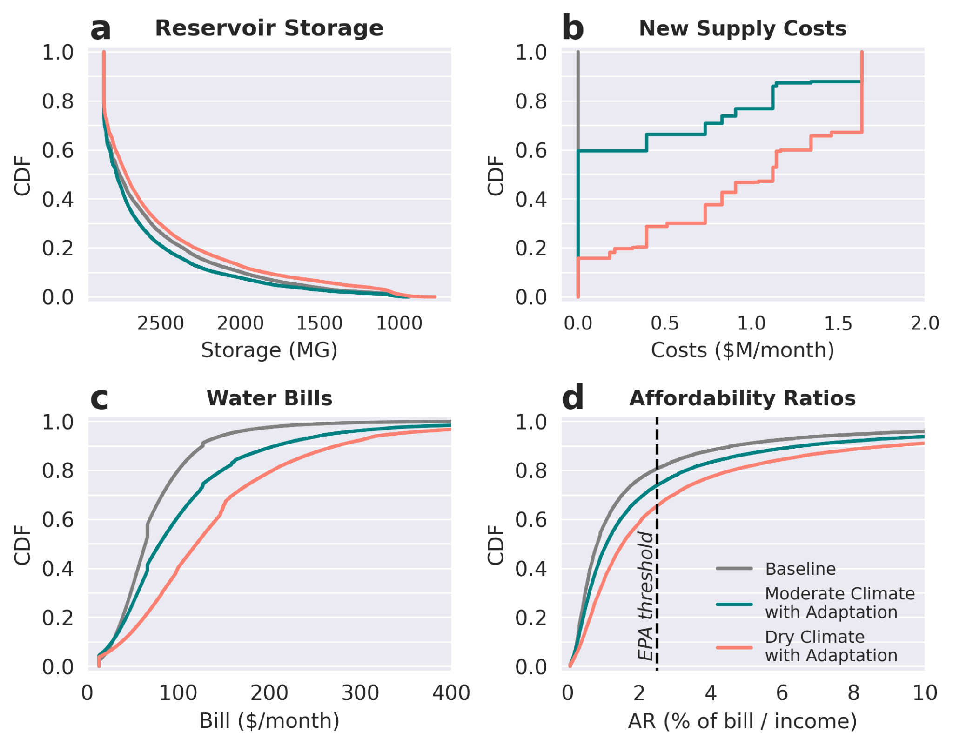
Fig. S18. Version of Figure 2 with different income estimate without “all climate simulations” scenario for simplicity. Differences are in panel d only.
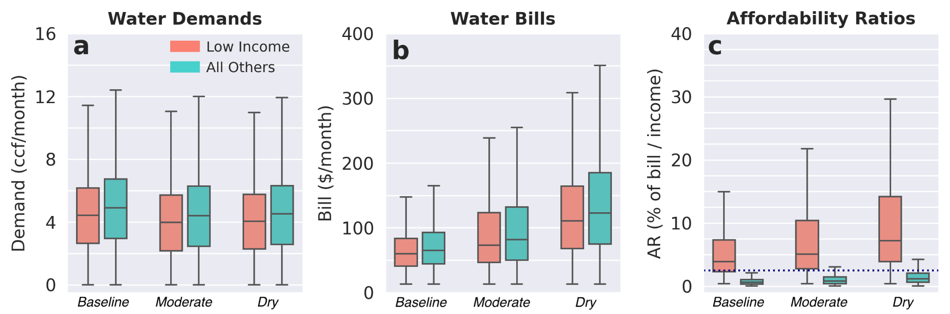
Fig. S19. Version of Figure 3 with different income estimate without “all climate simulations.”. Differences across all boxplots.

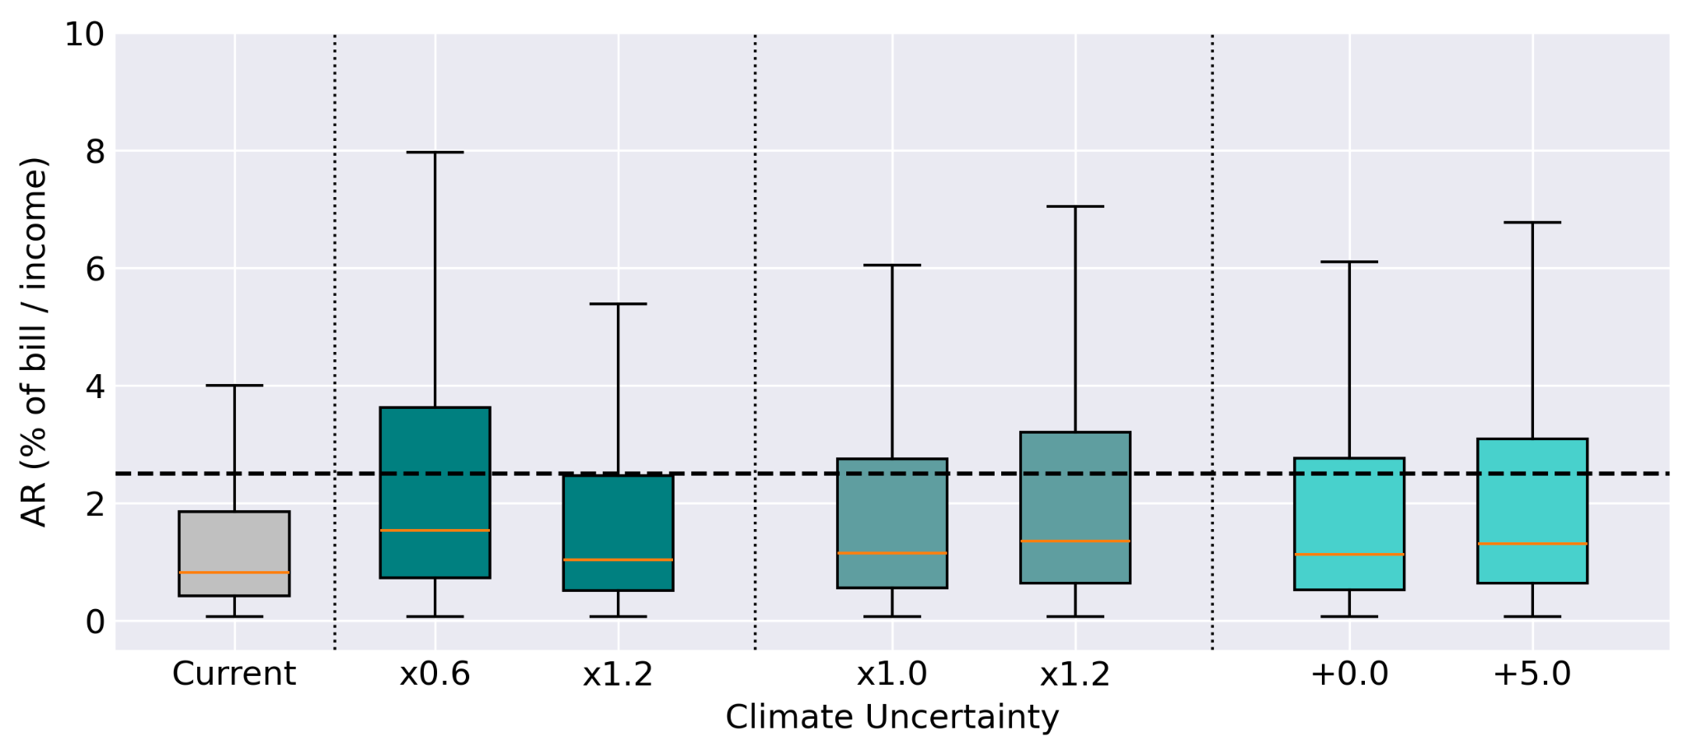
Fig. S20. Version of Figure 4 with different income estimate. Differences across all boxplots.

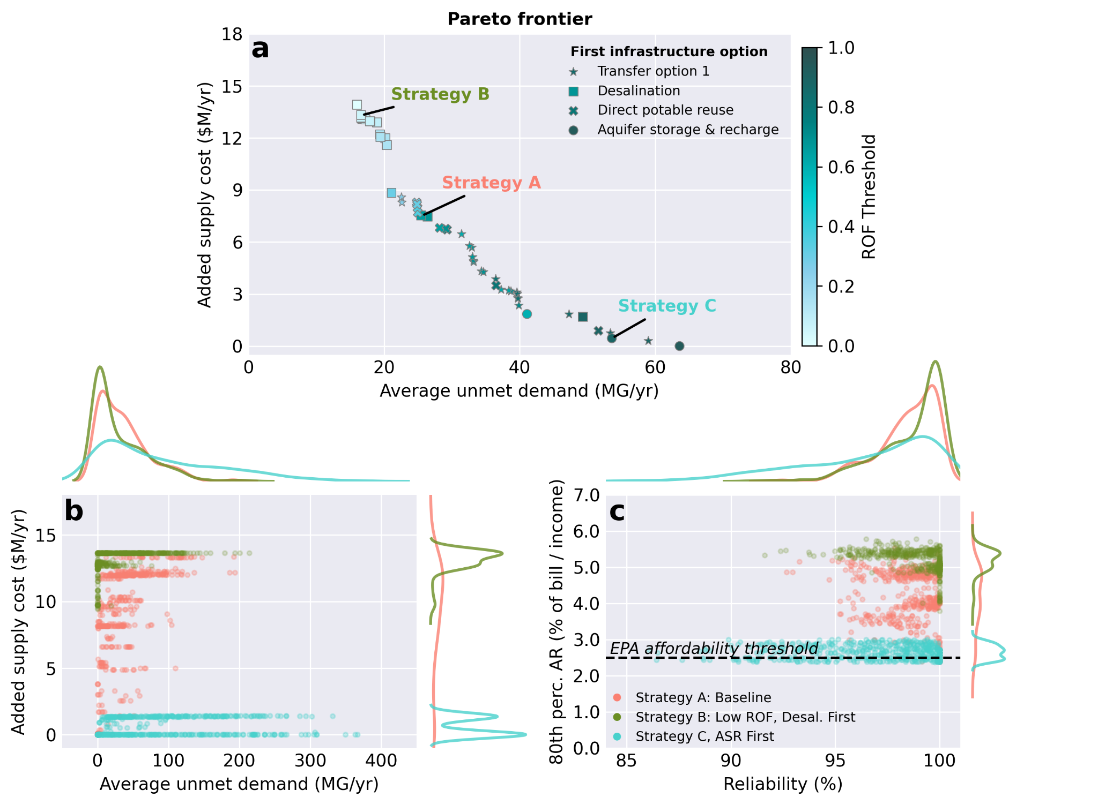
Fig. S21. Version of Figure 5 with different income estimate. Differences in panel c only.

Section S16. Multi-family and non-residential water demand scenarios
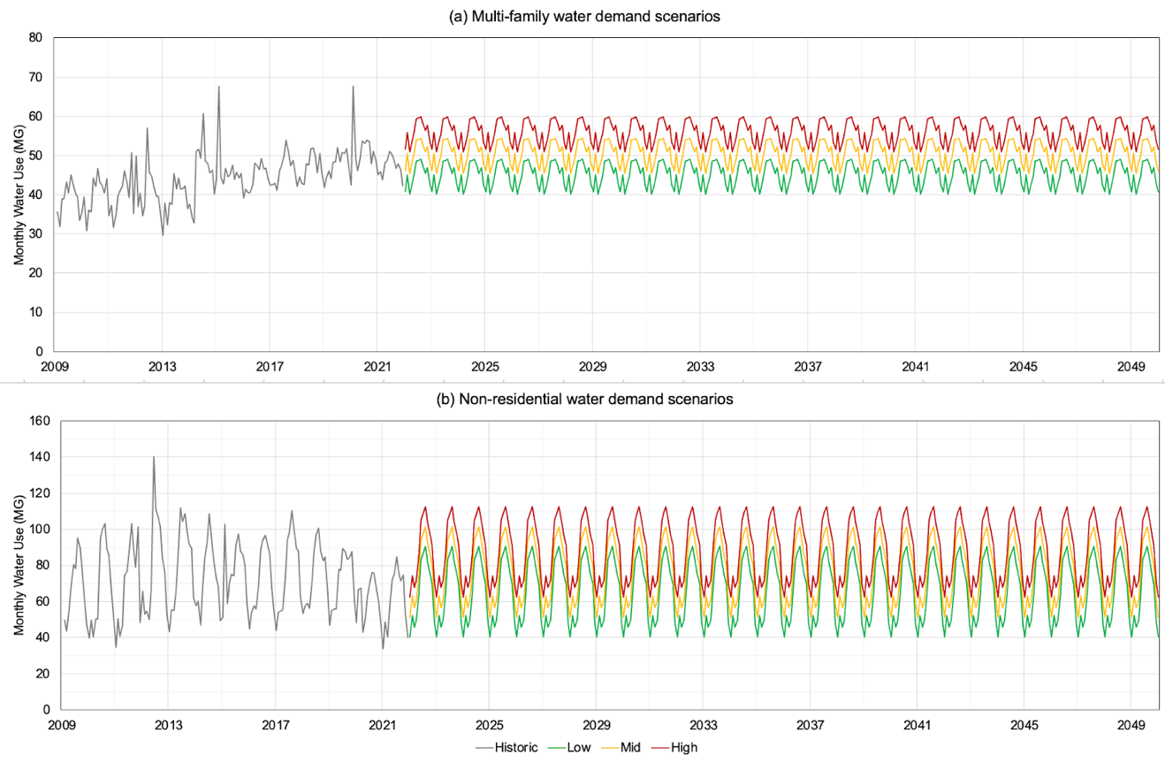
Fig. S22. Monthly low, medium, and high water demand scenarios for (a) multi-family and (b) non-residential establishments. We determine annual average values using 2020 Urban Water Management Plan 2025-2045 projected values.¹¹ Monthly anomalies, which remain the same across low, medium, and high scenarios, are calculated by averaging the difference between monthly water use and average annual water use for each year and each month of the year within each water demand category.
Section S17. Details on operation and maintenance scenario
We develop an assumption about future operations and maintenance (O&M) costs based on Santa Cruz’s 2016 and 2020 Long-Range Financial Plans, to capture the proportion of total utility costs that O&M represents.^{28,29} Our scenario assumes current (2020), stationary conditions, with all costs in 2020 real dollars. Revenue is sourced from four water bill charges: elevation surcharges and rate stabilization fees (both assumed constant), fixed fees, and volumetric charges. Ten percent of total remaining revenue is fixed, with each household paying a constant monthly amount. The remaining revenue is collected through volumetric charges, with the ratio of consumption to IRF charges based on 2020 data.²⁸ Using the same methodology as for rate increases, we calculate baseline tiered water rates and validate the results against 2022 proposed rates.²⁹ Required revenue and computed rates are detailed in Table S9.

Table S9. Fixed and volumetric water rates based on O&M cost assumptions
Scenario | Baseline
Year | 2020
Revenue parameters
Total revenue required ($M) | 45.1
Revenue from fixed fees ($M) | 4.0
Revenue from volumetric consumption charges ($M) | 28.1
Revenue from volumetric IRF charges ($M) | 10.2
Rates
Fixed fee ($/month/household) | 12.24
Consumption tier 1 ($/ccf) | 7.33
Consumption tier 2 ($/ccf) | 9.90
Consumption tier 3 ($/ccf) | 12.10
IRF tier 1 ($/ccf) | 2.30
IRF tier 2 ($/ccf) | 4.37
IRF tier 3 ($/ccf) | 6.90

Section S18. Additional assumptions for financing and rate design model
Table S10 includes ratios used to calculate tier 2+ quantity and Infrastructure Reinvestment Fee (IRF) volumetric charges based on tier 1 costs, using historical water rates data in Santa Cruz. Table S11 includes additional infrastructure financing assumptions. Figure S23 illustrates the process from additional revenue requirements to updated rates and water demands.
Table S10. Cost ratios between tier 1 and tiers 2+
Tier | Quantity Charge | IRF Charge
2 | 1.35 | 1.9
3 | 1.65 | 3.0

Table S11. Infrastructure financing assumptions
Assumption Name | Value
Loan interest rate | 3%
Loan amortization period | 30 years
Pay-as-you-go proportion of capital costs | 15%
Debt-financed proportion of capital costs | 85%

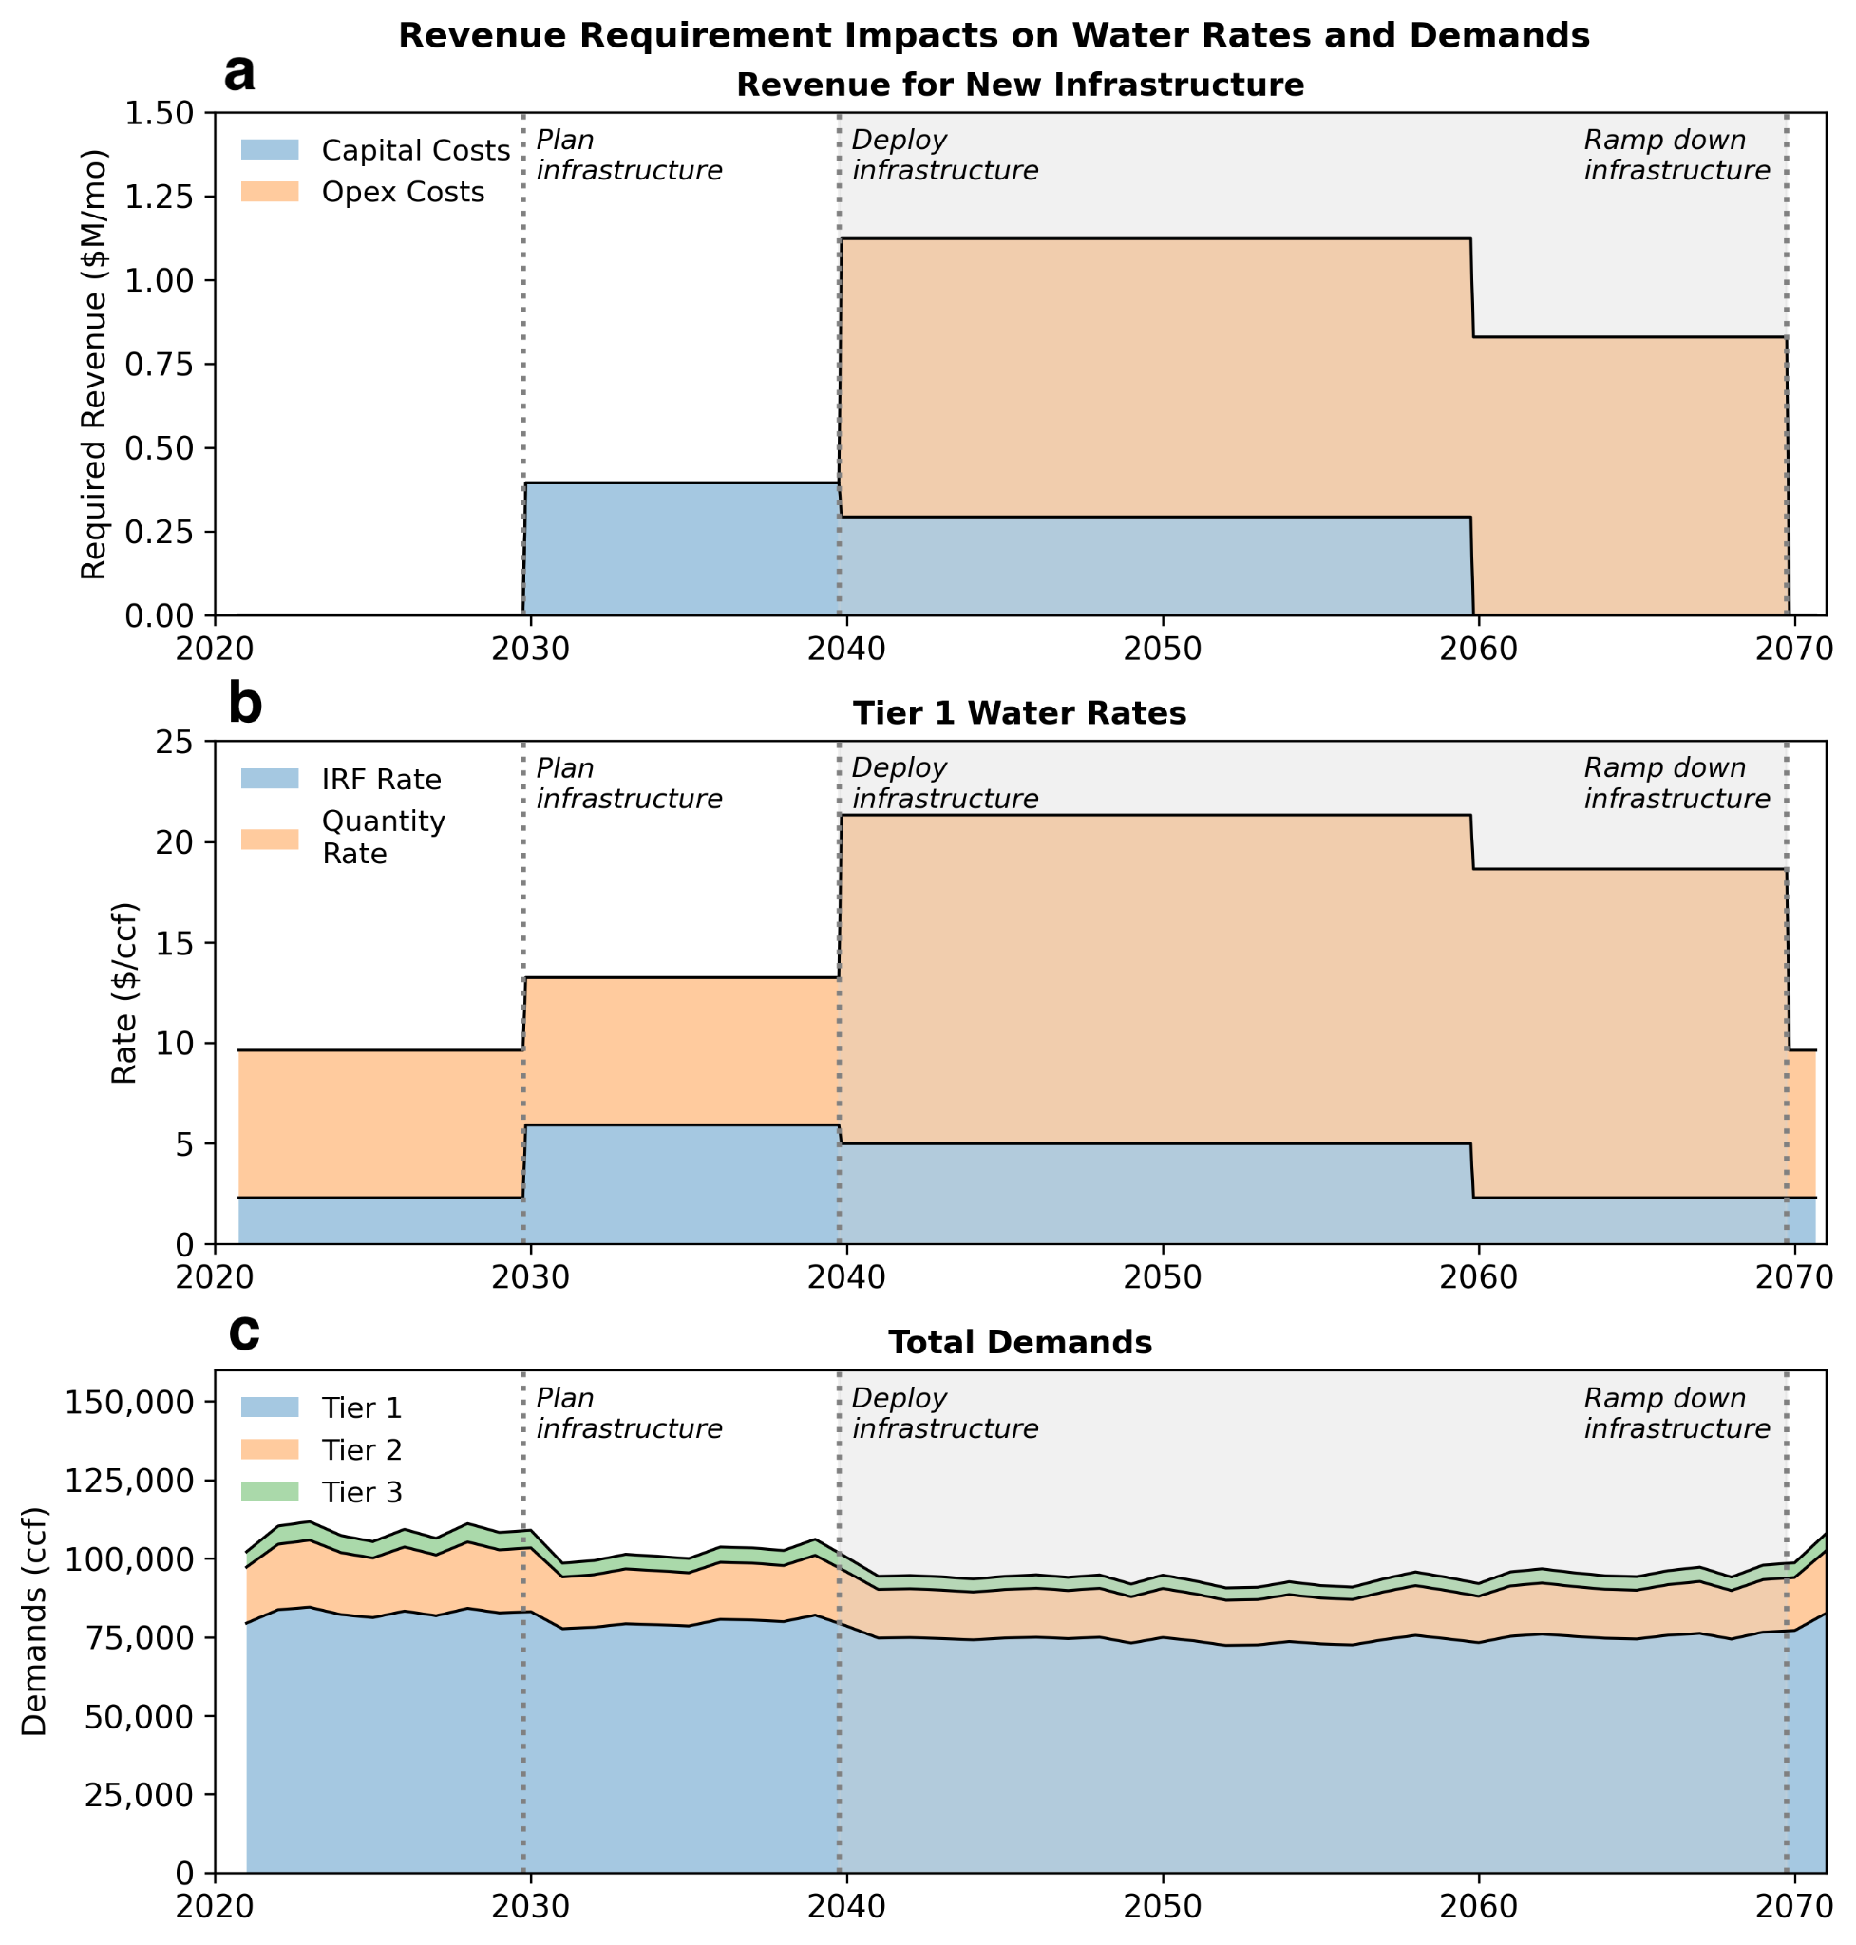
Fig. S23. Time series illustrating how a new infrastructure investment (a) adds revenue requirements, which then (b) increases water rates, and (c) impacts single-family water demands via the link between water price and price elasticity.

SI References

1. Maurer, E. P., Wood, A. W., Adam, J. C., Lettenmaier, D. P. & Nijssen, B. A Long-Term Hydrologically Based Dataset of Land Surface Fluxes and States for the Conterminous United States. https://journals.ametsoc.org/view/journals/clim/15/22/1520-0442_2002_015_3237_althbd_2.0.co_2.xml (2002).
2. Hydrosystems Research Group. Vulnerability Assessment and Adaptation Planning for Santa Cruz Water Department. (2021).
3. Steinschneider, S. & Brown, C. A semiparametric multivariate, multisite weather generator with low-frequency variability for use in climate risk assessments. Water Resources Research 49, 7205–7220 (2013).
4. Eyring, V. et al. Overview of the Coupled Model Intercomparison Project Phase 6 (CMIP6) experimental design and organization. Geoscientific Model Development 9, 1937–1958 (2016).
5. Cal-Adapt. https://cal-adapt.org/.
6. Pierce, D. W., Cayan, D. R., Feldman, D. R. & Risser, M. D. Future Increases in North American Extreme Precipitation in CMIP6 Downscaled with LOCA. https://doi.org/10.1175/JHM-D-22-0194.1 (2023) doi:10.1175/JHM-D-22-0194.1.
7. Hydrosystems Research Group. Vulnerability Assessment and Adaptation Planning for Santa Cruz Water Department. (2023).
8. United States Geological Survey. San Lorenzo R a Big Trees CA. (2024).
9. Saltelli, A. et al. Global Sensitivity Analysis: The Primer. (John Wiley & Sons, 2008).
10. Reed, P. M. et al. Addressing Uncertainty in MultiSector Dynamics Research — Addressing Uncertainty in MultiSector Dynamics Research Documentation. (2022).
11. Perez, S. E. 2020 Urban Water Management Plan. https://www.cityofsantacruz.com/home/showpublisheddocument/87122/637739611535800000 (2021).
12. Sebri, M. A meta-analysis of residential water demand studies. Environ Dev Sustain 16, 499–520 (2014).
13. Dalhuisen, J. M., Florax, R. J. G. M., Groot, H. L. F. de & Nijkamp, P. Price and Income Elasticities of Residential Water Demand: A Meta-Analysis. Land Economics 79, 292–308 (2003).
14. Wichman, C. J. The Economics of Equity and Affordability in Residential Water Pricing. Water Econs. Policy 11, 2530002 (2025).
15. Skerker, J. B., Verma, A., Edwards, M., Rachunok, B. & Fletcher, S. Alternative household water affordability metrics using water bill delinquency behavior. Environ. Res. Lett. 19, 074036 (2024).
16. Benjamin Rachunok & Sarah Fletcher. Socio-hydrological drought impacts on urban water affordability. Nature Water 1, 83–94 (2023).
17. Kennedy Jenks & Hydrosystems Research Group. Water Supply Augmentation Implementation Plan. (2025).
18. Balance Hydrologics, Inc. Appendix D-1 Baseflow Hydrology and Climate Change Affects Modeling. https://www.cityofsantacruz.com/home/showpublisheddocument/86975/637731703715270000 (2020).
19. Elsner, M. M. et al. Implications of 21st century climate change for the hydrology of Washington State. Climatic Change 102, 225–260 (2010).
20. Palmer, R. N. & Characklis, G. W. Reducing the costs of meeting regional water demand through risk-based transfer agreements. Journal of Environmental Management 90, 1703–1714 (2009).
21. Hadka, D. & Reed, P. Borg: An Auto-Adaptive Many-Objective Evolutionary Computing Framework. Evolutionary Computation 21, 231–259 (2013).
22. Olmstead, S. M., Michael Hanemann, W. & Stavins, R. N. Water demand under alternative price structures. Journal of Environmental Economics and Management 54, 181–198 (2007).
23. Klassert, C., Sigel, K., Klauer, B. & Gawel, E. Increasing Block Tariffs in an Arid Developing Country: A Discrete/Continuous Choice Model of Residential Water Demand in Jordan. Water 10, 248 (2018).
24. Worthington, A. C. & Hoffman, M. An Empirical Survey of Residential Water Demand Modelling. Journal of Economic Surveys 22, 842–871 (2008).
25. Rodell, M. et al. The Global Land Data Assimilation System in: Bulletin of the American Meteorological Society Volume 85 Issue 3 (2004). Bulletin of the American Meteorological Society 85, 381–394 (2004).
26. California Public Utilities Commission. 2021/2022 Annual Affordability Report. https://www.cpuc.ca.gov/-/media/cpuc-website/divisions/energy-division/documents/affordability-proceeding/2021-2022/2021-and-2022-annual-affordability-report.pdf (2023).
27. Azizi, K., Barnes, J. L., Anderies, J. M. & Garcia, M. Equity implications of efficient water conservation programs. Environ. Res. Lett. 19, 094015 (2024).
28. Menard, R. Long Range Financial Plan (WT). (2016).
29. Menard, R. 2021 Water Department Long-Range Financial Plan and Water Rate Schedule for FY 2023 to FY 2027 (WT). (2021).

