SUPPLIMENTARY DATA

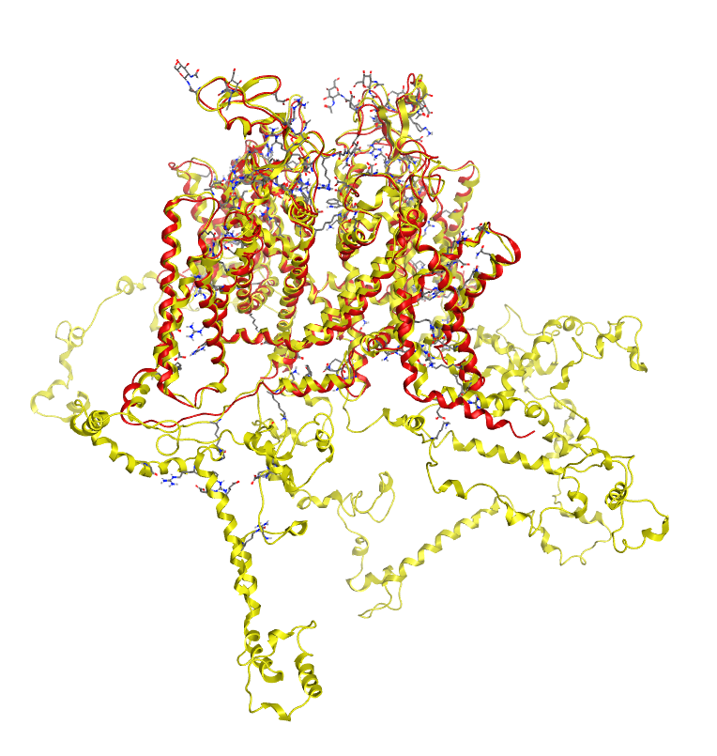
Figure S1: Superimposed structure of our predicted hNav1.5 model (yellow) and previously reported hNav1.5 structure PDB id: 7DTC (red)
A..
B.
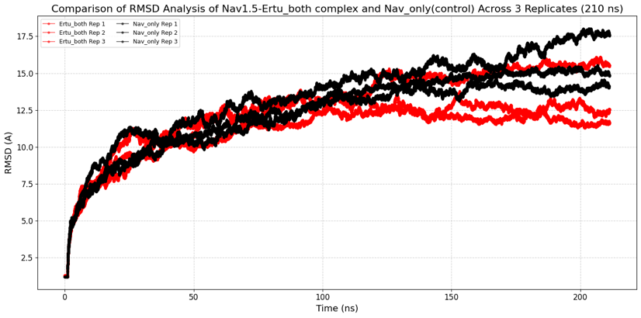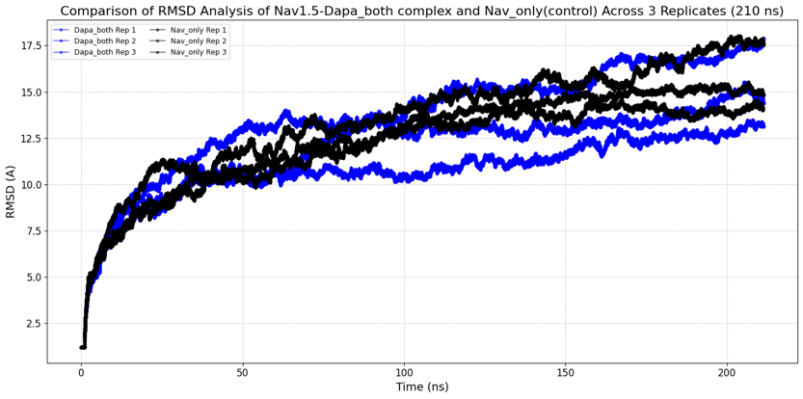
D.
C.
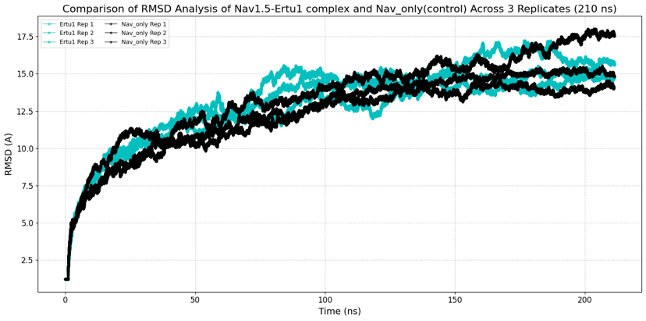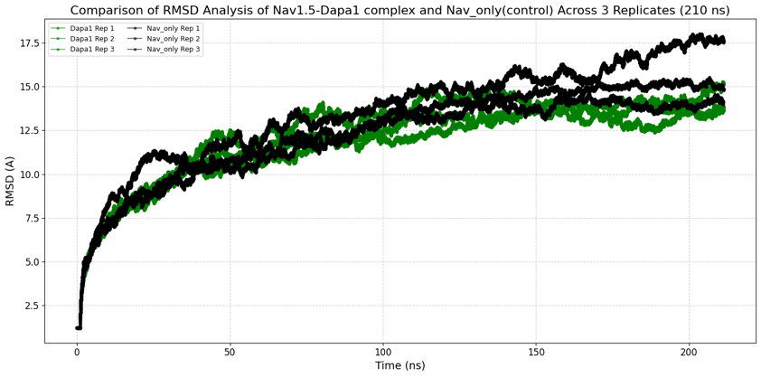
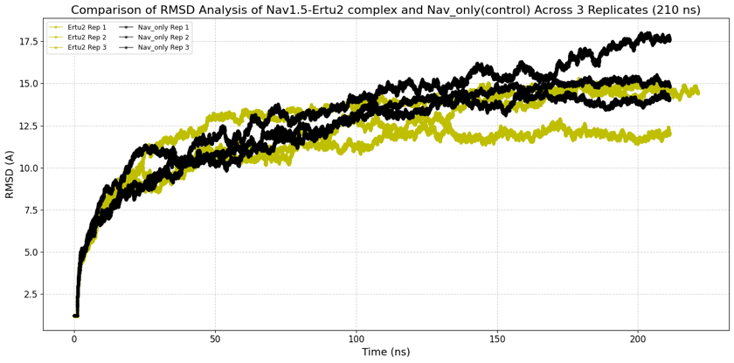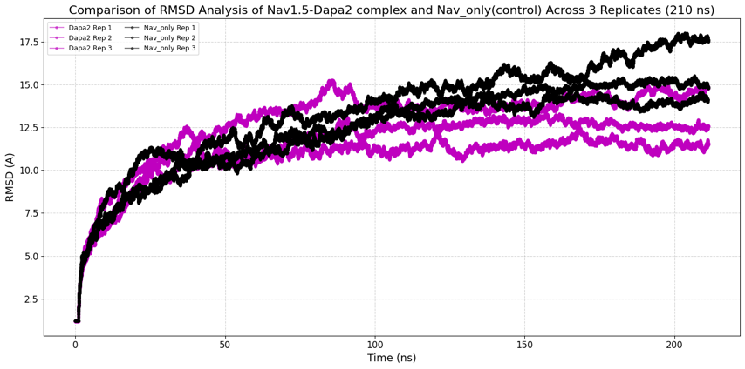
F..
E.
Figure S2: RMSD plot of all the replicas of all the systems individually comparing with the control replicas A. RSMD graph of all replicas of Ertu_both vs all replicas of wild type Nav1.5 B. Dapa_both vs wild type Nav1.5 C. Ertu1 vs wild type Nav1.5 D. Dapa1 vs wild type Nav1.5 E. Ertu2 vs wild type Nav1.5 F. Dapa2 vs wild type Nav1.5

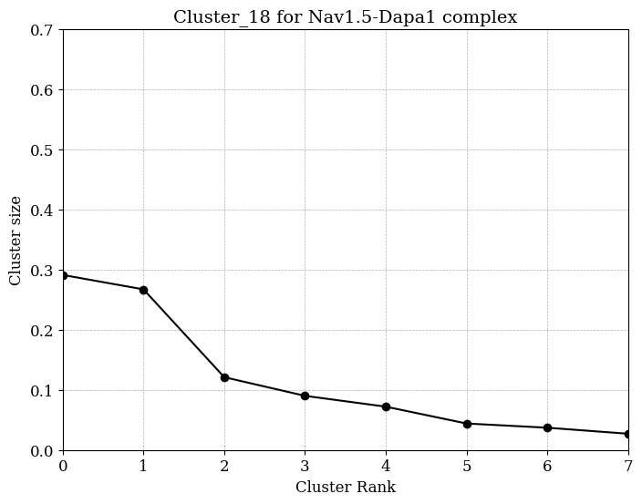
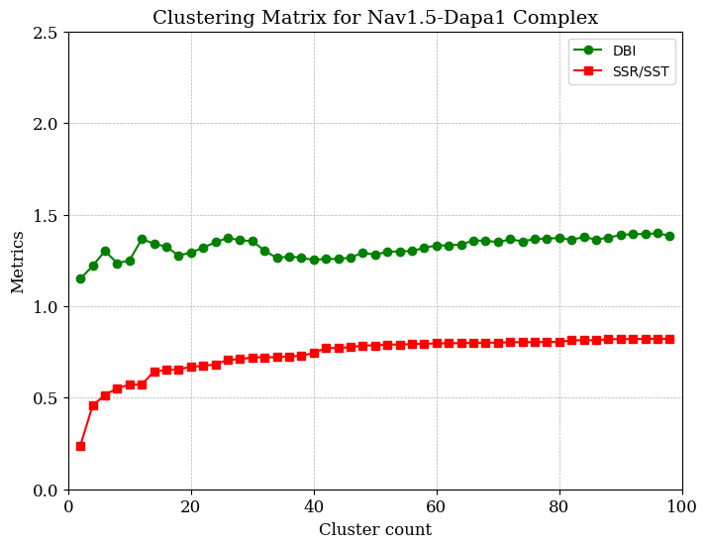
B.
A.

C.
D..
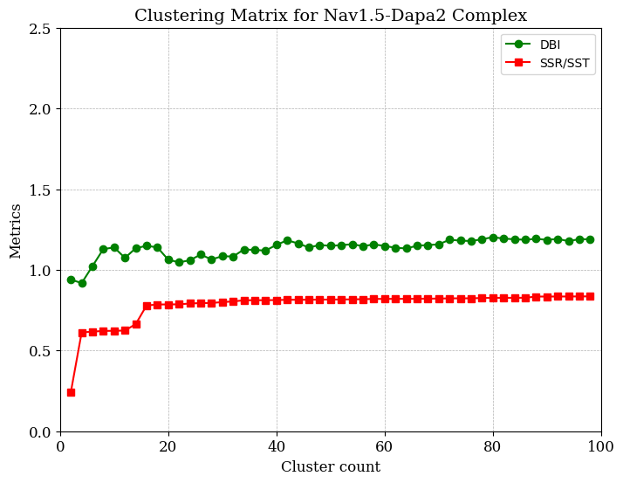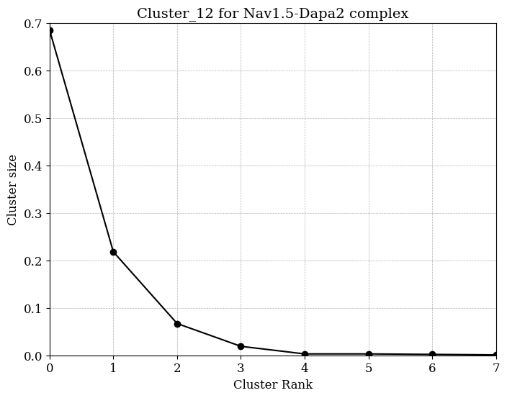
E.
F.
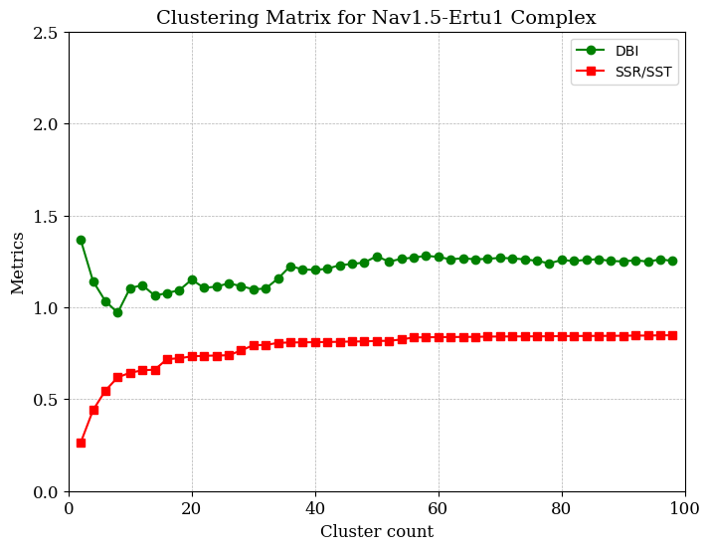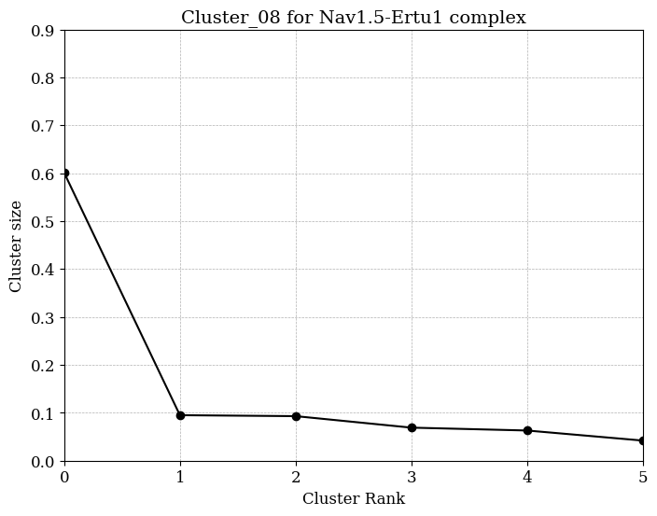
H..
G.
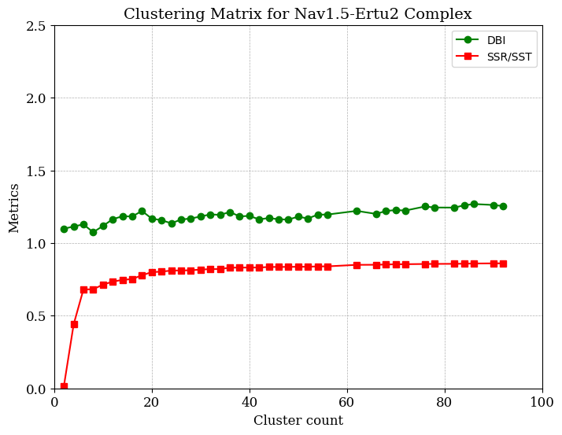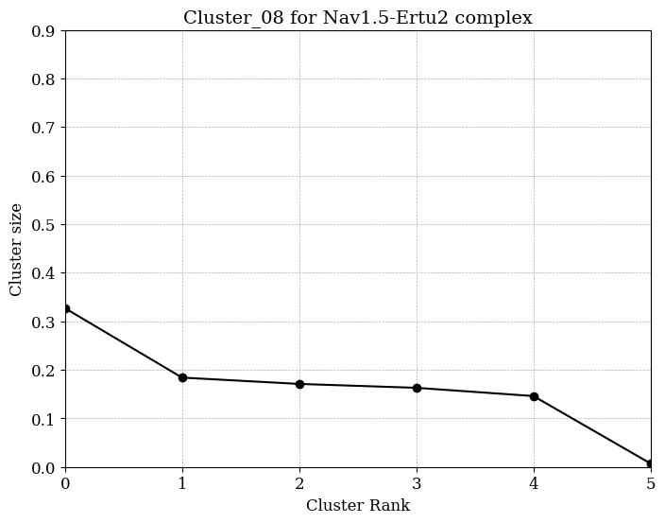
J.
I.
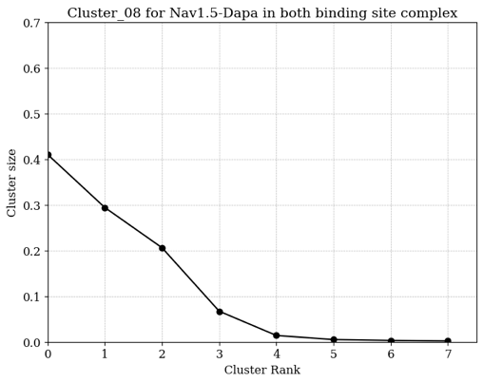
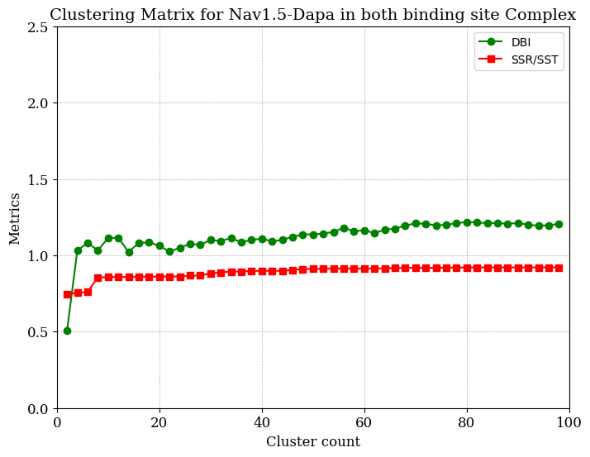

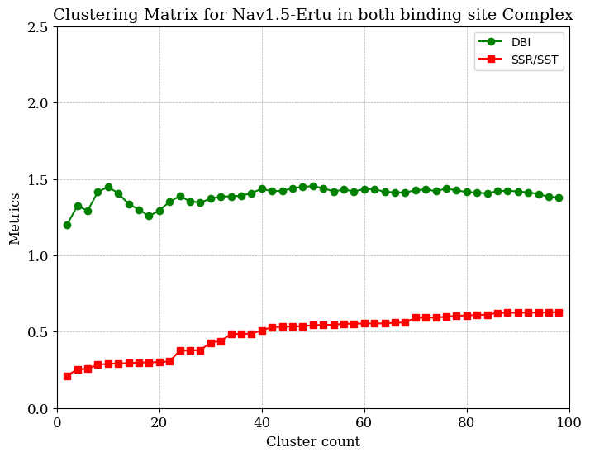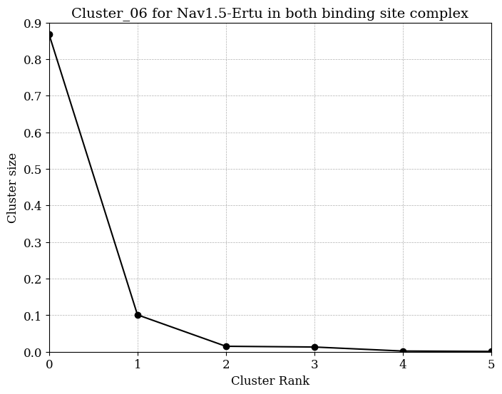
L.
K.

Figure S3: Conformational clustering of six different system’s trajectories. Clustering metrics detected for various cluster counts are displayed as well as the clusters’ sizes at for Nav1.5-dapa1 (A, B), Nav1.5-dapa2(C, D), Nav1.5-ertu1(E, F), Nav1.5-ertu2(G,H), Nav1.5-dapa_both(I, J), Nav1.5-ertu_both(K,L).

A.
B.
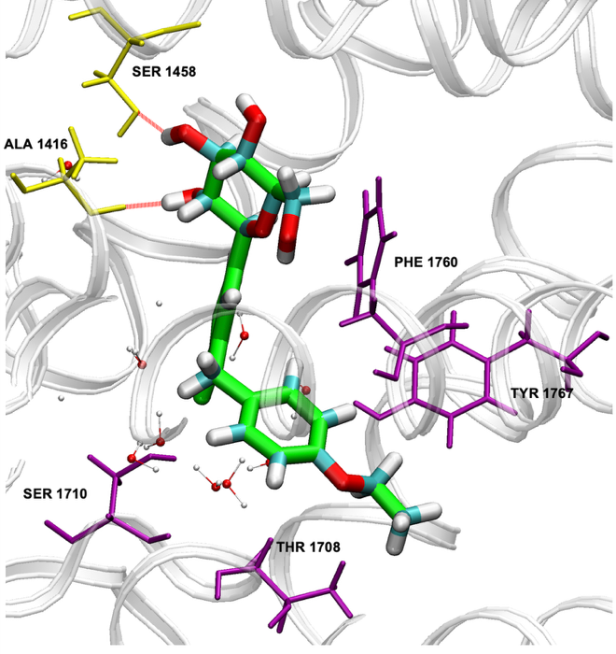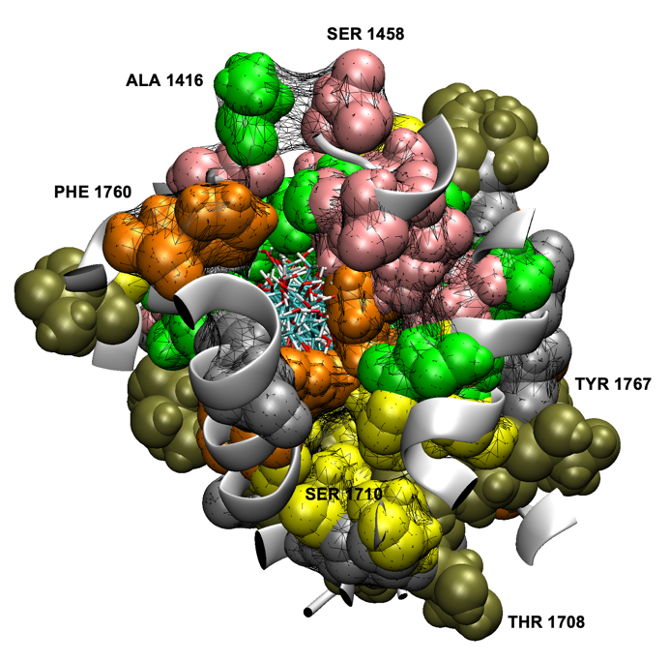
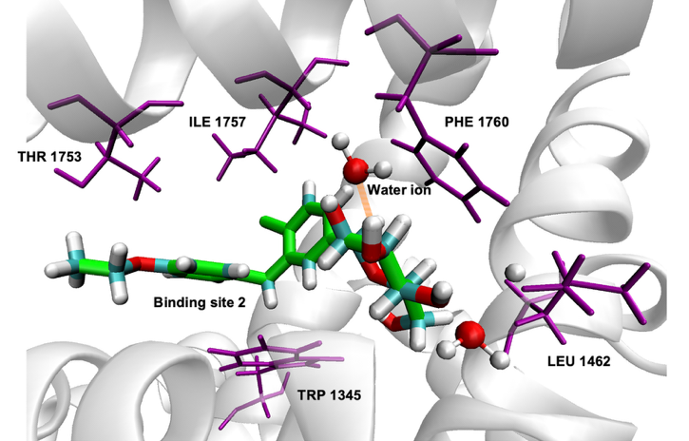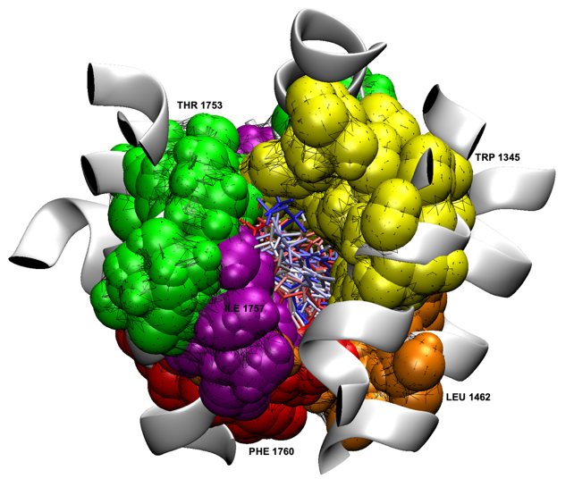
D.
C.
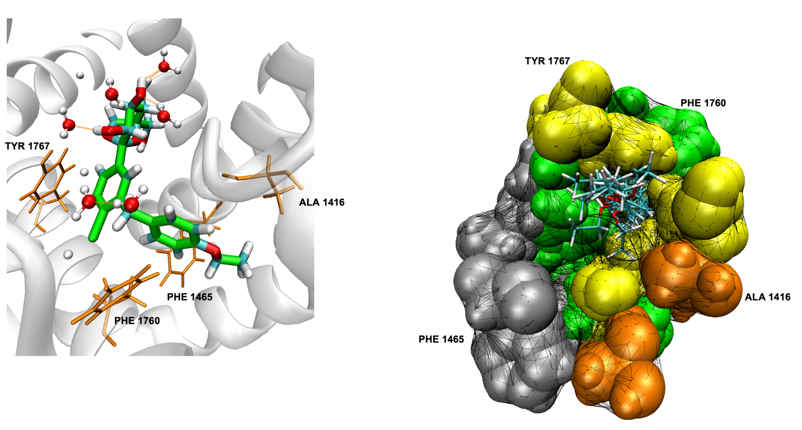
F.
E.

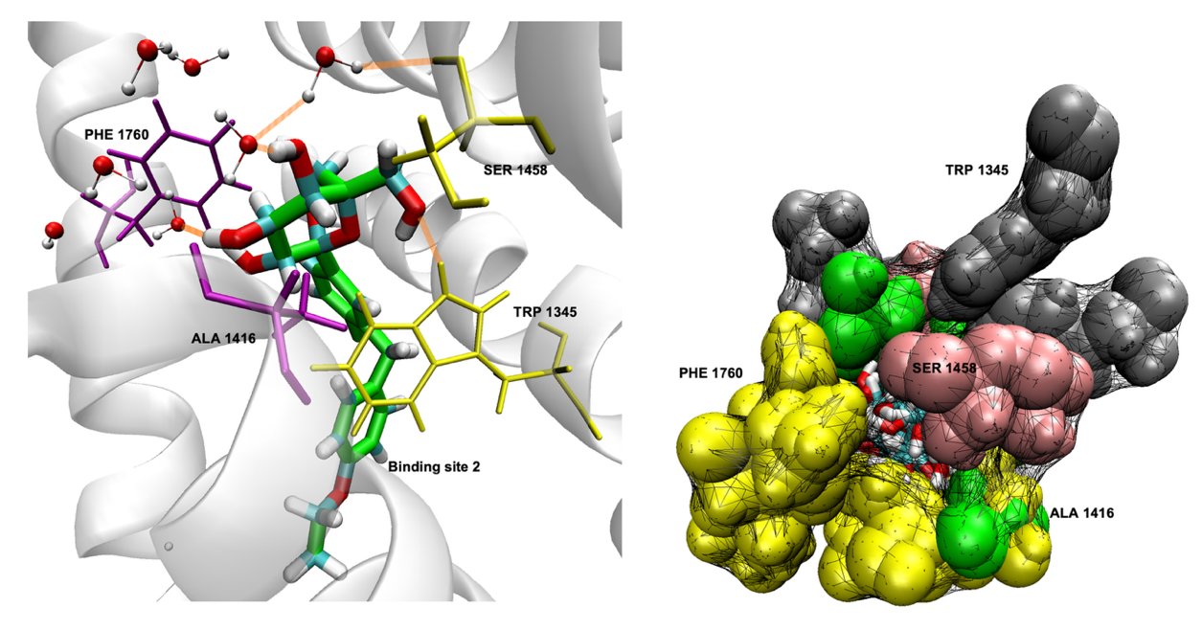
H.
G.

Figure S4: Mode of Binding and Binding pocket Analysis results for Nav1.5-dapa1(A, B) Nav1.5-dapa2(C, D), Nav1.5-ertu1(E, F), Nav1.5-ertu2(G, H) complexes.
A.

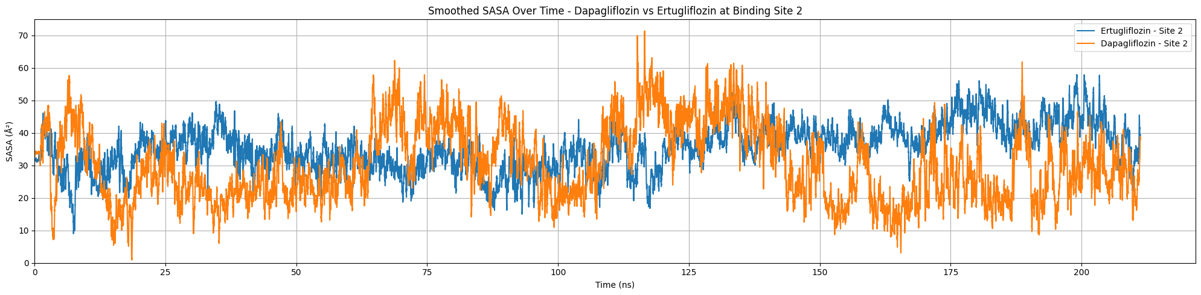

B.
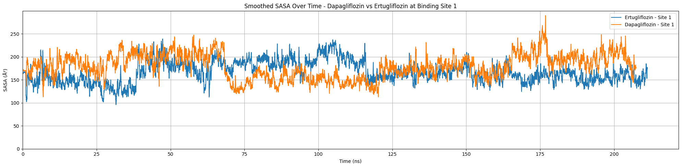

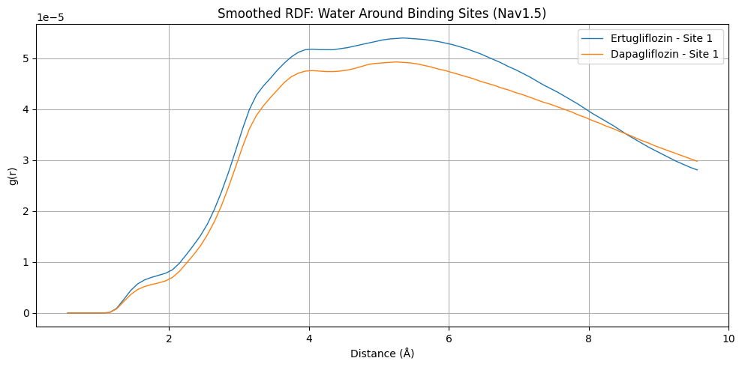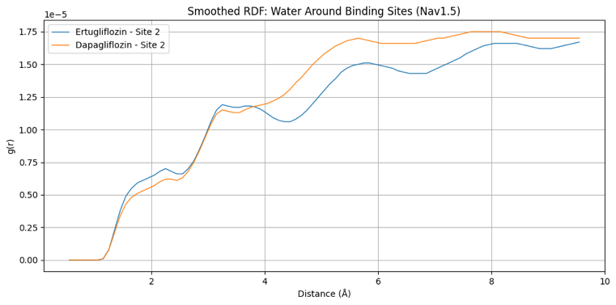
D.
C.

Figure S5. Solvent Accessible Surface Area (SASA) and Radial Distribution Function (RDF) analysis for dapagliflozin and ertugliflozin. (A) SASA at Binding Site 2 (BS2), (B) SASA at Binding Site 1 (BS1), (C) RDF at BS1, and (D) RDF at BS2.

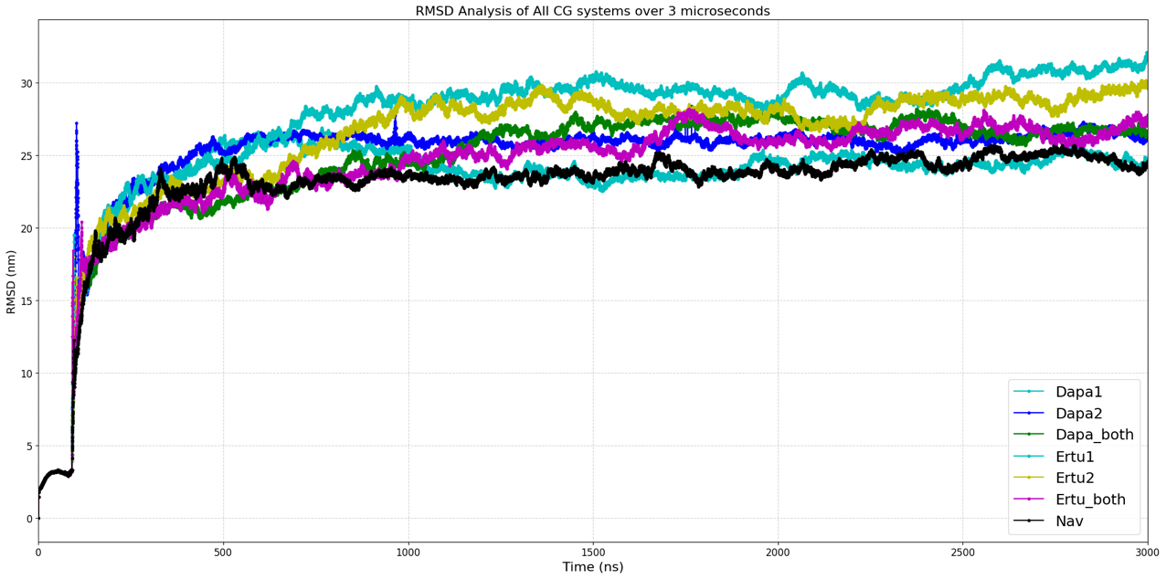
A.

B.
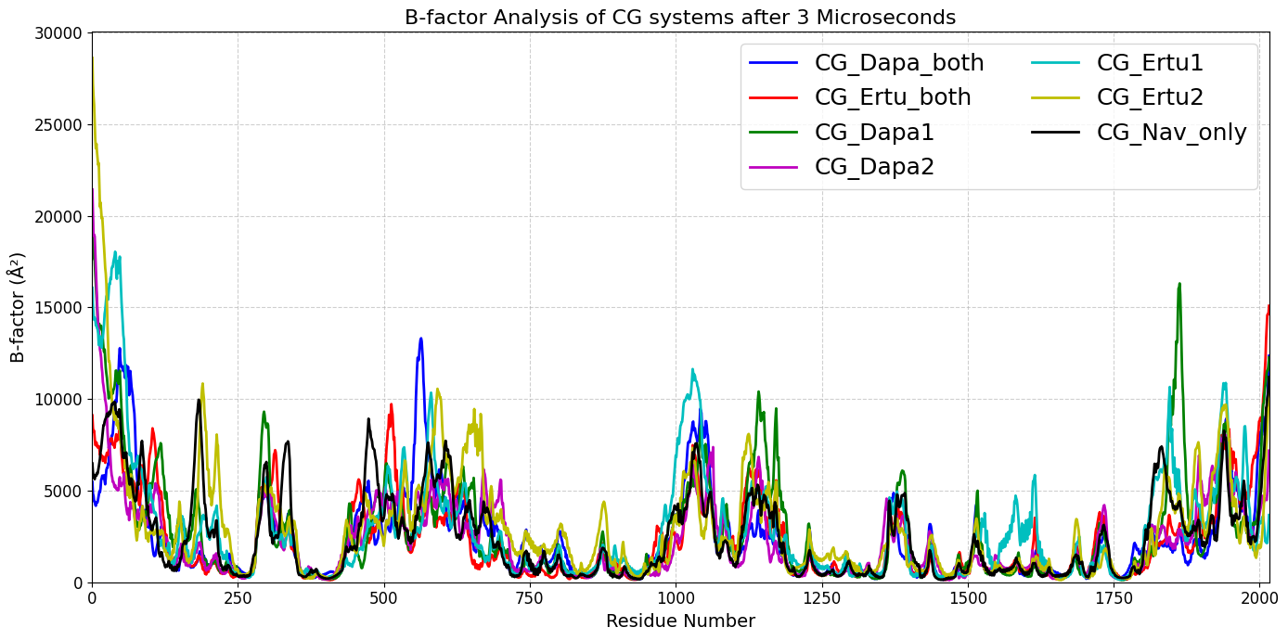
Figure S6: A. RMSD and B. B-factor of all CG systems after 3 Microseconds

B.
A.

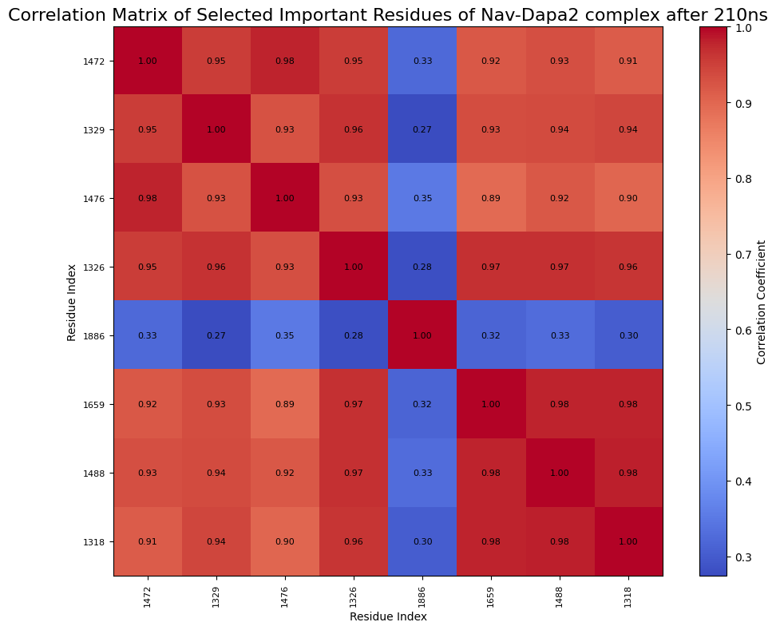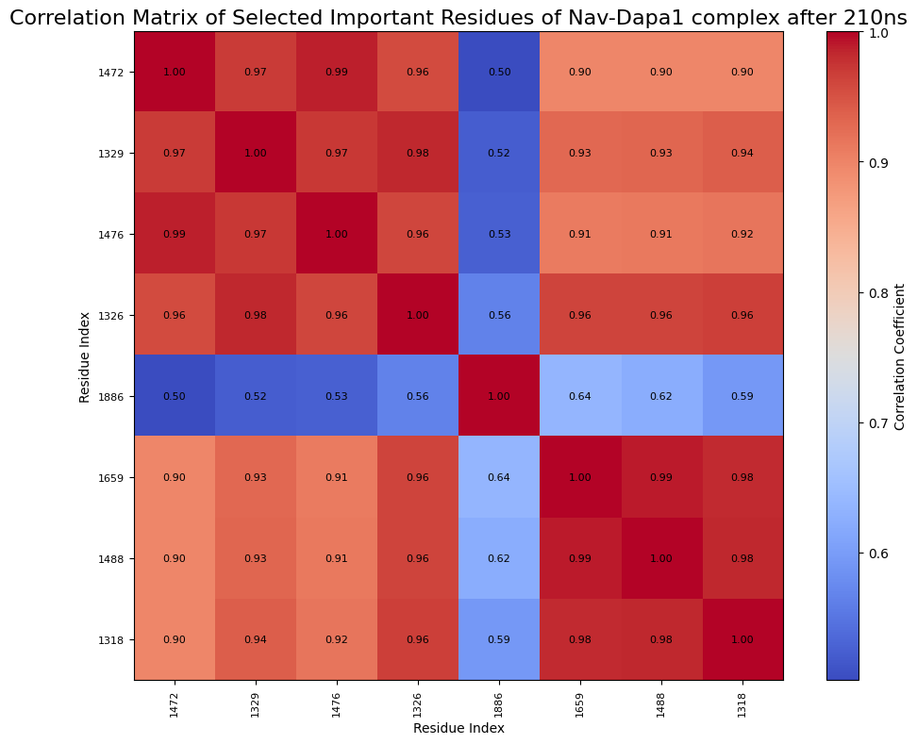

D.
C.
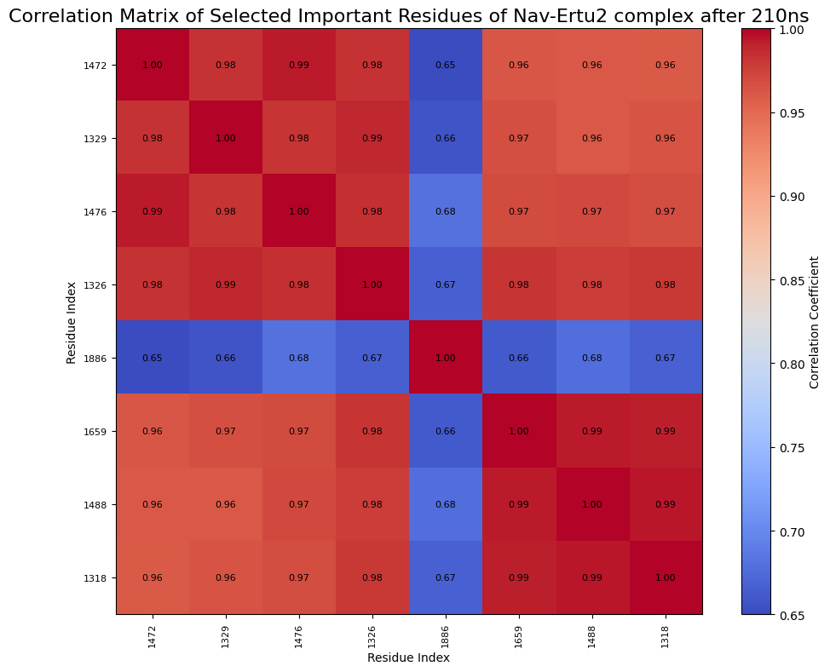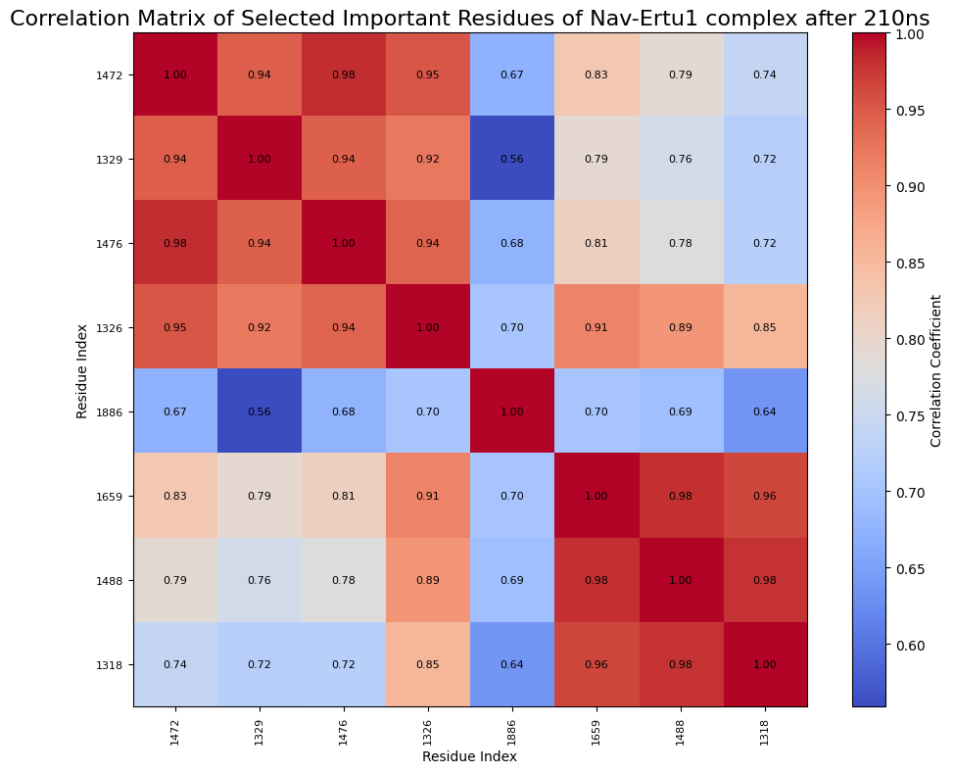
F.
E.

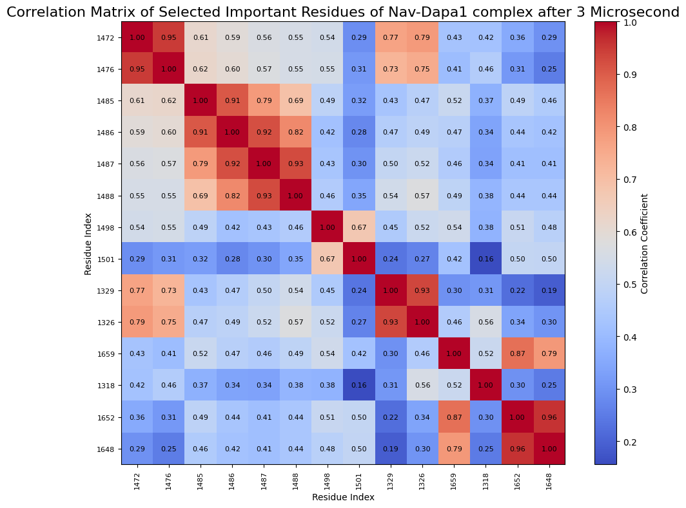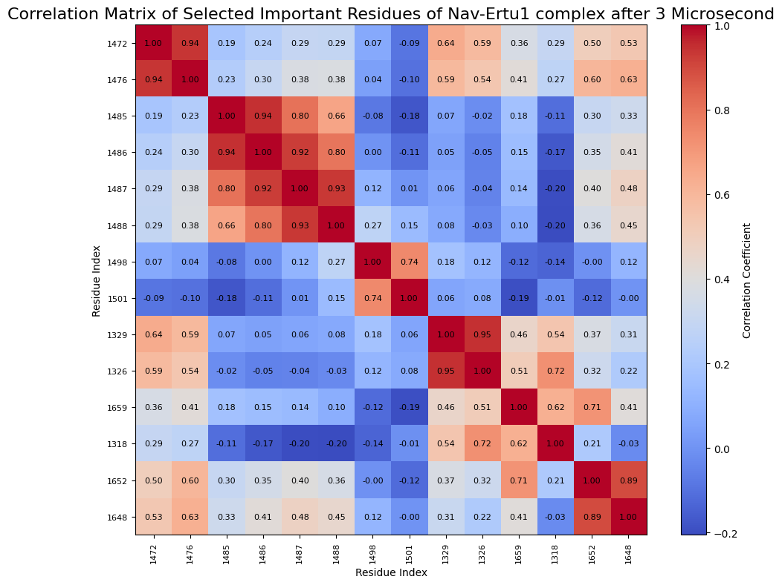

H.
G.
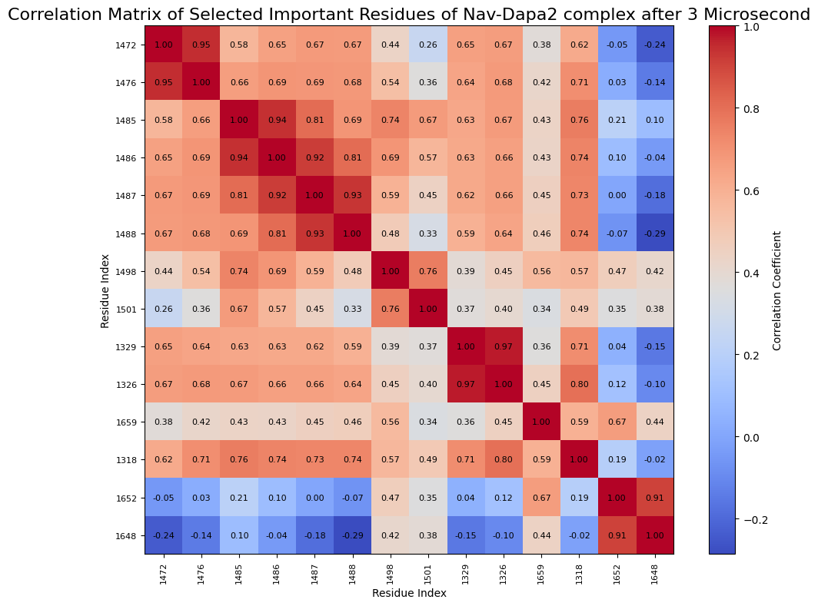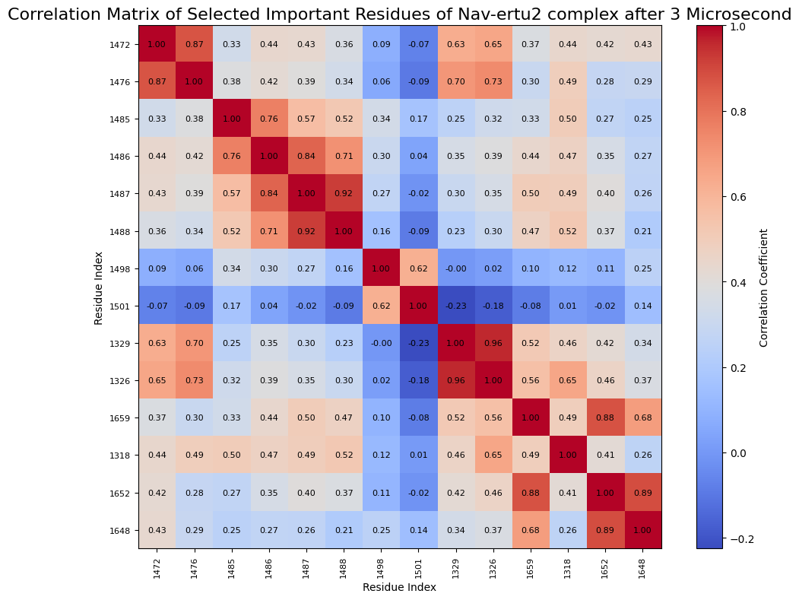
Figure S7: Correlation Matrix of Nav-dapa2, Nav-dapa1, Nav-ertu2 & Nav-ertu1 complex focusing KHBPs in single occupancy scenario after 200ns. (A, B, C, D). Correlation Matrix of Nav-dapa1, Nav-ertu1, Nav-dapa2 & Nav-ertu2 complex focusing KHBPs in single occupancy scenario after 3 microseconds (E, F, G, H).

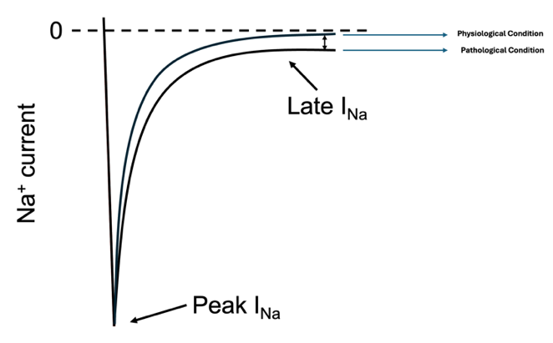
Figure S8: Late and Peak I_{Na} in Physiological and pathological conditions

Detailed Method:

M1. Detailed Workflow for Full-Length Nav1.5 Structure Prediction

Although a CryoEM structure for hNav1.5 exists (PDB ID: 7DTC), this structure is lacking key structural elements that we thought to be important in the current study. This includes DI-DII loop, DII-DIII loop, C and N terminal. Therefore, the Swiss model (https://swissmodel.expasy.org/)^{1,2} and Robetta baker lab neural network servers (https://robetta.bakerlab.org/)³ were used to predict the full structure of the Nav1.5 channel. In Swiss server we have used AlphaFold⁴, an artificial intelligence (AI) based homology modelling system developed by Google DeepMind which predicted the hNav1.5 3D structure from multiple sequence alignments and structural templates based on a trained neural network⁵. On the other hand, the RoseTTAFold server ³ from Robetta Baker lab is based on a deep learning-based model that processes sequence, distance, and coordinate information via a three-track network. Both AlphaFold and RoseTTAFold produce accurate protein models by utilizing deep learning methods. Our first step was to identify and obtain full structure of human Nav1.5 from the universal protein resource database (https://www.uniprot.org) with the following ID (Q14524). The 7DTC CryoEM structure was used as a template to build the full length hNav1.5 using the AlphaFold within Swiss model server. The resulting structure was subsequently submitted to the RoseTTAFold model within the Robetta baker lab server for further refinement and accurate loop modeling. Further protein engineering and more refining were done manually using Chimera software⁶ following the preliminary predictions from the two servers. The protein structure was optimized to resolve steric clashes and improve loop conformations, ensuring consistency with available functional data. To validate our model, we superimposed it onto the previously reported hNav1.5 structure (PDB ID: 7DTC), which showed excellent alignment across all domains, including the DIII–DIV linker. Figure S1 shows that. We further evaluated the positioning of the loop regions using the PPM 3.0 server to confirm their orientation in extracellular and intracellular environments.⁷ Additionally, we compared our model to a previously developed hNav1.5 structure from our laboratory for further validation⁸.

M2. Preparation and Docking of Ligands with Nav1.5 Structure:
Three SGLT2 inhibitors, namely empagliflozin (PubChem CID:11949646), dapagliflozin(PubChem CID:9887712) and ertugliflozin(PubChem CID: 44814423) were downloaded from the PubChem database (https://pubchem.ncbi.nlm.nih.gov/) in a spatial data file (SDF) format. All ligands were prepared for docking simulations (e.g. added hydrogen atoms, calculated their partial charges, protonated etc.) at temperature of 310 K and pH 7.0 using the molecular orientation environment (MOE) software⁹. Following compounds’ preparation, the MOE software was used for induced-fit docking to dock empagliflozin into Nav1.5 in two specific sites that previously identified in our lab¹⁰. As both dapagliflozin and ertugliflozin have similar structures to empagliflozin, we used pharmacophore-based docking after identifying the best binding pose for empagliflozin, to position ertugliflozin and dapagliflozin in the same location. The London dG scoring function was used as an initial filter for all docked poses, followed by a second refinement and rescoring step using GBVI/WSA dG scoring function. We constructed six distinct protein–ligand complexes and one without ligand wild type hNav1.5 to systematically investigate ligand binding and the allosteric changes within the protein. In these models, the two ligands, dapagliflozin and ertugliflozin, were each docked individually into two previously identified binding sites, designated as binding site 1 (BS1) and binding site 2 (BS2). Both BS1 and BS2 located in the pore region of the Nav1.5. BS1 is formed by Y1767, T1708, T1709, S1710 while BS2 is located within the pore region between DIII and DIV of Nav1.5 and includes numerous important residues, such as F1465, W1345, and T1461.This whole docking process resulted in four complexes, representing each ligand in each site separately. In addition, two more complexes were generated with both binding sites occupied simultaneously; one with dapagliflozin in both BS1 and BS2, and the other with ertugliflozin in both sites. Finally, to prepare the ligands for the all atomistic MD simulations, we used the antechamber^{11,12} module of Amber tools ¹³, to prepare force field parameters for each ligand using the GAFF2 FF.

M3. Adding Membrane and solution using CHARMM-GUI:

CHARMM-GUI server¹⁴ was used to prepare all seven systems. Five pairs of disulfide bonds were constructed for the 10 cystine residues (i.e., Cys280-Cys335, Cys326-Cys341, Cys906-Cys915, Cys1363-Cys1384, Cys1728-Cys1742). We then used the PPM v3 server⁷ to orient the protein within the membrane, followed by adding specific type of membrane. We selected dioleoylphosphatidylcholine (DOPC) membrane type to mimic the physiological heart environment, unsaturated phosphatidylcholines (e.g., DOPC) are more commonly found and prevalent than their saturated counterparts, such as DMPC^{15–17}. The whole system consisted of a total of 1117 lipid residues, splitted into 580 lipids is in the upper leaflet and 537 in the lower leaflet. We also added 25 Å of TIP3P¹⁸ water thickness in both sides of the membrane. The solvated systems were then neutralized by 594 Na+ and 557 Cl- counter ions at a physiological ionic concentration of 0.15 M. The charmmlipid2amber.py script (integrated within AMBER tools¹³) was then used to convert the charmm type membrane, water, ions into AMBER supported format. The pdb4amber module was also used to convert the protein into AMBER supported format. The size of all systems in X and Y axis was roughly 210 Å and 190 Å in Z axis approximately. A tleap script was finally used to add all components and to create protein-ligand-membrane-water-ion complex starting files to perform the all atomistic MD simulations.

M4. Classical All Atomistic Molecular Dynamics Simulations
The amber ff19SB¹⁹ force field was used to parameterize the hNav1.5 protein, the generalized AMBER force field version 2(GAFF2)²⁰ was used for all compounds, the LIPID21²¹, water.tip3p²² force field were used for the membrane and water, respectively ^{19,23,24}. In total, seven distinct systems were simulated: the apo hNav1.5 protein (ligand-free), dapagliflozin bound in BS1, dapagliflozin in BS2, ertugliflozin in BS1, ertugliflozin in BS2, both binding sites occupied by dapagliflozin, and both occupied by ertugliflozin. To ensure reproducibility and statistical robustness, each system was simulated in three independent replicas (n = 3), resulting in a total of 21 all-atom MD systems. For each system, the all atomistic MD simulation followed the following protocol. First, energy minimization was carried out in two steps; a conjugate gradient and steepest descent approach was used for 10,000 iterations in the initial minimization stage. The first 5,000 steps used steepest descent to minimize high-energy interactions, and then conjugate gradient minimization was employed. Periodic boundary conditions were implemented and nonbonded interactions were set to a cut off of 9.0 Å. Then, using 21,000 steps, a second minimization step was carried out, of which 12,000 steps using the steepest descent. During the minimization phase, protein backbone and lipid atoms were held stationary by applying harmonic heavy restrictions (50 kcal/mol) to the protein’s alpha carbons, ligand, and membrane’s phosphate and oxygen atoms in lipid heads, which allowed the surrounding environment to relax. This method optimized the shape of flexible regions while preserving structural integrity. After minimization, a Langevin thermostat was used to control the system's temperature during a heating stage, gradually raising it from 0 to 310 K over 400 ps steps²⁵ using an NPT ensemble with a pressure relaxation time of 2.0 ps and a target pressure of 1.0 atm. Coordinate wrapping was also enabled, and periodic boundary conditions were used. The threshold for nonbonded interactions is 12 Å. Hydrogen-containing bonds are subject to bond restrictions, enabling a 2 fs timestep. The Langevin thermostat is used to maintain the system at 310 K with a collision frequency of 3.0 ps⁻¹. For energies, trajectory coordinates, and restart files output files are written at 1000-step intervals. Following the heating phase, all systems had a one-ns equilibration phase during which the constraints were gradually removed. Ultimately, each system underwent an unrestricted production run lasting up to 210 ns.
M5. Statistical Analysis of B-Factor Values
flexibility of protein was examined using B-factor (atomic fluctuation) analysis. To make sure the patterns were flexible and consistent, B-factors were computed for each replica and then averaged throughout the duration of the three runs for each system. The presence and identity of ligands changed the flexibility of a number of areas, including important functional domains. Three different replicas of the ligand-bound and unbound (Nav1.5-only) systems were used to retrieve B-factor values for every residue. The mean B-factor and standard deviation for each residue were determined for each system. For every replica, the flexibility difference (Δ) between ligand-bound and unbound systems was calculated. A per-residue unpaired t-test was used to compare the three ligand-bound values to the corresponding Nav system values in order to determine if these differences were statistically significant. P-values less than 0.05 indicated that the residues were statistically significant and perhaps ligand-sensitive, which may be a sign of structural dynamics changes or allosteric regulations.
M6. Clustering and Hydrogen Bond Analysis
To identify the most dominate conformations for each system, clustering analysis on each trajectory was performed by combining each ligand conformations. The average-linkage algorithm was used as the clustering technique. Before clustering, and to eliminate any rotational and translational motion all trajectories were fitted to their original minimized conformations for each simulation. The "elbow criterion"²⁶ and the Davies-Bouldin index (DBI)²⁷ were employed as metrics for predicting the ideal clustering number. The ideal number of clusters was indicated when the Davies-Bouldin Index (DBI) reaches a local minimum and the SSR/SST percentage of variance levels plateau. On the other hand, the elbow criteria indicated that the proportion of variance explained by the data reaches a plateau after the ideal number of clusters. The centroid of each cluster served as a representative conformation for that cluster. To report the strongest observed H-bonds we used the whole trajectory to track all hydrogen bonds involving each ligand using a cut-off distance of 4 Å and a cut-off angle of 65◦. We used the CPPTRAJ module from AMBER 23 to perform a quantitative analysis on the stability and occupancy of these hydrogen bonds throughout the simulations^{28,29}. Overall, MDAnalysis ³⁰ and CPPTRAJ module was used to analyze MD trajectories.
M7. Solvent Accessible Surface Area, Radial Distribution Function, and Principal Component Analysis Analysis:
Throughout the MD simulations, the system's dominating movements, solvation effects, and structural dynamics were evaluated using Principal Component Analysis (PCA)³¹, Solvent Accessible Surface Area (SASA)³², and Radial Distribution Function (RDF). Protein or ligand residue exposure to the solvent environment during the simulation was measured using SASA Analysis. This was performed using the AMBER CPPTRAJ module's surf command. This method used the LCPO method³³ to calculate the solvent-accessible surface area. To calculate the ligand's overall solvation profile, SASA was computed for both sections of interest: (i) the complete ligand, and (ii) just the glucose moiety part, which was used to test the ligand's interaction with the surrounding solvent. This made it possible to compare how the solvation environment for the ligand as a whole and its polar substructure differed. To assess the distribution of water molecules around the binding sites’ atoms, RDF analysis was carried out throughout the trajectories. Regions of interest, such as particular ligand atoms and water oxygen atoms, were used to define atom pairs. Radial distribution functions g(r) were obtained from this analysis, which provided information on the local ordering of water molecules, favoured contact distances, and solvation shell structure. The protein's large-scale movements were further studied using PCA analysis. In order to eliminate global translational and rotational movements, each trajectory was first aligned to a reference frame utilizing backbone Cα atoms. Matrix cover was used to calculate the covariance matrix of atomic positional fluctuations, and analysis matrix was used to extract the principal components. The system's conformational dynamics were interpreted by visualizing the first few eigenvectors that represented the dominating modes of motion.
M8. Martini Coarse-Grained MD Simulations
Large-scale biomolecular and materials systems can be studied at a lower computing cost using the CG force fields such as the MARTINI force field version 3 (Martini 3)³⁴, which groups atoms into bigger interaction sites to simplify molecular simulations. Coarse graining is required to increase efficiency over all-atomistic simulations, enabling bigger system sizes and longer timeframes while retaining crucial physicochemical characteristics. To do that, we used CHARMM-GUI martini maker³⁵ to prepare each system by converting our predicted hNav1.5 structure in CG and by adding CG membrane, water and counter ions. Statistically significant rigid residues as obtained from all atomistic MD simulations were restrained during the CG simulations to mimic the effects of the bound ligands. Five separate restraint groups were created to perform this control as diverse residue feel different forces due the presence of the ligand. The size of each CG model in this study was around 410 Å in the X and Y directions and 388 Å in the Z direction, with 2,366 lipid residues in the top leaflet and 2,334 in the lower leaflet, it has 4,700 CG DOPC lipid residues in total. Water and 0.15 M NaCl counter ion were also added. Before production, each system underwent a five-step equilibration routine and was energy-minimized. The same simulation settings were used for each equilibration phase, but the position restraint force constants were gradually decreased to permit the system to gradually relax. Using preprocessor flags in the GROMACS.mdp³⁶ files, position constraints were imposed to the lipid headgroups and the protein backbone (BB beads). The leapfrog integrator ³⁷ with a time step of 20 fs and a total run time of 50000 steps were the simulation parameters utilized in each equilibration stage. A neighbor list that was updated every 20 steps was employed in combination with the Verlet cutoff³⁸ strategy. The reaction-field approach was used to treat non-bonded interactions, with a cutoff of 2.0 nm for both van der Waals and Coulomb interactions. Potential-shift-verlet³⁹ was selected as the van der Waals modifier. By applying the velocity-rescale thermostat to distinct groups (i.e., protein, membrane, and solute) temperature coupling was used. For every group, the reference temperature was set at 310 K and the coupling time constant was set at 1.0 ps. With a reference pressure of 1 bar, compressibility of 3×10⁻⁴ bar⁻¹, and a pressure coupling time constant of 5.0 ps, the Berendsen barostat was used to control the pressure in semi-isotropic mode. For reproducibility, initial velocities were produced using a fixed seed from a Maxwell-Boltzmann distribution⁴⁰ at 310 K. To ensure accurate application of positional restraints during pressure coupling, reference coordinates were uniformly scaled throughout the simulation. System properties such as atomic coordinates, temperature, and energy were recorded at regular intervals of 1000 steps. For the production, phase we created different restraint itp (portable topology file) files based on statistical analysis for our different ligand-based system. To translate atomistic flexibility into coarse-grained (CG) restraints, we categorized force constants into five levels based on the magnitude of ligand-induced rigidity. Specifically, if the delta B-factor value for a given residue (calculated as the difference between the mean B-factor of the ligand-free system and the mean B-factor of the ligand-bound system) was statistically significant and fell within the range of –100 to –200 Å² or lower, a force constant of 1.0 kcal/mol·Å² was applied to that residue in the CG model. As the rigidity increased, the applied force constant was progressively raised: 5 kcal/mol·Å² for delta B-factors between –200 and –300 Å², 10 kcal/mol·Å² for –300 to –400 Å², 15 kcal/mol·Å² for –400 to –500 Å², and 20 kcal/mol·Å² for residues with delta B-factors between –500 and –600 Å². This gradated approach allowed us to selectively apply positional restraints to residues based on the degree of ligand-induced stabilization, enabling the CG model to more accurately capture the structural effects observed in the all-atom simulations. Then we run the whole simulation for 3 microseconds.
M9. Correlation Matrix
To investigate potential allosteric effects induced by ligand binding, we performed Pearson’s correlation matrix analysis⁴¹ to evaluate correlated and anti-correlated motions among residues within the Nav1.5 channel. This approach enabled us to assess how specific regions of the protein moved in relation to one another throughout the course of the simulations. Correlation coefficients ranging from -1 to +1 were used to quantify the degree of the residue motions, with positive values indicating concerted movement and negative values indicating opposing directions. By comparing the correlation patterns between ligand-bound and ligand-free systems, we aimed to identify shifts in internal dynamics that may reflect long-range communication or allosteric modulation. This analysis was carried out for both the all-atom and coarse-grained systems to capture consistent trends across resolutions.

References:
(1) Bienert, S.; Waterhouse, A.; de Beer, T. A. P.; Tauriello, G.; Studer, G.; Bordoli, L.; Schwede, T. The SWISS-MODEL Repository—New Features and Functionality. Nucleic Acids Res 2017, 45 (D1), D313–D319. https://doi.org/10.1093/nar/gkw1132.
(2) Waterhouse, A.; Bertoni, M.; Bienert, S.; Studer, G.; Tauriello, G.; Gumienny, R.; Heer, F. T.; de Beer, T. A. P.; Rempfer, C.; Bordoli, L.; Lepore, R.; Schwede, T. SWISS-MODEL: Homology Modelling of Protein Structures and Complexes. Nucleic Acids Research 2018, 46 (W1), W296–W303. https://doi.org/10.1093/nar/gky427.
(3) Baek, M.; DiMaio, F.; Anishchenko, I.; Dauparas, J.; Ovchinnikov, S.; Lee, G. R.; Wang, J.; Cong, Q.; Kinch, L. N.; Schaeffer, R. D.; Millán, C.; Park, H.; Adams, C.; Glassman, C. R.; DeGiovanni, A.; Pereira, J. H.; Rodrigues, A. V.; Van Dijk, A. A.; Ebrecht, A. C.; Opperman, D. J.; Sagmeister, T.; Buhlheller, C.; Pavkov-Keller, T.; Rathinaswamy, M. K.; Dalwadi, U.; Yip, C. K.; Burke, J. E.; Garcia, K. C.; Grishin, N. V.; Adams, P. D.; Read, R. J.; Baker, D. Accurate Prediction of Protein Structures and Interactions Using a Three-Track Neural Network. Science 2021, 373 (6557), 871–876. https://doi.org/10.1126/science.abj8754.
(4) Jumper, J.; Evans, R.; Pritzel, A.; Green, T.; Figurnov, M.; Ronneberger, O.; Tunyasuvunakool, K.; Bates, R.; Žídek, A.; Potapenko, A.; Bridgland, A.; Meyer, C.; Kohl, S. A. A.; Ballard, A. J.; Cowie, A.; Romera-Paredes, B.; Nikolov, S.; Jain, R.; Adler, J.; Back, T.; Petersen, S.; Reiman, D.; Clancy, E.; Zielinski, M.; Steinegger, M.; Pacholska, M.; Berghammer, T.; Bodenstein, S.; Silver, D.; Vinyals, O.; Senior, A. W.; Kavukcuoglu, K.; Kohli, P.; Hassabis, D. Highly Accurate Protein Structure Prediction with AlphaFold. Nature 2021, 596 (7873), 583–589. https://doi.org/10.1038/s41586-021-03819-2.
(5) Jumper, J.; Evans, R.; Pritzel, A.; Green, T.; Figurnov, M.; Ronneberger, O.; Tunyasuvunakool, K.; Bates, R.; Žídek, A.; Potapenko, A.; Bridgland, A.; Meyer, C.; Kohl, S. A. A.; Ballard, A. J.; Cowie, A.; Romera-Paredes, B.; Nikolov, S.; Jain, R.; Adler, J.; Back, T.; Petersen, S.; Reiman, D.; Clancy, E.; Zielinski, M.; Steinegger, M.; Pacholska, M.; Berghammer, T.; Bodenstein, S.; Silver, D.; Vinyals, O.; Senior, A. W.; Kavukcuoglu, K.; Kohli, P.; Hassabis, D. Highly Accurate Protein Structure Prediction with AlphaFold. Nature 2021, 596 (7873), 583–589. https://doi.org/10.1038/s41586-021-03819-2.
(6) Pettersen, E. F.; Goddard, T. D.; Huang, C. C.; Couch, G. S.; Greenblatt, D. M.; Meng, E. C.; Ferrin, T. E. UCSF Chimera—A Visualization System for Exploratory Research and Analysis. J Comput Chem 2004, 25 (13), 1605–1612. https://doi.org/10.1002/jcc.20084.
(7) Lomize, A. L.; Todd, S. C.; Pogozheva, I. D. Spatial Arrangement of Proteins in Planar and Curved Membranes by PPM 3.0. Protein Science 2022, 31 (1), 209–220. https://doi.org/10.1002/pro.4219.
(8) Ahmed, M.; Jalily, H.; Ganesan, A.; Houghton, M.; Barakat, K. Modeling the Human Na_{v}1.5 Sodium Channel: Structural and Mechanistic Insights of Ion Permeation and Drug Blockade. DDDT 2017, Volume 11, 2301–2324. https://doi.org/10.2147/dddt.s133944.
(9) Vilar, S.; Cozza, G.; Moro, S. Medicinal Chemistry and the Molecular Operating Environment (MOE): Application of QSAR and Molecular Docking to Drug Discovery. CTMC 2008, 8 (18), 1555–1572. https://doi.org/10.2174/156802608786786624.
(10) Philippaert, K.; Kalyaanamoorthy, S.; Fatehi, M.; Long, W.; Soni, S.; Byrne, N. J.; Barr, A.; Singh, J.; Wong, J.; Palechuk, T.; Schneider, C.; Darwesh, A. M.; Maayah, Z. H.; Seubert, J. M.; Barakat, K.; Dyck, J. R. B.; Light, P. E. Cardiac Late Sodium Channel Current Is a Molecular Target for the Sodium/Glucose Cotransporter 2 Inhibitor Empagliflozin. Circulation 2021, 143 (22), 2188–2204. https://doi.org/10.1161/CIRCULATIONAHA.121.053350.
(11) Wang, J.; Wolf, R. M.; Caldwell, J. W.; Kollman, P. A.; Case, D. A. Development and Testing of a General Amber Force Field. J Comput Chem 2004, 25 (9), 1157–1174. https://doi.org/10.1002/jcc.20035.
(12) Wang, J.; Wang, W.; Kollman, P. A.; Case, D. A. Automatic Atom Type and Bond Type Perception in Molecular Mechanical Calculations. Journal of Molecular Graphics and Modelling 2006, 25 (2), 247–260. https://doi.org/10.1016/j.jmgm.2005.12.005.
(13) Case, D. A.; Aktulga, H. M.; Belfon, K.; Cerutti, D. S.; Cisneros, G. A.; Cruzeiro, V. W. D.; Forouzesh, N.; Giese, T. J.; Götz, A. W.; Gohlke, H.; Izadi, S.; Kasavajhala, K.; Kaymak, M. C.; King, E.; Kurtzman, T.; Lee, T.-S.; Li, P.; Liu, J.; Luchko, T.; Luo, R.; Manathunga, M.; Machado, M. R.; Nguyen, H. M.; O’Hearn, K. A.; Onufriev, A. V.; Pan, F.; Pantano, S.; Qi, R.; Rahnamoun, A.; Risheh, A.; Schott-Verdugo, S.; Shajan, A.; Swails, J.; Wang, J.; Wei, H.; Wu, X.; Wu, Y.; Zhang, S.; Zhao, S.; Zhu, Q.; Cheatham, T. E.; Roe, D. R.; Roitberg, A.; Simmerling, C.; York, D. M.; Nagan, M. C.; Merz, K. M. AmberTools. J. Chem. Inf. Model. 2023, 63 (20), 6183–6191. https://doi.org/10.1021/acs.jcim.3c01153.
(14) Jo, S.; Kim, T.; Iyer, V. G.; Im, W. CHARMM‐GUI: A Web‐based Graphical User Interface for CHARMM. J Comput Chem 2008, 29 (11), 1859–1865. https://doi.org/10.1002/jcc.20945.
(15) Horvath, S. E.; Daum, G. Lipids of Mitochondria. Progress in Lipid Research 2013, 52 (4), 590–614. https://doi.org/10.1016/j.plipres.2013.07.002.
(16) Post, J. A.; Langer, G. A.; Op Den Kamp, J. A. F.; Verkleij, A. J. Phospholipid Asymmetry in Cardiac Sarcolemma. Analysis of Intact Cells and ‘Gas-Dissected’ Membranes. Biochimica et Biophysica Acta (BBA) - Biomembranes 1988, 943 (2), 256–266. https://doi.org/10.1016/0005-2736(88)90557-3.
(17) Gloster, J. The Lipid Composition of Mitochondrial and Microsomal Fractions from Human Ventricular Myocardium. Journal of Molecular and Cellular Cardiology 1970, 1 (4), 459–465. https://doi.org/10.1016/0022-2828(70)90042-8.
(18) Mark, P.; Nilsson, L. Structure and Dynamics of the TIP3P, SPC, and SPC/E Water Models at 298 K. J. Phys. Chem. A 2001, 105 (43), 9954–9960. https://doi.org/10.1021/jp003020w.
(19) Tian, C.; Kasavajhala, K.; Belfon, K. A. A.; Raguette, L.; Huang, H.; Migues, A. N.; Bickel, J.; Wang, Y.; Pincay, J.; Wu, Q.; Simmerling, C. ff19SB: Amino-Acid-Specific Protein Backbone Parameters Trained against Quantum Mechanics Energy Surfaces in Solution. J. Chem. Theory Comput. 2020, 16 (1), 528–552. https://doi.org/10.1021/acs.jctc.9b00591.
(20) He, X.; Man, V. H.; Yang, W.; Lee, T.-S.; Wang, J. A Fast and High-Quality Charge Model for the next Generation General AMBER Force Field. The Journal of Chemical Physics 2020, 153 (11), 114502. https://doi.org/10.1063/5.0019056.
(21) Dickson, C. J.; Walker, R. C.; Gould, I. R. Lipid21: Complex Lipid Membrane Simulations with AMBER. J. Chem. Theory Comput. 2022, 18 (3), 1726–1736. https://doi.org/10.1021/acs.jctc.1c01217.
(22) Mark, P.; Nilsson, L. Structure and Dynamics of the TIP3P, SPC, and SPC/E Water Models at 298 K. J. Phys. Chem. A 2001, 105 (43), 9954–9960. https://doi.org/10.1021/jp003020w.
(23) Ponder, J. W.; Case, D. A. Force Fields for Protein Simulations. In Advances in Protein Chemistry; Elsevier, 2003; Vol. 66, pp 27–85. https://doi.org/10.1016/S0065-3233(03)66002-X.
(24) Götz, A. W.; Williamson, M. J.; Xu, D.; Poole, D.; Le Grand, S.; Walker, R. C. Routine Microsecond Molecular Dynamics Simulations with AMBER on GPUs. 1. Generalized Born. J. Chem. Theory Comput. 2012, 8 (5), 1542–1555. https://doi.org/10.1021/ct200909j.
(25) Davidchack, R. L.; Handel, R.; Tretyakov, M. V. Langevin Thermostat for Rigid Body Dynamics. The Journal of Chemical Physics 2009, 130 (23), 234101. https://doi.org/10.1063/1.3149788.
(26) Shao, J.; Tanner, S. W.; Thompson, N.; Cheatham, T. E. Clustering Molecular Dynamics Trajectories: 1. Characterizing the Performance of Different Clustering Algorithms. J. Chem. Theory Comput. 2007, 3 (6), 2312–2334. https://doi.org/10.1021/ct700119m.
(27) Davies, D. L.; Bouldin, D. W. A Cluster Separation Measure. IEEE Trans. Pattern Anal. Mach. Intell. 1979, PAMI-1 (2), 224–227. https://doi.org/10.1109/TPAMI.1979.4766909.
(28) Case, D. A.; Cheatham, T. E.; Darden, T.; Gohlke, H.; Luo, R.; Merz, K. M.; Onufriev, A.; Simmerling, C.; Wang, B.; Woods, R. J. The Amber Biomolecular Simulation Programs. J Comput Chem 2005, 26 (16), 1668–1688. https://doi.org/10.1002/jcc.20290.
(29) Roe, D. R.; Cheatham, T. E. PTRAJ and CPPTRAJ: Software for Processing and Analysis of Molecular Dynamics Trajectory Data. J. Chem. Theory Comput. 2013, 9 (7), 3084–3095. https://doi.org/10.1021/ct400341p.
(30) Gowers, R.; Linke, M.; Barnoud, J.; Reddy, T.; Melo, M.; Seyler, S.; Domański, J.; Dotson, D.; Buchoux, S.; Kenney, I.; Beckstein, O. MDAnalysis: A Python Package for the Rapid Analysis of Molecular Dynamics Simulations; Austin, Texas, 2016; pp 98–105. https://doi.org/10.25080/Majora-629e541a-00e.
(31) Maćkiewicz, A.; Ratajczak, W. Principal Components Analysis (PCA). Computers & Geosciences 1993, 19 (3), 303–342. https://doi.org/10.1016/0098-3004(93)90090-R.
(32) Durham, E.; Dorr, B.; Woetzel, N.; Staritzbichler, R.; Meiler, J. Solvent Accessible Surface Area Approximations for Rapid and Accurate Protein Structure Prediction. J Mol Model 2009, 15 (9), 1093–1108. https://doi.org/10.1007/s00894-009-0454-9.
(33) Weiser, J.; Shenkin, P. S.; Still, W. C. Approximate Atomic Surfaces from Linear Combinations of Pairwise Overlaps (LCPO). J. Comput. Chem. 1999, 20 (2), 217–230. https://doi.org/10.1002/(SICI)1096-987X(19990130)20:2<217::AID-JCC4>3.0.CO;2-A.
(34) Souza, P. C. T.; Alessandri, R.; Barnoud, J.; Thallmair, S.; Faustino, I.; Grünewald, F.; Patmanidis, I.; Abdizadeh, H.; Bruininks, B. M. H.; Wassenaar, T. A.; Kroon, P. C.; Melcr, J.; Nieto, V.; Corradi, V.; Khan, H. M.; Domański, J.; Javanainen, M.; Martinez-Seara, H.; Reuter, N.; Best, R. B.; Vattulainen, I.; Monticelli, L.; Periole, X.; Tieleman, D. P.; De Vries, A. H.; Marrink, S. J. Martini 3: A General Purpose Force Field for Coarse-Grained Molecular Dynamics. Nat Methods 2021, 18 (4), 382–388. https://doi.org/10.1038/s41592-021-01098-3.
(35) Hsu, P.; Bruininks, B. M. H.; Jefferies, D.; Cesar Telles De Souza, P.; Lee, J.; Patel, D. S.; Marrink, S. J.; Qi, Y.; Khalid, S.; Im, W. CHARMM‐GUI Martini Maker for Modeling and Simulation of Complex Bacterial Membranes with Lipopolysaccharides. J Comput Chem 2017, 38 (27), 2354–2363. https://doi.org/10.1002/jcc.24895.
(36) Berendsen, H. J. C.; Van Der Spoel, D.; Van Drunen, R. GROMACS: A Message-Passing Parallel Molecular Dynamics Implementation. Computer Physics Communications 1995, 91 (1–3), 43–56. https://doi.org/10.1016/0010-4655(95)00042-E.
(37) Hairer, E.; Lubich, C.; Shi, Y. Leapfrog Methods for Relativistic Charged-Particle Dynamics. arXiv 2023. https://doi.org/10.48550/ARXIV.2304.13578.
(38) Verlet, L. Computer “Experiments” on Classical Fluids. I. Thermodynamical Properties of Lennard-Jones Molecules. Phys. Rev. 1967, 159 (1), 98–103. https://doi.org/10.1103/PhysRev.159.98.
(39) De Almeida, A. R.; Colherinhas, G.; De Andrade, D. X. Effects of Coulomb and vdW Modifiers on Hydrogen-Bonds, Energy and Structural Properties of Peptide Nanomembranes: A Study by Molecular Dynamics Simulations. Journal of Molecular Liquids 2023, 382, 122017. https://doi.org/10.1016/j.molliq.2023.122017.
(40) Damião, G. J.; Rodrigues, C. G. The Maxwell-Boltzmann Velocity Distribution Function in Detail. arXiv 2021. https://doi.org/10.48550/ARXIV.2107.12354.
(41) Pearson’s Correlation Coefficient. In Encyclopedia of Public Health; Kirch, W., Ed.; Springer Netherlands: Dordrecht, 2008; pp 1090–1091. https://doi.org/10.1007/978-1-4020-5614-7_2569.

