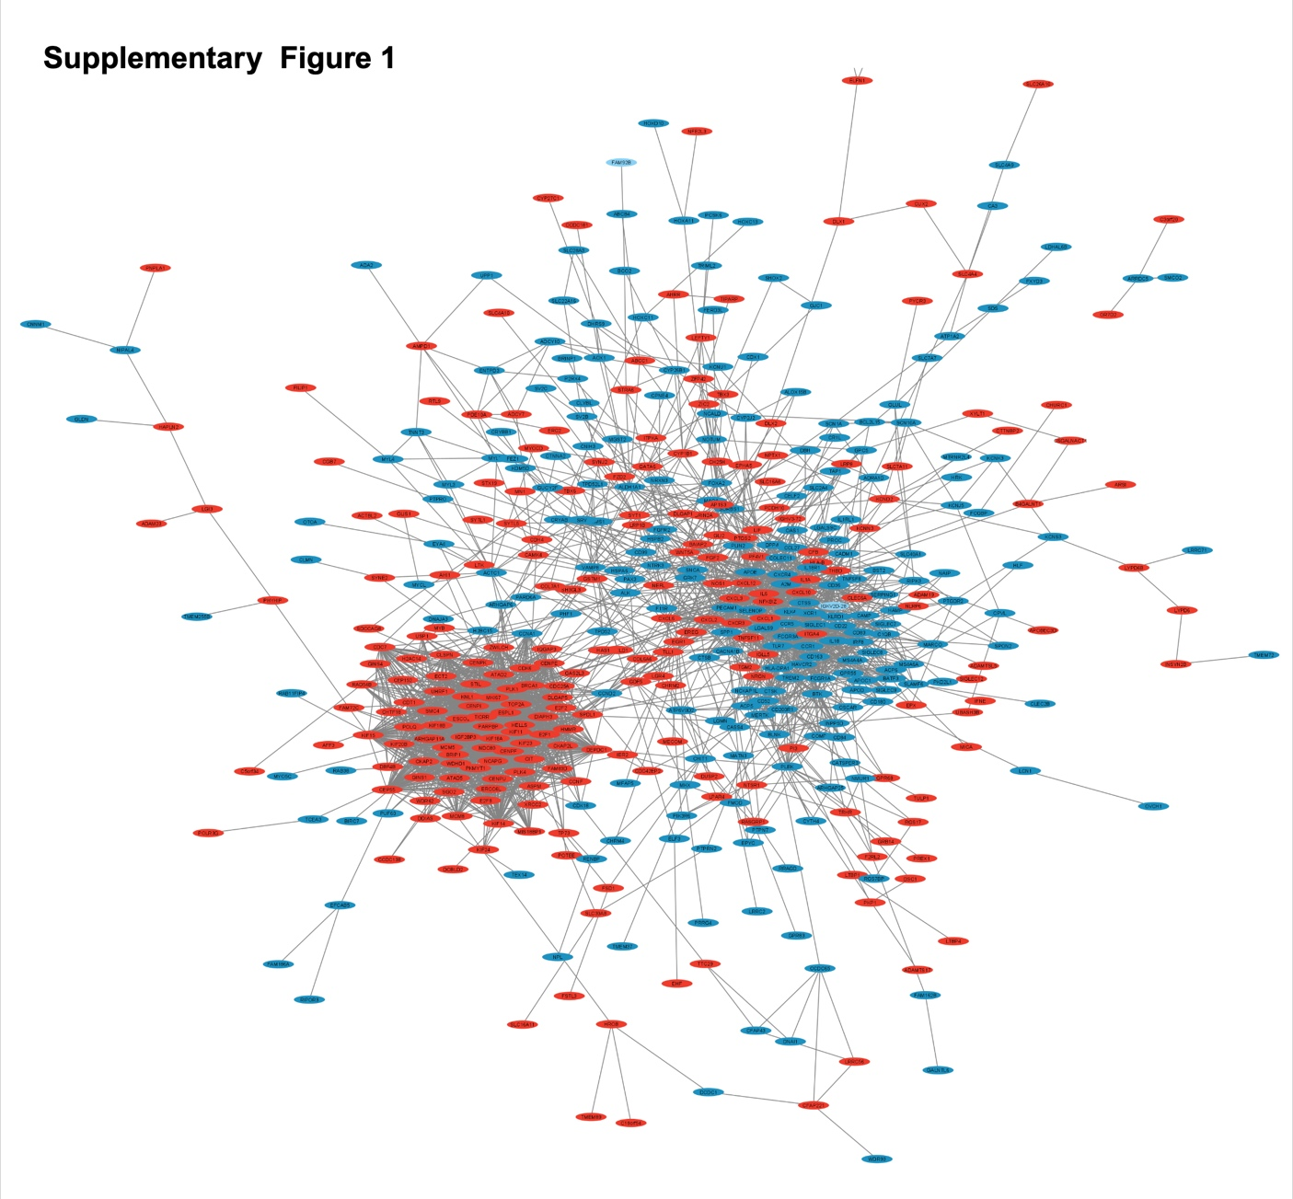
Supplementary Figure 1. Protein–protein interaction (PPI) network of all DEGs. Data were exported from STRING (version 12) and visualized in Cytoscape. Blue nodes represent downregulated DEGs; red nodes represent upregulated DEGs.

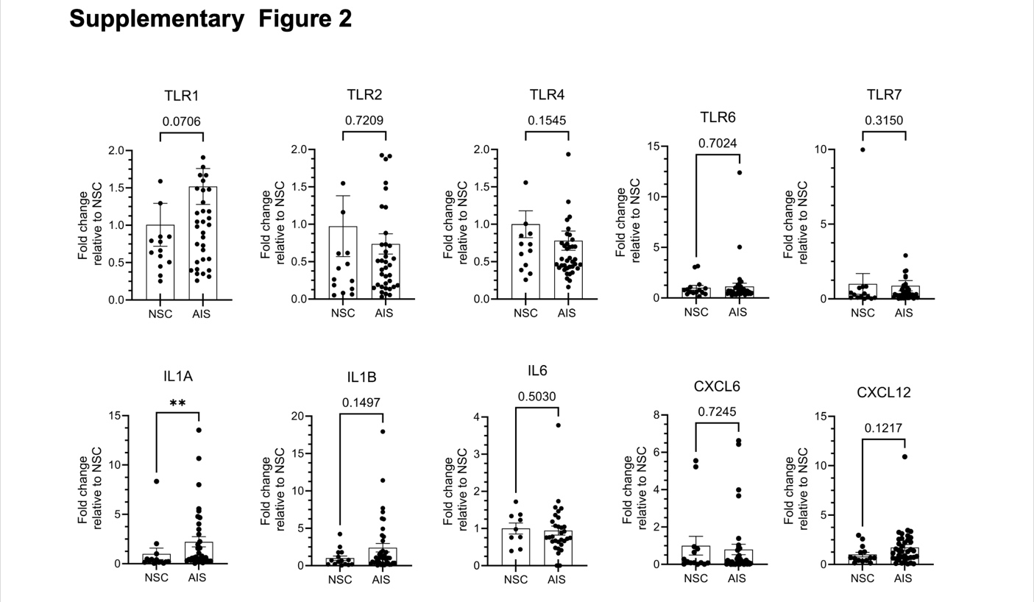
Supplementary Figure 2. Gene expression of TLRs and proinflammatory factors qPCR validation of TLRs and proinflammatory in a larger cohort (NSC n = 14, AIS n = 32-36). Data was analyzed using a two-tailed Mann–Whitney U test. Significance defined by *P<0.05, **P<0.01, ***P<0.001. Figure layout was designed using the BioRender.com platform.

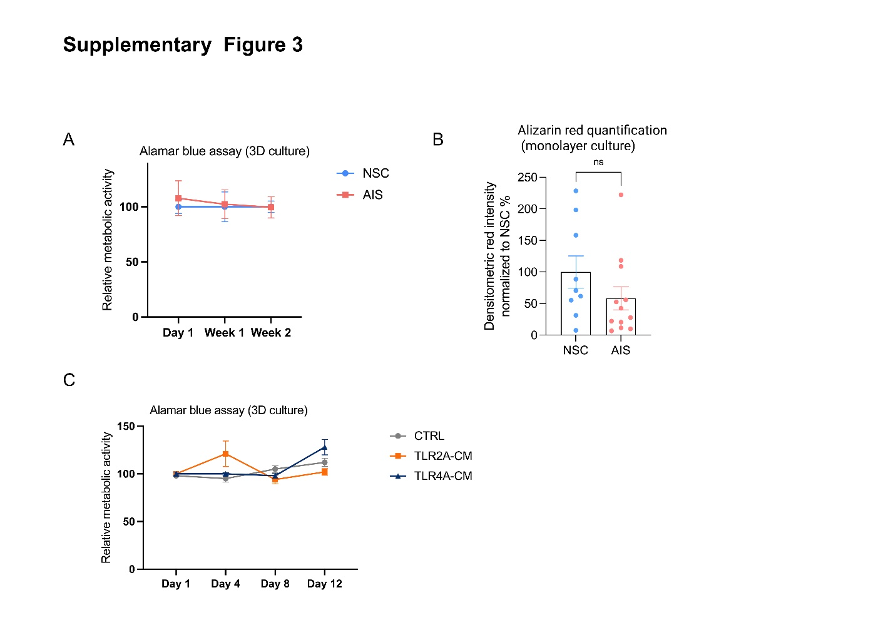
Supplementary Figure 3. (A) Metabolic activity of osteoblasts in HA–Col1 3D culture comparing NSC and AIS groups throughout the mineralization period. (B) Quantification of Alizarin Red staining in 2D monolayer osteoblast cultures. Student’s t-test was used for statistical analysis. (C) Metabolic activity of osteoblasts in HA–Col1 3D culture comparing CTRL-CM, TLR2A-CM, and TLR4A-CM groups throughout the mineralization period.

