Figure: Qualitative screening of PGP (Plant Growth-Promoting) traits
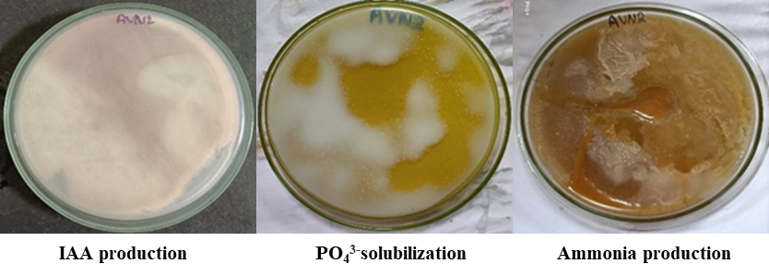

Figure: Antifungal activity of AVN2 against Fusarium oxysporum. Sp. Lycopersici in dual culture assay

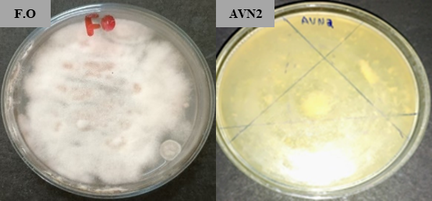

After 14 days, C. citreum AVN2 showed high growth inhibition on Fusarium. oxysporum sp. Lycopersici, confirming its antifungal activity.
The radius of pathogenic fungi alone in the control plate = 68 mm
The radius of pathogenic fungi along with C. citreum in a dual culture plate = 6mm
Radial growth inhibition
Control plate- Dual culture plate = 68-6 =62 mm

% of growth inhibition of C. citreum = (Radial growth inhibition/ radial growth of fungi without C. citreum) X 100
% of growth inhibition of C. citreum = 62/68X100= 91.1%
Table Radial growth inhibition of Fusarium. oxysporum sp. Lycopersici by endophytic C. citreum
 | Radius (mm) | Radial growth inhibition | % of growth inhibition of C. citreum
Radius of Pathogenic fungi alone in control plate | 68 mm | Control plate- Dual culture plate = 68-6 =62 mm | % of growth inhibition of C. citreum  62/68X100= 91.1%
Radius of pathogenic fungi along with C, citreum AVN2 | 6 mm | Control plate- Dual culture plate = 68-6 =62 mm | % of growth inhibition of C. citreum  62/68X100= 91.1%

Fig Structure of Bioactive compounds produced by C. citreum AVN2
