Cross-Equatorial Climate Linkages: Insights into Monsoon–Glaciation–Insolation Dynamics from Bakhira Lake Sediments, Ganga Plain, India

Nazakat Ali^{1,2}, Sajid Ali^{3*}, Anupam Sharma^{1,2}, Ali M Khan⁴, Shivansh Saxena^{1,2}, Ishwar Chandra Rahi¹, Rajveer Sharma⁵, Pankaj Kumar⁵, P. S. Ranhotra^{1,2}, Kamlesh Kumar^{1,2}, Manoj M. C.^{1,2}, Biswajeet Thakur^{1,2*}

Supplementary Information
Materials and Methods
The Ganga Plain is bordered by the Himalayan foothills to the north and the Peninsular Indian plateau to the south, with its width expanding toward the west and narrowing toward the east. The Ganga River originates from the Gomukh glacier in Uttarakhand, situated at an elevation of approximately 6.4 km above mean sea level (Supplementary Fig. 1). The plain is characterized by a vast network of rivers and their tributaries, forming a significant sediment dispersal system (Tandon et al. 2006; Sinha et al. 2006 and references therein). The Ganga River system carries an estimated suspended sediment load of about 524 million tons annually (Milliman and Meade 1983). Geographically, the Ganga Plain is subdivided into three segments: the Upper, Middle, and Lower Ganga Plains and our study area is located within the Middle Ganga Plain (Fig. 1). Situated within the vast Indo-Gangetic Plain of Uttar Pradesh, India, Bakhira Lake represents an active floodplain wetland shaped by monsoon-driven seasonal variations and fluvial dynamics. The region's geomorphology is primarily governed by deposition patterns of alluvial sediments comprising silt, sand and clay. Consequently, this wetland undergoes annual fluctuations in size due to monsoonal rainfall, impacting its physical boundaries as well as its ecological attributes. Hence, all this make this vast continuous deposited alluvial plain one of the best places to study the fluctuation in the rainfall intensity Since the Late Quaternary (Singh 1996).

Supplementary Fig. 1. Schematic map of the Ganga Plain with its geomorphic features (modified after Singh 1996).
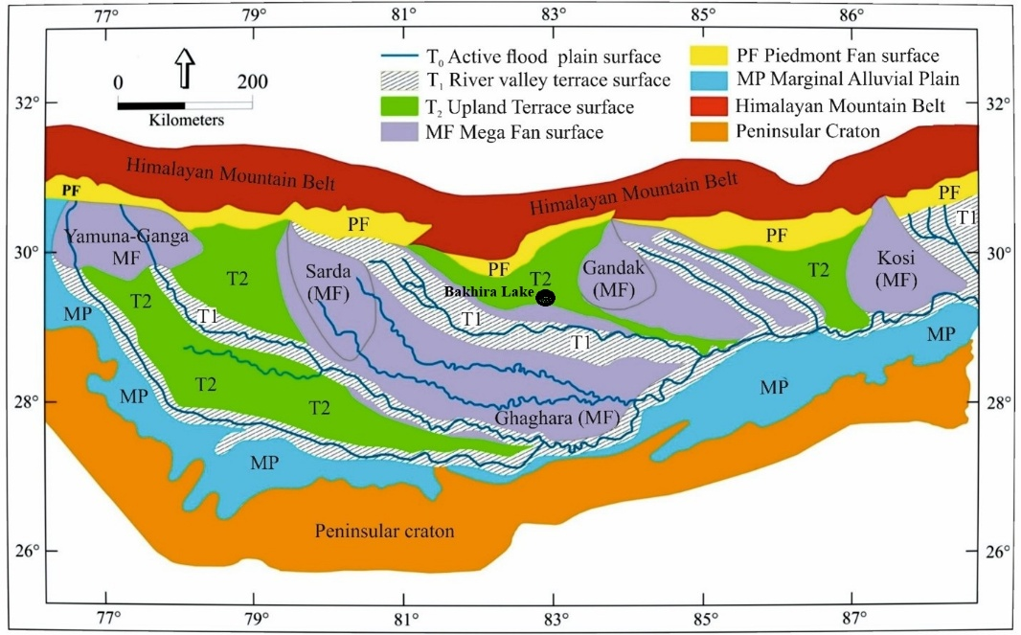

Closed ponds or lakes in northern India are locally referred to as Tals. The Bakhira Lake is one such oxbow lake, located close to Bakhira village in the Sant Kabir Nagar district in Uttar Pradesh, India. A ~406 cm long Bakhira Lake sediments trench was dug in summer of 2023 from the south western part of Bakhira Lake (26.80 N, 83.07 E; Fig. 1). A total of 203 samples at 2 cm interval were sampled from the Bakhira Lake sediment trench and core, prepared for various proxy analyses.
Lithology of Bakhira Lake sediments: The lithology of the Bakhira Lake sediments is divided into eight sections (Supplementary Fig. 2a). The surface layer (0–16 cm) consists of brownish mottled silty-clay with rootlets, indicating organic-rich deposition. The second section (16–46 cm) is blackish mud with rootlets, suggesting waterlogged conditions. The third section (46–70 cm) contains grayish-yellow mud, transitioning into yellowish silty-clay (70–102 cm) in the fourth section, reflecting varying depositional energy. The fifth section (102–150 cm) includes sticky yellowish mud with minor pebbles and pebbly mud, indicating higher-energy input. The sixth section (150–226 cm) consists of gray silty-clay and rubified silt with nodules. The seventh section (226–347 cm) comprises brown silt-clay, massive light brown clay and clay with fine sand, representing prolonged deposition. The deepest section (347–407 cm) features brownish-gray massive clay, sticky clay and granular clay with nodules.

Supplementary Fig. 2. (a) Litholog and, (b) age-depth plot of sedimentary core from Bakhira Lake.
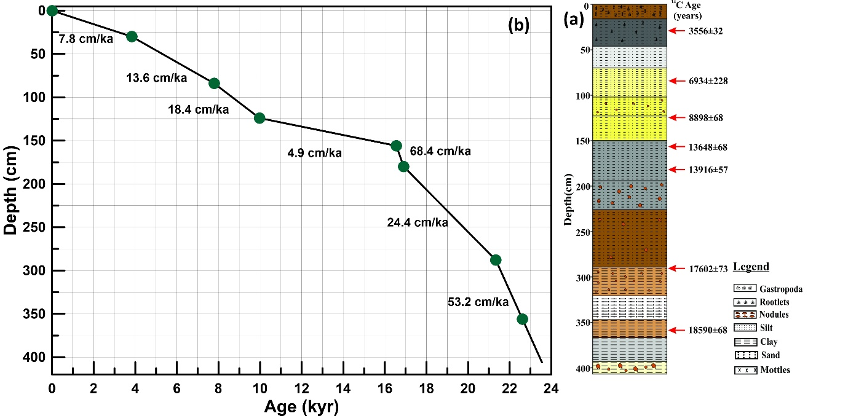
AMS dating: The chronology of the Bakhira Lake sediments was established by radiocarbon dates obtained on bulk sediment organic carbon using the Accelerator Mass Spectrometry (AMS) facility of Inter University Accelerator Centre (IUAC), New Delhi, India, following the methods described by Sharma et al. (2019). Seven samples from 30 cm, 84 cm, and 124 cm, 156 cm, 180 cm, and 288 cm and 356 cm depths were selected for dating. The powdered bulk samples were treated with 1 N HCl and 0.5 N NaOH to remove carbonates and humic acids, respectively. The organic carbon present in the samples was combusted in an elemental analyzer, and the evolved CO₂ was purified and converted to graphite using an Ion plus automated graphitization equipment. The ¹⁴C activity was measured using a 500 kV Pelletron accelerator at the IUAC. Radiocarbon ages were corrected for isotopic fractionation by normalizing to δ¹³C values of respective samples measured using a continuous-flow isotope ratio mass spectrometer. The ¹⁴C ages were calibrated to calendar years before present (cal yr BP) using OxCal v4.4 and IntCal20 dataset (Reimer et al. 2020).
Grain Size: A total of 194 samples were selected to investigate past changes in the grain size distributions of the detrital fraction throughout the studied intervals. Calcium carbonate, organic material and biogenic silica were removed with 10% acetic acid and in the second step 10% hydrogen peroxide, respectively. This is followed by a triple rinse with de-ionized water prior to measurements. Microscopic inspection of selected samples to verified that all disturbing components were removed successfully. The grain size distributions were determined using a laser diffraction particle size analyzer Beckman Coulter LS I3 320 at the Birbal Shani Institute of Palaeosciences, Lucknow, India, yielding 116 size classes from 0.04 to 1908 µm.
Clay mineral assemblages: A total of 44 sediment samples were analyzed for clay mineral assemblages. About 2g of each sample was treated with 10% hydrogen peroxide (H₂O₂) and 10% glacial acetic acid (CH₃COOH) to remove organic and carbonate fractions respectively, followed by a repeated rinse with Milli Q water to pH neutralization. Clay-size fraction (<2 μm) was separated using the Atterberg method, which is centrifuge-based, and settling durations were computed using SediCalc, a free program (Krumm 2006). To prepare the oriented clay slides, the clay fractions were evenly spread on a glass slide before air drying overnight at room temperature. These oriented slides were subsequently exposed to ethylene glycol for 12 hours. The analysis was carried out using an X-Ray diffractometer (PanAnalytical, model- X’PERT3 powder) using Ni-filtered CoKα radiation at 40 kV and 35 mA. In sediment samples, clay minerals were identified based on their characteristic "d-spacing" values (Chamley 1989). The relative abundance of each clay mineral was determined based on the position of the (001) series basal reflections in the XRD patterns, specifically smectite (001) at 17 Å, illite (001) at 10 Å, kaolinite (001) and chlorite (002) at 7 Å. Kaolinite and chlorite were further differentiated by analyzing their relative proportions using the peak area ratios at 3.57 Å and 3.54 Å, respectively. The illite crystallinity and illite chemistry index have been calculated from the X-ray diffractograms. Illite crystallinity was obtained from the half height width of the 10 Å peak (Chamley 1989). Illite chemistry index refers to a ratio of the 5 Å and 10 Å peak areas (Esquevin 1969).
Geochemical analysis: For geochemical analysis (major oxides, trace elements including Rare Earth Elements (REEs) in 43 sediment samples, 20g samples were crushed to a 200-mesh size using disc mil (Ritsch, Germany). The powdered samples treated with 10% HCl to remove carbonate fraction followed by repeated with Milli Q water to remove soluble fraction, and then samples were kept in hot air oven at 50ºC to complete dry the samples. The samples were ground into fine powder using an agate mortar and pestle. For removal of organic fraction, decarbonated powdered samples were kept in furnace at 550ºC for 4 hrs. Of these 50mg powdered samples were taken for complete digestion in a Savillex PFA vials. The samples were completely digested in three steps. The samples were digested by using a mixture of concentrated HF-HNO₃-HCLO₄ followed by HCl-HNO₃. Every step of the digestion process was repeated until a clear solution was achieved, and each step was completed on a hot plate at 130°C for 8 hours. To get a final volume of 50 ml, the residue was re-dissolved in 2% HNO₃ solution. The samples were measured for major, trace and REEs elements using Inductively coupled plasma-mass spectrometry (Agilent® 7700x Series, Q-ICP-MS). The U.S. Geological survey’s (USGS) geological reference standards (USGS; RGM-2, SGR-1b), were used for instrument calibration. The precision and accuracy of the measured elements through Q-ICP-MS were better than 1%. In the present study for the estimation of SiO₂ content, we have used Al₂O₃/TiO₂ ratio as proposed by Hayashi et al. (1997), for the intermediate and felsic composition rocks. Further, as we have treated all samples with H₂O₂ and acetic acid to remove all traces of organic and CaCO₃ contents before total dissolution of the samples. Hence, the difference in the sum of major oxide and total major element abundances is supposed to be SiO₂ concentration.
The CIA values are calculated as the formula CIA= {Al₂O₃/(Al₂O₃+CaO*+Na₂O+K₂O} x 100, (where CaO* is for the carbonate free silicate fraction) and all major oxides are expressed in molar proportions. The CIA value is dependant on the often-assumed composition of source rocks but generally values of 50 or less suggests no weathering, values between 50 to 60 indicate the initial stage of weathering, 65 to 84 a moderate degree of weathering and values > 84 suggests intense weathering (Fedo et al. 1996). The α^{Al}Na is also applied in this study to evaluate the chemical weathering conditions (Garzanti et al. 2013) and the calculation formula is as follows: α^{Al}Na =(Al/Na)sediment/(Al/Na)_{UCC}.
Supplementary Fig. 3. (a) Plot of the grain-size distribution for each sample along size distribution, (b) Number of end members vs variance, (c) Result of the EMMA (Weltje 1997), with the grain-size distribution of two first end members (EM1 and EM2) that explain more than 95 % of the total variance.
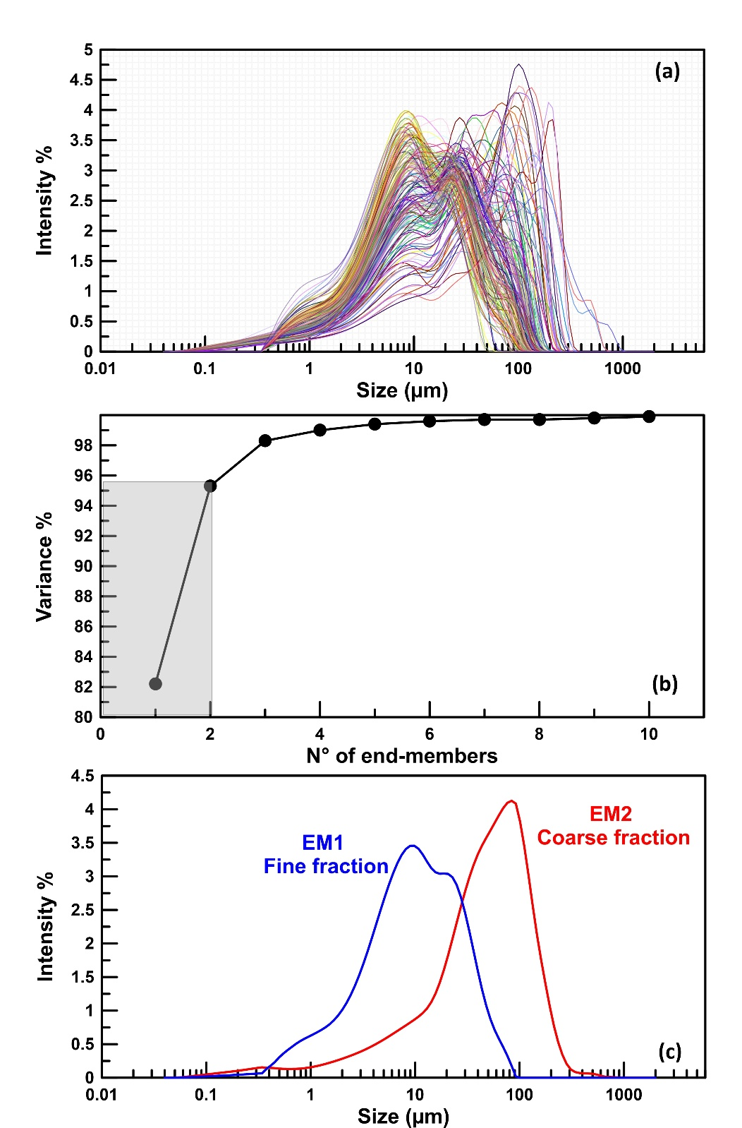

Supplementary Fig. 4. Distribution of the Major, Trace and REEs of the Bakhira lake sediments.

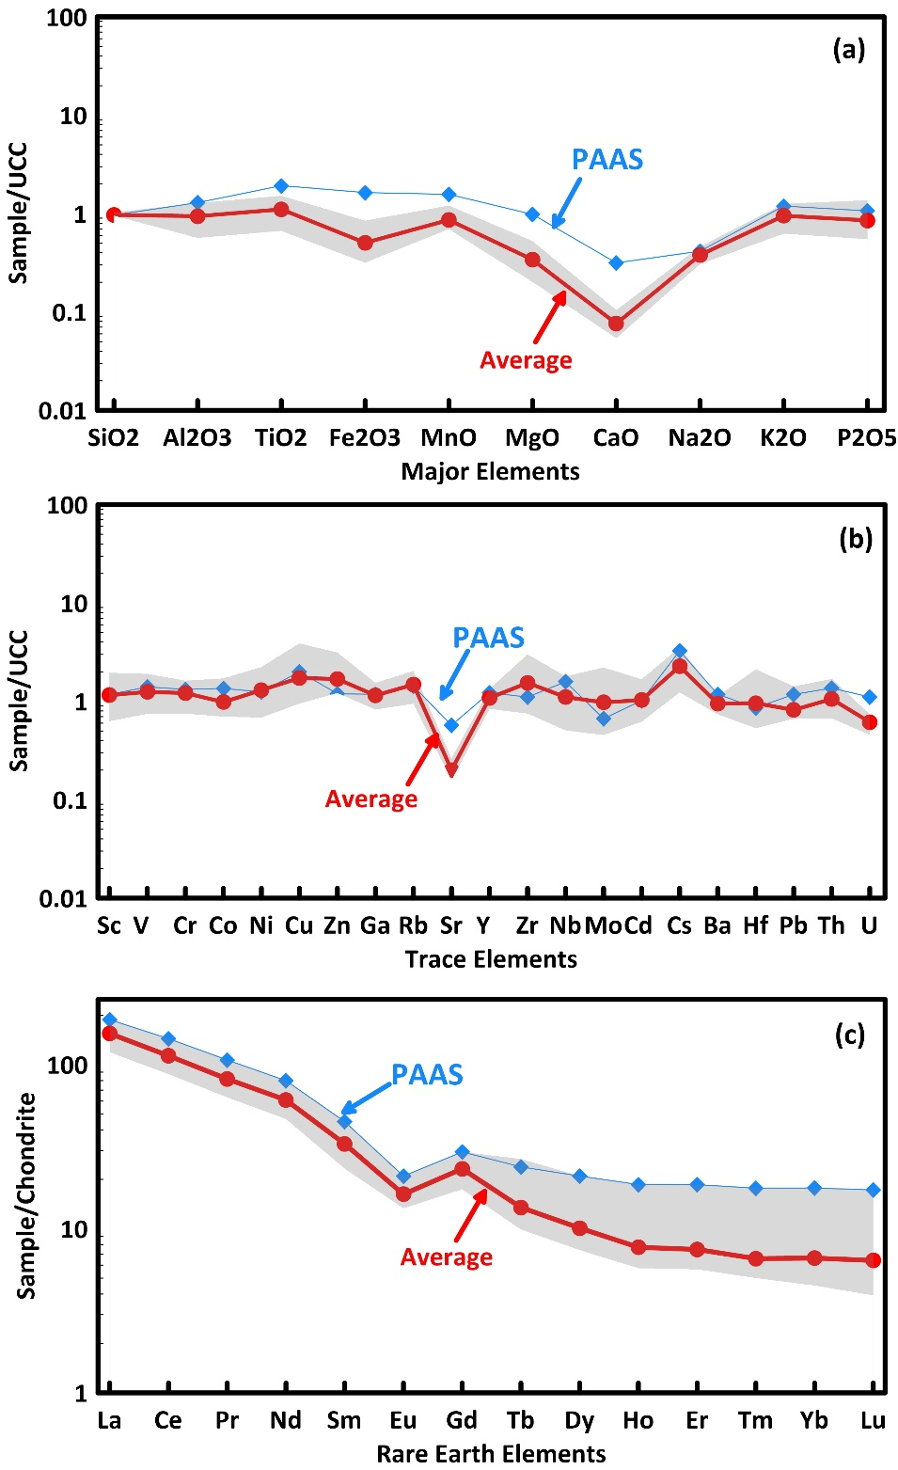

References
Chamley H (1989) Clay Sedimentology. Springer-Verlag, Berlin, pp 1–623
Esquevin J (1969) Influence of clay mineralogy on the crystal morphology of illites and their swelling and chemical reactivity. Bull Miner Soc France 92:153–158
Fedo CM, Eriksson KA, Krogstad EJ (1996) Geochemistry of shales from the Archean (~3.0 Ga) Buhwa Greenstone Belt, Zimbabwe: implications for provenance and source-area weathering. Geochim Cosmochim Acta 60(10):1751–1763
Garzanti E, Padoan M, Setti M, Najman Y, Peruta L, Villa IM (2013) Weathering geochemistry and Sr-Nd fingerprints of equatorial upper Nile and Congo muds. Geochem Geophys Geosyst 14(2):292–316
Hayashi K, Fujisawa H, Holland HD, Ohmoto H (1997) Geochemistry of ~1.9 Ga sedimentary rocks from northeastern Labrador, Canada. Geochim Cosmochim Acta 61(19):4115–4137
Krumm S (2006) SediCalc: computer program for calculating settling velocities and distribution of grain sizes by gravity sedimentation. Version 4.0. GeoZentrum Nordbayern
Milliman JD, Meade RH (1983) World-wide delivery of river sediment to the oceans. J Geol 91(1):1–21
Reimer PJ, Austin WE, Bard E, Bayliss A, Blackwell PG, Ramsey CB, … Talamo S (2020) The IntCal20 Northern Hemisphere radiocarbon age calibration curve (0-55 cal kBP). Radiocarbon 62(4):725–757
Sharma R, Umapathy GR, Kumar P, Ojha S, Gargari S, Joshi R, Kanjilal D (2019) AMS and upcoming geochronology facility at Inter University Accelerator Centre (IUAC), New Delhi, India. Nucl Instrum Methods Phys Res B 438:124–130
Singh IB (1996) Geological evolution of Ganga Plain—an overview. J Paleontol Soc India 41:99–137
Sinha R, Tandon SK, Gibling MR, Bhattacharjee PS, Dasgupta AS (2006) Late Quaternary geology and alluvial stratigraphy of the Ganga basin. Himalayan Geology 27(1):43–59
Tandon SK, Sinha R, Gibling MR, Bhattacharjee PS, Dasgupta AS (2006) Late Quaternary evolution of the Ganga Plain: Myths and misconceptions, recent developments and future perspectives. Curr Sci 91(6):837–843
Weltje GJ (1997) End-member modeling of compositional data: numerical-statistical algorithms for solving the explicit mixing problem. Math Geol 29(4):503–549

