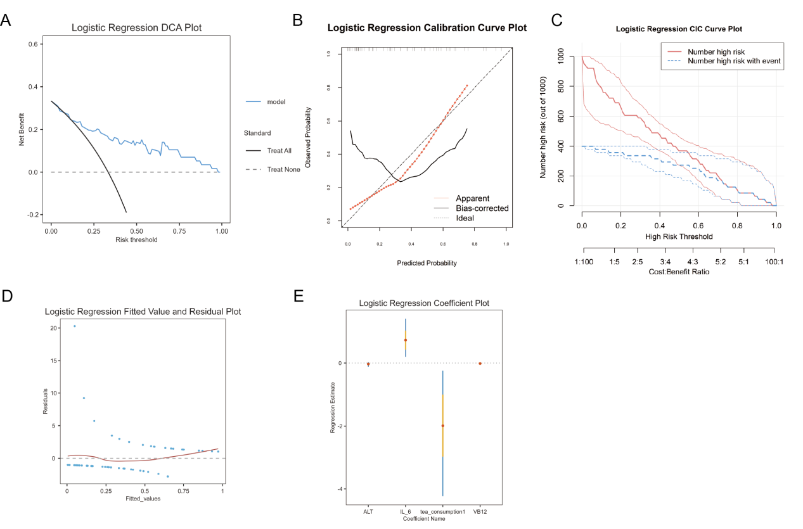
Supplementary Figure 1. Additional Model Performance Plots
A–B. Calibration curves; C. Decision curve; D. Residual scatter plot; E. Coefficient plot.

