Supplementary information
Machine Learning for Prompt Estimation of Macroseismic Intensity from Seismometric Data in Italy
Luca Patelli^{1*}, Michela Cameletti¹, Valerio De Rubeis², Nicola Alessandro Pino³, Claudia Piromallo², Paola Sbarra², Patrizia Tosi^{2*}
¹Department of Economics, University of Bergamo, Via dei Caniana, 2, Bergamo, 24127, Italy. ²Istituto Nazionale di Geofisica e Vulcanologia (INGV), Via di Vigna Murata 605, Roma, 00143, Italy. ³School of Science and Technology - Geology Section, University of Camerino, Piazza Cavour 19/f, Camerino, 62032, Italy.

The Variable Importance (VI, see the Materials and methods section) from the RF is displayed in Fig. SI-1. Our results indicate that the variables describing the earthquake and the distance to the source (namely depth, Mw_trasf and logst_IPODIST) are less important for predicting seismic intensity compared to GeoMean_pga and GeoMean_pgv, which play a dominant role.
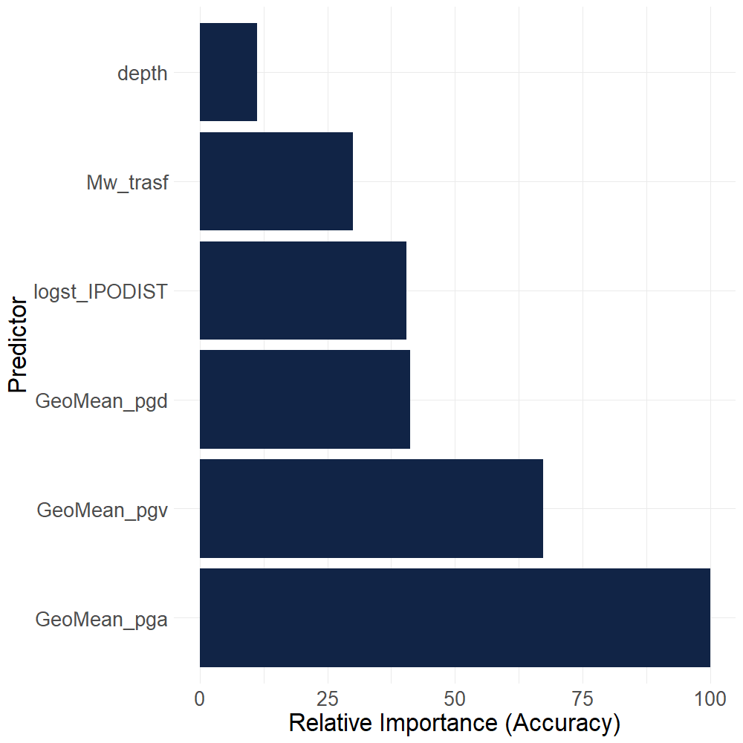
Fig. SI-1. Relative importance of the predictors from the RF (values are expressed relatively to the maximum).
In fact, the former variables used in traditional IPEs have limitations. They fail to capture the variability of ground motion due to factors such as detailed seismic source characteristics, geological properties of the site and the direction of seismic wave propagation. Consequently, the use of traditional IPEs alone can lead to under- or over-estimation of macroseismic intensity at a given site, with potential negative implications in terms of seismic hazard. To overcome these limitations, it is necessary to consider ground motion measures more directly related to the intensity of effects at a given location.

The surrogate of depth 2 is composed of 3 splits involving GeoMean_pga GeoMean_pgd, two of the most important predictors highlighted by the Variable Importance (VI, see Fig. SI-1). The aforementioned splits result in a total of four terminal nodes, which, as illustrated in the bottom panel of Fig. SI-2, have modal classes comprising at least 50% of the training observations. A focus on the intensity classes characterizing each terminal node reveals a similarity in the intensities present at each leaf. The first terminal node is identified by the path GeoMean_pga <= 1.7804407 & GeoMean_pga <= -0.003006; the observations in this node are characterized by low seismic intensities, ranging from intensity 1 to 4, with a mode on class 1. The intensity distribution for the second terminal node ($R_{2}$) also includes classes 5 and 6, albeit to a marginal extent, equivalent to less than the 5% of the observations. In contrast, nodes $R_{3}$ and $R_{4}$, which are defined by a split that considers GeoMean_pgd, exhibit a shift in the intensity distribution to higher levels, suggesting the expected onset of more disastrous effects.
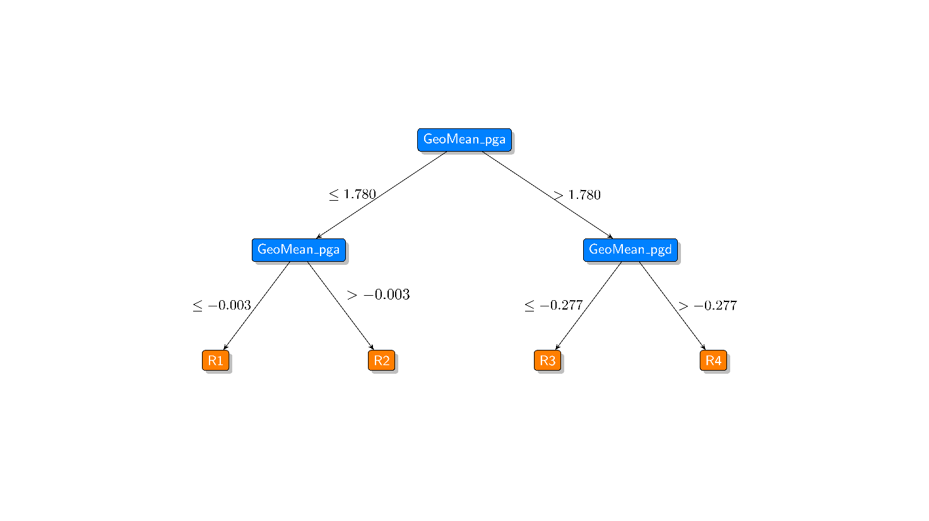
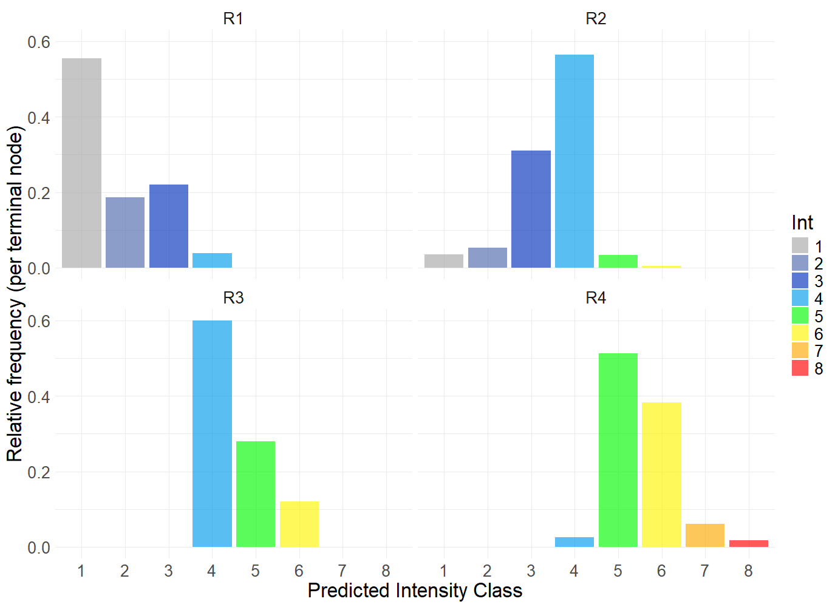
Fig. SI-2. Top: surrogate tree of depth 2 (S2), wherein the rectangles represent the predictor for the split, and the conditions are displayed along the branches. Bottom: distribution of the intensity classes in the four terminal nodes of S2 ($R_{1}$, ..., $R_{4}$).
Given that the dataset contains eight intensity classes, the presence of only four terminal nodes limits the predictions, preventing them from covering the entire range of intensity classes from 1 to 8. Consequently, an increase in the depth of the surrogate is necessary to try to obtain at least a terminal node for each intensity class.
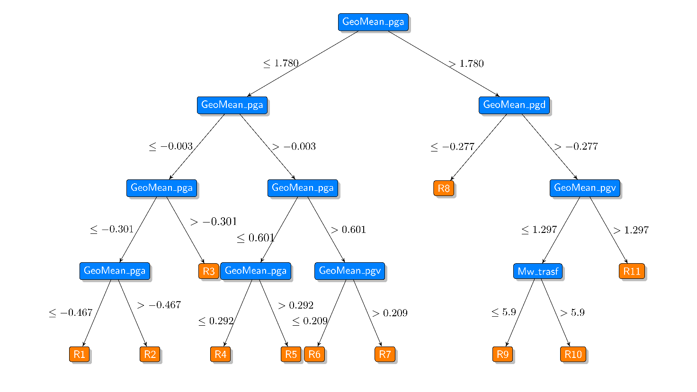
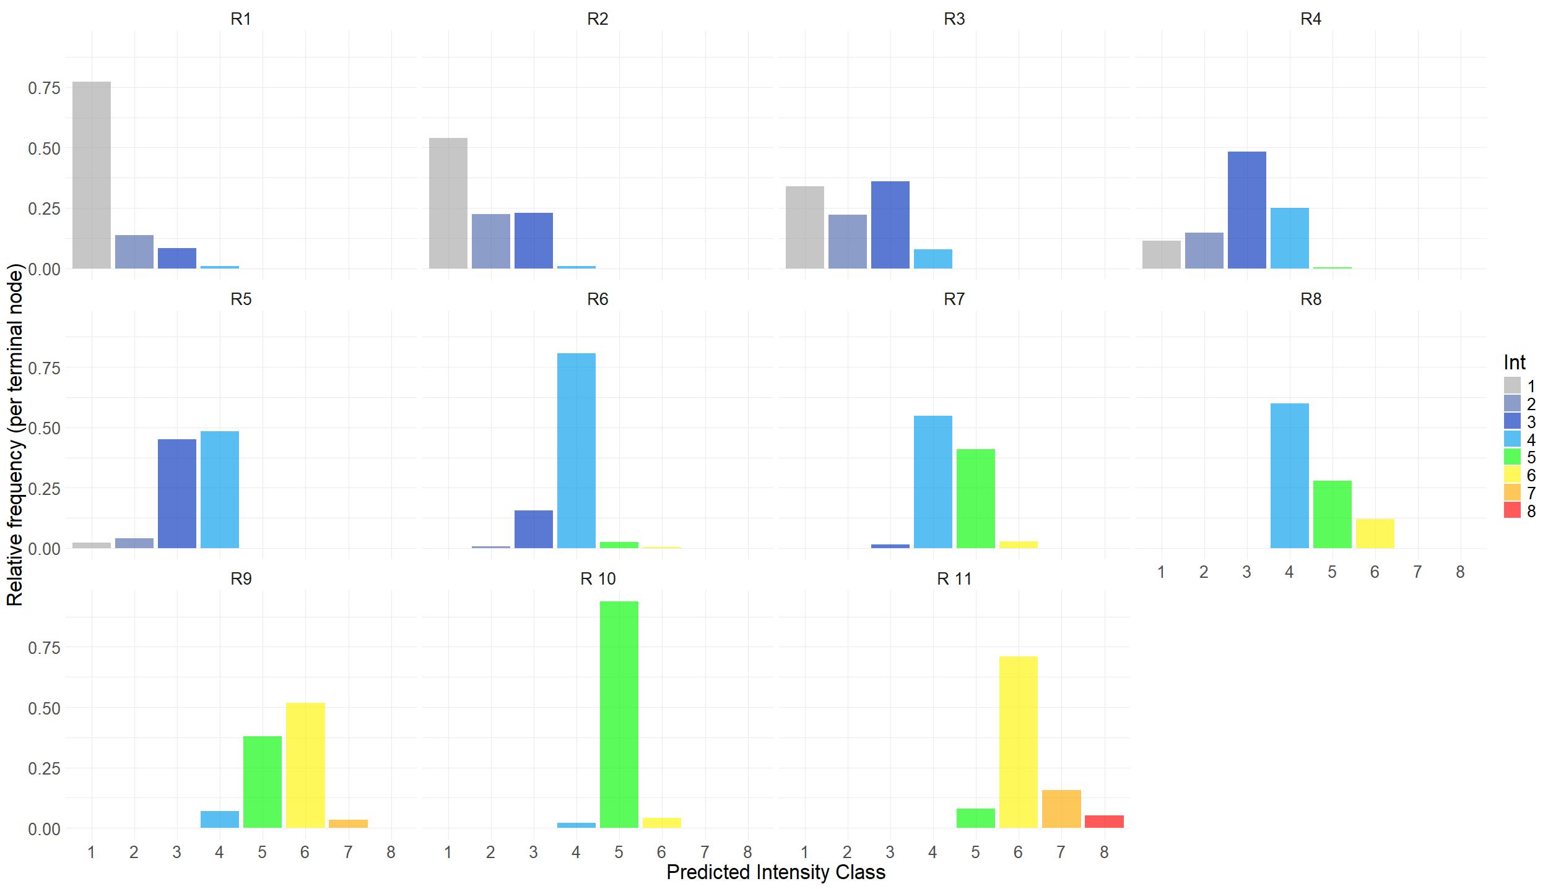

Fig. SI-3. Top: surrogate tree of depth 4 (S4), wherein the rectangles represent the predictor for the split, and the conditions are displayed along the branches. Bottom: distribution of the intensity classes in the eleven terminal nodes of S4 ($R_{1}$, ..., $R_{11}$).
An examination of the top panel of Fig. SI-3 reveals that S4 has a total of ten splits and terminates with eleven leaf nodes. From the root node to the leaf nodes, it can be observed that the splits involve from one to four different predictors. The terminal nodes displayed in the bottom panel illustrate that the left paths in the surrogate tree, which are solely based on GeoMean_pga, are characterized by intensity classes ranging from 1 to 4 (with the exception of $R_{4}$, where a small percentage of observations is represented by the intensity class 5). The inclusion of the predictor GeoMean_pgv in the paths leading to $R_{6}$ and $R_{7}$ results in a prevalence of high intensity classes within the intensity distributions. Starting from $R_{9}$ the modal intensity is higher than 4. With the exception of $R_{3}$, $R_{4}$ and $R_{5}$, the remaining nodes exhibit a clear modal class with a relative frequency above 0.50. Even in this more complex setting, it appears that not all the intensity classes are the predictions of at least one terminal node; this is the case of intensities 2, 7 and 8, which are intensity classes with specific reasons for under-reporting (as explained earlier).

