Low-Cost Air Quality Sensor Evaluation and Calibration in Contrasting Aerosol Environments

Pawan Gupta¹, Prakash Doraiswamy³, Alqamah Sayeed^{2,4}, Palak Balyan^{5,6}, Sagnik Dey⁵, Ryan Chartier³, Robert C. Levy¹,

¹NASA Goddard Space Flight Center, Washington, DC, USA.
² NASA Marshall Space Flight Center, Huntsville, AL, USA
³RTI International, Research Triangle Park, NC, USA.
⁴The University of Alabama in Huntsville, AL, USA.
⁵Indian Institute of Technology, New Delhi, India
⁶Health Effects Institute (HEI), Boston, U.S.A.
⁷Council on Energy, Environment, and Water (CEEW), New Delhi, India
⁸South Coast Air Quality Management District, CA, USA.
Correspondence to: Alqamah Sayeed (alqamah.sayeed@nasa.gov)

Supplementary Material
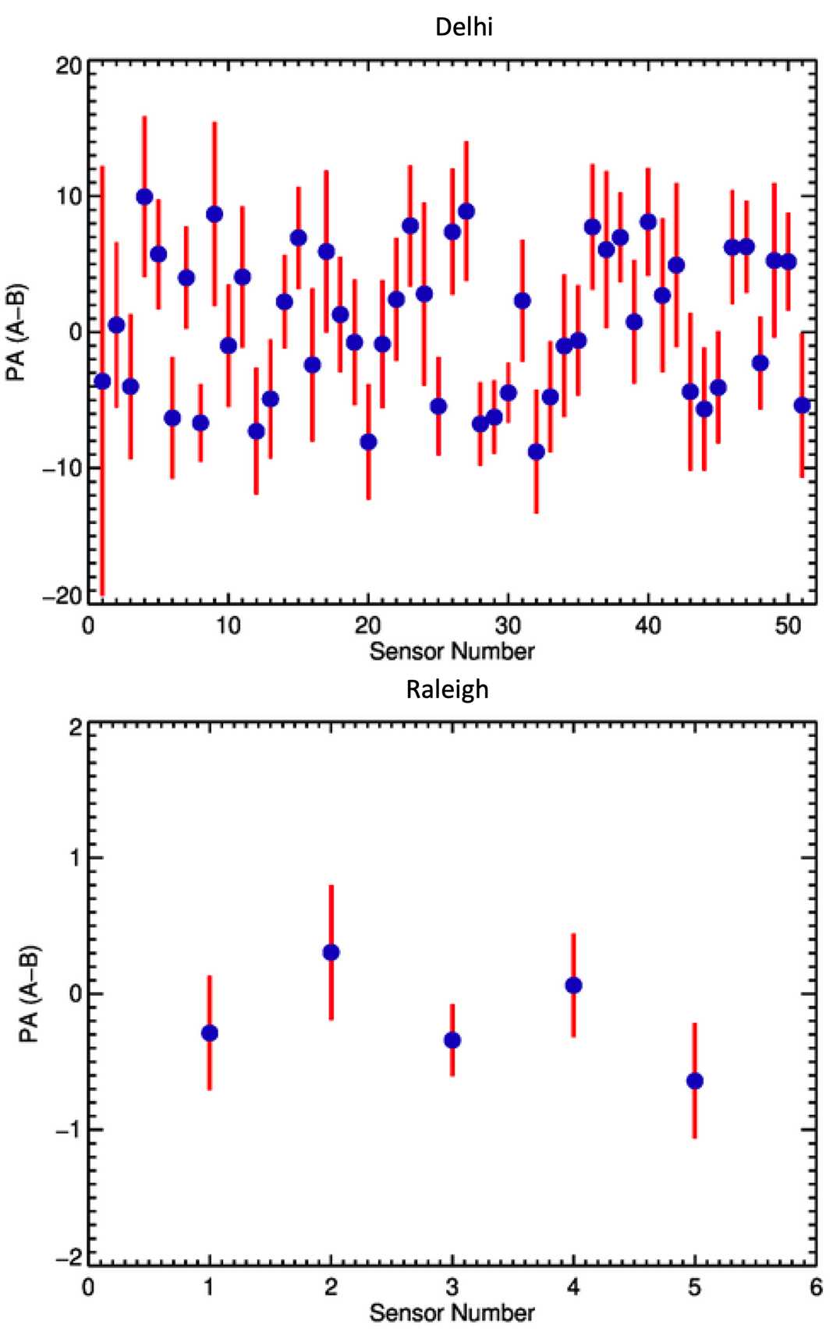

Figure S1. The plots show the mean difference in A & B measurements from each sensor for the two regions. The blue dot represents the mean, and the red vertical line is one standard deviation.

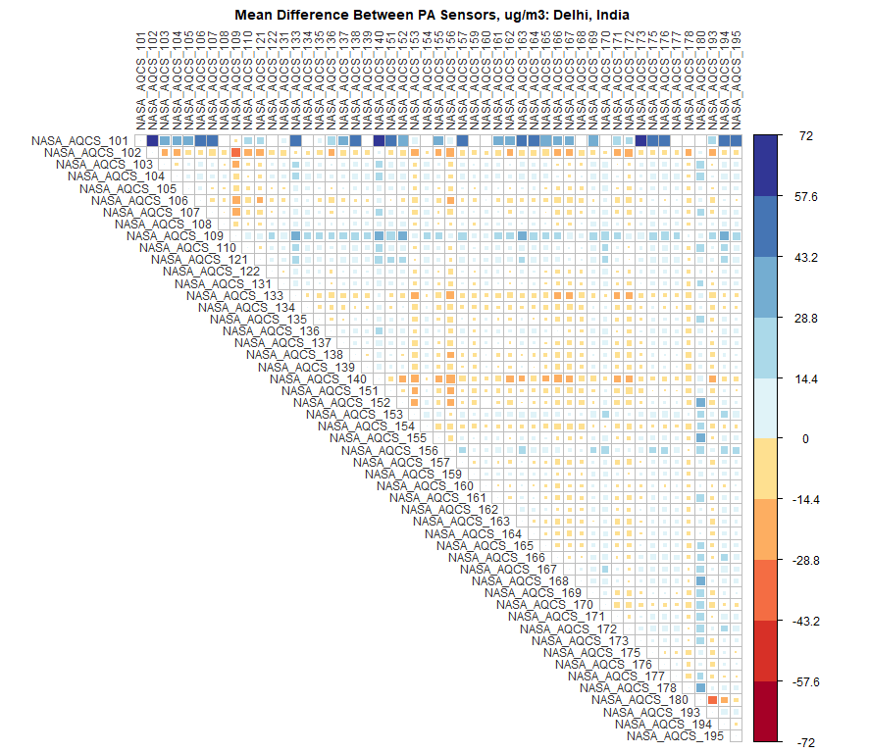

Figure S2.1. Mean Absolute Difference (µgm⁻³) Between Any Two Sensors in Delhi

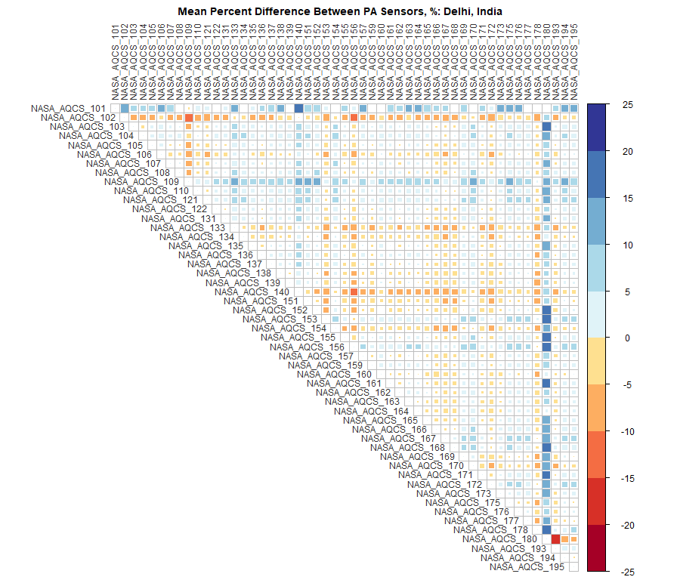

Figure S2.2. Mean Percent (%) Difference Between Any Two Sensors in Delhi

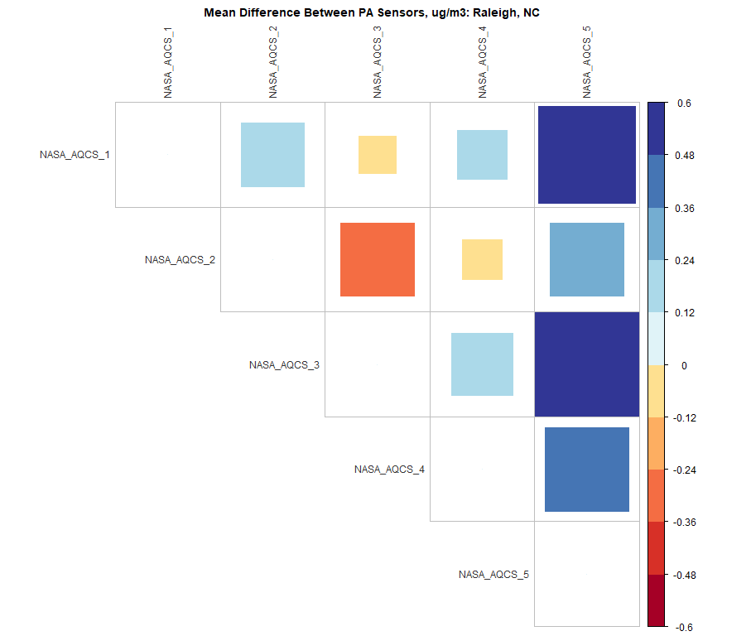

Figure S2.3. Mean Absolute Difference (µgm⁻³) Between Any Two Sensors in Raleigh

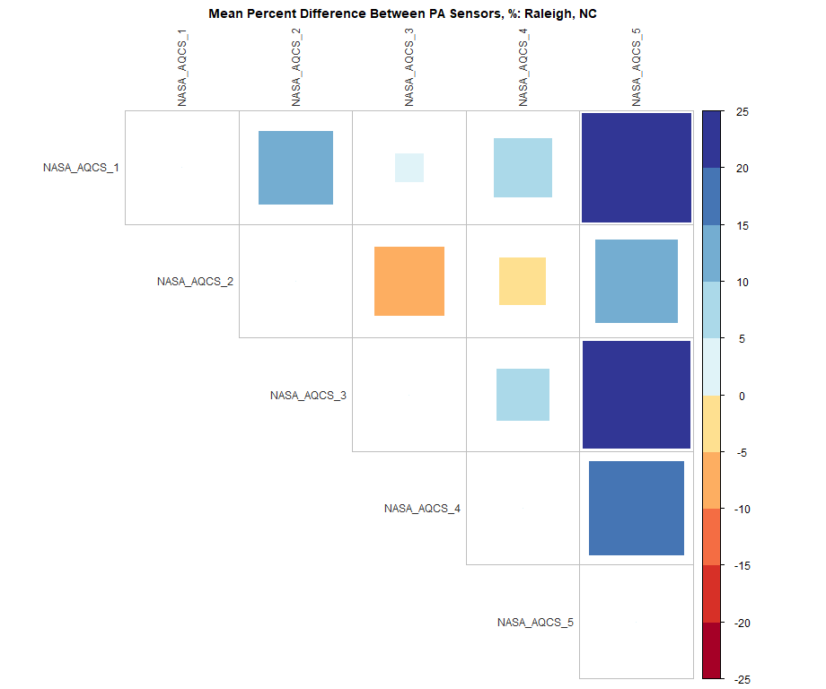

Figure S2.4. Mean Percent (%) Difference Between Any Two Sensors in Raleigh

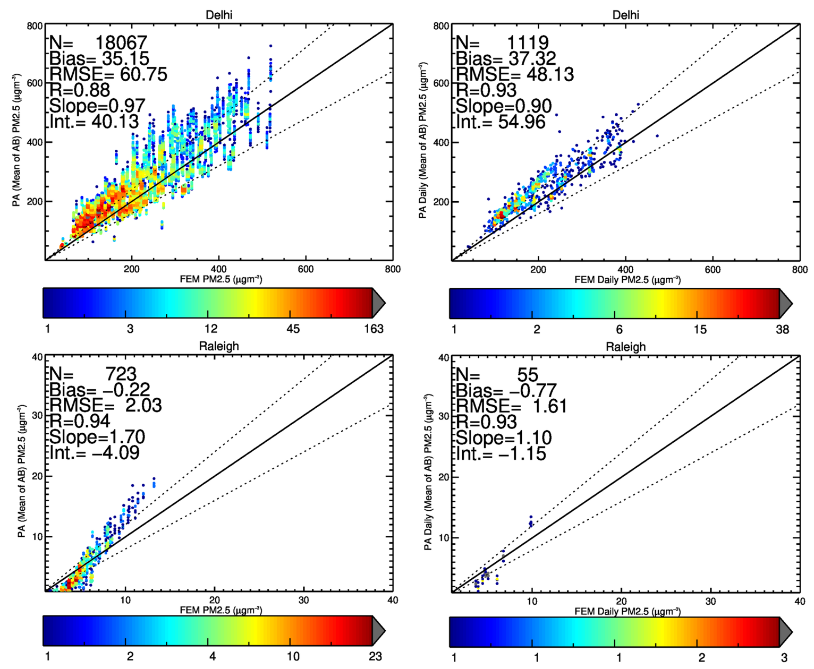
Figure S3: The density scatters plot of FEM and PA measurements of PM2.5 for the two locations after data cleaning for hourly (left) and daily (right) mean values. The color scale represents the density of data points while dividing the data into different PM2.5 bins.

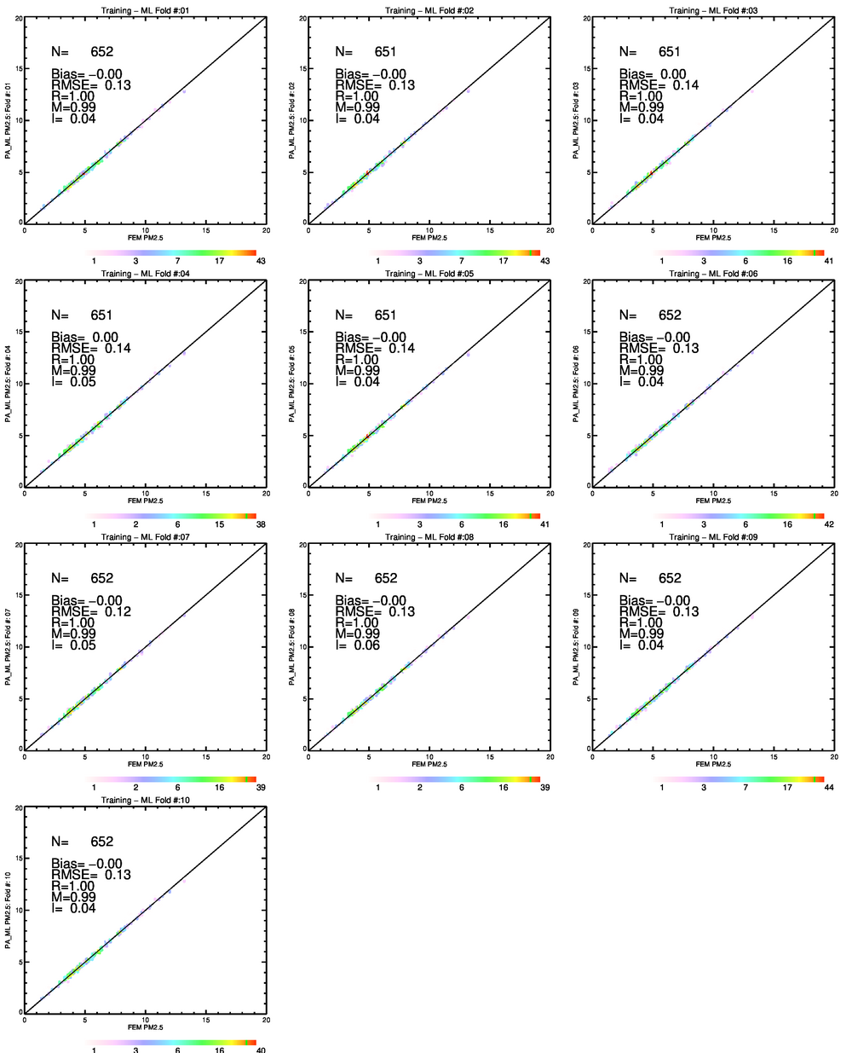

Figure S4.1 – Inter-comparison between FEM and ML output for Raleigh during 10-fold training of MLA. Each density scatter plot represents 1-fold.

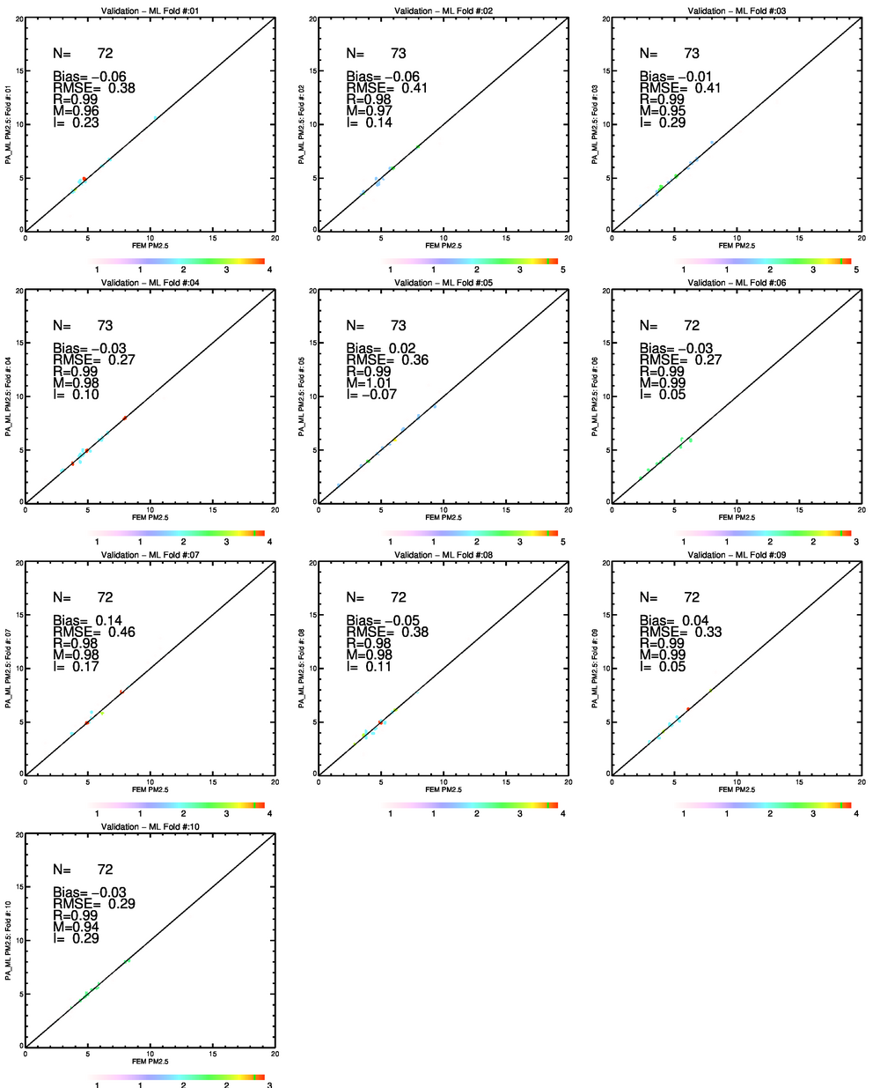

Figure S4.2 – same as Figure S3.1 but for 10-fold validation in Raleigh.

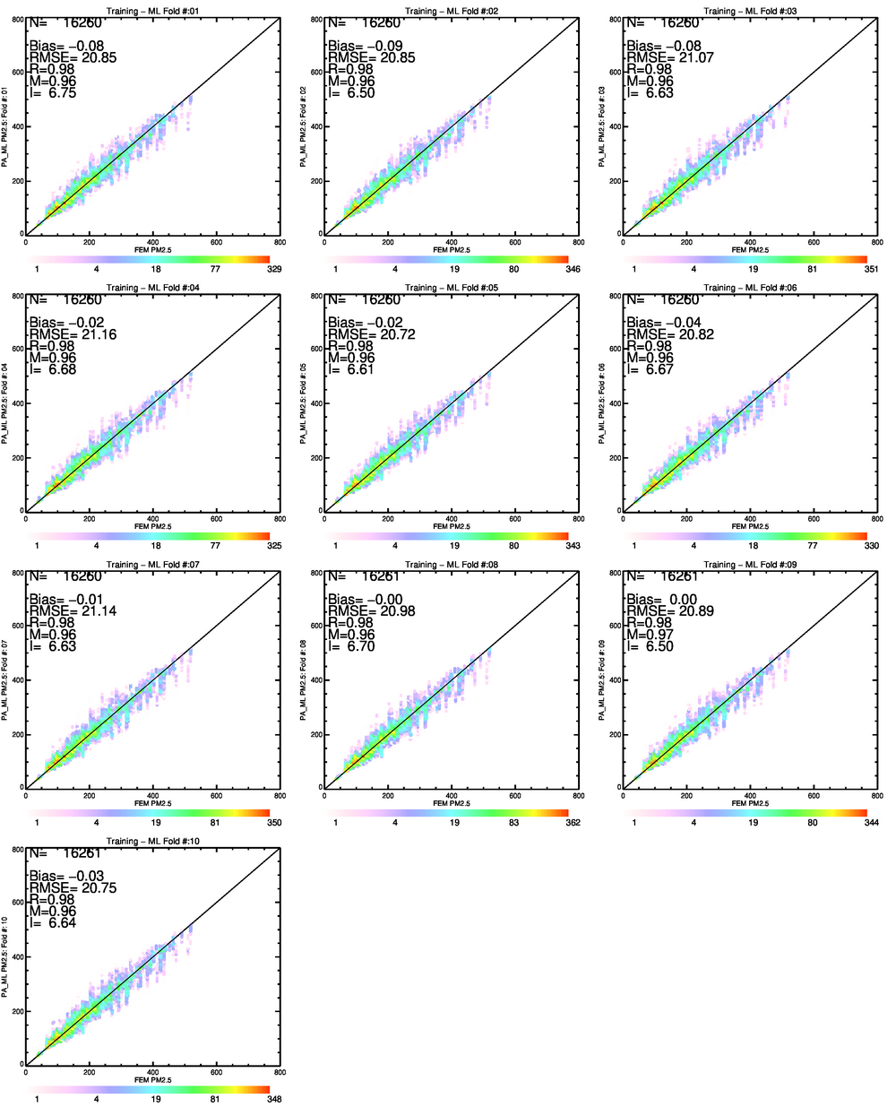
Figure S4.3 – same as Figure S3.1 but for 10-fold training for Delhi.

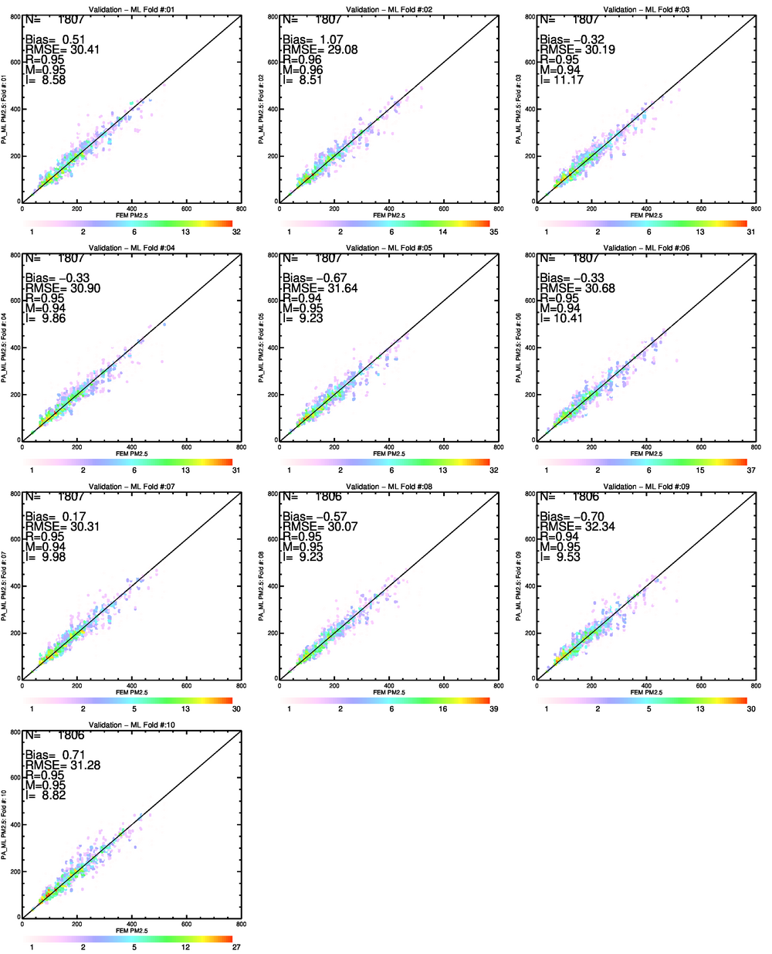

Figure S4.4 – same as Figure S3.1 but for 10-fold validation for Delhi.

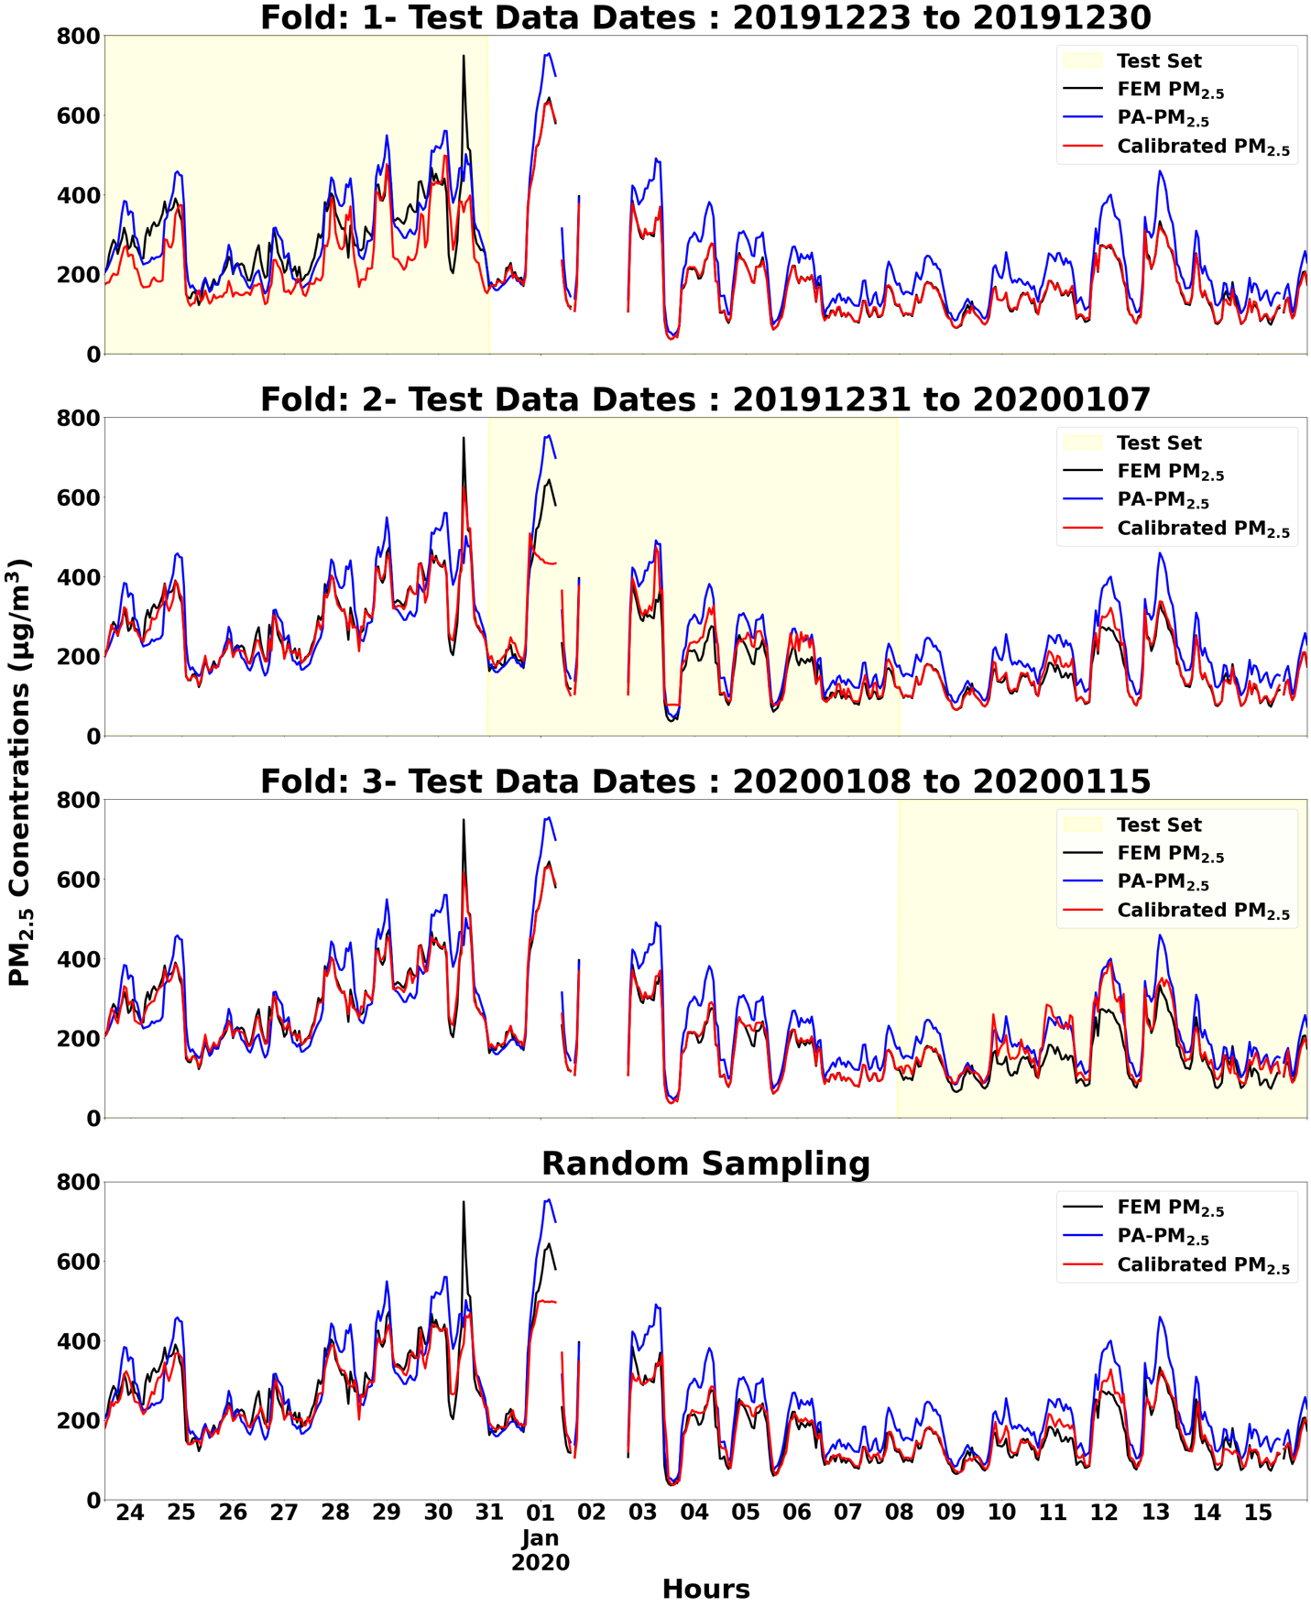

Figure S4.5 – We used a timeseries approach to train and validate a calibration model for India. The top three panels show the results of three different training and testing periods. In the first case, the model was trained on data from the last two weeks and tested on the first week of data. The results showed a large difference between the calibrated and FEM data. In the second case, the model was trained on data from the first and last weeks of data, and tested on the middle week. The difference between the calibrated and FEM data was smaller in this case. In the third case, the first two weeks were used for training and the last week for testing. The results were similar to the previous two cases. In the final attempt, a random sampling approach was used with 10-fold cross validation (S3.1-3.4). The results were much more consistent across the time period, with the calibrated data closely matching the FEM data.
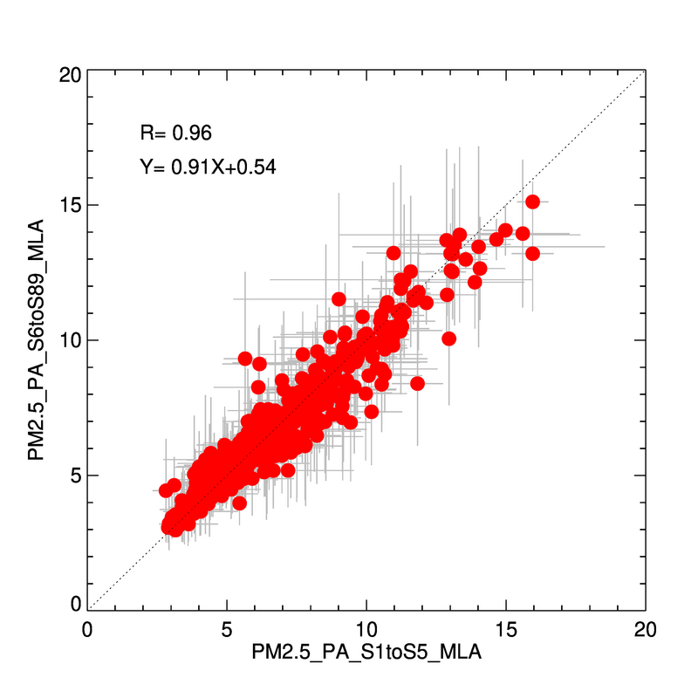

Figure S5. Inter-comparison between PM2.5 values from 5 sensors (x-axis) used for ML development, and the remaining 84 sensors at Raleigh. The same ML calibration is applied for both sets of sensors during their collocated measurement period. The red dots are mean, and grey lines are one standard deviation among sensors in each set. The PM2.5 unit is μgm⁻³.

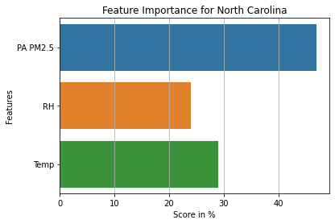

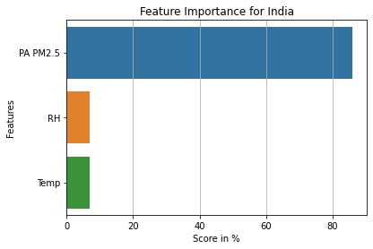

Figure S6. The input feature importance for RF model for Raleigh (top) and Delhi (bottom)

Table S1. The mean bias (MB), mean percentage bias (MB%), and mean percentage absolute bias (|MB%| for hourly and daily averages. The biases before and after corrections are provided.

Delhi | Hourly |  | MB | MB% | |MB%|
Delhi | Hourly | Raw Data | 35.1 | 23.8 | 28.9
Delhi | Hourly | Corrected Data | 0.22 | 2.0 | 9.1
Delhi | Daily | Raw Data | 37.3 | 23.7 | 25.3
Delhi | Daily | Corrected Data | 1.3 | 1.8 | 5.4
Raleigh | Hourly | Raw Data | -0.8 | -4.9 | 604
Raleigh | Hourly | Corrected Data | 0.02 | 4.1 | 10.9
Raleigh | Daily | Raw Data | -0.8 | -11.2 | 27.7
Raleigh | Daily | Corrected Data | 0.03 | 2.2 | 5.0

