Targeting VCX2 in Hepatocellular Carcinoma: An Omics-Guided Druggability Study Using Peruvian Natural Products
Luis Daniel Goyzueta-Mamani¹, Haruna Luz Barazorda-Ccahuana¹, Mayron Antonio Candia-Puma^{1,2}, Nadia M. Hamdy³, Miguel Angel Chávez-Fumagalli¹*
¹ Computational Biology and Chemistry Research Group, Vicerrectorado de Investigación, Universidad Católica de Santa María, Arequipa 04000, Peru.
² Facultad de Ciencias Farmacéuticas, Bioquímicas y Biotecnológicas, Universidad Católica de Santa María, Arequipa 04000, Peru.
³ Biochemistry Department, Faculty of Pharmacy, Ain Shams University, Abassia, Cairo 11566, Egypt
* Correspondence: mchavezf@ucsm.edu.pe

Single-cell RNA sequencing data processing and integration
To complement the description in the main Methods, additional technical details are provided here to ensure reproducibility:
The raw and normalized gene expression matrices were converted into Seurat objects using the “CreateSeuratObject” function. Cells with fewer than 100 expressed genes, more than 25% mitochondrial genome transcripts, and genes expressed in fewer than three cells were excluded from analysis.
Normalization was performed with the “NormalizeData” function, while batch-associated variation (UMIs and mitochondrial expression) was regressed using the “ScaleData” function. Highly variable genes were selected with the “FindVariableGenes” function and subjected to principal component analysis (PCA) with “RunPCA.” The “JackStraw” function was applied to test the statistical robustness of principal components and reduce noise.
Cells were clustered with the “FindClusters” function, embedding cells in a nearest-neighbor graph, and subsequently visualized in two-dimensional space with “RunUMAP.” For datasets spanning multiple tumor types, the “MergeSeurat” function was used to combine raw count matrices into a unified Seurat object.
Differential expression analyses were carried out with the “FindAllMarkers” and “FindMarkers” functions, applying the Wilcoxon test with Bonferroni correction. Results included adjusted p-values (“p_val_adj”) and log-transformed fold change (“avg_logFC”) values.
Cell type identities were annotated using the SingleR package, which calculates correlation scores between each query cell and a reference atlas, assigning each cluster to the reference with the highest correlation.
Functional enrichment analyses were performed with clusterProfiler[1] and enrichplot[2], including Gene Ontology (Biological Process, Molecular Function, and Cellular Component) and Kyoto Encyclopedia of Genes and Genomes (KEGG) pathways. Visualizations included UMAP dimensional reduction plots, bar plots, volcano plots, dot plots, and both expression and enrichment heatmaps, all generated with SCpubr[3].
Finally, the tumor dataset composition was as follows: hepatocellular carcinoma (n = 2) [4], muscle-invasive urothelial bladder cancer (n = 1) [5], triple-negative breast cancer (n = 6)[6], breast ductal carcinoma in situ (n = 1)[6], colorectal cancer (n = 16)[7], lung adenocarcinoma (n = 21)[8], lung squamous cell carcinoma (n = 7)[9], non-small cell lung cancer (n = 7)[9], ovarian carcinoma (n = 4)[10], pancreatic ductal adenocarcinoma (n = 24)[11], and stomach adenocarcinoma (n = 1)[12].
Protein-Protein Interaction (PPI) Network and Tissue-Specific Expression Analysis
To complement the description in the main Methods, additional details are provided here. Candidate biomarkers identified from differential expression analyses were mapped to their corresponding protein products before PPI construction. Functional enrichment performed with the StringApp[13] plugin included Gene Ontology terms across Biological Process, Molecular Function, and Cellular Component categories, as well as co-expression data in addition to KEGG annotations.
Network visualization in Cytoscape[14] followed default parameters; however, node sizes and colors were manually adjusted to reflect MCC-derived centrality scores and biological relevance.
Structural Refinement of VCX2: Molecular Dynamics and Protein Preparation
The amino acid sequence of VCX2 (UniProt ID: Q9H322) was retrieved in FASTA format from the UniProt database (accessed March 5, 2024). The initial three-dimensional model was obtained from the AlphaFold Protein Structure Database v4, which provides structural predictions of the human proteome using AlphaFold2. Since AlphaFold models often exhibit local conformational inaccuracies, particularly in loop regions and flexible termini, the structure was trimmed to remove unstructured N- and C-terminal tails before refinement. Protonation states were assigned at pH 7.4 using PDB2PQR and PropKa.
Molecular dynamics (MD) simulations were performed with GROMACS 2022.4 employing the CHARMM36m force field. The protein was solvated in a cubic TIP3P water box and neutralized with 0.15 M Na⁺/Cl⁻ ions. Refinement followed a four-stage protocol:
- Energy minimization: 5,000,000 steps of steepest descent minimization were performed to eliminate steric clashes.
- Simulated annealing: 12 cycles of 500 ps each were conducted, in which the system was incrementally heated to 500 K and cooled back to 300 K, yielding a total annealing time of 50 ns.
- Equilibration: Conducted under NVT conditions at 300 K for 5 ns with positional restraints on heavy atoms to allow solvent adaptation.
- Production MD: A 1000-ns (1 μs) unrestrained simulation was carried out under NPT conditions at 309 K (~36 °C) and 1 bar, using the V-rescale thermostat and Parrinello–Rahman barostat. Three independent replicates were run with randomized initial velocities to ensure reproducibility.

Structural stability was assessed via RMSD, RMSF, and total energy profiles. Principal component analysis (PCA) was performed on all replicates, with eigenvalue decay plots (Supplementary Fig. S4A) showing consistent variance distribution. The full trajectory PCA (Supplementary Fig. S4B) confirmed the emergence of stable metastable states with smooth transitions, supporting dynamic convergence.
The refined models were validated using ProSa-web (https://prosa.services.came.sbg.ac.at/prosa.php) and PDBsum (https://www.ebi.ac.uk/thornton-srv/databases/pdbsum/), accessed March 8, 2025. ProSa provided a global Z-score within the range of experimentally determined structures of similar sizes. Ramachandran plot analysis from PDBsum revealed that >95% of residues were in favored regions, 4.8% in additionally allowed regions, and 0% in disallowed regions, compared to 2.8% in the original AlphaFold prediction. Residue geometry, knowledge-based energy plots, and per-residue energy profiles further confirm stereochemical integrity.
Finally, the MD-refined structure was processed in Schrödinger Maestro v12.8.117 using the Protein Preparation Wizard. Bond orders were corrected based on CCD data; hydrogen atoms were added; side chains and loop regions were rebuilt with Prime; and protonation states were predicted at physiological pH (7.0 ± 0.2) using Epik. All solvent molecules and hetero ligands >3.0 Å from heteroatoms were removed. Hydrogen bonding networks were optimized, followed by energy minimization with the OPLS4 force field, generating the final receptor model. This structure was then used for binding site prediction (SiteMap) and subsequent docking studies.
Virtual screening with the Peruvian Natural Products Database (PeruNPDB)
The PeruNPDB virtual screening protocol is described here in greater detail to complement the main text. The PeruNPDB consists of a curated collection of small molecules derived from native Peruvian biodiversity, supplied in SMILES format[15] to encode connectivity and stereochemistry. A total of 280 SMILES-encoded compounds were retrieved from the official PeruNPDB web server (https://perunpdb.com.pe, accessed on April 15, 2024)[16].
Ligand preprocessing was carried out with OpenBabel (v3.1.1) integrated within the Python Prescription Virtual Screening Tool[17], converting SMILES into three-dimensional conformations followed by energy minimization. The refined VCX2 receptor, previously subjected to molecular dynamics, was used for docking simulations in PyRx (v0.9.8) employing AutoDock Vina (v1.2.5)[18]. Docking parameters were defined with the “Run AutoGrid” option, and calculations were executed with the Lamarckian Genetic Algorithm under the Run AutoDock module, using an exhaustiveness level of 20. For reproducibility, only the lowest energy pose for each ligand was retained.
To standardize results across the compound set, docking affinities were normalised using Z-scores. A statistical threshold of ±1.645 (corresponding to p < 0.05) was applied to define favorable interactions. Binding energy distributions were visualized using violin plots generated in GraphPad Prism (v10.0.2; GraphPad Software, San Diego, CA, USA).
Ligand Preparation, Active Site Calculation, and Glide Grid Generation
For reproducibility, additional methodological details are provided here. The top-ranked ligands from virtual screening were prepared with Schrödinger Maestro (v12.8.117) using the LigPrep wizard. Protonation states and tautomers were generated with Epik at pH 7.0 ± 2.0, with stereoisomer enumeration capped at 32 per compound. This ensured broad conformational coverage and accurate representation of ligand flexibility under physiological conditions.
Following structural refinement of VCX2, potential binding pockets were predicted with the SiteMap module. The algorithm ranked sites according to score, volume, enclosure, and hydrophobic/hydrophilic balance. To refine the pharmacophoric focus, site maps were cropped at 4.0 Å from the nearest site point. The highest-scoring binding site, which aligned with conformations stabilized in molecular dynamics and confirmed by principal component analysis, was selected for downstream docking.
Molecular Docking (MD) and MM-GBSA Binding Free Energy Calculations
Following receptor grid generation, molecular docking was carried out using the Glide module (Schrödinger Suite v12.8.117) within the binding pocket identified by SiteMap. A multi-tiered precision protocol was implemented:
- Standard Precision (SP) was first applied to filter unfavorable poses and identify plausible ligand orientations.
- Surviving candidates were redocked with Extra Precision (XP), which uses enhanced sampling and a refined scoring function to evaluate binding orientations and interaction energies more rigorously.
- During docking, the van der Waals scaling factor was set to 0.80 for nonpolar ligand atoms, and enhanced sampling was enabled to increase pose diversity.

Docking results were ranked by GlideScore, and top complexes were analyzed in Maestro with the Interaction Diagram tool to identify hydrogen bonds, salt bridges, hydrophobic contacts, and π–π stacking interactions within the VCX2 pocket.
To further evaluate binding energetics under thermodynamically realistic conditions, Molecular Mechanics/Generalized Born Surface Area (MM-GBSA) calculations were performed using the Prime module (v4.8, Schrödinger Suite) with the VSGB 2.0 solvation model and the OPLS4 force field.
Structural snapshots of protein–ligand complexes were extracted from the final 10 ns of the 100 ns MD trajectories (90–100 ns). This period was chosen based on RMSD stabilization and energy convergence, ensuring equilibrium conditions for free energy estimation.

Binding free energy (ΔG_{bind}) was calculated using the single-trajectory MM-GBSA approach, according to the following equations:
ΔG_{bind}​ = G_{complex}​−(G_{protein}​+G_{ligand}​) (1)
Where each free energy term G is defined as:
G = E_{MM}​+G_{solv}​+G_{SA} (2)
Thus,
G_{bind​} = ΔE_{MM} ​+ ΔG_{solv} ​+ ΔG_{SA}​ (3)
ΔE_{MM}: Difference in molecular mechanics energies (bonded, van der Waals, electrostatics) between the bound and unbound states.
ΔG_{solv}: Solvation free energy difference calculated using the VSGB 2.0 implicit solvation model.
ΔG_{SA}: Nonpolar solvation contribution estimated from solvent-accessible surface area (SASA).
Additionally, ligand strain energy and interaction energy were calculated to account for conformational penalties and steric clashes. Per-residue free energy contributions were obtained using the Prime Energy Visualizer, enabling the identification of key residues that drive binding affinity within the VCX2 active site.

Figure S1. Per-residue interaction energy (kcal/mol) between VCX2 and Luteolin-5-O-glucoside from MM-GBSA analysis.

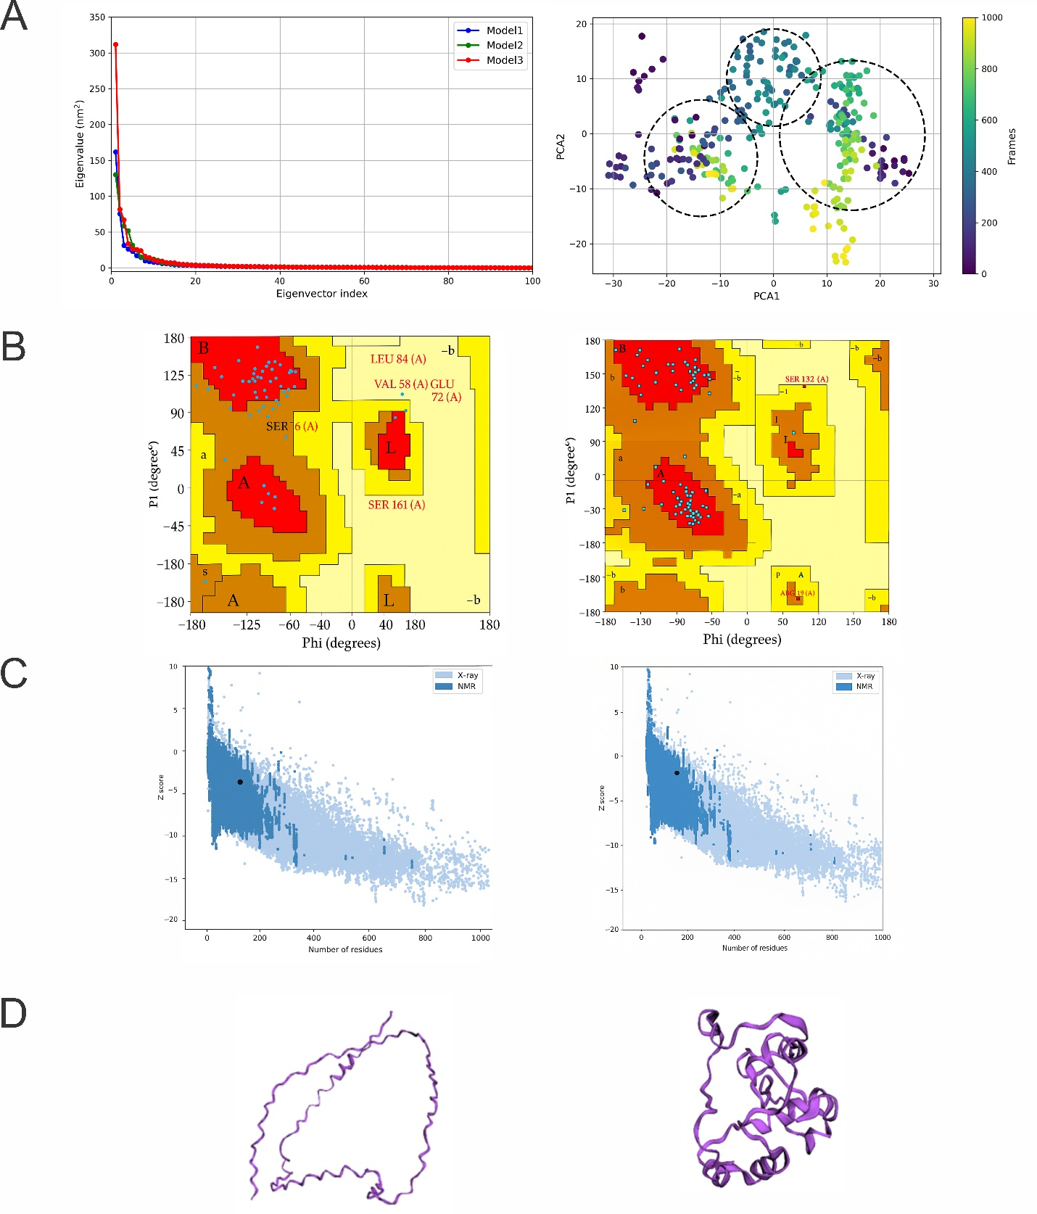
Figure S2. Principal component analysis (PCA) of protein dynamics. (A) (left) Eigenvalue plots for three independently modeled protein structures (Model1–Model3) show consistent decay, indicating stable and convergent dynamics. (right) PCA projection of a 1000 ns trajectory, with frames colored by time. Dashed circles highlight distinct conformational clusters, suggesting the presence of metastable states sampled during the simulation. Structural validation of the VCX2 (Variable Charge, X-linked 2) protein model before (left column) and after (right column) refinement. (B) Ramachandran plots (PROCHECK) show increased occupancy in favored regions post-refinement. (C) ProSA-web Z-scores indicate enhanced model quality compared to reference X-ray and NMR structures. (D) 3D cartoon representations of VCX2 show an improved folding and compactness model.

Table S1. Root-Mean-Square Deviation (RMSD) and standard deviation (± SD) of the VCX2 protein structure across different time intervals during a 999-nanosecond molecular dynamics simulation.
Time interval (ns) | Average RMSD (nm) | Standard Deviation (±nm)
0–100 | 0,0000 | 0,0000
100–250 | 0,0556 | 0,0291
250–500 | 0,1852 | 0,0884
500–750 | 0,2976 | 0,0572
750–999 | 0,3086 | 0,0619

References

1. Xu, S. et al. Using clusterProfiler to characterize multiomics data. Nat. Protoc. 1–29 (2024).
2. Yu, G. Enrichplot: visualization of functional enrichment result. R Packag. version 1, (2021).
3. Blanco-Carmona, E. Generating publication ready visualizations for Single Cell transcriptomics using SCpubr. bioRxiv 2002–2022 (2022).
4. D’Avola, D. et al. High-density single cell mRNA sequencing to characterize circulating tumor cells in hepatocellular carcinoma. Sci. Rep. 8, 11570 (2018).
5. Lee, H. W. et al. Single-cell RNA sequencing reveals the tumor microenvironment and facilitates strategic choices to circumvent treatment failure in a chemorefractory bladder cancer patient. Genome Med. 12, 1–21 (2020).
6. Gao, R. et al. Delineating copy number and clonal substructure in human tumors from single-cell transcriptomes. Nat. Biotechnol. 39, 599–608 (2021).
7. Lee, H.-O. et al. Lineage-dependent gene expression programs influence the immune landscape of colorectal cancer. Nat. Genet. 52, 594–603 (2020).
8. Laughney, A. M. et al. Regenerative lineages and immune-mediated pruning in lung cancer metastasis. Nat. Med. 26, 259–269 (2020).
9. Lambrechts, D. et al. Phenotype molding of stromal cells in the lung tumor microenvironment. Nat. Med. 24, 1277–1289 (2018).
10. Nelson, L. et al. A living biobank of ovarian cancer ex vivo models reveals profound mitotic heterogeneity. Nat. Commun. 11, 822 (2020).
11. Peng, J. et al. Single-cell RNA-seq highlights intra-tumoral heterogeneity and malignant progression in pancreatic ductal adenocarcinoma (vol 29, pg 777, 2019). CELL Res. 29, 777 (2019).
12. Zhang, P. et al. Dissecting the single-cell transcriptome network underlying gastric premalignant lesions and early gastric cancer. Cell Rep. 30, 4317 (2020).
13. Szklarczyk, D. et al. STRING v10: protein–protein interaction networks, integrated over the tree of life. Nucleic Acids Res. 43, D447–D452 (2015).
14. Shannon, P. et al. Cytoscape: a software environment for integrated models of biomolecular interaction networks. Genome Res. 13, 2498–2504 (2003).
15. Weininger, D. SMILES, a chemical language and information system. 1. Introduction to methodology and encoding rules. J. Chem. Inf. Comput. Sci. 28, 31–36 (1988).
16. Barazorda-Ccahuana, H. L. et al. PeruNPDB: the Peruvian Natural Products Database for in silico drug screening. Sci. Rep. 13, 7577 (2023).
17. Dallakyan, S. & Olson, A. J. Small-molecule library screening by docking with PyRx. Methods Mol. Biol. 1263, 243–250 (2015).
18. Trott, O. & Olson, A. J. AutoDock Vina: improving the speed and accuracy of docking with a new scoring function, efficient optimization, and multithreading. J. Comput. Chem. 31, 455–461 (2010).

