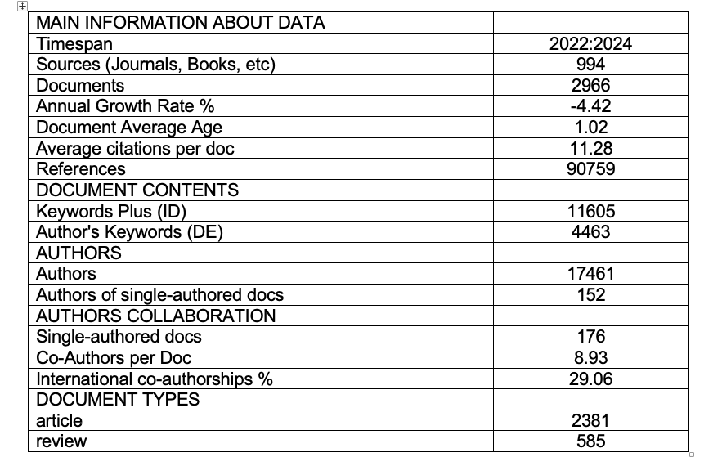
Table 1: Main Information about the Data

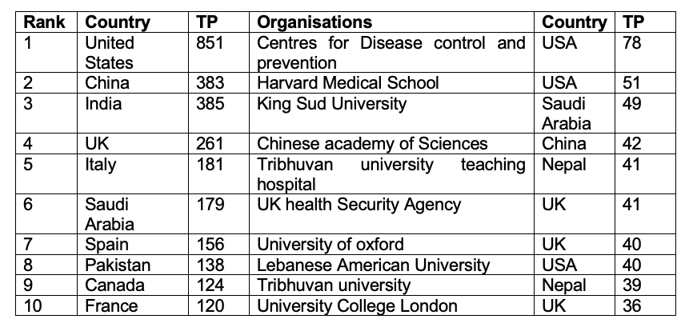
Table 2: The top 10 most influential countries and organisations in Monkeypox literature during 2022-24

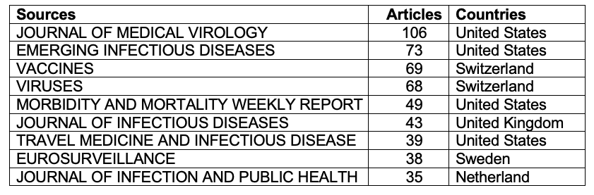
Table 3: Influential Research Journals

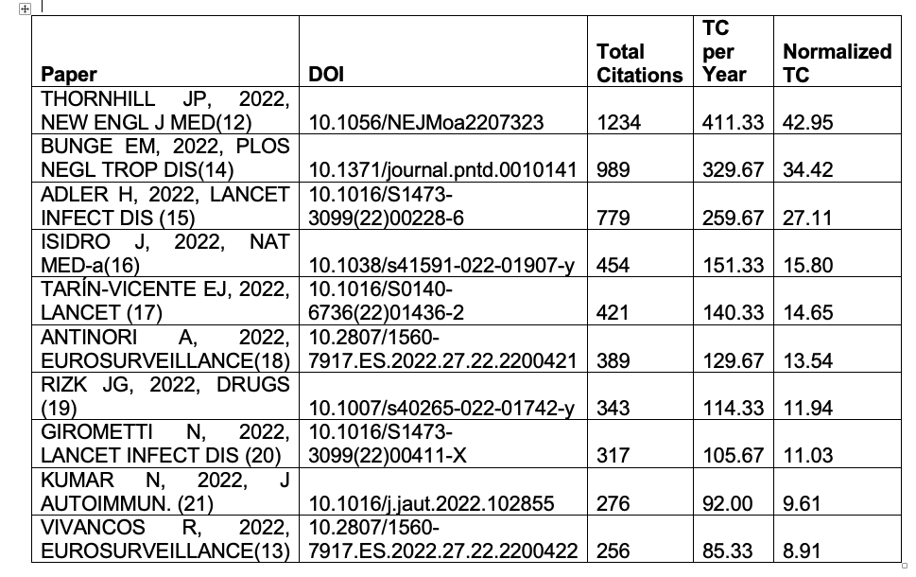
Table 4: Highly Cited Articles

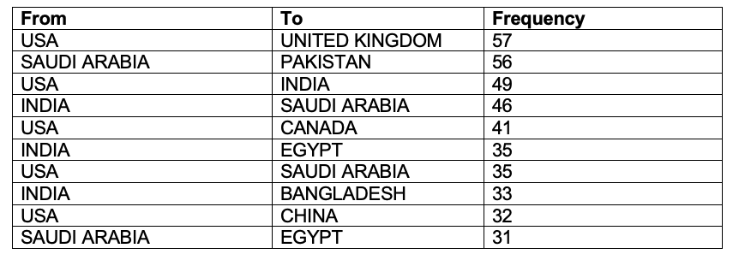
Table 5:Country Collaboration Table.

