Supplementary material
Supplementary Figure 1 Original trajectory groups for prenatal alcohol consumption based on the five group model
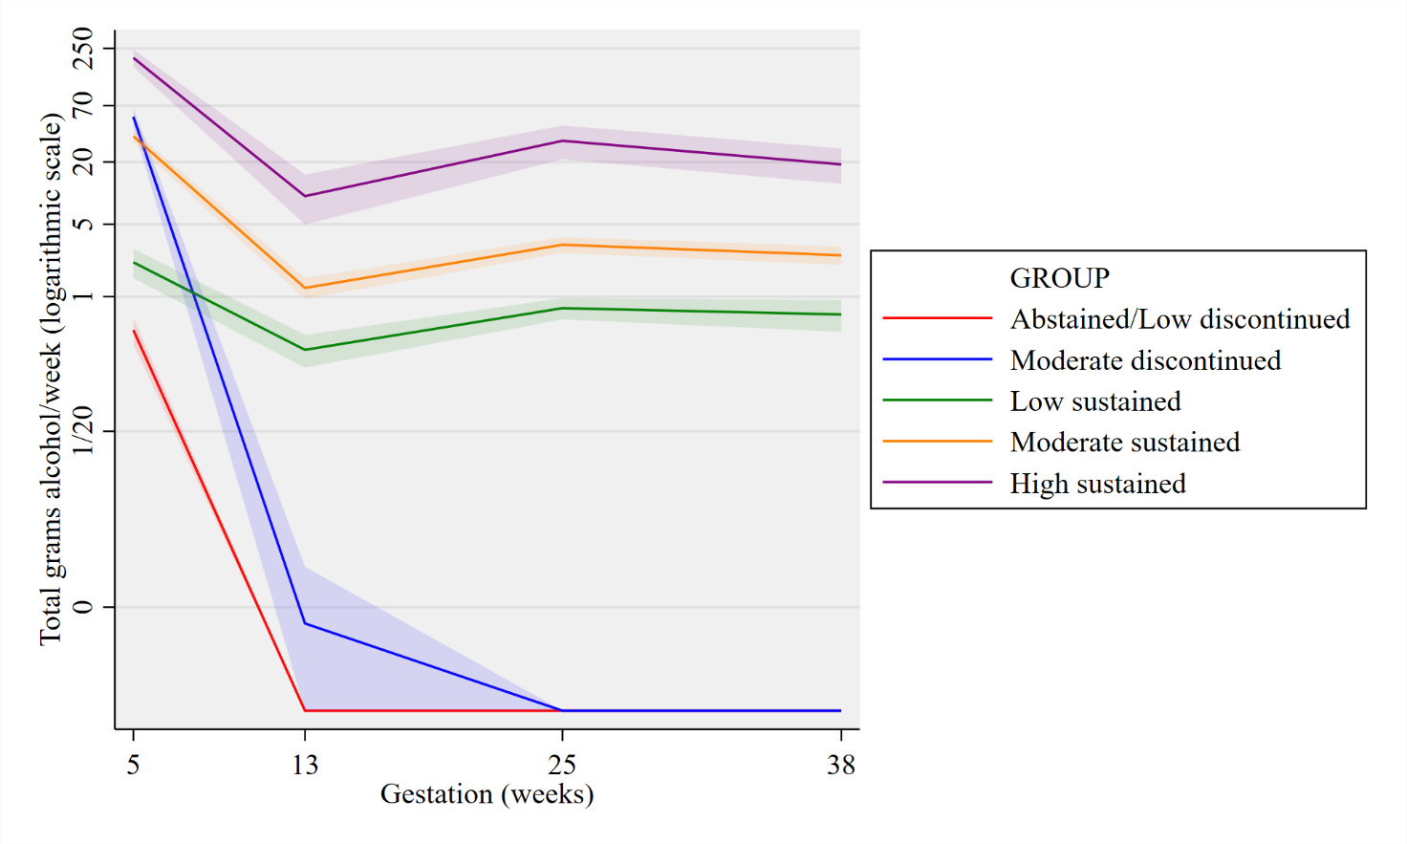
Supplementary Figure 2 Trajectory groups for prenatal alcohol consumption with linear y-scale for reference
