Figure S1 | Circadian rhythm disruption exacerbates DSS-induced colitis and impairs colonic clock gene expression.
(A) Body weight change (%) over 8 days of DSS treatment in wild-type (WT + DSS) and jet lag (Jet Lag + DSS) mice. Mice exposed to circadian disruption exhibited significantly greater weight loss. (B) Representative images of colons from WT + DSS and Jet Lag + DSS groups. (C) Quantification of colon length showing significant shortening in jet-lagged mice. (D) Disease Activity Index (DAI) scores were elevated in the Jet Lag + DSS group. (E) Histological scores based on hematoxylin and eosin-stained colonic sections revealed increased mucosal damage in jet-lagged mice. (F) Representative H&E-stained distal colon sections showing mucosal architecture and inflammatory infiltration. Scale bar, 200 μm. (G) Temporal expression profiles of core circadian clock genes (Per2, Per1, Bmal1, Clock, Cry1, and Nr1d1) in colonic tissue across four Zeitgeber time points (ZT0, ZT6, ZT12, ZT18) in WT and DSS-treated mice. Expression of Per2 and several other clock genes was markedly dampened in DSS mice, with further suppression under circadian disruption. Data are presented as mean ± SEM, n = 6 per group. *P < 0.05, by unpaired two-tailed t-test.

Figure S2 | Efficient deletion of Per2 in intestinal epithelial cells of conditional knockout mice.
(A) Western blot analysis of PER2 protein expression in isolated intestinal epithelial cells from Per2^{f/f} and Per2^{-/-} mice. GAPDH serves as the loading control. (B) Quantification of PER2 protein levels normalized to GAPDH, demonstrating significantly reduced expression in Per2^{-/-} mice. (C) Relative Per2 mRNA expression in epithelial cells measured by quantitative PCR. Per2 transcript levels were markedly decreased in the knockout group. (D) Immunofluorescence staining of PER2 (green) and DAPI (blue) in colonic tissue sections from Per2^{f/f} and Per2^{-/-} mice. PER2 signal was strongly reduced in the intestinal epithelium of knockout mice, confirming successful gene deletion. Scale bars, 100 μm. Data are presented as mean ± SEM, n = 6 per group. *P < 0.05, by unpaired two-tailed t-test.

Figure S3 | Increased necroptosis signaling in PER2-deficient mice and UC patients.
(A) Western blot analysis of necroptosis markers (ZBP1, MLKL, RIPK3) in colonic tissues from healthy controls (HC) and UC patients with or without sleep disruption (jet lag). GAPDH serves as a loading control. Necroptosis proteins were elevated in UC patients, particularly those with sleep disruption. (B) Confocal immunofluorescence images of colonic sections from Per2^{f/f}, Per2^{-/-}, Per2^{f/f} + DSS, and Per2^{-/-} + DSS mice. Sections were co-stained for MLKL (red), TUNEL (green), and DAPI (blue). Strong co-localization of TUNEL and MLKL signals was observed in Per2^{-/-} + DSS mice, indicating enhanced necroptotic cell death. Scale bar, 100 μm.

Figure S4 | Identification of STAT1 as a PER2-interacting necroptosis regulator.
(A) Venn diagram showing overlap between proteins identified by PER2 immunoprecipitation (IP) and mass spectrometry (FLAG IP-1 and IP-2) with a curated list of necroptosis-related genes. STAT1 and STAT3 were identified as shared candidates. (B) Quantitative analysis of STAT1 and STAT3 protein expression from Fig. 6A, comparing Per2^{-/-} + DSS and Per2^{f/f} + DSS groups. STAT1, but not STAT3, was significantly upregulated in Per2^{-/-} mice. (C) Schematic map of the pGL4.11 luciferase reporter plasmid containing the ZBP1 promoter sequence, indicating the location of the STAT1 binding site used for wild-type and mutant reporter constructs.

Figure S5 | Structural mapping of PER2 interaction domains and functional validation of PAS1 in necroptosis regulation.
(A) Schematic diagram of full-length and truncated PER2 constructs used for domain mapping. Mutants include deletions of PAS1, PAS2, PAC, and N-terminal fragments (N-N1, N-N2, N-N3) with defined amino acid boundaries. (B) Western blot analysis of necroptosis markers in LPS-treated NCM460 cells expressing ΔPAS1 mutant. Loss of the PAS1 domain reduced the expression of ZBP1, MLKL, RIPK3, and their phosphorylated forms (p-MLKL, p-RIPK3), indicating impaired necroptotic signaling.

Figure S6 | Morphological characterization of sodium alginate-Nifuroxazide hydrogel microspheres.
(A) Scanning electron microscopy (SEM) image of the external surface of sodium alginate–Nifuroxazide hydrogel microspheres, showing a relatively smooth and compact morphology. (B) SEM image of the internal structure of fractured microspheres, revealing a porous architecture that facilitates sustained drug release. Scale bars: 10 µm.

Figure. S1
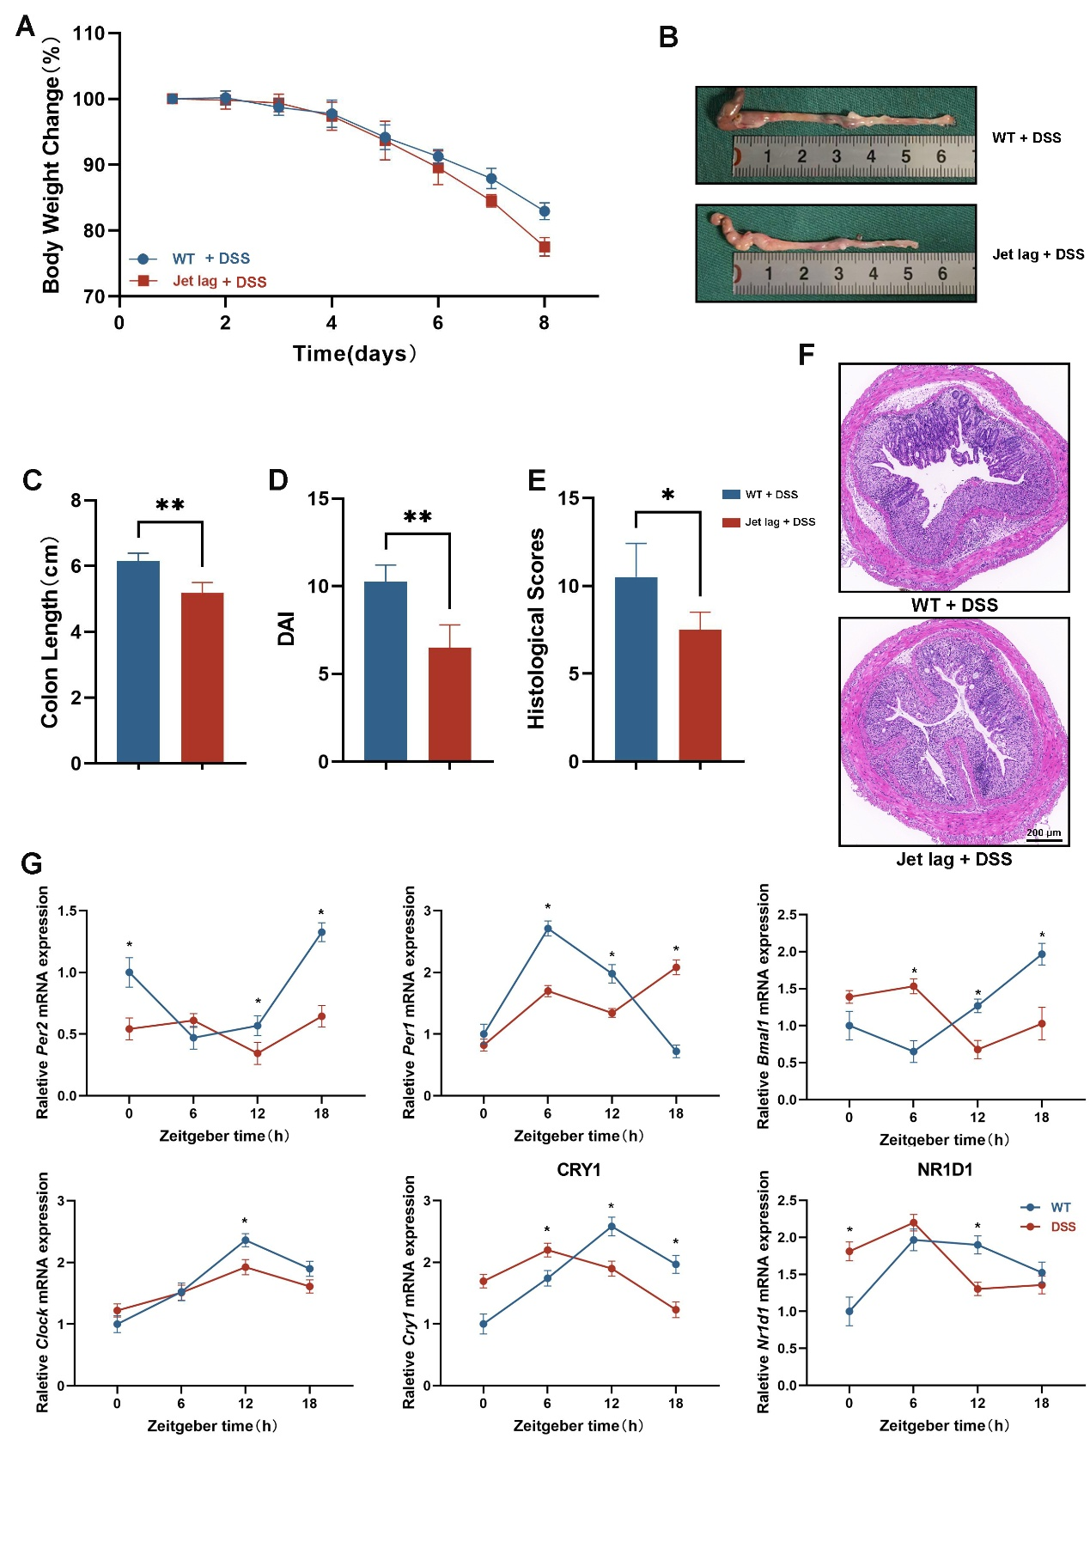

Figure. S2
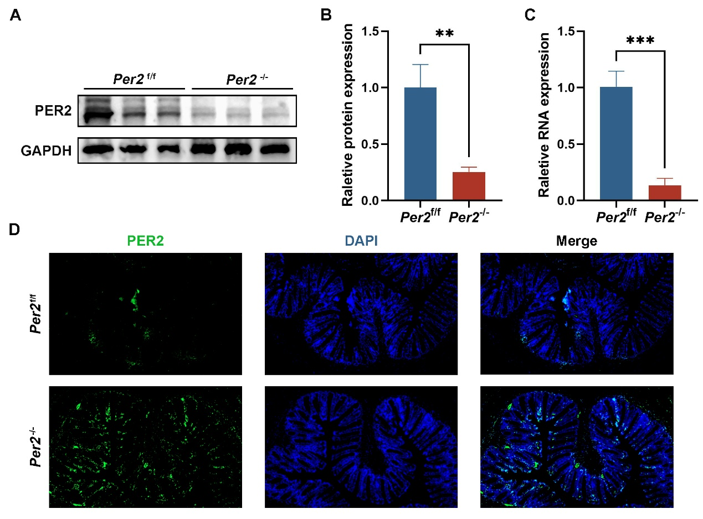

Figure. S3
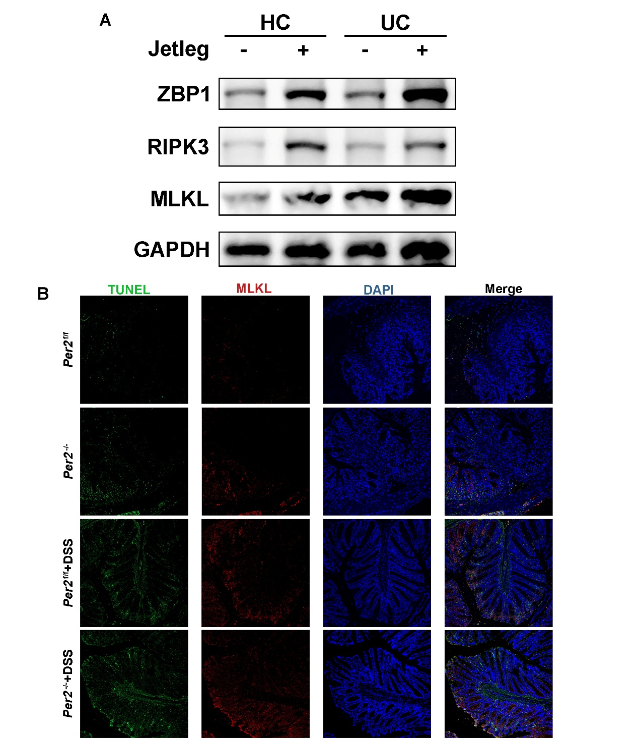

Figure. S4
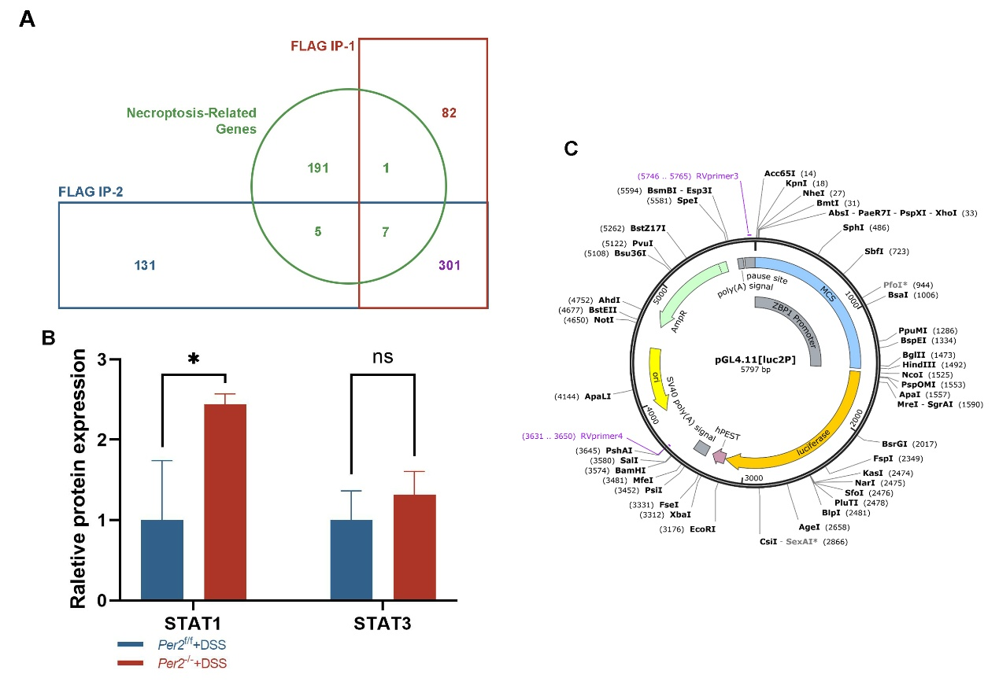

Figure. S5
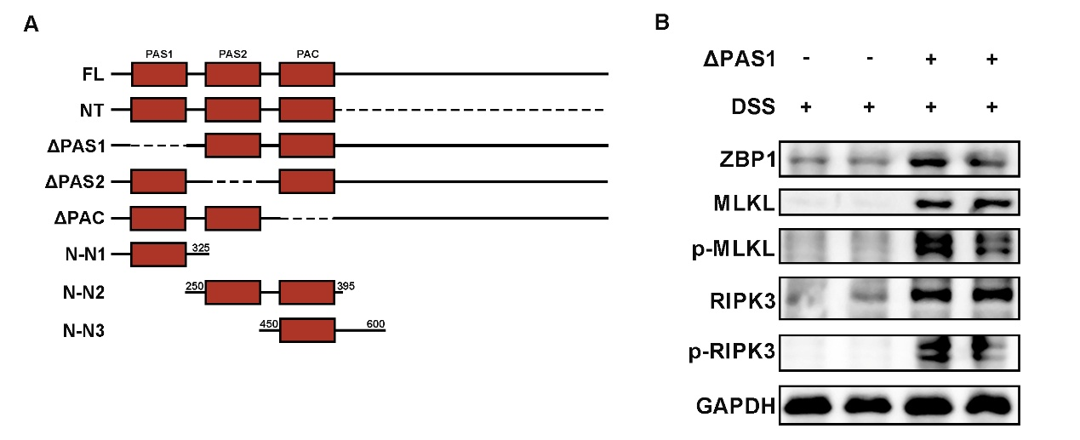

Figure. S6
